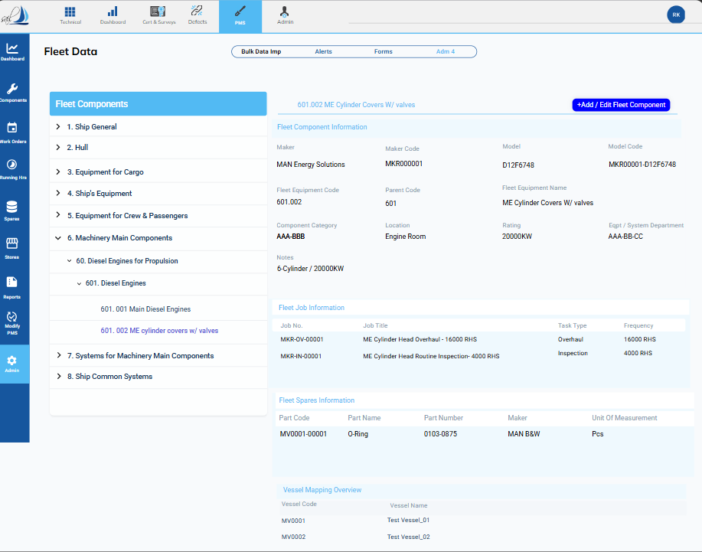

Fig 1
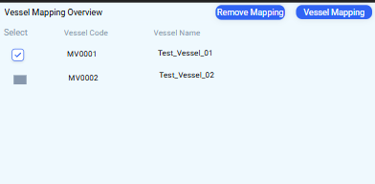
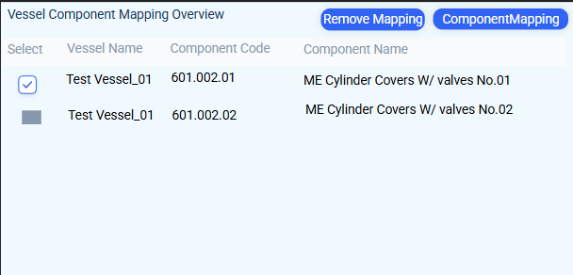

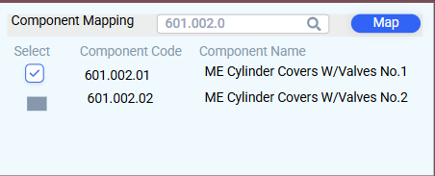
Fig 2 Fig 4

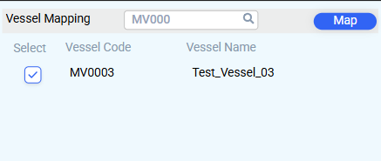
Fig 3 Fig 5

VESSEL MAPPING OVERVIEW GUIDE:
- Mapping Fleet Equipment Code with the Vessel
- Click on the Vessel Mapping Overview in Fig 1.
- The interface shown in Fig 2 will open.
- To remove equipment code mapping from a vessel, select the vessel from the list in Fig 2 and click on "Remove Mapping."
- To map a new vessel, click on the Vessel Mapping button in Fig 2.
- A popup window as shown in Fig 3 will open; select the vessel and click "Map."

- Mapping Fleet Equipment Code with the Vessel Component Code
- Click on the vessel name in either Fig 1 or Fig 2 for the vessel you want to link to the component code.
- The interface in Fig 4 will open, showing the list of component codes linked to the fleet equipment code.
- To unlink a component code, select the code and click on the "Remove Mapping" button in Fig 4.
- To map a new component code, click the component mapping button, which will open a popup as shown in Fig 5.
- The popup will display a list of component names and codes for the selected vessel.
- Select the correct component code and click the "Map" button in Fig 5.


Fleet Job Information

Fig 10
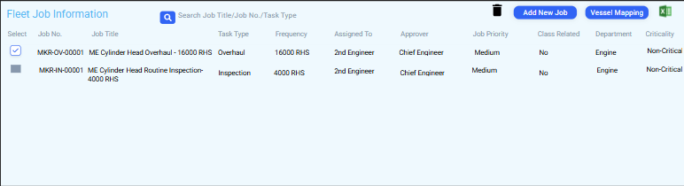
Fig 11

Fig 12
- · When you click on the Fleet Job Information﻿ on Fig 10, the Fig 11 interface will open.
- To link or unlink any job from the vessel, click on the vessel mapping button﻿ on Fig 11.
- Then, the Fig 12 popup will open, which will have a list of vessels linked with the Equipment code.
- From here, select the vessel you want to map or remove the mapping from, then click on the designated button.
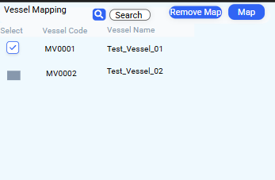



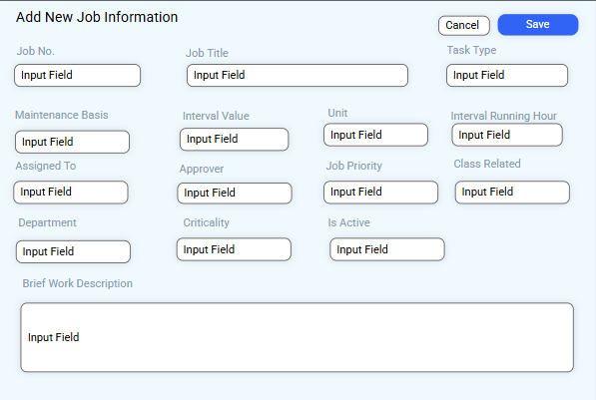
Fig 11
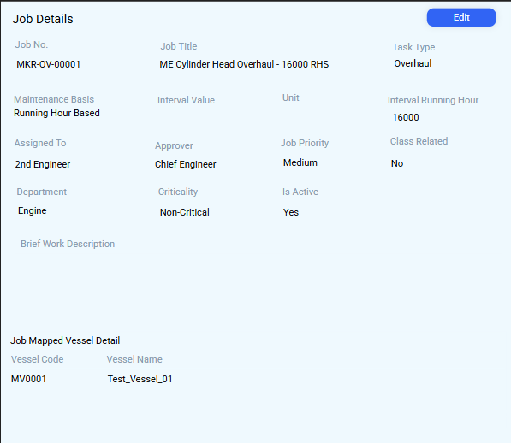
Fig 13

Fig 15
1. Job Details and Edit Job Details
- To know more details about the job, double-click on the job in Fig 11.
- Then the Fig 13 interface will open.
- To edit the job, click on the edit button﻿ in Fig 13.
- Then Fig 14 popup will open. Enter the data that needs to be edited and click on save﻿.
2. Add New Job Information
- To add a new job, click on the Add New Job Button﻿ in Fig 11.
- Then Fig 15 popup will open.
- Fill in all the required data and click on save﻿.

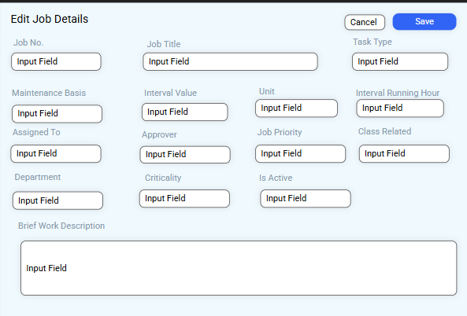
Fig 14


Fleet Spare Information

Fig 20
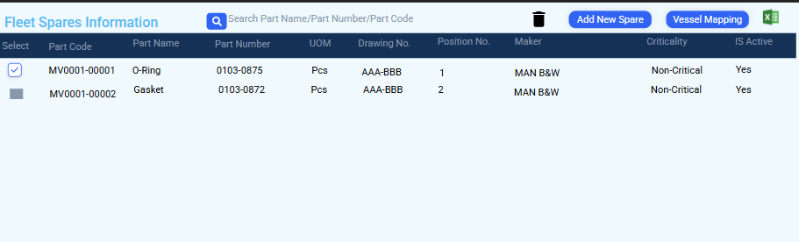
Fig 21

- · When you click on the Fleet Spare Information﻿ on Fig 20, the Fig 21 interface will open.
- To link or unlink any Spare from the vessel, click on the vessel mapping button﻿ on Fig 21.
- Then, the Fig 22 popup will open, which will have a list of vessels linked with the Equipment code.
- From here, select the vessel you want to map or remove the mapping from, then click on the designated button.

Fig 22



Fig 21
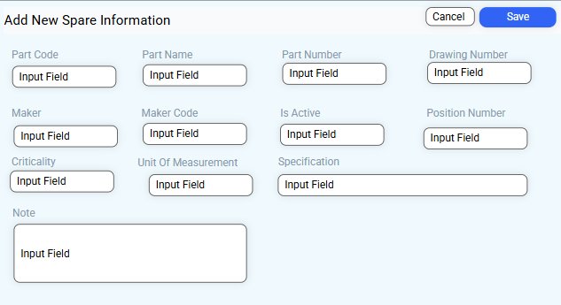
Fig 25
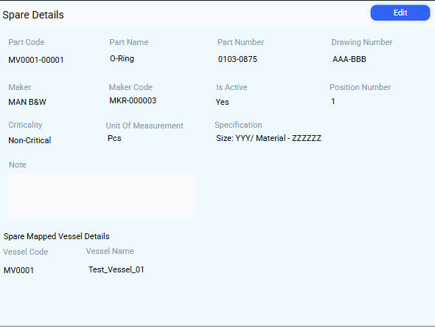
Fig 23

1. Spare Details and Edit Spare Details
- To know more details about the Spare, double-click on the job in Fig 21.
- Then the Fig 23 interface will open.
- To edit the Spare, click on the edit button﻿ in Fig 23.
- Then Fig 24 popup will open. Enter the data that needs to be edited and click on save﻿.
2. Add New Spare Information
- To add a new Spare, click on the Add New Job Button﻿ in Fig 21.
- Then Fig 25 popup will open.
- Fill in all the required data and click on save﻿.

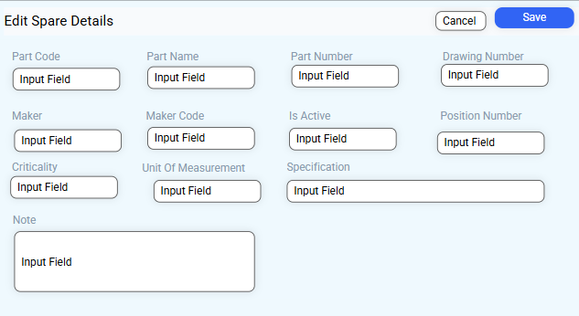
Fig 24

