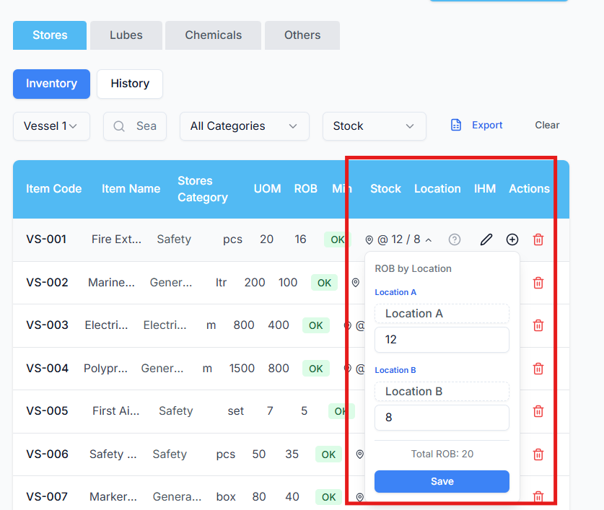
Prompt for Replit – Fix ROB Location Binding in Spares Popup
Analyse and correct the functionality for binding ROB location values in the Spares table popup when clicking on the Location field.
Current Observed Issue
- When clicking the ROB location field in the spares popup, the UI shows static labels like:
  - Location A
  - Location B
- However, the ROB location data does exist correctly and is already being returned by the Stores API.
Correct Data Source (Already Working)
The following API returns the correct ROB location values and must be treated as the authoritative source:
GET /technical/api/stores/{itemId}?itemType=stores
Example response:
locationA: "Bridge"
locationB: "Main Deck"
These values are the actual ROB locations and must be shown in the spares popup.
Incorrect / Conflicting Data Source
Another API is being used in parallel:
GET /technical/api/vessel-location-names/{vesselId}
Example response:
locationAName: "Location A"
locationBName: "Location B"
This API returns generic/static labels, not real ROB locations, and is currently overriding or being bound instead of the correct values.

Analysis Tasks
- Identify where and why the UI is calling the vessel-location-names API for ROB binding.
- Trace the data flow from:
  - API response
  - State / store assignment
  - Popup rendering logic
- Explain:
  - Why the correct Stores API data is fetched but not used
  - Why static vessel location names are taking precedence
- Confirm whether:
  - The static API was originally intended only for column headers / labels
  - And is incorrectly reused for ROB value binding

Fix Requirements
- Use only the Stores API response (locationA, locationB) for:
  - ROB location values in the spares popup
- Do not use vessel-location-names for value binding
- Ensure:
  - Clicking on a location field always reflects the actual stored ROB location
  - No regression in other modules using vessel location labels
- Keep existing APIs and functionality intact
- Fix binding logic only, not backend data

Validation
After applying the fix:
- Test clicking on ROB location fields for multiple spares
- Verify values match:
  - "Bridge", "Main Deck", etc.
- Confirm no fallback to "Location A" / "Location B"

Constraints
- Do not change database structure
- Do not remove APIs
- Do not introduce new endpoints
- Focus strictly on correcting data source selection and binding logic

