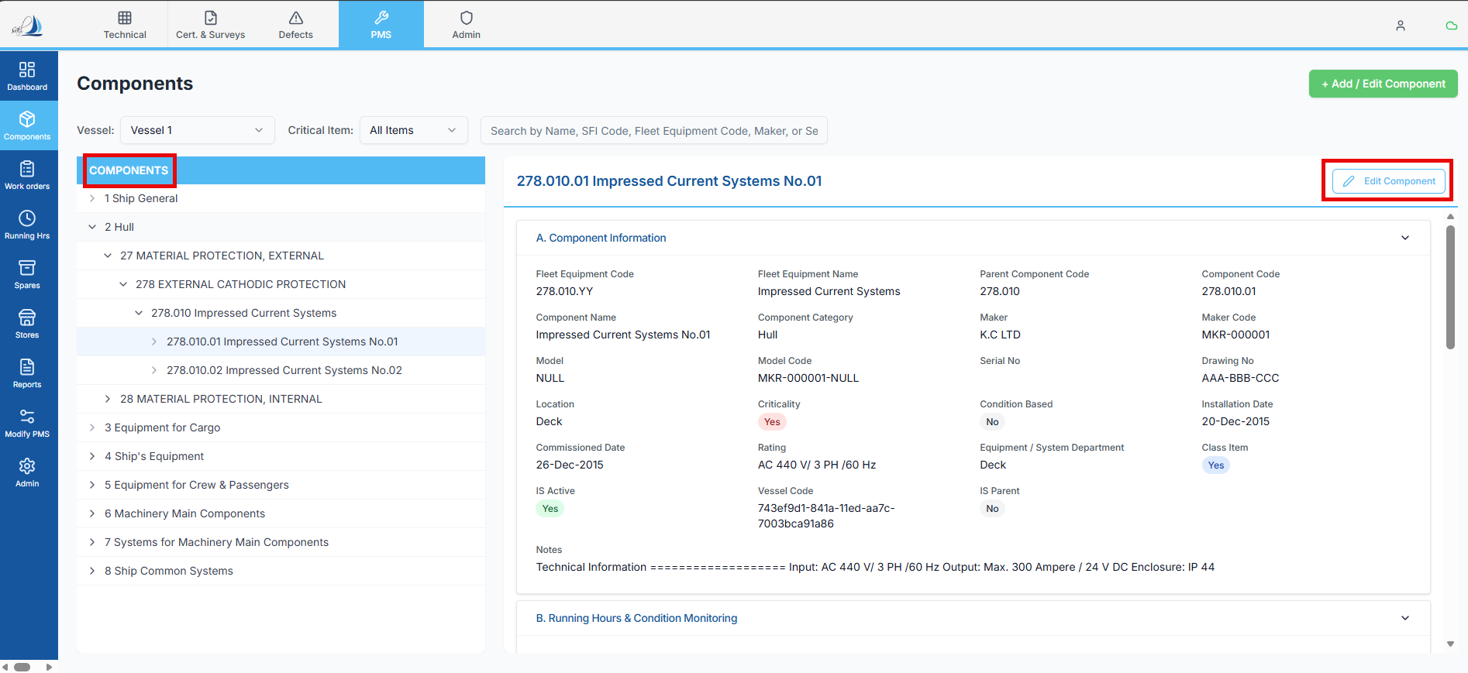
Components Section for reference

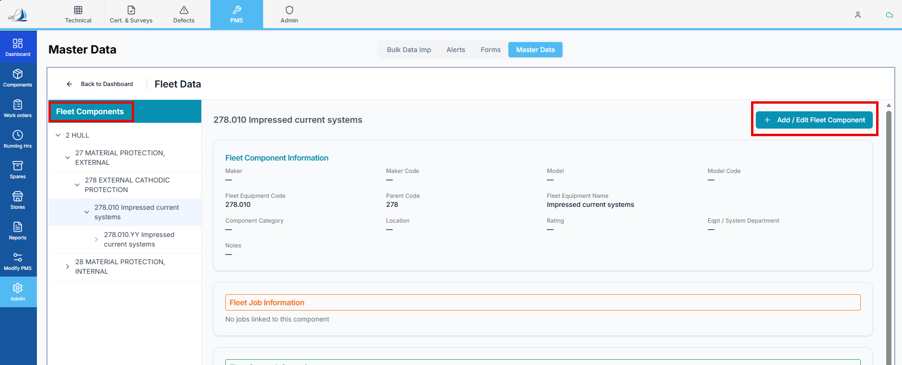
The Location where we are going to work – Fleet Components

Raplit Prompt
Title: Fleet → Fleet Component – Align +Add / Edit Behavior with Components → Edit Component
Purpose
Analyse the +Add / Edit Fleet Component functionality and define a detailed plan to make it behave functionally and experientially identical to the existing Components section → Edit Component feature.
This prompt focuses on how the alignment can be achieved and how it should be implemented, while first performing a deep analysis of the current gaps.

Problem Statement
Current situation:
- Fleet Component section has +Add / Edit Fleet Component functionality.
- Its behavior, data loading, and user experience are not aligned with:
  - Components section → Edit Component
Expected situation:
- Fleet Component Add/Edit flow should behave the same way as Components → Edit Component, including:
  - Screen behavior
  - Data loading pattern
  - Edit vs Create handling
  - Field population
  - Save/update behavior (conceptually)

Analysis Scope
1. Reference Analysis – Components → Edit Component
Analyse the Components section Edit Component feature and document:
- How Edit is triggered (button, action, routing)
- How the system identifies:
  - Edit mode vs Create mode
- How existing component data is:
  - Fetched
  - Passed to the edit screen
  - Bound to the form
- Form behavior:
  - Initial state setup
  - Field population sequence
  - Disabled / read-only fields (if any)
- Save / update flow at a high level (no code)
This will act as the reference implementation.

2. Current State Analysis – Fleet Component +Add / Edit
Analyse the current Fleet Component implementation:
- How +Add Fleet Component works
- How Edit Fleet Component works
- Whether Edit:
  - Receives a component identifier
  - Correctly switches to edit mode
- Whether existing Fleet Component data is:
  - Fetched correctly
  - Partially fetched
  - Not fetched at all
- Differences in:
  - Screen initialization
  - Data binding
  - User flow compared to Components → Edit Component

3. Gap Analysis
Identify and document gaps between:
- Components → Edit Component (reference)
- Fleet Component → +Add / Edit
This may include gaps in:
- Mode detection (add vs edit)
- Data loading sequence
- Form initialization
- Field population
- UX consistency
- Error handling behavior (conceptual)

Detailed Plan (To-Be)
4. Target Behavior Definition
Define the target behavior for Fleet Component Add/Edit:
Fleet Component List
→ +Add / Edit click
→ Screen opens
→ Mode determined (Add or Edit)
→ Existing data fetched (for Edit)
→ Form populated
→ User edits and saves
This behavior must mirror Components → Edit Component.

5. Alignment Strategy
Provide a detailed plan covering:
- How Fleet Component Add/Edit can:
  - Reuse the same interaction pattern
  - Follow the same lifecycle as Components Edit
- Whether:
  - The same screen structure can be reused
  - The same form initialization pattern can be followed
- How identifiers (Fleet Component Code / ID) should be:
  - Passed
  - Consumed
  - Used to fetch data
(Plan only – no code or API changes here.)

6. Implementation Planning (High-Level)
Define how the implementation should be approached, including:
- Changes required in:
  - Fleet Component UI layer
  - Routing / navigation flow
- Ensuring:
  - Edit mode reliably loads data
  - Add mode starts with clean state
- Maintaining:
  - Consistent UX with Components Edit
  - Predictable user behavior
No actual implementation details or code to be written in this prompt.

Constraints (Strict)
- Analysis and planning only
- Do not implement logic
- Do not change backend APIs in this phase
- Do not change database schema
- Do not impact Components section behavior
- Scope limited strictly to Fleet Component Add/Edit
- Follow existing PMS / Fleet architectural patterns

Expected Outcome
After this analysis and plan:
- Clear understanding of how Components → Edit Component works
- Clear identification of why Fleet Component Add/Edit differs
- A detailed, low-risk plan to align Fleet Component Add/Edit behavior
- Fleet Component Add/Edit can be implemented to behave exactly like Components Edit
- No impact on other modules or existing functionality

This should only concentrate on +Add/Edit Fleet Components function only Do not change any other functionality of vessel side.

