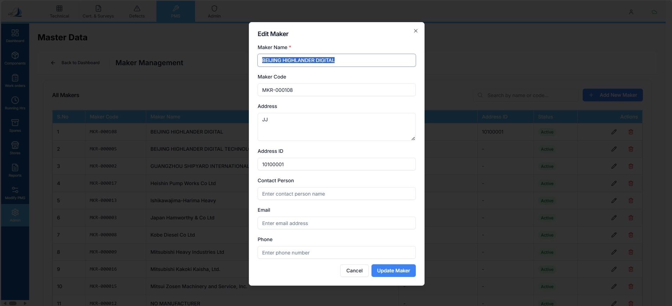

Raplit UI Prompt
Module: PMS → Admin → Master Data → Maker Management
Scope: Edit Maker Section
Change Type: UI Only

Context
In Maker Management → Edit Maker, the current UI does not display all required fields for editing.
This prompt addresses UI completeness only for the Edit Maker screen.

UI Requirements – Edit Maker
The Edit Maker section must display the following fields for editing:
- Maker Code
- Maker Name
- Address
- Address ID
- Contact Person
- Email
- Phone
- IS Active

Layout & Behavior
- Headers must remain static
- Field values must be editable
- No change to:
  - Save behavior
  - Validation logic
  - API calls
  - Data source
- Only field visibility and layout completeness are in scope

Constraints (Strict)
- UI CHANGE ONLY
- NO functionality or logic changes
- NO API or backend changes
- NO schema or data model changes
- Apply only to Edit Maker screen
- Do not impact Add Maker or other modules

Expected Outcome
- All listed fields are visible in Edit Maker UI
- Users can edit existing values
- Headers remain fixed while editing data
- Behavior remains unchanged beyond UI visibility

