- In the Ship Certificates Admin → Vessel tab, when the “Applicable to Vessel” checkbox is unchecked for a certificate and the record is saved, the system automatically re-checks the checkbox after save.
This results in incorrect applicability status being stored and displayed, causing inconsistencies in Vessel-level configuration. This is happening only in case of Vessel added certificates.

Before Save

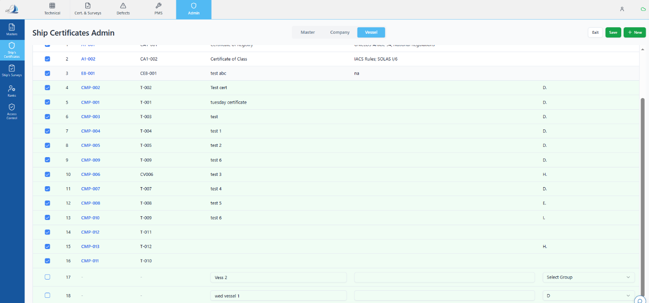

After Save

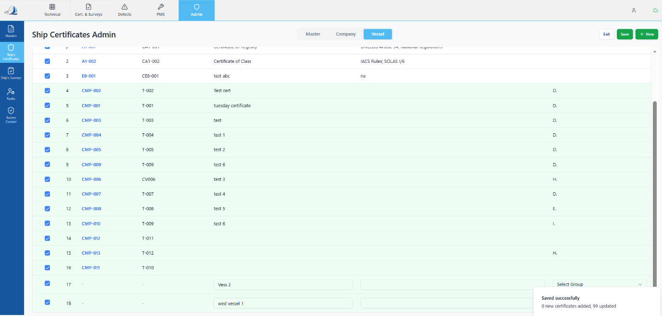

Expected behaviour:
When “Applicable to Vessel” is unchecked and saved:
- The checkbox should remain unchecked.
- The applicability status should be saved correctly.

Sahil's Comments: On Hold this point for now.
Application: Dev
Created Date: 08-04-26
Tester Status-
Developer Status-
Assigned to:
Priority:

- In the Ship Surveys → Vessel tab, for surveys that are added directly at the Vessel level (via Vessel → Edit → + Add Survey), the “Applicable to Vessel” checkbox does not retain its checked state after saving.
Even when the checkbox is checked before saving, the system automatically unchecks it after save, leading to incorrect applicability status.
This issue occurs only for vessel-added surveys and is the opposite of the behaviour observed in certificates.

Before save

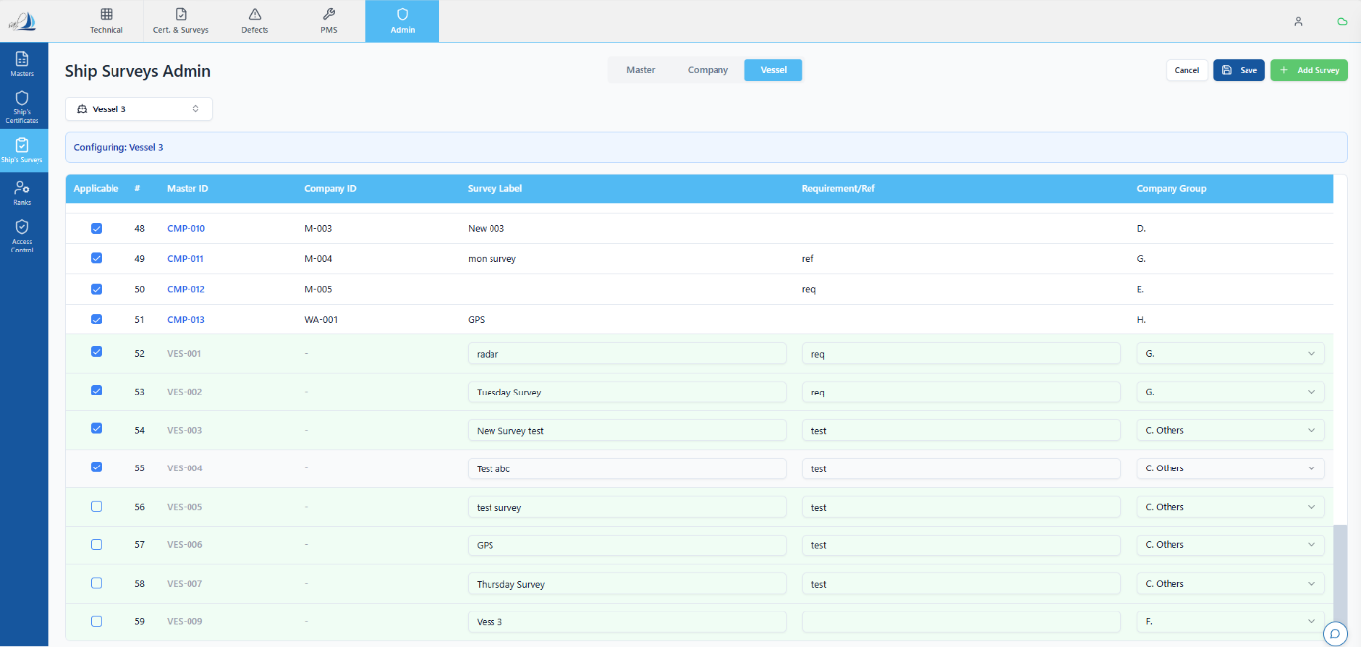

After save

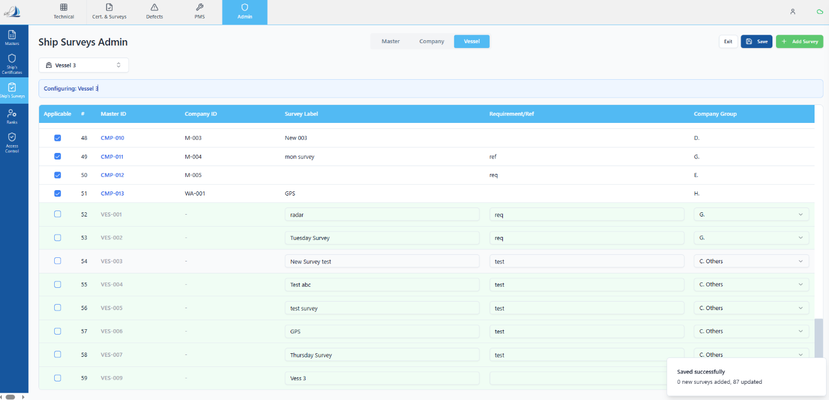

Expected Behaviour
- For surveys added from the Vessel tab:
  - If “Applicable to Vessel” is checked, it should remain checked after save.
  - The checkbox state should persist correctly and reflect user selection.

Sahil’s comments: For surveys added from the vessel tab the ‘Applicable to vessel’ checkbox is not relevant. It can by default be always checked or inactive.
Application: Dev
Created Date: 08-04-26
Tester Status-
Developer Status-
Assigned to:
Priority: Low

