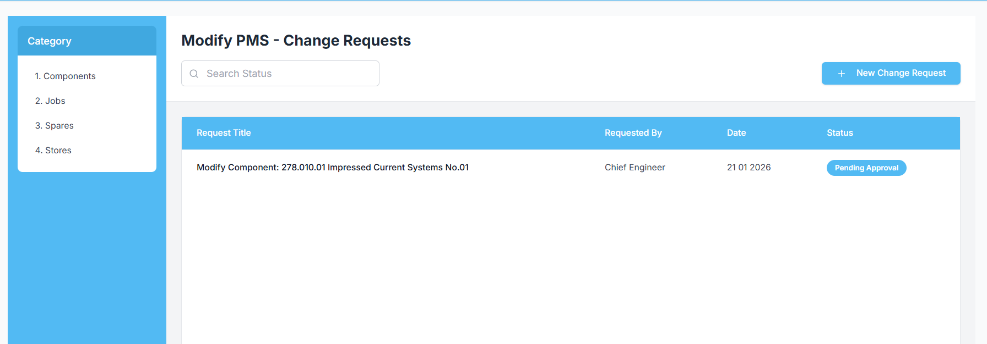

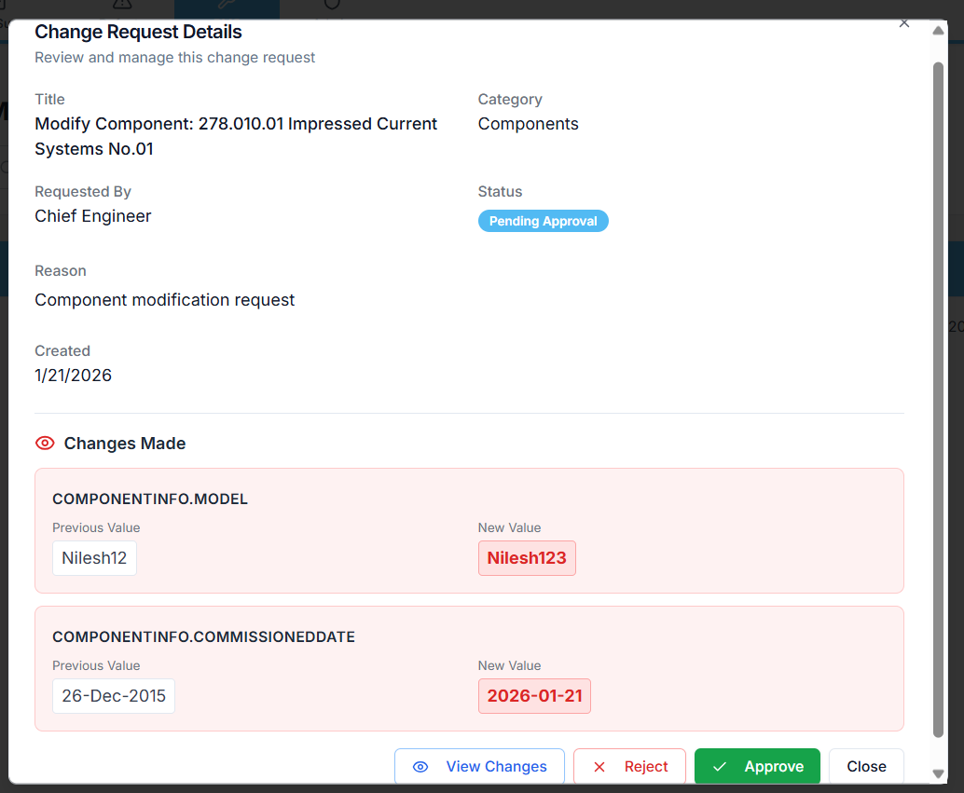
Prompt for Replit – Understand Change Request Approval → Target Module Reflection
Analyse only the internal functionality of the Change Request feature, specifically focusing on what happens after a Change Request is approved.
Objective
I want to clearly understand how approved Change Request data is expected to reflect in the target module (components, jobs, spares, stores), from a logical and implementation perspective.

Analysis Scope
Explain the following in sequence:
1. Role of the Change Request table
- What data is stored at creation time
- Purpose of:
  - snapshot data
  - proposed changes data
  - status and revision tracking
- How this table is designed to act as an intermediary between UI and core PMS data
2. Approval flow
- What exactly happens in the system when a Change Request is approved
- Which service / method is triggered on approval
- What data is read from the Change Request record at this stage
3. Translation of approved data
- How the approved change data is supposed to be:
  - interpreted
  - transformed
  - mapped
- How field-level changes from the Change Request should correspond to fields in the target module
4. Target module reflection
For each module (conceptually, not code changes):
- Components
  - How approved changes should update component attributes
  - How running hours, counters, inheritance, or hierarchy changes are expected to apply
- Jobs / Work Orders
  - How approved changes should affect job definitions, intervals, and scheduling
- Spares
  - How approved changes should affect spare details, ROB, and history
- Stores
  - How approved changes should affect store items, quantities, and transactions
5. Data flow summary
- End-to-end logical flow from:
  - Change Request approval
  - Data extraction from change_request
  - Application to target tables
  - UI reflection
- Clarify whether this flow is:
  - automatic
  - event-driven
  - manually triggered
6. Current behavior vs intended design
- Based on existing code and structure:
  - Explain whether approved changes are actually being applied
  - Or if the Change Request currently acts only as a record without execution
- Highlight any missing link in the reflection process

Constraints
- Do not modify code
- Do not propose fixes
- Do not redesign logic
- Only explain how it currently works and how it is intended to work

This explanation should help clearly understand how change_request data is meant to drive actual PMS updates, and where the reflection responsibility logically sits.

