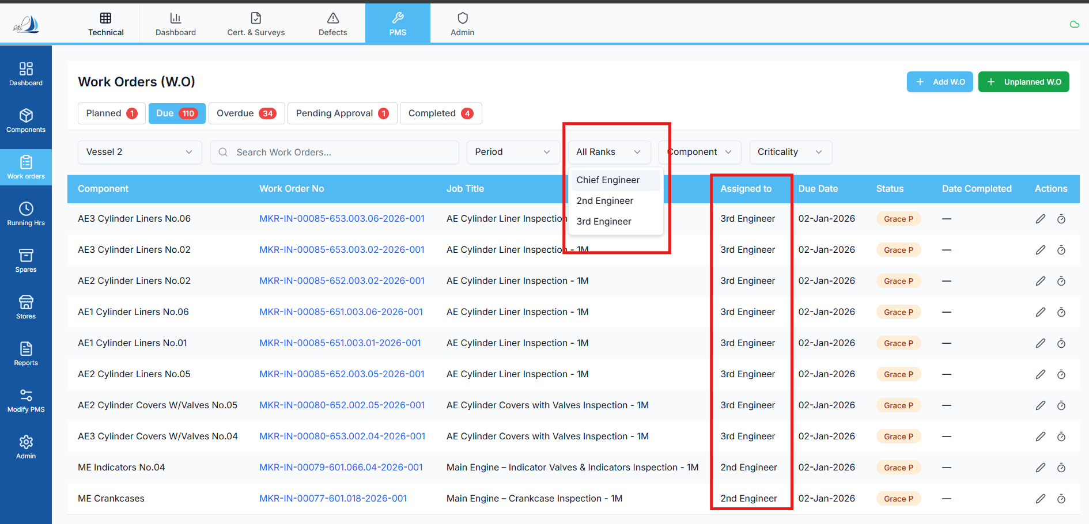

Replit Analysis & Fix Prompt — Work Order “Ranks” Filter Showing Limited Options
Context
In the Work Order sub-module, the Ranks filter currently displays only three options, which is incorrect and incomplete.
This limits usability and prevents proper filtering based on all assigned ranks.

❌ Current Incorrect Behavior
- The Ranks filter shows only three static or partial values
- It does not reflect all ranks actually used in work orders
- Users cannot filter work orders assigned to other ranks even though data exists

✅ Expected Correct Behavior
- The Ranks filter must:
  - Fetch all unique values from:
  - work_order.assigned_to
  - Dynamically bind those values into the filter dropdown
- Each value must appear only once (unique set)
- The filter must reflect actual data present in the work_order table

🧠 Analysis Required (Before Fix)
Replit must:
- Identify:
  - How the Ranks filter is currently populated
  - Whether values are hardcoded, cached, or derived from a limited dataset
- Explain:
  - Why only three ranks are being shown
  - Whether this is due to:
    - Static enum usage
    - API-level filtering
    - Incorrect query
    - Cached frontend data

🛠️ Fix Requirements (Strict)
Replit must:
- Update the data source for the Ranks filter to:
  - Query work_order.assigned_to
  - Extract a distinct / unique set
- Ensure:
  - Null or empty values are excluded
  - Display values match stored values exactly
- Bind the full unique set dynamically to the filter UI
- Keep:
  - All other filters unchanged
  - Existing sorting, pagination, and permissions logic untouched

🧪 Testing Requirements (Mandatory)
After applying the fix, Replit must:
- Verify:
  - All unique assigned_to values appear in the filter
- Apply the filter using:
  - At least two different rank values
- Confirm:
  - Work order list updates correctly
  - No regression in other filters (status, type, date, vessel, etc.)

🚫 What Must NOT Be Changed
- ❌ Work order table structure
- ❌ Business logic for assignment
- ❌ Role-based access control
- ❌ Backend authorization
- ❌ Other filter implementations

📄 Expected Output from Replit
Replit must provide:
- Root cause explanation for limited rank options
- Description of changes applied
- Proof that:
  - Filter options are fully dynamic
  - Filter works correctly after fix

