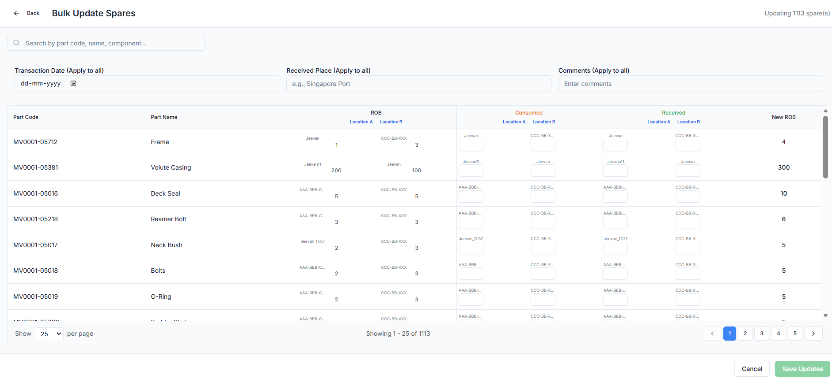
Raplit Prompt – UI Change Only: Bulk Update Spare Section (Transaction Mode Selector)
Module
PMS → Inventory → Bulk Update Spare

Objective
Improve UI clarity in the Bulk Update Spare screen by introducing a Transaction Mode selector (Consume / Receive) at the top, while reusing all existing backend logic and processing.
This change is UI-only.
No functional, logical, or data-processing behavior must change.

Scope of Change (UI Only)
1. New UI Control – Transaction Mode
Add a dropdown at the top section of the Bulk Update Spare screen.
Label: Mode of Transaction
Type: Dropdown
Options:
- Consume
- Receive
Default behavior:
- User must select a mode before interacting with the grid.

2. Existing UI Controls – No Change
The following UI elements must remain exactly as-is:
- Upper Search Bar
- Received Place
- Transaction Date
- Comments
No repositioning, renaming, or logic change is allowed.

3. Grid / Header Layout (UI Labeling Only)
After selecting Mode of Transaction, display the bulk update grid with the following headers:
Part Identification
- Part Code
- Part Name
- Part Number
Stock Information (Read-only)
- Current Stock
- Location A – ROB
- Location B – ROB
Transaction Entry
- Transaction Quantity (Editable)
Location-wise Transaction Columns
- Consume / Received – Location A / ROB
- Consume / Received – Location B / ROB
📌 Note:
The label Consume / Received must dynamically change based on the selected Mode of Transaction:
- If mode = Consume → label shows Consume
- If mode = Receive → label shows Received
This is label-level only, not logic-level.

4. Functional Behavior (Must Reuse Existing Logic)
- User selects Consume or Receive
- Grid loads with the above headers
- ROB values are displayed as read-only
- User enters quantities in location-wise columns
- On save, the system must:
  - Call the existing bulk consume logic for Consume
  - Call the existing bulk receive logic for Receive
⚠️ No new APIs, no conditional backend branching, no new calculations.

5. Expected Outcome
- Clear visibility of transaction intent (Consume vs Receive)
- Same bulk processing behavior as before
- Reduced user confusion
- Consistent UI for bulk inventory operations

🚫 Strict Non-Impact Constraints
This change must NOT:
❌ Modify backend APIs
❌ Change inventory calculation logic
❌ Change ROB update logic
❌ Change validation rules
❌ Introduce new database columns or tables
❌ Affect audit, history, or approval flow
❌ Alter existing consume / receive workflows
Only UI labeling and selection control is allowed.

