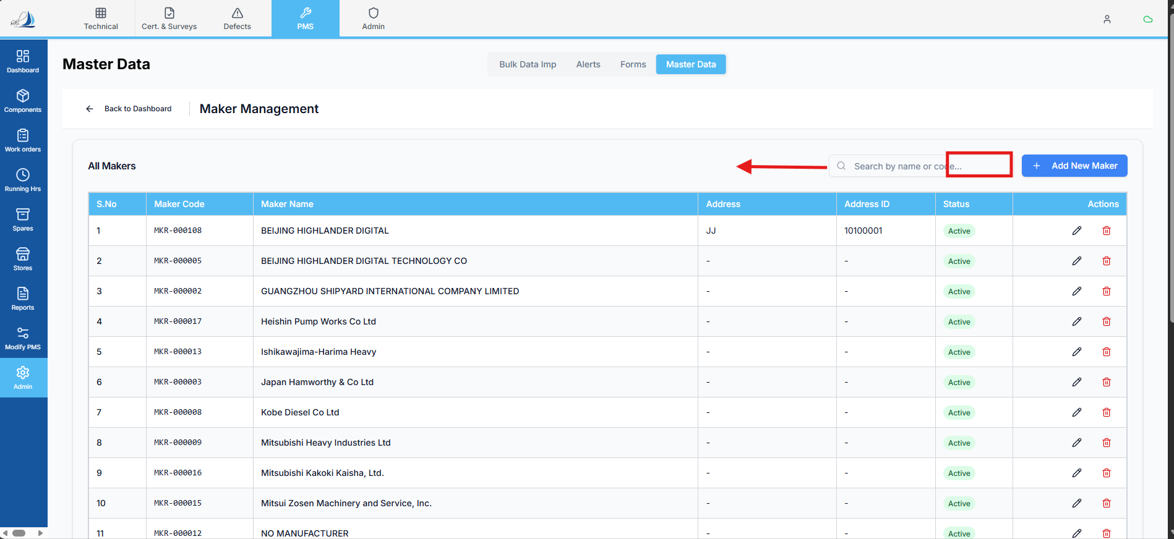 Raplit Prompt
Module: PMS → Admin → Master Data → Maker Management
Feature: Maker Details – Excel Export
Scope: Square Highlighted Section Only

Context
In the Maker Management screen, users need the ability to export Maker details into an Excel file for reference and offline usage.
Currently:
- No export option is available in the highlighted section
- Users cannot download Maker data in bulk in a standardized format

Requirement
- Add an Excel Export Button
  - Add an Excel Export button in the square highlighted section
  - Button placement must be limited strictly to this section
  - No other UI areas should be modified
- Export File Structure
  - The exported Excel sheet must follow the same column structure as the Bulk Import → Maker List template
- Mandatory Export Columns
The Excel export must include only the following columns, in the same order:
- Maker Code
- Maker Name
- Address
- Address ID
- Contact Person
- Email
- Phone
- IS Active

Analysis Expectations
- Analyse how Maker data is currently fetched for display
- Identify the data source used to populate Maker Management
- Ensure the export pulls data from the same authoritative source
- Ensure column names exactly match the Bulk Import Maker List sheet

Constraints (Strict)
- Scope limited to Maker Management screen
- Export button addition only in square highlighted section
- Do not change:
  - Existing UI behavior
  - Edit/Add Maker functionality
  - Bulk Import logic
- Do not add extra columns
- Do not modify Bulk Import template
- Follow existing export patterns used elsewhere in PMS (if any)

Expected Outcome
- Excel Export button is visible in the highlighted section
- Clicking the button downloads an Excel file
- Exported file structure matches Bulk Import Maker List format
- Data accuracy and column consistency are maintained

