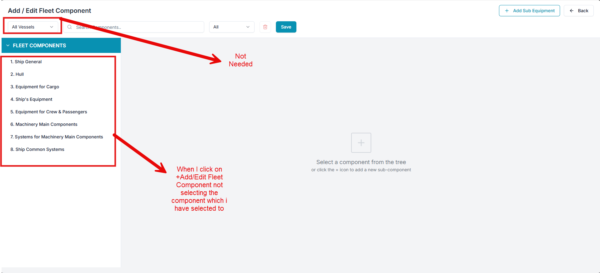

Raplit Prompt
Title: Fleet → Fleet Component – +Add/Edit Not Working (Analysis & Correction Plan, UI Scope Restricted)
Purpose
Analyse why the +Add / Edit Fleet Component functionality is not working as expected, and define a safe, controlled plan to correct it, ensuring behavior matches the previously defined functionality reference.
Any UI changes, if required, may be performed only on the attached Fleet Component page.
No UI changes are allowed outside this page.

Problem Statement
Current behavior:
- Vessel filter / dropdown is present but not required
- +Add / Edit Fleet Component is not working as intended
- Edit action opens incorrect or empty state
- Add action does not follow expected flow
Expected behavior:
- +Add / Edit Fleet Component must work identically to Components → Edit Component
- Vessel context must not affect Add/Edit behavior

Analysis Scope
1. Vessel Filter / Dropdown Analysis
Analyse and document:
- Why the Vessel filter exists in Fleet Component screen
- Whether it:
  - Is unused
  - Is incorrectly inherited
  - Interferes with Add/Edit initialization
- Confirm that Fleet Component is fleet-level master data
- Conclude whether Vessel filter should be:
  - Ignored
  - Hidden
  - Removed (UI-only, page-scoped)

2. +Add / Edit Action Flow Analysis
Analyse:
- +Add / Edit button behavior
- Route/state parameters passed
- Mode detection (Add vs Edit)
- Whether the selected Fleet Component identifier is passed correctly

3. Add/Edit Screen Initialization Analysis
Analyse:
- Form lifecycle on navigation
- Data fetch behavior in Edit mode
- Form binding issues
- State resets or missing prefill
- Dependency on Vessel filter state

4. Data & API Dependency Analysis
Analyse:
- APIs used for:
  - Fleet Component list
  - Fleet Component detail (Edit)
- Whether:
  - API is not invoked
  - API parameters are incorrect
  - Data source mismatch exists
- Parent–child hierarchy resolution issues

5. Root Cause Identification
Clearly identify:
- Primary reason +Add/Edit Fleet Component is broken
- Contributing factors (UI, routing, state, dependencies)
- Whether issue is structural or configuration-based

Correction Plan (To-Be)
6. Corrected Add/Edit Flow
Define the corrected interaction flow:
Fleet Component List
→ +Add / Edit click
→ Fleet Component Add/Edit screen
→ Mode resolved (Add / Edit)
→ Vessel dependency ignored
→ Data fetched (Edit only)
→ Form populated correctly

7. UI Adjustment Plan (Page-Scoped Only)
If UI changes are required:
- Changes are allowed only on the attached Fleet Component page
- Examples (analysis & plan only):
  - Hide or remove Vessel filter
  - Adjust button bindings
  - Correct form initialization triggers
- No shared UI components may be altered
- No global layout changes allowed

8. Safe Resolution Plan
Provide a step-by-step plan to:
- Align Fleet Component Add/Edit with Components Edit behavior
- Eliminate Vessel dependency from Add/Edit lifecycle
- Ensure:
  - Add mode initializes clean state
  - Edit mode loads and binds data
- Keep all changes:
  - Isolated
  - Backward compatible
  - Limited to Fleet Component module

Constraints (Strict)
- Analysis and planning only
- No implementation
- No backend or schema changes
- No impact to Components or other Fleet screens
- UI changes allowed only on the attached page
- Vessel filter logic excluded
- Wait for explicit PROCEED instruction

Expected Outcome
- Clear root cause identified
- UI impact clearly scoped
- Controlled correction plan prepared
- Fleet Component Add/Edit can be fixed without affecting any other functionality

