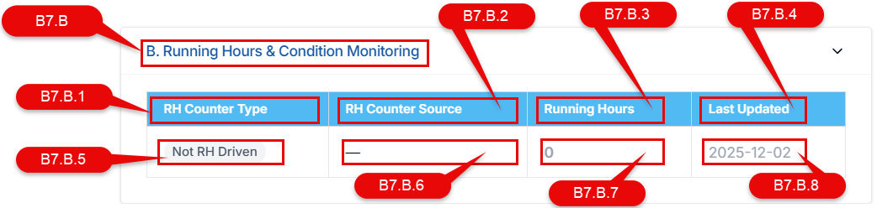
3 allowed values for B7.B.5 - Master (RH Owner), Inherited (Uses Master Counter), Not RH Driven.
MASTER
A component whose running hours are directly maintained at its own level and act as the reference running hours for itself and any linked inherited components.
INHERITED
A component that does not maintain its own running hours and instead inherits running hours from a linked MASTER component.

When B7.B.5 = Master, the component should be visible in RH module in the column D6.

When B7.B.5 = Inherited, It’s RH source is the B7.B.6 which is its parent component. Any changes in RH of the parent (source) component must reflect the same change (delta) to all the inherited children.

For the jobs with Maintenance Basis (JF.A1.12 ) = Running Hours , the Job must have an Running hour counter of their own for calculation of Next due JF.A1.26 and generation of work order.
RH_due = RH_last(WOF.B3.5) + F (JF.A1.14)
RH_generate = RH_due – Lead Time (I4.QL7.14.19)
IF RH_current (B7.B.7) >= RH_generate then generate Work order

Term | Meaning
RH Current | The running hours value used for calculations
RH Last Done | The running hours value at which a job was last completed
Effective RH Current | RH Current actually used for job calculations (MASTER RH for inherited items)

1. FINAL CORE RULES (LOCKED)
1.1 RH Counter Type (ONLY these 3)
MASTER
Running Hours are maintained at this component
Acts as the reference RH source
May have multiple INHERITED components linked to it
Examples:
Main Engine, DG1, DG2, Shaft Generator, Boiler (if RH tracked)

INHERITED
Running Hours are derived from a linked MASTER
Does NOT have an independent counter
STORES a cached copy of MASTER RH for:
reporting
performance
planning screens
Cached RH is read-only and system-updated only
Examples:
Piston, Liner, Exhaust Valve, Fuel Pump, Turbocharger parts

NOT RH DRIVEN
Running Hours are not applicable
RH fields remain NULL
Used for calendar / condition / one-time jobs

1.2 Ownership & Update Rules
Item | MASTER | INHERITED
RH editable | ✅ Yes | ❌ No
RH stored | ✅ Yes | ✅ Yes (cached)
RH source | Self | Linked MASTER
RH update | Manual / Auto | Cascade from MASTER

1.3 Equality rule (critical)
RH_last_done == Effective_RH_Current
ONLY at the moment a Work Order is completed
After completion:
RH_last_done is frozen
Effective RH continues increasing via MASTER

2. FINAL FORMULAS (RH-BASED JOBS)
Let:
RH_last_done = RH recorded when job was last completed
F = Frequency (RH)
LT = Lead Time (RH)
RH_master_current = MASTER running hours
RH_inherited_cached = cached RH for INHERITED component

2.1 Effective RH Current
If RH Counter Type = MASTER:
RH_effective_current = RH_master_current

If RH Counter Type = INHERITED:
RH_effective_current = RH_inherited_cached
And always enforce:
RH_inherited_cached = RH_master_current

2.2 Planning & Generation
RH_due = RH_last_done + F
RH_generate = RH_due – LT (I4.QL7.14.19)
RH_remaining = RH_due - RH_effective_current

2.3 Work Order generation rule
Generate Work Order when:
RH_effective_current ≥ RH_generate
AND
No open WO exists for this job cycle

2.4 Overdue rule
If RH_effective_current ≥ RH_due
→ Status = OVERDUE

2.5 Completion rule (ONLY place RH_last_done changes)
On WO completion:
RH_last_done = RH_effective_current

3. FINAL STATUS LOGIC (RECOMMENDED)
Condition | Status
RH_remaining < 0 | OVERDUE
RH_remaining = 0 | DUE
0 < RH_remaining ≤ LT | DUE SOON
RH_remaining > LT | PLANNED

4. FINAL DATABASE SCHEMA
4.1 COMPONENTS
components
----------
component_id (PK)
vessel_id
parent_component_id
component_name
component_code
is_machinery (bool)

rh_counter_type ENUM:
MASTER
INHERITED
NOT_RH_DRIVEN

rh_master_component_id (FK → components.component_id, nullable)

-- MASTER only
rh_current_master (number, nullable)
rh_master_updated_at (datetime)
rh_master_updated_by (user_id)
rh_master_update_source ENUM (MANUAL / IMPORT / AUTOMATION)

-- INHERITED only (system maintained)
rh_current_inherited_cached (number, nullable)
rh_inherited_updated_at (datetime)
Hard validations
MASTER
rh_current_master NOT NULL
rh_master_component_id NULL
rh_current_inherited_cached NULL
INHERITED
rh_master_component_id NOT NULL
rh_current_master NULL
rh_current_inherited_cached NOT NULL
NOT RH DRIVEN
All RH fields NULL

4.2 JOB TEMPLATES
job_templates
-------------
job_template_id (PK)
job_name
job_category
default_frequency_rh
default_lead_time_rh
default_job_driver ENUM (RH / CALENDAR / CONDITION)
criticality

4.3 COMPONENT JOBS (SCHEDULER CORE)
component_jobs
--------------
component_job_id (PK)
component_id (FK)
job_template_id (FK)

job_driver ENUM:
RH
CALENDAR
CONDITION

frequency_rh
lead_time_rh

rh_last_done
rh_last_done_at
rh_last_done_wo_id

active (bool)
Validations
If job_driver = RH
component.rh_counter_type ≠ NOT_RH_DRIVEN
frequency_rh > 0
lead_time_rh < frequency_rh

4.4 WORK ORDERS
work_orders
-----------
work_order_id (PK)
component_job_id
component_id
job_template_id

wo_status ENUM:
OPEN
IN_PROGRESS
COMPLETED
CANCELLED

generated_at
generate_rh_snapshot
due_rh_snapshot
effective_rh_at_generation

completed_at
effective_rh_at_completion
closed_by

5. CASCADE UPDATE RULE (VERY IMPORTANT)
Whenever a MASTER RH is updated:
master.rh_current_master = new_value
Then for all linked INHERITED components:
inherited.rh_current_inherited_cached = new_value
inherited.rh_inherited_updated_at = now
This guarantees:
Accurate reporting
Zero ambiguity
High performance queries

6. ENGINE EXECUTION FLOW
For each active RH-driven component job:
Identify MASTER (self or linked)
Read RH_effective_current
Calculate RH_due, RH_generate, RH_remaining
If no open WO AND RH_effective_current ≥ RH_generate
→ Generate WO
On completion → update RH_last_done

7. UI & REPORTING (MANDATORY WORDING)
MASTER component
Running Hours
Last Updated
INHERITED component
Effective Running Hours (Inherited)
Source: Main Engine
❌ Never show “Running Hours” alone for inherited items.

8. LINER / PISTON PLANNING (YOUR GOAL)
Hours Remaining formula
(rh_last_done + frequency_rh) - rh_current_inherited_cached
This allows:
“How much has this liner run?”
“When is the next liner replacement due?”
Forecasting across all units

ONE FINAL PRINCIPLE (REMEMBER THIS)
INHERITED components store running hours only as a mirrored snapshot of their MASTER — never as an independent counter.

