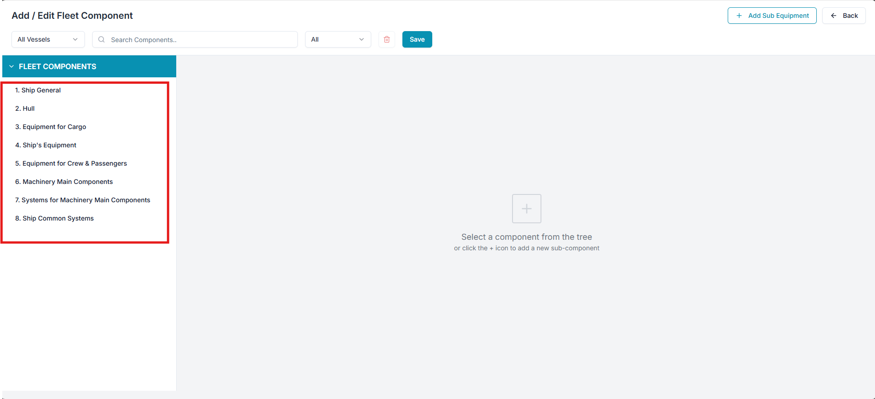
Raplit Analysis Prompt
Module: PMS → Admin → Master Data → Fleet Data → Fleet Components
Scope: UI Analysis & UI Change Plan ONLY

Context & Problem Statement
In the Fleet Components section of PMS Admin:
- The highlighted Fleet Components area currently appears to be static.
- It displays a fixed set of data, regardless of actual Fleet Components hierarchy.
- The + Add / Edit Fleet Components action:
  - Does not behave as expected
  - Does not open the Fleet Components management page correctly
- A Vessel filter / dropdown is visible, but it is not required in Fleet Components context.
This behavior is inconsistent with the Components → Add/Edit Components screen, which correctly displays:
- A dynamic tree view on the left
- Editable data panel on the right
- Static header with editable content below

Key Questions to Analyse
- Is the highlighted Fleet Components section static?
- If static:
  - Why was it implemented as static?
  - Why is it showing this specific dataset?
- Why does + Add / Edit Fleet Components not open the expected UI?
- Why is the Fleet Components tree view not being fetched and rendered dynamically?
- Why is a Vessel filter present, even though Fleet Components are fleet-level master data?

Correct & Expected UI Behavior (Reference-Based)
Reference Page (Do NOT modify):
Components → Add/Edit Components
This page is for layout and behavior reference only
Expected Fleet Components UI Flow
- Fleet Components Section (Landing View)
  - Should dynamically fetch and display the Fleet Components Tree View
  - Data must reflect hierarchy from Fleet Components master
  - No static or hardcoded dataset
- + Add / Edit Fleet Components Action
  - Should open the Fleet Components management page
  - Must NOT depend on vessel context
- Fleet Components Management Page Layout
  - Left Panel
    - Fleet Components Tree View (dynamic)
  - Right Panel
    - Fleet Data interface with editable columns
  - Header
    - Static (same behavior as Components module)
  - Body
    - Editable data only
- Vessel Filter
  - Not required
  - Should be removed from this page

Analysis (UI-Level Only)
- The Fleet Components section is likely:
  - Bound to a static UI container
  - Or mapped to a placeholder dataset
- The tree view component may not be:
  - Initialized
  - Bound to Fleet Components data source
- The + Add / Edit Fleet Components button may:
  - Be linked to an incorrect route
  - Be opening a page shell without data bindings
- Vessel filter presence suggests:
  - UI reused from vessel-specific modules
  - No UI separation between Fleet-level and Vessel-level masters

Detailed UI Correction Plan (No Logic / No Schema)
1. Fleet Components Section UI
- Replace static dataset binding with:
  - Fleet Components Tree View UI container
- Ensure UI is prepared to:
  - Render hierarchical data
  - Match Components tree layout visually
2. + Add / Edit Fleet Components Button
- Update UI navigation only:
  - Route to Fleet Components management page
- Ensure correct page container loads
3. Fleet Components Management Page
- Align layout with Components → Add/Edit Components
  - Left: Tree View
  - Right: Editable Fleet Data grid
- Header must remain static
- Only data area editable
4. Vessel Filter Removal
- Remove vessel dropdown from Fleet Components UI
- Fleet Components are fleet-level masters and must not depend on vessel context
5. UI Change Scope Control
- Any UI changes required:
  - Must be applied only within the attached Fleet Components page
  - Must not impact other modules
  - Must not affect Components module

Mandatory Constraints (Strict)
- ANALYSIS & PLAN ONLY
- NO business logic
- NO backend changes
- NO schema changes
- NO validations
- NO impact to other functions or modules
- UI changes allowed ONLY in the attached Fleet Components page
- Reference Components page strictly for layout/behavior
- WAIT for explicit PROCEED instruction

