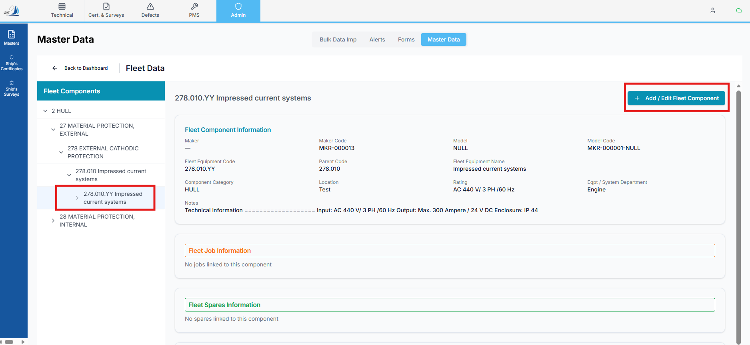
As you can see in the above scenario, I selected a Fleet Component and clicked on the + Add / Edit Fleet Component button.
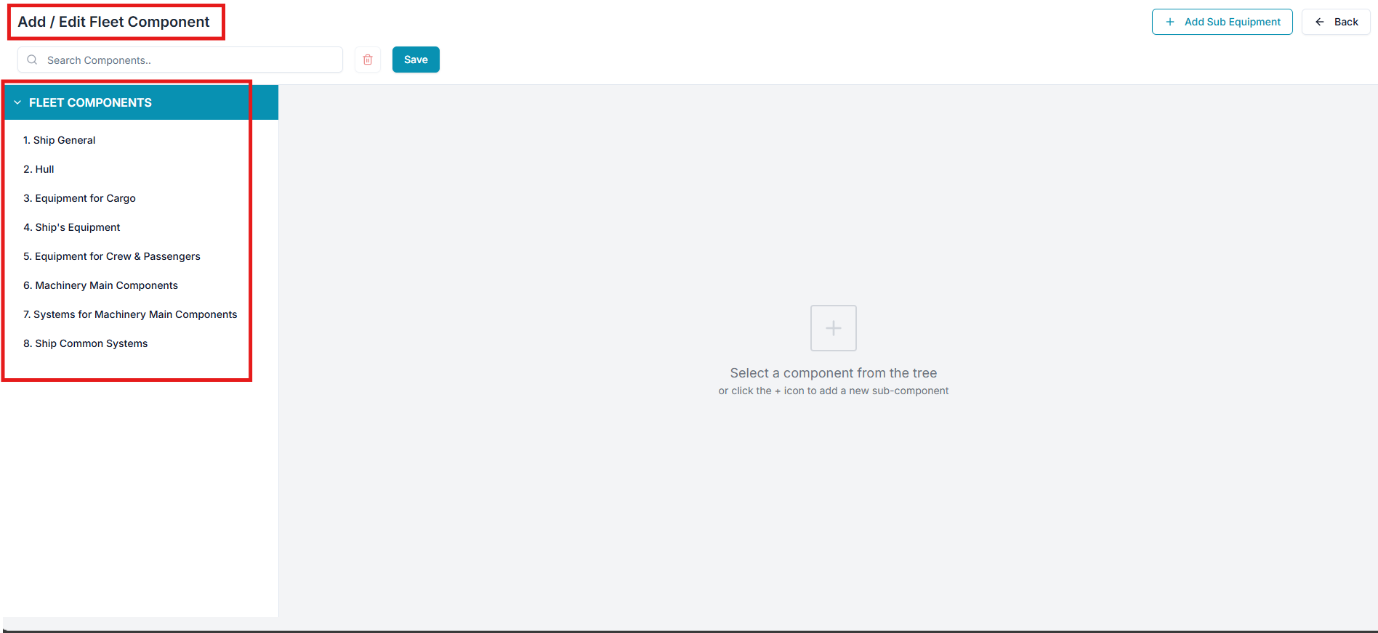

However, the page is opening in a different format. According to the expected functionality, it should open the same tree view structure as the Fleet Components Tree View in the Add/Edit Fleet Component display, but currently, it is not opening the same.
Concerns:
- Why is this issue occurring?
- What is the detailed plan to correct this?
- What is the proper solution to fix this behavior?

