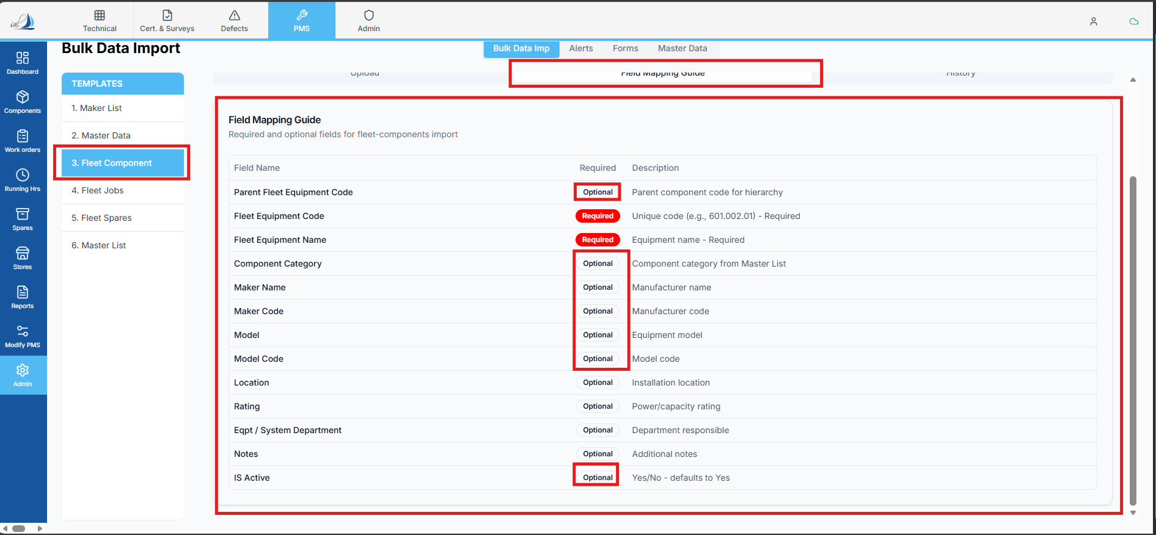

Raplit Analysis Prompt
Module: PMS → Admin → Bulk Data Import → Fleet Data Import → Fleet Components
Topic: Bulk Data Import – Fleet Components – Mapping Guide & Required Field Validation (Dry Run Only)

Context
In Bulk Data Import → Fleet Components, users upload an Excel template to import Fleet Component master data.
A Fleet Components Mapping Guide is available where:
- Excel columns are mapped to system fields
- Certain fields can be visually highlighted as Required
Currently:
- Required-field enforcement is either missing or unclear
- Users can proceed with uploads even when critical fields are empty
- Errors are detected late or inconsistently

Requirement Overview
- In the Mapping Guide screen:
  - Highlighted fields should be clearly marked as Required
  - This requirement is visual and logical, not cosmetic only
- During Dry Run validation of Fleet Components bulk upload:
  - Required-field validation must be applied
  - Missing required values must be detected before actual import
  - Import should not proceed if required fields are missing

Required Fields to Be Flagged
The following fields must be treated as mandatory for Fleet Components bulk import:
Field Name
Parent Fleet Equipment Code
Fleet Equipment Code
Fleet Equipment Name
Component Category
Maker Name
Maker Code
Model
Model Code
Eqpt / System Department
IS Active

Analysis Questions (To Be Answered)
- How does the Fleet Components Mapping Guide currently determine:
  - Which fields are required
  - How required fields are visually indicated
- Where is the dry run validation logic implemented for Fleet Components?
  - Frontend
  - Backend
  - Or shared bulk-import service
- Why required-field validation is not currently enforced (or partially enforced)?
- How other bulk imports (e.g., Components, Jobs, Spares) handle:
  - Required fields
  - Dry run validation
  - Error reporting
- At what stage of the dry run:
  - Required-field checks should be executed
  - Validation errors should be returned to UI

Detailed Analysis Scope
1. Mapping Guide Behavior
- Analyse how field metadata is defined:
  - Required vs optional
  - Static vs configurable
- Identify how the Mapping Guide UI consumes this metadata
2. Dry Run Validation Flow
- Analyse the dry run execution lifecycle:
  - File upload
  - Column parsing
  - Row-level validation
  - Error aggregation
- Identify where required-field checks logically belong
3. Error Reporting Mechanism
- How missing required fields should be:
  - Identified per row
  - Returned as structured errors
  - Displayed clearly to users before import

Detailed Plan (Design-Level Only)
Step 1: Define Required Field Metadata
- Clearly identify required fields for Fleet Components
- Ensure this metadata is:
  - Centralized
  - Consistent between Mapping Guide and Dry Run validation
Step 2: Mapping Guide Enhancement (Analysis Only)
- Mapping Guide should:
  - Mark listed fields as Required
  - Prevent ambiguity for users mapping Excel columns
Step 3: Dry Run Validation Design
- During dry run:
  - Each row must be checked for missing required fields
  - Empty, null, or invalid values must be flagged
- Validation must occur before actual import
Step 4: Validation Feedback Design
- Dry run response should:
  - Clearly list missing required fields
  - Associate errors with specific rows
  - Block import if validation fails
Step 5: Consistency Check
- Compare with:
  - Other bulk import modules
- Ensure Fleet Components follows the same validation architecture

Expected Outcome
- Required fields are clearly visible in the Mapping Guide
- Dry run detects missing mandatory data early
- Users cannot import incomplete Fleet Component data
- Bulk import behavior is consistent and predictable

Mandatory Constraints (Strict)
- ANALYSE & PLAN ONLY
- DO NOT implement logic
- DO NOT change database schema
- DO NOT impact other bulk imports
- DO NOT add runtime validations outside dry run
- DO NOT change UI outside Fleet Components Mapping Guide
- Scope limited strictly to Fleet Components bulk import
- WAIT for explicit PROCEED instruction

Do Not Effect the other section bulk import data.
Do not change the current functionality of Bulk Data import Fleet Components. Just implement this condition only.

