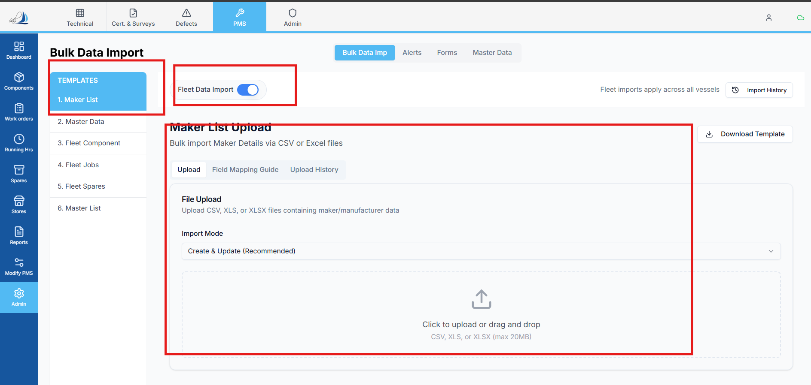

Replit Analysis & Fix Prompt – Maker List Bulk Upload (Fleet)
Analyse the Maker List bulk upload functionality for Fleet, as shown in the attached UI screenshot.
Current Problem:
- The upload flow is fake / dummy.
- No API call is made to the backend.
- A success toast is shown using a setTimeout, even though no data is uploaded or persisted.
- This gives a false-positive UX, making it appear as if the upload succeeded.
Reference File:
- MakerListUpload.tsx
Inside this file, analyse the handleUpload implementation:
- It only sets isUploading
- Uses setTimeout
- Shows a success toast
- Clears the selected file
- No API integration exists
What to Analyse:
- Why no backend API is being called for Maker List bulk upload.
- Whether any existing bulk upload API already exists in the backend that should be reused.
- If not, identify where a new backend endpoint should be added for:
  - Fleet Maker List bulk upload
- How the selected file is currently handled and why it is never sent to the server.
- Whether other bulk upload features (if any) follow a correct implementation pattern that should be mirrored.
What to Fix:
- Replace the dummy setTimeout-based success flow with a real API call.
- Ensure the selected file is:
  - Properly validated
  - Sent to the backend using the correct request type
- Success toast must be shown only after backend confirmation.
- Error handling must be added:
  - API failure
  - Invalid file
  - Backend validation errors
- Upload state (isUploading) must correctly reflect the API lifecycle.
Constraints:
- Do not keep any dummy logic.
- Do not show success unless data is actually saved.
- Follow existing architectural and API patterns used elsewhere in the application.
- Keep the fix scoped only to Maker List bulk upload (no unrelated refactors).
Expected Outcome:
- Maker List bulk upload actually sends data to backend.
- Data is persisted correctly.
- UI reflects real upload status.
- No fake success messages.
- Feature behaves consistently with other bulk uploads in the system.
Focus on analysis first, then propose the correct end-to-end flow (UI → API → DB) and implement the fix accordingly.

