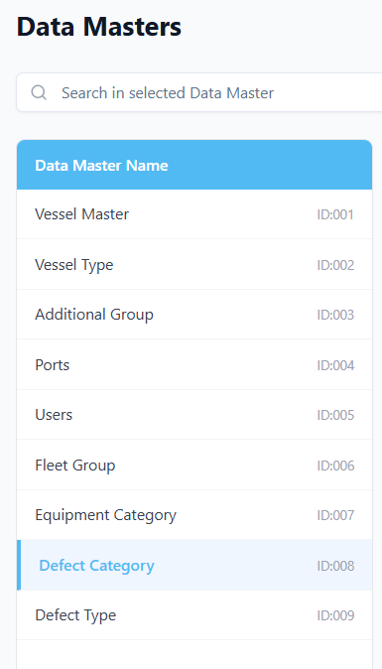
Prompt for Replit
Create database schema definitions for all remaining master tables in the base schema.
Context
- vessels schema is already implemented and should be used as the reference structure.
- defect_categories, defect_types, and users tables already exist.
- Build schemas for all other master tables that are currently missing proper schema definitions.

Step 1 — Schema Creation
- Identify all master tables in the base schema that do not yet have proper schema definitions.
- For each master table:
  - Create schema using the same structure and standards as vessels
  - Follow the same conventions:
    - UUID column (primary identifier)
    - Standard audit fields (sort_order, created_at, updated_at, created_by_uuid, updated_by_uuid, is_deleted, is_sync)
    - Proper indexing
    - Constraints where applicable
- Maintain consistency in:
  - Naming conventions
  - Default values
  - Data types
  - UUID usage
Do not modify:
- vessels
- defect_categories
- defect_types
- users

Step 2 — Data Sync Plan (Local DB)
After schema creation:
- Create a structured plan to:
  - Sync all master data into local DB
  - Ensure no duplicate entries
  - Preserve existing data
  - Maintain UUID consistency
- Identify:
  - Whether sync will use migration
  - Seed scripts
  - Manual sync script
- Ensure:
  - Referential integrity is maintained
  - No data loss
  - Idempotent execution (safe to run multiple times)

Step 3 — Verification & Success Confirmation
- Verify:
  - All master tables exist
  - Schema structure matches vessel standard
  - Data successfully synced
- Provide:
  - List of tables created
  - Sync result summary
  - Record counts per master table
- Return a clear final message:
“All master schemas created and local data sync completed successfully.”

Do not assume structure. Follow the vessels schema pattern strictly. Ensure consistency across all master tables.

