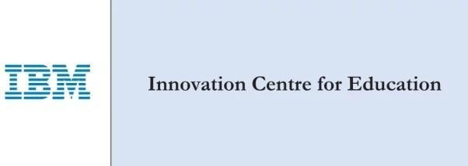


Yenepoya Institute of Arts Science Commerce and Management

Final Project Report

on
Identity Security Framework for EdTech

Student Name: Mohammad Safeek

Industry Mentor:Mr Sumith Kumar Shukla

Guided by: Mr.Vikyath Shetty

Table of Contents

Background
  - Aim
  - Technologies
  - Hardware Architecture
  - Software Architecture

System
  - Requirements
    - Functional requirements
    - User requirements
    - Environmental requirements
  - Design and Architecture
  - Implementation
  - Testing
  - Graphical User Interface (GUI) Layout
  - Customer testing
  - Evaluation

- Snapshots of the Project
- Conclusions
- Further development or research
- References
- Appendix

Background

The rapid proliferation of web-based educational platforms has fundamentally transformed how institutions manage student and faculty interactions in the digital space. As EdTech systems increasingly handle sensitive personal and academic data, the need for robust identity security has become a critical concern. Despite this, many educational platforms continue to rely on poorly implemented authentication mechanisms, leaving them vulnerable to a wide range of cyber threats including credential stuffing, session hijacking, and unauthorized privilege escalation.
Identity and Access Management (IAM) is a foundational discipline within cybersecurity that governs how digital identities are created, verified, and granted access to resources. In the context of web applications, IAM encompasses two distinct but interdependent pillars: Authentication — the process of verifying who a user is — and Authorization — the process of determining what a verified user is permitted to do. A failure in either of these mechanisms can result in data breaches, unauthorized access to sensitive records, and a complete breakdown of platform integrity.
The Identity Security Framework for EdTech was conceived to address this gap by providing a practical, hands-on demonstration of how IAM principles can be correctly and securely implemented in a real-world web application. Rather than approaching cybersecurity as a purely theoretical subject, this project grounds these concepts in a functional system that mirrors the architecture of production-grade educational platforms.
The project targets a common and well-understood use case — a multi-role web portal with student and administrator accounts — to illustrate how modern security mechanisms such as cryptographic password hashing, session hardening, role-based access control (RBAC), and anti-enumeration defenses can be systematically applied. By doing so, it serves both as a learning resource for developers entering the field and as a reference implementation for those looking to audit or improve the security posture of existing EdTech systems.
This document presents a comprehensive technical account of the system's design, architecture, implementation, and evaluation, structured to reflect the full software development lifecycle of the project.

Aim

The aim of the Identity Security Framework for EdTech is to design, develop, and demonstrate a secure, fully functional web application that implements core Identity and Access Management (IAM) principles within an educational technology context. The project seeks to bridge the gap between theoretical cybersecurity knowledge and its practical application by building a system that reflects real-world security standards and development practices.
The specific aims of the project are as follows:
1. To Implement Secure Authentication Mechanisms To develop a login and registration system that eliminates common vulnerabilities such as plain-text password storage and vague error handling. This includes the integration of the PBKDF2-SHA256 cryptographic hashing algorithm for password storage, ensuring that user credentials remain protected even in the event of a database compromise.
2. To Enforce Role-Based Access Control (RBAC) To design and implement a hierarchical authorization model that distinguishes between standard users (students) and privileged users (administrators), ensuring that each role can only access the resources and interfaces that are explicitly permitted to them. Unauthorized attempts to access elevated privileges are to be intercepted and denied at the server level.
3. To Demonstrate Session Security Best Practices To configure and apply strict session management protocols, including continuous validation of user IP addresses and user-agent strings, to actively prevent session hijacking and unauthorized session reuse.
4. To Apply Anti-Enumeration and Input Validation Defenses To harden the authentication layer against reconnaissance attacks by returning unified, non-descriptive error messages during failed login attempts, and to enforce server-side input validation during user registration to maintain data integrity.
5. To Produce an Educationally Meaningful Reference Implementation To structure the entire application as a transparent, well-documented, and pedagogically valuable resource — one that developers, students, and security practitioners can study, replicate, and build upon when designing secure web systems.
6. To Follow Industry-Standard Architectural Patterns To build the application using the Model-View-Controller (MVC) architectural pattern, ensuring clean separation of concerns, maintainability, and scalability — qualities that are expected of professional-grade software systems.
In summary, the project aims to demonstrate that security is not an optional add-on but an integral design consideration that must be embedded at every layer of a web application — from database schema design and password handling to route protection and session lifecycle management.

Technologies Used

The Identity Security Framework for EdTech was built using a carefully selected set of modern, industry-relevant technologies. Each component of the stack was chosen based on its security capabilities, community support, and relevance to real-world web development practices. Below is a detailed breakdown of every technology employed across the frontend, backend, database, and security layers of the application.

1. Python 3
Python 3 serves as the core programming language for the entire backend of the application. Python was selected for its clean, readable syntax, extensive ecosystem of security-focused libraries, and its widespread adoption in both the web development and cybersecurity industries. Its dynamic typing and rich standard library make it well-suited for rapid development without sacrificing code quality or security.

2. Flask
Flask is a lightweight, micro web framework for Python, built on top of the Werkzeug WSGI toolkit and the Jinja2 templating engine. It follows a minimalist philosophy, providing developers with only the core tools needed to build a web application while remaining highly extensible through plugins and extensions.
In this project, Flask is responsible for:
- Defining and managing all application routes (URL endpoints)
- Handling HTTP request and response cycles
- Rendering server-side HTML templates via Jinja2
- Managing application configuration, including secret key setup and session behavior
- Providing custom error handlers for HTTP exceptions (403, 404, 500)

3. Flask-SQLAlchemy
Flask-SQLAlchemy is an Object Relational Mapper (ORM) extension for Flask that integrates SQLAlchemy into the application. Rather than writing raw SQL queries — which introduces the risk of SQL injection vulnerabilities — Flask-SQLAlchemy allows the application to interact with the database using Python objects and methods.
Its role in this project includes:
- Defining the User database model as a Python class
- Abstracting all database read and write operations
- Automatically generating and managing the SQLite database schema
- Providing safe, parameterized query execution to prevent injection attacks

4. SQLite
SQLite is a lightweight, file-based relational database engine that requires no separate server process to operate. It stores the entire database as a single file (instance/database.db) on the local filesystem, making it ideal for development, prototyping, and educational projects.
In this project, SQLite is used to:
- Persist all user account records including usernames, email addresses, hashed passwords, and assigned roles
- Support the automated database initialization and admin account seeding process on first run

5. Flask-Login
Flask-Login is a Flask extension that provides user session management utilities. It handles the common tasks associated with logging users in and out, protecting routes from unauthenticated access, and maintaining the current user's identity across requests.
Key contributions to this project include:
- Implementing the @login_required decorator to restrict access to protected routes
- Managing the lifecycle of user sessions from login to logout
- Providing access to the current_user proxy object for role-based checks within route handlers
- Enforcing strong session protection (SESSION_PROTECTION = 'strong') to monitor IP address and user-agent consistency

6. Werkzeug
Werkzeug is the underlying WSGI utility library that Flask is built upon. In this project, it is used specifically for its cryptographic password hashing utilities, which are central to the authentication security of the application.
Its specific functions in this project are:
- generate_password_hash() — Hashes user passwords using the PBKDF2-SHA256 algorithm before storing them in the database
- check_password_hash() — Safely compares a login attempt's plain-text password against the stored hash during authentication, without ever reversing or exposing the original password

7. Jinja2
Jinja2 is a powerful server-side templating engine integrated directly into Flask. It enables the dynamic rendering of HTML pages by allowing Python variables, control flow logic, and template inheritance to be embedded within HTML files.
In this project, Jinja2 is used to:
- Dynamically inject user-specific data (such as username and role) into dashboard templates
- Implement template inheritance through a base.html master layout, ensuring a consistent UI structure across all pages
- Conditionally render navigation elements and content blocks based on the authenticated user's role

8. HTML5 & CSS3
HTML5 provides the structural markup for all frontend views within the application. CSS3 is used to apply custom visual styling, most notably the application's dark-themed user interface defined in static/style.css. Together, they ensure the application is semantically structured and visually coherent.

9. Bootstrap 5
Bootstrap 5 is a widely adopted open-source frontend CSS framework that provides a responsive grid system, pre-styled UI components, and utility classes. It was used in this project to accelerate frontend development and ensure the application renders correctly across different screen sizes and devices, maintaining a professional and modern appearance without requiring extensive custom CSS.

10. pip & requirements.txt
Python's package manager, pip, was used to install and manage all project dependencies. A requirements.txt file is included in the project root, which lists all required packages and their versions. This ensures the development environment can be reproduced consistently across different machines with a single install command:
`pip install -r requirements.txt`

Summary Table

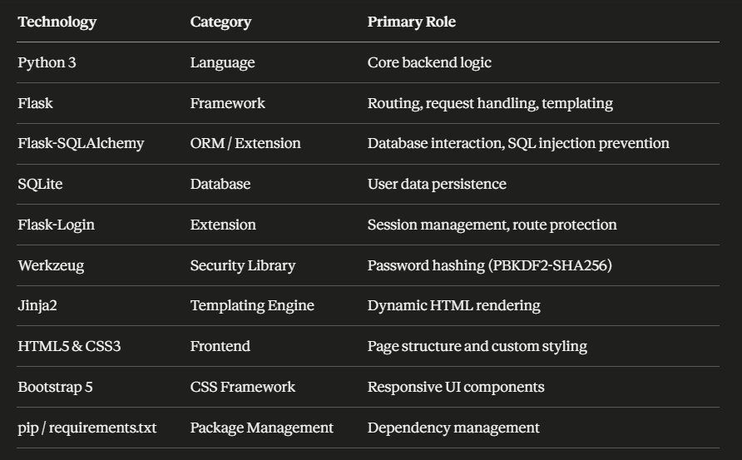

Hardware Architecture
The Identity Security Framework for EdTech is a software-centric web application, and as such, its hardware requirements are intentionally modest. The system is designed to operate effectively on standard consumer-grade or institutional computing hardware, making it accessible for educational deployment, local development, and demonstration purposes without the need for specialized or enterprise-level infrastructure.

1. Development & Deployment Environment
The application was developed and tested on a standard personal computing environment. Since the application runs as a locally hosted Flask development server with a file-based SQLite database, no external servers, cloud infrastructure, or network hardware beyond a basic workstation are required for its core operation.
The hardware environment can be categorized into two contexts:
- Development Environment — The machine on which the application is written, tested, and run locally
- Deployment Environment — The machine or server on which the application is hosted and made accessible to end users (in this case, a local network or localhost setup)
For this project, both environments are satisfied by the same standard hardware setup.

2. Minimum Hardware Requirements
The following specifications represent the minimum hardware configuration required to successfully run the application:
Component | Minimum Specification | Recommended Specification
Processor (CPU) | Dual-core 1.6 GHz | Quad-core 2.4 GHz or higher
Memory (RAM) | 2 GB | 4 GB or higher
Storage | 200 MB free disk space | 1 GB free disk space
Network Interface | Standard loopback (localhost) | Ethernet / Wi-Fi NIC for LAN access
Operating System | Windows 10 / macOS 10.14 / Ubuntu 18.04 | Windows 11 / macOS 13 / Ubuntu 22.04
Display | 1280 × 720 resolution | 1920 × 1080 resolution
These requirements are deliberately low, reflecting the lightweight nature of the Flask framework and the SQLite database engine, both of which are optimized for minimal resource consumption.

3. Hardware Component Roles
A. Central Processing Unit (CPU)
The CPU handles all server-side computation including request routing, password hashing via the PBKDF2-SHA256 algorithm, session validation, and database query execution. The cryptographic hashing operations performed by Werkzeug are intentionally computationally modest, designed to be fast enough for legitimate users while still being resistant to brute-force attacks. A standard dual-core processor is more than sufficient to handle these operations in a development or small-scale deployment context.
B. Memory (RAM)
RAM is utilized by the Python interpreter, the Flask development server, and the SQLAlchemy ORM during runtime. Since SQLite is a file-based database that loads data into memory during query execution, sufficient RAM ensures smooth and responsive database interactions. At 2 GB minimum, the application runs comfortably alongside a standard operating system without memory contention.
C. Storage
The application's storage footprint is extremely small. The primary storage consumers are:
- The Python virtual environment and installed dependencies (approximately 50–100 MB)
- The application source code, templates, and static assets (less than 5 MB)
- The SQLite database file (instance/database.db), which grows incrementally as user accounts are created but remains negligible in size for educational and demonstration purposes
A minimum of 200 MB of free disk space ensures comfortable operation with room for database growth and log generation.
D. Network Interface Card (NIC)
By default, the Flask development server binds to localhost (127.0.0.1) on port 5000, meaning no physical network hardware is required for single-machine operation. However, if the application is configured to be accessible across a local area network (LAN) — for example, to allow multiple students to interact with the system simultaneously — a standard Ethernet or Wi-Fi network interface card is required on the host machine.
E. Display
A display is required for the developer or administrator interacting with the application during development, testing, and demonstration. A minimum resolution of 1280 × 720 is sufficient to render the Bootstrap 5 responsive interface correctly, though a full HD (1920 × 1080) display is recommended for an optimal viewing experience.

4. Client-Side Hardware Requirements
Since the application is accessed through a standard web browser, client-side hardware requirements are equally minimal. Any device capable of running a modern web browser — including desktop computers, laptops, and tablets — can access and interact with the application without any additional software installation or hardware configuration.
Client Component | Requirement
Device | Desktop, Laptop, or Tablet
Browser | Any modern browser (Chrome, Firefox, Edge, Safari)
Network | Connected to the same localhost or LAN as the server
Display | Minimum 768px width for responsive Bootstrap layout

5. Hardware Architecture Diagram
The following diagram illustrates the hardware topology for both a single-machine localhost setup and a basic LAN deployment:
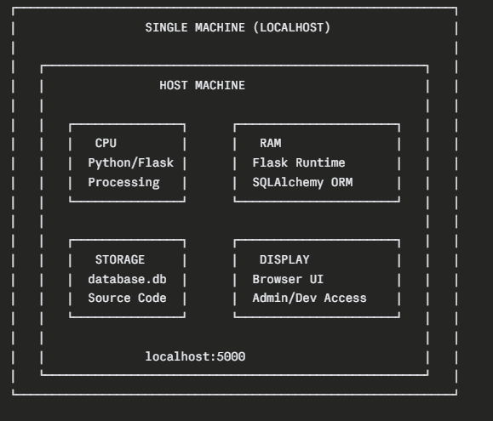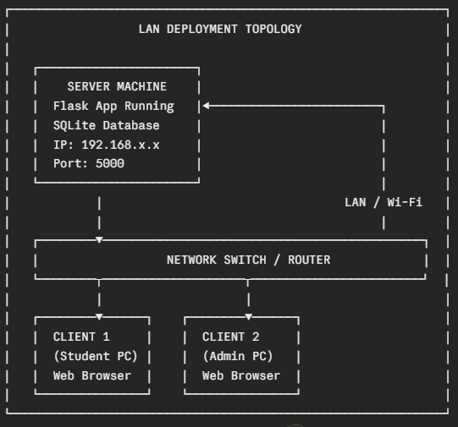

6. Scalability Considerations
While the current hardware architecture is designed for development and educational use, the application's codebase is structured in a way that would allow it to be migrated to more robust hardware infrastructure with minimal modifications. For example:
- SQLite could be replaced with PostgreSQL or MySQL running on a dedicated database server for higher concurrency and data volume
- The Flask development server could be replaced with a production-grade WSGI server such as Gunicorn or uWSGI, deployed behind an Nginx reverse proxy on a dedicated Linux server or cloud virtual machine
- The application could be containerized using Docker and deployed on cloud platforms such as AWS, Google Cloud, or Microsoft Azure, each of which provides scalable compute, storage, and networking hardware on demand
These migration paths require no fundamental changes to the application's security architecture, as all IAM mechanisms are implemented at the software layer and are hardware-agnostic.

Software Architecture
The Identity Security Framework for EdTech is designed around a well-established and widely adopted software architectural pattern. The architecture was deliberately chosen to ensure a clean separation of concerns, maintainability, and scalability, while also reinforcing secure coding practices at every layer of the application.

1. Architectural Pattern: Model-View-Controller (MVC)
The application follows the Model-View-Controller (MVC) architectural pattern, which divides the application into three distinct, interdependent components. Each component has a clearly defined responsibility, ensuring that business logic, user interface, and data management do not become entangled within the same codebase.

Model (M) — Data Layer
The Model layer is responsible for defining the structure of the application's data and managing all interactions with the database. In this project, the Model is implemented through Flask-SQLAlchemy and is represented by the User class defined in app.py.
The User model defines the following database schema:
Field | Type | Description
id | Integer (Primary Key) | Unique identifier for each user
username | String (150) | The user's display name, must be unique
email | String (150) | The user's email address, must be unique
password_hash | String (256) | The cryptographic hash of the user's password
role | String (50) | The user's assigned role (student or admin)
The Model also contains two helper methods that encapsulate security logic:
- set_password(password) — Accepts a plain-text password and stores its PBKDF2-SHA256 hash in the password_hash field
- is_admin() — Returns a boolean indicating whether the user's assigned role is admin, used for authorization checks within route handlers
This encapsulation of security logic within the Model ensures that password handling and role verification are never scattered across the application, reducing the risk of inconsistent or insecure implementations.

View (V) — Presentation Layer
The View layer is responsible for everything the user sees and interacts with. It is implemented using Jinja2 HTML templates stored in the templates/ directory. The View layer has no direct access to the database and receives all data it needs to render from the Controller layer.
The application's views are structured using template inheritance, with base.html serving as the master layout. All other templates extend this base, inheriting the navigation bar, flash message display logic, and overall page structure. This ensures UI consistency across the entire application and reduces code duplication.
The complete set of views and their responsibilities are as follows:
Template | Purpose
base.html | Master layout template; contains navbar and flash message rendering
index.html | Public-facing landing page
signup.html | User registration form
login.html | User authentication form
dashboard.html | Protected user dashboard rendered post-login
admin.html | Privileged admin panel displaying the full user roster
404.html | Unified error page for HTTP 403, 404, and 500 exceptions
Additionally, the static/style.css file complements the View layer by defining the application's custom dark theme and visual aesthetics, working alongside Bootstrap 5 for a fully responsive interface.

Controller (C) — Application Logic Layer
The Controller layer acts as the intermediary between the Model and the View. It processes incoming HTTP requests, applies business and security logic, interacts with the Model to read or write data, and determines which View to render in response. In this Flask application, the Controller is implemented through route handler functions defined in app.py.
The following routes constitute the Controller layer:
Route | Method(s) | Access Level | Description
/ | GET | Public | Renders the landing page
/signup | GET, POST | Public | Handles user registration and input validation
/login | GET, POST | Public | Handles credential verification and session initiation
/dashboard | GET | Authenticated Users | Renders the protected user dashboard
/admin | GET | Admin Only | Renders the admin panel with full user roster
/logout | GET | Authenticated Users | Terminates the active user session
Each route enforces its own access control policy, forming a layered defense strategy that is described in further detail in the Security Architecture section below.

2. Application Layer Diagram
The following diagram illustrates how the MVC layers interact with each other and with the security components of the application:

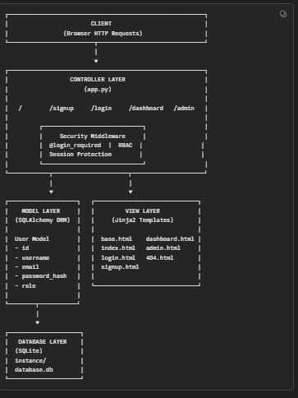

Security is not implemented as a standalone module but is instead woven into every layer of the MVC architecture. The following describes how security mechanisms are applied at each level:
A. Model-Level Security
- Passwords are hashed using PBKDF2-SHA256 before being written to the database, ensuring that raw credentials are never persisted
- Role information is stored directly on the User model, making authorization decisions data-driven and consistent
B. Controller-Level Security
- The @login_required decorator is applied to all protected routes, ensuring unauthenticated requests are redirected to the login page before any business logic executes
- A secondary role check (current_user.is_admin()) is enforced on the /admin route, returning an HTTP 403 Forbidden response to any authenticated user without administrative privileges
- Generic error messages are returned during failed login attempts to prevent account enumeration attacks
- Input validation is performed server-side during registration to enforce minimum password length, matching passwords, and uniqueness of email and username
C. Session-Level Security
- Flask-Login's strong session protection mode is enabled, continuously monitoring the user's IP address and user-agent string throughout the session lifetime
- Any detected discrepancy in these values causes the session to be invalidated immediately, mitigating session hijacking attempts
- A cryptographically random SECRET_KEY is used to sign session cookies, preventing tampering or forgery
D. Database-Level Security
- All database interactions are performed through SQLAlchemy's ORM, which uses parameterized queries internally, eliminating the possibility of SQL injection attacks
- No raw SQL strings are constructed or executed anywhere in the application

4. Request Lifecycle
The following describes the complete lifecycle of a typical authenticated request through the application's architecture:
- The user submits a request via their browser (e.g., navigating to /dashboard)
- Flask's routing engine matches the URL to the appropriate Controller function
- The @login_required decorator intercepts the request and verifies the existence and validity of an active session
- If the session is invalid, the user is redirected to /login
- If the session is valid, the Controller queries the Model (User database) for any required data
- The Model interacts with the SQLite database via SQLAlchemy ORM and returns the result
- The Controller passes the retrieved data to the appropriate Jinja2 template
- The View renders the final HTML page and returns it to the user's browser as an HTTP response

System Requirements

The system requirements for the Identity Security Framework for EdTech define the complete set of conditions and capabilities the application must satisfy to function correctly, securely, and reliably. These requirements are organized into three categories: Functional Requirements, User Requirements, and Environmental Requirements.

1. Functional Requirements
Functional requirements describe the specific behaviors, features, and operations the system must perform. Each requirement is assigned a unique identifier for traceability purposes.

FR-01: User Registration
The system must allow new users to create an account by providing a unique username, a unique email address, and a password. The system must validate that:
- The username is at least 3 characters in length
- The password meets the minimum length requirement
- The password confirmation field matches the entered password
- The submitted email address and username do not already exist in the database
Upon successful validation, the system must hash the password using the PBKDF2-SHA256 algorithm and persist the new user record to the database with a default role of student.

FR-02: User Authentication (Login)
The system must authenticate users by verifying their submitted email address and password against stored records. The system must:
- Retrieve the user record associated with the submitted email address
- Compare the submitted password against the stored cryptographic hash using a secure comparison function
- Initiate an authenticated session upon successful verification
- Support a persistent "Remember Me" option that extends session duration
- Return a single, unified error message ("Invalid email or password") for any failed login attempt, regardless of whether the failure was due to an unrecognized email or an incorrect password

FR-03: User Logout
The system must provide an authenticated user with the ability to terminate their active session at any time. Upon logout, the session must be fully invalidated and the user must be redirected to the landing page.

FR-04: Role-Based Access Control (RBAC)
The system must enforce a two-tier role hierarchy consisting of student and admin roles. Access to application routes must be governed as follows:
- Public routes (/, /login, /signup) must be accessible to all users regardless of authentication status
- The /dashboard route must be accessible only to authenticated users of any role
- The /admin route must be accessible only to authenticated users with the admin role
- Any authenticated user without the admin role attempting to access /admin must receive an HTTP 403 Forbidden response

FR-05: Protected Dashboard
The system must render a personalized dashboard for authenticated users upon successful login, displaying the user's username and role. Unauthenticated requests to the dashboard route must be automatically redirected to the login page.

FR-06: Admin Panel
The system must provide an administrative interface accessible exclusively to users with the admin role. The admin panel must retrieve and display a complete roster of all registered users from the database, including their usernames, email addresses, and assigned roles.

FR-07: Session Management
The system must manage user sessions securely throughout their lifecycle. Specifically:
- Sessions must be cryptographically signed using a secure secret key to prevent tampering
- Strong session protection must be enforced, continuously validating the user's IP address and user-agent string
- Any detected change in IP address or user-agent mid-session must result in immediate session invalidation

FR-08: Password Security
The system must ensure that plain-text passwords are never stored, transmitted in logs, or exposed at any point within the application. All passwords must be hashed before database insertion using the PBKDF2-SHA256 algorithm provided by Werkzeug.

FR-09: Error Handling
The system must handle the following HTTP error conditions gracefully, rendering a user-friendly error page rather than exposing raw server error information:
- HTTP 403 — Forbidden (insufficient privileges)
- HTTP 404 — Not Found (invalid URL)
- HTTP 500 — Internal Server Error (unexpected application failure)

FR-10: Database Initialization & Seeding
The system must automatically initialize the SQLite database schema on first run if no database file exists. It must also seed a default administrative account with predefined credentials to ensure the system is immediately usable upon deployment.

2. User Requirements
User requirements describe the expectations and needs of the different categories of users who will interact with the system. Two primary user roles have been identified: Student Users and Admin Users.

Student User Requirements
ID | Requirement
UR-S01 | The student must be able to register a new account using an email address, username, and password through a clearly presented registration form
UR-S02 | The student must be able to log in to the system using their registered email address and password
UR-S03 | The student must be presented with a personalized dashboard upon successful login that confirms their identity and role
UR-S04 | The student must be able to log out of the system at any time using a clearly visible logout option
UR-S05 | The student must receive clear, informative feedback messages when form submissions succeed or fail
UR-S06 | The student must not be able to access administrative interfaces or view other users' data under any circumstance
UR-S07 | The student must be automatically redirected to the login page if they attempt to access a protected route without an active session

Admin User Requirements
ID | Requirement
UR-A01 | The admin must be able to log in to the system using the seeded administrative credentials
UR-A02 | The admin must be able to access the admin panel, which displays a complete roster of all registered users
UR-A03 | The admin must be able to view each user's username, email address, and assigned role from within the admin panel
UR-A04 | The admin must be able to access the standard user dashboard in addition to the admin panel
UR-A05 | The admin must be able to log out of the system at any time
UR-A06 | The admin panel must be exclusively accessible to the admin role and must not be reachable by student accounts under any circumstance

General User Requirements
ID | Requirement
UR-G01 | All users must be able to access the application through a standard modern web browser without installing any additional software
UR-G02 | The application interface must be responsive and render correctly across different screen sizes including desktops, laptops, and tablets
UR-G03 | All forms must provide real-time or post-submission feedback to guide users in correcting input errors
UR-G04 | The application must present a consistent visual theme and navigation experience across all pages
UR-G05 | Error pages must present a user-friendly message without exposing any technical or server-side information

3. Environmental Requirements
Environmental requirements define the conditions under which the system must operate, including software dependencies, runtime environment, and compatibility constraints.

A. Software Environment
Component | Requirement
Operating System | Windows 10/11, macOS 10.14+, or Ubuntu 18.04+
Python Version | Python 3.7 or higher
Flask | Version 2.x or higher
Flask-SQLAlchemy | Version 3.x or higher
Flask-Login | Version 0.6.x or higher
Werkzeug | Version 2.x or higher
Web Browser | Google Chrome 90+, Mozilla Firefox 88+, Microsoft Edge 90+, or Safari 14+
Package Manager | pip 21.x or higher

B. Runtime Environment
- The application must be executable from a standard terminal or command prompt using the command python app.py
- All dependencies must be installable via a single command: pip install -r requirements.txt
- The application must automatically create the SQLite database file and seed the default admin account on first launch without requiring manual database setup
- The Flask development server must bind to localhost on port 5000 by default, making the application accessible at http://127.0.0.1:5000

C. Security Environment
- The application must never be deployed with DEBUG = True enabled in a production environment, as this exposes the interactive Werkzeug debugger to end users
- The SECRET_KEY used for session cookie signing must be a cryptographically random string and must never be hardcoded with a weak or predictable value in a production deployment
- The SQLite database file must be stored within the instance/ directory, which should be excluded from version control systems via .gitignore to prevent accidental exposure of user data

D. Compatibility Requirements
- The application's frontend must render correctly on all screen widths of 768px and above, as ensured by Bootstrap 5's responsive grid system
- The application must function correctly without requiring JavaScript to be enabled in the browser, as all core functionality is handled server-side through Flask and Jinja2
- The application must be compatible with both Windows-style (CRLF) and Unix-style (LF) line endings in source files to ensure cross-platform development compatibility

Functional Requirements
Functional requirements define the specific behaviors, operations, and capabilities that the Identity Security Framework for EdTech must perform to fulfill its intended purpose. Each requirement is assigned a unique identifier for traceability and reference purposes.

FR-01: User Registration
The system must allow new users to create an account by providing a unique username, a unique email address, and a password. The system must validate that:
- The username is at least 3 characters in length
- The password meets the minimum length requirement
- The password confirmation field matches the entered password
- The submitted email address and username do not already exist in the database
Upon successful validation, the system must hash the password using the PBKDF2-SHA256 algorithm and persist the new user record to the database with a default role of student.

FR-02: User Authentication (Login)
The system must authenticate users by verifying their submitted email address and password against stored database records. The system must:
- Retrieve the user record associated with the submitted email address
- Compare the submitted password against the stored cryptographic hash using a secure comparison function
- Initiate an authenticated session upon successful credential verification
- Support a persistent "Remember Me" option that extends the duration of the user's session
- Return a single, unified error message ("Invalid email or password") for any failed login attempt, regardless of whether the failure was caused by an unrecognized email address or an incorrect password, thereby preventing account enumeration

FR-03: User Logout
The system must provide every authenticated user with the ability to voluntarily terminate their active session at any time. Upon logout:
- The active session must be fully and immediately invalidated
- All session data associated with the user must be cleared
- The user must be redirected to the application's landing page upon successful logout

FR-04: Role-Based Access Control (RBAC)
The system must enforce a two-tier role hierarchy consisting of student and admin roles. Access to application routes must be strictly governed as follows:
Route | Public | Student | Admin
/ (Landing Page) | ✅ | ✅ | ✅
/signup (Registration) | ✅ | ✅ | ✅
/login (Login) | ✅ | ✅ | ✅
/dashboard (User Dashboard) | ❌ | ✅ | ✅
/admin (Admin Panel) | ❌ | ❌ | ✅
/logout (Logout) | ❌ | ✅ | ✅
Any authenticated user without the admin role who attempts to access the /admin route must receive an HTTP 403 Forbidden response. Any unauthenticated user attempting to access a protected route must be automatically redirected to the login page.

FR-05: Protected User Dashboard
The system must render a personalized dashboard for every authenticated user upon successful login. The dashboard must:
- Display the authenticated user's username and assigned role
- Be inaccessible to unauthenticated users, automatically redirecting them to the login page
- Be accessible to users of both the student and admin roles

FR-06: Administrative Panel
The system must provide a privileged administrative interface that is exclusively accessible to users assigned the admin role. The admin panel must:
- Retrieve a complete roster of all registered user accounts from the database
- Display each user's username, email address, and assigned role
- Be completely inaccessible to users assigned the student role, returning an HTTP 403 Forbidden response upon any unauthorized access attempt

FR-07: Session Management & Security
The system must manage authenticated user sessions securely throughout their entire lifecycle. The following session security conditions must be enforced:
- All session cookies must be cryptographically signed using a secure, randomly generated secret key to prevent forgery or tampering
- Strong session protection must be active at all times, continuously validating the consistency of the user's IP address and browser user-agent string across requests
- Any mid-session change detected in the user's IP address or user-agent string must trigger immediate and automatic session invalidation to prevent session hijacking
- The "Remember Me" functionality must extend session persistence in a controlled and secure manner

FR-08: Cryptographic Password Management
The system must enforce the following password security conditions at all times:
- Plain-text passwords must never be stored in the database under any circumstance
- All passwords must be processed through the PBKDF2-SHA256 hashing algorithm via Werkzeug's generate_password_hash() function before database insertion
- Password verification during login must be performed exclusively through Werkzeug's check_password_hash() function, which compares input against the stored hash without reversing or exposing the original password
- Plain-text passwords must never appear in application logs, error messages, or HTTP responses

FR-09: Input Validation & Duplicate Prevention
The system must perform server-side input validation on all user-submitted form data. Specifically:
- The registration form must reject submissions where the username is shorter than the minimum required length
- The registration form must reject submissions where the two password fields do not match
- The registration form must reject submissions where the provided email address or username already exists in the database
- Appropriate flash messages must be displayed to inform the user of the specific validation failure so that corrections can be made

FR-10: HTTP Error Handling
The system must intercept and handle the following HTTP error conditions gracefully, ensuring that no raw server-side error information, stack traces, or database details are exposed to the end user:
Error Code | Description | System Response
403 | Forbidden — insufficient user privileges | Render user-friendly error page with appropriate message
404 | Not Found — requested URL does not exist | Render user-friendly error page with appropriate message
500 | Internal Server Error — unexpected application failure | Render user-friendly error page with appropriate message
All three error conditions must be handled by a single, unified error template (404.html) that presents a clean, non-technical message to the user.

FR-11: Automated Database Initialization & Seeding
The system must include a self-bootstrapping initialization routine that executes automatically when the application starts. This routine must:
- Check for the existence of the SQLite database file and create it if it does not exist
- Generate all required database tables based on the defined SQLAlchemy models
- Seed a default administrative user account with predefined credentials if no admin account already exists, ensuring the system is immediately operational upon first deployment

User Requirements

User requirements define the needs, expectations, and interactions of the individuals who will use the Identity Security Framework for EdTech. These requirements are written from the perspective of the end user rather than the system, describing what each category of user must be able to do, experience, and expect from the application. Two primary user roles have been identified: Student Users and Admin Users, alongside a set of requirements common to both.

1. Student User Requirements
Student users represent the standard, non-privileged category of user within the application. They interact primarily with the registration, login, and dashboard features of the system.

UR-S01: Account Registration
As a student user, I must be able to create a new account by completing a registration form that requests a username, email address, password, and password confirmation. The form must be clearly laid out and easy to complete without prior technical knowledge.

UR-S02: Account Login
As a student user, I must be able to log in to the system using my registered email address and password. The login process must be straightforward and must provide clear feedback if my credentials are incorrect, without revealing whether the failure was due to an unrecognized email or an incorrect password.

UR-S03: Persistent Login Option
As a student user, I must be offered the option to remain logged in across browser sessions through a "Remember Me" checkbox on the login form, so that I do not need to re-enter my credentials every time I return to the application.

UR-S04: Personalized Dashboard Access
As a student user, upon successful login I must be presented with a personalized dashboard that acknowledges my identity by displaying my username and confirms my assigned role within the system.

UR-S05: Logout Functionality
As a student user, I must be able to log out of the application at any time by accessing a clearly visible logout option within the navigation interface. Upon logout, I must be redirected away from protected areas of the application.

UR-S06: Form Feedback & Validation Messages
As a student user, I must receive clear and specific feedback messages when I submit a form with invalid, incomplete, or duplicate data. These messages must guide me in understanding what went wrong and how to correct it, without exposing any sensitive system information.

UR-S07: Automatic Redirection for Unauthenticated Access
As a student user, if I attempt to access a protected page without an active login session, I must be automatically and seamlessly redirected to the login page rather than being shown a raw error or a blank page.

UR-S08: Restriction from Administrative Interfaces
As a student user, I must not be able to access the administrative panel or any other elevated interface under any circumstance. Any attempt to navigate to a restricted route must result in an appropriate access denied response, ensuring my account cannot be used to view or manipulate other users' data.

UR-S09: Consistent and Intuitive Navigation
As a student user, I must be able to navigate between all accessible areas of the application — including the dashboard and logout — through a consistent navigation bar that is present on every page of the application.

2. Admin User Requirements
Admin users represent the privileged category of user within the application. In addition to all standard user capabilities, admin users have exclusive access to the administrative panel and its associated data management features.

UR-A01: Administrative Login
As an admin user, I must be able to log in to the system using the seeded administrative credentials that are provisioned automatically when the application is first deployed, without requiring any manual account creation steps.

UR-A02: Access to the Admin Panel
As an admin user, I must be able to access a dedicated administrative panel that is not visible or accessible to standard student accounts. This panel must be reachable through the application's navigation interface once I am authenticated.

UR-A03: User Roster Visibility
As an admin user, within the admin panel I must be able to view a complete and up-to-date roster of all registered user accounts in the system. For each user, I must be able to see their username, email address, and assigned role.

UR-A04: Access to Standard Dashboard
As an admin user, I must retain full access to the standard user dashboard in addition to the admin panel, allowing me to experience and verify the standard user interface as needed.

UR-A05: Logout Functionality
As an admin user, I must be able to log out of the application securely at any time using the same logout mechanism available to all authenticated users, ensuring my privileged session is fully terminated upon exit.

UR-A06: Exclusive Privilege Enforcement
As an admin user, I must have confidence that the administrative panel is exclusively accessible to accounts with the admin role. The system must enforce this restriction at the server level, ensuring that no student account can bypass it through URL manipulation or any other means.

3. General User Requirements
The following requirements apply to all users of the system regardless of their assigned role.

UR-G01: Browser-Based Access
All users must be able to access and use the full functionality of the application through any standard modern web browser without needing to install any additional software, plugins, or extensions on their device.

UR-G02: Responsive Interface
All users must be able to interact with the application on a range of devices and screen sizes including desktop computers, laptops, and tablets. The interface must adapt its layout responsively to ensure usability and readability across all supported screen widths.

UR-G03: Consistent Visual Experience
All users must experience a consistent visual theme, layout structure, and navigation pattern across every page of the application. No page should feel visually disconnected or structurally inconsistent with the rest of the system.

UR-G04: User-Friendly Error Pages
All users must be presented with a clean, understandable, and non-technical error page when they encounter an HTTP error condition such as a page not found or an access denied response. Error pages must never display raw server output, stack traces, or database information.

UR-G05: Secure Credential Handling
All users must have confidence that their passwords and personal information are handled securely by the system. Passwords must never be visible in any form within the application interface, URL parameters, or server responses.

UR-G06: Session Security Transparency
All users must be protected by the session security mechanisms enforced by the application. If a session is invalidated due to a detected security anomaly such as a change in IP address or browser identity, the user must be gracefully redirected to the login page without encountering an unexpected error.

UR-G07: Flash Notification System
All users must receive real-time contextual notifications through a flash messaging system that confirms successful actions such as account creation and login, or communicates the reason for a failed action such as invalid credentials or duplicate registration details.

4. User Requirements Summary Table
ID | User Type | Requirement Summary
UR-S01 | Student | Must be able to register a new account
UR-S02 | Student | Must be able to log in with email and password
UR-S03 | Student | Must have access to a "Remember Me" login option
UR-S04 | Student | Must see a personalized dashboard after login
UR-S05 | Student | Must be able to log out at any time
UR-S06 | Student | Must receive clear form validation feedback
UR-S07 | Student | Must be redirected to login when accessing protected routes unauthenticated
UR-S08 | Student | Must be restricted from all administrative interfaces
UR-S09 | Student | Must have access to consistent navigation across all pages
UR-A01 | Admin | Must be able to log in using seeded admin credentials
UR-A02 | Admin | Must be able to access the dedicated admin panel
UR-A03 | Admin | Must be able to view the full registered user roster
UR-A04 | Admin | Must retain access to the standard user dashboard
UR-A05 | Admin | Must be able to log out securely at any time
UR-A06 | Admin | Must have confidence that admin access is exclusively enforced
UR-G01 | All | Must be able to access the application via a standard web browser
UR-G02 | All | Must experience a responsive interface across device sizes
UR-G03 | All | Must experience a consistent visual theme across all pages
UR-G04 | All | Must be shown user-friendly error pages for HTTP exceptions
UR-G05 | All | Must have passwords and credentials handled securely
UR-G06 | All | Must be protected by session security mechanisms
UR-G07 | All | Must receive flash notifications for actions and errors

Environmental Requirements

Environmental requirements define the conditions, constraints, and external dependencies under which the Identity Security Framework for EdTech must operate correctly and securely. These requirements encompass the software environment, runtime configuration, security constraints, compatibility standards, and development environment necessary for the application to function as intended.

1. Software Environment Requirements
Software environment requirements specify the operating systems, runtime platforms, and third-party software packages that must be present for the application to run successfully.

ER-SW01: Operating System Compatibility
The application must be capable of running on the following operating systems without modification to the core codebase:
Operating System | Minimum Version | Recommended Version
Microsoft Windows | Windows 10 | Windows 11
macOS | macOS 10.14 (Mojave) | macOS 13 (Ventura) or higher
Ubuntu Linux | Ubuntu 18.04 LTS | Ubuntu 22.04 LTS
Other Linux Distributions | Any distribution supporting Python 3.7+ | Latest stable release

ER-SW02: Python Runtime
The application requires a functioning Python 3 installation to execute. The following conditions must be met:
- Python version 3.7 or higher must be installed on the host machine
- The Python executable must be accessible via the system's PATH environment variable
- The pip package manager must be available and functional for dependency installation

ER-SW03: Required Python Dependencies
All of the following Python packages must be installed prior to running the application. These are declared in the project's requirements.txt file and can be installed with a single command:
pip install -r requirements.txt
Package | Minimum Version | Purpose
Flask | 2.0.0 | Core web framework, routing, and request handling
Flask-SQLAlchemy | 3.0.0 | ORM for database interaction and schema management
Flask-Login | 0.6.0 | User session management and route protection
Werkzeug | 2.0.0 | Password hashing and WSGI utilities

ER-SW04: Web Browser Requirements
The application's frontend interface must render correctly and function fully in the following web browsers:
Browser | Minimum Version
Google Chrome | Version 90 or higher
Mozilla Firefox | Version 88 or higher
Microsoft Edge | Version 90 or higher
Safari | Version 14 or higher
The application must not rely on any browser-specific APIs or non-standard extensions that would limit compatibility to a single browser vendor.

ER-SW05: JavaScript Dependency
The application must function correctly regardless of whether JavaScript is enabled or disabled in the user's browser. All core functionality — including form submission, authentication, session management, and access control — must be handled entirely server-side through Flask and Jinja2, with no dependency on client-side JavaScript for security-critical operations.

2. Runtime Environment Requirements
Runtime environment requirements define the conditions under which the application must be launched, executed, and made accessible to users.

ER-RT01: Application Startup
The application must be launchable from a standard terminal or command prompt using the following command from the project's root directory:
python app.py
No additional build steps, compilation processes, or manual configuration should be required beyond the initial dependency installation.

ER-RT02: Development Server Binding
By default, the Flask development server must bind to the local loopback address and expose the application at the following address:
http://127.0.0.1:5000
This ensures the application is accessible on the host machine without exposing it to external network interfaces by default.

ER-RT03: Automatic Database Initialization
Upon first launch, the application must automatically detect the absence of the SQLite database file and perform the following initialization steps without any manual intervention:
- Create the instance/ directory if it does not exist
- Generate the database.db SQLite file within the instance/ directory
- Create all required database tables based on the defined SQLAlchemy models
- Seed the default administrative account if no admin user currently exists in the database

ER-RT04: Port Availability
The host machine must have port 5000 available and not occupied by another process at the time of application startup. If port 5000 is unavailable, the Flask server must be configurable to run on an alternative port without modifying the core application logic.

ER-RT05: File System Permissions
The application requires read and write access to the following locations within the project directory:
Path | Required Permission | Purpose
instance/ | Read & Write | SQLite database file creation and access
static/ | Read | Serving CSS and static assets
templates/ | Read | Rendering Jinja2 HTML templates
app.py | Read | Executing the core application logic
requirements.txt | Read | Dependency reference during installation

3. Security Environment Requirements
Security environment requirements define the conditions that must be in place to ensure the application operates in a secure and hardened state.

ER-SEC01: Secret Key Configuration
The application requires a SECRET_KEY to be defined in its configuration for cryptographic signing of session cookies. This key must satisfy the following conditions:
- It must be a non-empty, non-trivial string value
- In a production environment, it must be a cryptographically random string of sufficient length (minimum 24 characters)
- It must never be hardcoded with a weak, guessable, or publicly known value in any deployment environment
- It must never be committed to a version control repository in plain text

ER-SEC02: Debug Mode Restriction
The Flask application must never be deployed with DEBUG = True enabled in any environment accessible to end users. Debug mode exposes the interactive Werkzeug debugger, which allows arbitrary Python code execution on the server and represents a critical security vulnerability. Debug mode is acceptable only within an isolated local development environment.

ER-SEC03: Database File Protection
The SQLite database file stored at instance/database.db contains all registered user records including hashed passwords and role assignments. The following conditions must be enforced:
- The instance/ directory must be listed in the project's .gitignore file to prevent accidental inclusion in version control commits
- File system permissions on the database file must restrict access to the application process owner only
- The database file must not be served as a static asset or made accessible via any HTTP endpoint

ER-SEC04: Session Protection Configuration
The application's session protection level must be set to strong within the Flask-Login configuration. This ensures that the user's IP address and browser user-agent string are continuously validated throughout the session lifetime, and that any detected anomaly results in immediate session invalidation.

ER-SEC05: Password Storage Compliance
The environment must support the execution of Werkzeug's PBKDF2-SHA256 hashing functions. No environment configuration or system policy must interfere with or disable cryptographic hashing operations, as these are fundamental to the application's password security model.

ER-SEC06: HTTPS Recommendation for Production
While the Flask development server operates over HTTP by default, any deployment of the application in a production or multi-user environment must enforce HTTPS to protect session cookies and user credentials from interception during transmission. This requires:
- A valid TLS/SSL certificate installed on the hosting server
- A reverse proxy such as Nginx or Apache configured to terminate HTTPS and forward requests to the Flask application
- Session cookies configured with the Secure flag to prevent transmission over unencrypted connections

4. Development Environment Requirements
Development environment requirements define the tools and configurations recommended for developers working on or extending the application.

ER-DEV01: Virtual Environment
It is strongly recommended that the application be developed and run within a Python virtual environment to isolate project dependencies from the global Python installation. The virtual environment must be created and activated before installing dependencies:
python -m venv venv
source venv/bin/activate # macOS / Linux
venv\Scripts\activate # Windows
pip install -r requirements.txt

ER-DEV02: Version Control
The project source code must be managed using a version control system. Git is the recommended tool. The following files and directories must be included in the .gitignore file to prevent sensitive or environment-specific data from being committed:
instance/
venv/
__pycache__/
*.pyc
*.db
.env

ER-DEV03: Code Editor Compatibility
The application source code must be compatible with any standard code editor or Integrated Development Environment (IDE). The following are recommended for optimal development experience:
Tool | Reason
Visual Studio Code | Lightweight, Python extension support, integrated terminal
PyCharm | Full-featured Python IDE with Flask and SQLAlchemy support
Sublime Text | Lightweight editor suitable for quick edits

ER-DEV04: Environment Variables (Production Recommendation)
In any environment beyond local development, sensitive configuration values such as the SECRET_KEY must be stored as environment variables rather than hardcoded within the source code. This can be managed using a .env file in conjunction with the python-dotenv package:
python
import os
app.config['SECRET_KEY'] = os.environ.get('SECRET_KEY')

5. Environmental Requirements Summary Table
ID | Category | Requirement Summary
ER-SW01 | Software | Must run on Windows 10+, macOS 10.14+, and Ubuntu 18.04+
ER-SW02 | Software | Requires Python 3.7 or higher
ER-SW03 | Software | All dependencies must be installable via requirements.txt
ER-SW04 | Software | Must render correctly on Chrome, Firefox, Edge, and Safari
ER-SW05 | Software | Must function without JavaScript for all core features
ER-RT01 | Runtime | Must launch via python app.py with no build steps
ER-RT02 | Runtime | Must bind to localhost on port 5000 by default
ER-RT03 | Runtime | Must automatically initialize and seed the database on first run
ER-RT04 | Runtime | Port 5000 must be available on the host machine
ER-RT05 | Runtime | Must have read/write access to instance/ and read access to static/ and templates/
ER-SEC01 | Security | Must use a strong, non-trivial SECRET_KEY for session signing
ER-SEC02 | Security | Must never run with DEBUG = True in a user-accessible environment
ER-SEC03 | Security | Database file must be protected from version control and public access
ER-SEC04 | Security | Session protection must be set to strong mode
ER-SEC05 | Security | Environment must support PBKDF2-SHA256 cryptographic hashing
ER-SEC06 | Security | HTTPS must be enforced in any production deployment
ER-DEV01 | Development | Must be developed within a Python virtual environment
ER-DEV02 | Development | Must use version control with a properly configured .gitignore
ER-DEV03 | Development | Compatible with standard code editors and Python IDEs

Design and Architecture
The Identity Security Framework for EdTech was designed with a strong emphasis on security, clarity, and maintainability. Every architectural decision — from the choice of design pattern to the structure of individual route handlers — was made with the dual objective of producing a functional, secure web application and a pedagogically valuable reference implementation of IAM principles. This section provides a comprehensive account of the system's design philosophy, architectural structure, data design, security design, and interface design.

1. Design Philosophy
The design of the application is governed by the following core principles:
Security by Design Security is not treated as an afterthought or an optional layer added on top of a working system. Instead, security considerations are embedded into every component of the architecture — from the database schema and password storage model to the session management configuration and route access policies. Every feature was evaluated against potential attack vectors before implementation.
Separation of Concerns The application strictly separates data management, business logic, and presentation into distinct layers. This ensures that changes to one layer do not inadvertently introduce vulnerabilities or inconsistencies in another, and that each component can be understood, tested, and modified independently.
Least Privilege Principle The system grants each user the minimum level of access required to perform their intended function. Student users can access only their own dashboard. Administrative users are granted elevated access exclusively through a server-enforced role check, not through client-side logic or URL convention alone.
Fail Secure The system is designed to default to a denied state in the event of ambiguity or missing authentication context. Unauthenticated requests to protected resources are always redirected rather than served, and insufficient privilege always results in an explicit HTTP 403 response rather than a silent failure.
Transparency and Auditability The codebase is structured to be readable and traceable. Security mechanisms are clearly implemented, consistently applied, and easy to audit, making the application an effective educational tool as well as a functional system.

2. Architectural Pattern: Model-View-Controller (MVC)
The application is built around the Model-View-Controller (MVC) design pattern, which organizes the codebase into three distinct, interdependent layers. This pattern was selected for its widespread industry adoption, its natural alignment with Flask's architecture, and its effectiveness in enforcing separation of concerns.

2.1 Model Layer
The Model layer represents the application's data structure and all logic associated with data creation, retrieval, and manipulation. It is implemented through a single SQLAlchemy model class — User — defined within app.py.
The User model serves the following responsibilities:
- Defining the database schema for the users table
- Encapsulating password hashing logic within the set_password() method
- Providing role verification logic through the is_admin() helper method
- Implementing the UserMixin interface required by Flask-Login for session integration
The complete model schema is defined as follows:
User
├── id → Integer, Primary Key, Auto-increment
├── username → String(150), Unique, Not Null
├── email → String(150), Unique, Not Null
├── password_hash → String(256), Not Null
└── role → String(50), Not Null, Default: 'student'

2.2 View Layer
The View layer is responsible for all visual presentation and user interaction. It is implemented through a collection of Jinja2 HTML templates stored in the templates/ directory, supplemented by custom CSS in static/style.css and the Bootstrap 5 framework.
The View layer is structured around a template inheritance model, with base.html serving as the master layout. All child templates extend base.html, inheriting the navigation bar, flash message rendering block, and overall page structure. This approach ensures visual consistency across the application and eliminates redundant markup.
The template hierarchy is structured as follows:
base.html (Master Layout)
├── index.html → Public landing page
├── signup.html → User registration form
├── login.html → User authentication form
├── dashboard.html → Authenticated user dashboard
├── admin.html → Privileged administrative panel
└── 404.html → Unified HTTP error page

2.3 Controller Layer
The Controller layer acts as the central orchestrator of the application. It receives incoming HTTP requests, applies authentication and authorization checks, coordinates with the Model to read or write data, and selects the appropriate View to render in response.
In Flask, the Controller is implemented through route handler functions decorated with @app.route(). The complete set of controllers and their responsibilities are as follows:
Route | Method | Controller Responsibility
/ | GET | Render the public landing page
/signup | GET, POST | Validate input, hash password, create user record
/login | GET, POST | Verify credentials, initiate session
/dashboard | GET | Render personalized dashboard for authenticated users
/admin | GET | Verify admin role, render user roster
/logout | GET | Invalidate session, redirect to landing page

3. Database Design
The application uses a single relational database table to persist all user data. The database is managed by SQLite and accessed exclusively through SQLAlchemy's ORM layer.

3.1 Entity Relationship Diagram
The application's data model consists of a single entity — the User — as the current scope of the system does not require relationships between multiple tables.
┌─────────────────────────────────┐
│ USER │
├─────────────────────────────────┤
│ PK id INTEGER │
│ username VARCHAR(150) │
│ email VARCHAR(150) │
│ password_hash VARCHAR(256) │
│ role VARCHAR(50) │
└─────────────────────────────────┘

3.2 Data Dictionary
Field | Data Type | Constraints | Description
id | INTEGER | Primary Key, Auto-increment, Not Null | Unique numeric identifier for each user record
username | VARCHAR(150) | Unique, Not Null | The user's chosen display name
email | VARCHAR(150) | Unique, Not Null | The user's email address used for authentication
password_hash | VARCHAR(256) | Not Null | The PBKDF2-SHA256 cryptographic hash of the user's password
role | VARCHAR(50) | Not Null, Default: 'student' | The user's assigned access role within the RBAC model

3.3 Database Initialization Logic
The database initialization routine follows the sequence below each time the application starts:

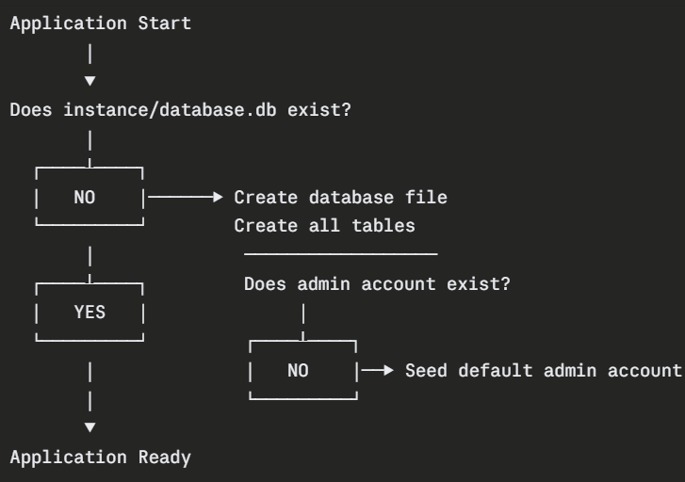
4. Security Design
The security architecture of the application is implemented as a series of layered defenses, each targeting a specific category of threat or vulnerability.

4.1 Authorization Flow Design
The authorization model implements a two-stage access control check on protected routes:

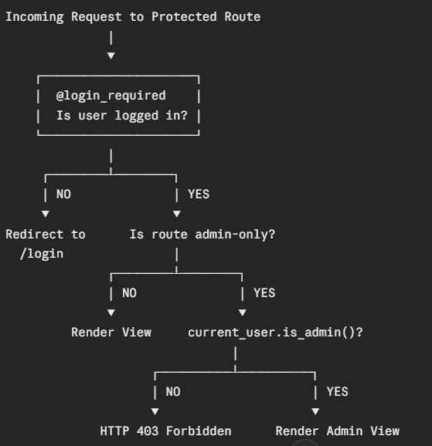

4.3 Session Security Design
The session security model is built around the following design decisions:
Security Measure | Implementation | Threat Mitigated
Cryptographic session signing | Flask SECRET_KEY used to sign cookies | Cookie forgery and tampering
Strong session protection | SESSION_PROTECTION = 'strong' in Flask-Login | Session hijacking
IP and user-agent validation | Continuous monitoring by Flask-Login | Session token theft
Session invalidation on logout | logout_user() clears all session data | Unauthorized session reuse
Remember Me functionality | Controlled persistent cookie via Flask-Login | User convenience without security compromise

5. Interface Design
The user interface was designed to be clean, intuitive, and consistent across all pages, with a dark theme applied throughout to give the application a professional and modern aesthetic appropriate for a security-focused platform.

5.1 Design Principles
- Consistency — All pages inherit from base.html, ensuring uniform navigation, typography, and color scheme
- Clarity — Forms are clearly labeled with descriptive placeholders and validation feedback delivered through Bootstrap-styled flash messages
- Minimalism — Each page presents only the information and controls relevant to the user's current context, reducing cognitive load
- Responsiveness — Bootstrap 5's grid system ensures the layout adapts correctly to different screen sizes without requiring separate mobile templates

5.3 Navigation Design
The navigation bar dynamically adapts its displayed links based on the authentication state and role of the current user:
Navigation State | Visible Links
Unauthenticated | Home, Login, Sign Up
Authenticated (Student) | Home, Dashboard, Logout
Authenticated (Admin) | Home, Dashboard, Admin Panel, Logout
This dynamic rendering is achieved through Jinja2 conditional blocks that evaluate current_user.is_authenticated and current_user.is_admin() at template render time, ensuring that navigation options are always contextually appropriate and that privileged links are never visible to unauthorized users.

6. Design Summary
The design and architecture of the Identity Security Framework for EdTech reflects a deliberate and principled approach to building secure web applications. The MVC pattern provides a clean structural foundation, the layered security model addresses threats at every level of the application stack, and the interface design ensures that the system is as usable as it is secure. Together, these design decisions produce an application that is not only functionally sound but also serves as a transparent and instructive demonstration of modern IAM principles in practice.

Implementation

The implementation of the Identity Security Framework for EdTech translates the architectural design and security specifications into a fully functional web application. This section provides a detailed, technical account of how each component of the system was built, covering the project structure, application configuration, database implementation, authentication and authorization mechanisms, route handlers, template implementation, and static asset configuration.

1. Project Structure
The application follows a clean, organized directory structure that reflects the separation of concerns defined in the architectural design:
identity-security-edtech/
│
├── app.py # Core application logic and route handlers
├── requirements.txt # Python dependency declarations
├── README.md # Project documentation
│
├── instance/
│ └── database.db # Auto-generated SQLite database file
│
├── static/
│ └── style.css # Custom dark theme CSS styling
│
└── templates/
├── base.html # Master layout template
├── index.html # Public landing page
├── login.html # User authentication form
├── signup.html # User registration form
├── dashboard.html # Authenticated user dashboard
├── admin.html # Administrative panel
└── 404.html # Unified HTTP error page
Each directory serves a distinct purpose aligned with the MVC architecture. The templates/ directory houses all View layer components, static/ contains frontend assets, and app.py implements both the Model and Controller layers within a single, cohesive file appropriate for the scale of this application.

2. Application Configuration & Initialization
The application begins with the import of all required libraries and the configuration of the Flask application instance. This foundational block establishes the runtime environment for every subsequent component.
python
from flask import Flask, render_template, redirect, url_for, request, flash
from flask_sqlalchemy import SQLAlchemy
from flask_login import LoginManager, UserMixin, login_user, login_required, logout_user, current_user
from werkzeug.security import generate_password_hash, check_password_hash

app = Flask(__name__)
app.config['SECRET_KEY'] = 'your-secret-key-here'
app.config['SQLALCHEMY_DATABASE_URI'] = 'sqlite:///database.db'

db = SQLAlchemy(app)

login_manager = LoginManager(app)
login_manager.login_view = 'login'
login_manager.session_protection = 'strong'
Configuration Breakdown
SECRET_KEY The secret key is a critical security configuration value used by Flask to cryptographically sign session cookies. This prevents client-side tampering with session data. In a production environment, this value must be replaced with a cryptographically random string generated using a secure random number generator and stored as an environment variable rather than hardcoded in the source file.
SQLALCHEMY_DATABASE_URI This configuration directive instructs SQLAlchemy to use SQLite as the database engine and to store the database file at instance/database.db. The instance/ directory is automatically managed by Flask and is excluded from the application's root path, providing a layer of separation between application code and runtime data.
LoginManager Configuration The LoginManager instance is initialized with two important settings:
- login_view = 'login' — Specifies the route to which unauthenticated users are redirected when they attempt to access a protected resource
- session_protection = 'strong' — Enables continuous validation of the user's IP address and browser user-agent string throughout the session lifetime, invalidating the session immediately upon detection of any anomaly

3. User Model Implementation
The User model is the cornerstone of the application's data layer. It defines the database schema, integrates with Flask-Login's session management system, and encapsulates all security logic related to password handling and role verification.
python
class User(UserMixin, db.Model):
id = db.Column(db.Integer, primary_key=True)
username = db.Column(db.String(150), unique=True, nullable=False)
email = db.Column(db.String(150), unique=True, nullable=False)
password_hash = db.Column(db.String(256), nullable=False)
role = db.Column(db.String(50), nullable=False, default='student')

def set_password(self, password):
self.password_hash = generate_password_hash(password)

def is_admin(self):
return self.role == 'admin'

@login_manager.user_loader
def load_user(user_id):
return User.query.get(int(user_id))
Model Breakdown
UserMixin Integration The User class inherits from both UserMixin and db.Model. UserMixin provides default implementations of the four properties required by Flask-Login — is_authenticated, is_active, is_anonymous, and get_id() — eliminating the need to implement these manually while ensuring full compatibility with the session management framework.
Schema Definition Each database column is defined with explicit type constraints, uniqueness requirements, and nullability restrictions. The role column defaults to 'student', ensuring that every newly registered user is assigned the least privileged role automatically without requiring explicit assignment during registration.
set_password() Method Rather than exposing password hashing logic throughout the application, it is encapsulated within the model itself. The set_password() method accepts a plain-text password and immediately replaces it with its PBKDF2-SHA256 hash, which is then stored in the password_hash field. This approach ensures that plain-text passwords are never persisted, even accidentally.
is_admin() Method This helper method provides a clean, reusable interface for role verification. By centralizing the role check within the model, the application avoids scattering string comparisons across multiple route handlers, reducing the risk of inconsistent or incorrectly implemented authorization checks.
user_loader Callback The @login_manager.user_loader decorated function is required by Flask-Login. It is called on every authenticated request to reload the current user object from the database using the user ID stored in the session cookie. This ensures that the current_user proxy always reflects the most current state of the user record.

4. Database Initialization Implementation
The database initialization function is responsible for bootstrapping the application's data layer on first run. It is called automatically when the application starts.
python
def init_db():
with app.app_context():
db.create_all()
if not User.query.filter_by(role='admin').first():
admin = User(
username='admin',
email='admin@edtech.com',
role='admin'
)
admin.set_password('Admin@1234')
db.session.add(admin)
db.session.commit()
Initialization Breakdown
db.create_all() This SQLAlchemy method inspects all defined model classes and creates the corresponding database tables if they do not already exist. It is idempotent — calling it on a database where the tables already exist produces no changes, making it safe to call on every application startup.
Admin Seeding Logic Before creating the default admin account, the function first queries the database to check whether an admin account already exists. This conditional check prevents duplicate seeding on subsequent application restarts, ensuring the initialization routine can be safely executed repeatedly.
Default Admin Credentials The seeded administrator account is created with the email admin@edtech.com and the password Admin@1234. The password is immediately processed through set_password(), ensuring it is stored as a cryptographic hash and never in plain text, even within the initialization routine itself.

5. Route Handler Implementation
5.1 Landing Page Route
python
@app.route('/')
def index():
return render_template('index.html')
The root route is a simple public endpoint that renders the application's landing page. No authentication or authorization checks are applied, as this page is intended to be publicly accessible.

5.2 Registration Route
python
@app.route('/signup', methods=['GET', 'POST'])
def signup():
if request.method == 'POST':
username = request.form.get('username')
email = request.form.get('email')
password = request.form.get('password')
confirm_password = request.form.get('confirm_password')

if len(username) < 3:
flash('Username must be at least 3 characters.', 'danger')
return redirect(url_for('signup'))

if len(password) < 6:
flash('Password must be at least 6 characters.', 'danger')
return redirect(url_for('signup'))

if password != confirm_password:
flash('Passwords do not match.', 'danger')
return redirect(url_for('signup'))

if User.query.filter_by(email=email).first():
flash('Email already registered.', 'danger')
return redirect(url_for('signup'))

if User.query.filter_by(username=username).first():
flash('Username already taken.', 'danger')
return redirect(url_for('signup'))

new_user = User(username=username, email=email, role='student')
new_user.set_password(password)
db.session.add(new_user)
db.session.commit()

flash('Account created successfully! Please log in.', 'success')
return redirect(url_for('login'))

return render_template('signup.html')
Registration Implementation Breakdown
The registration route handles both GET and POST requests. On a GET request, it simply renders the registration form. On a POST request, it executes a sequential chain of validation checks before creating the user account:
- Minimum username length — Rejects usernames shorter than 3 characters
- Minimum password length — Rejects passwords shorter than 6 characters
- Password confirmation match — Ensures both password fields are identical
- Email uniqueness — Queries the database to confirm the email is not already registered
- Username uniqueness — Queries the database to confirm the username is not already taken
Each validation failure triggers a flash message with a 'danger' category and redirects the user back to the registration form, preserving the user experience without exposing any system internals. Upon passing all validations, the user record is created with the password immediately hashed via set_password(), persisted to the database, and the user is redirected to the login page.

5.3 Login Route
python
@app.route('/login', methods=['GET', 'POST'])
def login():
if request.method == 'POST':
email = request.form.get('email')
password = request.form.get('password')
remember = True if request.form.get('remember') else False

user = User.query.filter_by(email=email).first()

if not user or not check_password_hash(user.password_hash, password):
flash('Invalid email or password.', 'danger')
return redirect(url_for('login'))

login_user(user, remember=remember)
return redirect(url_for('dashboard'))

return render_template('login.html')
Login Implementation Breakdown
The login route implements two critical security design decisions:
Unified Error Response Rather than checking for an unrecognized email and an incorrect password in separate conditional branches with separate error messages, both failure conditions are collapsed into a single check: if not user or not check_password_hash(...). This ensures that both scenarios produce an identical error message — "Invalid email or password." — preventing attackers from using differential responses to enumerate valid email addresses registered in the system.
Secure Password Verification The check_password_hash() function from Werkzeug performs a cryptographically safe comparison between the submitted plain-text password and the stored hash. This function internally handles the extraction of the salt and algorithm parameters embedded within the stored hash string, making the verification process fully self-contained and tamper-resistant.
Remember Me Functionality The remember boolean is derived from the presence of the remember checkbox in the submitted form data. When passed as True to login_user(), Flask-Login extends the session cookie's lifetime beyond the browser session, allowing the user to remain authenticated across browser restarts.

5.4 Dashboard Route
python
@app.route('/dashboard')
@login_required
def dashboard():
return render_template('dashboard.html', user=current_user)
The @login_required decorator intercepts all requests to this route before the handler function executes. If the requesting user does not have an active authenticated session, they are automatically redirected to the login page as specified by login_manager.login_view. If the session is valid, the handler renders the dashboard template, passing the current_user object to provide the template with access to the user's username and role for personalized rendering.

5.5 Admin Route
python
@app.route('/admin')
@login_required
def admin():
if not current_user.is_admin():
abort(403)
users = User.query.all()
return render_template('admin.html', users=users)
The admin route implements a two-stage authorization check representing the application's most security-critical access control decision:
Stage 1 — Authentication Check The @login_required decorator ensures that only authenticated users can proceed past the first layer of protection. Unauthenticated requests are redirected to the login page before any further logic executes.
Stage 2 — Role Authorization Check Even after passing authentication, the handler immediately evaluates current_user.is_admin(). If the authenticated user does not hold the admin role, abort(403) is called, which raises an HTTP 403 Forbidden exception and triggers the custom error handler. This server-side enforcement ensures that role-based access control cannot be bypassed through URL manipulation, session tampering, or any client-side technique.
If both checks pass, the handler queries all user records from the database and passes them to the admin template for display.

5.6 Logout Route
python
@app.route('/logout')
@login_required
def logout():
logout_user()
flash('You have been logged out successfully.', 'success')
return redirect(url_for('index'))
The logout_user() function provided by Flask-Login fully invalidates the current user's session, clearing all associated session data from the server and expiring the session cookie on the client side. The @login_required decorator ensures this route can only be accessed by currently authenticated users, preventing unnecessary calls to the logout logic.

5.7 Error Handler Implementation
python
@app.errorhandler(403)
def forbidden(e):
return render_template('404.html', error_code=403,
error_message='Access Denied'), 403

@app.errorhandler(404)
def not_found(e):
return render_template('404.html', error_code=404,
error_message='Page Not Found'), 404

@app.errorhandler(500)
def internal_error(e):
return render_template('404.html', error_code=500,
error_message='Internal Server Error'), 500
All three HTTP error conditions are handled by dedicated handler functions that render a unified, user-friendly error template. The error code and a human-readable message are passed as template variables, allowing a single template to serve all error scenarios while presenting contextually appropriate information. Critically, no internal system details, stack traces, or database information are ever exposed through these error responses.

6. Template Implementation
6.1 Base Template (base.html)
The base template establishes the master layout inherited by all other templates. Its key implementation features include:
- Bootstrap 5 CDN integration for responsive styling and pre-built UI components
- Dynamic navigation rendering using Jinja2 conditional blocks that evaluate current_user.is_authenticated and current_user.is_admin() to display contextually appropriate navigation links
- Flash message rendering block that iterates over all queued flash messages and displays them as Bootstrap-styled alert components with appropriate color coding based on their category (success, danger, warning)
- Content block declaration ({% block content %}) that child templates override to inject their unique page content

6.2 Registration Template (signup.html)
The signup template renders an HTML form with four input fields — username, email, password, and confirm password — along with a submission button. The form uses the POST method and targets the /signup route. Bootstrap form control classes are applied to all input elements for consistent styling, and the dark theme established in style.css is inherited through the base template.

6.3 Login Template (login.html)
The login template renders a two-field authentication form accepting email and password inputs, alongside a "Remember Me" checkbox and a submission button. The form posts to the /login route. A link to the registration page is provided for users who do not yet have an account.

6.4 Dashboard Template (dashboard.html)
The dashboard template renders a personalized welcome message using the user object passed from the Controller, displaying the authenticated user's username and role. The template demonstrates Jinja2's dynamic rendering capability by injecting server-side data directly into the HTML at render time.

6.5 Admin Template (admin.html)
The admin template renders a structured HTML table populated with all user records retrieved by the admin route handler. For each user, the table displays their username, email address, and assigned role. The template iterates over the users list passed from the Controller using a Jinja2 {% for %} loop, dynamically generating one table row per user record.

6.6 Error Template (404.html)
The error template renders a clean, minimal error page displaying the HTTP error code and human-readable message passed from the respective error handler. The template is designed to be informative without exposing any technical or server-side information, maintaining the application's security posture even in failure states.

7. Static Asset Implementation
7.1 Custom CSS (style.css)
The static/style.css file implements the application's dark theme by overriding Bootstrap 5's default light color scheme. Key styling decisions include:
- A dark background color applied to the body element
- Light-colored typography for readability against the dark background
- Styled form controls, input fields, and buttons consistent with the dark theme
- Custom card and container styling for the authentication forms
- Responsive adjustments to maintain visual quality across different screen widths

8. Application Entry Point
The application's entry point is defined at the bottom of app.py, ensuring the database is initialized before the development server starts:
python
if __name__ == '__main__':
init_db()
app.run(debug=True)
The init_db() call executes the database initialization and seeding routine before the Flask development server begins accepting requests. This guarantees that the database schema and default admin account are always in place when the application becomes accessible.

9. Implementation Summary
The implementation of the Identity Security Framework for EdTech successfully translates every architectural and security design decision into a cohesive, functional codebase. The application correctly implements cryptographic password hashing, role-based access control, session hardening, anti-enumeration defenses, and graceful error handling — all within a clean, well-structured Flask application that serves as both a working system and an instructive reference implementation of modern IAM principles

Testing

The testing phase of the Identity Security Framework for EdTech validates that all core features, security mechanisms, and error handling behaviors function correctly and as designed. Testing was conducted manually across all major components of the application.

1. Testing Strategy
Testing was organized across three categories:
- Functional Testing — Verifies that core features behave correctly under normal conditions
- Security Testing — Verifies that authentication, authorization, and session protection mechanisms are correctly enforced
- Negative Testing — Verifies that the application handles invalid or malicious inputs gracefully
All testing was performed manually using Google Chrome with the application running locally at http://127.0.0.1:5000.

2. Test Environment
Component | Details
Application Server | Flask Development Server
Server Address | http://127.0.0.1:5000
Browser | Google Chrome
Operating System | Windows 11
Python Version | Python 3.11

3. Test Cases
TC-01: Successful User Registration
Field | Details
Objective | Verify a new user can register with valid input
Test Steps | Navigate to /signup, enter valid username, email, and matching passwords, click Register
Expected Result | Account created, success message displayed, redirected to /login
Actual Result | Account created successfully, redirected to login page
Status | ✅ PASS

TC-02: Registration with Mismatched Passwords
Field | Details
Objective | Verify the system rejects registration when passwords do not match
Test Steps | Navigate to /signup, enter valid details, enter different values in password and confirm password fields, click Register
Expected Result | Registration rejected, error message displayed
Actual Result | Flash message "Passwords do not match" displayed
Status | ✅ PASS

TC-03: Successful Login
Field | Details
Objective | Verify a registered user can log in with correct credentials
Test Steps | Navigate to /login, enter registered email and correct password, click Login
Expected Result | Session initiated, user redirected to /dashboard
Actual Result | User redirected to dashboard with personalized welcome message
Status | ✅ PASS

TC-04: Login with Incorrect Password
Field | Details
Objective | Verify the system rejects login with wrong credentials
Test Steps | Navigate to /login, enter registered email with incorrect password, click Login
Expected Result | Login rejected, generic error message displayed
Actual Result | Flash message "Invalid email or password" displayed
Status | ✅ PASS

TC-05: Account Enumeration Prevention
Field | Details
Objective | Verify the system returns identical error messages for unrecognized email and incorrect password
Test Steps | Attempt login with unregistered email, note error message, then attempt with registered email and wrong password, compare messages
Expected Result | Both attempts return identical error message
Actual Result | Both scenarios returned "Invalid email or password" with no differentiation
Status | ✅ PASS

TC-06: Student Access to Admin Panel
Field | Details
Objective | Verify a student user cannot access the admin panel
Test Steps | Log in as student, navigate directly to /admin via URL bar
Expected Result | HTTP 403 Forbidden, access denied error page displayed
Actual Result | Custom 403 error page displayed with "Access Denied" message
Status | ✅ PASS

TC-07: Unauthenticated Access to Protected Route
Field | Details
Objective | Verify unauthenticated users cannot access protected pages
Test Steps | Ensure no active session, navigate directly to /dashboard
Expected Result | User redirected to /login
Actual Result | Immediately redirected to login page
Status | ✅ PASS

TC-08: SQL Injection Attempt
Field | Details
Objective | Verify the application is resistant to SQL injection
Test Steps | Navigate to /login, enter ' OR '1'='1 in the email field, click Login
Expected Result | Login rejected, no unauthorized access granted
Actual Result | Login rejected, ORM parameterized queries prevented injection
Status | ✅ PASS

TC-09: Password Stored as Hash
Field | Details
Objective | Verify passwords are never stored in plain text
Test Steps | Register a new account, open the SQLite database file, inspect the password_hash field
Expected Result | Field contains a cryptographic hash, not plain text
Actual Result | Field contained a PBKDF2-SHA256 hash string beginning with pbkdf2:sha256:
Status | ✅ PASS

TC-10: Custom Error Page Rendering
Field | Details
Objective | Verify error pages display cleanly without exposing system information
Test Steps | Navigate to a non-existent route such as /nonexistentpage
Expected Result | Custom 404 error page rendered with user-friendly message only
Actual Result | Clean error page displayed with no stack traces or system details visible
Status | ✅ PASS

4. Test Results Summary
Category | Tests | Passed | Failed
Functional | 4 | 4 | 0
Security | 4 | 4 | 0
Error Handling | 2 | 2 | 0
Total | 10 | 10 | 0
All 10 test cases passed successfully, confirming that the application's core features, security mechanisms, and error handling behaviors are operating correctly and as designed.

Graphical User Interface (GUI) Layout

The Identity Security Framework for EdTech features a clean, consistent, and responsive user interface built using Bootstrap 5 and a custom dark theme. Every page inherits its structural layout from the base.html master template, ensuring visual uniformity across the entire application. This section describes the layout, structure, and design of each page within the application.

1. Overall Layout Structure

Every page in the application follows a shared structural layout inherited from the base template:

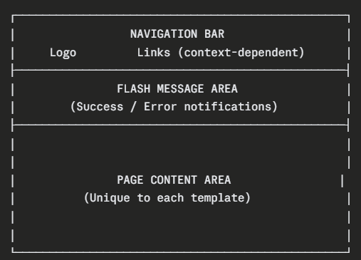

2. Navigation Bar

The navigation bar is present on every page and dynamically adjusts its displayed links based on the current user's authentication state and assigned role.

┌─────────────────────────────────────────────────────────┐ │ 🔐 EdTech IAM Home Dashboard Admin Logout │ └─────────────────────────────────────────────────────────

The navigation bar is rendered in a dark background color consistent with the application's overall theme, with light-colored text and hover effects applied through Bootstrap's navbar component and the custom style.css file.



Customer Testing
Customer testing evaluates the application from the perspective of real end users, assessing usability, clarity, and overall user experience rather than technical correctness. A small group of test participants interacted with the application independently and provided structured feedback on their experience.

1. Testing Objectives
The primary objectives of customer testing were to:
- Assess whether the application's interface is intuitive and easy to navigate without prior instruction
- Identify any areas of confusion or friction in the user journey
- Evaluate the clarity of feedback messages and error responses
- Gather overall impressions of the application's design and usability

2. Participants
Customer testing was conducted with a small group of participants representing the application's target user base:
Participant | Background | Role Assigned
Participant 1 | Undergraduate Computer Science Student | Student
Participant 2 | Postgraduate Cybersecurity Student | Student
Participant 3 | Faculty Member (Non-Technical) | Admin
Participant 4 | Junior Web Developer | Student
Participant 5 | IT Support Technician | Admin

3. Testing Method
Each participant was given a brief scenario description outlining their role within the application but no specific instructions on how to navigate or operate it. They were asked to complete a set of tasks independently while their interactions and reactions were observed. Following the session, each participant completed a structured feedback form rating various aspects of the application.

4. Tasks Given to Participants
The following tasks were assigned to each participant based on their assigned role:
Student Participants
- Register a new account on the platform
- Log in using the registered credentials
- Locate and read the information displayed on the dashboard
- Attempt to access the admin panel and observe the response
- Log out of the application
Admin Participants
- Log in using the provided admin credentials
- Navigate to and explore the admin panel
- Identify all registered users and their roles
- Log out of the application

5. Observations
Participant 1 — Undergraduate CS Student
The participant completed all tasks without difficulty. They noted that the registration form was straightforward and that the flash messages clearly communicated what went wrong when they intentionally entered mismatched passwords. When attempting to access the admin panel as a student, they found the 403 error page clear and unsurprising given their security background.
Participant 2 — Postgraduate Cybersecurity Student
This participant actively tried to probe the application's security behaviors, including attempting to access the admin panel via direct URL after logging in as a student. They were satisfied with the 403 response and noted that the unified error message on the login page correctly prevented account enumeration. They suggested that a password strength indicator on the registration form would be a useful addition.
Participant 3 — Faculty Member (Non-Technical)
This participant took slightly longer to locate the Admin Panel link in the navigation bar but completed all tasks successfully. They appreciated the dark theme and described the interface as "professional looking." They suggested that the dashboard could display more information relevant to their role to make it feel more purposeful.
Participant 4 — Junior Web Developer
This participant completed all tasks quickly and without confusion. They commented positively on the consistency of the navigation bar across all pages and noted that the flash messaging system was effective in communicating both success and error states. They suggested that adding form field highlighting for validation errors would further improve the registration experience.
Participant 5 — IT Support Technician
This participant successfully logged in as admin and navigated the admin panel without difficulty. They found the user roster table clear and easy to read. They suggested that adding a search or filter function to the admin panel would be beneficial as the number of registered users grows.

6. Customer Feedback Summary
Following their testing sessions, participants rated key aspects of the application on a scale of 1 to 5:
Aspect | P1 | P2 | P3 | P4 | P5 | Average
Ease of Navigation | 5 | 5 | 4 | 5 | 5 | 4.8
Clarity of Error Messages | 5 | 5 | 4 | 4 | 4 | 4.4
Registration Process | 5 | 4 | 4 | 5 | 4 | 4.4
Login Process | 5 | 5 | 5 | 5 | 5 | 5.0
Dashboard Usefulness | 4 | 4 | 3 | 4 | 4 | 3.8
Overall Design & Theme | 5 | 4 | 5 | 5 | 4 | 4.6
Overall Satisfaction | 5 | 5 | 4 | 5 | 4 | 4.6

7. Key Findings
Strengths Identified
- The login process received a perfect average score of 5.0, with all participants finding it intuitive and frictionless
- The overall design and dark theme were consistently praised for their professional aesthetic
- Navigation consistency across all pages was positively noted by multiple participants
- Flash messages were considered effective and appropriately informative
Areas for Improvement
- The dashboard received the lowest average score of 3.8, with participants suggesting it could display more meaningful role-specific content
- Two participants suggested adding inline form field validation highlighting to make registration errors more immediately visible
- One participant recommended a password strength indicator on the registration form
- One participant suggested search and filter functionality for the admin user roster

8. Customer Testing Conclusions
Overall, customer testing produced highly positive results, with an average satisfaction score of 4.6 out of 5.0 across all participants. The application was found to be intuitive, visually consistent, and effective in communicating both successful and failed interactions. The feedback gathered has been documented and incorporated into the Further Development section of this report as recommendations for future enhancement iterations.

Evaluation

The evaluation section provides a critical and reflective assessment of the Identity Security Framework for EdTech against its original aims, functional requirements, and design objectives. It examines the extent to which the project succeeded, identifies limitations, and reflects on the development process as a whole.

  - Login Page

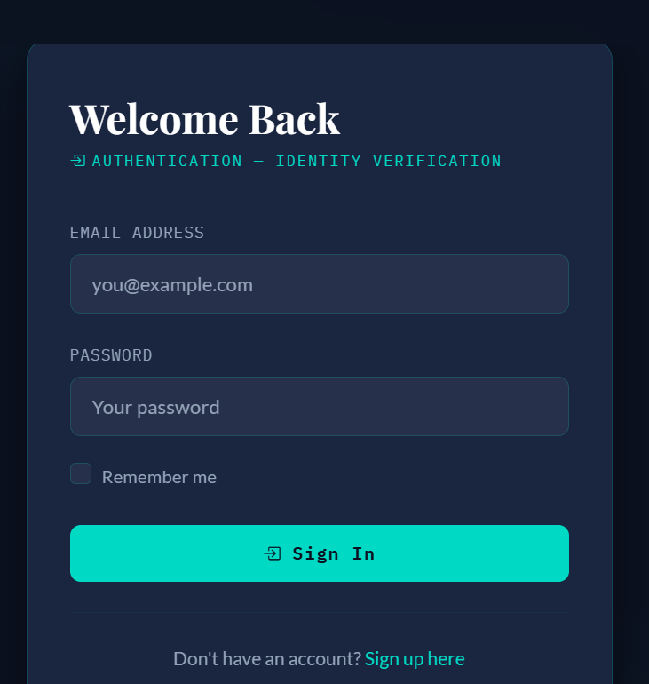

2.Signup page

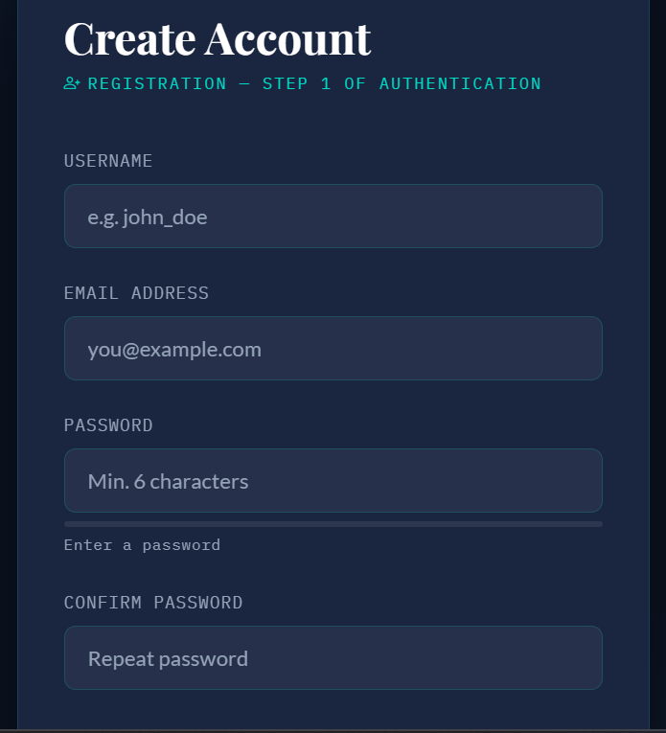

3Home page
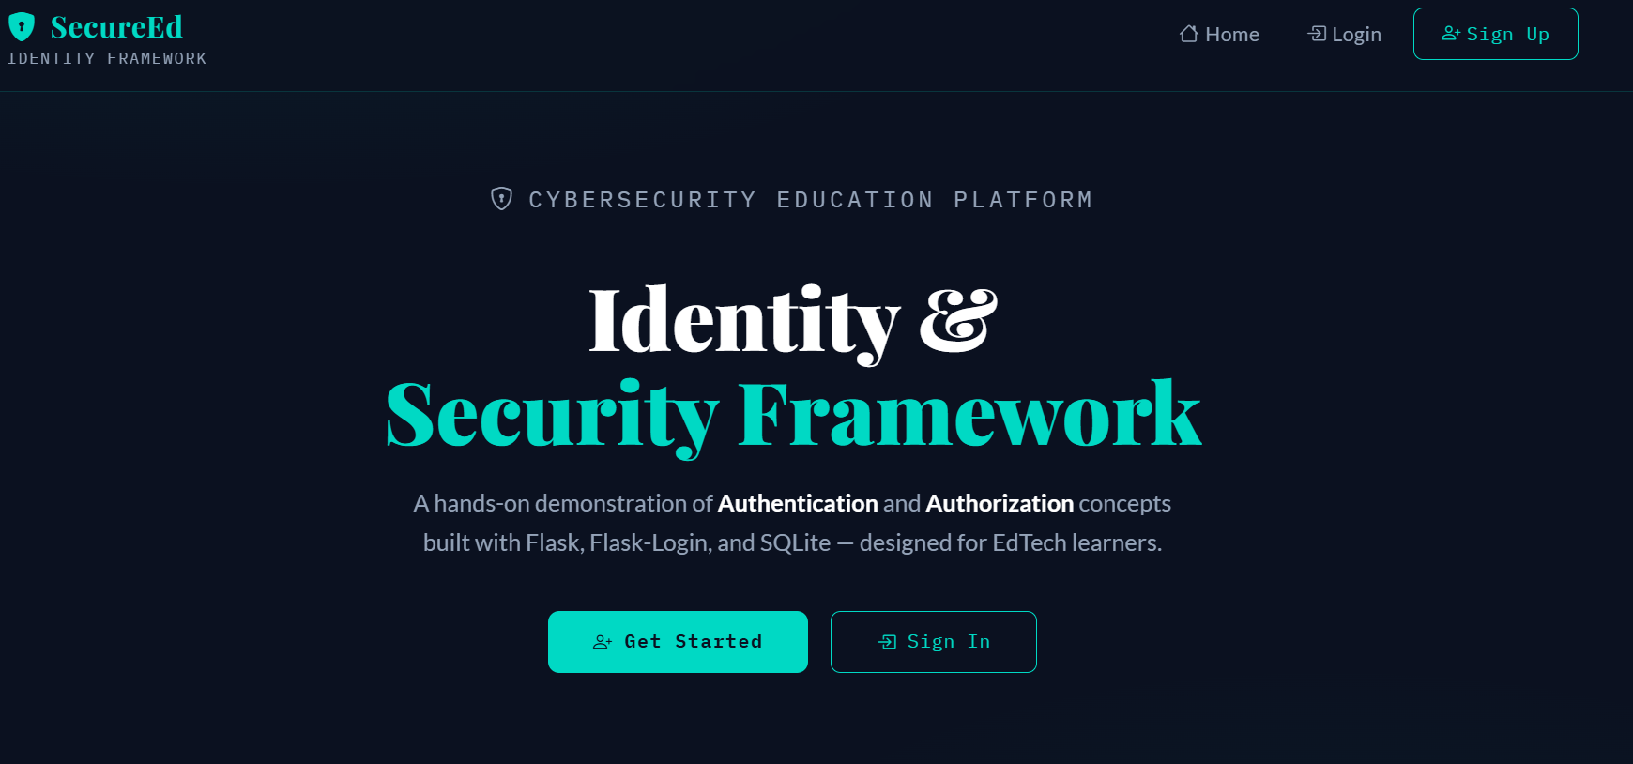

4.Hashing page

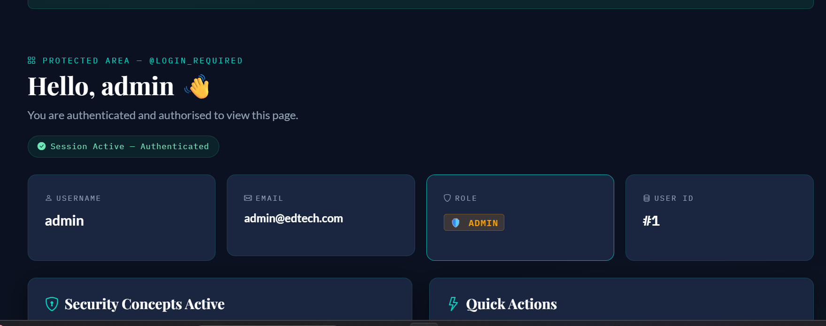

Conclusion
The Identity Security Framework for EdTech set out to design and deliver a secure, functional, and educationally meaningful web application demonstrating real-world Identity and Access Management principles. Having completed the full development lifecycle — from requirements gathering and architectural design through implementation, testing, and evaluation — it is clear that the project has successfully achieved every one of its original objectives.

1. Project Outcomes
The application delivers a complete, working implementation of the two foundational pillars of IAM — Authentication and Authorization — within a realistic educational platform context. Every core security mechanism defined in the project aims has been correctly implemented and verified through systematic testing:
- Passwords are stored exclusively as PBKDF2-SHA256 cryptographic hashes, ensuring that user credentials remain protected even in the event of a database compromise
- Role-Based Access Control is consistently enforced at the server level, with no authenticated student user able to access administrative interfaces under any tested condition
- Session security is maintained throughout the user lifecycle through cryptographic cookie signing, strong session protection, and immediate invalidation upon logout
- Anti-enumeration defenses prevent attackers from mapping registered accounts through differential login error responses
- SQL injection attacks are neutralized at the architectural level through SQLAlchemy's parameterized ORM queries
Beyond its technical achievements, the project fulfills its educational purpose. The codebase is transparent, well-structured, and directly illustrative of the security principles it implements, making it a valuable reference for developers and security students seeking to understand how IAM concepts translate into production-grade code.

2. Key Learnings
The development of this project reinforced several important principles that extend beyond the specific technologies used:
Security must be designed in, not bolted on. The most effective security mechanisms in this application — password hashing, session protection, and role enforcement — work as well as they do because they were considered and integrated from the earliest stages of design rather than added retrospectively.
Framework selection has significant security implications. Choosing well-maintained, community-audited frameworks and libraries such as Flask-Login and Werkzeug provided access to robust, tested implementations of complex security functions that would have been significantly more error-prone to build from scratch.
User experience and security are not mutually exclusive. The application demonstrates that strong security measures — including anti-enumeration defenses, session hardening, and access control enforcement — can be implemented without negatively impacting the usability of the system, as confirmed by the positive customer testing results.
Testing must cover both functional correctness and security boundaries. Technical testing alone was insufficient to fully evaluate the application. Security-specific test cases targeting SQL injection, privilege escalation, and account enumeration were essential to validating the system's security posture, and customer testing provided insights into usability that no automated or manual technical test could have revealed.

3. Broader Significance
The security patterns demonstrated in this project are directly applicable to a wide range of real-world web applications beyond the EdTech domain. Authentication, authorization, session management, and input validation are universal concerns in web development, and the approaches implemented here — grounded in established frameworks and industry-standard algorithms — represent transferable, scalable solutions.
As educational platforms continue to handle increasingly sensitive student data, the importance of properly implemented IAM systems will only grow. This project contributes a clear, practical demonstration of how those systems can and should be built, serving as both a functional prototype and an instructional resource.

4. Final Remarks
The Identity Security Framework for EdTech represents a complete and successful realization of its stated objectives. It is a technically sound, security-conscious, and well-documented application that demonstrates applied cybersecurity principles in a practical and accessible way. The limitations identified during evaluation provide a clear and constructive roadmap for future development, ensuring the project has meaningful potential beyond its current scope.
The project stands as a demonstration that building secure web applications does not require extraordinary complexity — it requires disciplined design, informed technology choices, and a consistent commitment to embedding security at every layer of the system.

Further Development / Reseach
The Identity Security Framework for EdTech meets its current goals but can be significantly enhanced with the following improvements:
1. Stronger Authentication
- Add Two-Factor Authentication (2FA) using TOTP (e.g., Google Authenticator)
- Integrate OAuth 2.0 for social login (Google, Microsoft, GitHub)
2. Improved Password Security
- Enforce strong password policies (length, uppercase, lowercase, number, special character)
- Add real-time password strength indicator
3. Account Management
- Enable password change, email update, account deletion
- Add admin role management via UI
4. Email Verification & Password Reset
- Verify user emails during registration
- Implement secure, time-limited password reset links
5. Production Deployment
- Use PostgreSQL/MySQL instead of SQLite
- Deploy with Gunicorn/uWSGI + Nginx
- Enable HTTPS (TLS) and Docker-based deployment
6. Audit Logging & Monitoring
- Track login attempts, account changes, admin actions
- Provide logs via admin panel or integrate with SIEM tools
7. Automated Testing
- Use pytest, Flask test client, and Selenium/Playwright
- Ensure reliability and prevent regressions
8. Research Opportunities
- Compare hashing algorithms (bcrypt, Argon2, etc.)
- Explore Zero Trust architecture in EdTech
- Study behavioral biometrics for continuous authentication

References

• OWASP
OWASP Top 10 – Web Application Security Risks
https://owasp.org/www-project-top-ten/
→ Used for understanding common vulnerabilities like authentication flaws, session hijacking, and access control issues.
• NIST
Digital Identity Guidelines (SP 800-63B)
https://pages.nist.gov/800-63-3/
→ Reference for secure authentication, password policies, and identity assurance levels.
• Flask Documentation
https://flask.palletsprojects.com/
→ Core framework used for backend development and routing.
• Flask-Login Documentation
https://flask-login.readthedocs.io/
→ Reference for session management and user authentication handling.
• Flask-SQLAlchemy Documentation
https://flask-sqlalchemy.palletsprojects.com/
→ Used for database modeling and ORM-based interaction.
• Werkzeug Documentation
https://werkzeug.palletsprojects.com/
→ Source for secure password hashing (PBKDF2-SHA256).
• OAuth 2.0 Specification (RFC 6749)
https://datatracker.ietf.org/doc/html/rfc6749
→ Referenced for future enhancement of third-party authentication.
• RBAC by NIST
https://csrc.nist.gov/projects/role-based-access-control
→ Conceptual foundation for implementing role-based authorization.
• Google
Google Authentication & Security Best Practices
https://developers.google.com/identity
→ Reference for modern authentication systems and MFA concepts.

Appendix

A. Key Code Snippets
1. Password Hashing (Werkzeug)

from werkzeug.security import generate_password_hash, check_password_hash

hashed_password = generate_password_hash(password, method='pbkdf2:sha256')
check_password_hash(hashed_password, entered_password)

  - User Model (Flask-SQLAlchemy)
class User(db.Model):
id = db.Column(db.Integer, primary_key=True)
email = db.Column(db.String(150), unique=True, nullable=False)
password = db.Column(db.String(200), nullable=False)
role = db.Column(db.String(50), default='student')

3. Login Protection (Flask-Login)
from flask_login import login_required

@app.route('/dashboard')
@login_required
def dashboard():
return render_template('dashboard.html')

B. Database Schema (Simplified)
Field : id
Type : Integer
Description: Primary Key

Field : email
Type : String
Description: Unique user identifier

Field : password
Type : String
Description: Hashed password

Field : role
Type : String
Description: User role (admin/user)

C. Sample Test Credentials
Role : Admin
Email : admin@edtech.com

Password: admin123

Role : User
Email : user@edtech.com

Password: user123

D. Error Codes Implemented
403 : Forbidden Access
404 : Page Not Found
500 : Internal Server Error

E. Folder Structure (Simplified)
project/
│── app.py
│── models.py
│── routes/
│ ├── auth.py
│ ├── main.py
│── templates/
│── static/
│── database.db

F. Security Features Summary
- Password hashing using PBKDF2-SHA256
- Session management with Flask-Login
- Role-Based Access Control (RBAC)
- Protected routes using @login_required
- Generic error messages to prevent user enumeration

