**Reading and Research Report**

Problem Domain

Communication is an important factor in the foraging performance of social insects, like ants. During foraging, ants keep track of the food sources by using memory (site fidelity) or communicating it through pheromones. Previous field experiments showed that the rate of seed collection depends on the distribution of food in the environment. If food is spatially clustered, then ants recruit nest mates to collect from large clusters. However, we don't know how large a food pile needs to be for recruitment to occur. Goal of our research was to investigate the answer of this question.

Methods:

To simulate the behavior of ants we have used Argos simulator which uses CPFA. We have tuned the parameters of CPFA using the GA. We prepared specific environment for our GA. we look at evolving the CPFA on a larger arena size, 20 by 20, with more seeds, power rank 5 which has 1280 seeds in varying size clusters. We evolve two types of genetic algorithms (GAs) in this environment: one that limits the pheromone rate and one that uses the full range of values of the CPFA. We look at finding when swarms are able to collaboratively collect from piles and see if this collaborative collection causes an increase in collection rate. We use change point detection through the CUSUM method. We are able to detect change points that seem to match the data but the results are not completely conclusive as they require manual intervention to match data. We wanted to take a closer look at when a pile is discovered by ants. To do so we have used our developed CUSUM module. We traced collection time for all of the seeds. Then we have separated seeds according to their distribution type. To detect the discovery of piles or a collective recruitment, we have used CUSUM algorithm which is capable of detecting change points. We have created timelines of collected seeds using sliding windows of 60 seconds with varying sliding amounts based on the pile type. This timeline contains the rate of seed collection. To get the optimum results for change detection. CUSUM uses the following equations for detecting change points

Our Results:

We analyzed foraging rates on different sizes of piles in simulation. Using a power law distribution to arrange seeds in piles of different sizes, we observed that for significantly large piles of seeds, the ants take more time to discover a pile, but once discovered, seeds are collected at an increased rate from that pile (Figure 1). We also observed that ants may repeatedly lose track of found piles and then re-find them. Using change point analysis on seed intake time series, we were able to trace the discovery and loss of a piles by detecting changes in the foraging rate. We found multiple positive and negative change points for single large piles of foods and no change points for small clusters of foods, which suggests that ants do not recruit to small clusters of food. We have tried to trace the discovery of piles by detecting abrupt changes in their foraging rate. We have varied sliding window size and sliding amount to get the optimum result for detecting changes. It can be inferred from Figure 5 that if the piles are not significantly large then detecting of changes in collection of seeds is difficult. We are able to detect change points for one, four and sixteen large piles by varying the thresholds and drifts. But for sixty four piles of four seeds it was not possible to detect the changes as the distribution is close to a random distribution of seeds.

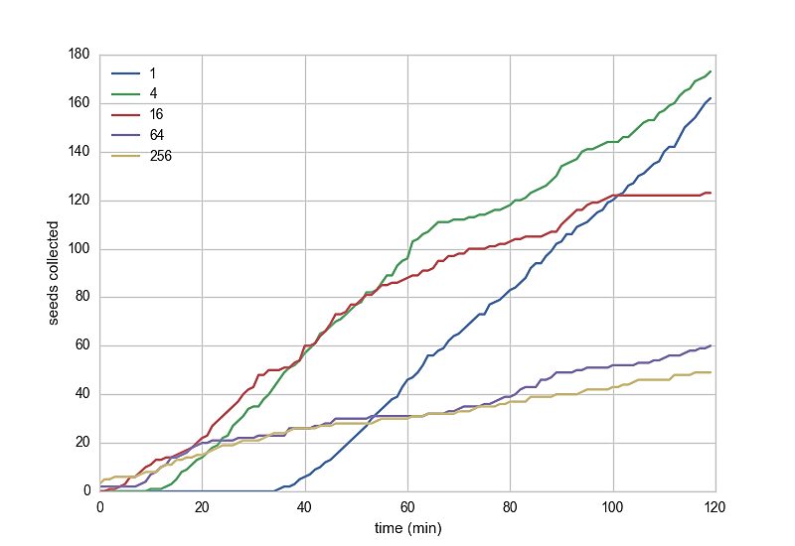

Figure 1: The time series is generated from one experiment of simulated iAnt data. It shows the rate of colleting seeds from different types of piles. Blue line is for 1 large pile of 256 seeds. Green line is for 4 piles of 64 seeds. The red, purple and yellow lines are for 16 piles of 16 seeds, 64 piles of 4 seeds and 256 random seeds respectively. It can be inferred from the figure that large piles takes more time to be discovered, but once they are discovered, the foraging rate from that pile increases.

The drifts, threshold values, sliding windows and their sliding amounts are given in the table for different types of pile size of seeds.

|  |  |  |  |  |
| --- | --- | --- | --- | --- |
| Seeds in Pile | Sliding Window | Sliding Amount | Threshold | Drift |
| 256 | 60 | 10 | 1 | 1 |
| 64 | 60 | 20 | 1.5 | 0.8 |
| 16 | 60 | 40 | 1 | 0.5 |

|  |  |
| --- | --- |
| (a) | (b) |
| (c) | (d) |
| (e) | (f) |
| *Figure 2: 2a and 2b shows the discovery of one large pile multiple times. 2a detects the change points in the sliding windows and 2b shows the actual time that the changes occur. 2c represents the change points for Four piles in the sliding window and 2d represents actual change points in time. 2e and 2f detects the changes in foraging rate for Sixteen Piles.* | |