 

School of Computer Science & Software Engineering

Bachelor of Computer Science (Digital Systems Security)

CSCI321 - Project

**Technical Document**

Group: FYP-25-S2-14P

Zikry Bin Affendi 8380338 zba505@uowmail.edu.au

Tan Zhi Qin 8259240 zqt072@uowmail.edu.au

Muhammad Hannan Azman 8220852 mha986@uowmail.edu.au

Wong Xin Yang 8497035 xyw523@uowmail.edu.au

Ernest Yeo Jun Long 8535139 ejly205@uowmail.edu.au

Supervisor: Tian Sion Hui

Assessor: Japit Sionggo

# Introduction

## 1.1 Overview

The Safe QR Application allows its user to be in a safe and secured position when scanning and interacting with QR codes. It protects users from harmful threats, gives warnings of different categories and allows users to access links in a sandbox environment. This project aims to enhance public safety by developing a QR code scanner application that detects malware embedded within QR codes.

## 1.2 Scope

This document outlines the technical aspects of the SafeQR application, including system architecture, features, technologies used, and user interface design. It serves as a comprehensive guide for developers, testers, and stakeholders to understand the inner workings of the application and its components.

## 1.3 User Documentation

When users open the app, they will first see a screen asking them to either sign up or log in. Once logged in, they can navigate different features using tabs or buttons, including scanning QR codes, checking their scan history, managing user profile and adjusting settings. The app will then assess the QR code and deliver instant safety feedback and suggestions. After scanning, users can review the results and access their history from their profile. They can also personalize settings for QR scanning and safety alerts.

# Functional Requirements

## 2.1 Core Feature

| S/N | Feature | Description |
| --- | --- | --- |
| 01 | Allow/Disallow Camera Access | A safety feature that asks user permission for access to the camera. User can select “While using the app”, “Only this time”, “Don’t Allow” |
| 02 | Scan QR Code via Device’s In-built Camera | Allow user to scan QR codes directly using their device’s camera |
| 03 | Turn On Flashlight when scanning QR Code | Allow user to turn on the flashlight to scan QR code when in a low lighting environment |
| 04 | Receive results on QR Code Scan results | Allow users to receive corresponding alerts after scanning the QR Code. The application categorizes the QR code into one of four outcomes—Safe, Unsafe. A short and brief description will also be included to educate users behind every result. |
| 05 | Importing QR Code from gallery | Allow users to take a photo of QR Code and save it in the gallery first. Then, import it to the application later to scan. |
| 06 | View History | Allows users to review their past QR code scan results, providing a record of previous interactions for reference or security purposes |
| 07 | Toggle App Theme | Users can adjust the app theme to their preference such as switching between dark and light modes for optimal viewing comfort. |
| 08 | Sandbox for Safe Browsing | Run potentially unsafe URLs in a secured, isolated environment to protect the user’s device from malicious content |
| 09 | Front/Back Camera Scanning | Allowing users to use both front and back cameras to scan the QR code. Providing a backup option if one camera malfunctions. This dual-camera functionality ensures uninterrupted scanning and enhances user convenience. |
| 10 | Clearing Scanned QR Codes History | Allowing users to clear the scanned QR codes history. This feature provides an additional layer of privacy and helps users manage their stored data more effectively. |
| 11 | Report Malicious Link | Allowing users to report malicious links embedded in QR code. This feature helps protect other users from potential threats and contributes to a safer scanning environment via the relevant channel. |
| 12 | Share QR Results | Allowing users to share the results with their friends via messenger application or email. So that friends and family can be cautious of these malicious links. |

## 2.2 User Stories

# .

# As a user, I want to scan the QR code with my phone camera to quickly access the encoded information.

# As a user, I want to upload QR code from my phone’s photo library. So I can upload in the application and check on the link when I am free.

# As a user, I want to be able to view the past histories of QR codes scanned, so I would have a list of records for my future reference

# As a user, I want the application to provide me with precautions if the scanned QR code is flagged as having malicious content.

# As a user, I want to be able to open the link in a sandbox environment within the application, so I can safely view the content without being exposed to suspicious content.

# As a user, I want to be able to choose between light or dark mode within the application so that I can adjust the display for optimal viewing comfort.

# As a user, I want to be able to report malicious links to the relevant authorities so that appropriate action can be taken to block or remove the link, ensuring a safer scanning experience for everyone.

# As a user, I want to share the QR code results with my family and friends so that they can access the same information quickly and conveniently.

# As a user, I want to be able to turn on a flashlight when scanning QR code. So that even in a bad lighting environment, I will still be able to scan QR code and determine if the QR is safe or malicious

# As a user, I want to clear the history result of the QR code I have scanned.

# As a user, I want to be able to use the front camera to scan the QR code. In the event where my rear camera is not working, I still have an option to use the front camera.

## 2.3 Use Case Diagram and Description

## 2.3.1 Use Case Diagram

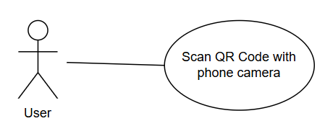

# Use Case Description

# 

| **Use Case Name:** | Scan QR code with phone camera | **Use Case ID:** #TC-004 |
| --- | --- | --- |
| **Pre-Condition(s):** | User must install and open the application | |
| **Actor:** | User | |
| **Description:** | As a user, I want to scan the QR code with my phone camera to quickly access the encoded information | |
| **Normal Flow:** | 1. User aligns phone camera to the QR code | |
| **Alternate Flow:** | - | |

# 

# 

## 2.3.2 Use Case Diagram

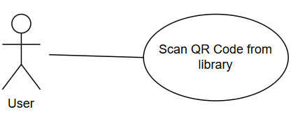

# Use Case Description

# 

| **Use Case Name:** | Upload QR code from photo library | **Use Case ID:** #TC-005 |
| --- | --- | --- |
| **Pre-Condition(s):** | User must have a valid QR code in library | |
| **Actor:** | User | |
| **Description:** | As a user, I want to upload QR code from my phone’s photo library. | |
| **Normal Flow:** | 1. On the main page after successful login, user clicks on “Upload QR” 2. User selects the QR code from photo library 3. System will scan QR code that the user chose | |
| **Alternate Flow:** | If the user chose an invalid image - for example a blurry QR code image or an image which is not a QR code | |

# 

# 

## 2.3.3 Use Case Diagram

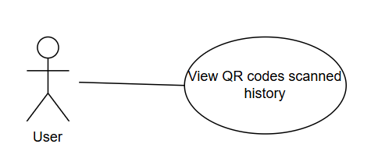

# Use Case Description

# 

| **Use Case Name:** | View QR codes scanned history | **Use Case ID:** #TC-006 |
| --- | --- | --- |
| **Pre-Condition(s):** | Have already scanned QR codes before | |
| **Actor:** | User | |
| **Description:** | As a user, I want to be able to view the past histories of QR codes scanned, so I would have a list of records for my future reference | |
| **Normal Flow:** | 1. On the main page, user clicks “QR History” button 2. System will retrieve a list of QR codes that user have scanned in the past | |
| **Alternate Flow:** | - | |

# 

# 

# 

## 2.3.4 Use Case Diagram

# 

# 

# 

# 

# Use Case Description

# 

| **Use Case Name:** | Actions to take if QR codes contains malicious contents | **Use Case ID:** #TC-007 |
| --- | --- | --- |
| **Pre-Condition(s):** | The contents of the QR code scanned has to be malicious | |
| **Actor:** | User | |
| **Description:** | As a user, I want the application to provide me with precautions if the scanned QR code is flagged as having malicious content. | |
| **Normal Flow:** | 1. User scans QR code from phone camera or photo library 2. System will flag the content of the QR codes to be malicious | |
| **Alternate Flow:** | Invalid QR code | |

# 

## 2.3.5 Use Case Diagram

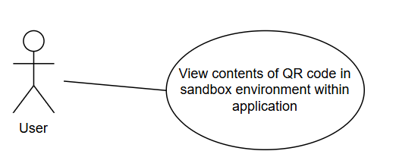

# Use Case Description

# 

| **Use Case Name:** | View contents of QR code in sandbox environment | **Use Case ID:**#TC-008 |
| --- | --- | --- |
| **Pre-Condition(s):** | Have already scanned a valid QR code | |
| **Actor:** | User | |
| **Description:** | As a user, I want to be able to open the link in a sandbox environment within the application, so I can safely view the content without being exposed to suspicious content. | |
| **Normal Flow:** | 1. Application will open the link in a sandbox environment within application 2. Contents of the link will be displayed | |
| **Alternate Flow:** | Application will show an error message if the contents of the link cannot be loaded. | |

## 

## 2.3.6 Use Case Diagram

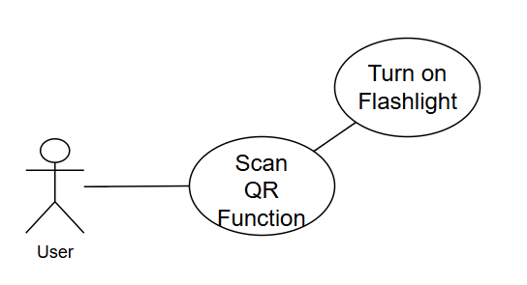

# Use Case Description

# 

| **Use Case Name:** | Turn on Flashlight when scanning QR Code | **Use Case ID:** #TC-009 |
| --- | --- | --- |
| **Pre-Condition(s):** | In a bad lighting environment | |
| **Actor:** | User | |
| **Description:** | As a user, I want to be able to scan QR code in a bad lighting environment | |
| **Normal Flow:** | 1. Go to Scan QR function 2. Press the flashlight button to turn on flashlight | |
| **Alternate Flow:** | - | |

## 

## 

## 2.3.7 Use Case Diagram

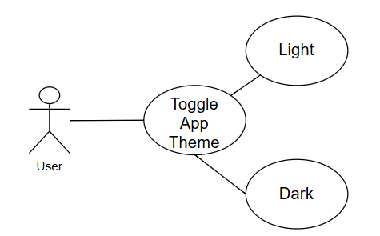

# Use Case Description

# 

| **Use Case Name:** | Toggle App Theme | **Use Case ID:** #TC-010 |
| --- | --- | --- |
| **Pre-Condition(s):** | - | |
| **Actor:** | User | |
| **Description:** | As a user, I want to be able to choose between light or dark mode within the application so that I can adjust the display for optimal viewing comfort. | |
| **Normal Flow:** | 1. Go to Settings 2. User can make the option to toggle “Dark mode” on app | |
| **Alternate Flow:** | - | |

## 

## 

## 

## 

## 

## 

## 

## 

## 

## 

## 

## 2.3.8 Use Case Diagram

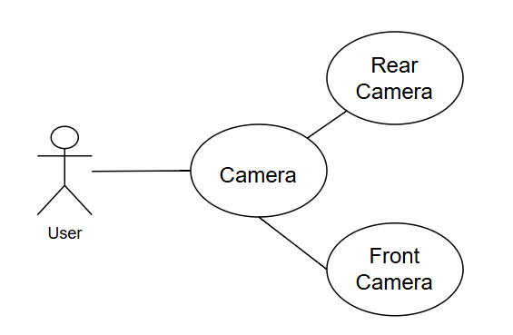

# Use Case Description

# 

| **Use Case Name:** | Flip to front camera | **Use Case ID:** #TC-011 |
| --- | --- | --- |
| **Pre-Condition(s):** | User must be at the scan QR scanner page | |
| **Actor:** | User | |
| **Description:** | As a user, I want to have the option to use either a front or rear camera to scan QR code. In the event that one of the cameras breaks down, I still can use the other one. | |
| **Normal Flow:** | 1. Go to Scan QR function 2. Tap the on camera icon to switch camera | |
| **Alternate Flow:** | - | |

## 

## 

## 

## 

## 

## 

## 

## 

## 

## 

## 2.3.9 Use Case Diagram

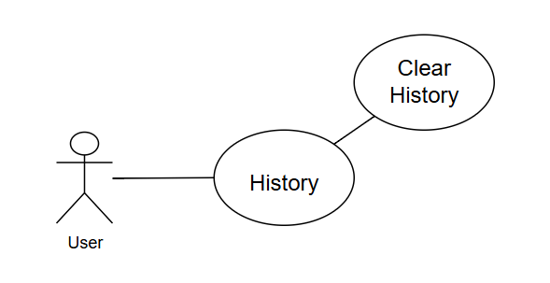

# Use Case Description

# 

| **Use Case Name:** | Clear History | **Use Case ID:** #TC-012 |
| --- | --- | --- |
| **Pre-Condition(s):** | User must be at the History page | |
| **Actor:** | User | |
| **Description:** | As a user, I want to be able to clear the search history of QR codes that were scanned before. | |
| **Normal Flow:** | 1. Go to “History” page 2. Tap on the “Click history” icon | |
| **Alternate Flow:** | - | |

## 

## 

## 

## 

## 

## 

## 

## 

## 

## 

## 

## 

## 

## 

## 2.3.10 Use Case Diagram

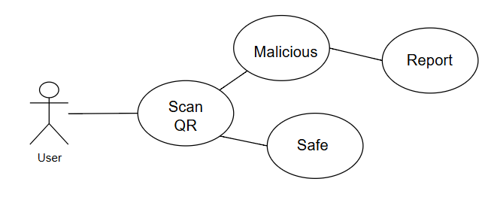

# Use Case Description

# 

| **Use Case Name:** | Report Malicious Link | **Use Case ID:** #TC-013 |
| --- | --- | --- |
| **Pre-Condition(s):** | Reporting button is only available when the scanned result is marked as malicious | |
| **Actor:** | User | |
| **Description:** | As a user, after knowing that the QR code I scanned is malicious, I want to report it to the relevant authorities so that further actions can be taken. | |
| **Normal Flow:** | 1. Scan QR code 2. Result came out and it is malicious 3. Tap on the “Report This Scam” | |
| **Alternate Flow:** | - | |

## 

## 2.3.11 Use Case Diagram

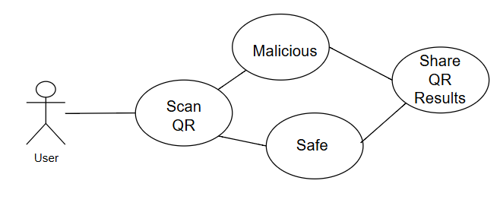

# Use Case Description

# 

| **Use Case Name:** | Share QR Results | **Use Case ID:** #11 |
| --- | --- | --- |
| **Pre-Condition(s):** | Have a scanned result. | |
| **Actor:** | User | |
| **Description:** | As a user, I want to share the scanned QR results to my friends and family. So that they are able to know what is safe and what to be cautious. | |
| **Normal Flow:** | 1. Scan QR 2. Receive Result 3. Click on “Share results” to share the scanned QR results via messenger/email | |
| **Alternate Flow:** | - | |

## 

## 2.5 User Activity Diagram

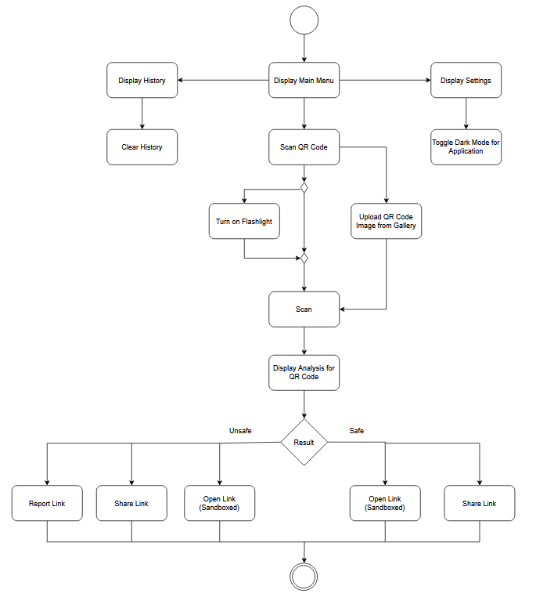

## 2.6 Sequence Diagram

**Scan QR Code**

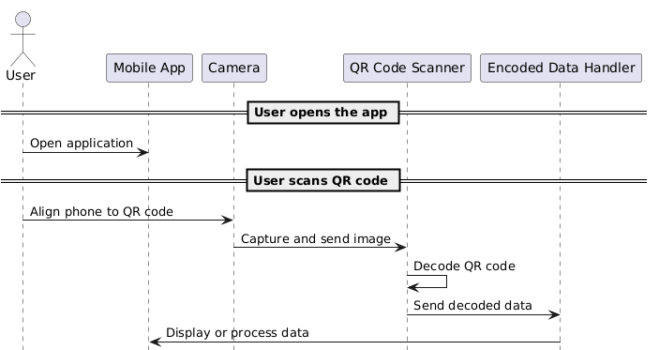

**Scan QR Code from photo library**

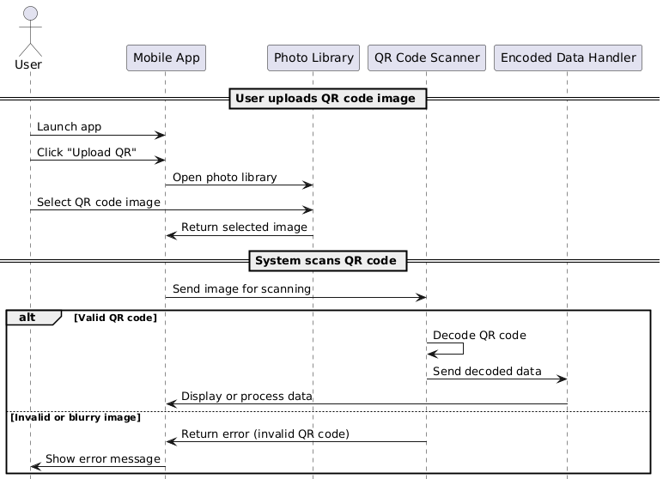

**View History**

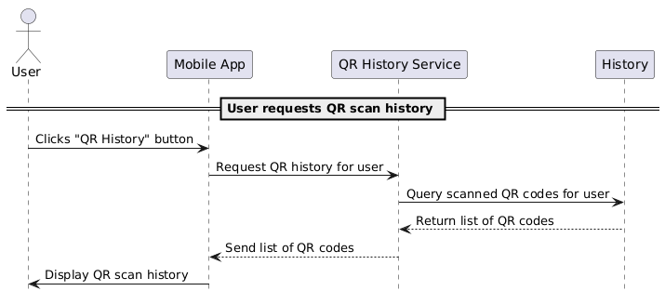

**Action to take if QR Code is malicious**

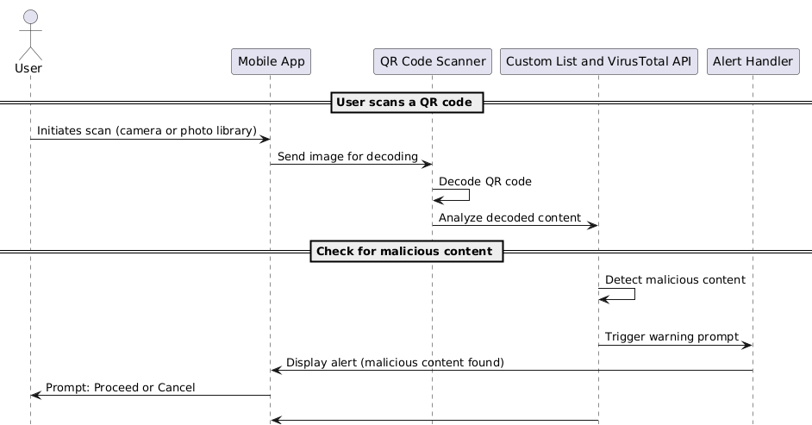

**View contents of scanned QR within Sandbox Environment**

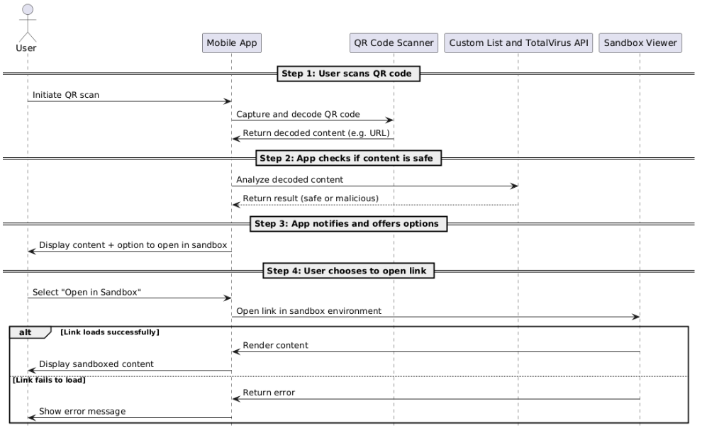

**Turning on Flashlight**

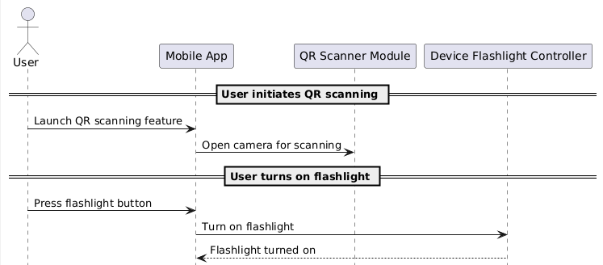

# 

# 

# 

# 

# 

# 

# 

# 

# 

# 

# 

# 

# 

# 

# 

# 

# 

# 

# 

# 

# 

# 

# 

# 

# **Turning on Flashlight**

# 

# 

# 

# 

# 

# 

# 

# 

# 

# 

# 

# 

# 

# 

# 

# 

# 

# 

# 

# 

# 

# **Switching between front and rear cameras**

# 

# 

# 

# **Clearing Scanned History**

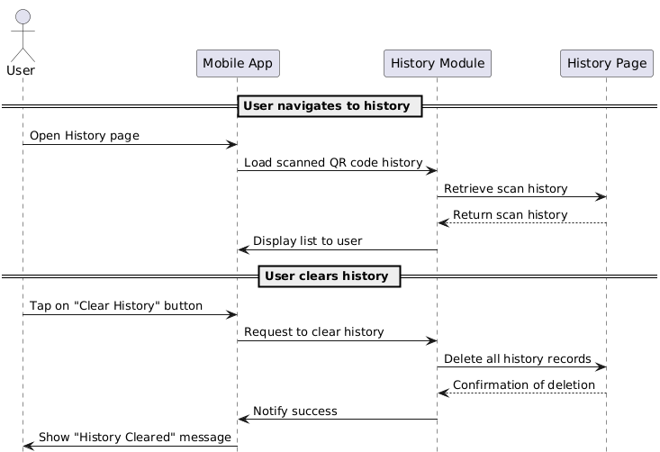

# 

# 

# 

# 

# 

# 

# 

# 

# 

# 

# 

# 

# 

# 

# 

# 

# **Reporting Malicious Link/QR**

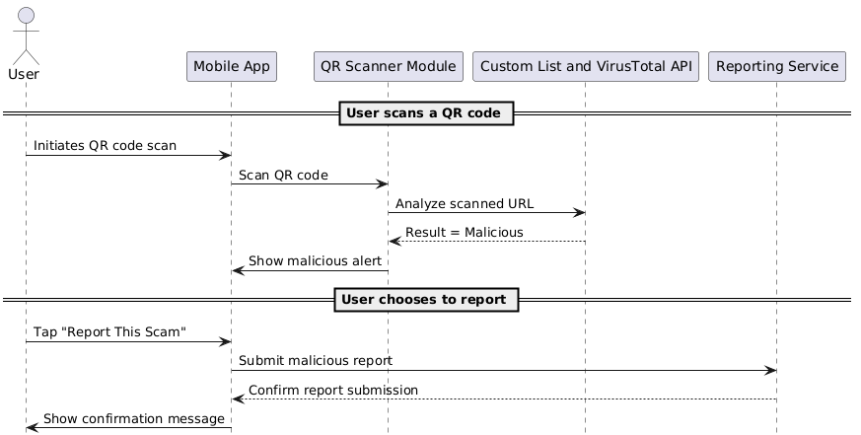

# 

# **Share Scanned QR Results**

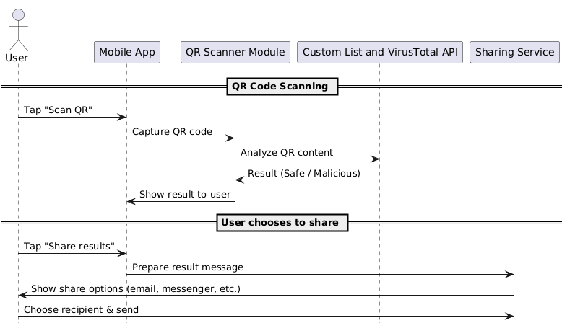

# Wireframes

The wireframes in this document serve as a preliminary UI design to the design and structure of the final application. These wireframes are not final and are subjected to changes based on updates on functions, as well as user feedbacks and technical considerations.

**Preliminary Wireframe**

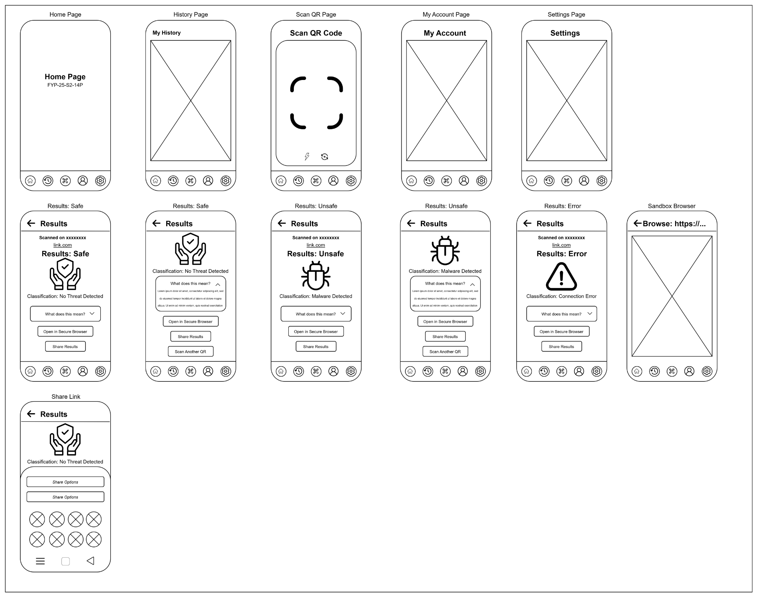

**Final Design Wireframe**

# 

# Interface Design

This section displays the final design of the SafeQR application, emphasizing the actual user interface of the completely created product. The pictures below depict the main displays and features that users will engage with during their experience.

The User Manual provides thorough instructions on how to use all of the app's features. It contains step-by-step instructions, useful hints, and detailed descriptions of each interface and capability, ensuring that users can take full advantage of the application's capabilities.

Home Page, History Page:

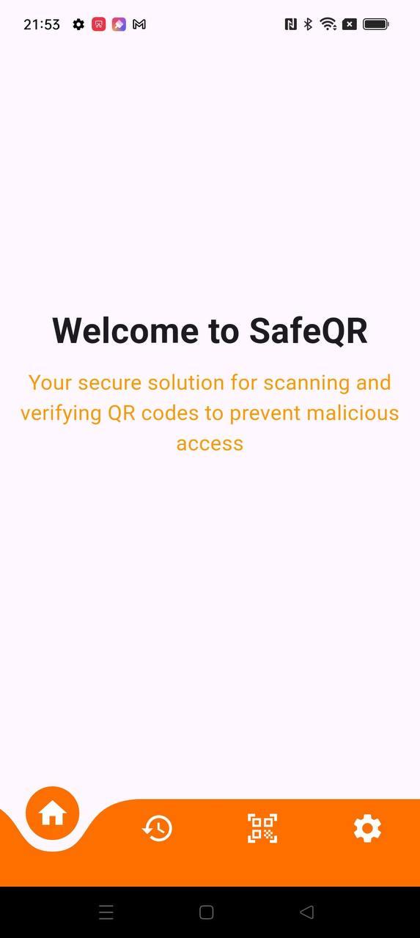

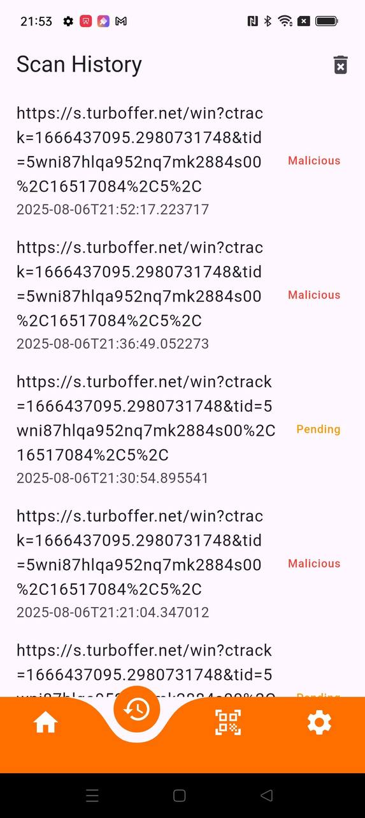

Results, Safe:

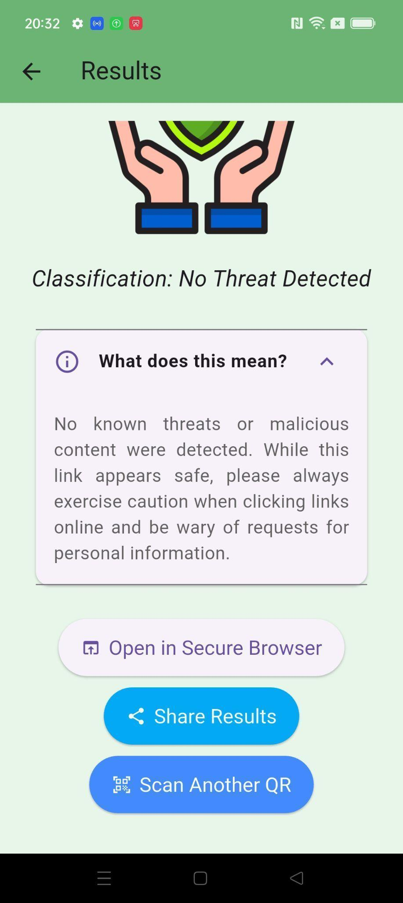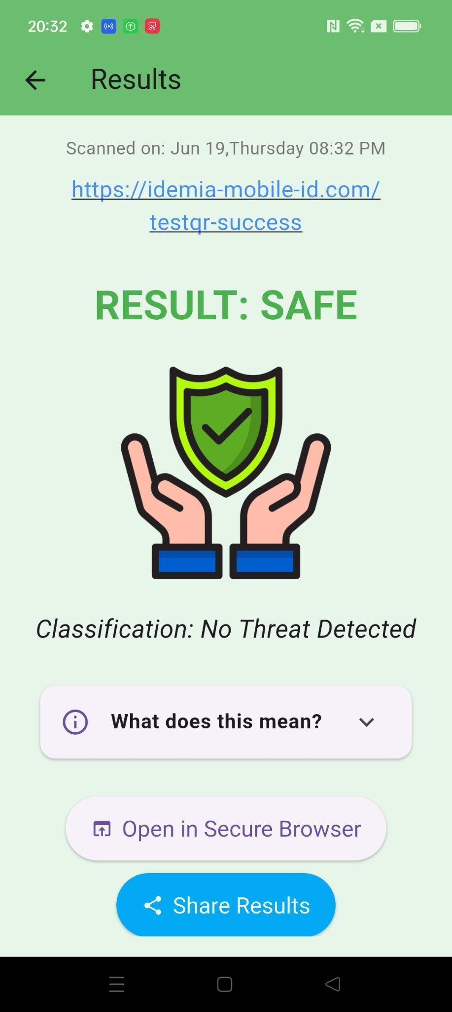

Results, Unsafe, Error:

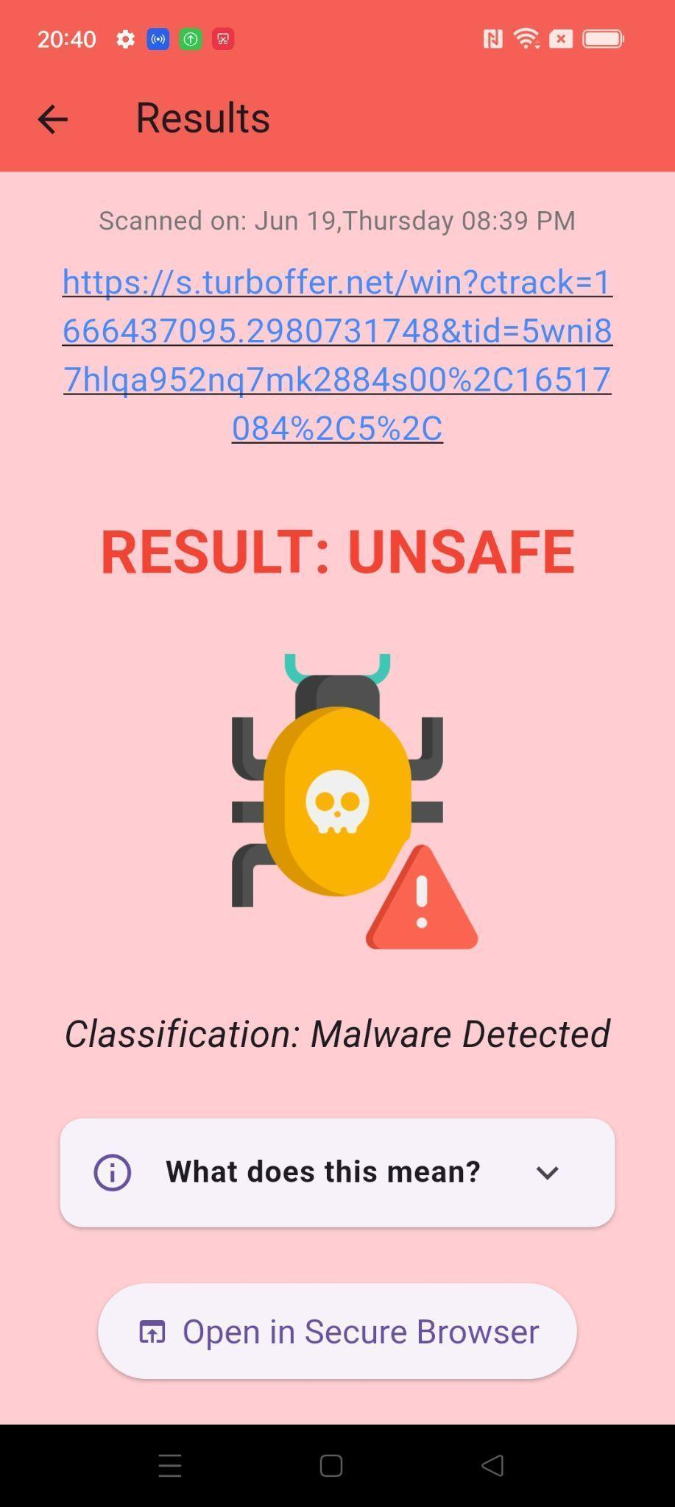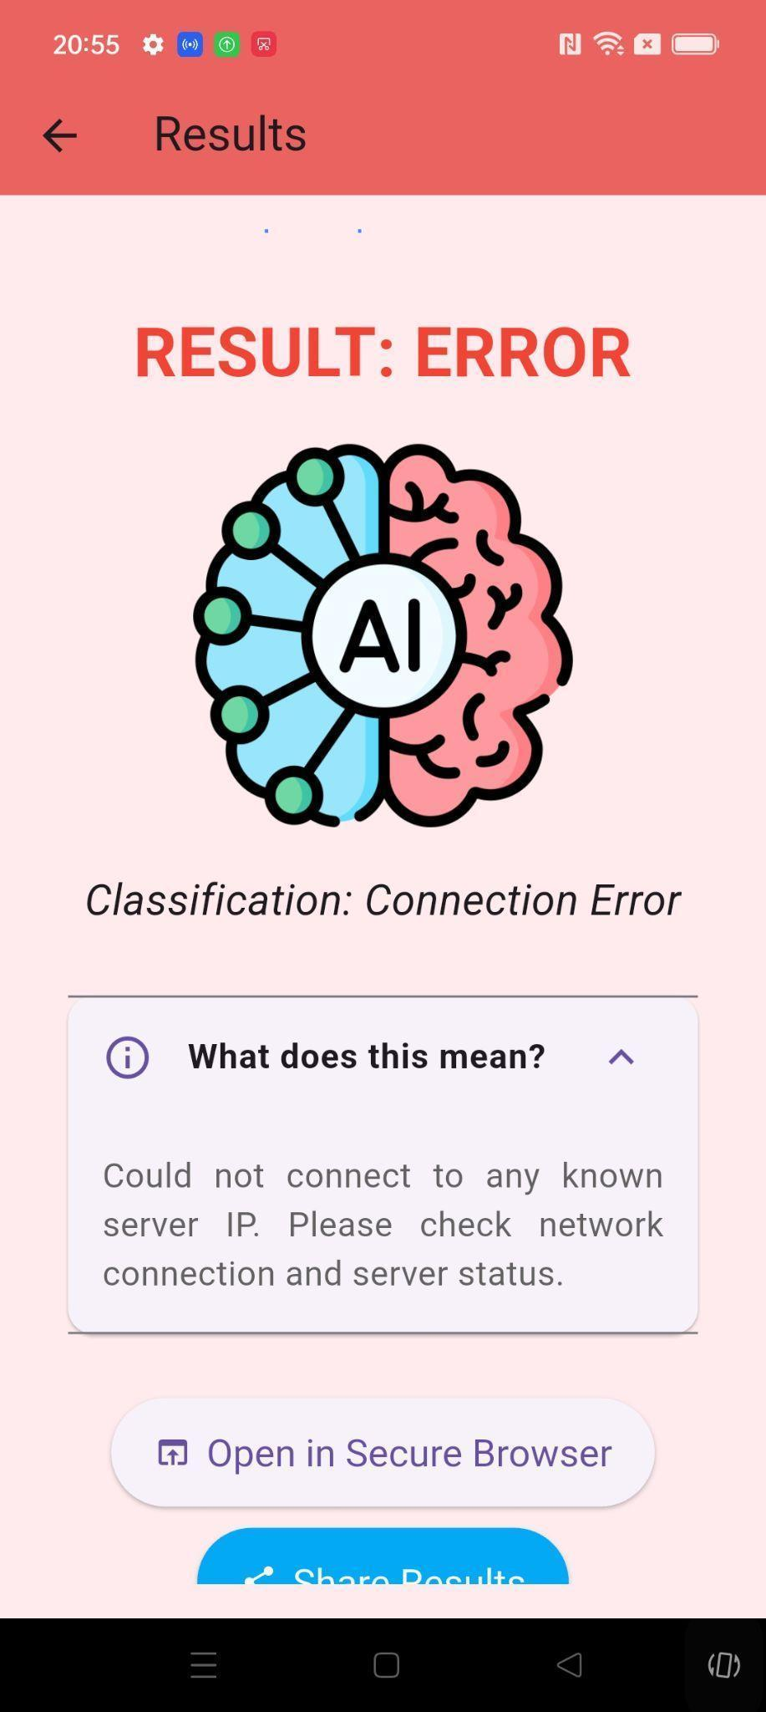

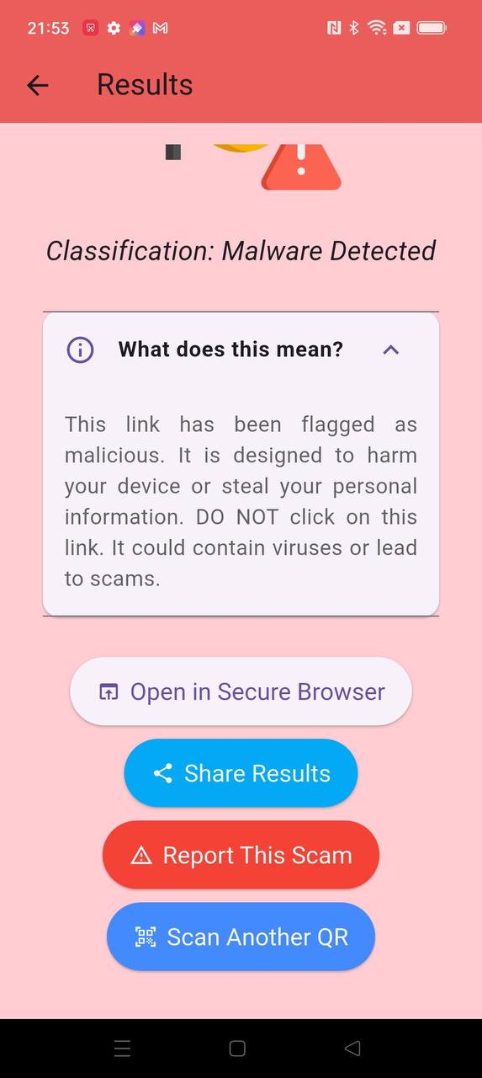

# Testing

## 5.1 Test Objective

**Objective**: The primary goal of this test plan is to assess and validate the functionalities and features of the Safe QR application modules.

**This includes**: Ensuring all features perform according to specified requirements with a strong focus on security protocols. Identifying, documenting, and resolving any security vulnerabilities, bugs, or areas for improvement to prevent malicious code exploitation.

**Expected Outcome**: A Safe QR application that is thoroughly vetted for security and functionality, ready for production use.

## 5.2 Test Cases



# Backend APIs

**VirusTotal API integration**

Purpose

* The API is used to analyze URLs extracted from QR codes against VirusTotal's massive database of known malware, phishing sites, and other cyber threats.
* It provides a **first layer** of security screening before additional checks (like the custom AI model).

Key Features of VirusTotal API

1. URL Scanning
   1. The backend (Flask server) sends the extracted URL to VirusTotal's /urls/scan or /urls/report endpoint
   2. VirusTotal checks the URL against:
      1. 70+ antivirus engines (e.g., Kaspersky, McAfee, Symantec)
      2. Web reputation databases (phishing, scam, malicious hosting)
      3. Historical scan results (if the URL was previously analyzed)
2. Threat Intelligence
   1. Returns a comprehensive report with:
      1. Detection ratio (out of how many engines flagged this as malicious)
      2. Threat categories (malware, phishing, spam, etc)
      3. Timestamp of last analysis
3. Rate Limits & Caching
   1. VirusTotal’s free tier has rate limits (eg. 500 requests/day, 4 requests/min)
   2. Flask backend caches results to avoid redundant API calls for same URL
4. Response Handling
   1. The backend parses VirusTotal’s JSON response to classify the URL as
      1. Safe (0 detections)
      2. Suspicious (low detection rate or mixed reputation)
      3. Malicious (high detection rate)
      4. Error (invalid URL or API failure)

**Custom List**

Purpose

* Acts as an additional first-line blacklist to detect malicious domains
* Help conserve VirusToal API calls by pre-filtering URLs against a trusted community-maintained threat list

Key Features of Custom List

1. URL Checking
   1. When the URL is extracted from a QR Code, it is first checked against the blacklist.txt blacklist file.
   2. If the domain matches the blacklist, the URL is immediately flagged as Malicious and VirusToal API Call is skipped
   3. If not found in blacklist, proceed with VirusTotal scanning
2. Caching
   1. Results from Custom List and VirusTotal checks are cached for efficient repeated lookups

# System Architecture

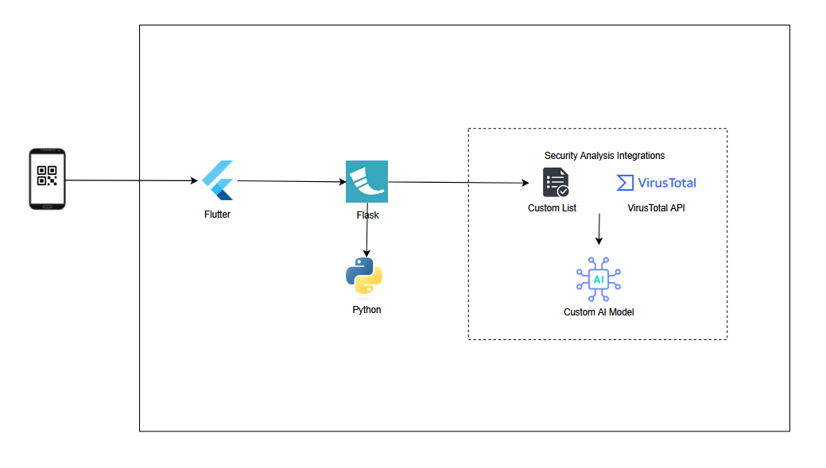

## 

## 7.1. Technical Design Considerations

1. Operational Effectiveness:

Operational effectiveness emphasizes consistency in execution and the smooth functioning of deployed systems. It focuses on clear process ownership, automation of repetitive workflows, and rapid incident detection.

To maintain high standards, systems should integrate health checks, auto-recovery mechanisms, and automated deployment pipelines. Regular evaluations and iterative refinements ensure alignment with evolving technical and business needs.

1. Security:

Securing applications and infrastructure is critical to protecting user trust and maintaining system integrity. This involves enforcing strong access controls, safeguarding data through encryption and deploying detection tools for potential threats.

A sound security approach uses defense-in-depth strategies, it combines authentication, logging, auditing and regular vulnerability assessments. These minimise attack surfaces and respond swiftly to anomalies.

1. Economic Efficiency

Optimising for cost ensures that the system delivers value without unnecessary spendings. This includes having sufficient compute instances, avoiding idle resource allocation, and leveraging cost-effective managed services.

Proactive cost reviews and usage analytics help identify inefficiencies and opportunities for automation to further reduce operational overhead.

# Technology Used

Our QR Malware Detection project leverages a combination of robust software and frameworks across its development, frontend, backend, and security analysis integrations:

## 8.1 Development Environment

Android Studio: The integrated development environment (IDE) primarily used for building, debugging, and running the Flutter-based cross-platform application, especially when targeting Android devices and emulators.

## 

## 8.2 Frontend Application

Flutter: A Google-developed UI toolkit enabling the creation of natively compiled, cross-platform applications from a single codebase. This ensures a consistent and seamless user experience for the QR code scanning, analysis results display, and secure browsing features [cite: image_7aad83.png].

Dart: The programming language used for Flutter development.

Core Flutter Packages:

http: For making network requests to the Flask backend and external APIs.

intl: For internationalization, specifically used for formatting dates and times.

webview_flutter: For embedding a web browser (secure sandbox) directly within the application to view URLs.

share_plus: For enabling users to share analysis results easily.

## 8.3 Backend Server

Flask: A lightweight and flexible Python web framework that serves as the project's backend. It handles incoming API requests from the Flutter app, orchestrates the URL analysis process by communicating with external services, and provides results back to the frontend [cite: image_7aad83.png].

Python: The primary programming language for all backend logic, including API integrations, data processing, and the AI model (or its placeholder).

Python Libraries:

requests: For making HTTP requests to external services like VirusTotal.

python-dotenv: For securely loading environment variables (like API keys) from a .env file.

json: For handling JSON data parsing and serialization.

time: For managing time-related operations (e.g., timestamps in the analysis cache).

Security Analysis Integrations

VirusTotal API: A critical component for the initial and extensive layer of URL detection. The backend server queries VirusTotal to scan URLs against a vast repository of antivirus engines and website scanners for known threats [cite: image_7aad83.png].

Custom AI Model (Current State: Placeholder Logic):

Your project incorporates an "AI model for a second layer of detection" [cite: image_7aad83.png].

Currently, the AI model's functionality in server.py is implemented using placeholder string-matching logic. This means it classifies URLs based on whether the literal terms "malicious" or "suspicious" are present within the URL string itself (e.g., if "malicious" in url.lower():).

# References

<https://docs.virustotal.com/reference/overview>

<https://flask.palletsprojects.com/en/stable/>

<https://www.geeksforgeeks.org/python/how-to-run-a-flask-application/>

<http://flutter.dev/>

<https://cert.pl/en/warning-list/>

# 