 

School of Computer Science & Software Engineering

Bachelor of Computer Science (Digital Systems Security)

CSCI321 - Project

**Project Requirement**

Group: FYP-25-S2-14P

Zikry Bin Affendi 8380338 zba505@uowmail.edu.au

Tan Zhi Qin 8259240 zqt072@uowmail.edu.au

Muhammad Hannan Azman 8220852 mha986@uowmail.edu.au

Wong Xin Yang 8497035 xyw523@uowmail.edu.au

Ernest Yeo Jun Long 8535139 ejly205@uowmail.edu.au

Supervisor: Tian Sion Hui

Assessor: Japit Sionggo

# Document Control

### Title: Project Requirement

### Document Name: FYP-25-S2-14P_ProjReqms

| **Owner** | **Current Version** | **Last Change on** | | **Approved by** |
| --- | --- | --- | --- | --- |
| **Date** | **Time** |
| Zikry | Ver 1.0 | 9 May 2025 | 06:00 pm | pending |

**Distribution List**

| **Name** | **Title/Role** | **Where** |
| --- | --- | --- |
|  |  |  |
|  |  |  |
|  |  |  |
|  |  |  |
|  |  |  |
|  |  |  |
|  |  |  |
|  |  |  |
|  |  |  |

**Record of Revision**

| **Revision Date** | **Description** | **Section Affected** | **Changes Made by** | **Version after Revision** |
| --- | --- | --- | --- | --- |
|  |  |  |  |  |
|  |  |  |  |  |
|  |  |  |  |  |
|  |  |  |  |  |
|  |  |  |  |  |
|  |  |  |  |  |
|  |  |  |  |  |
|  |  |  |  |  |
|  |  |  |  |  |
|  |  |  |  |  |
|  |  |  |  |  |
|  |  |  |  |  |
|  |  |  |  |  |
|  |  |  |  |  |
|  |  |  |  |  |

**Contents**

1. **Introduction 4**
2. **Project Description 4**
   1. Background 4
   2. Research 5
   3. Objectives 5
   4. Identified Stakeholders / Users 6
3. **Our Solution 6**
   1. Functional Requirements 6
   2. Non-Functional Requirements 7
   3. Core Features of Application 7
4. **User Stories 8**
   1. Use Case Diagram 8-17
   2. Use Case Description 8-17
5. **Scope and Problem of Limitation 17**
6. **Project Planning 18**
   1. Development Method 18
   2. Roles and Responsibilities 19
   3. Timetable 20-22
7. **Appendix 23**

# Introduction

The increasing reliance on QR codes for tasks such as accessing online content and making transactions has brought an increase in security challenges. Cybercriminals tend to leverage on these to carry out harmful attacks such as phishing, malware distribution and data theft. These vulnerabilities highlight to us the utmost need for a secure way to handle QR interactions.

The main objective of this project is to introduce user-friendly mobile application designed to strengthen security when interacting with QR codes. Our team’s main goal is to protect the users by identifying suspicious content, preventing unauthorized access, and ensuring safe digital interactions.

This documentation outlines the project’s context, goals and structure. It defines how our SafeQR project needs to succeed, outlining how the requirements support its development. Additionally, it details how information is structured and used throughout the project, offering stakeholders a transparent view of its progress, direction, key use cases, and lastly, the business analysis behind it.

# Project Description

**Background**

QR (Quick Response) codes are gaining popularity across various industries due to being convenient and multi-purpose. They can be found in areas such as mobile payments, contactless menus, application downloads, and business promotions. Due to such rapid and widespread use of QR Codes, it introduces new cybersecurity concerns too. QR codes, unlike URLs, are not readable and evaluated before scanning, allowing attackers to embed malicious intents into the QR codes. QR Codes have also skyrocketed during the COVID-19 pandemic as businesses and governments pushed for touchless interactions.

Despite these risks, most QR scanning applications aim to focus on functionality and speed, neglecting user safety. They do not provide any way for users to know what the purpose of the QR code is, until they open it. This leaves users vulnerable, especially those unfamiliar with the risks of QR Codes.

This project aims to solve these issues by building Safe QR, a mobile application which prioritises security features such as QR payload inspection, sandboxed browsing, and malicious link detection. These features would ensure that users are protected when scanning any QR codes.

**Research**

The team has done some research on existing secure QR code applications that are available in the market. This allows us to have a base idea on what our end goals are, making it relevant for our final year project.

1. **Trendmicro QRSCanner** - a QR scanner application designed to enhance user security when scanning QR codes.

Key features:

* **Versatile Scanning Options:** It supports scanning from both the live camera and saved images, accommodating various user needs
* **Barcode Scanning:** Beyond QR codes, the app can scan barcodes, facilitating quick searches for product information
* **Support for Various Data Types:** The scanner recognizes QR codes containing text, contact information, Wi-Fi credentials, and location data

1. **Dhiway SEQR Scanne**r - a security-focused QR code scanning application designed to ensure safe and informed interactions with QR codes

Key features:

* **Versatile Scanning Capabilities:** app supports scanning various QR code types, including those related to payment, websites, advertisement, products, contacts, telephone numbers and location maps.
* **User Privacy and Local Scan History:** privacy friendly approach, maintaining a searchable activity log that can stores scan history and basic metadata locally on the user’s device

**Objectives**

Our main goal is to develop an application which is called SafeQR that ensures the integrity and safety of data transmitted via QR codes. This involves creating a user-friendly yet robust QR code scanning system that is embedded with security features.

Apart from that, the team conducted extensive research on several topics pertaining to QR code technology. This includes risk assessment of QR codes, encryption techniques, authentication methods, and ways to develop an application. Therefore, we aim to work towards this goal by improving our solution to keep with new security threats and by making it easier to work with other QR scanning apps.

**Identified Stakeholders / Users**

| **Stakeholder** | **Role** | **Interest/Responsibility** |
| --- | --- | --- |
| Project Team (Developers) | Responsible for planning, designing, coding, testing, and deploying the Safe QR app. | Ensure the system meets functional and security requirements, and is delivered on time. |
| Tian Sion Hui (Supervisor) | Provides guidance and feedback throughout the project lifecycle. | Provides academic guidance, monitors objectives, and reviews project progress |
| Japit Sionggo (Assessor) | Evaluates the final deliverable, report, and presentation of the FYP. | Assesses project’s quality, innovation and technical understanding |
| End Users | General mobile users who will use to application to scan and verify QR codes | Expect a secure, user-friendly application that protects them from QR-based threats |

**Our Solution**

**Functional Requirements**

1. **Scanning of QR Code**: The application would have the feature to either scan QR code from the users’ camera phone or via uploading from the phone’s photo library
2. **Checking the QR codes’ contents for suspicious/malicious patterns**: The application would analyse the contents embedded URL link of the scanned QR code and alert the user via the application if malicious contents were to be found.
3. **Sandboxing Environment**: The application would have the option to open the URL link of the QR code in a safe environment within the application. This would allow the users to preview the contents before making the decision to proceed without having to compromise on their security.

**Non-Functional Requirements**

1. **Application Performance**: Our application to be efficient and responsive when analyzing the QR code so that users can experience minimal latency.
2. **Reliability**: SafeQR makes sure the scan results are trustworthy and the data stays intact. Every time you scan a QR code, the app uses strong verification methods to give you accurate and reliable information. It also provides real-time updates and clear feedback, helping you make smart decisions based on what the scan finds.
3. **Security**: SafeQR puts data security first during every scan. It uses encryption to keep information safe from online threats, and adds extra layers like authentication and access control to protect your personal details. With this strong security setup, data stays private and secure., helping to make smart decisions based on what the scan finds.
4. **Usability**: SafeQR is built with a clean, easy-to-use interface that follows common design practices. It's designed to be simple and straightforward, so users can navigate and scan QR codes without any confusion or hassle.
5. **Scalability**: SafeQR is built to grow with its users. As more people use the app and the amount of data increases, it continues to run smoothly without any lag. Its structure is set up in a way that can handle more activity over time, making sure the app stays quick and reliable no matter how much it's being used

**Core Features of Application**

1. Scanning of QR code using phone camera/uploading from photo library to perform checking on content
2. Sandbox environment within the application to preview content of links
3. User Profiles
4. Viewing of past histories scanned
5. Save QR codes scanned
6. Getting warning alerts from application if malicious content were to be present from links

**User Stories**

# User

As a user, I want to create an account in the application so that I will have an account to access the application.

As a user, I want to login using my account so that I can use the features in the application.

As a user, I want to be able to logout from my account when I wish to end the application session.

As a user, I want to be able to update my account so I can input up-to-date personal details.

As a user, I want to be able to delete my account so that I can no longer get notifications from the application.

As a user, I want to scan the QR code with my phone camera to quickly access the encoded information.

As a user, I want to upload QR code from my phone’s photo library.

As a user, I want to be able to save QR codes that I have scanned, so that I can view them easily in the future.

As a user, I want to be able to view the past histories of QR codes scanned, so I would have a list of records for my future reference.  
As a user, I want the application to provide me with precautions if the scanned QR code is flagged as having malicious content.

As a user, I want to be able to open the link in a sandbox environment within the application, so I can safely view the content without being exposed to suspicious content.

# Use Case Diagram

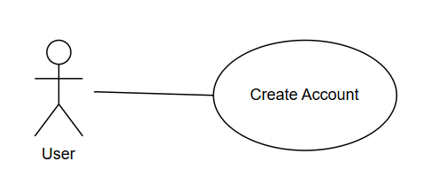

# Use Case Description

# 

| **Use Case Name:** | Create Account | **Use Case ID:** #1 |
| --- | --- | --- |
| **Pre-Condition(s):** | A working database must be present | |
| **Actor:** | User | |
| **Description:** | As a user, I want to login using my account so that I can use the features in the application. | |
| **Normal Flow:** | 1. On the main page of the application, user will click on the “Create An Account” button 2. User will be redirected to another page to input their personal details and click on “Submit” button. | |
| **Alternate Flow:** | An error message will be displayed if user were to input invalid information | |

# 

# Use Case Diagram

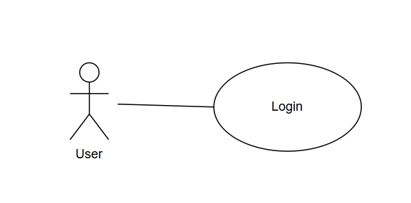

# Use Case Description

# 

| **Use Case Name:** | Account Login | **Use Case ID:** #2 |
| --- | --- | --- |
| **Pre-Condition(s):** | A valid account in the system | |
| **Actor:** | User | |
| **Description:** | As a user, I want to login using my account so that I can use the features in the application. | |
| **Normal Flow:** | 1. On the login page of the application, user input their username and password and click on “Login” button 2. System checks if the account is valid or exists. 3. System will then display the features of the application. | |
| **Alternate Flow:** | An error message will be displayed if the user entered the wrong password or username. (Or even the username does not exist.) | |

# 

# Use Case Diagram

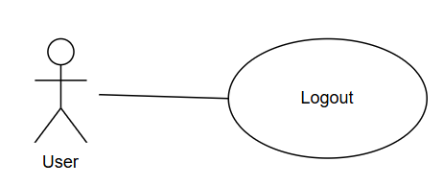

# Use Case Description

# 

| **Use Case Name:** | Account Logout | **Use Case ID:** #3 |
| --- | --- | --- |
| **Pre-Condition(s):** | An account which has already been logged in | |
| **Actor:** | User | |
| **Description:** | As a user, I want to be able to logout from my account when I wish to end the application session. | |
| **Normal Flow:** | 1. On the top navigation bar, user click “Logout” button 2. System will then redirect user to login page | |
| **Alternate Flow:** |  | |

# 

# Use Case Diagram

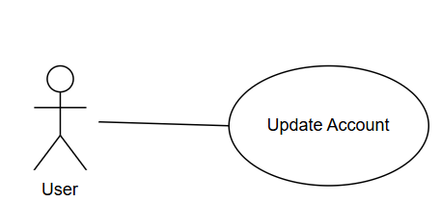

# Use Case Description

# 

| **Use Case Name:** | Update Account | **Use Case ID:** #4 |
| --- | --- | --- |
| **Pre-Condition(s):** | An account which has already been logged in | |
| **Actor:** | User | |
| **Description:** | As a user, I want to be able to update my account so I can input up-to-date personal details. | |
| **Normal Flow:** | 1. On the top navigation bar, user click “My Account” 2. On the user’s account page, user click on “Update Account” button. 3. Lastly, user click “Save” button | |
| **Alternate Flow:** |  | |

# 

# 

# Use Case Diagram

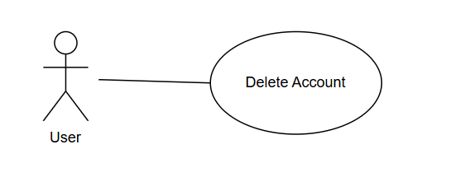

# Use Case Description

# 

| **Use Case Name:** | Delete Account | **Use Case ID:** #5 |
| --- | --- | --- |
| **Pre-Condition(s):** | An existing account and user must login to that account | |
| **Actor:** | User | |
| **Description:** | As a user, I want to be able to delete my account so that I can no longer get notifications from the application. | |
| **Normal Flow:** | 1. On the navigation bar, user clicks “My Account” button 2. System will redirect user to the account page 3. User clicks on “Delete My Account” 4. System will wipe out the particular account | |
| **Alternate Flow:** | - | |

# 

# Use Case Diagram

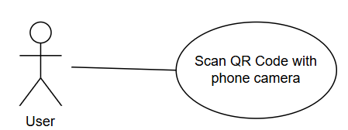

# Use Case Description

# 

| **Use Case Name:** | Scan QR code with phone camera | **Use Case ID:** #6 |
| --- | --- | --- |
| **Pre-Condition(s):** | User must successfully login to the account | |
| **Actor:** | User | |
| **Description:** | As a user, I want to scan the QR code with my phone camera to quickly access the encoded information | |
| **Normal Flow:** | 1. User login to account 2. On the main page after successful login, user aligns phone camera to the QR code | |
| **Alternate Flow:** | - | |

# 

# 

# Use Case Diagram

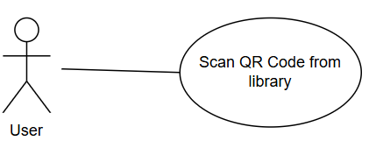

# Use Case Description

# 

| **Use Case Name:** | Upload QR code from photo library | **Use Case ID:** #7 |
| --- | --- | --- |
| **Pre-Condition(s):** | User must successfully login to the account | |
| **Actor:** | User | |
| **Description:** | As a user, I want to upload QR code from my phone’s photo library. | |
| **Normal Flow:** | 1. User login to account 2. On the main page after successful login, user clicks on “Upload QR” 3. User selects the QR code from photo library 4. System will scan QR code that the user chose | |
| **Alternate Flow:** | If the user chose an invalid image - for example a blurry QR code image or an image which is not a QR code | |

# 

# 

# Use Case Diagram

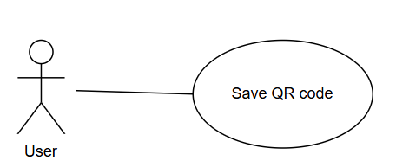

# Use Case Description

# 

| **Use Case Name:** | Save QR code | **Use Case ID:** #8 |
| --- | --- | --- |
| **Pre-Condition(s):** | User must successfully login to the account  User must scan the QR code either by phone camera or selecting from photo library | |
| **Actor:** | User | |
| **Description:** | As a user, I want to be able to save QR codes that I have scanned, so that I can view them easily in the future. | |
| **Normal Flow:** | 1. User scans the QR code and the system will redirect and display the contents in a sandbox environment. 2. User clicks on “Save This QR” button | |
| **Alternate Flow:** | If the QR code contains malicious/suspicious contents, the system will prompt the user to confirm if the user wants to proceed to explore contents from the link. | |

# 

# 

# Use Case Diagram

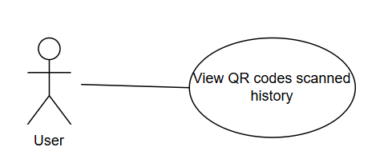

# Use Case Description

# 

| **Use Case Name:** | View QR codes scanned history | **Use Case ID:** #9 |
| --- | --- | --- |
| **Pre-Condition(s):** | User is already logged in to account  Have already scanned QR codes before | |
| **Actor:** | User | |
| **Description:** | As a user, I want to be able to view the past histories of QR codes scanned, so I would have a list of records for my future reference | |
| **Normal Flow:** | 1. On the main page, user clicks “QR History” button 2. System will retrieve a list of QR codes that user have scanned in the past | |
| **Alternate Flow:** | - | |

# 

# 

# 

# Use Case Diagram

# 

# 

# 

# 

# Use Case Description

# 

| **Use Case Name:** | Actions to take if QR codes contains malicious contents | **Use Case ID:** #10 |
| --- | --- | --- |
| **Pre-Condition(s):** | The contents of the QR code scanned has to be malicious | |
| **Actor:** | User | |
| **Description:** | As a user, I want the application to provide me with precautions if the scanned QR code is flagged as having malicious content. | |
| **Normal Flow:** | 1. User scans QR code from phone camera or photo library 2. System will flag the content of the QR codes to be malicious | |
| **Alternate Flow:** | Invalid QR code | |

# 

# Use Case Diagram

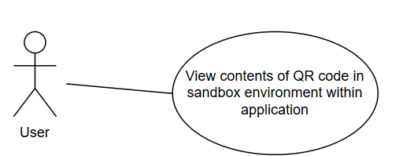

# Use Case Description

# 

| **Use Case Name:** | View contents of QR code in sandbox environment within applicationhistory | **Use Case ID:** #11 |
| --- | --- | --- |
| **Pre-Condition(s):** | Have already scanned a valid QR code | |
| **Actor:** | User | |
| **Description:** | As a user, I want to be able to open the link in a sandbox environment within the application, so I can safely view the content without being exposed to suspicious content. | |
| **Normal Flow:** | 1. Application will open the link in a sandbox environment within application 2. Contents of the link will be displayed | |
| **Alternate Flow:** | Application will show an error message if the contents of the link cannot be loaded. | |

# 

## Scope and Problems of Limitation

**Technology Access and Integration**:  
One potential issue we’ve identified is the need for specific technologies or services for security checks, like APIs for real-time URL safety scans. Some of these services may require premium access, and if we don’t have access to the necessary resources, it could slow things down. To overcome this, we’ll research and implement free or open-source alternatives where possible, or look for collaboration opportunities with platforms that can provide the needed resources.

**Device Compatibility**:  
Since the app will be running on different Android devices, there might be cases where certain older or lower-end models don’t fully support the features we’re implementing, such as advanced encryption methods or high-quality QR scanning. To mitigate this, we’ll prioritize testing on a range of devices but focus mainly on the latest versions of Android to ensure broad compatibility.

**Real-Time Data Processing**:  
The process of scanning and verifying QR codes in real time can sometimes be resource-heavy, especially when the network is slow or unreliable. While we plan to optimize the code for speed, there’s always the chance that slower internet connections may affect performance. We will handle this by implementing offline functionality where the app can store results locally and update once a connection is reestablished.

# Project Planning

## Development Method

Our team has chosen to adopt the Agile/Scrum development methodology to manage our project. Agile is well-suited for our team structure as we are part-time students with full-time jobs, and it lets us break down development into sprints with clearly defined sprint goals. We can then work on our tasks independently as long as it’s done by the end of the sprint, which accommodates our varying schedules.

We are managing our tasks, backlogs, and sprints using Jira, which supports Agile workflows and provides clear visibility into project progress and responsibilities. Documentation is stored in Google Drive using clearly labelled folders, ensuring easy access and collaboration across the team. Github is also used for version control and code management, which is integrated with Jira.

We have set the sprint length to be 2 weeks.

To meet the objectives of our project, we will:

* Conduct planning sessions at the start of each sprint.
* Break down user stories into actionable tasks and assign them in Jira.
* Track progress using Kanban and sprint boards in Jira.
* Hold regular check-ins asynchronously (weekly) and synchronously (bi-weekly).
* Conduct sprint reviews and retrospectives to continuously improve our process and output.

This approach enables us to manage the project efficiently while maintaining adaptability, frequent collaboration, and focus on delivering value incrementally.

## 

## Roles and Responsibilities

| **Name** | **Title/Role** | **Responsibilities** |
| --- | --- | --- |
| Zikry Bin Affendi | **Team Leader**  **Product Owner**  Documentation | Communicates with supervisor on project deliverables  Define and prioritize the product backlog |
| Tan Zhi Qin | **Development Team**  Documentation | Building and delivering the product increment.  Documenting meeting minutes for project tracking |
| Muhammad Hannan Azman | **Scrum Master**  Documentation | Facilitate scrum events (sprint planning, weekly standups, reviews)  Building and delivering the product increment. |
| Wong Xin Yang | **Development Team**  Documentation  Research and Analysis | Building and delivering the product increment. |
| Ernest Yeo Jun Long | **Development Team**  Documentation  Research and Analysis | Building and delivering the product increment. |

## 

## Timetable

| Week Number | Date | Activity |
| --- | --- | --- |
| 1, 2 | 5 April - 18 April 2025 | • First Lecture (refer to subject outline for date and location)  • Meeting with team members  • Election of team leader (Product owner)  • Familiarisation with project description  • Meeting with supervisor  • Clarification of project with supervisor  • Discussion on overall Project Plan with supervisor  • Discussion on Project Proposal (Pitch Document) with supervisor  • Familiarization with basic research  • Familiarization with development methodology  • Adoption of document templates for meeting minutes, time logs …etc.  • Literature/current product review  • Confirmation of Project Plan and Project Proposal (Pitch Document)    • Start Sprint 0  • Creation of Initial Product Backlog  • Sprint 0 Review  • Sprint 0 Retrospective |
| 3, 4 | 19 April - 2 May 2025 | • Meeting with team members  • Update Product Backlog  • Sprint 2 Planning  • Start Sprint 2  • Meeting with supervisor  • Sprint 2 Review  • Sprint 2 Retrospective |
| 5, 6 | 3 May - 16 May 2025 | • Meeting with team members  • Update Product Backlog  • Sprint 2 Planning  • Start Sprint 2  • Meeting with supervisor  • Sprint 2 Review  • Sprint 2 Retrospective |
| 7, 8 | 17 May - 30 May 2025 | • Meeting with team members  • Update Product Backlog  • Sprint 3 Planning  • Start Sprint 3  • Meeting with supervisor  • Sprint 3 Review  • Sprint 3 Retrospective |
| 9, 10 | 31 May - 13 June 2025 | • Second Lecture (refer to subject outline for date and location)  • Meeting with team members  • Update Product Backlog  • Sprint 5 Planning  • Start Sprint 5  • Meeting with supervisor  • Sprint 5 Review  • Sprint 5 Retrospective |
| 11, 12 | 14 June - 27 June 2025 | • Second Lecture (refer to subject outline for date and location)  • Meeting with team members  • Update Product Backlog  • Sprint 5 Planning  • Start Sprint 5  • Meeting with supervisor  • Sprint 5 Review  • Sprint 5 Retrospective |
| 13,14 | 28 June - 11 July 2025 | • Meeting with team members  • Update Product Backlog  • Sprint 6 Planning  • Start Sprint 6  • Meeting with supervisor  • Sprint 6 Review  • Sprint 6 Retrospective |
| 15, 16 | 12 July - 25 July 2025 | • Meeting with team members  • Update Product Backlog  • Sprint 7 Planning  • Start Sprint 7  • Meeting with supervisor  • Sprint 7 Review  • Sprint 7 Retrospective |
| 17, 18 | 26 July - 8 August 2025 | • Meeting with team members  • Update Product Backlog  • Sprint 8 Planning  • Start Sprint 8  • Meeting with supervisor  • Sprint 8 Review  • Sprint 8 Retrospective |
| 19, 20 | 9 August - 22 August 2025 | • Meeting with team members  • Update Product Backlog  • Sprint 9 Planning  • Start Sprint 9  • Meeting with supervisor  • Sprint 9 Review  • Sprint 9 Retrospective  • Meeting with supervisor  • Demonstration of Project  • Submission of final products |

## 

**Appendix**

1. How to Use QR Codes Safely

<https://www.trendmicro.com/vinfo/sg/security/news/cybercrime-and-digital-threats/hidden-scams-in-malicious-scans-how-to-use-qr-codes-safely>

1. Types of QR Code Scanners

<http://uniqode.com/blog/qr-code-basics/best-qr-code-scanner-apps>

1. Scrum/Notion

<https://gridfiti.com/notion-scrum-agile-templates/>

1. History of QR code

<https://www.qrcode.com/en/history/>

1. Understanding Scrum

<https://www.atlassian.com/agile/scrum>

1. Creating QR code scanner app in Android Studio

<https://medium.com/@aahsanaahmed26/creating-a-qr-code-and-barcode-scanner-app-in-android-studio-using-java-with-scan-bot-sdk-3695eb8446a9>

1. Connecting to Firebase

<https://developer.android.com/studio/write/firebase>