
Assessment to be completed at project initiation to inform project scope.

PROJECT INFO & COMPLETE STREETS ASSESSMENT - STREAMLINED
For projects up to $100,000 and spot improvement projects

Project Name: 21st Ave S – Bayview to College Walkway
Project Location: 21st Ave S – S Bayview St to S College St
Program(s) / Funding Source(s): PMP New Sidewalks
Project Manager / Owner: David Burgesser
Outreach Lead: David Burgesser
TOD lead: John Marek

Project Budget/Estimate: $150,000
Billing Number(s): TBD
DotMaps ID: 76310
Initial Outreach Completed: Yes, contacted neighbors requesting improvements in this area.

Desired Delivery Date / Time Constraints: Q3, 2024
Move Seattle Accomplishments: 1.75 blocks of new sidewalks (1.75x M-SWIN)

Project Delivery PM: (To be filled by PDD)
Project Delivery Designer: (To be filled by PDD)
Delivery Method(s): (To be filled by PDD)
WO issue deadline: (To be filled by PDD)

Description of Scope:
- New 6-8’ asphalt walkway with pre-cast concrete wheel stops on the west side of 21st Ave S between S Bayview St and S College St. Include a planting strip/conveyance swale with trees between the walkway and the roadway wherever grades allow or raised asphalt walkway supported by wheel stops (if feasible).
- Construct curb ramps/at-grade flush transitions on all four corners of 21st Ave S & S College St. The east-west facing ramps on the SW and SE corners are under design by SSRP (Tony Chang) and planned for 2024 construction (designs to be provided).

Project Log:
- 7/10/2023, David Burgesser - Conducted site visit to verify extents of school zone and observe grade challenges and site conditions.
- 7/14/2023, David Burgesser – Reached out to SSRP team (Tony Chang) to verify curb ramp scope at 21st Ave S & S College St. Tony provided design plans and notified that the curb ramp construction would not occur until 2024 at the earliest.

Reviewed & Approved:
- John Marek (Date/Initials – Traffic Ops)
- David Burgesser (Date/Initials – Program Owner)
- Reiner Blanco (Date/Initials – Project Delivery)
- Tom Hewitt (Date/Initials – ADA Coordinator)

Concept Design
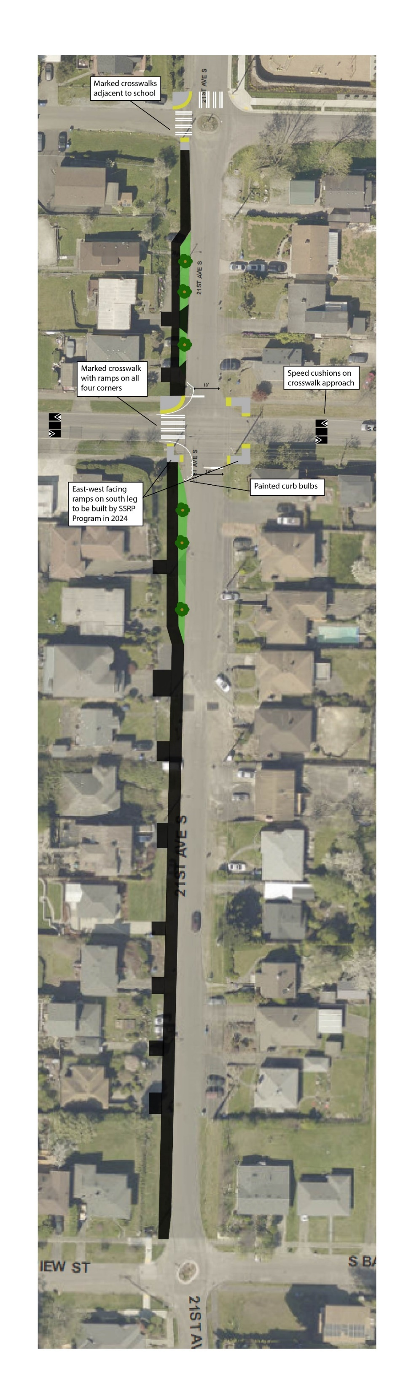
21st Ave S – Bayview to College

