
Assessment to be completed at project initiation to inform project scope.

PROJECT INFO & COMPLETE STREETS ASSESSMENT - STREAMLINED
For projects up to $100,000 and spot improvement projects

Project Name: 21st Ave S – College to Walker Walkway
Project Location: 21st Ave S – S College St to S Walker St
Program(s) / Funding Source(s): PMP New Sidewalks
Project Manager / Owner: David Burgesser
Outreach Lead: David Burgesser
TOD lead: John Marek

Project Budget/Estimate: $200,000
Billing Number(s): TBD
DotMaps ID: 76310
Initial Outreach Completed: Yes, contacted neighbors requesting improvements in this area.

Desired Delivery Date / Time Constraints: Q3, 2024
Move Seattle Accomplishments: 1 blocks of new sidewalks (1x M-SWIN)

Project Delivery PM: (To be filled by PDD)
Project Delivery Designer: (To be filled by PDD)
Delivery Method(s): (To be filled by PDD)
WO issue deadline: (To be filled by PDD)

Description of Scope:
- New 6-8’ asphalt walkway with pre-cast concrete wheel stops on the west side of 21st Ave S between S College St and S Walker St. Include a planting strip/conveyance swale with trees between the walkway and the roadway wherever grades allow or raised asphalt walkway supported by wheel stops (if feasible).
- Construct missing curb ramps/at-grade flush transitions on the SW and NW corners of 21st Ave S & S Walker St.
- Mark crosswalks on the north and west legs of 21st Ave S & S Walker St connecting these ramps to facilitate the final connection to the Giddens School/Lake Washington Girls Middle School.
- Construct curb ramps/at-grade flush transitions on all four corners of 21st Ave S & S College St. The east-west facing ramps on the SW and SE corners are under design by SSRP (Tony Chang) and planned for 2024 construction (designs to be provided).
- Add 20MPH school zone signage on S College St between 20th Ave S & 22nd Ave S (on crosswalk approaches).
- Install painted curb bulbs on the NW and SW corners of the 21st Ave S & S College St intersection to narrow the intersection throat to 18’.
- Install a marked crosswalk on the west leg of 21st Ave S & S College St.
  - Tier 1 crossing connecting directly into the signed school zone on the north side of the intersection.
- Install speed cushions on the westbound approach to the 21st Ave S & S College St intersection.
  - 85% speed: 32.7MPH (collected e/o 18th Ave S in 10/2022)
  - AWDT: 5,806 (collected e/o 18th Ave S in 10/2022)
  - Slope (21st to 22nd): 3%
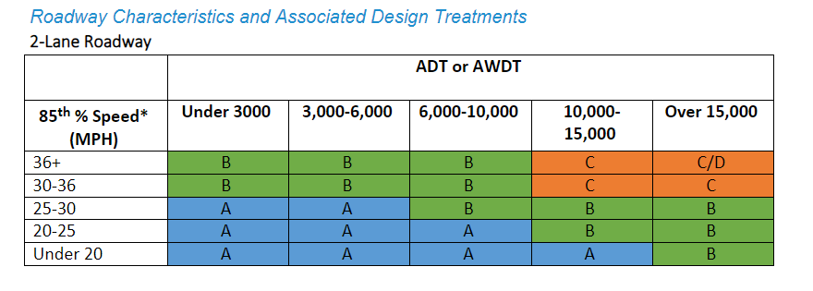

Project Log:
- 7/10/2023, David Burgesser - Conducted site visit to verify extents of school zone and observe grade challenges and site conditions.
- 7/14/2023, David Burgesser – Reached out to SSRP team (Tony Chang) to verify curb ramp scope at 21st Ave S & S College St. Tony provided design plans and notified that the curb ramp construction would not occur until 2024 at the earliest.

Reviewed & Approved:
- John Marek (Date/Initials – Traffic Ops)
- David Burgesser (Date/Initials – Program Owner)
- Reiner Blanco (Date/Initials – Project Delivery)
- Tom Hewitt (Date/Initials – ADA Coordinator)

Concept Design
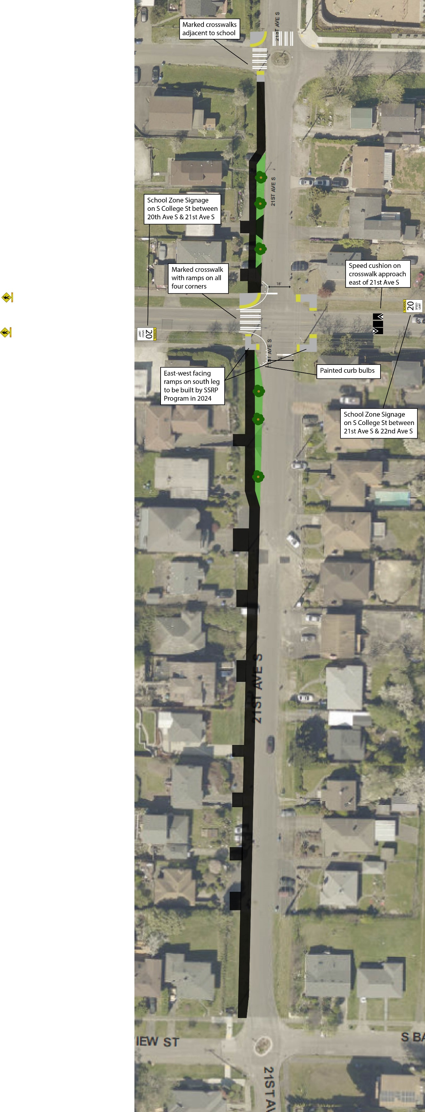
21st Ave S – College to Walker

