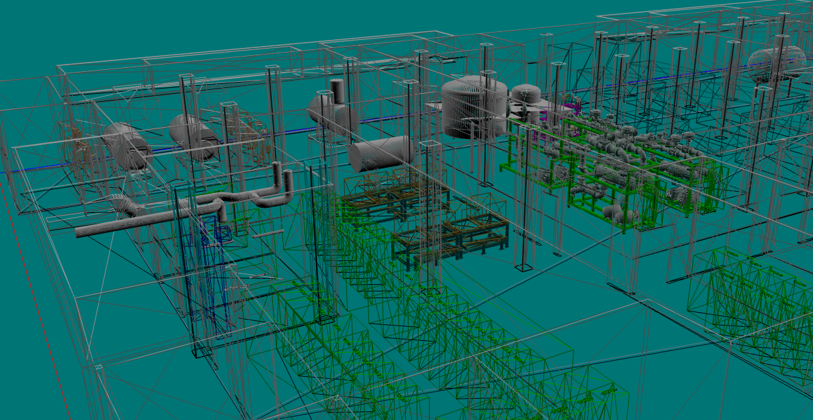
1. 要求系统SIL2
有火焰探测器的区域，采用了和利时的SIS控制器与三江消防盘搭配使用，但这是两套系统，和利时的SIS系统有SIL2等级，但三江消防盘没有。

对没有火焰探测器的区域，方案中就只配了三江的消防盘，那就完全没有SIL等级了。

2. 要求冗余CPU
三江消防盘的描述里写了冗余处理器，但实际上三江消防盘没有冗余CPU的能力

3. 火焰探测器要求内置加热器
火焰探测器采用上海翼捷的产品，没有内置加热器。其投标书中，料单中的型号，和证书中的型号，以及技术符合项表中的型号全都不一致，且不提供数据表，让人无法查询。在技术对照表中，对于带加热器后的功耗，回复是模拟量输出的电流水平，用牛头不对马嘴的回答搪塞。
火焰探测器配置的HART信号分离上传至IAMS的部件在料单中没有。

4. 工程师站
工程师站只配了和利时的部分，没配三江的部分

5. HSSD要求采样管分管报警
标书要求高灵敏度探测器的四根采样管需要区分报警，每台机器输出应达到10个输出，格里特配的三江JTY-GX-1104采用没有国际认证，四根采样管也无法分管报警

6. 防爆手报按钮
防爆型手报全部报的本安类型的，但是全部都没有配安全隔离栅

7. 缺少信息
无系统描述，无结构图，无电源计算，无进度安排，无数据表，料单中设备均缺少细节，只有笼统的型号和描述，如3014-RIE的报警主机，型号写SEC3020+LKS系列，描述为6回路主机，但该主机的CPU数目，通讯卡，交换机，光纤盘，卡笼、模块、附件型号和数目全无。让人无法查询。

1. Require SIL2 For FACP
In areas where flame detectors exist, Hollysys SIS controller combination with Sanjiang fire control panel is proposed. However, these are two separate systems. The Hollysys SIS system has SIL2 rating, while the Sanjiang fire control panel does not.
For areas without flame detectors, the proposal only includes the Sanjiang fire control panel, which have no SIL rating at all.

2. Require Redundant CPU
The description of the Sanjiang fire control panel in proposal BOM mentions a redundant processors is included, however, in reality, the Sanjiang fire control panel does not have the capability for supporting a redundant CPU.

3. flame detector require built-in heater
The flame detector, F750 UV/IR3 lacks a built-in heater in fact.
In proposal, the model number in the bill of material is FD750 UR/IR3, in the certificate model number is F750 UV/IR3, and in the technical compliance table model number is F750 UR/IR3. no data sheet is provided, wrong model making it difficult for people to conduct a search.
In the technical comparison table, for the power consumption with a heater on, the response is current mA level of analog output, which is a fully irrelevant answer.
For Flame detector, it need HART, but in system, there’s no kits for how to upload HART to IAMS.

4. Engineer Station
The engineer station is only for the Hollysys components, no for Sanjiang FACP.

5. HSSD requires pipe-wise Alarm
The RFQ requires that the four sampling pipe should be capable of distinguishing alarm for each pipe, and each HSSD should provide 10 outputs. However, the Sanjiang JTY-GX-1104 proposed are unable to distinguish alarms for each pipe, and it have no any international certification.

6. Explosion-Proof manual alarm call point
The explosion-proof manual call point proposed are all of the intrinsically safe type, but none safety isolation barriers has been included in proposal.

7. Missing information
There is no system description, no structural diagram, no power consumption/battery calculation, no project schedule, no data sheet for equipment.
equipment listed in the bill of materials lacks details.
There are only very general models and descriptions, such as for 3014-RIE FACP, which SEC3020+LKS series as model and described as a 6-loop controller. However, there is no detailed information about the number of CPUs, communication cards, switches, fiber optic panels, FO converter, module chassis, modules, accessories, or their models and quantities. It is impossible to conduct a investigate.

