Climate Change Visualisation: Three Case Studies

DESN2003 Data Visualisation Assignment 1

Saf Bannister U6062525

Climate change is a hot topic for data visualisation. There are a lot of interesting and creative examples, but how effective are these visualisations at communicating the issue? What story do they tell?

# Climate Spiral (NASA)

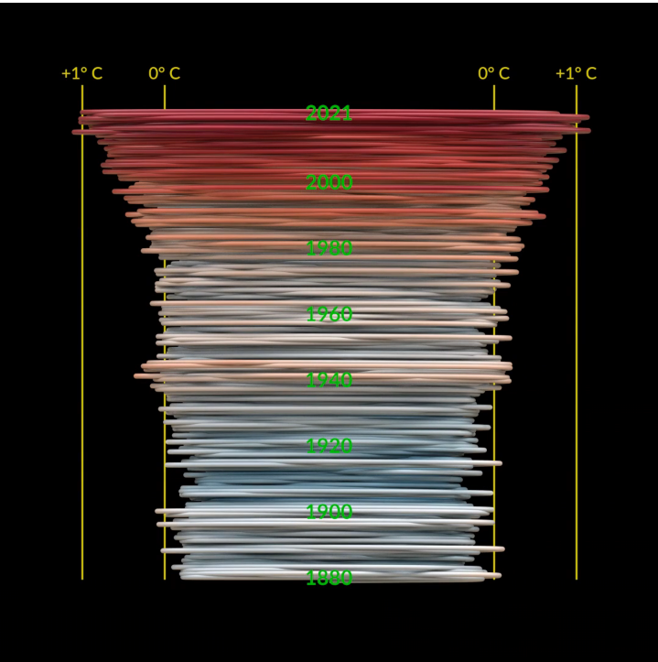

Image: Mark SubbaRao, NASA

This is a spiral graph based on the GISS Surface Temperature Analysis, which is an estimate of surface temperature change. The base period is 1951- 1980, with the temperature difference measured based on that period. This means that the shape produced looks different to how it might if the base period had been defined differently. Additionally, it only takes monthly data, and has a very low level of granularity. Instead, it shows a very broad representation of the data over a large area, over a long period of time. The data is available here: <https://data.giss.nasa.gov/gistemp/tabledata_v4/GLB.Ts+dSST.csv>

The choice to use the data on average temperature change rather than average temperature is interesting, as that data is less intuitively understandable.

This visualisation, based on a similar 2016 spiral graph by Ed Hawkins, is in the form of a spiral graph, where decreases in global temperature mean a smaller radius and increases in global temperature mean a higher radius. As time increases, the spiral grows upwards. Circular visualisation can be difficult to read. By representing the data in 3D space, it has been given a tactility which means that it is more easily and intuitively read. The 3D form itself resembles a tornado, which is potentially symbolic of the weather events caused by sudden changes in climate. The graph also uses colour to communicate higher temperatures. The use of blue and red in climate change visualisations is common, becoming both a shared language between them and a reference to the culturally ingrained colour meanings of red = hot and blue = cold. In this graph, however, the colours are muted, which takes away from the overall impact.

This representation is appropriate for the dataset, as it shows very clearly the effects of climate change on temperature on a global scale of a long time. This fits with the intent of the piece. By including an element of animation, this visualisation shows the combination of the slow increase in temperature change over time and the rapid spike within the last decade. Despite that, being a circular graph, the visualisation is less easily readable than a more typical representation such as the famous hockey stick graph.

# See the drastic toll climate change is taking on our oceans (National Geographic)

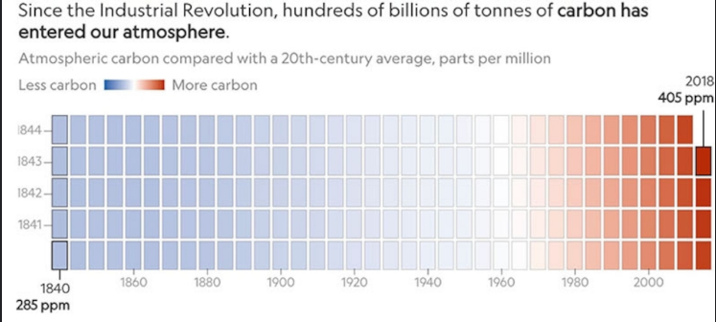

Image: Kennedy Elliot, National Geographic [full graph appendix 1]

This series of heatmaps displays yearly data on various metrics related to the effects of carbon emissions on oceans. The first graph displays carbon emissions, with subsequent graphs displaying other metrics: surface temperature, heat penetration, sea levels, arctic sea shrinkage, ice sheet melt, and acidity. These are put together to tell a broad story about climate change’s effects on the ocean. The sources are listed as Ted Scambos, University of Colorado Boulder; Boyin Huang, NOAA; Thomas L. Mote, University of Georgia; NOAA; NSIDC; University of Hawai'i at Manoa. Which data comes from which source is unclear, and which specific papers are being referred to, if any, is also unclear.

The visual representation of the data uses coloured rectangles to represent years, with the colour representing climate change related outcomes on oceans. In these graphs, blue is used to represent things being less affected by climate change, and red is used to represent things being more affected. This fits with the colour meanings discussed earlier (red=hot / blue=cold) but applies it to a variety of other metrics to tell a complete story. The colour scales themselves are vague, with the only labelled numbers being at the start and end of the graph. Given the vagueness of the scales, and the unavailability of the data, there is a potential for manipulation.

While the data is displayed on a yearly basis, the rectangles representing years are stacked in such a way that it is read as more of a 5-year trend. Determining which individual year is which rectangle is difficult, as the scale goes down or up depending on the column. To pinpoint a specific year, the viewer must count up and down the rows and columns. So, the data is really represented in 5-year chunks. The first graph in the series shows carbon emissions, and subsequent graphs are on the same year scale, inviting comparison.

Where this series is successful is in the ability for the viewer to see the story that’s being told. Each individual graph is unclear and difficult to get anything but an idea of a broad trend from, but as a group of graphs, they show a series of broad trends which show the various effects of climate change on oceans. By omitting extraneous details on the individual graphs, they become easier for the viewer to digest as a series.

# Warming Represented as Elevation (Unstable Ground)

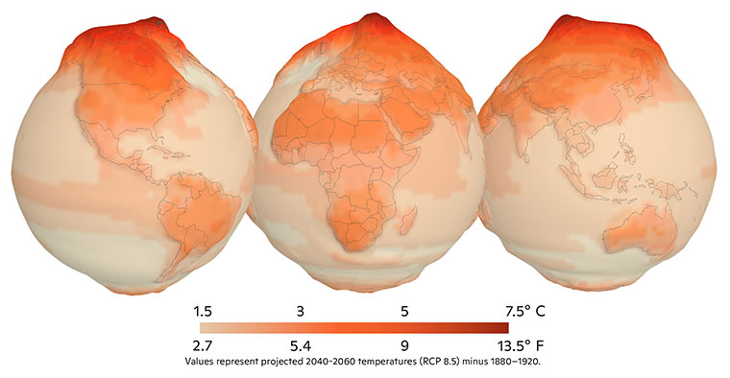

Image: Greg Fiske and Carl Churchill, Woodwell Climate Research Centre

This is a representation of projected 2040-2060 temperatures (based on RCP 8.5) minus 1880-1920, with both darker colour and higher elevation denoting a higher temperature increase. Instead of showing the data averaged over the entire globe, it is shown per smaller region, in order to demonstrate the greater increase concentrated around the Arctic. The exact research data this model is based on is not cited directly. RCP 8.5 was designed as the worst-case scenario for climate change (Hausfather, 2019). It was likely used here to illustrate the regional differences in warming most clearly.

This is a 3D warped geospacial globe with heatmapping as a secondary way to display the data, as well to provide a key with which to interpret the elevation on the geospatial figure. While previous colour representations of temperature used a blue to red scale, this one uses an orange to red scale. That is representative of the fact that even the lowest shown temperature increase is still an increase compared to historical data.

Unstable Ground, a project by the Woodwell Climate Research Centre, is based around educating the public on the effects of a warming Arctic. The purpose of this visualisation is to demonstrate the severity of projected warming in the Arctic region. This mapping is effective to that purpose, as it makes the severity of temperature increase at the pole very visually obvious – it juts out the top, calling attention to itself. The globe representation and its orientation are especially appropriate for data concerning the Arctic, as that location is at the top of the globe and therefore stands out in the information hierarchy. Showing the globe from three angles rather than allowing the viewer to interact with the model keeps the story tightly focused on the Arctic region.

# Bibliography

Hausfather, Z, 2019. *Explainer: The high-emissions ‘RCP8.5’ global warming scenario*. Online, available: <https://www.carbonbrief.org/explainer-the-high-emissions-rcp8-5-global-warming-scenario/> Accessed 14/08/2022

Woodwell Climate Research Centre, 2021. *Unstable Ground.* Online, available; <https://www.unstableground.org> Accessed 14/08/2022

Elliott, K. 2019. *See the Drastic Toll Climate Change is Having on Our Oceans*. Online, available: [www.nationalgeographic.com/environment/article/see-the-drastic-toll-climate-change-is-taking-on-our-oceans](http://www.nationalgeographic.com/environment/article/see-the-drastic-toll-climate-change-is-taking-on-our-oceans) Accessed 14/08/2022

SubbaRao, M, 2022. *GISTEMP Climate Spiral*. Online, available: <https://svs.gsfc.nasa.gov/4975> Accessed 14/08/2022

# Appendix 1: See the drastic toll climate change is taking on our oceans full graph

As National Geographic is paywalled, find here a copy of the full graph.