Shoe Shop POS
User Manual

Version 1.0.0 | June 2026
Platform: Windows Desktop (Electron + SQLite)
Currency: Pakistani Rupees (Rs. / PKR)

Table of Contents
Table of Contents 2
1. Introduction 5
1.1 About Shoe Shop POS 5
1.2 Who Should Use This Manual 5
1.3 Currency 5
2. System Requirements & Installation 6
2.1 Requirements 6
2.2 Installation 6
2.3 Database Location 6
2.4 First Launch 7
3. Getting Started — Login 8
3.1 Login Screen 8
3.2 Default Credentials 8
3.3 Login Fields 8
3.4 Role-Based Redirection 9
3.5 Login Errors 9
4. Dashboard 10
4.1 Date Filter 10
4.2 Stats Cards (Top Row) 10
4.3 Quick Action Buttons 11
4.4 Charts (Admin Only) 11
Bar Chart — Sales Overview 11
Line Chart — 30-Day Sales Trend 11
Pie Chart — Sales by Category 11
4.5 Tables (Admin Only) 12
Top Selling Products 12
Recent Transactions 12
5. POS / Billing Screen 13
5.1 Screen Layout 13
5.2 Adding Products to Cart 13
Method 1: Barcode Scanner 13
Method 2: Manual Search 13
Method 3: Variant Selection 14
5.3 Managing Cart Items 15
5.4 Customer Information (Optional) 15
5.5 Discounts 16
5.6 Payment Methods 17
5.7 Order Totals 17
5.8 Completing a Sale 17
5.9 Receipt & Printing 18
5.10 Holding a Bill 19
5.11 Refund / Return 19
6. Product Management 21
6.1 View Modes 21
6.2 Searching & Filtering 22
6.3 Adding a New Product 22
6.4 Auto-Variant Detection 23
6.5 Barcode Management 24
6.6 Editing a Product 24
6.7 Toggle Active/Inactive 24
6.8 Deleting a Product 24
6.9 Bulk Import from Excel 25
6.10 Export to Excel 25
7. Inventory & Stock Management 26
7.1 Stock Table 26
7.2 Low Stock Filter 26
7.3 Searching Inventory 26
7.4 Stock Adjustment 27
7.5 Stock Adjustment History 27
7.6 Variant Groups in Inventory 28
7.7 Supplier Management 28
Viewing Suppliers 29
Adding a Supplier 29
7.8 Receive Stock (Purchase Orders) 29
8. Reports 31
8.1 Date Range 31
8.2 Summary Cards 31
8.3 Report Tabs 31
Sales Report 31
Top Products 32
Categories 32
Bill History 33
8.4 Export to Excel 34
9. Settings 35
9.1 Settings Tabs 35
9.2 Shop Info 35
Categories & Brands Management 36
9.3 User Management 37
User Roles 37
Adding a User 38
Editing a User 38
Deactivating a User 39
9.4 Supplier Management 39
9.5 Printer Setup 39
Auto-Detect 40
Manual Entry 40
Test Print 40
9.6 Backup 41
Backup Now 41
Last Backup 41
9.7 Theme 41
10. Keyboard Shortcuts 43
11. Troubleshooting 44
11.1 Application Won't Start 44
11.2 Printer Not Working 44
11.3 Barcode Scanner Not Adding Products 44
11.4 Login Issues 44
11.5 Database Reset (Full Clean) 44
12. Appendix — Database & Data Management 46
12.1 Database Schema 46
12.2 Seed Data 46
12.3 Default Data Created by App 47

1. Introduction

1.1 About Shoe Shop POS
Shoe Shop POS is a desktop Point-of-Sale application built specifically for shoe retail stores. It runs on Windows and uses a local SQLite database — no internet connection is required for daily operations.
The system provides:
- Product management with support for sizes, colors, brands, and categories
- Barcode scanning and generation for quick checkout
- Thermal receipt printing for bills and barcode labels
- Sales reporting with profit calculations and visual charts
- Inventory tracking with low-stock alerts and stock adjustment history
- Supplier management and purchase order recording
- Role-based access — Admin (full access) and Cashier (POS + sales only)
- Light / Dark theme toggle

1.2 Who Should Use This Manual
Audience | Purpose
Shop Owners / Admins | Configure the system, manage users, and view reports
Cashiers | Process sales, handle payments, and print receipts
Technical Support | Installation, troubleshooting, and data management

1.3 Currency
All monetary values are displayed in Pakistani Rupees (Rs. / PKR).

2. System Requirements & Installation

2.1 Requirements
Component | Requirement
Operating System | Windows 10 or Windows 11 (64-bit)
Processor | Intel Core i3 or equivalent
RAM | 4 GB minimum (8 GB recommended)
Storage | 500 MB free space
Printer | 80mm thermal receipt printer (optional but recommended)
Barcode Scanner | USB barcode scanner in keyboard-emulation mode (optional)

2.2 Installation
1. Run the provided installer (ShoeShopPOS Setup.exe).
2. Follow the on-screen installation wizard.
3. Once installed, launch Shoe Shop POS from the Start Menu or desktop shortcut.
4. The application will automatically create the database on first launch.

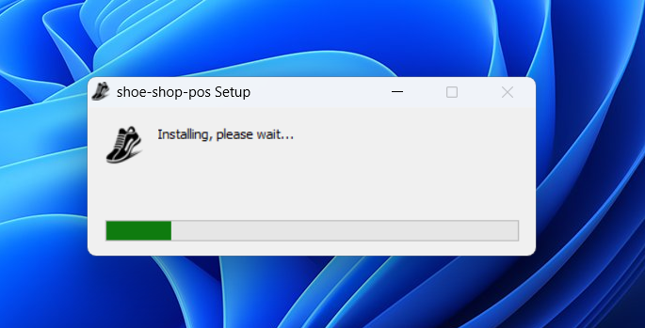
Figure 2-1: Installation setup screen

2.3 Database Location
The database file is stored at:
C:\ProgramData\ShoeShopPOS\pos.db

This folder also contains Write-Ahead Log (WAL) files for performance.

2.4 First Launch
On first launch, the system automatically:
- Creates the SQLite database and all required tables
- Seeds 8 default product categories (Sneakers, Sandals, Formal, Casual, Sports, Boots, Slippers, Heels)
- Creates the default admin user
- Creates default shop information

3. Getting Started — Login

3.1 Login Screen
When you launch the application, the Login Screen appears.

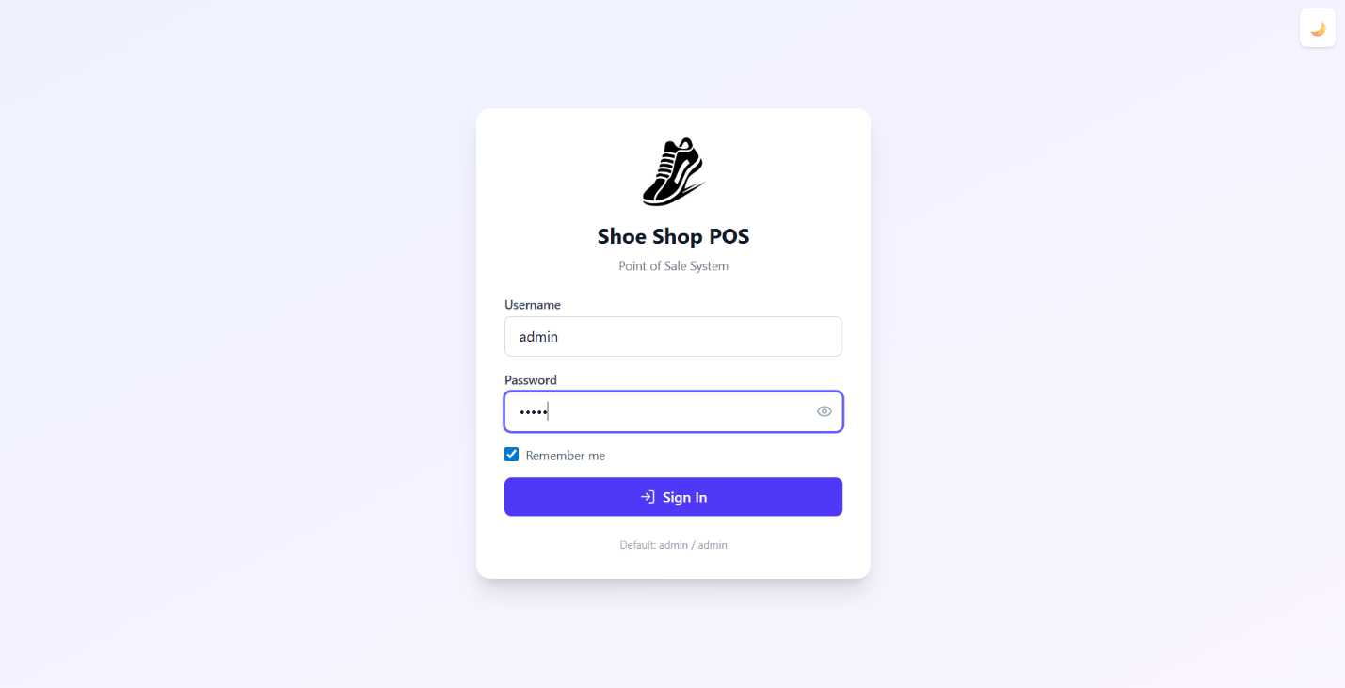
Figure 3-1: Login page with username, password, remember me, and theme toggle

3.2 Default Credentials
Username | Password | Role
admin | admin | Admin (full access)
cashier1 | cashier123 | Cashier (sales only)
cashier2 | cashier123 | Cashier (sales only)

Warning: Change the default password after first login!

3.3 Login Fields
Field | Description
Username | Enter your assigned username
Password | Enter your password (toggle to show/hide)
Remember Me | Check to save your username locally for faster login next time
Theme Toggle (top-right) | Switch between Light and Dark mode before logging in

3.4 Role-Based Redirection
After successful login, you are redirected based on your role:
Role | Redirected To
Admin | Dashboard (business overview)
Cashier | POS / Billing (to start taking orders immediately)

3.5 Login Errors
If you see "Invalid username or password":
- Check that Caps Lock is off
- Ensure you're using the correct username
- Contact the admin to reset your password

4. Dashboard
The Dashboard provides a real-time business overview. Accessible only to Admin users (Cashiers see a simplified view).

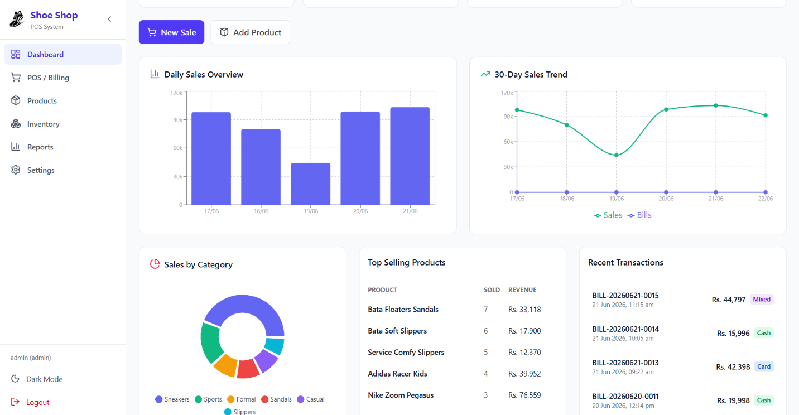
Figure 4-1: Dashboard with stats cards, charts, and recent transactions

4.1 Date Filter
At the top-right, you can filter data by:
Filter | Description
Today | Shows data for the current day
Week | Shows data for the last 7 days
Month | Shows data for the last 30 days

4.2 Stats Cards (Top Row)
Four cards display key metrics:
Card | Description
Sales | Total revenue for the selected period
Total Bills | Number of completed bills
Avg Bill | Average bill amount (Revenue / Bills)
Low Stock Items | Number of products below minimum stock level (clickable — navigates to Inventory)

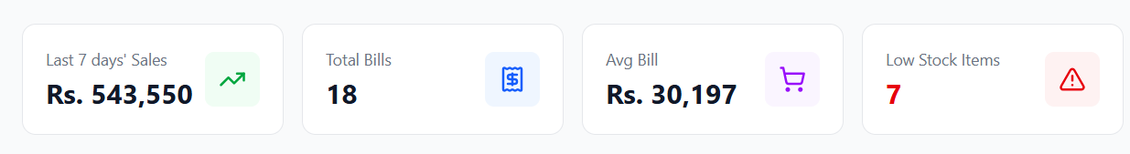
Figure 4-2: Four stats cards showing today’s sales, bills, avg bill, and low stock alerts

4.3 Quick Action Buttons
- New Sale — Opens the POS / Billing screen to start a new sale
- Add Product — Opens the Product form to add a new product (Admin only)

4.4 Charts (Admin Only)

Bar Chart — Sales Overview
Shows daily revenue for the selected period.

Line Chart — 30-Day Sales Trend
Shows the sales trend and bill count over the last 30 days.

Pie Chart — Sales by Category
Shows revenue distribution across product categories.

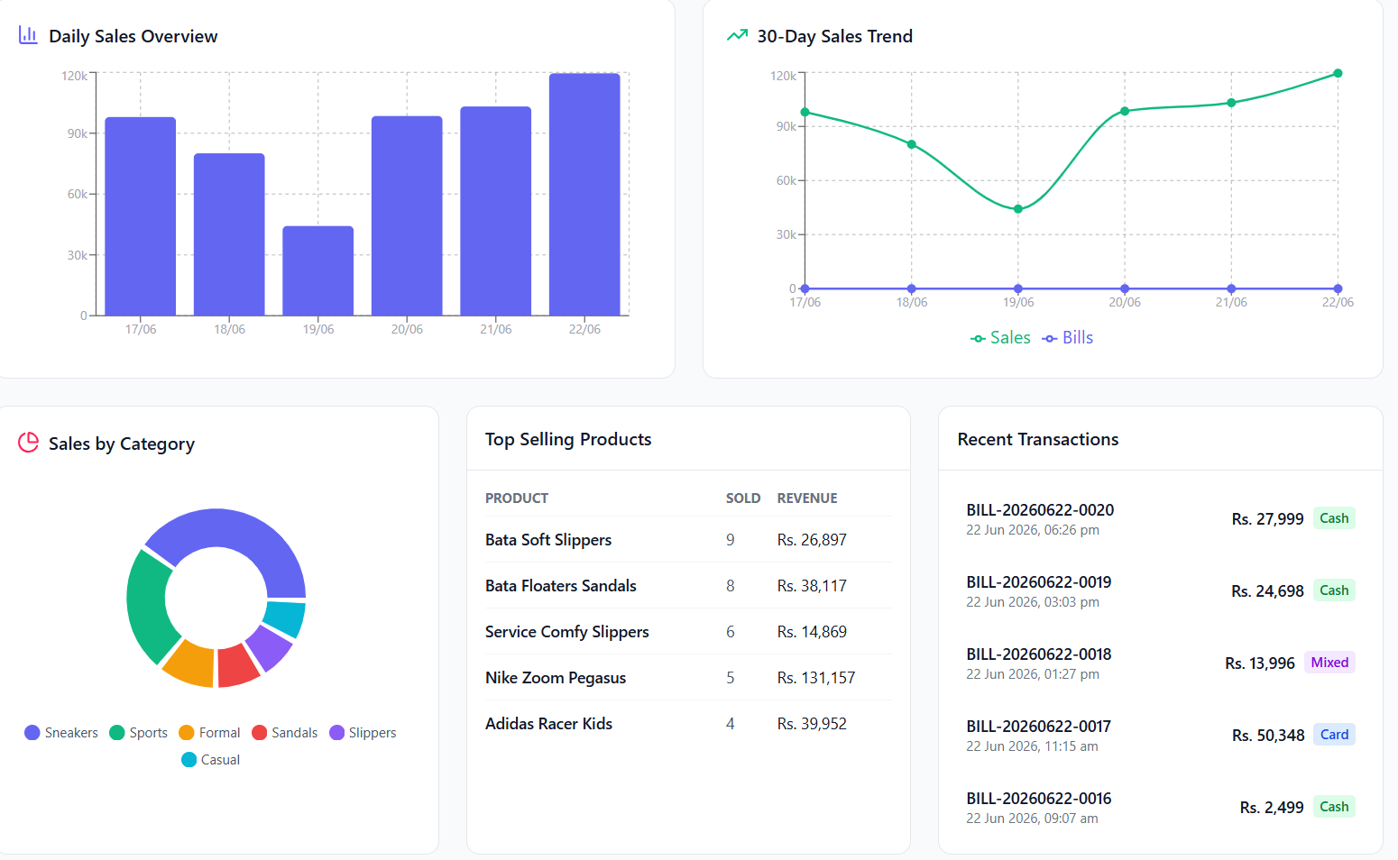
Figure 4-3: Dashboard charts showing sales data visually

4.5 Tables (Admin Only)

Top Selling Products
Lists the best-selling products sorted by quantity sold, with revenue.
Column | Description
Product | Product name
Sold | Quantity sold
Revenue | Total revenue from this product

Recent Transactions
Shows the last 5 completed sales with bill number, amount, and payment type (Cash / Card / Mixed).

5. POS / Billing Screen
The POS / Billing screen is the core of the system — where you create and process customer orders.

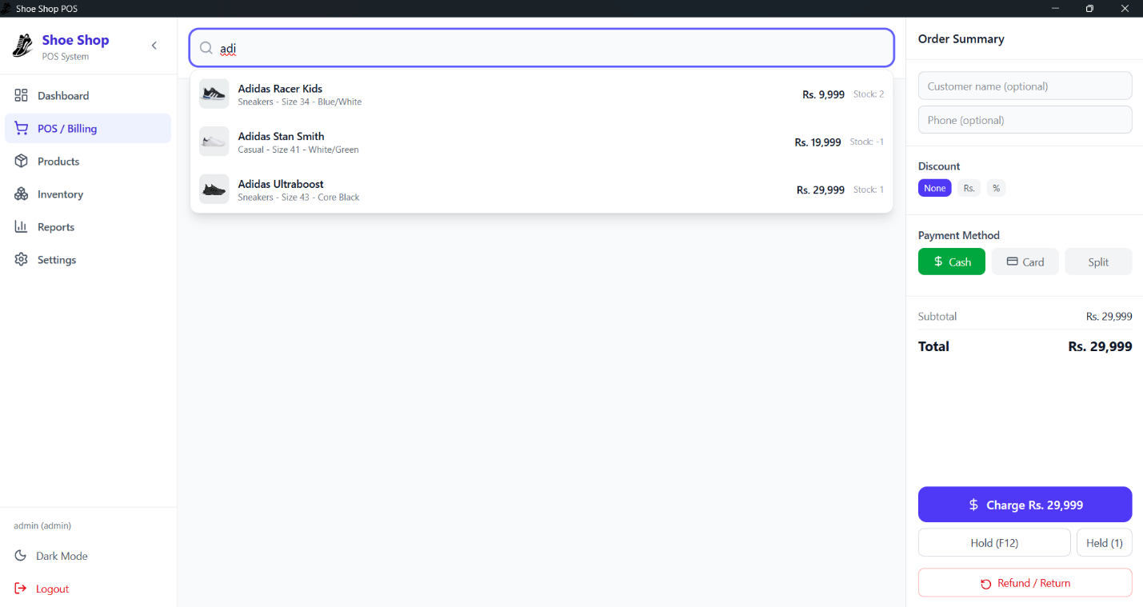
Figure 5-1: Full POS screen layout

5.1 Screen Layout
Section | Description
Left (Main Area) | Search bar at top, cart items list below
Right (Summary Panel) | Customer info, discount, payment, cart totals, and action buttons

5.2 Adding Products to Cart

Method 1: Barcode Scanner
1. Ensure the search bar is NOT focused (click anywhere outside input fields).
2. Scan the barcode using your USB barcode scanner.
3. The product is automatically added to the cart.

Method 2: Manual Search
1. Click the search bar or press F2.
2. Type a product name, category, brand, or barcode.
3. Search results appear as product cards below the search bar.
4. Click a product card to add it to the cart.


Figure 5-3: Search results with product cards

Method 3: Variant Selection
If a product has multiple variants (different sizes/colors), it appears with a purple left border. Click the variant group to open a variant picker table — select the specific size and color combination.

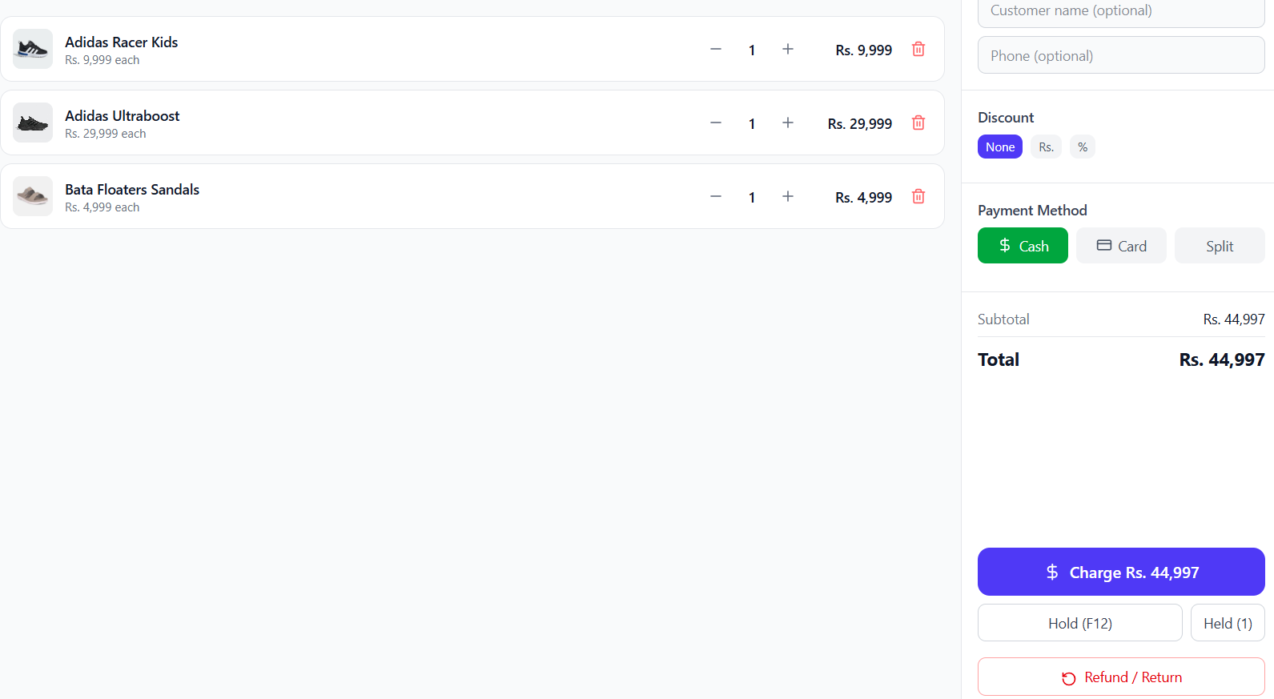
Figure 5-4: Variant selection modal showing sizes and colors in a grid

5.3 Managing Cart Items
Each cart item shows:
- Product image (or placeholder)
- Product name
- Unit price
- Quantity controls (+ / - buttons)
- Subtotal (price x quantity)
- Delete button
You can:
- Increase quantity — Click the + button
- Decrease quantity — Click the - button (removes item at 0)
- Remove item — Click the delete button

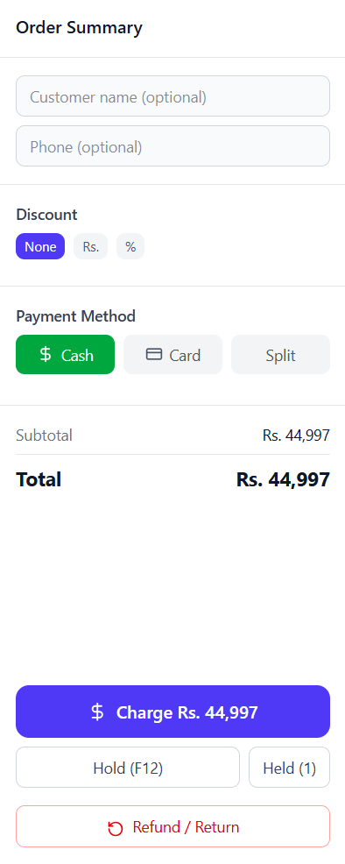
Figure 5-5: Cart items showing product details, quantities, and subtotals

5.4 Customer Information (Optional)
Field | Description
Customer Name | Optional name on the receipt
Phone | Optional phone number for records
NTN | Optional National Tax Number for corporate invoices

These fields are optional and can be left blank for walk-in customers.

5.5 Discounts
The system supports three discount modes:
Mode | Description
None | No discount applied
Rs. | Fixed amount discount (e.g., Rs. 500 off)
% | Percentage discount (e.g., 10% off)

To apply:
1. Click Rs. or % button.
2. Enter the discount value in the input field.
3. The discount amount updates automatically in the totals.

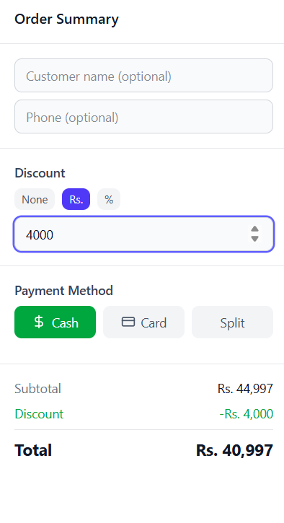
Figure 5-6: Discount selection panel

5.6 Payment Methods
Method | Color | Description
Cash | Green | Customer pays in cash
Card | Blue | Customer pays by card
Split | Purple | Partial cash + partial card

For Split payment, enter the cash amount and card amount separately.

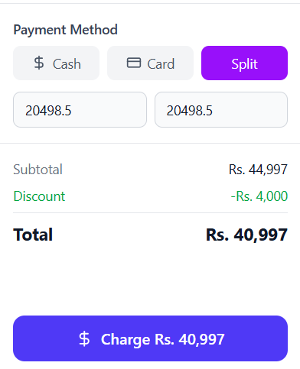
Figure 5-7: Payment method selection

5.7 Order Totals
Item | Description
Subtotal | Sum of all item prices before discount
Discount | Discount amount (shown in green, negative)
Total | Final amount to charge

5.8 Completing a Sale
1. Click Charge [amount] button.
2. A Payment Confirmation modal appears.
3. For Cash payments: Enter the Cash Tendered amount — the system auto-calculates Change Due.
4. Click Confirm & Complete Sale.
5. A Receipt modal appears with the sale summary.

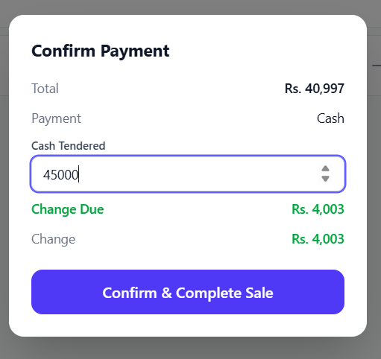
Figure 5-8: Payment confirmation dialog

5.9 Receipt & Printing
After payment, the receipt modal shows:
- Success indicator
- Bill number
- Receipt preview (items, amounts, total)
- Print Receipt button — sends to the configured thermal printer
- New Sale button — clears the cart and starts a new sale (also press F1)

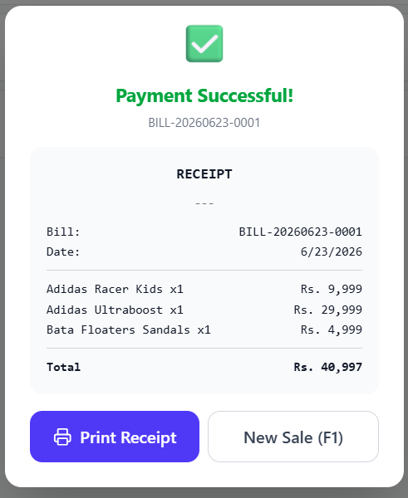
Figure 5-9: Receipt preview and print options

5.10 Holding a Bill
1. Click Hold (F12).
2. The current cart is saved as a "held bill."
3. Start a new sale.
4. Click Held (count) to view all held bills.
5. Click Return to Cart on any held bill to restore it.

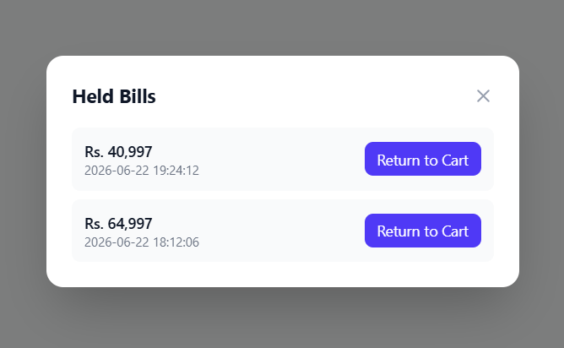
Figure 5-10: Held bills list showing saved incomplete bills

5.11 Refund / Return
1. Click Refund / Return at the bottom of the right panel.
2. Enter the Bill Number to search for the original sale.
3. Select which items and quantities to refund.
4. Enter a Reason for the refund.
5. Click Process Refund.
6. A refund bill is created, and stock is restored.

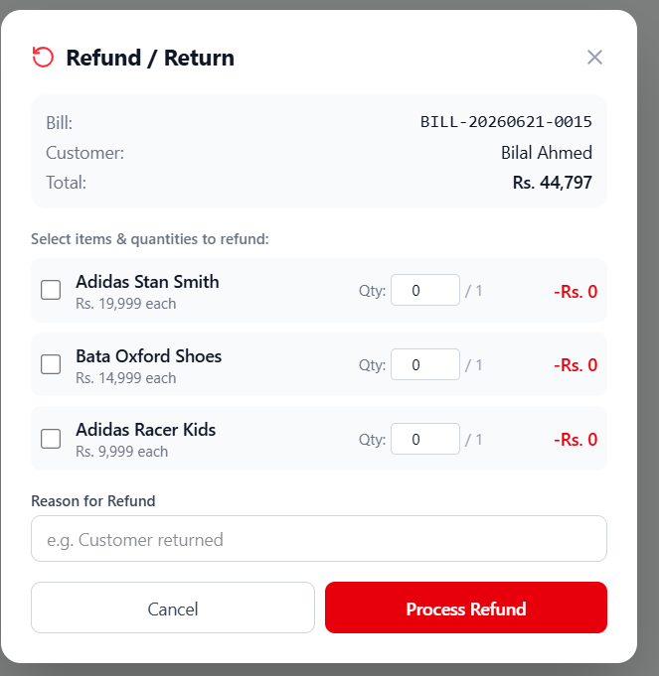
Figure 5-11: Refund processing interface

6. Product Management
The Products screen lets you manage all inventory items.

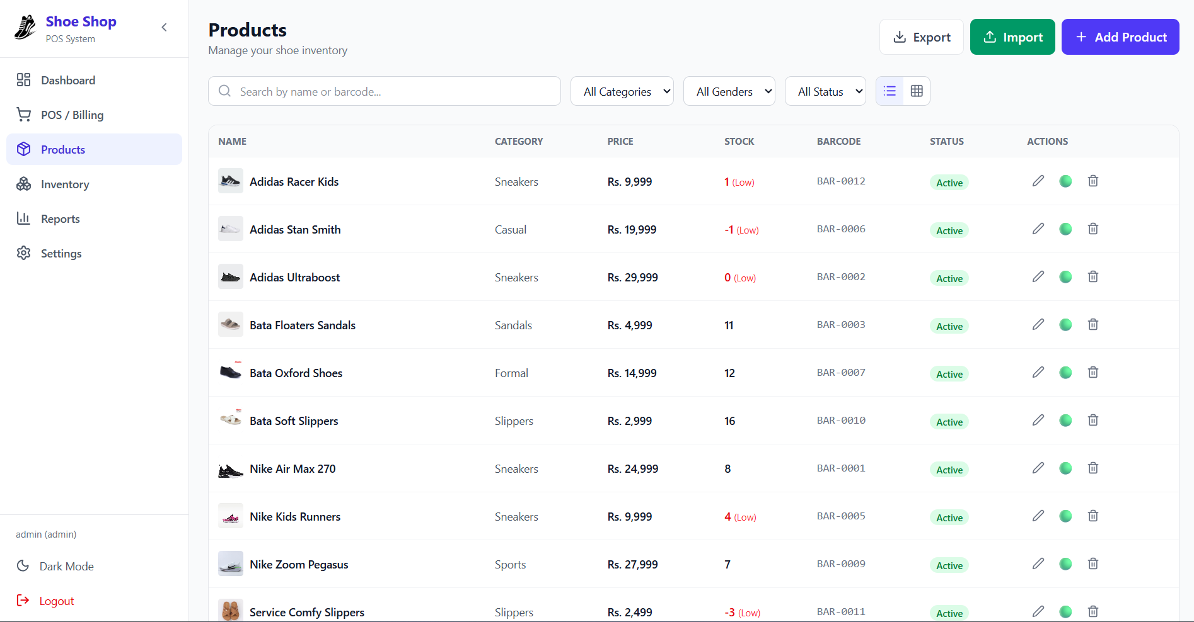
Figure 6-1: Products list showing all items with search and filters

6.1 View Modes
View | Icon | Description
Table View | List icon | List view with columns: Name, Category, Price, Stock, Barcode, Status, Actions
Grid View | Grid icon | Card view with product image, name, price, and stock

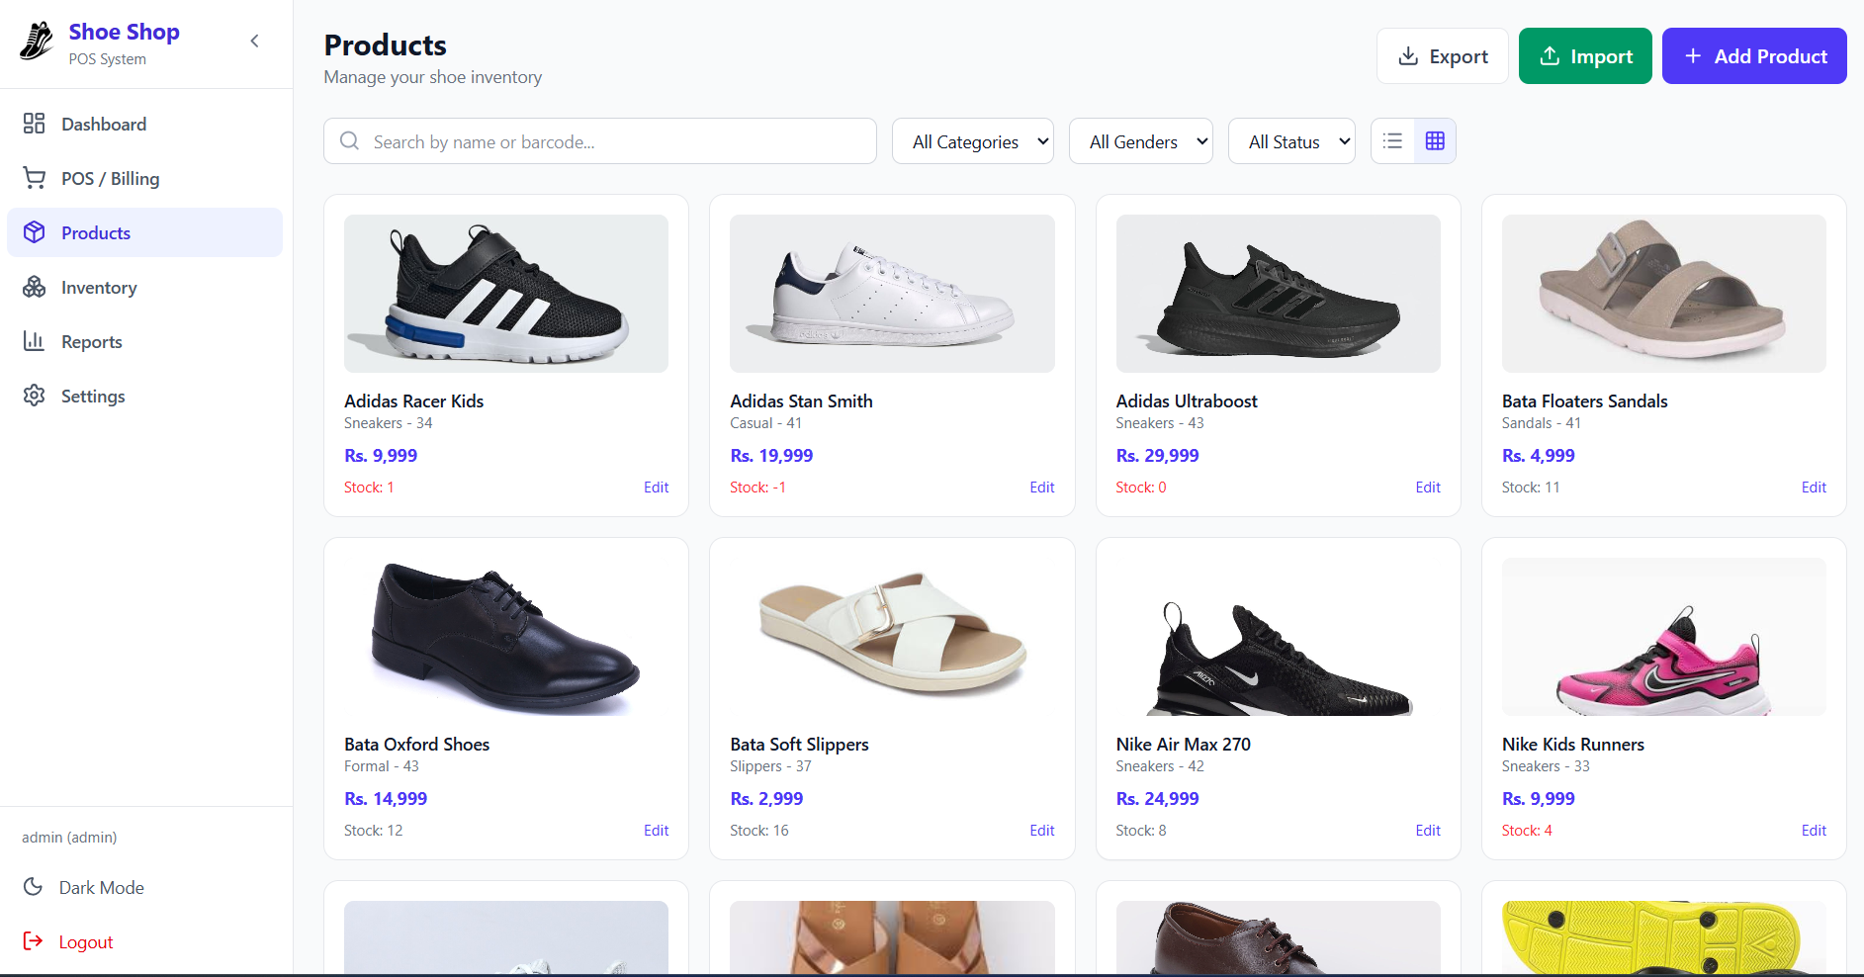
Figure 6-2: Grid view showing product cards

6.2 Searching & Filtering
- Search — Type a product name or barcode
- Category — Filter by selected category
- Gender — Filter by Men / Women / Kids / Unisex
- Status — Filter by Active / Inactive / All

6.3 Adding a New Product
Click Add Product button and fill in the product details (required fields marked with *):
Field | Required | Description
Product Name | Yes | Name of the shoe
Category | No | Select from existing categories
Brand | No | Select from existing brands
Gender | No | Men / Women / Kids / Unisex
Size | No | Single size (e.g., 42) or comma-separated for multiple sizes
Color | No | Single color or comma-separated for multiple colors
Buying Price | No | Cost price for profit calculation
Selling Price | Yes | Retail price
Stock | No | Initial stock quantity
Min Stock Level | No | Low stock alert threshold (default: 5)
Product Image | No | Upload an image
Barcode | No | Auto-generated or enter manually

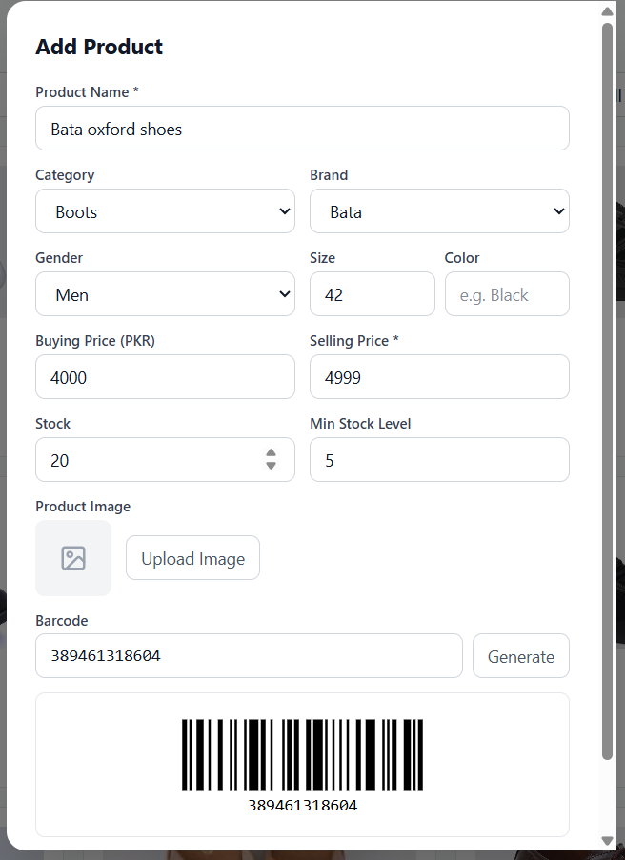
Figure 6-3: Add/Edit product form

6.4 Auto-Variant Detection
If you enter multiple sizes or multiple colors separated by commas (e.g., 42,43,44 or Black,White,Blue), the system automatically detects this and offers to create product variants. A variant preview table shows all combinations with their auto-generated barcodes.

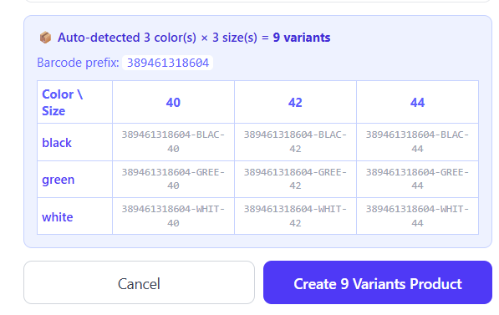
Figure 6-4: Auto-variant detection preview

6.5 Barcode Management
- Auto-generate — Click Generate to create a random barcode
- Manual entry — Type any barcode manually
- Duplicate validation — The system checks for duplicate barcodes
- Preview — The barcode is rendered as a visual barcode image

6.6 Editing a Product
In table view, click the Edit button next to any product. The form opens with all existing data pre-filled.

6.7 Toggle Active/Inactive
Click the toggle button to activate or deactivate a product. Inactive products won't appear in POS search results.

6.8 Deleting a Product
1. Click the Delete button.
2. If the product has no sale records, it's deleted immediately.
3. If the product has sale records, a confirmation dialog warns you. Confirm to delete permanently.

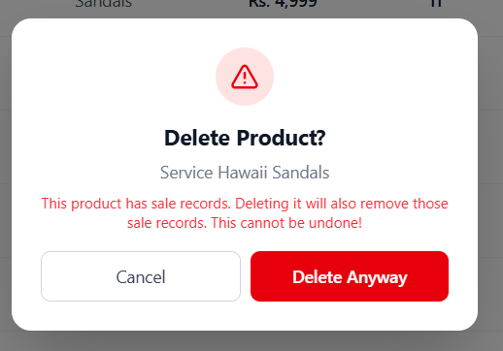
Figure 6-5: Delete confirmation dialog with warning about associated sale records

6.9 Bulk Import from Excel
1. Click Import button.
2. Select an Excel file (.xlsx) with the following columns:
Column | Required | Description
Name | Yes | Product name
Category | No | Must match existing category name
Gender | No | Men / Women / Kids / Unisex
Size | No | Product size
Color | No | Product color
Buying Price | No | Cost price
Selling Price | No | Retail price
Stock | No | Initial quantity
Barcode | No | Unique barcode

3. The import result modal shows: Imported count, Skipped rows, and any errors.

6.10 Export to Excel
Click Export to download all products as an Excel (.xlsx) file.

7. Inventory & Stock Management
The Inventory screen lets you track stock levels, adjust quantities, record purchases from suppliers, and view stock history.

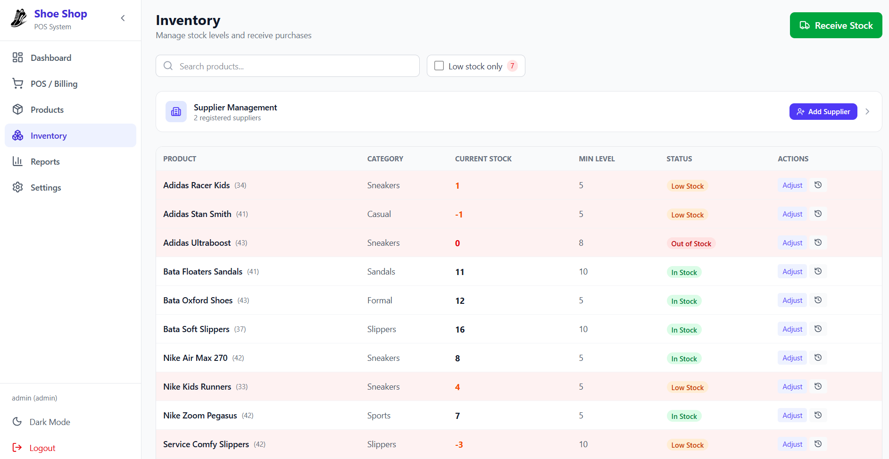
Figure 7-1: Inventory screen showing all products with stock levels

7.1 Stock Table
Column | Description
Product | Product name (with size if applicable)
Category | Product category
Current Stock | Current quantity in bold
Min Level | Minimum stock alert threshold
Status | Color-coded badge (In Stock / Low Stock / Out of Stock)
Actions | Adjust / History buttons

Rows with Low Stock or Out of Stock have a red/orange background highlight.

7.2 Low Stock Filter
Check “Low stock only” to show only products at or below their minimum stock level. The badge next to the filter shows the total count of low-stock items.

7.3 Searching Inventory
Type in the search bar to filter products by name or barcode.

7.4 Stock Adjustment
To manually adjust stock:
1. Click Adjust next to a product.
2. In the modal, set the New Quantity.
3. Select a Reason Type:
Reason | Description
Physical Count | Stock found different during counting
Damaged | Product damaged and cannot be sold
Lost | Product lost or stolen
Return to Supplier | Sent back to supplier
Restock | Additional stock received (for manual entry without supplier)

4. Add an optional Reason note.
5. Click Update Stock.

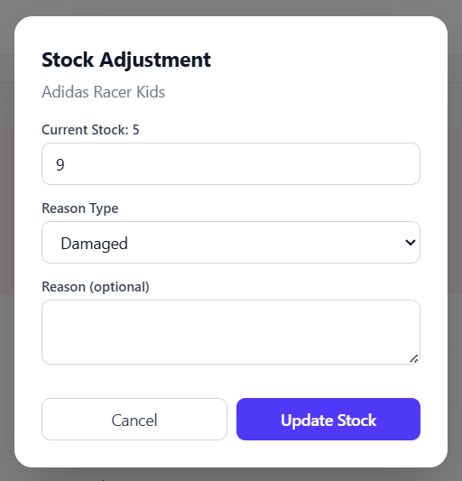
Figure 7-2: Stock adjustment form with reason selection

7.5 Stock Adjustment History
Click the History button next to any product to view all stock changes:
Column | Description
Date | When the adjustment was made
Change | + or - quantity change (green/red)
Reason | Reason type and note
Old -> New | Stock before and after

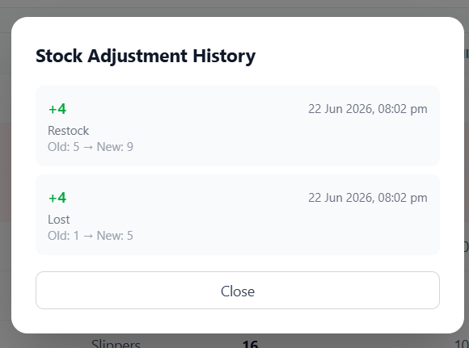
Figure 7-3: Stock adjustment history log

7.6 Variant Groups in Inventory
Products with multiple variants (sizes/colors) are grouped together with an indented list:
- Parent row — Shows total stock and a "colors x sizes" badge
- Click the parent row to expand and see individual variant stock levels
- Each variant row shows its specific size, color, barcode, and stock

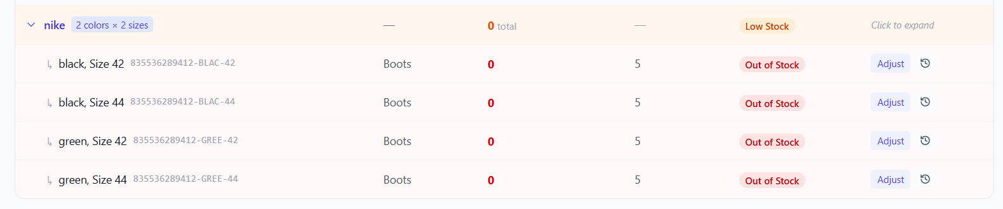
Figure 7-4: Expanded variant group showing individual variant stock

7.7 Supplier Management

Viewing Suppliers
Click the Supplier Management section at the top of the page to expand/collapse the supplier list.

Adding a Supplier
1. Click Add Supplier button.
2. Fill in the form:
Field | Required | Description
Supplier Name | Yes | Full company name
Phone | No | Contact phone number
Address | No | Business address

3. Click Add Supplier.

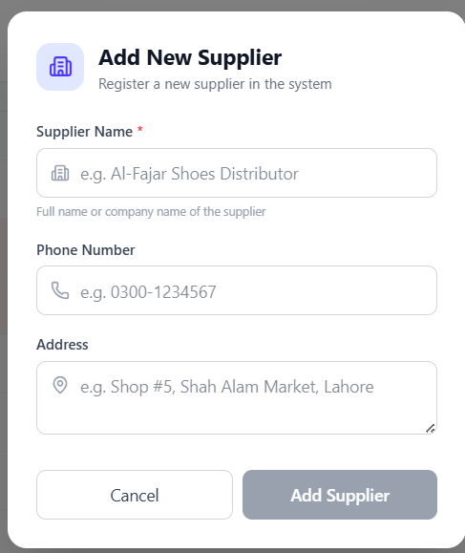
Figure 7-5: Add new supplier form with name, phone, and address

7.8 Receive Stock (Purchase Orders)
1. Click Receive Stock button.
2. Fill in the purchase form:
Field | Required | Description
Supplier | Yes | Select from registered suppliers
Invoice Number | No | Supplier's invoice reference
Items | Yes | One or more products with quantity and buying price

3. For each item: select a Product, enter Quantity received, enter Buying Price (unit cost).
4. Click + Add Another Item to add more products.
5. Click Receive Stock to complete.
The system automatically records the purchase, updates product stock quantities, and updates buying prices for profit calculations.

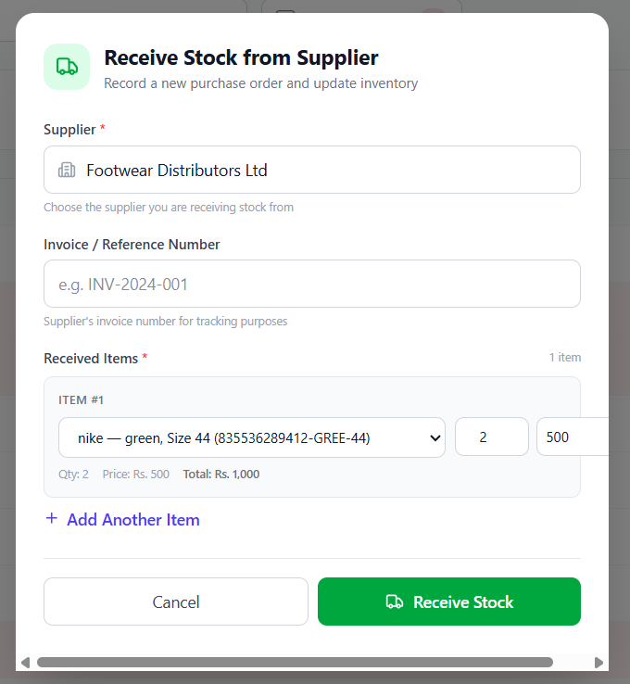
Figure 7-6: Purchase order / receive stock form

8. Reports
The Reports screen provides business analytics and historical data.

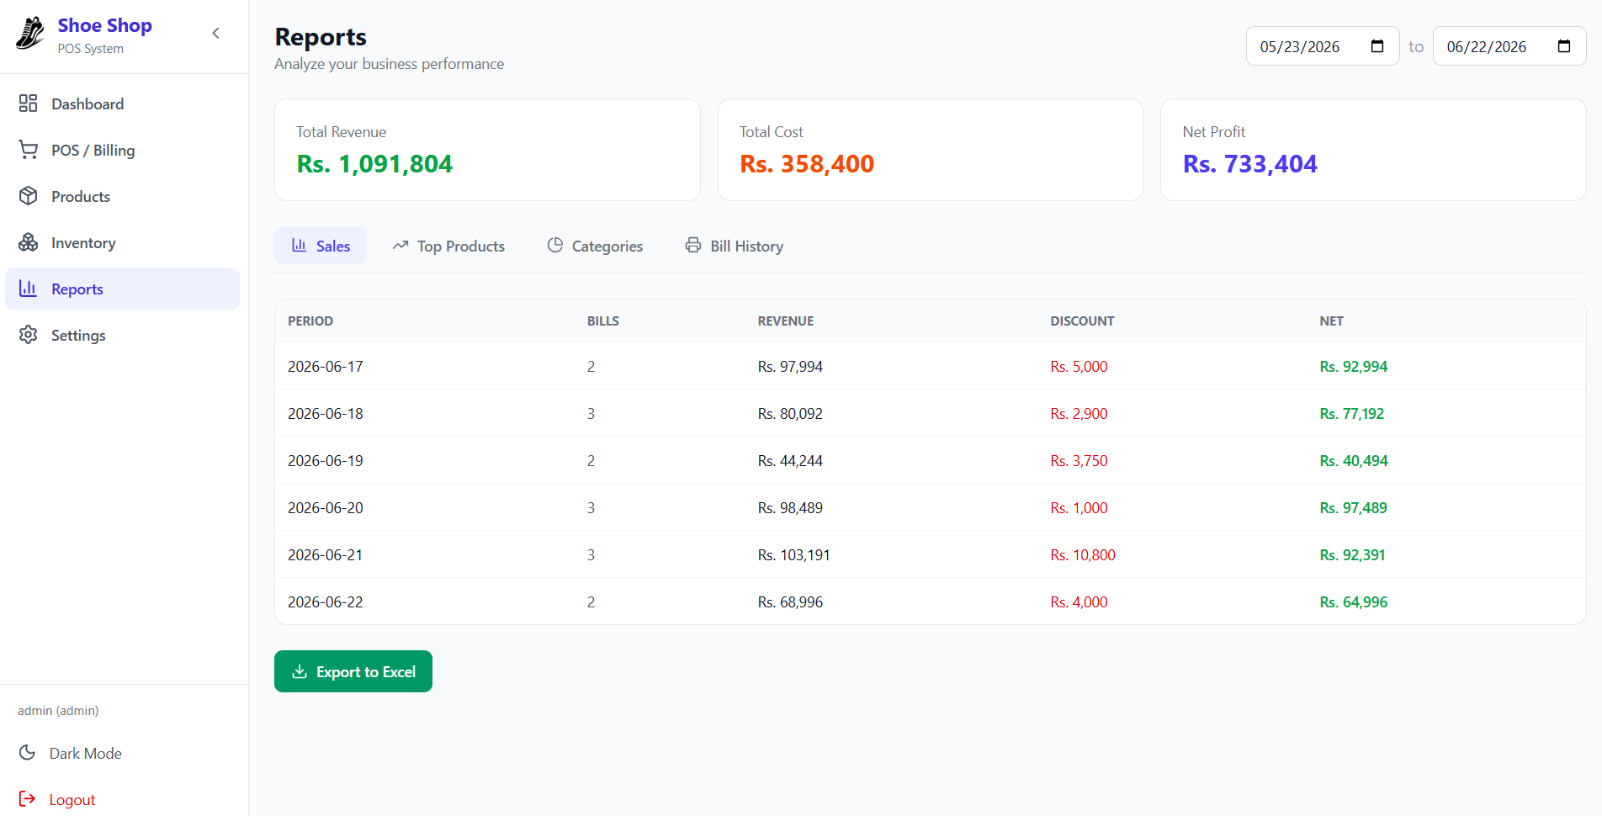
Figure 8-1: Reports screen overview

8.1 Date Range
Select a From and To date to filter all report data.

8.2 Summary Cards
Card | Color | Description
Total Revenue | Green | Total sales revenue for the period
Total Cost | Orange | Total cost of goods sold
Net Profit | Purple | Revenue minus cost

Profit margin is displayed as a percentage in the Categories tab.

8.3 Report Tabs

Sales Report
Shows daily/weekly/monthly sales data:
Column | Description
Period | Date or period label
Bills | Number of bills
Revenue | Gross sales amount
Discount | Total discounts given
Net | Revenue after discounts

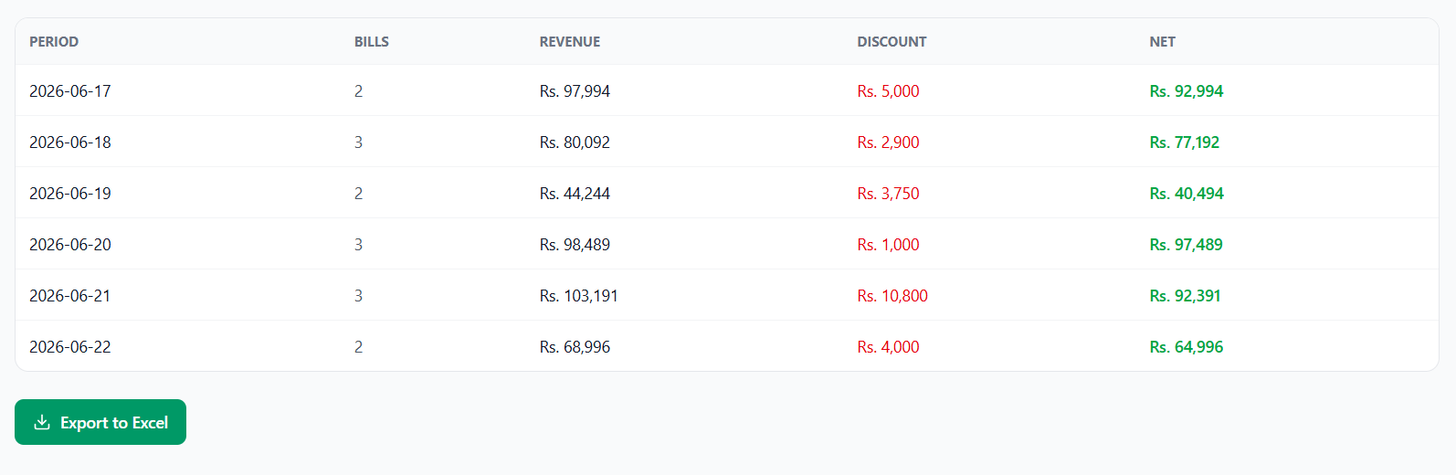
Figure 8-2: Sales report with daily breakdown

Top Products
Shows best-selling products ranked by quantity sold:
Column | Description
# | Rank
Product | Product name
Qty Sold | Total quantity sold
Revenue | Total revenue from this product

Categories

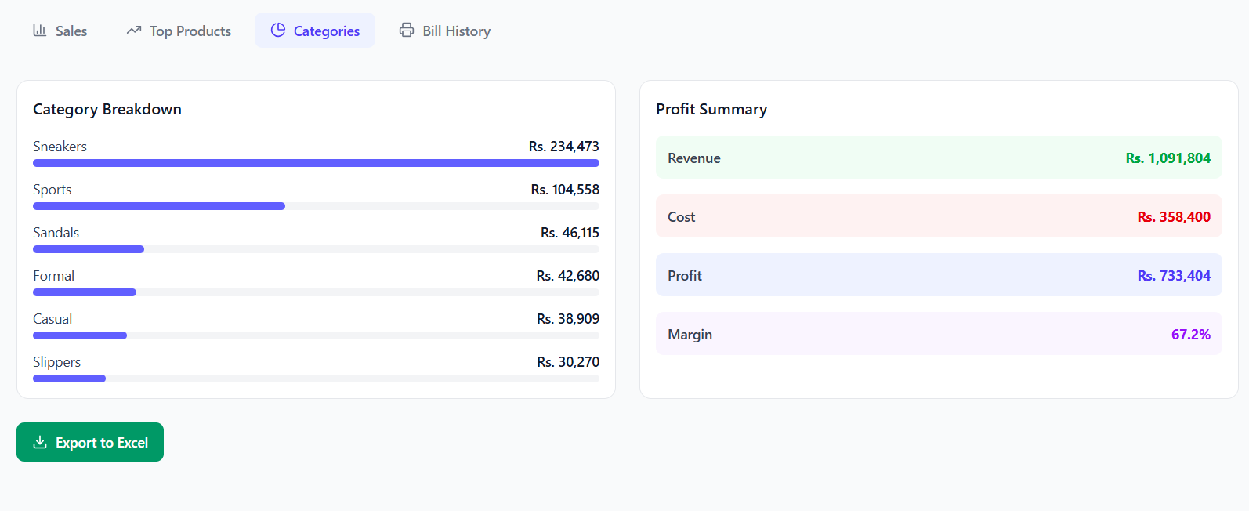
Figure 8-3: Category breakdown bars and profit summary

- Category Breakdown — Bar visualization of sales by category
- Profit Summary — Revenue, Cost, Profit, and Margin percentage

Bill History
Complete list of all bills for the selected period:
Column | Description
Bill No | Bill number (clickable)
Date | Date and time
Customer | Customer name
Amount | Net amount
Payment | Cash / Card / Mixed
Status | Active / Void / Refund
Actions | Reprint / Void

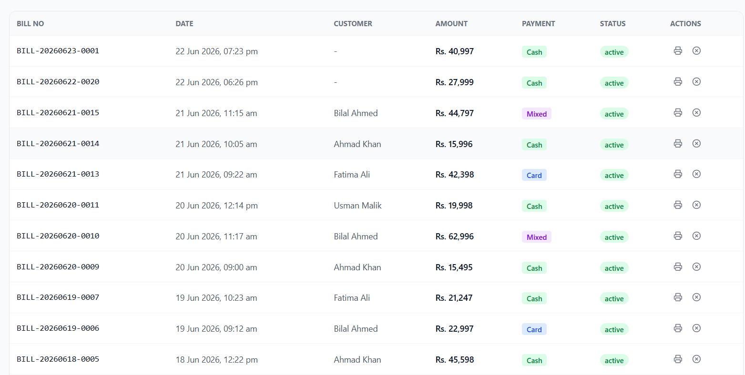
Figure 8-4: Bill history list

Bill Actions:
Action | Description | Who Can Use
Reprint | Print the receipt again | Admin + Cashier
Void | Cancel the bill (restores stock) | Admin only

8.4 Export to Excel
Click Export to Excel to download the current report view as an .xlsx file. The exported file includes:
- Sales data for the selected period
- Revenue, cost, and profit figures
- All filtered bills

9. Settings
The Settings screen lets you configure system preferences.

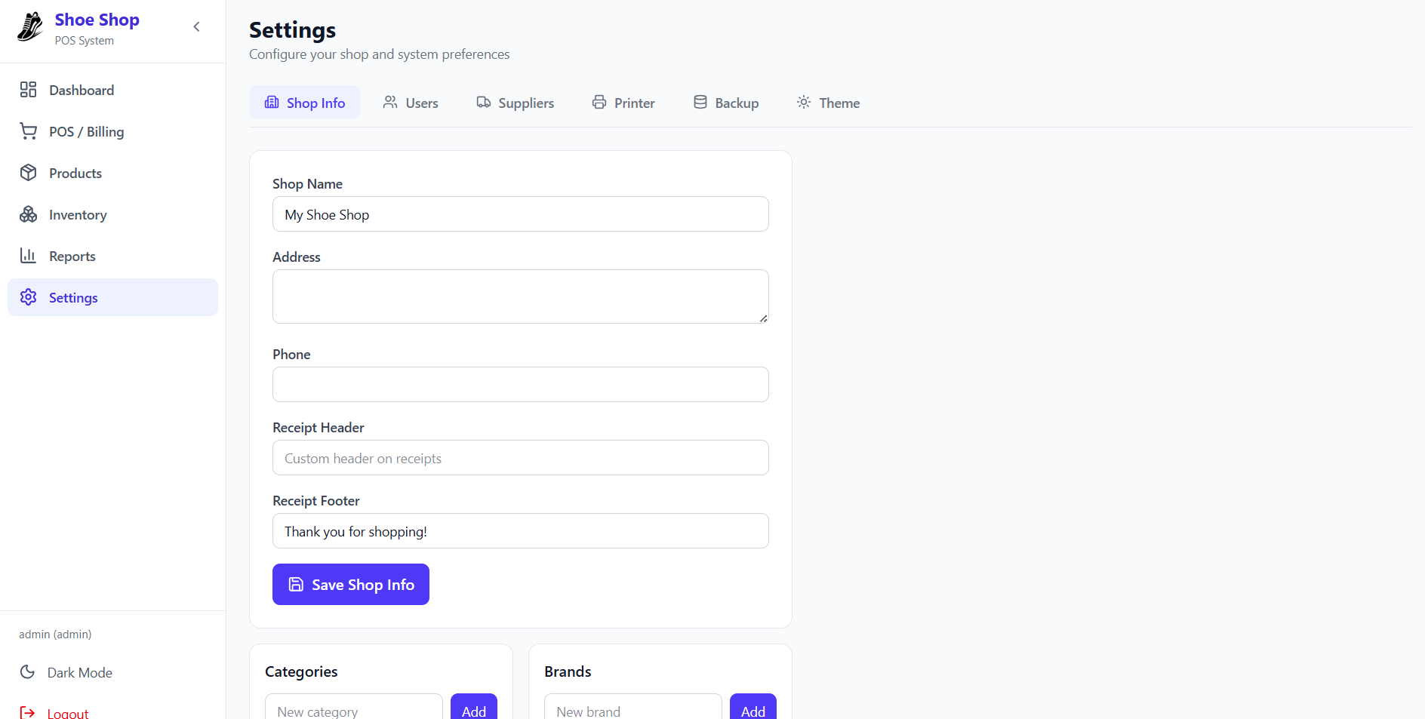
Figure 9-1: Settings screen showing all configuration tabs

9.1 Settings Tabs
Tab | Description
Shop Info | Business name, address, phone, receipt customization
Users | Add, edit, and manage system users
Suppliers | View and manage registered suppliers
Printer | Configure thermal printer for receipts
Backup | Database backup management
Theme | Light / Dark mode toggle

9.2 Shop Info
Configure the information that appears on receipts:
Field | Description
Shop Name | Business name (appears on receipts)
Address | Shop address
Phone | Contact number
Receipt Header | Custom text at top of receipt
Receipt Footer | Custom text at bottom of receipt (default: “Thank you for shopping!”)

Click Save Shop Info to apply changes.

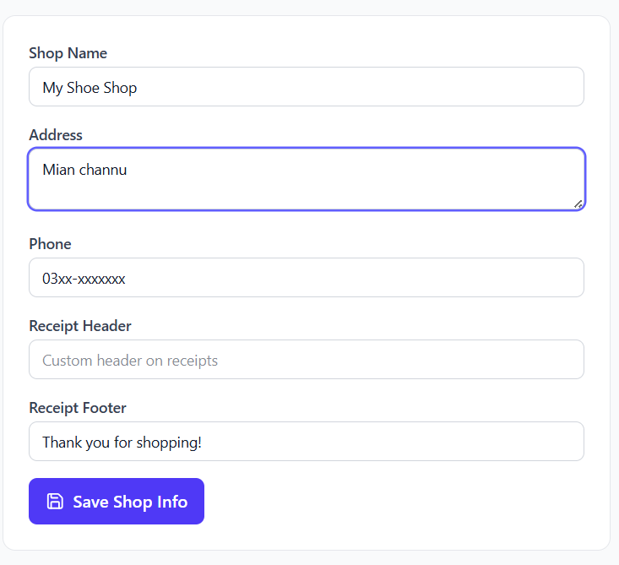
Figure 9-2: Shop information configuration form

Categories & Brands Management
From the Shop Info tab, you can also:
- Add Category — Enter a name and click Add
- Add Brand — Enter a name and click Add
These are used in product forms for dropdown selections.

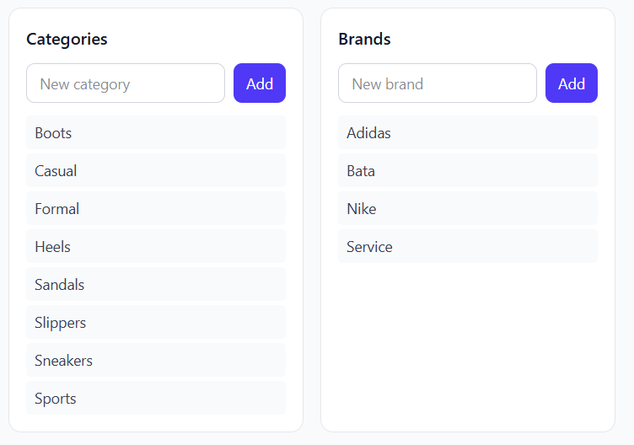
Figure 9-3: Category and brand management

9.3 User Management
The Users tab lets you manage who can access the system.

User Roles
Role | Access
Admin | Full access — Dashboard, POS, Products, Inventory, Reports, Settings
Cashier | Limited access — POS, Products (view only), Inventory (view only)

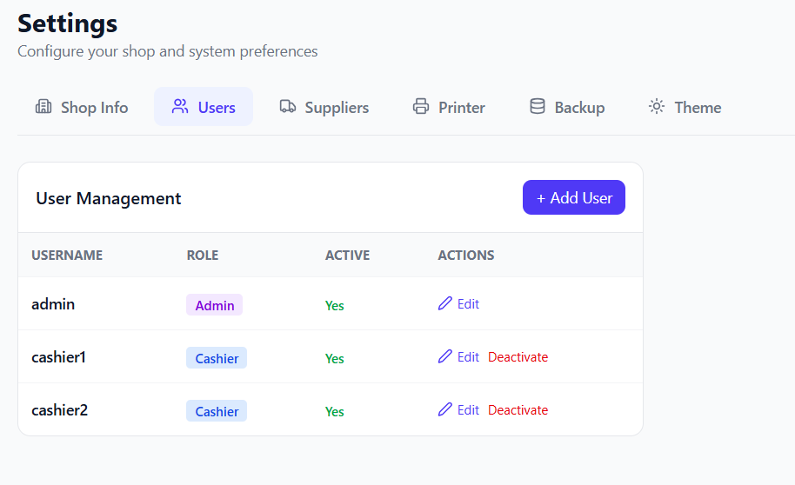
Figure 9-4: Users list showing username, role, and status

Adding a User
1. Click + Add User.
2. Enter Username (unique login name), Password (login password), Role (Admin or Cashier).
3. Click Create User.

Editing a User
Click Edit next to any user to:
- Change username
- Set a new password (leave blank to keep current)
- Change role (Admin role cannot be changed for security)
- Toggle Active status (Admin is always active)

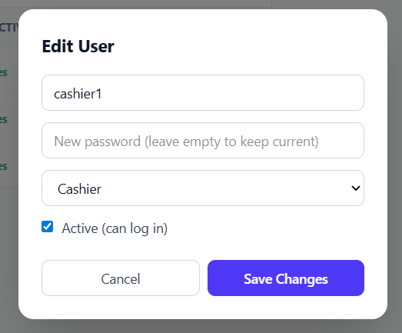
Figure 9-5: Edit user dialog with role and active status

Deactivating a User
Click Deactivate to prevent a user from logging in. The admin user cannot be deactivated.

9.4 Supplier Management
From Settings -> Suppliers tab, you can view all registered suppliers and add new ones.

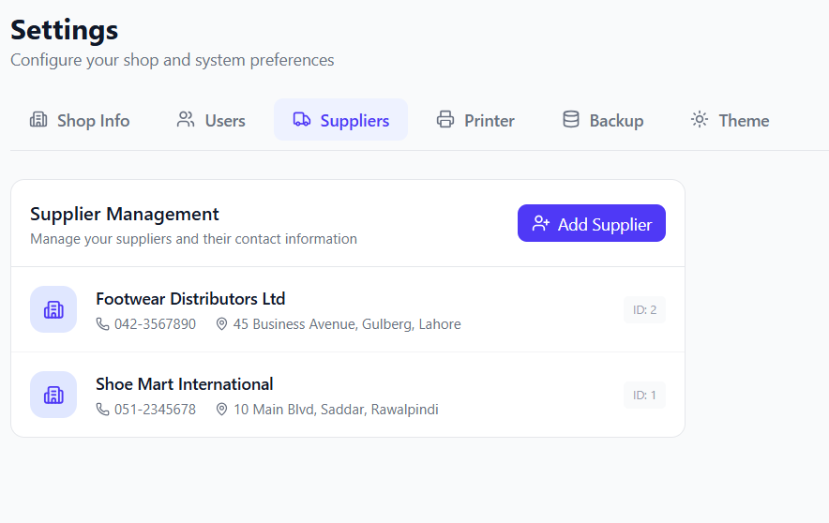
Figure 9-6: Suppliers list with contact details

Each supplier shows: Company name, Phone number, Address, Supplier ID.
Click Add Supplier to register a new supplier using the same form as in Inventory.

9.5 Printer Setup
Configure a thermal receipt printer for printing bills.

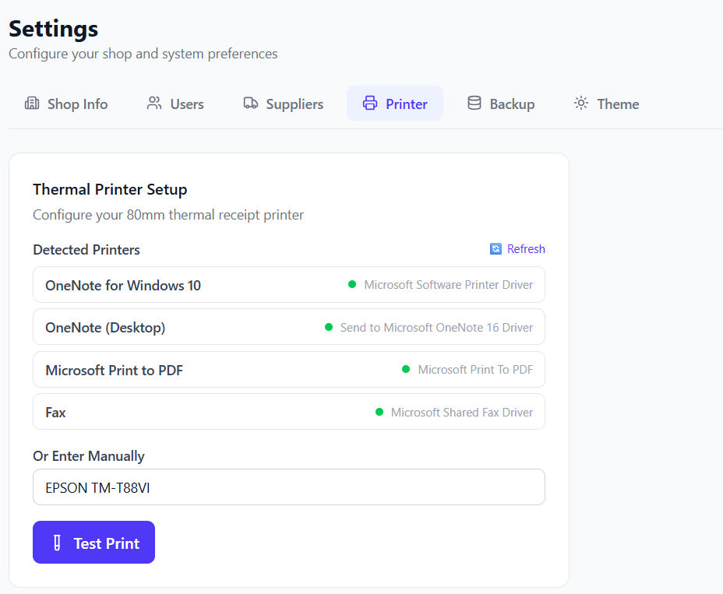
Figure 9-7: Printer configuration page with detected printers

Auto-Detect
1. Click Refresh to scan for installed Windows printers.
2. Detected printers are listed with their status (ready/yellow).
3. Click a printer name to select it.

Manual Entry
If your printer isn’t detected, type the printer name exactly as shown in:
Windows Settings -> Bluetooth & Devices -> Printers & Scanners

Test Print
Click Test Print to send a test receipt to the selected printer. The status message will indicate success or failure.

Note: The printer name must match exactly as configured in Windows. Receipts are formatted for 80mm thermal paper.

9.6 Backup
The Backup tab lets you manage database backups.

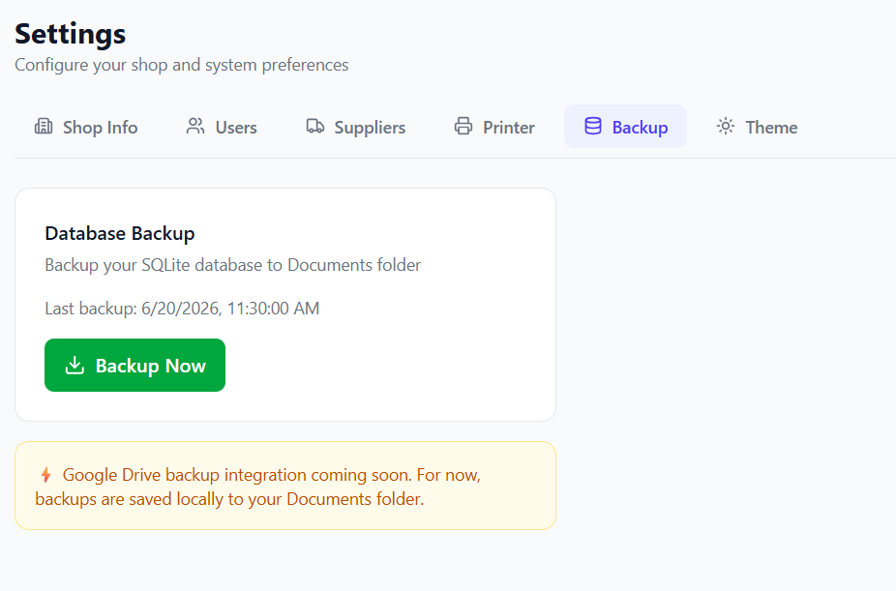
Figure 9-8: Database backup page

Backup Now
Click Backup Now to create a copy of the database. Backups are saved to your Documents folder in a ShoeShopPOS_Backups directory.

Last Backup
The system displays the timestamp of the last successful backup.

Note: Google Drive backup integration is planned for a future update.

9.7 Theme
Toggle between Light and Dark modes.

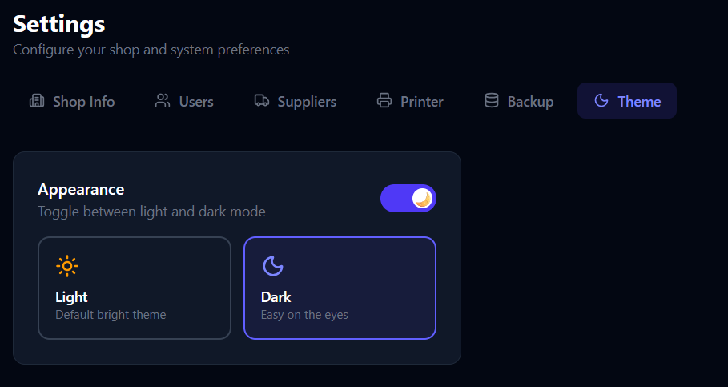
Figure 9-9: Theme selection interface

Click either the Light or Dark card, or use the toggle switch. The setting is saved and persists across app restarts.

10. Keyboard Shortcuts
The POS / Billing screen supports the following keyboard shortcuts:
Key | Action
F1 | New Sale (clears cart and starts fresh)
F2 | Focus / Search bar
F12 | Hold current bill

Note: Barcode Scanner Mode: When no text input field is focused, keystrokes from a barcode scanner are automatically captured and looked up. The scanner must be in keyboard-emulation mode.

11. Troubleshooting

11.1 Application Won't Start
Symptoms: Application crashes on launch or shows a blank screen.
Solutions:
1. Ensure the database path exists: C:\ProgramData\ShoeShopPOS\
2. Delete the database file and restart the app (a fresh database will be created):
C:\ProgramData\ShoeShopPOS\pos.db

3. Reinstall the application.

11.2 Printer Not Working
Symptoms: "No printer configured" error when printing receipts.
Solutions:
1. Go to Settings -> Printer.
2. Click Refresh to detect printers.
3. Ensure the printer is installed in Windows.
4. Check the printer name matches exactly.
5. Run a Test Print to verify.

11.3 Barcode Scanner Not Adding Products
Symptoms: Scanning a barcode does not add the product to the cart.
Solutions:
1. Ensure no input field is focused (click on the empty cart area first).
2. Verify the barcode exists in the Products database.
3. Check that the product is Active (not Inactive).
4. Ensure the scanner is in keyboard-emulation mode.

11.4 Login Issues
Symptoms: "Invalid username or password" for valid credentials.
Solutions:
1. Check Caps Lock is off.
2. Reset the admin password using the seed script:
node scripts/seed.cjs

(This recreates default users if the database is empty.)

11.5 Database Reset (Full Clean)
To completely reset the database:
1. Close the application.
2. Delete the database file:
C:\ProgramData\ShoeShopPOS\pos.db
C:\ProgramData\ShoeShopPOS\pos.db-wal
C:\ProgramData\ShoeShopPOS\pos.db-shm

3. Restart the application — a fresh database is created automatically.

Important: This deletes ALL data including products, sales, and users!

12. Appendix — Database & Data Management

12.1 Database Schema
The application uses SQLite with the following tables:
Table | Description
users | System users (admin/cashier) with hashed passwords
categories | Product categories (Sneakers, Sandals, etc.)
brands | Product brands
products | Main product catalog with stock, pricing, barcodes
suppliers | Supplier contact information
purchases | Purchase orders from suppliers
purchase_items | Individual items in each purchase
sales | Completed and held bills
sale_items | Individual items in each sale
stock_adjustments | Stock change history with reasons
settings | Key-value settings (printer name, backup time)
shop_info | Shop name, address, receipt customization

12.2 Seed Data
The system comes with a seed script at:
scripts/seed.cjs

To run:
node scripts/seed.cjs

This script seeds the database with:
- 4 brands (Nike, Adidas, Bata, Service)
- 12 products covering all categories and genders
- 2 suppliers
- 2 purchase orders
- 5 days of sales (including active, void, and held bills)
- Stock adjustments
- System settings

Note: The seed script only runs if the products table is empty.

12.3 Default Data Created by App
On first launch, the app automatically creates:
Item | Value
Admin user | admin / admin
8 Categories | Sneakers, Sandals, Formal, Casual, Sports, Boots, Slippers, Heels
Default shop | Name: My Shoe Shop

End of User Manual | Shoe Shop POS v1.0 | June 2026
For support, contact your system administrator.

