Assignment: LU Factorization

1. ***Why do we use Matrix Decomposition?***

Matrix decomposition techniques can be used to reduce the dimensionality of data which is essential in data science and analytics when we are dealing with high-dimensional datasets.

Matrix decomposition methods can also provide an efficient way to solve systems of linear equations which are common in engineering and the sciences.

We can also use matrix decomposition methods to approximate matrices by expressing them as a product of simpler matrices or factors. This is particularly useful in data science and analytics for tasks like matrix completion and recommender systems.[1]

1. ***When does a Square Matrix have an LU Decomposition?***

A square matrix, A, has an LU decomposition if it can be factored into the product of a lower triangular matrix (L) and an upper triangular matrix (U). Mathematically, this can be represented as A=LU

For a square matrix to have an LU decomposition, it must satisfy certain conditions. The LU decomposition exists if and only if the matrix A is non-singular (i.e., it has a nonzero determinant) and it doesn't have any zero pivots during the LU factorization process (i.e., no row exchanges are necessary).[2]

1. ***Use an example of a 3x3 matrix and show all steps needed to find the LU decomposition***

To find the LU decomposition of this matrix, we need to decompose it into a lower triangular matrix (L) and an upper triangular matrix (U) such that A = LU. Suppose:

**Step 1:** Generate a matrix A = LU such that L is the lower triangular matrix with principal diagonal elements being equal to 1 and U is the upper triangular matrix. This implies:

**Step 2:** Now, we write AX = B as LUX =B.

**Step 3:** We assume UX = Y

**Step 4:** We can see that LY = B. On solving this equation, we get y1, y2, and y3.

**Step 5:** Substituting in Y, we get UX = Y

Thus, we get the LU decomposition for a 3 x 3 matrix granted that it can be done.[3] How can we prove this? If the matrix A is invertible, it admits an LU factorization if and only if all of the leading principal minors are non-zero.

1. ***Run the following MATLAB program to compare the speed***

It appears to be a 9x speedup just by using LU decomposition!

1. ***Find a real example from, Physics, engineering, data science, economics where LU plays an important role.***

**Physics**

One real example from physics where LU decomposition plays an important role is in solving systems of linear equations arising from the numerical simulation of electromagnetic fields in waveguides or transmission lines.

In electromagnetics, particularly in computational electromagnetics, Maxwell's equations are often discretized using finite difference, finite element, or other numerical methods to solve for the electric and magnetic fields in complex structures like waveguides or transmission lines. These discretized equations typically lead to large systems of linear equations.[4]

This decomposition is particularly advantageous in numerical simulations of electromagnetic fields because it enables the efficient solution of large sparse linear systems.

**Engineering**

One real-world example where LU decomposition plays an important role in engineering is in solving systems of linear equations, particularly in finite element analysis (FEA). FEA is a numerical method used to approximate solutions to boundary value problems in engineering and physics.

In FEA, a complex structure is divided into smaller, simpler elements, and the behavior of each element is analyzed separately. These elements are interconnected at their nodes, forming a system of linear equations that need to be solved to determine the overall behavior of the structure.

LU decomposition helps to efficiently solve the resulting system of linear equations, allowing engineers to accurately analyze the structural integrity and performance of the bridge before it is built or to assess its behavior under different scenarios during its service life

**Data Science**

One real-world example where LU decomposition plays an important role is in linear regression analysis. In multiple linear regression, the goal is to model the relationship between multiple independent variables (predictors) and a dependent variable (response). This involves solving a system of linear equations, where the coefficients of the independent variables are determined through a process of minimization of the sum of squared errors.

By using LU decomposition, computational efficiency is improved, and the process of solving the linear regression model becomes more stable and numerically accurate, especially when dealing with large datasets or systems of equations.[5]

**Economics**

One real-world example where LU decomposition plays an important role in economics is in input-output analysis. Input-output analysis is a method used to study the interdependencies between different sectors of an economy. It helps economists understand how changes in one sector can impact other sectors and the economy as a whole.

In input-output analysis, the economy is represented as a matrix where each row represents the inputs required by each sector to produce its output, and each column represents the outputs of each sector that are used as inputs by other sectors. The matrix is known as the Leontief input-output matrix.[6]

LU decomposition can be used to solve the system of equations represented by the input-output matrix. This decomposition breaks down the matrix into lower triangular and upper triangular matrices, making it easier to solve the system using techniques like forward and backward substitution.

MATLAB code to compare speed

runs = 100;

time1 = zeros(1,runs);

time2 = zeros(1,runs);

**for** t = 1:runs

A = randi(20, 1000) - randi(10, 1000);

b = randi(20, 1000, 1) - randi(10, 1000, 1);

[L, U, P] = lu(A);

tic

x = U\(L\(P*b));

time1(t) = toc;

tic

x = A\b;

time2(t) = toc;

**end**

disp(['mean time LU : ', num2str(mean(time1))])

disp(['mean left divide: ', num2str(mean(time2))])

figure, histogram(time1,50)

figure, histogram(time2,50)

figure, histogram([time1(:) time2(:)],100)

Reference:

1. <https://arxiv.org/pdf/math/0506382v1.pdf>
2. <https://www.math.ucdavis.edu/~linear/old/notes11.pdf>

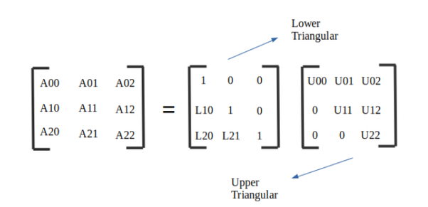

Matrix multiplication is not commutative. L * U is not the same as U * L.

LU decomposition is not always guaranteed. It is guaranteed only when the leading co-factors are not zero. Leading minors are the determinant determined for the 1x1, 2x2 and the 3x3 matrix for the pivot term.

In the example below,

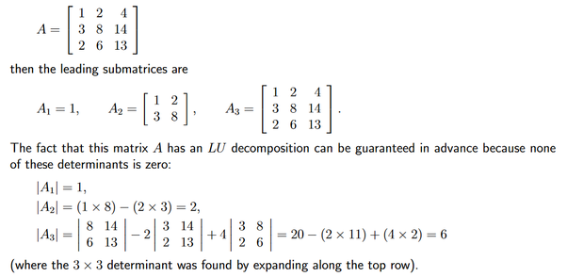

In the matrix below-

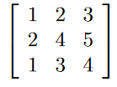

The second leading submatrix = 4 -4 = 0. Thus, LU factorization is not possible for this case.

1. Deisenroth, M. P., Faisal, A. A., & Ong, C. S. (2024). Matrix Decompositions. In Mathematics for Machine Learning (pp. 98–136). essay, Cambridge University Press.
2. Okunev, P., & Johnson, C. R. (2005, June 19). Necessary and sufficient conditions for existence of the Lu factorization of an arbitrary matrix. arXiv.org. <https://arxiv.org/abs/math.NA/0506382>
3. Admin. (2022, November 9). Lu decomposition: Lu Decomposition Method of factorisation steps. BYJUS. <https://byjus.com/maths/lu-decomposition/>
4. W. C. Gibson, "Efficient Solution of Electromagnetic Scattering Problems Using Multilevel Adaptive Cross Approximation and LU Factorization," in IEEE Transactions on Antennas and Propagation, vol. 68, no. 5, pp. 3815-3823, May 2020, doi: 10.1109/TAP.2019.2963619.
5. Zieffler, M. R. & A. (2022, August 9). Matrix algebra for educational scientists. Chapter 22 Statistical Application: Estimating Regression Coefficients with LU Decomposition. <https://zief0002.github.io/matrix-algebra/statistical-application-estimating-regression-coefficients-with-lu-decomposition.html>
6. Dongarra, J. J., Gustayson, F. G., and Karp, A. Implementing Linear Algebra Algorithms for Dense Matrices on

   a Vector Pipeline Machine. SIAM Review, 26, 1 (January

   1984).

   Johnsson, S. Lennart. Communication Efficient Basic Linear Algebra Computations on Hypercube Architectures.

   Journal of Parallel and Distributed Computing, 4, pp.

   133-172 (1987).

   Trefethen, Lloyd N. and Schreiber, Robert S. AverageCase Stability of Gaussian Elimination. M.I.T. Department of Mathematics, Numerical Analysis Report 88-3

   (May 1988).

   Vava,sis, Stephen. Implementation of QR factorization on the CM-2. Thinking Machines Corporation (17 September

   1988)