**UniPro**

**Jeong Eun Chong (B1002334)**

**Chong Jun Ming (B1201361)**

**Introduction**

There has a saying, ‘Measure 10 times before cutting.’ means ‘Be considerable before doing something’. This is especially pointing about wise consume. We are living in the Ocean of Information and technology, and this environment made big change to people nowadays whether they are seller or customer. Originally internet was developed for communicate and share information and data between professional technicians, but business was started by people who realized the develop possibility of internet, and it made a hit as internet technology popularized. Development of E-commerce contributed to Internet development very much for sure.

Before internet developed, every consumption was only made through offline, and get goods from oversea was limited stock and even more expensive than original price. If customer want the item then they had no other choice although they knew the price is abnormal. However, the condition has changed after internet, and transit technologies developed. Customers started to order through online from local places, and receive items by parcels. Dependency on offline sellers is decreased, and advantage of them became demerit. Then sellers also expanded their business to online, and in this process, a lot of similar items got various prices as setting of sellers. In old time, market chose customer, but as customers become worldwide, customers choose market nowadays. Sellers started offer some promotions to attract customers, and since too much information it made customers confuse.

So, we decided to develop one web site, Unipro, as provide and share customers known promotion information to help each other to consume wisely.

**Project Aim**

Our project aim is let users share their known promotion information to help each users to consume wisely whether is online or offline. Throughout share each other information, give users clear and wise consume information and help them to make better decision.

**Project Objective**

This platform will provide the sharing information services between user to user in particular categories, like Clothes, IT, Food, etc.

* To educate users about wise consumption for their wanted item.
* To increase communicate between users for additional information.
* Centralize the information so user don’t need to research many sites.
* To provide the location (geographical coordinate) of promotion place, if it’s offline promotion.

**Project Scope**

This platform allows users to use the platform via internet web browser and there will be functionalities.

* Allow user to sign up and log in
* Allow user to post their known promotion information
* Allow user to comment and recommend / non-recommend the promotion information
* Allow user to rank up based on the number of recommends
* Allow user to sort posts based on the filter(Categories, popularity, most recommended, etc.) what user set

**Methodology**

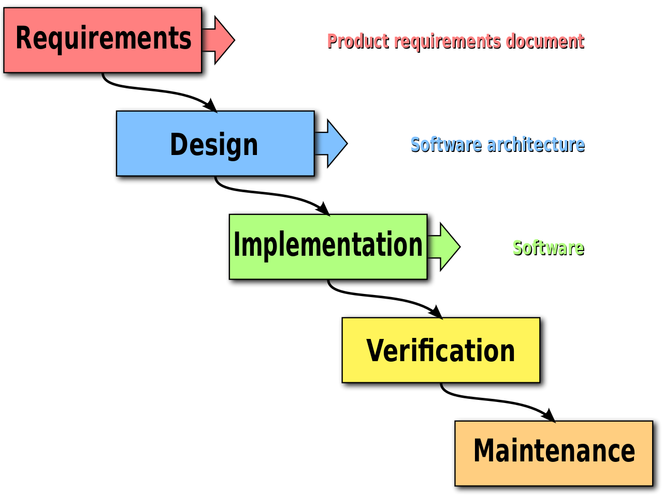

For our project, we decided to implement Waterfall development model. The reason why we choose this model is Waterfall is most common, simple and easy to understand the concept of each processes and easy to manage for web development. We can check the result of each phases at the end of phase. Waterfall must be in strict orders, without any overlapping or iterative steps. Means it can be disadvantage because it’s very difficult to go back current process to change. To implement waterfall model, we need to approach to each phases very carefully and completely.

**Work Breakdown Diagram**

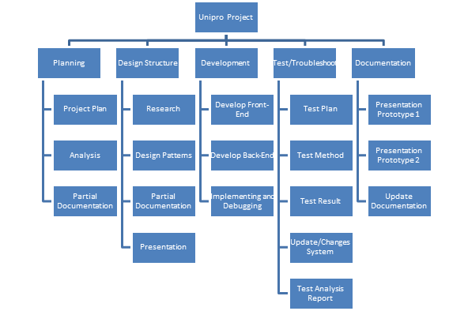

**Work Breakdown Table**

|  |  |  |  |
| --- | --- | --- | --- |
| **Name** | **Task** | **Milestone/Deliverable** | **Date** |
| Chong Jun Ming  & Jeong Eun Chong | Complete Project Plan/Proposal | Project Proposal | 6/2/17 |
|  | Complete the requirements and Specifications | Project Requirements Specification Document | 20/2/17 |
|  | Prepare presentation for Assignment 1 and 2 | Presentation for Assignment 1/2 | 24/2/17 |
| FIRST ITERATION | | | |
|  | Design Site Structure | Site Structure | 23/2/17 |
|  | Search & Download Resources | Relevant Resource Collected | 24/2/17 |
|  | Design the Interface of Unipro | Unipro Interface | 5/3/17 |
|  | Design the Architectural | Unipro Architectural | 5/3/17 |
|  | Design the Data | Unipro Data System | 5/3/17 |
|  | Create Database/File Design | Unipro Database Created | 5/3/17 |
|  | Do testing and troubleshoot | Tested and changes made | 8/3/17 |
|  | Compile Documentation | Documentation for Part 3 | 11/3/17 |
|  | Prepare for Presentation Prototype 1 | Presentation for prototype 1 | 13/3/17 |
| SECOND ITERATION | | | |
|  | Update Designs | Lower Half of The Project Complete and Update | 26/3/17 |
|  | Update testing and troubleshoot | Tested and changes made | 31/3/17 |
|  | Compile Documentation | Final Documentation | 3/4/17 |
|  | Prepare for Presentation Prototype 2 | Presentation for prototype 2 | 6/4/17 |

**Gantt Chart**

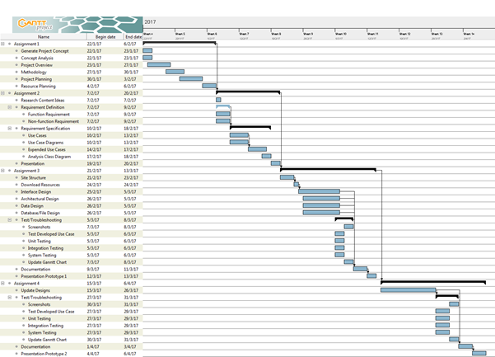

**Resource Planning**

* **Project Development**

|  |  |  |
| --- | --- | --- |
| **Hardware Type** | **Model/Version** | **Purposes** |
| Intel i5 CPU | I5 – 2450M | · Processes Data and Tasks |
| Notebook DELL | Inspiron N4110 | · Run Programs and Display |

|  |  |  |
| --- | --- | --- |
| **Software Type** | **Model/Version** | **Purposes** |
| Notepad++ | 6.9.1 | · To coding using for back-end and front-end |
| XAMMP | 1.3.5 | · To create server for database |
| Workbench | 6.3CE | · To coding and create database |

* **Demo Environment**

|  |  |  |
| --- | --- | --- |
| **Hardware Type** | **Model/Version** | **Purposes** |
| Intel i5 CPU | I5 – 2450M | · Processes Data and Tasks |
| Notebook DELL | Inspiron N4110 | · Run Programs and Display |

|  |  |  |
| --- | --- | --- |
| **Software Type** | **Model/Version** | **Purposes** |
| Google Chrome | 55.0.2883.87 | · To display the website  · test function  · check compatibility |
| Internet Explorer | 11.0.23 | · To display the website  · test function  · check compatibility |

**Risk Management**

|  |  |  |  |
| --- | --- | --- | --- |
| **Risk** | **Likelihood** | **Potential Impact** | **Mitigation** |
| Sickness | Low | Low | Stay healthy, inform to teammate |
| Lack of Communication | Low | High | Keep contact each other and ask if anything else can’t understand |
| Not meeting schedule | Moderate | High | Keep review and update the schedule to remind plan and try to finish each schedule in time |
| Computer failure | Low | High | Keep backup to other storage |

**References**

* What is waterfall model? - Definition from WhatIs.com. (n.d.). Retrieved February 07, 2017, from <http://searchsoftwarequality.techtarget.com/definition/waterfall-model>
* The History Of Ecommerce: How Did It All Begin? (2011, October 26). Retrieved February 07, 2017, from <http://www.miva.com/blog/the-history-of-ecommerce-how-did-it-all-begin/>
* Avoid the Common Risks: Web Development Project Management. (2011, March 12). Retrieved February 07, 2017, from http://www.brighthubpm.com/risk-management/109875-common-risks-in-web-development-project-management/