Assignment 4

Yan Li

August 21 2015

# Load packages, data and set the working library:

.libPaths("C:/work/Rpackages/R3.2.1")  
suppressMessages(library(ggplot2))  
suppressMessages(library(dplyr))  
suppressMessages(library(mosaicData))  
suppressMessages(library(babynames))  
suppressMessages(library(fastR))  
suppressMessages(library(tidyr))  
suppressMessages(library(ggvis))  
suppressMessages(library(scales))  
  
#turn off warning messages  
options(warn=-1)  
  
#Set working directory  
setwd("C:\\work\\Rggplot2\\Lesson 4")

The data used in this assignmet is Texas:

Texas <- read.csv("texas.csv")  
head(Texas,1)

## county long lat group order state disease icd_code  
## 1 anderson -95.75271 31.5356 1 1 texas Circulatory system I00-I99  
## year count population rate rank bin  
## 1 2006 181 56474 320.5 134 < 1e5

#Simplified the data: delete duplicated rows  
PopChoro <- unique(Texas[c("county", "long", "lat", "group", "order", "population",   
"bin")])  
head(PopChoro,2)

## county long lat group order population bin  
## 1 anderson -95.75271 31.53560 1 1 56474 < 1e5  
## 2 anderson -95.76989 31.55852 1 2 56474 < 1e5

The original plot of Texas data showing the population by county:

q <- qplot(long, lat, data = PopChoro, geom = "polygon", group = group, fill = bin)  
  
q

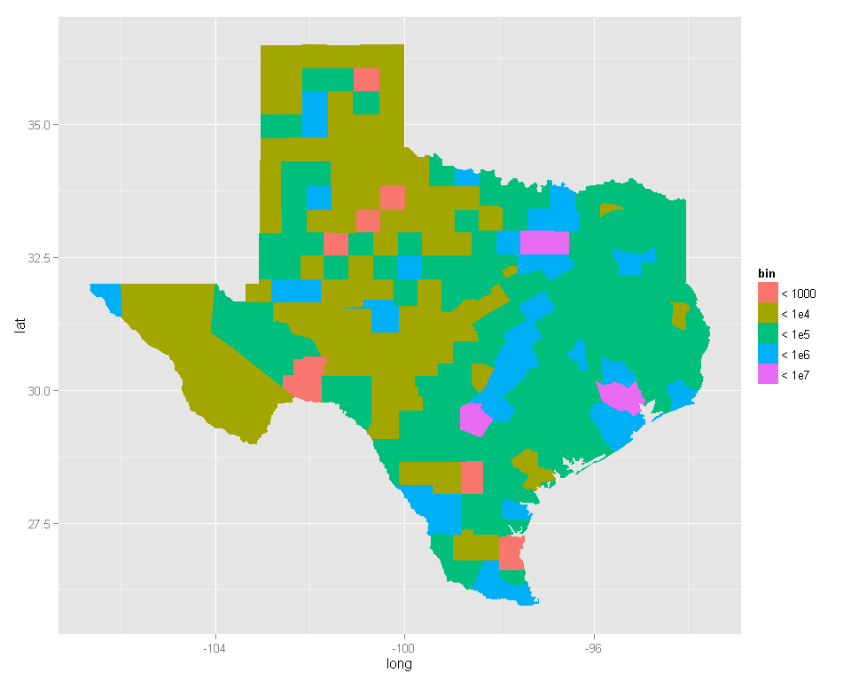

This assignment is to improve the plot by:

1 Adding an informative title

2 Choosing a better color scale

3 Giving more informative title and keys on the legend

4 Removing the unnecessary x and y axis labels

5 Making it look more like a map by giving it a white background.

6 (Extra credit) Use a better coordination system (skim Chapter 6 "Positioning" for some ideas)

# 1 Adding an informative title

#Add texts by labs()  
myLabs<- labs(title="Population of Texas by County",  
x = "longitude of Texas (long)",  
y = "lattitude of Texas (lat)",  
fill = "population range (bin)")  
  
q+myLabs

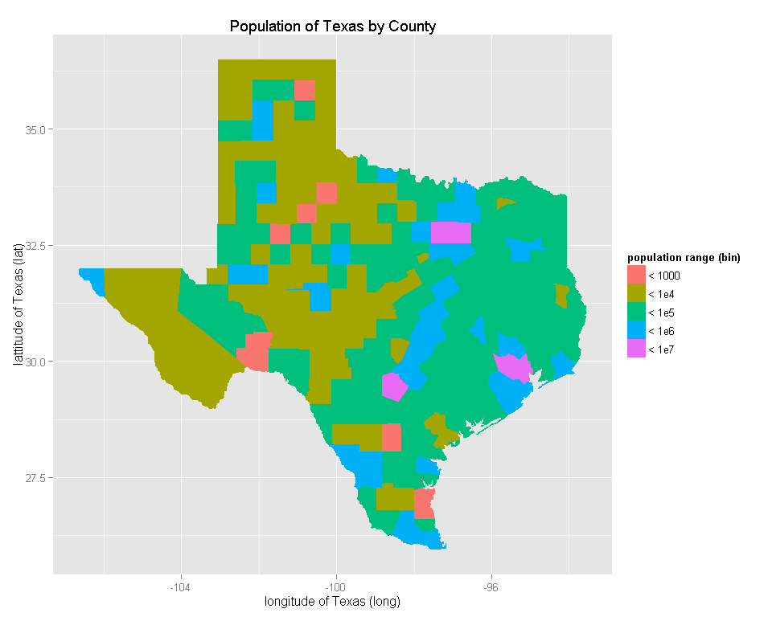

#Add some fomata and colors  
myTheme<- theme(plot.title = element_text(colour='navy', size=18, face='bold', family='serif'),  
 axis.title.x = element_text(colour='blue', size=14, family='serif'),  
 axis.title.y = element_text(colour='blue', size=14, family='serif')  
 )  
  
q+myLabs+myTheme

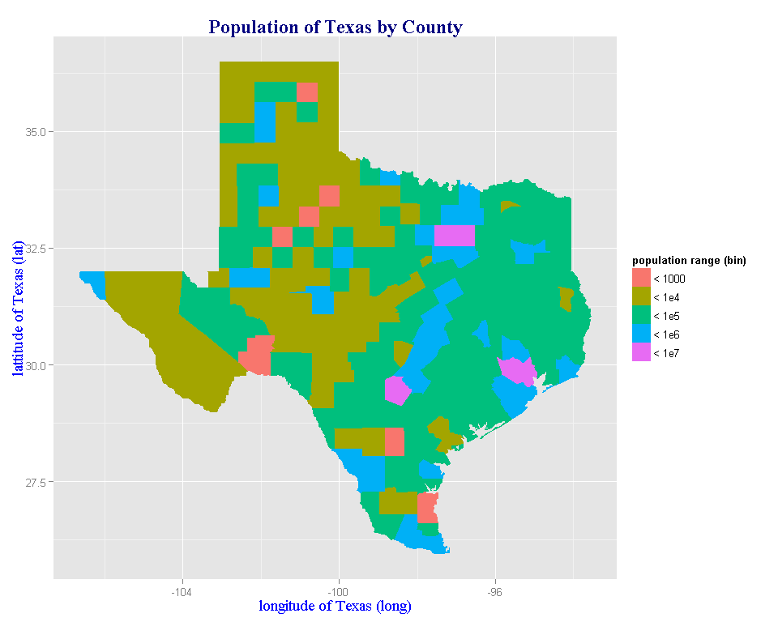

# 2 Choosing a better color scale

#Use qulitative red pallete to show the populations change  
  
# qplot(long, lat, data = PopChoro)+ geom_polygon(aes(group= group, fill = bin))+scale_fill_brewer(type = "qual")  
  
myScale <- scale_fill_brewer(type = "qual", palette = "Reds")  
  
q+myLabs+myTheme+myScale

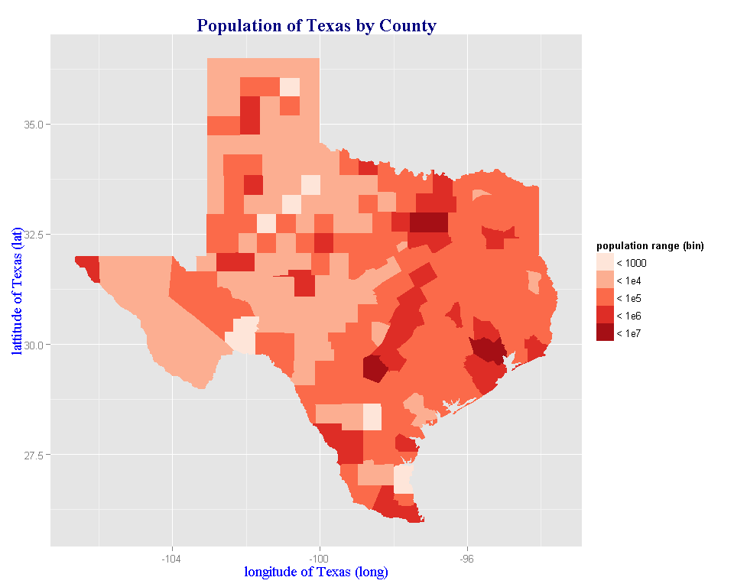

# 3 Giving more informative title and keys on the legend

The title was modified in question 1 by labs(). The following change the font color and size.

myTheme2 <- theme(legend.title = element_text(colour='red', size=10, family='serif'),  
 legend.text = element_text(colour='red', size=10, family='serif'))  
  
q+myLabs+myTheme+myScale+myTheme2

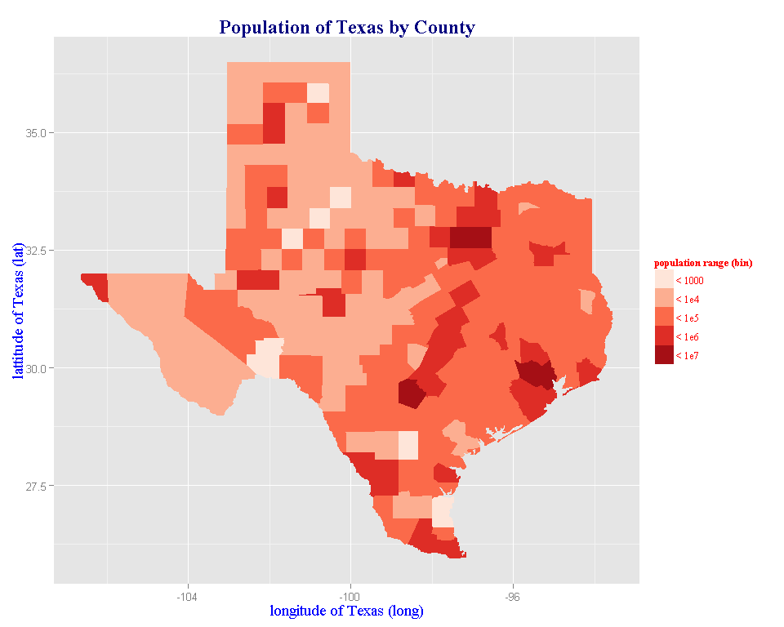

# 4 Removing the unnecessary x and y axis labels

myTheme3 <- theme(axis.text.x = element_blank(),  
axis.ticks.x = element_blank(),  
axis.text.y = element_blank(),  
axis.ticks.y = element_blank())  
  
q+myLabs+myTheme+myScale+myTheme2+myTheme3

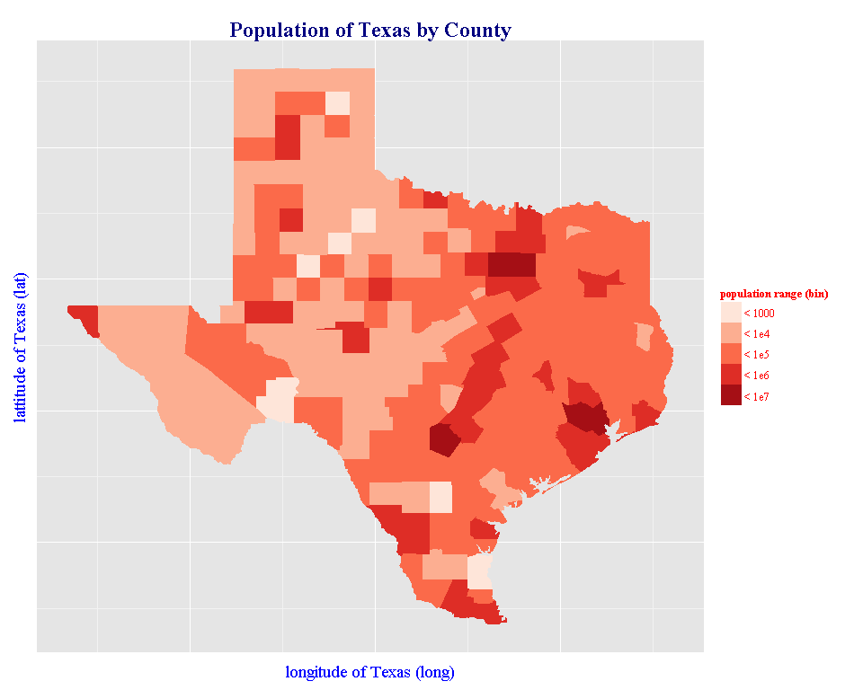

# 5 Making it look more like a map by giving it a white background.

myTheme4 <- theme(panel.grid.major=element_line(colour="white"),  
panel.grid.minor=element_line(colour="white"),  
panel.background=element_rect(fill=alpha("white",0.2)))  
  
q+myLabs+myTheme+myScale+myTheme2+myTheme3+myTheme4

