# 一、图标

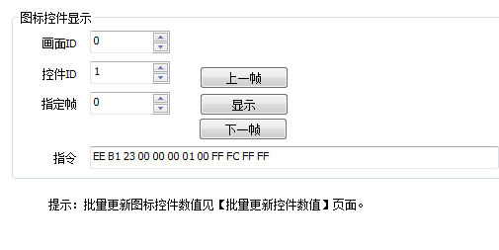

|  |  |  |  |  |  |  |  |  |  |  |  |
| --- | --- | --- | --- | --- | --- | --- | --- | --- | --- | --- | --- |
| 0 | 1 | 2 | 3 | 4 | 5 | 6 | 7 | 8 | 9 | 10 | 12 |
| EE | B1 | 23 | 00 | 00 | 00 | 01 | 00 | FF | FC | FF | FF |

|  |  |  |  |  |
| --- | --- | --- | --- | --- |
| **位（从左向右,0起）** | **颜色** | **内容** | **范围** | **备注** |
| 3-4 | 黄色 | 画面ID | 0-1 |  |
| 5-6 | 绿色 | 控件ID | 1-20 |  |
| 7 | 蓝色 | 指定帧 | 0-1 | 0：绿色（导通）  1：红色（断开） |

例如：EE B1 23 **00 00 00 0A 01** FF FC FF FF

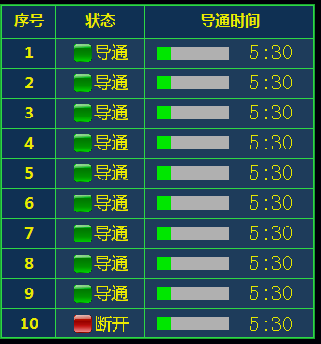

# 二、进度条

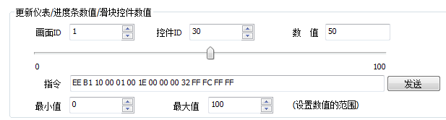

|  |  |  |  |  |  |  |  |  |  |  |  |  |  |  |
| --- | --- | --- | --- | --- | --- | --- | --- | --- | --- | --- | --- | --- | --- | --- |
| 0 | 1 | 2 | 3 | 4 | 5 | 6 | 7 | 8 | 9 | 10 | 11 | 12 | 13 | 14 |
| EE | B1 | 10 | 00 | 00 | 00 | 01 | 00 | 00 | 00 | 00 | FF | FC | FF | FF |

|  |  |  |  |  |
| --- | --- | --- | --- | --- |
| **位（从左向右,0起）** | **颜色** | **内容** | **范围** | **备注** |
| 3-4 | 黄色 | 画面ID | 0-1 |  |
| 5-6 | 绿色 | 控件ID | 21-40 |  |
| 7-10 | 蓝色 | 进度条数值 | 0-100 |  |

EE B1 10 **00 00 00 1E 00 00 00 32** FF FC FF FF

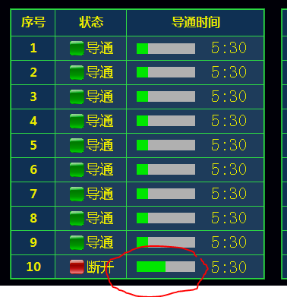

# 三、文本

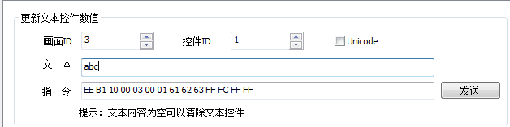

|  |  |  |  |  |  |  |  |  |  |  |  |  |  |  |
| --- | --- | --- | --- | --- | --- | --- | --- | --- | --- | --- | --- | --- | --- | --- |
| 0 | 1 | 2 | 3 | 4 | 5 | 6 | 7 | 8 | 9 | 10 | 11 | 12 | 13 | 14 |
| EE | B1 | 10 | 00 | 03 | 00 | 01 | 35 | 3A | 34 | 30 | FF | FC | FF | FF |

|  |  |  |  |  |
| --- | --- | --- | --- | --- |
| **位（从左向右,0起）** | **颜色** | **内容** | **范围** | **备注** |
| 3-4 | 黄色 | 画面ID | 0-1 |  |
| 5-6 | 绿色 | 控件ID | 51-60 |  |
| 7-10 | 蓝色 | 文本数值 | X:XX |  |

EE B1 10 00 00 00 32 31 3A 34 36 FF FC FF FF

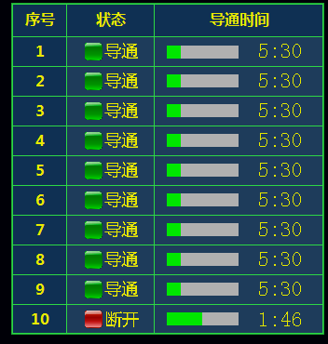

# 四、暂停、继续、停止

|  |  |  |  |  |  |  |  |  |
| --- | --- | --- | --- | --- | --- | --- | --- | --- |
| 0 | 1 | 2 | 3 | 4 | 5 | 6 | 7 | 8 |
| AB | CA | AB | 00 | 0X | FF | FC | FF | FF |

AB CA AB 00 01 FF FC FF FF

|  |  |
| --- | --- |
| **数值** | **含义** |
| 00 01 | 暂停 |
| 00 02 | 继续 |
| 00 03 | 停止 |