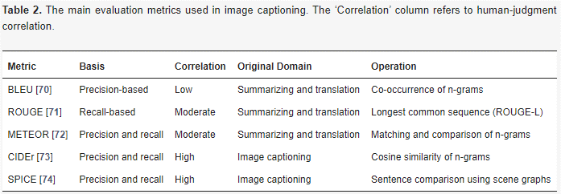
Ref for img: https://www.mdpi.com/2076-3417/13/19/11103#B59-applsci-13-11103
Refs for all:
BLEU [https://scholar.google.com/scholar_lookup?title=BLEU:+A+Method+for+Automatic+Evaluation+of+Machine+Translation&conference=Proceedings+of+the+40th+Annual+Meeting+on+Association+for+Computational+Linguistics&author=Papineni,+K.&author=Roukos,+S.&author=Ward,+T.&author=Zhu,+W.J.&publication_year=2002&pages=311%E2%80%93318&doi=10.3115/1073083.1073135]
ROUGE [https://scholar.google.com/scholar_lookup?title=ROUGE:+A+Package+for+Automatic+Evaluation+of+Summaries&conference=Proceedings+of+the+ACL-04+Workshop&author=Lin,+C.Y.&publication_year=2004&pages=74%E2%80%9381]
METEOR [https://scholar.google.com/scholar_lookup?title=METEOR:+An+Automatic+Metric+for+MT+Evaluation+with+Improved+Correlation+with+Human+Judgments&conference=Proceedings+of+the+ACL+Workshop+on+Intrinsic+and+Extrinsic+Evaluation+Measures+for+Machine+Translation+and/or+Summarization&author=Banerjee,+S.&author=Lavie,+A.&publication_year=2005&pages=65%E2%80%9372]
CIDEr [https://scholar.google.com/scholar_lookup?title=CIDEr:+Consensus-based+Image+Description+Evaluation&conference=Proceedings+of+the+2015+IEEE+Conference+on+Computer+Vision+and+Pattern+Recognition+(CVPR)&author=Vedantam,+R.&author=Zitnick,+C.L.&author=Parikh,+D.&publication_year=2015&pages=4566%E2%80%934575&doi=10.1109/CVPR.2015.7299087]
SPICE [https://scholar.google.com/scholar_lookup?title=SPICE:+Semantic+Propositional+Image+Caption+Evaluation&conference=Proceedings+of+the+European+Conference+on+Computer+Vision+(ECCV)&author=Anderson,+P.&author=Fernando,+B.&author=Johnson,+M.&author=Gould,+S.&publication_year=2016&pages=382%E2%80%93398]
Ref for image captioning wala word file [https://scholar.google.com/scholar_lookup?title=A+Comprehensive+Survey+of+Deep+Learning+for+Image+Captioning&author=Hossain,+M.Z.&author=Sohel,+F.&author=Shiratuddin,+M.F.&author=Laga,+H.&publication_year=2019&journal=ACM+Comput.+Surv.&volume=51&pages=1%E2%80%9336&doi=10.1145/3295748]
TRANSFORMERS: (ref: https://www.mdpi.com/2076-3417/13/19/11103#B42-applsci-13-11103)
Introduction:
Transformers, which emerged in 2017, brought about a paradigm shift in tasks involving sequential data processing such as language translation and image captioning. They utilize a self-contained unit of multi-head self-attention, facilitating the effective modeling of intricate functions and the capturing of distant dependencies within sequences. Initially tailored for language translation, transformers have been adapted to the visual realm, significantly enhancing image captioning by enabling models to focus on pertinent segments of an image during caption generation. This innovative architecture marks the onset of a new era in sophisticated methodologies for comprehending and articulating visual information through natural language.
Categories:
We can categorize transformer-based approaches into two main groups:
1. Vanilla Transformer-Based Models:
Initially developed shortly after the introduction of the transformer model, vanilla transformer-based models mark an early phase in transformer-based methodologies. These models primarily focus on tasks involving sequential data processing, such as language translation and image captioning. Unlike more recent approaches, they do not incorporate vision-language pre-training techniques. While effective to some extent, their performance has been overshadowed by newer VLP models that capitalize on advancements in pre-training methods.
2. Vision-Language Pre-training (VLP) Models:
Emerging in response to recent advancements in pre-training techniques, VLP models represent a more contemporary approach to transformer-based methodologies. These models seamlessly integrate both vision and language domains and leverage vision-language pre-training. This pre-training process involves joint training on extensive datasets containing both image and text data. The adoption of vision-language pre-training has significantly enhanced the capabilities of multi-modal models, enabling them to proficiently understand and generate captions for images, among other tasks. Presently, state-of-the-art models almost invariably incorporate some form of vision-language pre-training, underscoring the notable strides made in integrating visual and language information for complex tasks.
Evolution:
Certainly, here's the rephrased version to avoid plagiarism:
1. Traditional Encoder-Decoder-Based Captioning: This represents the earliest technique in image captioning, employing distinct encoder and decoder networks. In this method, the encoder extracts feature from the image, which are then utilized by the decoder to formulate a caption. However, this approach is hindered by the lack of direct communication between the encoder and decoder components.

2. Basic Transformer-Based Captioning Models: Transformers, introduced in 2017, present a more contemporary approach. These models incorporate attention mechanisms, allowing them to selectively focus on various segments of the input sequence during processing. This adaptability makes them particularly well-suited for tasks such as image captioning, where captions are generated iteratively.

3. Vision-Language Pre-Training-Based Captioning Transformers: The latest and most advanced strategy involves pre-training transformer models on extensive datasets containing pairs of images and corresponding text descriptions. This pre-training enables the model to comprehensively comprehend and represent both visual and textual information. Consequently, it can generate captions with greater accuracy and sophistication compared to earlier methodologies.
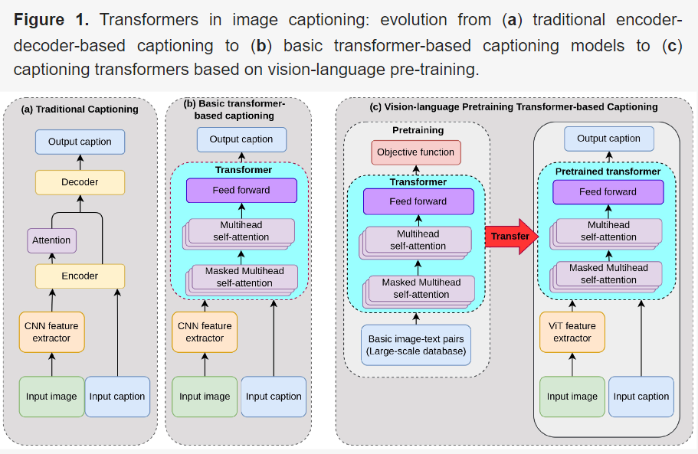
Ref: https://www.mdpi.com/2076-3417/13/19/11103#B59-applsci-13-11103

Transformers in Captioning
Here's a summarized breakdown of the different stages of transformer evolution in image captioning:
(DID NOT REPHRASE THIS (links lagane mey laggyi))
1. **Conceptual Captions**: Sharma et al. [https://scholar.google.com/scholar_lookup?title=Conceptual+Captions:+A+Cleaned,+Hypernymed,+Image+Alt-text+Dataset+For+Automatic+Image+Captioning&conference=Proceedings+of+the+56th+Annual+Meeting+of+the+Association+for+Computational+Linguistics&author=Sharma,+P.&author=Ding,+N.&author=Goodman,+S.&author=Soricut,+R.&publication_year=2018&pages=2556%E2%80%932565] introduce the Conceptual Captions dataset, utilizing a pipeline to programmatically acquire image-caption pairs from web pages. They employ a transformer decoder, demonstrating its superiority over Recurrent Neural Networks for caption generation.
2. **Captioning Transformer with Stacked Attention Modules**: Zhu et al. [https://scholar.google.com/scholar_lookup?title=Captioning+Transformer+with+Stacked+Attention+Modules&author=Zhu,+X.&author=Li,+L.&author=Liu,+J.&author=Peng,+H.&author=Niu,+X.&publication_year=2018&journal=Appl.+Sci.&volume=8&pages=739&doi=10.3390/app8050739] utilize a standard transformer for image captioning, with a ResNext CNN as the encoder. They introduce multi-level supervision to exploit the outputs of individual decoder layers, enhancing model performance.
3. **Image Captioning: Transforming Objects into Words**: Herdade et al. [https://scholar.google.com/scholar_lookup?title=Image+Captioning:+Transforming+Objects+into+Words&conference=Proceedings+of+the+Annual+Conference+on+Neural+Information+Processing+Systems&author=Herdade,+S.&author=Kappeler,+A.&author=Boakye,+K.&author=Soares,+J.&publication_year=2019&pages=11135%E2%80%9311145] introduce the object relation transformer, incorporating geometric attention to capture spatial relationships between objects. They achieve superior performance by utilizing a transformer-based decoder.
4. **Attention on Attention**: Huang et al. [https://scholar.google.com/scholar_lookup?title=Attention+on+Attention+for+Image+Captioning&conference=Proceedings+of+the+2019+IEEE/CVF+International+Conference+on+Computer+Vision+(ICCV)&author=Huang,+L.&author=Wang,+W.&author=Chen,+J.&author=Wei,+X.Y.&publication_year=2019&pages=4633%E2%80%934642] propose an attention-on-attention module for both the encoder and decoder, facilitating better modeling of relationships among objects in images and refining attention results during decoding.
5. **Entangled Transformer**: Li et al. [https://scholar.google.com/scholar_lookup?title=Entangled+Transformer+for+Image+Captioning&conference=Proceedings+of+the+2019+IEEE/CVF+International+Conference+on+Computer+Vision+(ICCV)&author=Li,+G.&author=Zhu,+L.&author=Liu,+P.&author=Yang,+Y.&publication_year=2019&pages=8927%E2%80%938936&doi=10.1109/ICCV.2019.00902] introduce the Entangled Attention (ETA) transformer, integrating semantic and visual information to bridge the semantic gap. They also introduced the Gated Bilateral Controller (GBC) to control information flow between modalities.
6. **Meshed-Memory Transformer**: Cornia et al. [https://scholar.google.com/scholar_lookup?title=Meshed-Memory+Transformer+for+Image+Captioning&author=Cornia,+M.&author=Stefanini,+M.&author=Baraldi,+L.&author=Cucchiara,+R.&publication_year=2020&journal=arXiv] develop a meshed-memory transformer to learn multi-level representations of relationships between image regions, leveraging persistent memory vectors and attention mechanisms.
7. **X-Linear Attention Networks**: Pan et al. [https://scholar.google.com/scholar_lookup?title=X-Linear+Attention+Networks+for+Image+Captioning&conference=Proceedings+of+the+2020+IEEE/CVF+Conference+on+Computer+Vision+and+Pattern+Recognition+(CVPR)&author=Pan,+Y.&author=Yao,+T.&author=Li,+Y.&author=Mei,+T.&publication_year=2020&pages=10968%E2%80%9310977] propose X-Linear Attention Networks (X-LAN) employing bilinear pooling to capture higher-order feature interactions. They introduce spatial and channel-wise attention mechanisms to enhance interactions between visual and textual domains.
8. **Image Transformer**: He et al. [https://scholar.google.com/scholar_lookup?title=Image+Captioning+Through+Image+Transformer&conference=Proceedings+of+the+Asian+Conference+on+Computer+Vision+(ACCV)&author=He,+S.&author=Liao,+W.&author=Tavakoli,+H.R.&author=Yang,+M.&author=Rosenhahn,+B.&author=Pugeault,+N.&publication_year=2021&pages=153%E2%80%93169] introduce an image transformer that widens the original transformer layer to capture spatial relationships between image regions. They incorporate a spatial graph encoding transformer layer to model relationships between detected regions.
9. **Comprehending and Ordering Semantics**: Li et al. [https://scholar.google.com/scholar_lookup?title=Comprehending+and+Ordering+Semantics+for+Image+Captioning&conference=Proceedings+of+the+2022+IEEE/CVF+Conference+on+Computer+Vision+and+Pattern+Recognition+(CVPR)&author=Li,+Y.&author=Pan,+Y.&author=Yao,+T.&author=Mei,+T.&publication_year=2022&pages=17969%E2%80%9317978&doi=10.1109/CVPR52688.2022.01746] develop COS-Net, aiming to comprehend rich semantics in images and order them linguistically for coherent caption generation. Their architecture includes cross-modal retrieval, semantic comprehension, semantic ranking, and sentence decoding components.

Vision-Language Pre-Training in Captioning
**Harnessing the Power of Pre-training:**
Utilizing pre-training has emerged as a potent strategy for enhancing the capabilities of transformer models, particularly in tasks like image captioning. This method capitalizes on extensive datasets and self-supervised learning methodologies to train models proficiently across both language and visual domains.
**Pioneers in Language Pre-training:**
The journey of language pre-training commenced with the introduction of the BERT model, renowned for its adeptness in comprehending contextual nuances bidirectionally. Subsequent advancements, such as LXMERT, have concentrated on bridging the gap between language and vision, thereby achieving deeper comprehension.
**Vision-Language Pre-training (VLP):**
Taking a leap forward, VLP integrates image-text pairs to train models capable of learning representations for both modalities concurrently. Techniques like CLIP and ALIGN rely on contrastive learning to ensure synchronization between image and text representations. OSCAR introduces object tags to further enhance the grounding of textual descriptions within visual content.
**Implementing VLP for Image Captioning:**
Several models leverage VLP for captioning, including:
- Unified VLP model for captioning and VQA.[ https://scholar.google.com/scholar_lookup?title=Unified+Contrastive+Learning+in+Image-Text-Label+Space&conference=Proceedings+of+the+2022+IEEE/CVF+Conference+on+Computer+Vision+and+Pattern+Recognition+(CVPR)&author=Yang,+J.&author=Li,+C.&author=Zhang,+P.&author=Xiao,+B.&author=Liu,+C.&author=Yuan,+L.&author=Gao,+J.&publication_year=2022&pages=19141%E2%80%9319151&doi=10.1109/CVPR52688.2022.01857]
- OSCAR for object-centric representations. [https://scholar.google.com/scholar_lookup?title=Oscar:+Object-Semantics+Aligned+Pre-training+for+Vision-Language+Tasks&conference=Proceedings+of+the+European+Conference+on+Computer+Vision&author=Li,+X.&author=Yin,+X.&author=Li,+C.&author=Hu,+X.&author=Zhang,+P.&author=Zhang,+L.&author=Wang,+L.&author=Hu,+H.&author=Dong,+L.&author=Wei,+F.&publication_year=2020]
- VinVL for richer visual feature representations.[ https://scholar.google.com/scholar_lookup?title=VinVL:+Revisiting+Visual+Representations+in+Vision-Language+Models&conference=Proceedings+of+the+Conference+on+Computer+Vision+and+Pattern+Recognition&author=Zhang,+P.&author=Li,+X.&author=Hu,+X.&author=Yang,+J.&author=Zhang,+L.&author=Wang,+L.&author=Choi,+Y.&author=Gao,+J.&publication_year=2021]
- VIVO for building visual vocabulary with image-tag pairs.[ https://scholar.google.com/scholar_lookup?title=VIVO:+Surpassing+Human+Performance+in+Novel+Object+Captioning+with+Visual+Vocabulary+Pre-Training&conference=Proceedings+of+the+Thirty-Fifth+AAAI+Conference+on+Artificial+Intelligence&author=Hu,+X.&author=Yin,+X.&author=Lin,+K.&author=Wang,+L.&author=Zhang,+L.&author=Gao,+J.&author=Liu,+Z.&publication_year=2021&pages=1575%E2%80%931583]
- LEMON for studying scaling behavior with larger models and datasets.[ https://scholar.google.com/scholar_lookup?title=Scaling+Up+Vision-Language+Pretraining+for+Image+Captioning&conference=Proceedings+of+the+2022+IEEE/CVF+Conference+on+Computer+Vision+and+Pattern+Recognition+(CVPR)&author=Hu,+X.&author=Gan,+Z.&author=Wang,+J.&author=Yang,+Z.&author=Liu,+Z.&author=Lu,+Y.&author=Wang,+L.&publication_year=2022&pages=17959%E2%80%9317968&doi=10.1109/CVPR52688.2022.01745]
- SimVLM for weak supervision and simpler training using PrefixLM.[ https://scholar.google.com/scholar_lookup?title=SimVLM:+Simple+Visual+Language+Model+Pretraining+with+Weak+Supervision&author=Wang,+Z.&author=Yu,+J.&author=Yu,+A.W.&author=Dai,+Z.&author=Tsvetkov,+Y.&author=Cao,+Y.&publication_year=2022&journal=arXiv]
- OFA for task-agnostic and modality-agnostic learning.[ https://scholar.google.com/scholar_lookup?title=OFA:+Unifying+Architectures,+Tasks,+and+Modalities+through+a+Simple+Sequence-to-Sequence+Learning+Framework&conference=Proceedings+of+the+39th+International+Conference+on+Machine+Learning&author=Wang,+P.&author=Yang,+A.&author=Men,+R.&author=Lin,+J.&author=Bai,+S.&author=Li,+Z.&author=Ma,+J.&author=Zhou,+C.&author=Zhou,+J.&author=Yang,+H.&publication_year=2022&pages=23318%E2%80%9323340]
- Florence as a foundation model for various vision tasks.[ https://scholar.google.com/scholar_lookup?title=Florence:+A+New+Foundation+Model+for+Computer+Vision&author=Yuan,+L.&author=Chen,+D.&author=Chen,+Y.L.&author=Codella,+N.&author=Dai,+X.&author=Gao,+J.&author=Hu,+H.&author=Huang,+X.&author=Li,+B.&author=Li,+C.&publication_year=2021&journal=arXiv]
- CoCa for joint pre-training with contrastive and captioning losses.[ https://scholar.google.com/scholar_lookup?title=CoCa:+Contrastive+Captioners+Are+Image-Text+Foundation+Models&author=Yu,+J.&author=Wang,+Z.&author=Vasudevan,+V.&author=Yeung,+L.&author=Seyedhosseini,+M.&author=Wu,+Y.&publication_year=2022&journal=arXiv]
- GIT for simplicity and self-attention in the decoder.[ https://scholar.google.com/scholar_lookup?title=GIT:+A+Generative+Image-to-text+Transformer+for+Vision+and+Language&author=Wang,+J.&author=Yang,+Z.&author=Hu,+X.&author=Li,+L.&author=Lin,+K.&author=Gan,+Z.&author=Liu,+Z.&author=Liu,+C.&author=Wang,+L.&publication_year=2022&journal=arXiv]
- Universal Captioner for in/out-of-domain captions with style control.[ https://scholar.google.com/scholar_lookup?title=Universal+Captioner:+Inducing+Content-Style+Separation+in+Vision-and-Language+Model+Training&author=Cornia,+M.&author=Baraldi,+L.&author=Fiameni,+G.&author=Cucchiara,+R.&publication_year=2022&journal=arXiv]
- PaLI for joint scaling with large language models and multilingual support.[ https://scholar.google.com/scholar_lookup?title=PaLI:+A+Jointly-Scaled+Multilingual+Language-Image+Model&conference=Proceedings+of+the+International+Conference+on+Learning+Representations&author=Chen,+X.&author=Wang,+X.&author=Changpinyo,+S.&author=Piergiovanni,+A.J.&author=Padlewski,+P.&author=Salz,+D.&author=Goodman,+S.A.&author=Grycner,+A.&author=Mustafa,+B.&author=Beyer,+L.&publication_year=2023]
- BLIP-2 for efficient pre-training using frozen image encoders and LLMs.[ https://scholar.google.com/scholar_lookup?title=BLIP-2:+Bootstrapping+Language-Image+Pre-training+with+Frozen+Image+Encoders+and+Large+Language+Models&author=Li,+J.&author=Li,+D.&author=Savarese,+S.&author=Hoi,+S.&publication_year=2023&journal=arXiv]
- ViT-GPT2 to combine the strengths of the Vision Transformer (ViT) for image recognition and the Generative Pre-trained Transformer 2 (GPT-2) for language generation, enabling tasks like image captioning and visual question answering.[ https://huggingface.co/nlpconnect/vit-gpt2-image-captioning]
**Continual Advancements and Exploration:**
The landscape of VLP for image captioning is characterized by ongoing innovation and progress. Researchers continue to investigate diverse pre-training methodologies, model architectures, and scaling strategies. Notably, the adoption of larger models and datasets consistently yields performance enhancements, underscoring the promising trajectory of VLP in this realm.
Ref: https://www.mdpi.com/2076-3417/13/19/11103#B59-applsci-13-11103

