- Convert the ERD shown in Figure 1 into tables. List the conversion rules used and the resulting tables with primary keys, foreign keys, other columns, and not null constraints for foreign keys. You do not need to provide CREATE TABLE statements.
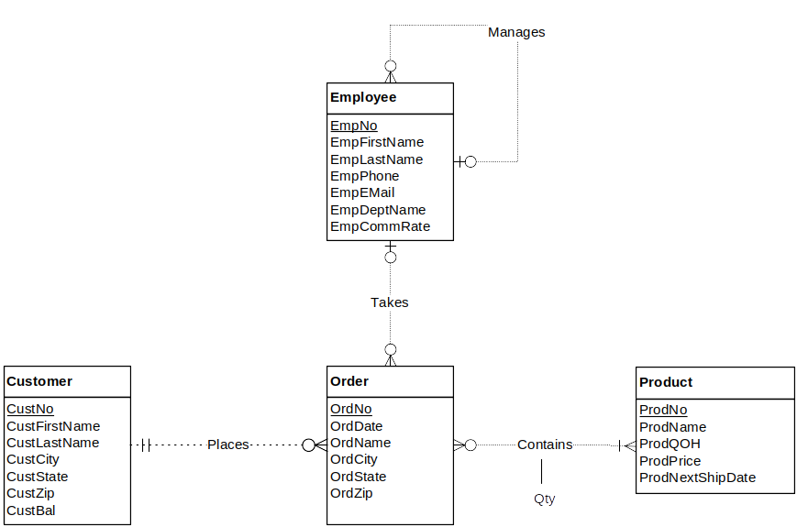
Figure 1: ERD for Problem 1

Solution :
Result after conversion
Customer(CustNo, CustFirstName, CustLastName, CustCity, CustState, CustZip, CustBal)

Employee(EmpNo, supempno, EmpFirstName, EmpLastName, EmpPhone, EmpEmail, EmpDeptName, EmpCommRate)
FOREIGN KEY(supempno) REFERENCES Employee

Product(ProdNo, ProdName, ProdQOH, ProdPrice, ProdNextShipDate)

Order(OrdNo, CustNo, EmpNo, OrdDate, OrdName, OrdCity, OrdZip)
FOREIGN KEY(custno) REFERENCES customer
FOREIGN KEY(empno) REFERENCES employee
CustNo NOT NULL

Contains(OrdNo, ProdNo, Qty)
FOREIGN KEY(ordno) REFERENCES order
FOREIGN KEY(prodno) REFERENCES product

Conversion rules
- Use the entity type rule to convert each entity type
- Use the 1-M relationship rule for all relationships except the contains relationship
- Use the M-N rule to convert the contains relationship

