- For the following problem, define an ERD for the initial requirements and then revise the ERD for the new requirements. Your solution should have an initial ERD, a revised ERD, and a list of design decisions for each ERD. In performing your analysis, you may want to follow the approach presented in module 8.
The database supports the placement office of a leading graduate school of business. The primary purpose of the database is to schedule interviews and facilitate searches by students and companies. Consider the following requirements in your initial ERD:
- Student data include a unique student identifier, a name, a phone number, an e-mail address, a web address, a major, a minor, and a GPA.
- The placement office maintains a standard list of positions based on the Labor Department’s list of occupations. Position data include a unique position identifier and a position description. Because the position list is standardized, multiple companies may interview for the same position.
- Company data include a unique company identifier, a company name, and a list of positions and interviewers. Each company must map its positions into the position list maintained by the placement office. For each available position, the company lists the cities in which positions are available.
- Interviewer data include a unique interviewer identifier, a name, a phone, an e-mail address, and a web address. Each interviewer works for one company.
- An interview includes a unique interview identifier, a date, a time, a location (building and room), an interviewer, and a student. An interviewer may conduct multiple interviews.
After reviewing your initial design, the placement office decides to revise the requirements. Make a separate ERD to show your refinements. Refine your original ERD to support the following new requirements:
- Allow companies to use their own language to describe positions. The placement office will not maintain a list of standard positions.
- Allow companies to reserve blocks of interview time. The interview blocks will not specify times for individual interviews. Rather a company will request a block of X hours during a specified week. Companies reserve interview blocks before the placement office schedules individual interviews. Thus, the placement office needs to store interviews as well as interview blocks.
- Allow students to submit bids for interview blocks. Students receive a set amount of bid dollars that they can allocate among bids. The bid mechanism is a pseudo-market approach to allocating interviews, a scarce resource. A bid contains a unique bid identifier, a bid amount, and a company. A student can submit many bids and an interview block can receive many bids.Allow companies to indicate availability dates and number of openings for positions.
- Allow companies to reserve blocks of interview time. The interview blocks will not specify times for individual interviews. Rather a company will request a block of X hours during a specified week. Companies reserve interview blocks before the placement office schedules individual interviews. Thus, the placement office needs to store interviews as well as interview blocks.
- Allow students to submit bids for interview blocks. Students receive a set amount of bid dollars that they can allocate among bids. The bid mechanism is a pseudo-market approach to allocating interviews, a scarce resource. A bid contains a unique bid identifier, a bid amount, and a company. A student can submit many bids and an interview block can receive many bids.

Solution:
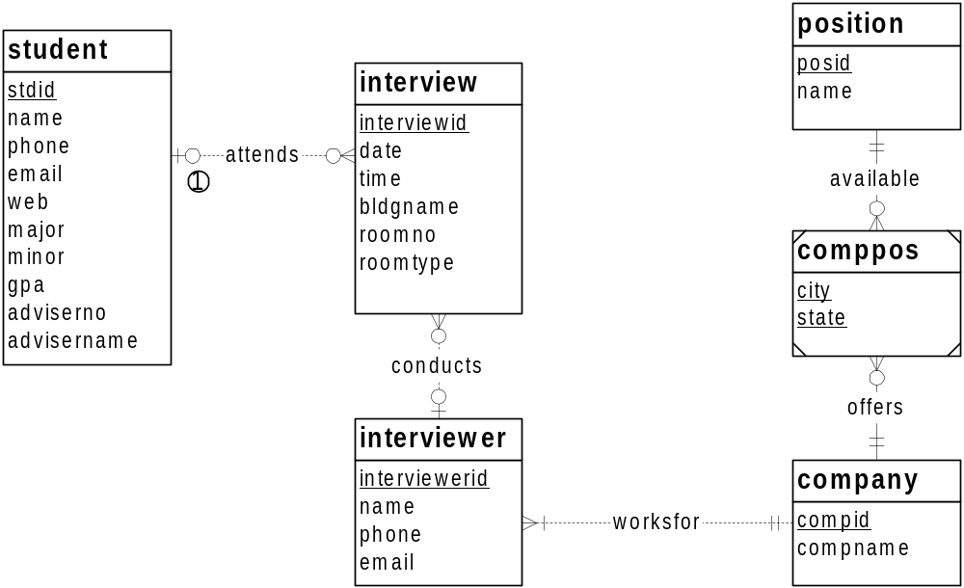

1. An interview may be initially setup without knowing the student or interviewer.

The Student, Interview, Interviewer, Company, and Position entity types follow directly from the narrative. The narrative statement clearly indicates attributes and a primary key for each entity type. The M side of the 1-M relationships, Attends, Conducts, and WorksFor, follows from the narrative with students attending multiple interviews, interviewers conducting multiple interviews, and companies having a list of interviewers. The one side of the 1-M relationships follows from an interview having an interviewer and student, as well as an interviewer working for one company. The minimum cardinalities are not specified in the narrative so additional requirements collection is necessary.
Note that there is no entity type for the placement office. The placement office is the client for the database. If the problem indicated that the database should support multiple placement offices, a placement entity type may be useful.
The difficult part of the narrative involves the relationship between company and positions. The problem narrative indicates that multiple companies may interview for the same position and a company may interview for a list of positions so an M-N relationship is necessary.
The most difficult part of the narrative indicates that a company lists the cities in which positons are available. The solution ERD uses an associative entity type (CompPos) in which the primary key is a combination of CompId, PosId, City, and State. City by itself may not be unique. To incorporate companies with international employment opportunities, country should be added.
If a Location entity type is used, a more complex solution is possible. An associative entity type with three 1-M identifying relationships among Location, Position, and Company would work. The Location entity type would have attributes for city, state, and possibly country. More requirements collection is needed to determine the most appropriate solution. As a default, the CompPos entity type in the solution ERD is preferred because it is simpler.

Transformations: see ERD below
- Remove the position entity type so that positions are not standardized across companies. Add attributes to the comppos entity type for the position name, start date, end date, and number of openings. To reduce the number of attributes in the combined primary key of comppos, a unique identifier has been added. In this case, the compid, city, state, and startdate attributes are a combined candidate key.
- Add an entity type (interviewblock) and relationships between interviewblock and interview and between interviewblock and company. The new entity type and relationships allow companies to schedule blocks of time. An interview block will contain a collection of interviews with the same company.
- Add an entity type for bids. The bid entity type should be connected to student and interviewblock.

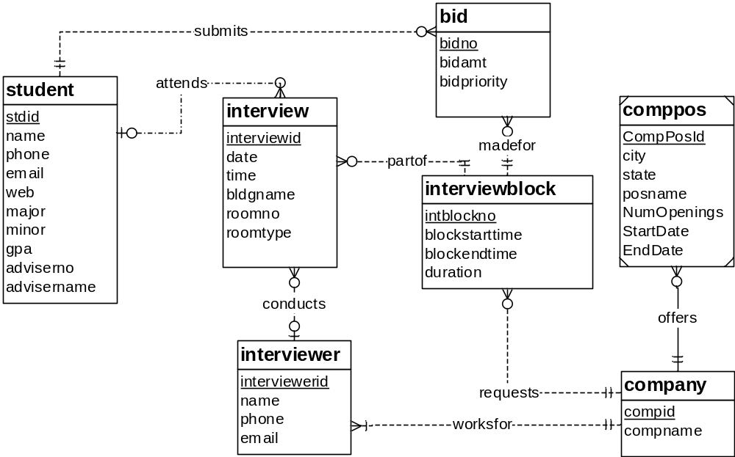

The Position entity has been eliminated because the problem indicates that a standardized position list is not maintained. A transformation to contract the entity type structure has been made so that CompPos only has one identifying relationship.
The problem definition indicates the need for the Bid and InterviewBlock entity types. For interview blocks, the attributes must be discerned from the problem statement. To represent blocks of time, the InterviewBlock entity type has attributes for start time, end time, and duration for each interview. The primary key (IntBlockNo) is not specified in the problem statement so additional requirements collection is needed.
The narrative provides incomplete details about some new relationships. The narrative indicates that a student can submit many bids and a bid contains one student. However, the minimum cardinality specifications are omitted. For interview blocks, the narrative indicates that companies request interview blocks before related interviews are added. A bid is made for a slot in an interview block with a company. The minimum cardinalities in the MadeFor, Requests, and PartOf relationships are not specified in the problem statement.
The problem statement needs another revision about the bidding process. The current design does not store details about connecting winning bids to interviews. More requirements collection is necessary.

