- For the Expense Report ERD shown in Figure 1, identify and resolve errors and note incompleteness in the specifications. Your solution should include a list of errors and a revised ERD. For each error, identify the type of error (diagram or design) and the specific error within each error type. Note that the ERD may have both diagram and design errors. If you are using the ER Assistant, you can use the Check Diagram feature after checking the diagram rules yourself. Specifications for the ERD appear below:
- The Expense Reporting database tracks expense reports and expense report items along with users, expense categories, status codes, and limits on expense category spending.
- For each user, the database records the unique user number, the first name, the last name, the phone number, the e-mail address, the spending limit, the organizational relationships among users, and the expense categories (at least one) available to the user. A user can manage other users but have at most one manager. For each expense category available to a user, there is a limit amount.
- For each expense category, the database records the unique category number, the category description, the spending limit, and the users permitted to use the expense category. When an expense category is initially created, there may not be related users.
- For each status code, the database records the unique status number, the status description, and the expense reports using the status code.
- For each expense report, the database records the unique expense report number, the description, the submitted date, the status date, the status code (required), the user number (required), and the related expense items.
- For each expense item, the database records the unique item number, the description, the expense date, the amount, the expense category (required), and the expense report number (required).

Solution:

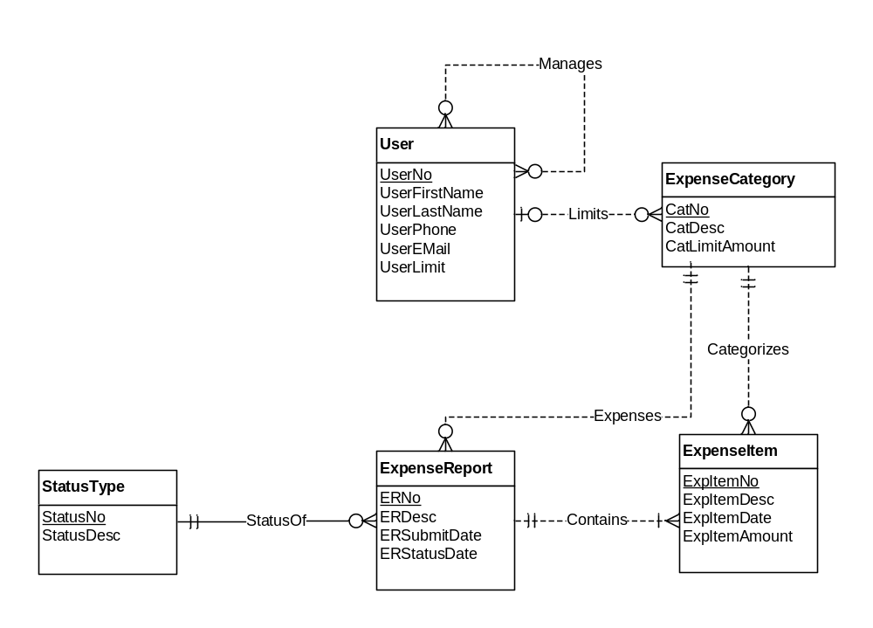
Figure 1: ERD for the Expense Reporting Database

The ERD below fixes the errors in the original ERD. The following list describes the problem resolutions.

- The Manages relationship should be 1-M, not M-N (cardinality design error).
- The Limits relationship should be M-N, not 1-M (cardinality design error).
- The minimum cardinality in the Limits relationships for Users should be 1, not 0 so that a user has at least one expense category.
- The Limits relationship should have an attribute for the amount.
- The minimum cardinality of the Limits relationship for a user should be 1, not 0 (cardinality design error).
- ExpenseItem should not be a weak entity type (weak entity type diagram error).
- The Submits relationship was added from User to ExpenseReport. Without this relationship, the user for an expense report cannot be determined (missing relationship design error).
- The StatusOf relationship should not be identifying (identifying relationship diagram error).
- The Expenses relationship from ExpenseCategory to ExpenseReport should be removed because it is inconsistent with the specification and redundant if corrected (cardinality and redundant relationship design errors). The specification indicates that an expense report is related to many expense items and that each expense item is related to one expense category. Thus, an expense report can be related to many expense categories. Revising the Expenses relationship to M-N makes the relationship redundant with the Contains and Categorizes relationships.
- The specification is incomplete about attribute constraints such as null value allowed and data types.

