**How to compile and execute your program?**

* In my case I used “ jnetpcap-1.4.r1425-1.win64 “ version
* The polices are coded as class inside the file IDS file
* all trace Pcap files should be in the same folder

**How to run:**

1. Press Run 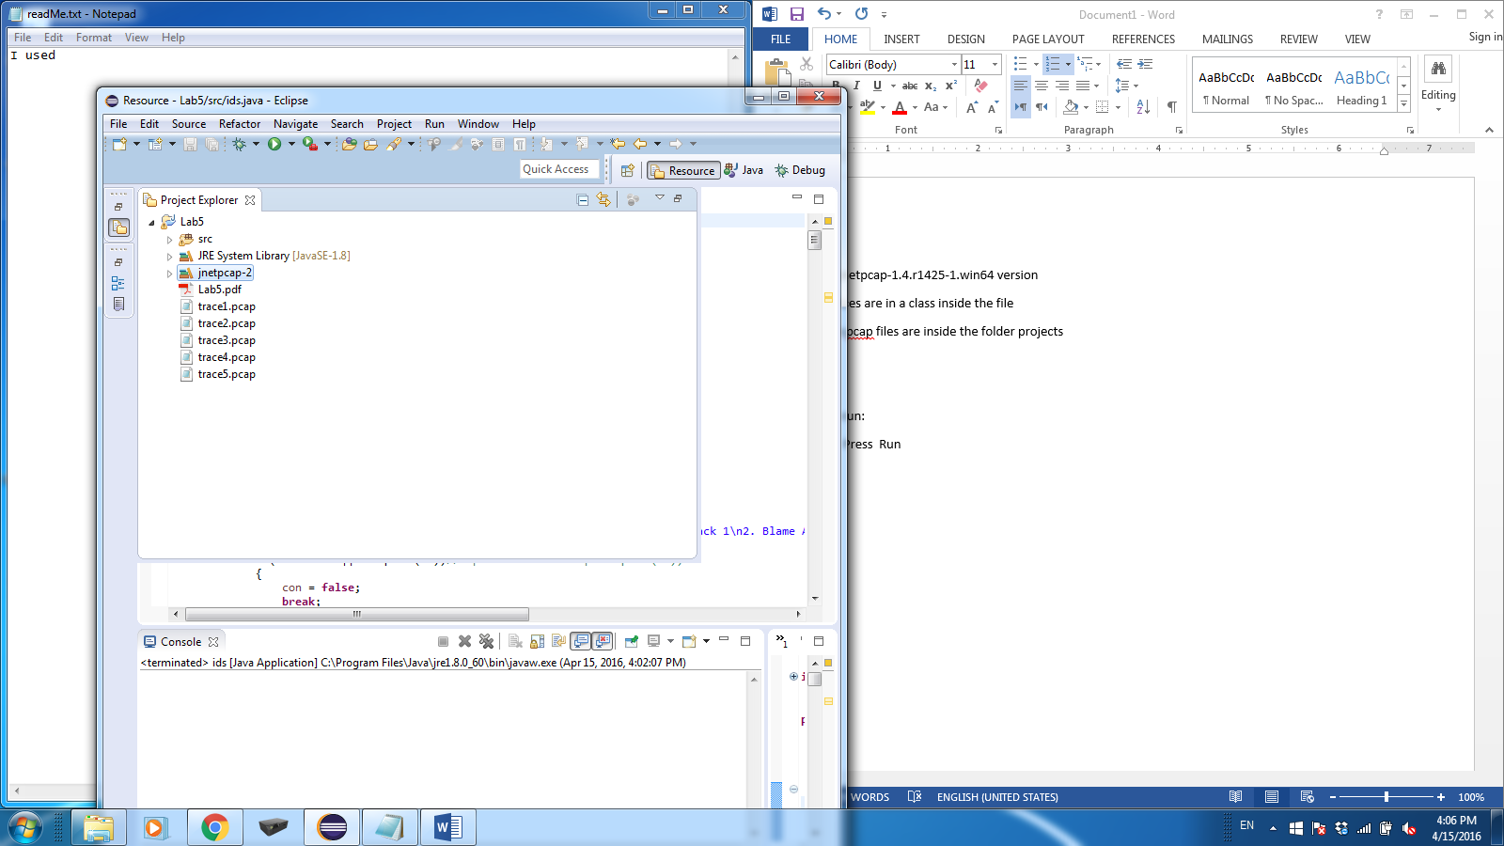 window will appear
2. Enter policy Number you want to test and press **OK** or press **cancel** to exist

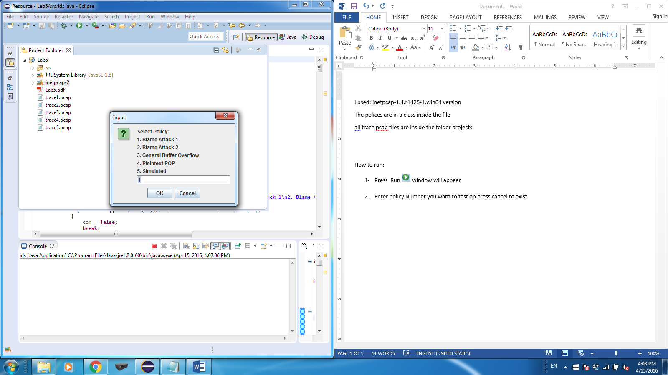

1. Enter Trace file Number you want to test and press **OK** or press **cancel** to exist

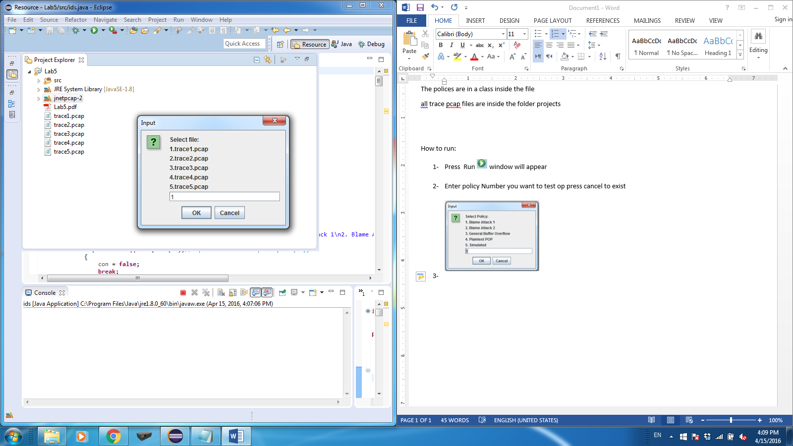

1. If there is a results an alert will appear otherwise you will go to step 2

