safighauri.com
Complete Website Build Document
All copy approved. Design notes, photo placements, and link instructions included throughout.
April 2026 | For Claude Design
DOCUMENT MAP
HOW TO USE THIS DOCUMENT

- All page copy is in black text — paste it directly.
- DESIGN NOTE boxes (amber) give layout, colour, and structural instructions.
- PHOTO PLACEMENT boxes (green) give exact photo instructions.
- LINK INSTRUCTION boxes (blue) give exact link behaviour for every URL.
- Build order: Home → About → Legal Practice → Intelligence → Media & Speaking → Contact → Press Kit.
- Primary nav: Home · About · Legal Practice · Intelligence · Media & Speaking · Contact
- Footer nav: Press Kit · LinkedIn · Email
GLOBAL DESIGN SYSTEM
GLOBAL DESIGN SYSTEM

Primary colour: Navy #0D2140
Accent colour: Gold #9A7B20
Background: White #FFFFFF
Body text: Charcoal #333333
Section backgrounds: Light grey #F5F5F5
Typography: Inter (primary), or similar editorial sans-serif. Generous line-height (1.7).
Nav: Fixed/sticky at top. Logo wordmark left. Links right.
Mobile-first. No stock legal imagery. No animated elements. No cookie popups. No sidebar layouts.
All external links open in new tab (target='_blank'). All internal links stay in same tab.

PAGE 1 — HOME (URL: safighauri.com/)

DESIGN NOTE: Full-width dark navy hero (#0D2140). Large name in white. Subtitle in gold. Location line in small white. Two CTA buttons below. Below hero: white background media strip. Then identity columns, anchor statement, three work cards, short bio, bottom CTA strip.

HERO SECTION
HEADLINE — large, white, bold:
Safi Ghauri
SUBHEADLINE — medium weight, gold:
Barrister · Digital Assets Counsel · Geopolitical Analyst
LOCATION LINE — small, white:
São Paulo · Dubai · Islamabad
BUTTON 1 — gold fill:
Start a Conversation
BUTTON 2 — white outline:
Explore Intelligence

LINK INSTRUCTION: Button 1 'Start a Conversation' → links to /contact (same tab). Button 2 'Explore Intelligence' → links to /intelligence (same tab).

MEDIA STRIP
DESIGN NOTE: White background strip directly below hero. Small label left, publication names in muted charcoal right. No logos needed — text-only works cleanly here.
As cited in:
The Independent (UK) · Bloomberg Arabic · CNA (Channel NewsAsia) · Reuters · Gulf News · China Business Law Journal

IDENTITY — THREE COLUMNS
DESIGN NOTE: Three equal-width columns. No section heading. Minimal card design — thin border or subtle shadow. Each card: role title bold navy, firm name gold, description charcoal.

COLUMN 1 | COLUMN 2 | COLUMN 3
Managing Partner | Partner | Political Analyst
Esquare Legal | Tahota Law Firm | PTV World
Crypto-native cross-border law firm. UAE · Brazil · Pakistan · China. | Top-100 global firm. 4,000+ practitioners. 30+ offices worldwide. | 300+ broadcast appearances. National Defense University Pakistan. South America Correspondent, São Paulo.

ANCHOR STATEMENT
DESIGN NOTE: Single line, centred, large type (approx 28–32px), navy or charcoal. Full-width. Significant white space above and below. This is the positioning line — make it land.
Law at the intersection of capital, governance, and strategy.

THREE RECENT WORK CARDS
DESIGN NOTE: Cards on light grey background (#F5F5F5). Each card: small category tag + year top-left (navy, caps, small), headline bold, description regular. Three equal columns on desktop, stacked on mobile.

CARD 1
MEDIA · April 2026
The Independent (UK) — Hormuz Blockade
Quoted alongside Chatham House, Kpler, and New York Law School on the tactical and legal dimensions of the US naval interdiction regime in the Strait of Hormuz.

CARD 2
SPEAKING · October 2025
Horasis Global Summit, São Paulo
Speaker on digital assets regulation at the 10th Horasis Global Meeting — 1,000 leaders from 50 countries, hosted at the University of São Paulo.

CARD 3
SPEAKING · March 2026
DARTE — European Commission + UNIDROIT, São Paulo
Panellist at the Digital Assets Roundtable Experts series, co-organised by the European Commission and UNIDROIT, on MiCA and Travel Rule implementation across Latin America.

LINK INSTRUCTION: Card 1 'The Independent' article links to: https://uk.news.yahoo.com/tough-talk-trump-blockade-strait-113345400.html (new tab). Cards 2 and 3 have no external links — they are descriptive.

SHORT BIO
DESIGN NOTE: Two paragraphs in a clean centred column, max-width ~700px, on white background. Small 'Full biography →' link below, gold arrow.
Safi Ghauri is a Pakistani barrister qualified at Lincoln's Inn. He is the Managing Partner of Esquare Legal and a Partner of Tahota Law Firm, one of China's top-100 global law firms. He is based in São Paulo.

His practice spans landmark litigation at Pakistan's Supreme Court, digital asset regulatory mandates across four continents, and multi-billion dollar cross-border transactions. In parallel, he has made over 300 broadcast appearances as a political analyst and spoken at Horasis, COP30, the European Commission's DARTE expert series, ETH LATAM and Stellar Meridian.

Full biography →
LINK INSTRUCTION: 'Full biography →' links to /about (same tab).

BOTTOM CTA STRIP
DESIGN NOTE: Full-width navy background (#0D2140). White text. Single centred button in gold. Generous padding above and below.
Working at the intersection of cross-border law, digital assets, and geopolitical complexity?

[ Start a Conversation ]
LINK INSTRUCTION: Button 'Start a Conversation' → links to /contact (same tab).

PAGE 2 — ABOUT (URL: safighauri.com/about)

DESIGN NOTE: Long-form narrative page. Single main column, max-width 720px, centred. Credentials panel floats top-right on desktop (sticky sidebar), stacks below intro on mobile. Three pull quotes enlarged and displayed as typographic blockquotes between sections. One professional headshot near the top. No additional photos.

PHOTO PLACEMENT: ONE PHOTO ONLY on this page. Place a professional headshot (formal, high quality, not mid-speech) in the top-right of the page on desktop — beside the opening paragraph. On mobile it sits above the opening paragraph, full-width. Alt text: 'Safi Ghauri, Managing Partner, Esquare Legal'. Use the photo attached here.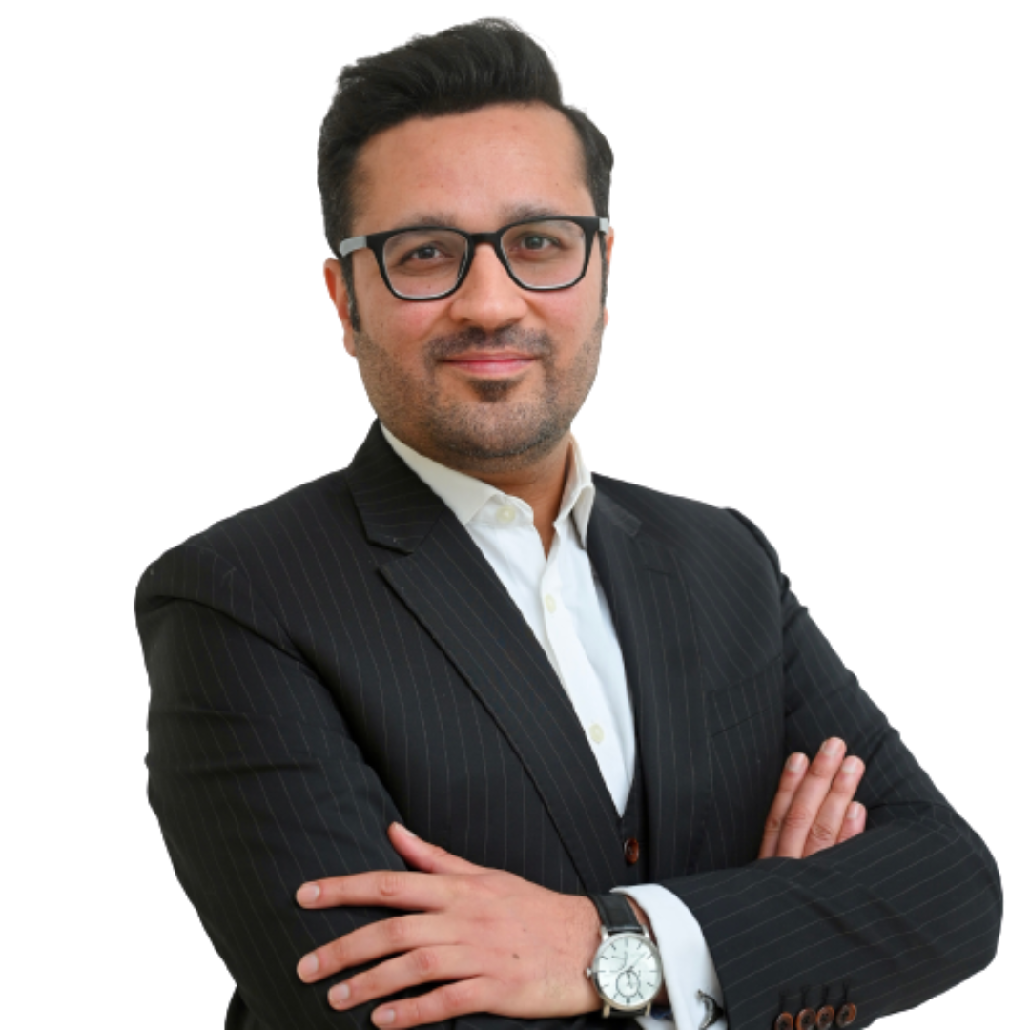

PAGE TITLE
About

OPENING
Safi Ghauri grew up across more than seven cities and several countries. His father is a Harvard alumnus, a high-ranking judge, and a career civil servant — the kind of trajectory that moves a family across continents and never permits the assumption that any single city is the whole world. By the time he left for London, he had already learned what most lawyers spend a career trying to acquire: that every room has its own rules, and the person who reads them fastest wins.

DESIGN NOTE: PULL QUOTE — display this line enlarged as a typographic blockquote after the opening paragraph: 'Every room has its own rules, and the person who reads them fastest wins.'

THE MAKING OF A PRACTITIONER
He qualified as a barrister at Lincoln's Inn and holds two masters degrees from City St George’s, University of London. Before returning to Pakistan, he trained at Clyde & Co in London and at international commercial law firms in New York and Orlando. It gave him a working model of how international practice actually operates, not how it is described in textbooks.

He founded Esquare Legal in 2009. Technology law as a formal practice area barely existed in Pakistan at the time. He built it anyway, in the conviction that the country's economic future would be decided by whether its legal infrastructure could keep pace with its technology sector.

THE CASES THAT SHAPED THE PRACTICE
The early years were not spent waiting for the fintech revolution to arrive. While building the technology practice, he was simultaneously handling cases that were reshaping Pakistani legal history.

His LLM thesis was extensively cited in the NRO judgement, specifically on the recovery of illegal proceeds. That body of work remains directly relevant today: cryptocurrency has become one of the most significant instruments for the movement of illicit capital globally, and he is among the few practitioners who understands both the legal architecture of recovering laundered proceeds and the technical infrastructure through which those proceeds now move.

In May 2016, he filed the first-ever Panama Leaks case in Pakistan's Election Commission on behalf of a PTI client against Captain Safdar. It was the legal template that Imran Khan's team replicated in their Supreme Court petition weeks later. He spent months in ECP and Supreme Court proceedings as the case became the most consequential political litigation in Pakistan's modern history.

He served as lead counsel for the Jang/Geo Group in defamation proceedings that produced Pakistan's largest-ever defamation award of Rs100 million. He also represented all associations of Pakistan International Airlines — collectively over 300,000 employees — in the PIA privatisation challenge. He successfully carried out a high stakes case in Supreme Court of India in a successful cryptocurrency matter before three of the court's senior-most judges, managed by him alongside Indian external counsel.

These cases established something important: he was not a technology lawyer who occasionally appeared in court. He was a litigator with the range to operate at the highest level of any matter he took on.

BUILDING THE FINTECH INDUSTRY
The regulatory work that followed did not merely advise on frameworks that already existed. It built them.

His firm secured Pakistan's first-ever Buy Now, Pay Later licence from the Securities and Exchange Commission for QisstPay, in 2021. There was no precedent for the application when it was filed. The firm also established the lending fintech sector in Pakistan and holds more NBFC licences than any other legal practice in the country. Across the full arc of Pakistan's digital financial regulation from the earliest SECP fintech frameworks until the formation of PVARA, Esquare was in the room at state level before the institutions that would govern the industry had been formally constituted.

He has advised both the companies seeking licences and presented directly to the regulators issuing them. That dual perspective is not common.

INTERNATIONAL EXPANSION
The practice expanded outward through a series of roles that each added a different dimension to his operational picture.

As Vice President of Legal and Compliance at Fasset in Dubai, he secured the firm's VARA licence, one of the earliest and most comprehensive virtual asset licences issued by Dubai's regulator. As Head of Legal at Klink Financial in Berlin, he worked across crypto offerwall and digital asset product structures spanning EU and US markets.

His current portfolio of active mandates includes RWA Inc, a leading global real-world asset tokenisation platform. Tharwa, an Islamic stablecoin project, and InvoiceMate, one of the UAE's leading fintech platforms. These are not advisory engagements. They are embedded, retainer-based relationships where he functions as General Counsel at board level.

The most significant structural step was the Tahota partnership. Tahota Law Firm is one of China's top-100 global law firms with 4,000+ practitioners, 30+ offices across Asia, the US, and Australia, headquartered in Chengdu. Esquare Legal held the official law firm mandate for the Chinese Embassy in Pakistan, for the Chinese Overseas Association, and for the Chinese Business Association in Pakistan. The firm led the RUDA project, a $4.8 Billion Chinese infrastructure initiative representing one of the largest Chinese investment projects outside China at the time of execution. It was covered by the China Business Law Journal.

He was not a local counsel being instructed by a Chinese firm. He was the partner.

DESIGN NOTE: PULL QUOTE — display this line as a typographic blockquote: 'He was not a local counsel being instructed by a Chinese firm. He was the partner.'

BRAZIL
In 2024, Safi relocated to São Paulo and established Esquare Legal's Brazil presence. The decision was not incidental. Chinese capital is flowing into Brazilian agriculture, infrastructure, and energy at a pace that most of the MENA legal world has not yet noticed. The MENA-to-Brazil corridor is equally underserved. He is now inside both of those flows simultaneously — present, registered, and advising on the cross-border transactions that neither side fully understands yet. In addition Brazil serves as a LATAM base in a growing digital assets market that promises to be the next frontier for crypto.

Brazil is his operating base. São Paulo is where the next chapter of the practice is being written.

THE ANALYST
Running parallel to the legal career, not alongside it, not separate from it, but genuinely parallel is a fifteen-year record as a political and legal analyst.

Over 300 broadcast appearances on PTV World, Pakistan's international channel. Topics spanning national security postures, South Asian strategic dynamics, the geopolitics of financial regulation, and the Middle East in active conflict. He trained at Pakistan's National Defense University, the institution that forms Pakistan's senior military officers and strategic studies scholars. He is PTV's officially appointed South America Correspondent, and communicates news from São Paulo to Pakistan, the Middle east and Chinese business groups.

This is not commentary for its own sake. The geopolitical analysis feeds directly into the legal and advisory work and it is how he identifies where the risk is before his clients have to ask.

THE SPEAKING RECORD
He has spoken on digital assets regulation at the Horasis Global Summit (Aka Mini Davos) with 1,000 leaders from 50 countries, hosted at the University of São Paulo. At COP30 in Belém, on blockchain infrastructure for climate finance. At the European Commission and UNIDROIT's DARTE expert series, on MiCA and Travel Rule implementation across Latin America. He has trained judges and prosecutors for UNODC. He has panelled at FATF. He has spoken at Stellar Meridian at the Copacabana Palace and at ETH Latam.

He has been a distinguished judge for IMechE's engineering competitions across UAE, Pakistan, Africa, and global finals every year since 2018.

The common thread is the same: he is in the rooms where the frameworks are being argued, not the rooms where they are being explained.

DESIGN NOTE: PULL QUOTE — display this line as a typographic blockquote: 'In the rooms where the frameworks are being argued, not the rooms where they are being explained.'

THE PERSON
He is a deep-sea diver and loves rock music. A serious coffee, tea and yerba mate drinker. Someone who has been described as Pakistan's most prolific tech lawyer, a description he accepts as historically accurate and strategically insufficient.

He speaks English, Urdu and Hindi fluently, Mandarin and Portuguese conversationally. His Chinese cultural fluency, the understanding of protocol, hierarchy, and what is said between the lines in a Chinese business meeting runs considerably deeper than his spoken language.

He works best on problems that have no clean jurisdictional answer.

CREDENTIALS PANEL
DESIGN NOTE: Style as a clean two-column box. On desktop: sticky sidebar top-right, visible as the page scrolls. On mobile: placed after the opening paragraph. Border-left gold accent (#9A7B20).
QUALIFICATIONS | ROLES
Barrister — Lincoln's Inn, London | Managing Partner, Esquare Legal
LLM — City St. George, University of London | Partner, Tahota Law Firm
Fintech Law & Policy - Duke University | South America Correspondent, Pakistan TV
NDU National Security Workshop | General Counsel to Select companies
Registered and licensed in UAE, Brazil, Pakistan, overseas Barrister UK

LINK INSTRUCTION: No external links on this page except: 'Esquare Legal' in credentials panel links to https://esquarelegal.com (new tab). 'Tahota Law Firm' can link to Tahota's website if desired (new tab).

PAGE 3 — LEGAL PRACTICE (URL: safighauri.com/practice)

DESIGN NOTE: Six practice areas. Desktop: 3x2 card grid. Each card shows title + first two lines. On hover or tap, card expands to show full text. This keeps the page visually clean while housing full substance. Closing CTA block at the bottom links strongly to Esquare Legal.

PAGE TITLE
Legal Practice

PAGE INTRO
Safi Ghauri's legal practice operates at the intersection of three of the world's most active capital corridors namely the UAE, Brazil, and Greater China. The work is not jurisdictional. It is structural: building the legal architecture that allows capital, technology, and institutions to move across borders without colliding with the frameworks designed to stop them.

Through Esquare Legal, founded in 2009, and through the Tahota Law Firm partnership, he advises on matters where the regulation is still being written, the precedents are still being set, and the answer to 'is this legal?' depends entirely on which desk you are sitting at.

PRACTICE AREA 1: Digital Assets & Crypto Regulation
From MiCA compliance in the EU to VARA licensing in Dubai to VASP registration in Brazil, Safi has built regulatory pathways across more jurisdictions than most specialists encounter in a career. He secured a full-scope VARA licence in Dubai, advised on Pakistan's first BNPL licence, and has handled crypto licensing across multiple jurisdictions and activity types.

His work in this area has been cited in peer-reviewed academic research ranging from PHD theses of Tsinghua University in 2024 to blockchain arbitration, published through China's arbitration research community in 2025. He participated in the European Commission and UNIDROIT's DARTE expert series on the implementation of MiCA and the Travel Rule across Latin America, working at the level where the frameworks are being constructed, not merely interpreted.

He is the practitioner other practitioners come to when the problem crosses more than one jurisdiction simultaneously.

PRACTICE AREA 2: Fintech Regulatory Licensing
Licensing in emerging markets requires more than knowledge of the relevant statute. It requires relationships, an understanding of where the regulator is trying to go, and the credibility to make the case in a room the regulator respects.

Esquare Legal established the fintech lending sector in Pakistan and holds more NBFC licences than any other legal practice in the country. The firm was present in every state-level crypto policy conversation in Pakistan before the regulatory bodies that would govern the industry were formally constituted. The QisstPay BNPL, Pakistan's first-ever licence of its kind from the SECP is the most documented example of a pattern that has repeated itself across multiple jurisdictions and product categories.
He has advised the companies seeking licences. He has also presented directly to the regulators issuing them. That dual perspective is not common.

PRACTICE AREA 3: Cross-Border Corporate & Transactions
China-to-Pakistan infrastructure. MENA-to-Brazil capital deployment. EU-to-UAE digital asset structuring. These are not transactions most firms can handle across all relevant jurisdictions simultaneously.

Through the Tahota partnership and direct regional presence across four jurisdictions, Esquare structures cross-border transactions that require legal architecture across multiple regulatory regimes at once. The firm held the official law firm mandate for the Chinese Embassy in Pakistan and was involved in multibillion dollar CPEC projects. The firm also led the RUDA project, one of the largest Chinese infrastructure investments outside China at the time of execution.

When a transaction requires São Paulo, Dubai, Karachi, and Chengdu to agree simultaneously, this is the practice that handles it.

PRACTICE AREA 4: High-Stakes Dispute Resolution
His litigation record includes securing Pakistan's largest-ever defamation award for Pakistan’s largest media house, the Jang/Geo Group, representing all associations of Pakistan International Airlines (300,000+ employees) in the PIA privatisation challenge, and initiating the Panama Leaks Election Commission proceedings that became the template for the most consequential political litigation in Pakistan's modern history. His LLM thesis was cited in the NRO judgement on the recovery of illegal proceeds, a body of work that now directly informs his practice in crypto-asset tracing and the recovery of digitally laundered capital.

He has also managed complex appellate strategy before the Supreme Court of India in a successful cryptocurrency matter before three of the court's senior-most judges.

Dispute resolution at this level requires understanding not just the applicable law but the institutional context, the political landscape, and what winning actually means for the client beyond the judgement itself.

PRACTICE AREA 5: Blockchain Architecture & Smart Contract Law
Smart contracts are not self-enforcing in any jurisdiction that matters commercially. The code executes. The legal effect of that execution is a different question entirely.

Safi has been involved directly with some major blockchains like Ethereum, Stellar, Canton, Hadera and has advised major institutional investors and infrastructure protocols on blockchain architecture. He has been cited in peer-reviewed academic publications on the enforceability of blockchain-based dispute resolution, the Kleros mechanism, and what legal infrastructure foundations are required before institutional capital will follow tokenisation infrastructure into new jurisdictions. His practical advice shapes how companies design smart contract systems for RWA tokenization that hold up under enforcement scrutiny across multiple legal regimes, not just in the jurisdiction where they are deployed, but in every jurisdiction where their counterparties operate.

PRACTICE AREA 6: Fractional General Counsel
For founders and institutions that need GC-level strategic thinking embedded in their operations, not transactional outside counsel engaged per matter, Safi takes on Fractional General Counsel engagements.

He attends board meetings. He advises on commercial decisions, not just legal ones. He has served as embedded legal and strategic counsel across Web3 companies, financial institutions, and cross-border ventures at critical stages of their development. He operates on a retainer-plus-equity model.

Current capacity is limited.

JURISDICTIONS & ENQUIRIES
 | DETAILS
JURISDICTIONS | UAE · Brazil · Pakistan · China · EU · India ·USA ·Canada ·Japan· Malaysia ·UK ·KSA · Qatar
FIRM | Esquare Legal — esquarelegal.com
PARTNERSHIP | Tahota Law Firm — top-100 global · 4,000+ practitioners · Chengdu-headquartered
ENQUIRIES | safighauri@esquarelegal.com

LINK INSTRUCTION: 'esquarelegal.com' in the table links to https://esquarelegal.com (new tab). 'safighauri@esquarelegal.com' uses mailto: link. Closing CTA button 'Visit Esquare Legal' links to https://esquarelegal.com (new tab).

CLOSING CTA
DESIGN NOTE: Strong CTA block at page bottom. Not subtle — this is the commercial off-ramp. Navy background, white text, gold button.
For detailed practice capability and client enquiries:

[ Visit Esquare Legal → ]

PAGE 4 — INTELLIGENCE (URL: safighauri.com/intelligence)

DESIGN NOTE: Editorial page. Long-form. Single column, max-width 720px. Opening statement large and centred. Analytical framework in running prose. Six analysis areas as expandable sections or clearly delineated blocks. Broadcast record with editable citations block. Three writing cards. Availability CTA at bottom.

OPENING STATEMENT
DESIGN NOTE: Display this text large and centred, like a magazine cover line. Dark navy background, white text. Full-width. Below it: the body opens on white.
Safi Ghauri reads the room the law is being written in.

The legal architecture of global capital, the geopolitical forces that direct it, and the technology that moves it are not separate disciplines. They are the same analytical frame applied to different subject matter. This page documents the analytical work — fifteen years of political commentary, published writing, and strategic analysis — that runs alongside the legal practice and directly informs it.

The legal work tells him how capital moves.
The geopolitical work tells him why, and where it is about to move next.

THE ANALYTICAL FRAMEWORK
His framework sits at the convergence of three things most commentators treat separately: the legal architecture of international capital flows, the geopolitical forces that shape them, and the emerging technology infrastructure through which they are being restructured.

A sanctions regime is a legal instrument. It is also a geopolitical weapon. Its effect on a client's cross-border transaction is a commercial problem. The analyst who can read all three simultaneously — and who holds the legal licence to act on that reading — occupies a position that is genuinely rare.

He trained at Pakistan's National Defense University. His LLM thesis was cited in the NRO judgement on the recovery of illegal proceeds — a body of work that now directly informs how he thinks about crypto-asset tracing and the movement of digitally laundered capital across jurisdictions. The legal scholarship and the strategic analysis have always fed each other.

AREAS OF ANALYSIS

Cryptocurrency as a Geopolitical Instrument
The US dollar's structural role in the global financial system and the mechanics of its defence through sanctions architecture. BRICS payment alternatives being built on Mbridge and the serious legal questions they raise about enforceability and capital flight. State-level crypto adoption as a geopolitical act — not a technology decision. The use of digital assets for the movement of illicit capital and the international legal frameworks for recovery.

This is not theoretical. His LLM thesis addressed the recovery of illegal proceeds at state level. That analysis now applies directly to the most active frontier of financial crime — a frontier where the instruments are new but the underlying legal questions about tracing, freezing, and recovering criminal proceeds are ones he has already worked through.

Digital Finance and the Regulatory Frontier
Why MiCA, VARA, and the GENIUS Act are not merely compliance frameworks but instruments of economic statecraft. The Travel Rule as a structural mechanism for asserting jurisdictional reach over borderless capital. How regulatory arbitrage between MENA, Latin America, and Asia is creating both opportunity and systemic risk simultaneously. The legal infrastructure that must exist before institutional capital will follow tokenisation into new jurisdictions — and why the gap between on-chain execution and off-chain legal enforcement remains the primary unsolved problem in Web3 institutional adoption.

The Global South: Brazil, Pakistan, China
Three countries simultaneously navigating rapid domestic regulatory development, active foreign capital inflows, and structural repositioning within the global order. The China-Brazil capital corridor — currently one of the most significant and least-covered FDI stories globally. Pakistan's role as a diplomatic and commercial bridge between East and West. Why these three markets, understood together, offer a more coherent picture of where global capital is actually moving than any single-jurisdiction analysis can provide.

He is not observing this corridor. He is operating inside it — registered in Brazil, partnered in China through Tahota, and actively advising on the cross-border transactions that connect these flows.

The Middle East: Conflict, Capital, and Commercial Law
The Gulf states as commercial legal jurisdictions under active geopolitical pressure. Force majeure in the context of active military interdiction. OFAC exposure for firms routing transactions through conflict-adjacent corridors. The legal and financial implications of strait closures and naval interdiction regimes for cross-border commercial contracts. The structural vulnerabilities of GCC economies to prolonged regional instability — and which are best positioned to absorb the pressure.

China's Infrastructure Architecture
What BRI projects actually look like in legal and commercial practice — the mandate structures, the enforcement vulnerabilities, what the contracts say and what they do not. Based on direct experience leading the RUDA project and holding mandates for the Chinese Embassy in Pakistan and the Chinese Business Association. He has delivered invited addresses on the interpretation of Chinese infrastructure contracts to civil service and policy officers — what the standard clauses mean in practice, where the leverage sits, and how enforcement operates outside the framework Western commercial lawyers expect to find.

This is analysis from inside the architecture, not observation of it from the outside.

Pakistan's Strategic Architecture
Pakistan as a back-channel diplomatic power — why its informal diplomatic infrastructure consistently succeeds where formal channels fail, and what that means for countries and institutions that need to operate in the region. The internal political economy that drives its foreign policy decisions, understood from three decades of engagement with its legal and political institutions.

The US-China-India triangle and where Pakistan sits within it: not as a passive buffer, but as an active node in the back-channel architecture of the current global order. The legal and institutional dimensions of Pakistan's role as a diplomatic intermediary — including its most recent exercise of that role in brokering the ceasefire between the United States and Iran.

THE BROADCAST RECORD
DESIGN NOTE: This section has two parts: a permanent statement (never changes) and an editable citations block below it (updated as new coverage arrives via Qwoted and direct outreach). Clearly separate them visually — perhaps a thin rule between them.

Safi Ghauri has made over 300 appearances on PTV World, Pakistan's international broadcast channel, as a political and legal analyst — covering Pakistan's national security posture, South Asian strategic dynamics, active conflict analysis in the Middle East, the geopolitics of financial regulation, and global capital flows.

He is PTV's officially appointed South America Correspondent, reporting from São Paulo, the first appointment of its kind for the channel in the region.

DESIGN NOTE: EMBED VIDEO HERE: Embed one strong PTV broadcast clip via YouTube iframe. Choose a clip that shows him clearly in a broadcast setting, mid-analysis (not an introduction segment). Code: <iframe width='100%' height='400' src='https://www.youtube.com/embed/[VIDEO-ID]' frameborder='0' allowfullscreen></iframe>. Ask Safi to provide the preferred YouTube video ID.

EDITABLE CITATIONS BLOCK — update as new coverage arrives:

THE INDEPENDENT (UK) · April 2026
Cited alongside Chatham House, Kpler, and New York Law School — tactical and legal dimensions of the US naval interdiction regime in the Strait of Hormuz.
→ uk.news.yahoo.com/tough-talk-trump-blockade-strait-113345400.html

BLOOMBERG ARABIC (ASHARQ BUSINESS) · April 2026
Three-question interview on the financial dimensions of the Hormuz crisis: dollar dominance, Pakistan's diplomatic exposure as ceasefire broker, and structural vulnerabilities of GCC economies.
→ asharqbusiness.com/economics/128075/
CNA (CHANNEL NEWSASIA)
Multiple appearances
REUTERS ·
Expert commentary and multiple appearances.
Cited as expert commentator on Pakistan's National Security Council proceedings and geopolitical analysis.

[ADD NEW CITATIONS HERE AS THEY ARRIVE]

LINK INSTRUCTION: All citation URLs in the broadcast record open in new tab. Format as: <a href='[URL]' target='_blank'>Read article →</a>. For any paywalled article, link anyway — the publication name carries the authority.

WRITING
DESIGN NOTE: Three cards side by side on desktop, stacked on mobile. Each card: publication/type label top, title bold, description, arrow link at bottom.

CARD 1
PEER-REVIEWED · 2025
The Integration of Blockchain Technology with Arbitration Mechanisms
Expert interviewee in a peer-reviewed paper on the enforceability of decentralised dispute resolution, the Kleros mechanism, and smart contract enforcement across jurisdictions. Published through the Chinese Arbitration Research Institute. Indexed on SSRN.
→ papers.ssrn.com/sol3/papers.cfm?abstract_id=5687149

CARD 2
PEER-REVIEWED · Journal of Indian Studies, 2024
Navigating Socio-Economic and Security Challenges: An Exploration of CBDC Implementation in Pakistan
Legal and policy analysis of Central Bank Digital Currency implementation — architecture models, monetary sovereignty, financial inclusion, and regulatory gaps in Pakistan's existing statutory framework. Benchmarked against China's e-CNY, the EU Digital Euro, and Nigeria's eNaira. Co-authored with Gul Rukh Nafees and Syed Abdullah Anwer.
→ pu.edu.pk/images/journal/indianStudies/PDF/4_v10_1_24.pdf

CARD 3
ONGOING · LinkedIn Newsletter
Digital Assets Briefing
Regulatory intelligence published to an audience of 10,000+ practitioners, founders, and policymakers. MiCA implementation, the GENIUS Act and its implications for Latin American markets, VARA licensing in Dubai, and the legal architecture of RWA tokenisation.
→ linkedin.com/in/safi-ghauri

LINK INSTRUCTION: CARD 1 SSRN link: https://papers.ssrn.com/sol3/papers.cfm?abstract_id=5687149 (new tab). CARD 2 PDF link: https://pu.edu.pk/images/journal/indianStudies/PDF/4_v10_1_24.pdf (new tab). CARD 3 LinkedIn link: https://linkedin.com/in/safi-ghauri (new tab). All writing links open in new tab.

AVAILABILITY
Available for broadcast commentary, print and digital interviews, expert opinion, conference panels, and advisory engagements on the subjects documented here.

Media requests: safighauri@esquarelegal.com
Speaking and panels: Media & Speaking →

Response within 24 hours.
LINK INSTRUCTION: 'Media & Speaking →' links to /media-speaking (same tab). Email uses mailto:safighauri@esquarelegal.com.

PAGE 5 — MEDIA & SPEAKING (URL: safighauri.com/media-speaking)

DESIGN NOTE: This page serves two distinct users: (1) broadcast producers and journalists who need citation proof quickly, and (2) conference organisers who need speaker bios and topics. Organise in clearly separated sections with anchor links in a sub-nav at top of page: Broadcast | Print Citations | Speaking Engagements | Speaker Bios | Speaking Topics | Booking. The Press Kit download button should be prominent — top-right of page or immediately after the opening.

PHOTO PLACEMENT: ONE SPEAKING PHOTO on this page. Place it at the top of the Speaking Engagements section (Section 3). Alt text: 'Safi Ghauri speaking at UNODC Workshop for Judges and Prosecutors'. Use photo below
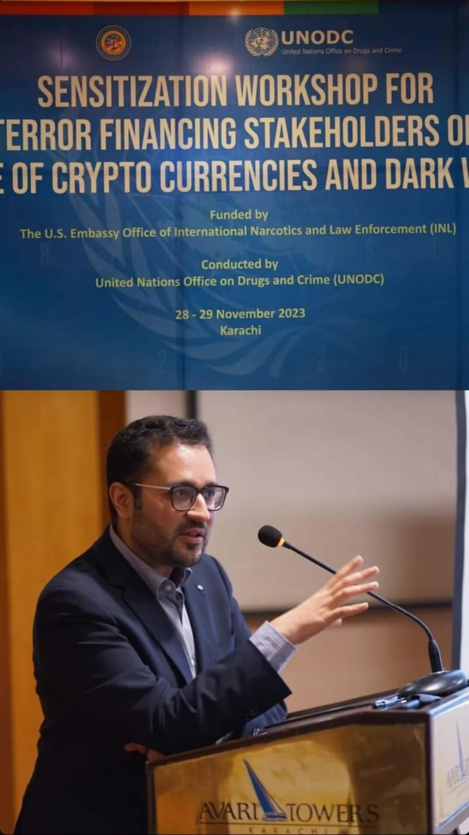

PAGE TITLE
Media & Speaking

OPENING
The public record of Safi Ghauri's broadcast appearances, print citations, and speaking engagements. This page documents where he has been asked to speak, who he has appeared alongside, and what he has been asked to address.

The calibre of the peer group tells the story.

SECTION 1: BROADCAST
BROADCAST RECORD

Over 300 appearances on PTV World, Pakistan's international broadcast channel, as a political and legal analyst. Coverage spans Pakistan's national security posture, South Asian strategic dynamics, active conflict in the Middle East, the geopolitics of financial regulation, and global capital flows.

Officially appointed as PTV World's South America Correspondent — reporting from São Paulo, Brazil.

DESIGN NOTE: EMBED VIDEO HERE: Same YouTube embed as on Intelligence page, or a different clip if a stronger broadcast-quality clip exists. Place directly below the broadcast record statement. Bookers need to see him on camera without clicking away.
Use this youtube video
Newsroom With Sana Maqbool | PakistanTV
Safi’s segment starts at 17:00 and then again at at 27:00. Label accordingly
Label it “Safi Ghauri on Regime Change in Venezuala”

EDITABLE BLOCK — update as new citations arrive via Qwoted:

THE INDEPENDENT (UK) · April 2026
'Trump's blockade appears to be turning back tankers in the Strait of Hormuz — but Iran has a trick up its sleeve.' Cited on the asymmetric naval threat posed by unmanned underwater vehicles to US assets enforcing the blockade. Peer group: Chatham House, Kpler, New York Law School, Birkbeck.
→ uk.news.yahoo.com/tough-talk-trump-blockade-strait-113345400.html

BLOOMBERG ARABIC (ASHARQ BUSINESS) · April 2026
Three-question interview on the financial and strategic dimensions of the Hormuz crisis. Dollar dominance and energy opportunism; Pakistan's diplomatic exposure as ceasefire broker; the GCC states as structural losers of a prolonged strait closure.
→ asharqbusiness.com/economics/128075/

[ADD NEW CITATIONS HERE AS THEY ARRIVE]

SECTION 2: PRINT & DIGITAL CITATIONS

GULF NEWS
'UAE Legal Experts Welcome Crypto Rules.' Cited on the legal implications of Dubai's digital assets regulatory framework.

CHINA BUSINESS LAW JOURNAL
Coverage of the RUDA project — cited in the context of one of the largest Chinese infrastructure investment projects outside China. Via Esquare Legal's Chinese Embassy mandate.
China Deals of the Year 2024 | Law.asia

DAWN · Multiple citations
First-ever BNPL licence in Pakistan — QisstPay, December 2021. PIA privatisation associations challenge. NRO-related proceedings.
→ dawn.com/news/1665552
https://dawn.com/news/1242527/pia-associations-take-legal-course

GEO.TV · March 2022
Lead counsel in defamation proceedings producing Pakistan's largest-ever defamation award — Rs100 million for the Jang/Geo Group.
→ geo.tv/latest/404649

YAHOO FINANCE / BUSINESS WIRE · January 2024
"Light on Crypto Adoption and Education at Future Fest" — Named as "Managing Partner Esquare Legal" on conference screen during KuCoin Future Fest panel on crypto markets in Asia and Africa.
→ https://finance.yahoo.com/news/kucoin-farrukh-kiani-sheds-light-163000736.html

ACADEMIC & INSTITUTIONAL

CHINESE ARBITRATION RESEARCH INSTITUTE · 2025
Expert interviewee, peer-reviewed paper on blockchain arbitration and smart contract enforceability. Indexed on SSRN.
→ papers.ssrn.com/sol3/papers.cfm?abstract_id=5687149

NEPRA OFFICIAL NEWSLETTER · Q2 2023
Named as presenter alongside NEPRA Chairman at the Blockchain in Energy Trade Webinar. Pakistan's national electricity regulator.
→ nepra.org.pk [newsletter PDF — add direct link when confirmed]
COMPANY LAW REFERENCE BOOK · 2024
Acknowledgment in "Judgements (Head Notes) on Company Law (1947 to 2021)" by Jawed Hussain, Author of Pakistan's Companies Act 2017. Named among key contributors in the acknowledgments section.

LINK INSTRUCTION: All citation URLs: new tab. For paywalled articles (Gulf News), link to the article page anyway — the URL confirms the citation exists. For the NEPRA PDF, the direct link is: https://nepra.org.pk/publications/News%20Letters/2023/Newsletter%202nd%20Qurater%20Apr-Jun%202023.pdf

SECTION 3: SPEAKING ENGAGEMENTS

PHOTO PLACEMENT: Place the speaking photo HERE — above the Tier 1 table. Full column width. One photo only. Alt text: 'Safi Ghauri speaking at DARTE, European Commission and UNIDROIT's DARTE expert series, on MiCA and Travel Rule implementation across Latin America'.
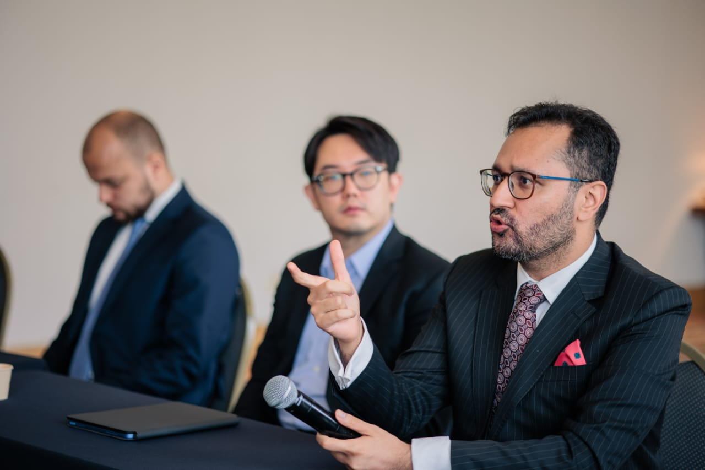

GLOBAL GOVERNANCE & INTERGOVERNMENTAL
Event | Date | Role & Context
Horasis Global Summit, University of São Paulo | Oct 2025 | Speaker on digital assets regulation. 1,000 leaders from 50 countries. Opened by the Vice Governor of São Paulo state.
COP30 Side Events, Belém, Brazil | 2025 | Speaker on blockchain technology for climate finance infrastructure. UN climate conference.
UNODC Sensitization Workshop for Terror Financing Stakeholders on use of Cryptocurrencies and Dark Web, Training for Judges and Prosecutors | 2023 | Trainer. United Nations Office on Drugs and Crime. Funded by U.S. Embassy Office of International Narcotics and Law Enforcement (INL).
FATF Panel on Cryptocurrencies, Pakistan | 2023 | Panellist. Financial Action Task Force.
Training Civil Servants — Freedom of Information and Right to Information, National Centre for Rural Development (NCRD) | 2023 | Trainer for government officials.

MAJOR INTERNATIONAL CONFERENCES
Event | Date | Role & Context
DARTE — European Commission + UNIDROIT, World Trade Center São Paulo | Mar 2026 | Panellist. Co-organised by European Commission and UNIDROIT. MiCA and Travel Rule across Latin America.
Stellar Meridian, Copacabana Palace, Rio de Janeiro | Sep 2025 | Speaker. 1,200+ attendees. Former Central Bank of Brazil President keynoted. PayPal PYUSD launched at conference.
ETH Latam, São Paulo | 2025 | Panellist, closed-door high-level regulatory session with ETH Latam leadership.
Singularity by Stellar, Goa, India | Feb 2026 | Legal mentor on digital assets and regulation.

TIER 3 — REGULATORY & INSTITUTIONAL
Event | Date | Role & Context
Panel on Chinese Infrastructure Contracts, Islamabad | 2023 | Invited address on the interpretation and commercial implications of Chinese infrastructure contracts, delivered to civil service and policy officers at a leading policy institution.
NEPRA Blockchain in Energy Trade Webinar, Pakistan | Jun 2023 | Presenter alongside NEPRA Chairman Tauseef H. Farooqi.
Training Civil Servants — Freedom of Expression, Islamabad | 2023 | Trainer for government officials.
Google Developers Club — Web3 Panel | 2022 | Panellist.

TIER 4 — MULTI-YEAR INSTITUTIONAL JUDGING
Event | Date | Role & Context
IMechE Speak Out for Engineering — UAE nationals, Middle East regionals, Pakistan nationals, Africa regionals, Global finals | 2018–2024 | Distinguished Judge, all tiers, every year since 2018. UK Institution of Mechanical Engineers.
IMechE Abul Kalam Design Challenge, National Pakistan | 2019 | Distinguished Judge.

SECTION 4: SPEAKER BIOS
DESIGN NOTE: Each bio block should have a 'Copy to clipboard' button below it — one click copies the full text. This is a critical UX feature for event teams building brochures. Also add a 'Download approved headshots' link to a Google Drive folder — see link instruction below.

ONE LINE:
Barrister and strategic adviser operating at the intersection of digital asset regulation, cross-border capital flows, and geopolitical intelligence across MENA, Latin America, and Asia.
[Copy]

SHORT (2 sentences):
Safi Ghauri is the Managing Partner of Esquare Legal and a Partner of Tahota Law Firm (top-100 global, 4,000+ practitioners). A barrister qualified at Lincoln's Inn and registered to practise in Brazil, he advises on digital asset regulation and cross-border transactions across MENA, Brazil, and China — while maintaining a parallel record as a geopolitical analyst with over 300 broadcast appearances and citations in citations in The Independent (UK), Bloomberg Arabic, CNA, and Reuters..
[Copy]

FULL (for conference programmes):
Barrister Safi Ghauri is the Managing Partner of Esquare Legal, a crypto-native cross-border law firm operating across the UAE, Brazil, Pakistan, and China through a partnership with Tahota Law Firm (top-100 global, 4,000+ practitioners, 30+ offices). Qualified at Lincoln's Inn and registered to practise in Brazil, he is based in São Paulo.

His landmark cases include Pakistan's largest-ever defamation award, the NRO litigation, the Panama Leaks Election Commission proceedings, representing all associations of Pakistan International Airlines (300,000+ employees) in the PIA privatisation challenge, and a successful cryptocurrency matter before three Supreme Court of India judges. He secured Pakistan's first BNPL licence and established the country's lending fintech sector. He led the RUDA project, one of the largest Chinese overseas infrastructure investments at the time, valued at $4.8 billion. He secured one of VARA's earliest virtual asset licences and has overseen hundreds of millions of dollars in fundraising. He has since obtained dozens of crypto licenses for clients around the world.

A political analyst with over 300 broadcast appearances, he trained at Pakistan's National Defense University and serves as PTV World's South America Correspondent. He has delivered invited addresses on the interpretation of Chinese infrastructure contracts to civil service and policy officers. He has spoken at the Horasis Global Summit, COP30, and the European Commission and UNIDROIT's DARTE expert series. He has trained judges and prosecutors for UNODC and panelled at FATF.
[Copy]

LINK INSTRUCTION: 'Download approved headshots' button: create a Google Drive folder with 2-3 high-res approved photos (formal headshot, speaking/on-stage, broadcast still). Set to Anyone with link can view. Link the button to that folder URL (new tab). This replaces the need to host image files on the website.

SECTION 5: SPEAKING TOPICS

TOPIC 1: The Geopolitics of Digital Capital
Cryptocurrency and digital assets are instruments of economic statecraft, not merely technology plays. MiCA, VARA, and the GENIUS Act are geopolitical battlegrounds. The Travel Rule is a jurisdictional power grab dressed as compliance. BRICS payment alternatives raise serious questions about dollar dominance that no regulator wants to answer in public. This session addresses what is actually happening, stripped of the consensus language.

TOPIC 2: Cross-Border Digital Asset Regulation — MENA, Brazil, and China Simultaneously
Most regulatory panels discuss one jurisdiction. This session addresses three active, fast-moving frameworks at the same time — and what it means in practice to structure a transaction that must satisfy all of them. Based on live mandates across all three corridors.

TOPIC 3: China's Infrastructure Architecture — Reading the Contracts
What BRI projects actually look like from the inside: the mandate structures, the enforcement clauses, where the leverage sits, and what Western practitioners consistently miss when reading Chinese infrastructure agreements. Drawing on direct experience leading the RUDA project, holding Chinese Embassy mandates, and delivering invited addresses on this subject to civil service and policy officers.

TOPIC 4: Illicit Capital in the Digital Age — From the NRO to Crypto-Asset Tracing
The legal architecture for recovering laundered proceeds — built from LLM research cited in Pakistan's NRO judgement — now applies directly to the most active frontier of financial crime. Crypto has become the primary instrument for the movement of illicit capital across borders. This session addresses what recovery looks like in practice, across jurisdictions, and what institutional capacity is required to make it work.

TOPIC 5: Brazil as a Global Capital Hub — What the MENA World Has Not Yet Noticed
Chinese FDI into Brazilian agriculture, infrastructure, and energy is accelerating. The MENA-to-Brazil corridor is equally underserved by legal and advisory infrastructure. Delivered from inside the opportunity — by a practitioner who is registered, present, and actively advising on the transactions connecting these flows.

PRESS KIT
DESIGN NOTE: Prominent button. Place this near the top of the page as well as at the bottom — journalists often look for the press kit before reading anything else. Style as a clearly visible secondary CTA.
For journalists and programme teams requiring verified biographical details, publication-ready bios, and citation records:

[ Download Press Kit → ]
LINK INSTRUCTION: Press Kit button links to /press-kit (same tab).

BOOKING
For broadcast commentary, speaking invitations, panel bookings, and media enquiries:

safighauri@esquarelegal.com

[ Start a Conversation ]
Response within 24 hours.
LINK INSTRUCTION: Email: mailto:safighauri@esquarelegal.com. Button 'Start a Conversation' links to /contact (same tab).

PAGE 6 — CONTACT (URL: safighauri.com/contact)

DESIGN NOTE: Deliberately minimal. White background. Maximum width 600px, centred. No form fields — direct routes only. The restraint signals confidence. The quality of everything else on the site has already done the filtering.

PAGE TITLE
Contact

OPENING
The right conversation starts here.

CONTACT ROUTES
ENQUIRY TYPE | DETAILS
All enquiries | safighauri@esquarelegal.com  Response within 24 hours
30-minute consultation | https://calendar.app.google/fYU66mddhFCSq1Tt9
LinkedIn | linkedin.com/in/safi-ghauri

LINK INSTRUCTION: All email addresses use mailto: links. Calendar booking link: replace the placeholder with your live Google Calendar or Calendly URL. LinkedIn: https://linkedin.com/in/safi-ghauri (new tab). Recommendation: use direct calendar link rather than a contact form — it is faster and signals confidence.

ESQUARE LEGAL
For formal legal mandates and firm enquiries:

[ Visit Esquare Legal → ]
LINK INSTRUCTION: 'Visit Esquare Legal' links to https://esquarelegal.com (new tab).

PAGE 7 — PRESS KIT (URL: safighauri.com/press-kit)

DESIGN NOTE: Utility page. Clean, reference-format. Not for general visitors — for journalists and event teams under deadline. Everything they need in one place: bios in three lengths (with copy buttons), verified facts table, photo download link, JSON-LD schema. Link prominently from Media & Speaking page and footer.

PAGE TITLE
Press Kit

Verified biographical information and materials for editorial and programme use. All details confirmed as of April 2026.

VERIFIED FACTS — FOR EDITORIAL USE
DESIGN NOTE: Render as a clean two-column reference table. Journalists copy from this directly. Include the ZoomInfo error note prominently — it has been causing incorrect citations online.
FIELD | VERIFIED INFORMATION
Public name | Safi Ghauri
Legal name variant | Safiullah Ghauri / Barrister Safi Ullah Ghauri (historical Pakistani legal records)
Title | Managing Partner, Esquare Legal | Partner, Tahota Law Firm
Base | São Paulo, Brazil (operating base) | Dubai, UAE (firm headquarters)
Qualified as | Barrister — Lincoln's Inn, London | Registered to practise — Brazil
Education | LLB — University of London | Bar at Law — Lincoln's Inn
National security training | National Security Workshop — National Defense University of Pakistan
Broadcast record | 300+ appearances, PTV World | Official South America Correspondent
Primary contact | safighauri@esquarelegal.com
IMPORTANT — ZoomInfo error | ZoomInfo lists location as Houston, Texas. This is incorrect. Correction submitted April 2026. Correct base: Sao Paulo, Brazil / Dubai, UAE.

BIOS — READY FOR EDITORIAL USE
DESIGN NOTE: Each bio block has a 'Copy to clipboard' button. Same three bios as on Media & Speaking — reproduced here for journalists who land directly on the press kit.

ONE LINE:
Barrister and strategic adviser operating at the intersection of digital asset regulation, cross-border capital flows, and geopolitical intelligence across MENA, Latin America, and Asia.
[Copy]

SHORT (for article attribution):
Safi Ghauri is the Managing Partner of Esquare Legal and a Partner of Tahota Law Firm (top-100 global, 4,000+ practitioners). A barrister qualified at Lincoln's Inn and registered to practise in Brazil, he advises on digital asset regulation and cross-border transactions across MENA, Brazil, and China — while maintaining a parallel record as a geopolitical analyst with over 300 broadcast appearances and citations in citations in The Independent (UK), Bloomberg Arabic, CNA, and Reuters.
[Copy]

FULL (for conference programmes):
Barrister Safi Ghauri is the Managing Partner of Esquare Legal, a crypto-native cross-border law firm operating across the UAE, Brazil, Pakistan, and China through a partnership with Tahota Law Firm (top-100 global, 4,000+ practitioners, 30+ offices). Qualified at Lincoln's Inn and registered to practise in Brazil, he is based in São Paulo.

His landmark cases include Pakistan's largest-ever defamation award, the NRO litigation, the Panama Leaks Election Commission proceedings, representing all associations of Pakistan International Airlines (300,000+ employees) in the PIA privatisation challenge, and a successful cryptocurrency matter before three Supreme Court of India judges. He secured Pakistan's first BNPL licence and established the country's lending fintech sector. He led the RUDA project, one of the largest Chinese overseas infrastructure investments at the time, valued at $4.8 billion. He secured one of VARA's earliest virtual asset licences and has overseen hundreds of millions of dollars in fundraising. He has since obtained dozens of crypto licenses for clients around the world.

A political analyst with over 300 broadcast appearances, he trained at Pakistan's National Defense University and serves as PTV World's South America Correspondent. He has delivered invited addresses on the interpretation of Chinese infrastructure contracts to civil service and policy officers. He has spoken at the Horasis Global Summit, COP30, and the European Commission and UNIDROIT's DARTE expert series. He has trained judges and prosecutors for UNODC and panelled at FATF.
[Copy]

HEADSHOTS
DESIGN NOTE: Add a 'Download approved headshots' button linking to a Google Drive folder. The folder should contain: (1) formal headshot — high-res, plain background; (2) speaking/on-stage photo — Stellar Meridian or Horasis if clean individual shot available; (3) broadcast/PTV still if quality is sufficient. All photos minimum 300dpi, minimum 1500px wide. Folder: Anyone with link can view (not edit). Note in small text below the button: 'For queries about photo use, contact safighauri@esquarelegal.com'.
Download folder link
Safi Ghauri pics - Google Drive

[ Download Approved Headshots → ]

JSON-LD STRUCTURED DATA
DESIGN NOTE: Add this schema to the homepage <head> section. It tells AI systems (ChatGPT, Gemini, Perplexity) and Google exactly who Safi Ghauri is. This is critical for GEO — Generative Engine Optimisation. Do not skip this step.

{
"@context": "https://schema.org",
"@type": "Person",
"name": "Safi Ghauri",
"alternateName": ["Safiullah Ghauri", "Safi Ull Ghauri", "Barrister Safi Ghauri"],
"jobTitle": "Managing Partner",
"affiliation": [
{ "@type": "Organization", "name": "Esquare Legal", "url": "https://esquarelegal.com" },
{ "@type": "Organization", "name": "Tahota Law Firm" }
],
"alumniOf": { "@type": "Organization", "name": "Lincolns Inn, London" },
"address": {
"@type": "PostalAddress",
"addressLocality": "Sao Paulo",
"addressCountry": "BR"
},
"sameAs": [
"https://linkedin.com/in/safi-ghauri",
"https://twitter.com/safighauri",
"https://uk.news.yahoo.com/tough-talk-trump-blockade-strait-113345400.html"
],
"knowsAbout": [
"Digital Asset Regulation", "Cross-Border Law", "Geopolitics",
"Pakistan", "UAE", "Brazil", "China", "Fintech", "Crypto Law",
"MiCA", "VARA", "CBDC", "Blockchain Arbitration"
],
"description": "Pakistani barrister qualified at Lincolns Inn, registered in Brazil.
Managing Partner Esquare Legal. Partner Tahota Law Firm. 300+ PTV World broadcast
appearances. Speaker Horasis, COP30, EU Commission DARTE. Cited The Independent UK,
Bloomberg Arabic."
}

POST-LAUNCH TECHNICAL CHECKLIST
DESIGN NOTE: Complete all of these on launch day.
- Register safighauri.com on Namecheap (~$12/year). Buy domain only — no hosting add-ons.
- Deploy on Vercel (free). Connect domain in Vercel dashboard. SSL is automatic.
- Submit sitemap.xml to Google Search Console immediately after launch.
- Set up Google Alerts for: 'Safi Ghauri' AND 'Safi Ghori' (Arabic transliteration variant).
- Add safighauri.com to LinkedIn Featured section and About section.
- Add safighauri.com to Qwoted profile, ZoomInfo profile, and Muck Rack profile.
- Verify ZoomInfo Houston error has been corrected (correction submitted April 2026).
- Upload 2-3 approved headshots to Google Drive folder — link from Press Kit and Media & Speaking.
- Upload strongest PTV broadcast clip to YouTube with metadata: 'Safi Ghauri on [topic] — PTV World'. Embed on Intelligence and Media & Speaking pages.
- Test all mailto: links and calendar booking link on mobile and desktop.
- Test all external links open in new tab.
- Test copy-to-clipboard buttons on speaker bios.

— End of Website Build Document —
All copy is final-draft. Feed this document to Claude Design to build safighauri.com.

