RECEIPT OF EMPLOYEE HANDBOOK

This employee handbook describes information and rules regarding the following company:

Rapid Software Technologies Inc.

Name of Employee:

Employee Handbook was received on:

I acknowledge that the company has the right to change anything in this handbook, if they see it to be necessary. I realize that the information in the handbook is basic guidelines to how the company is run, but they are not guaranteeing. If changes are made, the company will give me written notification of changes and when the changes will go into effect. If I have any questions on anything in the book, I know I can ask the Human Resources Department.

I acknowledge that the company can let me go at any time, for any reason. This handbook does not promise job security and is not a contract of employment.

# Signature of Recipient:

Printed Name:

Date:

# WITNESS:

Human Resources Dept. Signature: 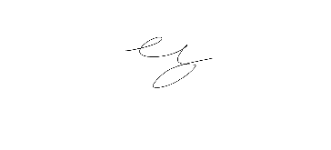

Printed Name: Nick Tarasenko