Understanding of Questionnaire Platform

1. Project Overview & Objectives

1.1 Project Objective
Based on my understanding of the High-Level Design (HLD), the objective of this project is to build a workflow-driven questionnaire platform for collecting structured personal and family health information required for genetic risk assessment. The current implementation is intentionally focused on data collection and persistence, with the collected questionnaire data eventually being exported (in JSON format) to the pedigree system for downstream assessment, risk scoring, recommendations, and reporting without requiring significant changes to the core platform.

1.2 My Overall Understanding
After studying the HLD, my understanding of the platform is as follows:
- The system is designed as a generic questionnaire platform that can support multiple clients and future capabilities beyond the initial implementation.
- The primary objective of Phase 1 is to collect and persist structured patient information (only personal details for now) through workflow-based questionnaires.
- The platform will have an extensible design so that questionnaire data collected today can be directly used by future assessment and reporting modules without restructuring the system.
- All business logic, questionnaire flow, and decision-making reside in the backend, while the client remains a thin interface responsible only for user interaction. This design enables multiple clients, such as CLI, Web, and Mobile, to communicate with the same backend through REST APIs.
“The client shouldn't think, the server should think.”
- The architecture divides the system into dedicated components such as the Workflow Engine, Template Engine, Rule Engine, and Persistence Layer, with each component responsible for a single, well-defined function.
- Questionnaire flow and clinical rules are designed to be configurable, allowing workflows and business rules to evolve with minimal changes to the application code.
- The questionnaire supports rule-based navigation, where subsequent questions are determined dynamically based on previous responses. For example, women-specific questions are presented only when the patient's gender satisfies the corresponding rule.
- The platform supports Save & Resume by persisting every response immediately after it is submitted. This ensures that if a questionnaire is interrupted, the user can continue from the exact point where they left off without losing any previously entered information.

1.3 Overall System Flow

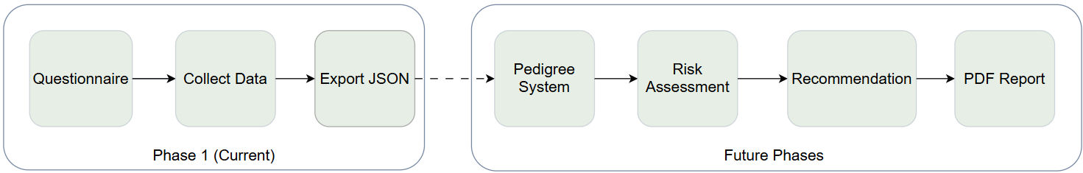
2. High-Level Architecture
2.1 System Architecture Overview
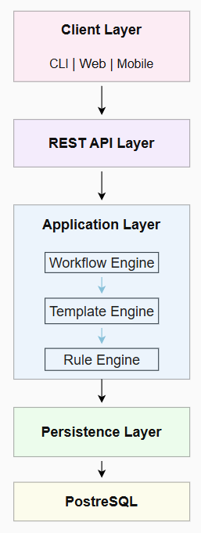
  Component | Responsibility
  Client Layer (Currently CLI) | Provides the user interface for the questionnaire, captures user input, and forwards every action to the backend through REST APIs without performing any business logic.
  REST API Layer | Serves as the single communication gateway between client applications and the backend, ensuring a consistent interface for current and future clients.
  Workflow Engine | Controls the overall questionnaire flow by identifying the current workflow section and deciding what should happen next.
  Template Engine | Loads and instantiates the appropriate question template based on the active workflow and contextual information provided by the Workflow Engine.
  Rule Engine | Evaluates visibility, conditional, repetition, and skip rules to dynamically determine which questions should be presented to the user.
  Persistence Layer | Persists questionnaire sessions, responses, and related data while managing all interactions with the underlying database.
  PostgreSQL | Acts as the persistent data store for patient information, questionnaire sessions, responses, family members, diseases, and mutations.
2.2 Request Flow
The platform follows a layered request-processing approach, where every client request passes through the backend components in sequence. The client interacts with the system through the REST API, which serves as the single entry point. Once a request is received, the Workflow Engine identifies the current workflow stage and coordinates the overall questionnaire flow. It requests the required questions from the Template Engine, after which the Rule Engine evaluates the applicable visibility, conditional, repetition, and skip rules before the question is sent back to the client. When the user submits an answer, the Persistence Layer stores the response and updates the questionnaire session. Using this updated state, the Workflow Engine coordinates the next step in the questionnaire, and the same process continues until the questionnaire is completed.
3. Questionnaire Workflow

3.1 Overall Workflow

User Perspective  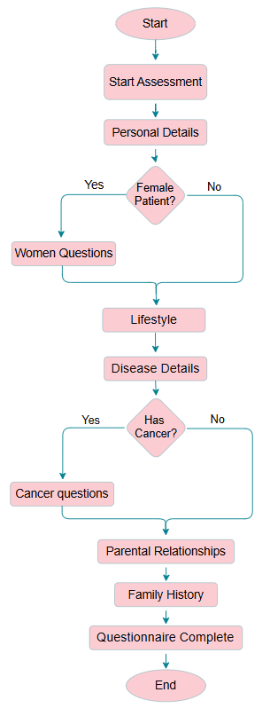 | System Perspective  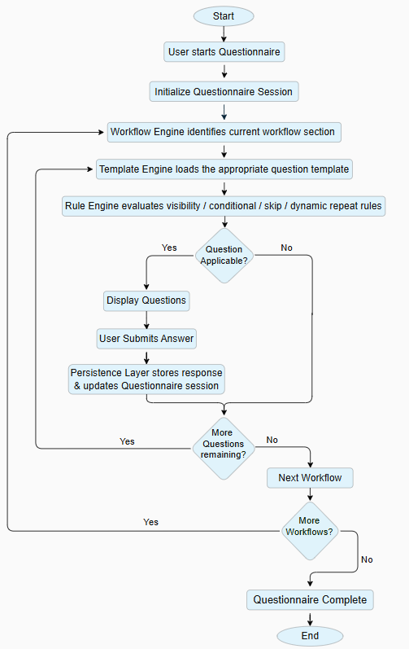

3.2 Workflow Execution

The questionnaire progresses through a series of predefined workflow sections. The Workflow Engine coordinates the overall flow by identifying the current workflow and managing the transition between workflow sections. For each step, the Template Engine loads the appropriate question set, while the Rule Engine applies visibility, conditional, repetition, and skip rules before presenting the question to the user. Every response is immediately stored along with the questionnaire session, enabling the Save & Resume functionality. This process continues until all workflow sections have been completed.
4. Data Model & Key Design Observations
4.1 Data Model Overview
Based on my understanding of the HLD, the data model separates questionnaire data into dedicated entities, keeping patient information, questionnaire progress, responses, family history, and clinical data organized while supporting future capabilities such as risk assessment, pedigree generation, and reporting.

Core Entities -

Entity | Purpose
PERSON | Stores the proband (patient) information.
FAMILY_MEMBER | Stores information about relatives associated with the patient.
QUESTIONNAIRE_SESSION | Tracks questionnaire progress and supports Save & Resume.
QUESTION_RESPONSE | Stores every questionnaire response along with related metadata.
DISEASE & MUTATION | Store structured clinical information for both the patient and family members.
4.2 Key Design Observations

Reusable Questionnaire Design
From the HLD, I understood that the questionnaire is designed for reusability. A single Family Member template is reused for different relatives by passing the relationship type as context, reducing duplication and simplifying maintenance.

Configurable Questionnaire Flow
Another key observation is that the questionnaire flow is not hardcoded in the application. Instead, rules such as question visibility, conditional questions, repetition, and skipping are configured externally, making it possible to modify questionnaire behavior without changing the core application logic.

Handling Repeated Family Members
One important concept is the use of relationship_instance_id. It uniquely links repeated responses to the correct family member, preventing answers from being overwritten.

Separation of Questionnaire and Clinical Data
I also observed that questionnaire responses and clinical information are stored separately. This keeps diseases and mutations structured, making them easier to use for future risk assessment and reporting.

5. Current Implementation Scope
Based on the discussions and the current project requirements, the initial implementation will focus on the Personal Details workflow. The objective of the current implementation is to establish the core questionnaire platform by implementing the workflow engine, rule-based question flow, response persistence, and session management. The remaining workflow sections, including Lifestyle, Disease, Parental Relationship, and Family History, will be implemented incrementally using the same architecture and execution flow described in this document. This phased approach allows the platform to be validated with a smaller workflow before extending it to the complete questionnaire.

