Questionnaire Platform
High-Level Design
Phase 1 — Questionnaire collection
Healthcare & genomics · family-history assessment
Status: Draft for review

Contents

1. Overview
This document describes the high-level design of a questionnaire platform that collects structured family-history and personal health information for a genetic-risk assessment workflow. A command-line client is the first consumer, but the system is deliberately built as a platform rather than a CLI application: all logic lives server-side behind a REST boundary, so additional clients (Web, Mobile) can be added later without change to the core.
Phase 1 is scoped to data collection only. Assessment, risk scoring, pedigree generation and reporting are explicitly deferred to later phases; the data model is shaped so those capabilities can read the same store without restructuring.

2. Architecture
The platform is a strict top-down layered stack. Each layer communicates only with the one directly beneath it. As a result the client carries no business logic, and the REST API is the single integration surface for every present and future client.
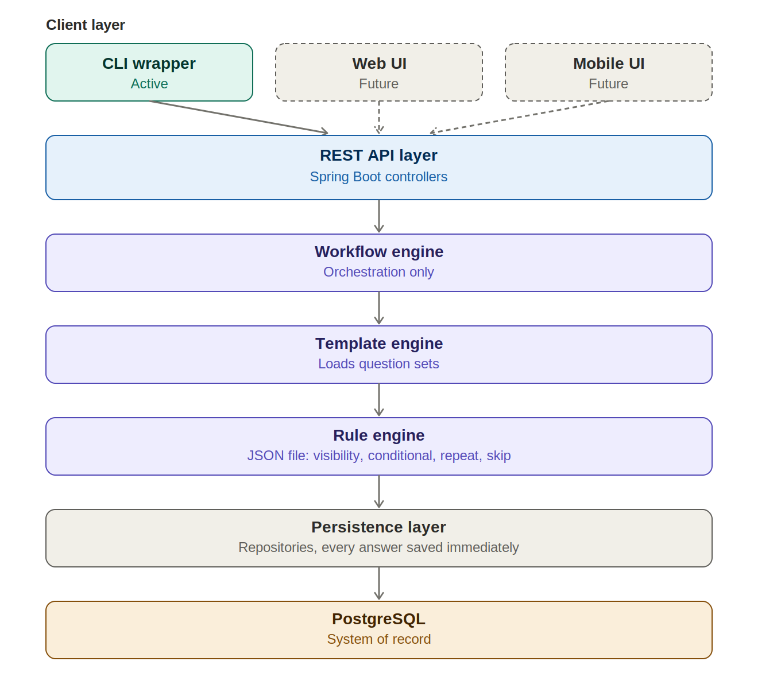
The Workflow, Template and Rule engines are the heart of the server. They are kept as three single-responsibility components so that a change to stage ordering, question content, or conditional behaviour each touches exactly one engine.

3. Request flow
The CLI is a thin translator: one command maps to exactly one REST call, with no decisions made on the client. This keeps the contract identical for any future client.
CLI command | REST call
family-history start | POST /api/v1/assessment/start
family-history next | GET /api/v1/assessment/{id}/next-question
family-history answer Q001 YES | POST /api/v1/assessment/{id}/answer

4. Engines

4.1 Workflow Section engine
Responsible for orchestration only — it sequences five workflows and delegates content and logic to the other engines. Each workflow owns one or more templates.
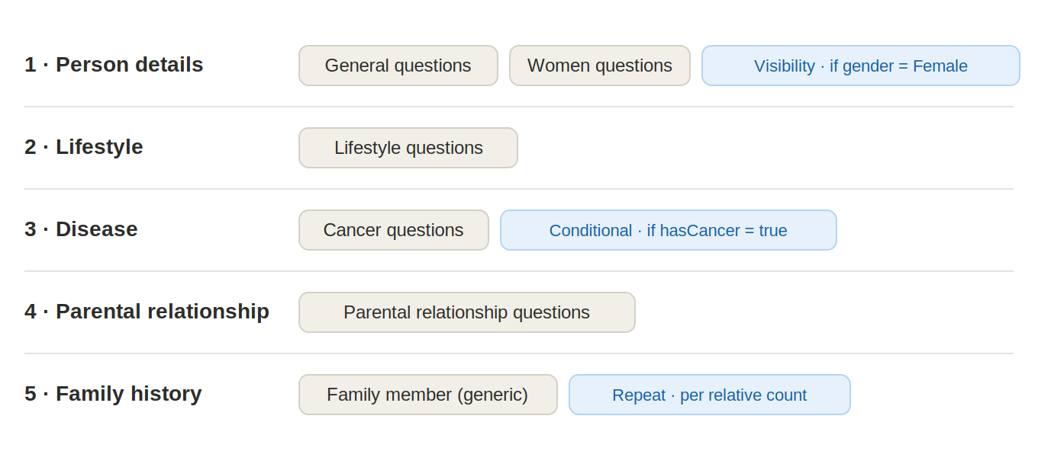

4.2 Template engine
Loads the question set for each stage. A single generic Family Member template is reused for every relative instead of separate Mother, Father and Sibling templates. The workflow passes the relationship as context when it instantiates the template:
{ "relationshipType": "MOTHER" } // or "FATHER", "SIBLING", ...
relationshipType is stored on the family-member record and is also available to the rule engine, so one template can vary its questions by relative. This is the primary maintenance win of the design.

4.3 Rule engine
All rules live in an external JSON file loaded by the engine, so clinical logic is configuration rather than code. Four rule types are supported: visibility, conditional question, dynamic repetition, and skip.
{ "type": "visibility", "condition": "gender == FEMALE", "template": "WomenQuestions" }
{ "type": "conditional", "condition": "hasCancer == true", "template": "CancerQuestions" }
{ "type": "repeat", "condition": "siblingCount > 0", "template": "FamilyMember",
"countField": "siblingCount" }

5. Question templates across subjects
Because a family member is person-shaped, the same question templates that apply to the proband(main patient) also apply to each relative. The General, Women and Cancer templates are shared; their answers are written to QUESTION_RESPONSE, and any diagnoses or variants captured become DISEASE or MUTATION records attached to whichever subject they describe.
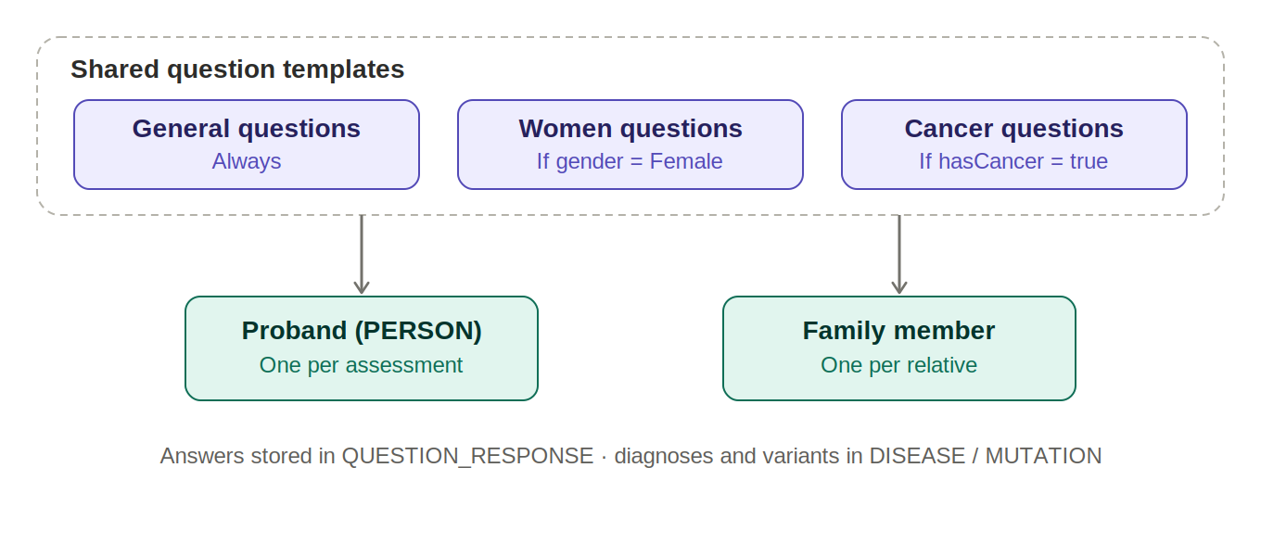

6. Data model
Six tables make up the Phase 1 model. The proband lives in PERSON; relatives live in FAMILY_MEMBER, keyed to the proband so proband-centric search is fast. DISEASE and MUTATION are normalized clinical tables that attach to either the proband or a relative. Every answer is captured in QUESTION_RESPONSE, typed and instance-scoped.
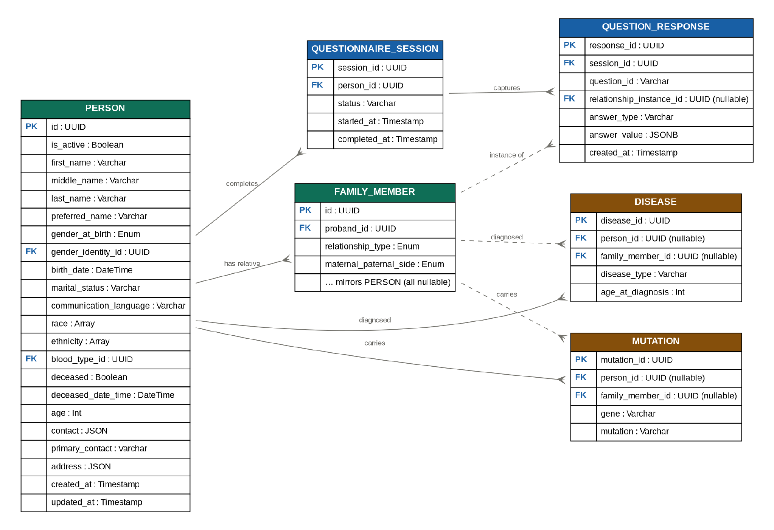

6.1 PERSON
The proband — subject of the assessment. The full schema is owned separately and will continue to grow; the columns below cover the agreed baseline.
Key | Column | Type
PK | id | UUID
 | is_active | Boolean
 | first_name | Varchar
 | middle_name | Varchar
 | last_name | Varchar
 | preferred_name | Varchar
 | gender_at_birth | Enum
FK | gender_identity_id | UUID
 | birth_date | DateTime
 | marital_status | Varchar
 | communication_language | Varchar
 | race | Array
 | ethnicity | Array
FK | blood_type_id | UUID
 | deceased | Boolean
 | deceased_date_time | DateTime
 | age | Int
 | contact | JSON
 | primary_contact | Varchar
 | address | JSON
 | created_at | Timestamp
 | updated_at | Timestamp

6.2 FAMILY_MEMBER
A relative. Person-shaped and keyed to the proband. It mirrors every PERSON column (all nullable, since family history is usually partial) and adds the relationship fields below.
Key | Column | Type
PK | id | UUID
FK | proband_id | UUID → PERSON
 | relationship_type | Enum
 | maternal_paternal_side | Enum
 | … mirrors every PERSON column | all nullable

6.3 QUESTIONNAIRE_SESSION
Tracks one assessment run and supports save-and-resume.
Key | Column | Type
PK | session_id | UUID
FK | person_id | UUID
 | status | Varchar
 | started_at | Timestamp
 | completed_at | Timestamp

6.4 QUESTION_RESPONSE
The system of record for every answer. answer_type names the shape (BOOLEAN, NUMBER, STRING, ARRAY, OBJECT) and answer_value holds the value as JSONB, so one table absorbs all answer shapes without per-type columns.
Key | Column | Type
PK | response_id | UUID
FK | session_id | UUID
 | question_id | Varchar
FK | relationship_instance_id | UUID (nullable)
 | answer_type | Varchar
 | answer_value | JSONB
 | created_at | Timestamp

6.5 DISEASE and MUTATION
Both tables carry two nullable foreign keys — person_id and family_member_id — with a check constraint that exactly one is set. A diagnosis or variant can therefore belong to the proband or to any relative, and remains queryable structurally rather than buried inside answer JSON. This structured shape is what later feeds risk scoring.
Key | Column | Type
PK | disease_id | UUID
FK | person_id | UUID (nullable)
FK | family_member_id | UUID (nullable)
 | disease_type | Varchar
 | age_at_diagnosis | Int

Key | Column | Type
PK | mutation_id | UUID
FK | person_id | UUID (nullable)
FK | family_member_id | UUID (nullable)
 | gene | Varchar
 | mutation | Varchar

6.6 Field-level notes
- are both arrays — a person may report more than one of each.
- and are JSON objects; is a separate scalar identifying the preferred contact.
- plus and capture vital status; a separate column is intentionally omitted as it would only duplicate .
- If a person needs more than one address or contact method as first-class rows, / can be promoted to shared CONTACT / ADDRESS tables referenced by both PERSON and FAMILY_MEMBER.

7. Key design decisions

7.1 relationship_instance_id — why repeats need it
When the proband answers siblingCount = 3, two things happen. First, that answer is stored as a single QUESTION_RESPONSE of type NUMBER. Second, the dynamic-repetition rule fires and the engine serves the generic Family Member template three times — once per sibling — creating three FAMILY_MEMBER rows.
The subtlety: all three repetitions reuse the same template and therefore the same question identifiers. An answer keyed only by (session_id, question_id) would collide — sibling 2's answers would overwrite sibling 1's, and there would be no way to reconstruct who answered what.
relationship_instance_id solves this by pinning each repeated answer to the specific FAMILY_MEMBER row it describes. The three siblings stay fully separate and reconstructable. For proband-level questions (Person, Lifestyle, Disease workflows) the field is simply null. In short, it is the dimension that makes repeated templates recoverable, and it must be present from day one.

7.2 Generic Family Member template
One template parameterised by relationshipType replaces per-relative templates, dramatically reducing the number of templates to maintain while keeping behaviour configurable through rules.

7.3 Rules as configuration
Externalising all rules to a JSON file means clinical and branching logic can change without a code deployment, which suits a domain where question logic evolves frequently.

7.4 Persist every answer
Answers are written immediately on entry rather than at the end of a session. Combined with QUESTIONNAIRE_SESSION status, this gives reliable save-and-resume and ensures an interrupted session loses nothing.

8. Phase 1 scope and evolution
Phase 1 delivers data collection only: the six tables above, five workflows, JSON-driven rules, and save-and-resume with every answer persisted on entry. The later phases read this same store.
- REST API, CLI wrapper, questionnaire collection, JSON export.
- assessment engine, risk scoring, recommendations.
- pedigree generator, PDF report, FHIR export.
The DISEASE and MUTATION tables are already shaped to feed the Phase 2 assessment engine, so no structural change is expected when scoring is introduced.

