# Normality Tests

## Plots for valence variable

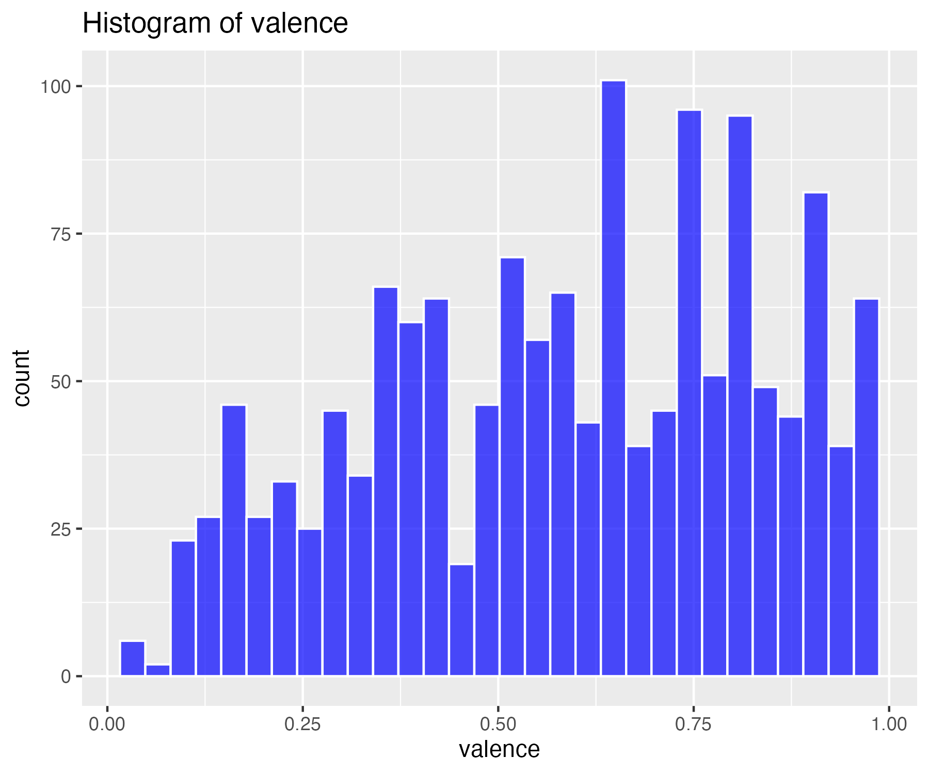

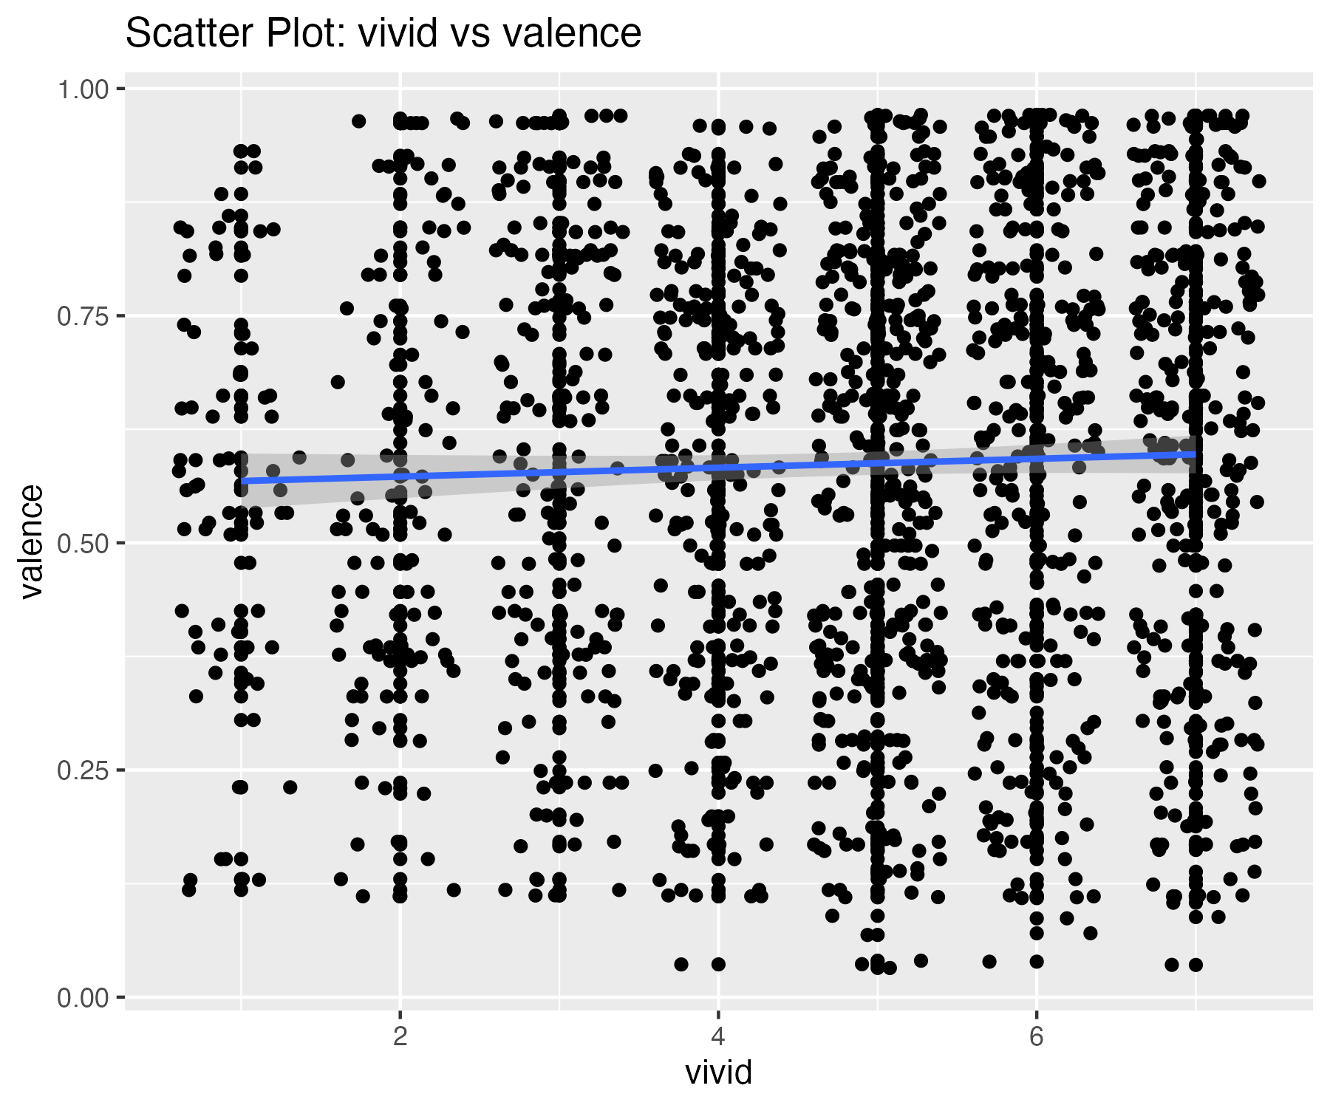

0 outliers were identified in the valence variable.

## Scatterplot of valence variable with outliers removed

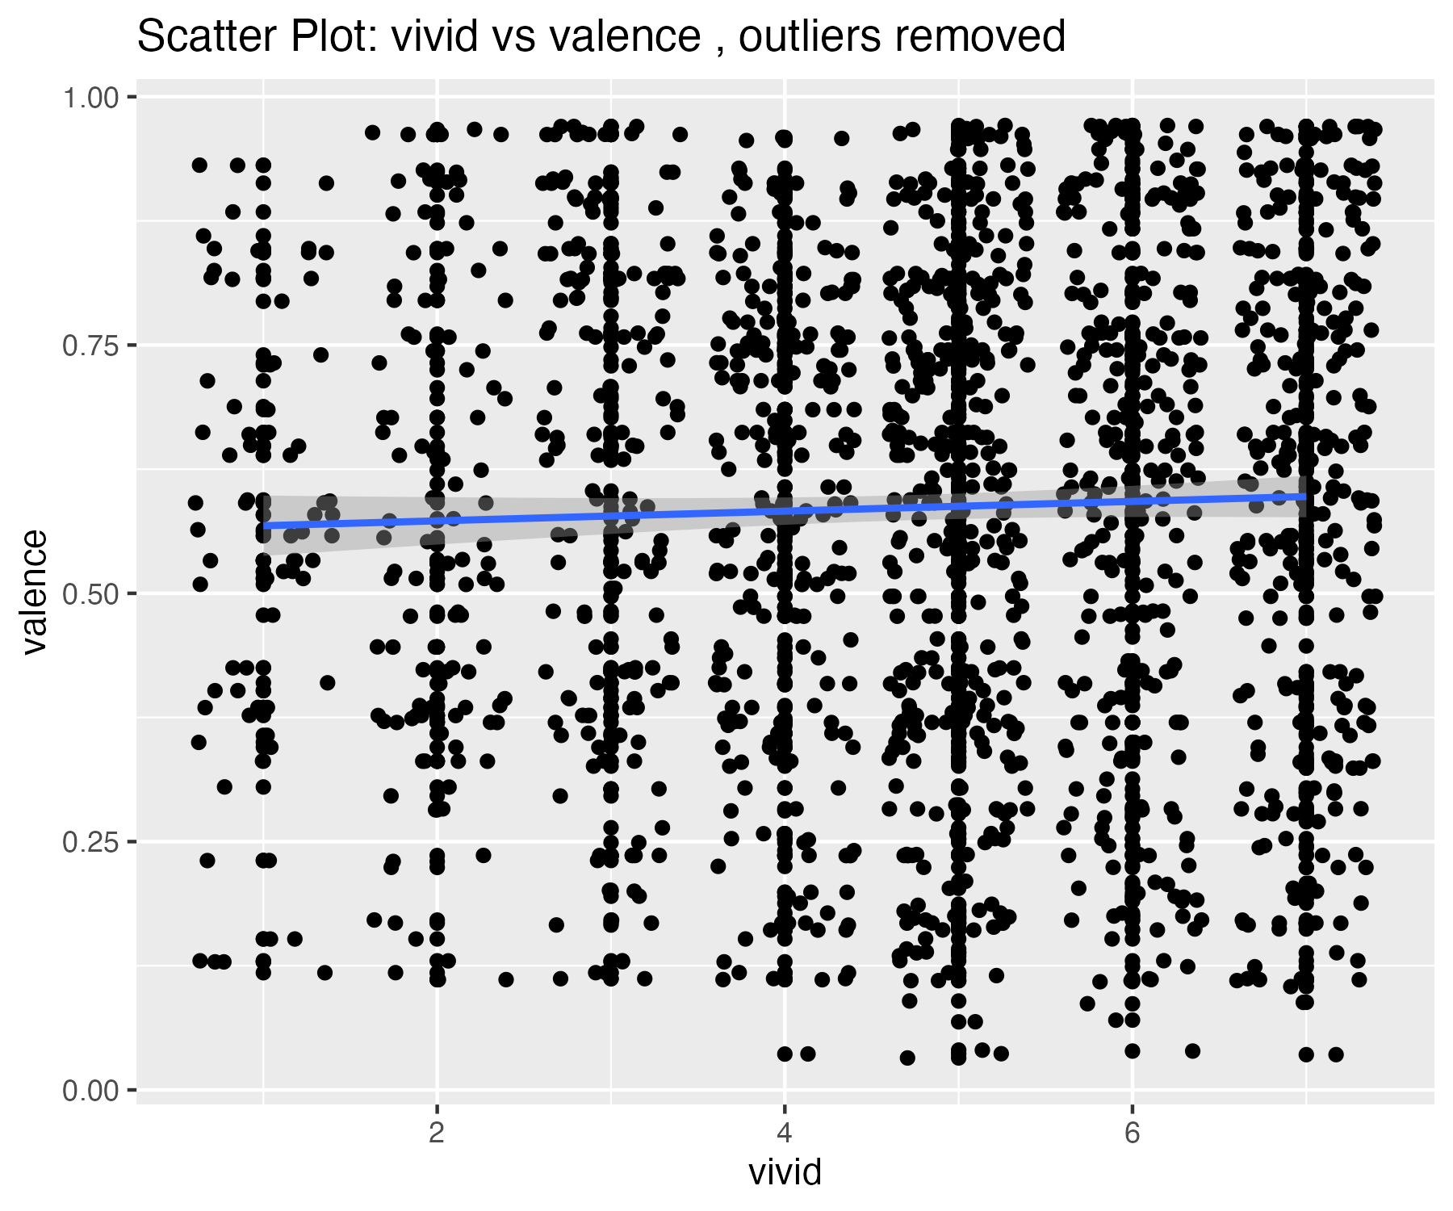

## Plots for loudness variable

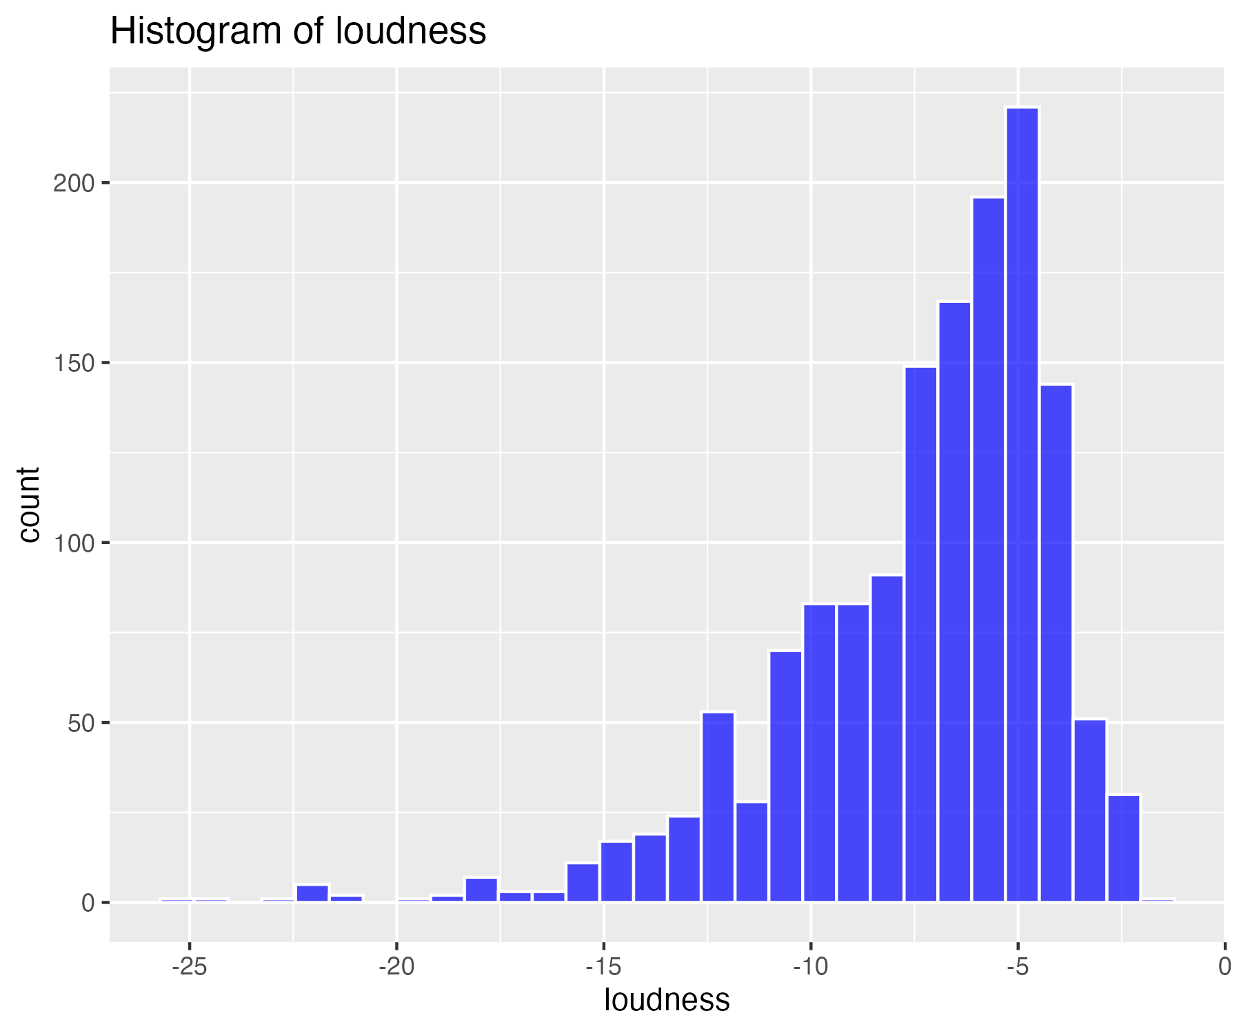

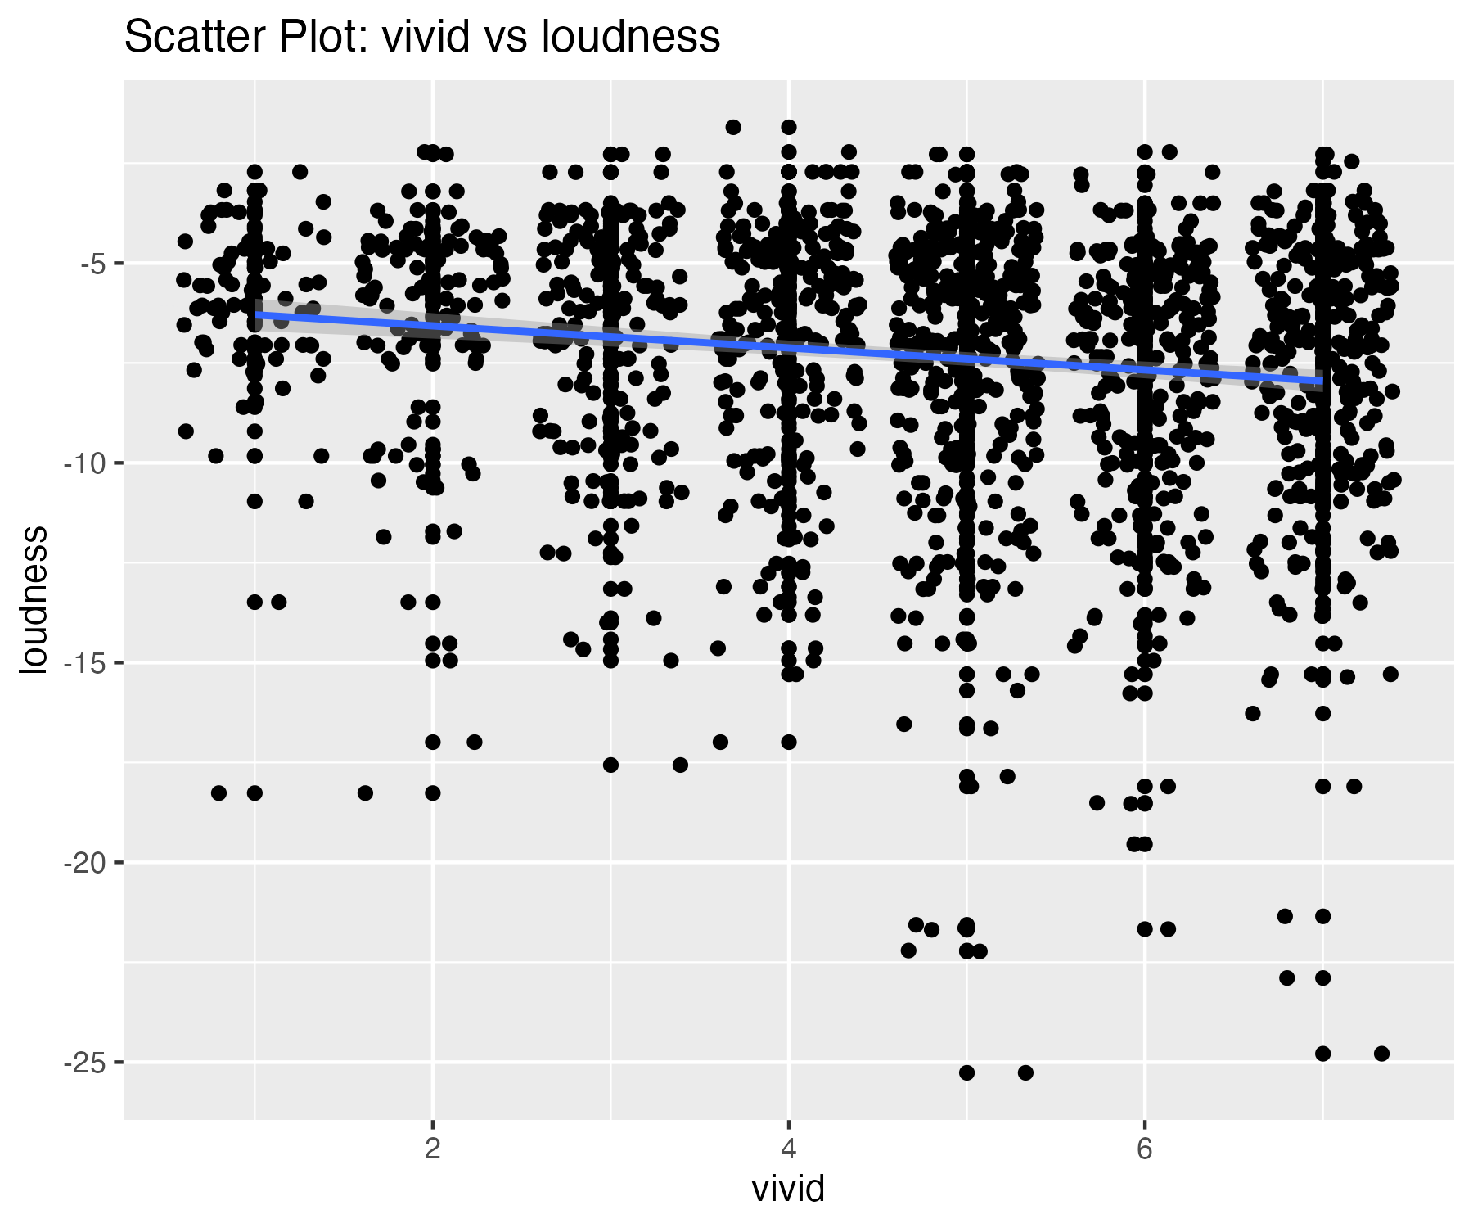

18 outliers were identified in the loudness variable.

## Scatterplot of loudness variable with outliers removed

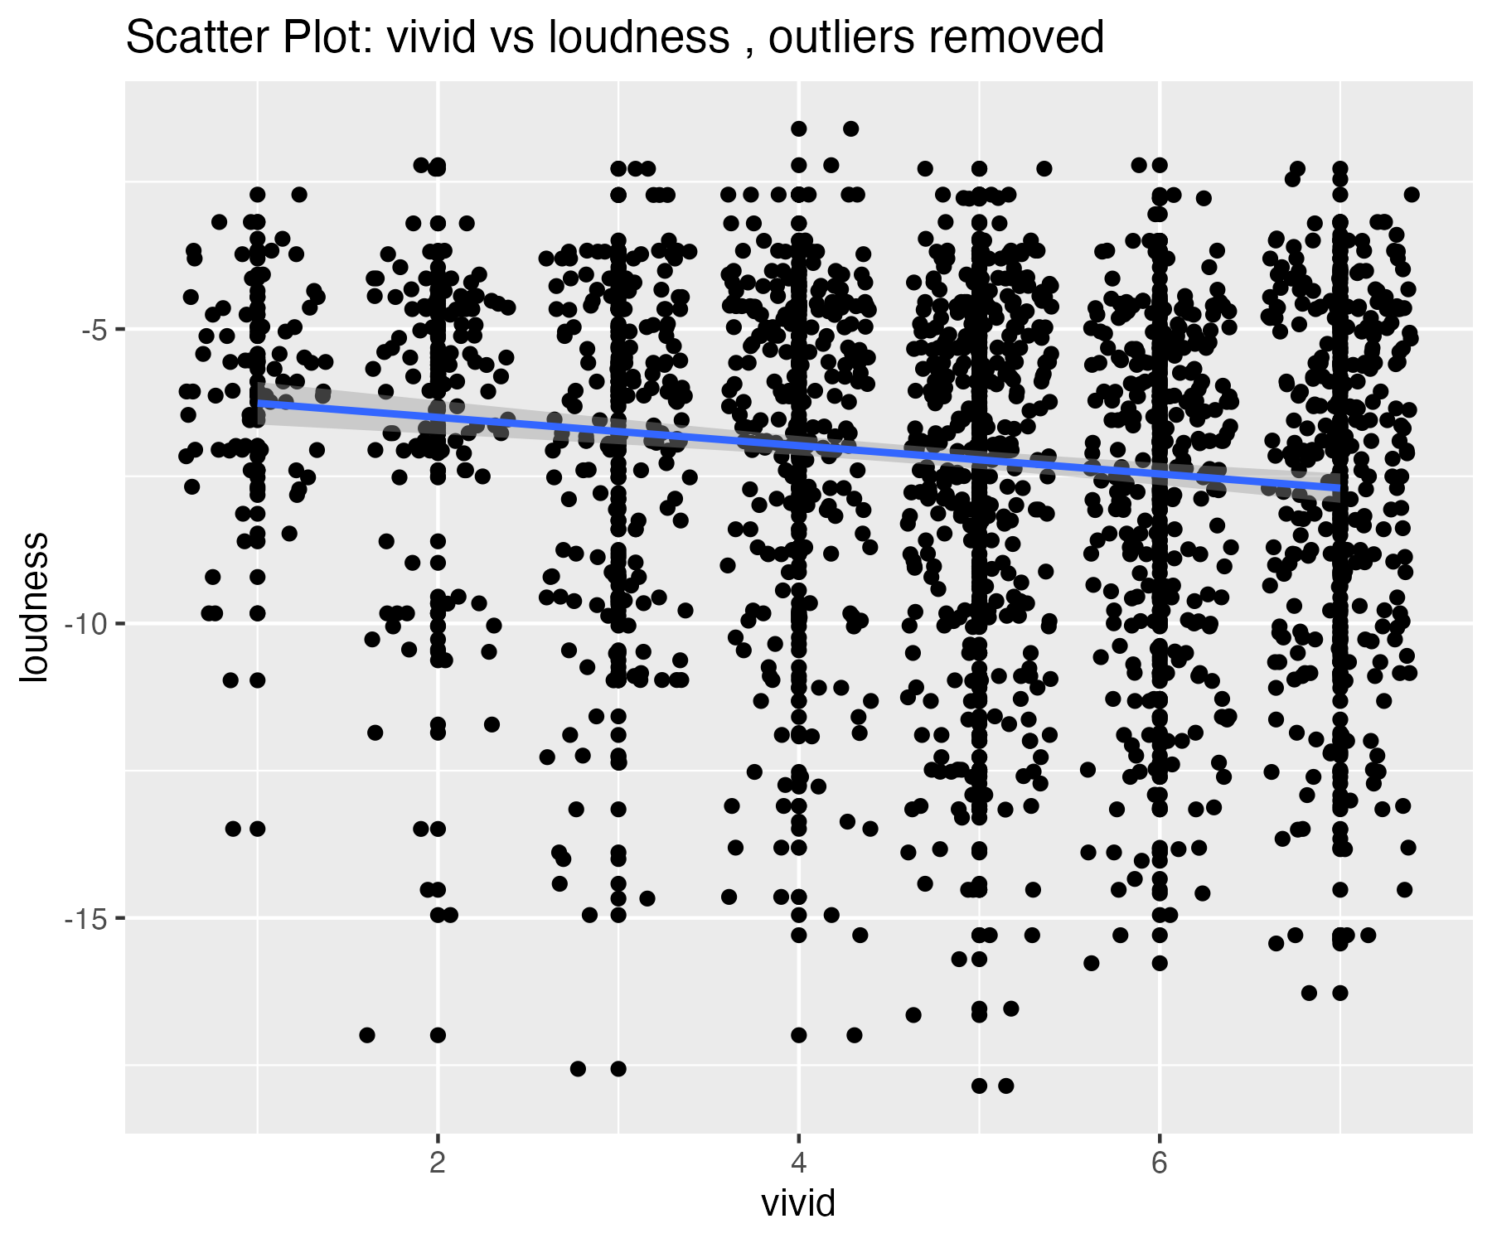

## Descriptives summary table for all variables

| matrix.nrow...20..ncol...1. | valence | loudness |
| --- | --- | --- |
| nbr.val | 1,464.00 | 1,464.00 |
| nbr.null | 0.00 | 0.00 |
| nbr.na | 0.00 | 0.00 |
| min | 0.03 | -25.27 |
| max | 0.97 | -1.60 |
| range | 0.94 | 23.67 |
| sum | 859.70 | -10,709.35 |
| median | 0.61 | -6.55 |
| mean | 0.59 | -7.32 |
| SE.mean | 0.01 | 0.09 |
| CI.mean.0.95 | 0.01 | 0.17 |
| var | 0.06 | 10.68 |
| std.dev | 0.24 | 3.27 |
| coef.var | 0.42 | -0.45 |
| skewness | -0.27 | -1.44 |
| skew.2SE | -2.14 | -11.23 |
| kurtosis | -0.98 | 3.09 |
| kurt.2SE | -3.83 | 12.10 |
| normtest.W | 0.96 | 0.90 |
| normtest.p | 0.00 | 0.00 |

## Descriptives summary table for all variables with outliers removed

| matrix.nrow...20..ncol...1. | valence | loudness |
| --- | --- | --- |
| nbr.val | 1,464.00 | 1,446.00 |
| nbr.null | 0.00 | 0.00 |
| nbr.na | 0.00 | 0.00 |
| min | 0.03 | -17.85 |
| max | 0.97 | -1.60 |
| range | 0.94 | 16.25 |
| sum | 859.70 | -10,336.61 |
| median | 0.61 | -6.55 |
| mean | 0.59 | -7.15 |
| SE.mean | 0.01 | 0.08 |
| CI.mean.0.95 | 0.01 | 0.15 |
| var | 0.06 | 8.49 |
| std.dev | 0.24 | 2.91 |
| coef.var | 0.42 | -0.41 |
| skewness | -0.27 | -0.91 |
| skew.2SE | -2.14 | -7.06 |
| kurtosis | -0.98 | 0.38 |
| kurt.2SE | -3.83 | 1.49 |
| normtest.W | 0.96 | 0.94 |
| normtest.p | 0.00 | 0.00 |