# LMEM Assumption Checking

X.1 Model formula and summary output

X.1.1 Plot of observed versus predicted values. Look for a straight line pattern

X.1.2 Plot of fitted values against residuals. Inspect for homoscedasticity. Plot should not be funnel shaped

X.1.3 Q-Q Plot: data points should be aligned on red line. Indication of normality of residuals

X.1.4 ACF. Look for no significant autocorrelations

## Model 1 :

memenergy ~ danceability + acousticness + (1 | pptnum) + (1 | Title)

| Estimate | Std. Error | df | t value | Pr(>|t|) |
| --- | --- | --- | --- | --- |
| 3.771 | 0.171 | 343.826 | 22.004 | 0.000 |
| -0.037 | 0.234 | 297.146 | -0.156 | 0.876 |
| -0.680 | 0.141 | 332.777 | -4.814 | 0.000 |

(Estimate = -0.037, SE = 0.234, t(297.146) = -0.156, p = 0.876)

### Plot: obspreds

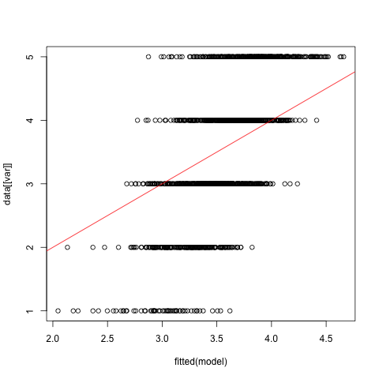

### Plot: homosced

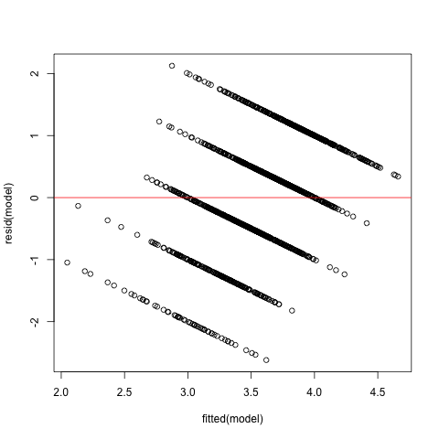

### Plot: qq

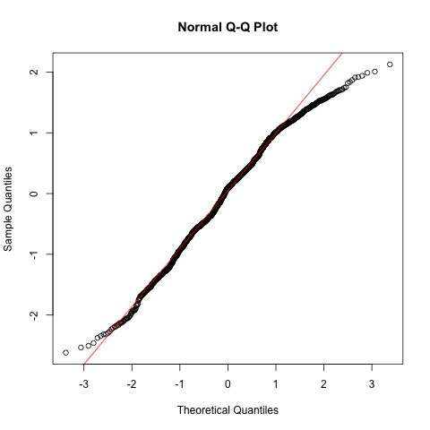

### Plot: acf

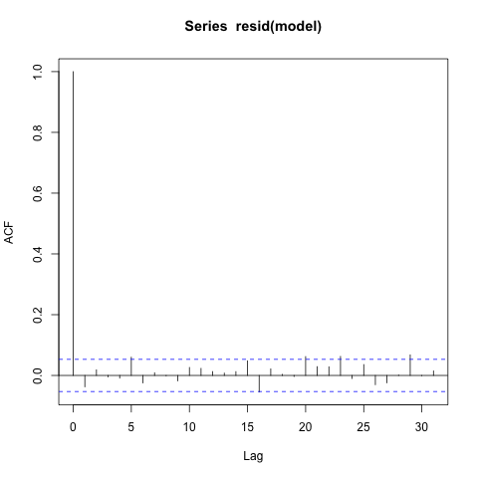

## Model 2 :

social ~ danceability + acousticness + (1 | pptnum) + (1 | Title)

| Estimate | Std. Error | df | t value | Pr(>|t|) |
| --- | --- | --- | --- | --- |
| 3.060 | 0.213 | 441.816 | 14.373 | 0.000 |
| 0.280 | 0.289 | 382.413 | 0.966 | 0.335 |
| -0.423 | 0.175 | 413.550 | -2.417 | 0.016 |

(Estimate = 0.28, SE = 0.289, t(382.413) = 0.966, p = 0.335)

### Plot: obspreds

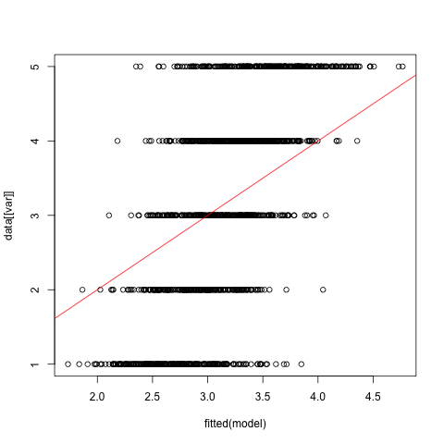

### Plot: homosced

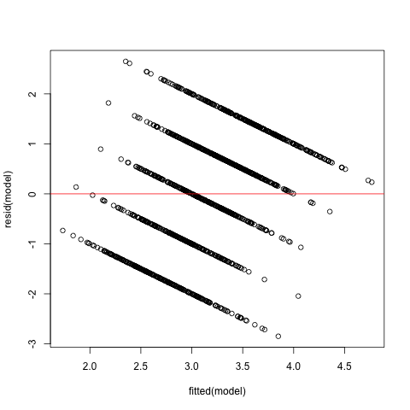

### Plot: qq

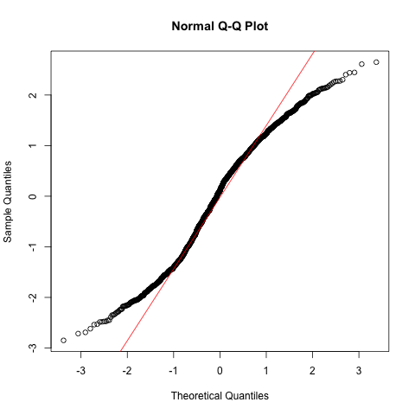

### Plot: acf

