## Histogram of non-transformed danceability

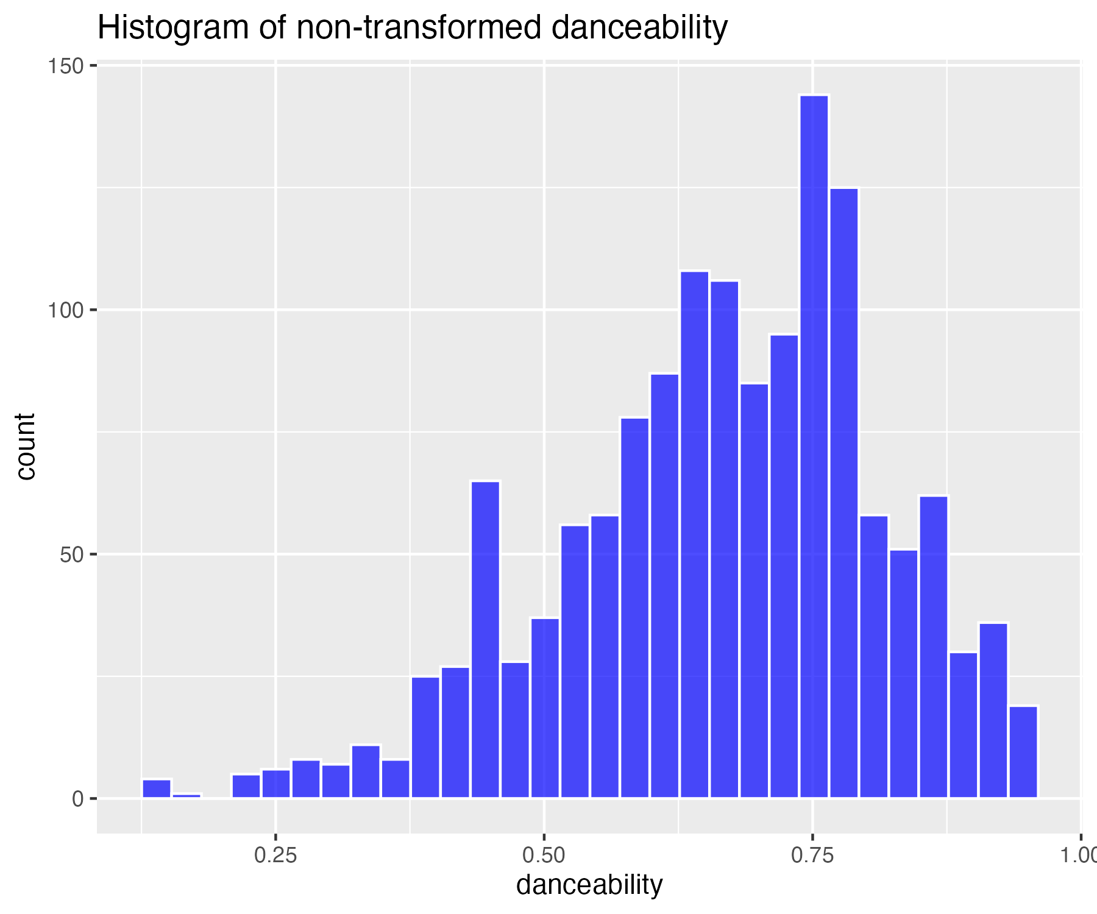

## Square-root transform of danceability (for moderate skew)

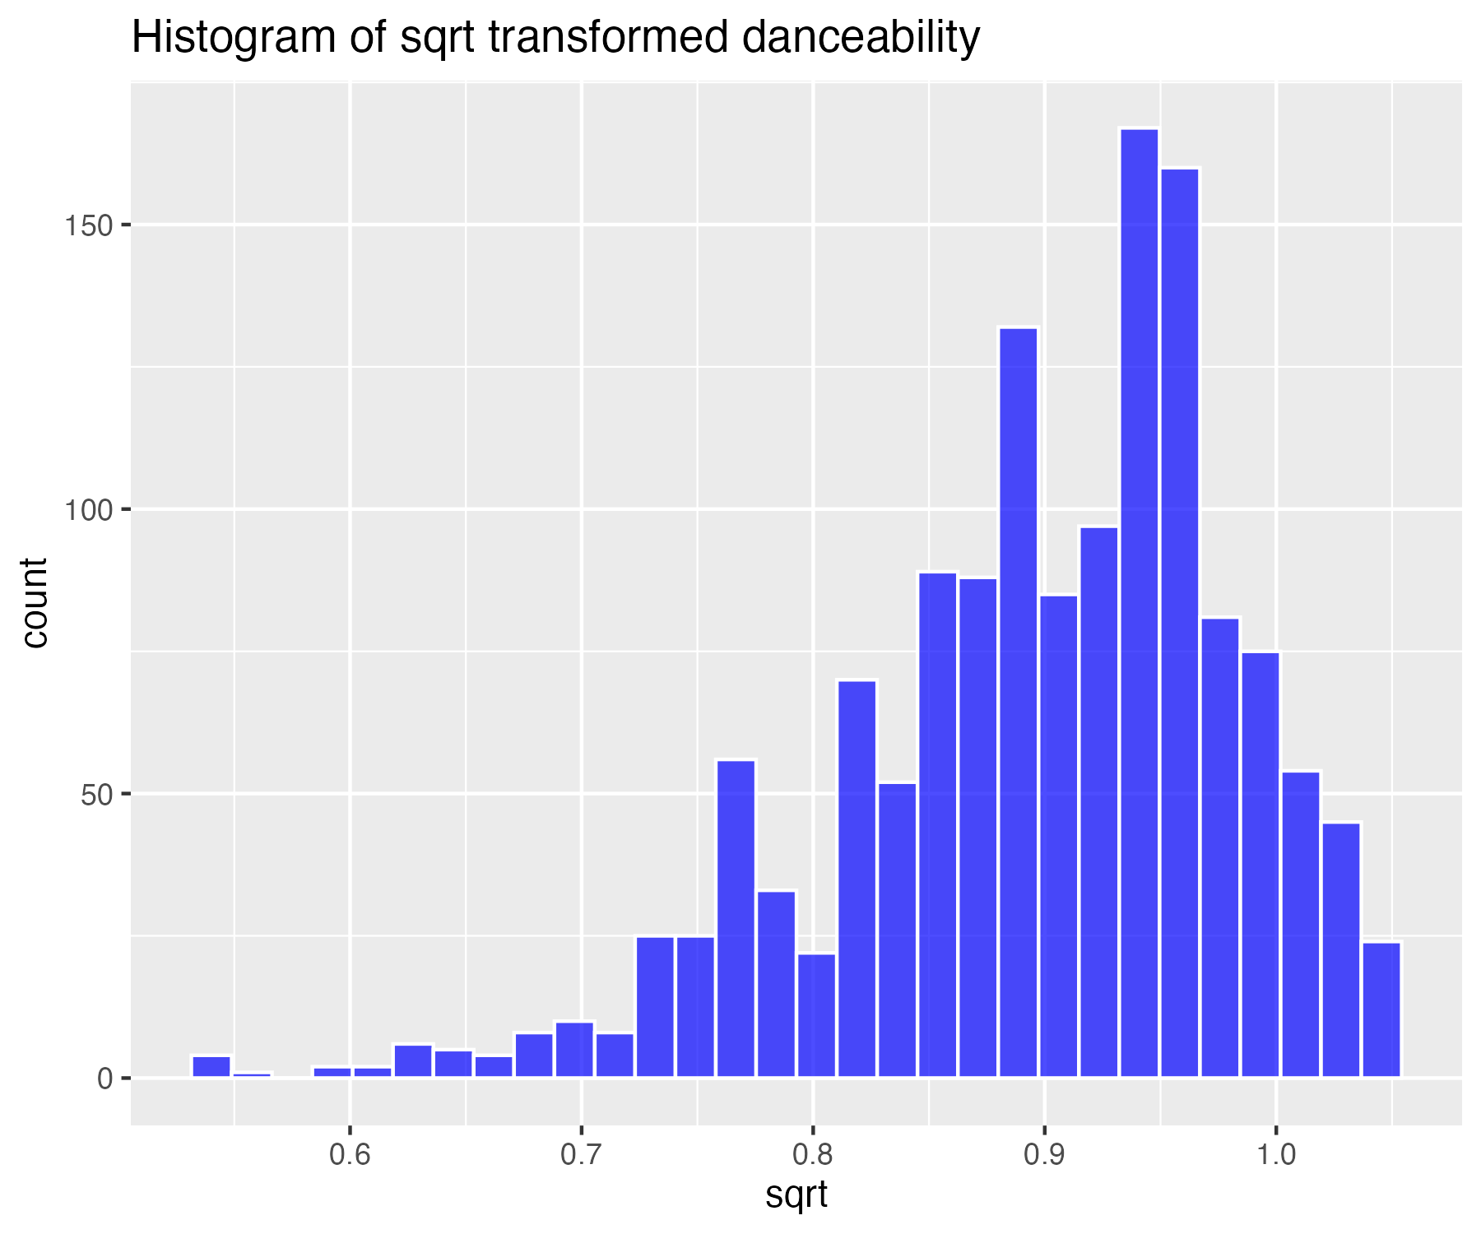

## Log base 10 transform of danceability (for high skew)

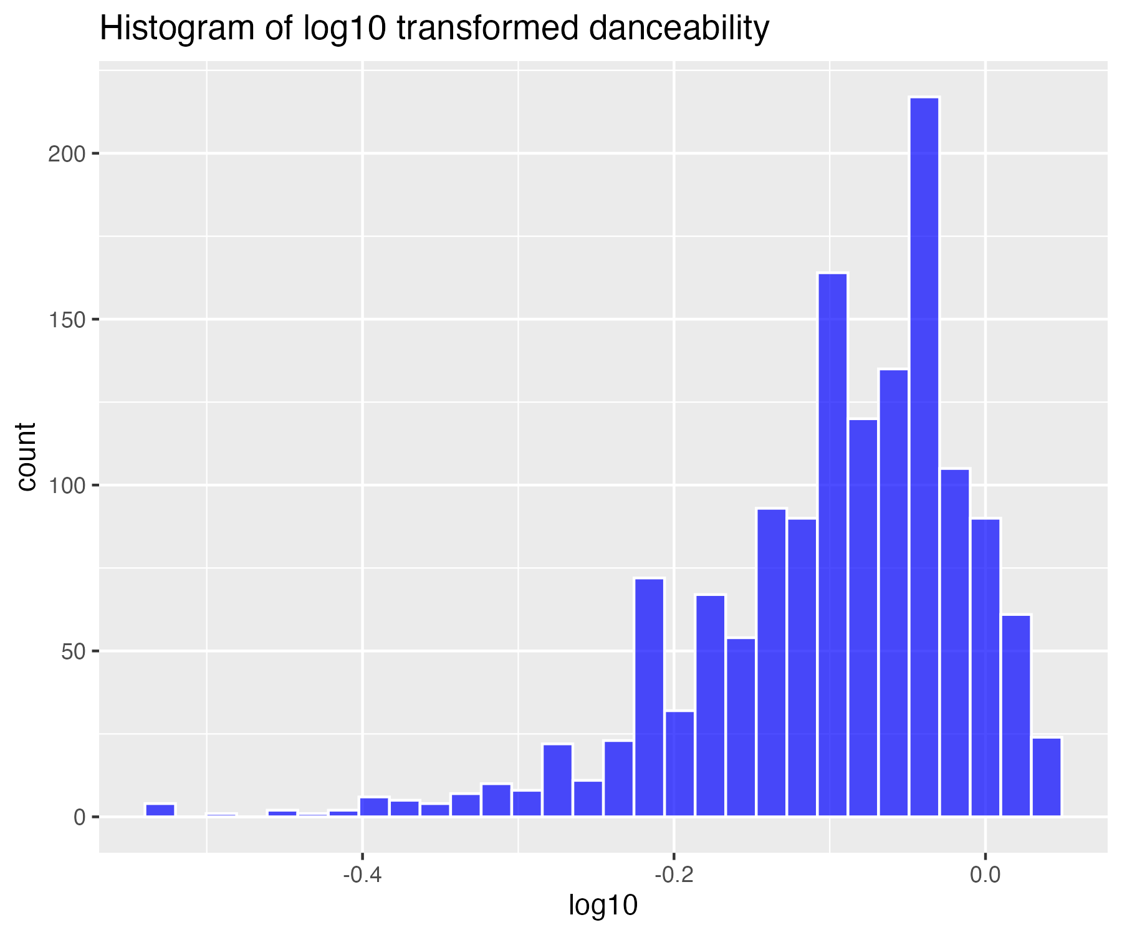

## Natural log transform of danceability (for higher skew)

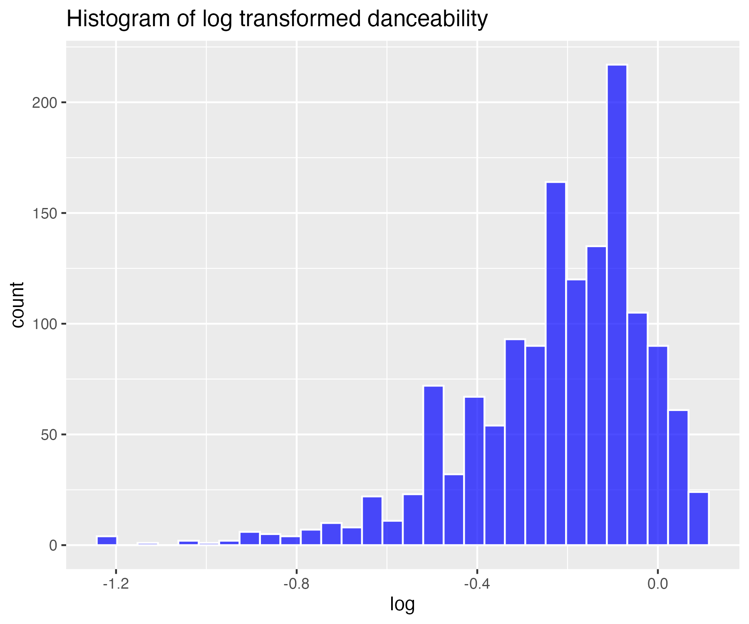

## Inverse transform of danceability (for severe skew)

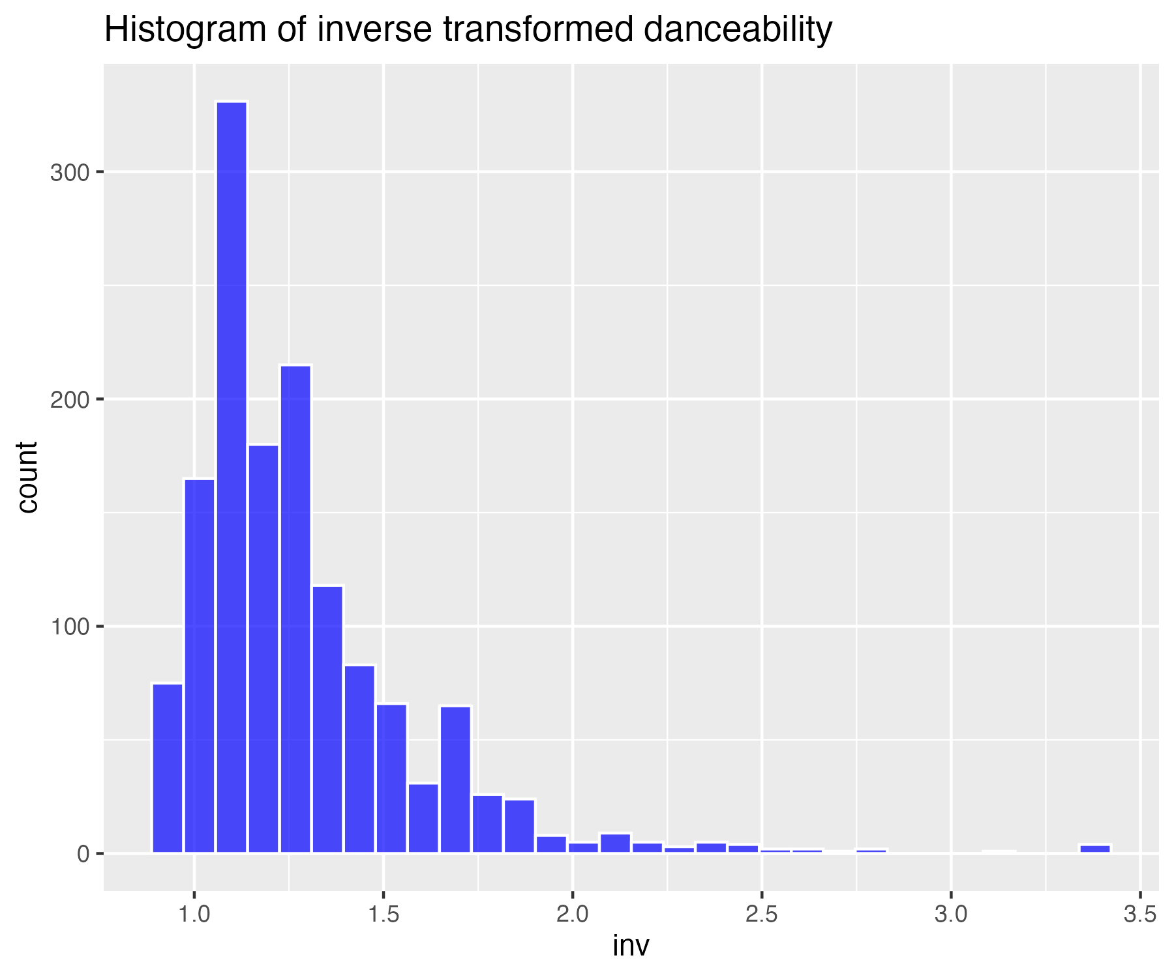

## Histogram of non-transformed energy

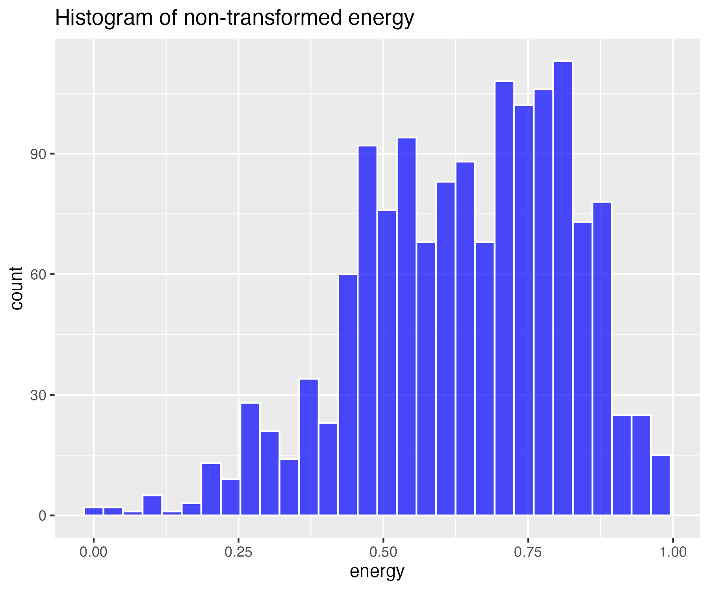

## Square-root transform of energy (for moderate skew)

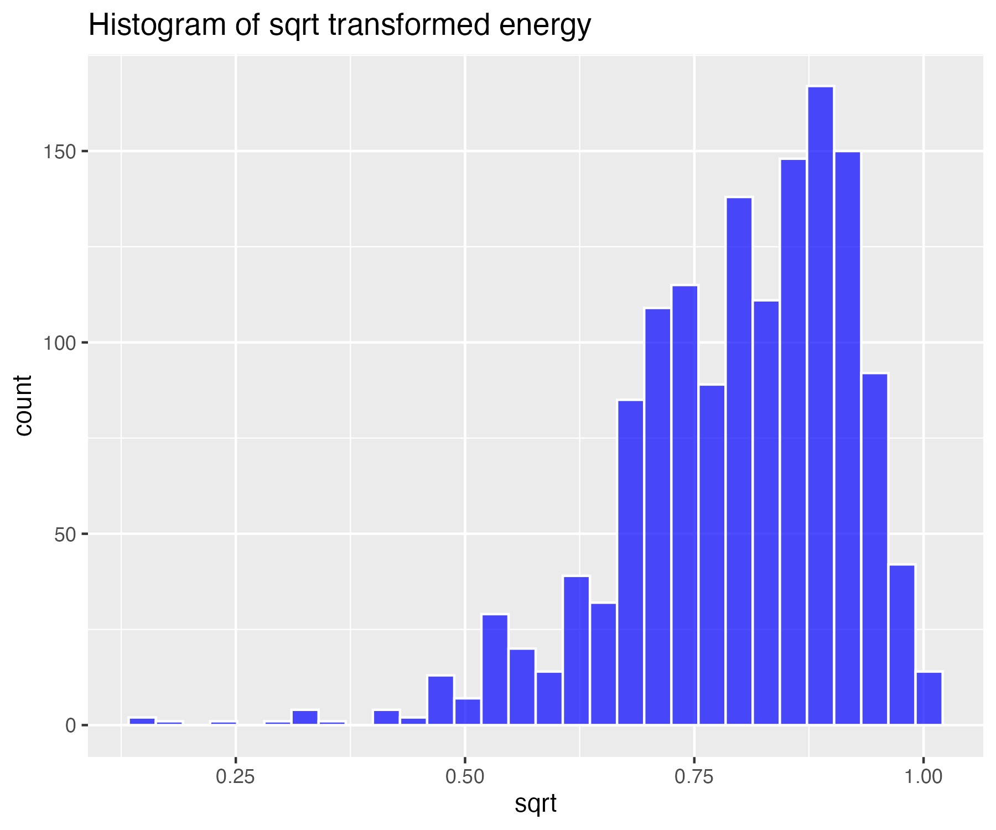

## Log base 10 transform of energy (for high skew)

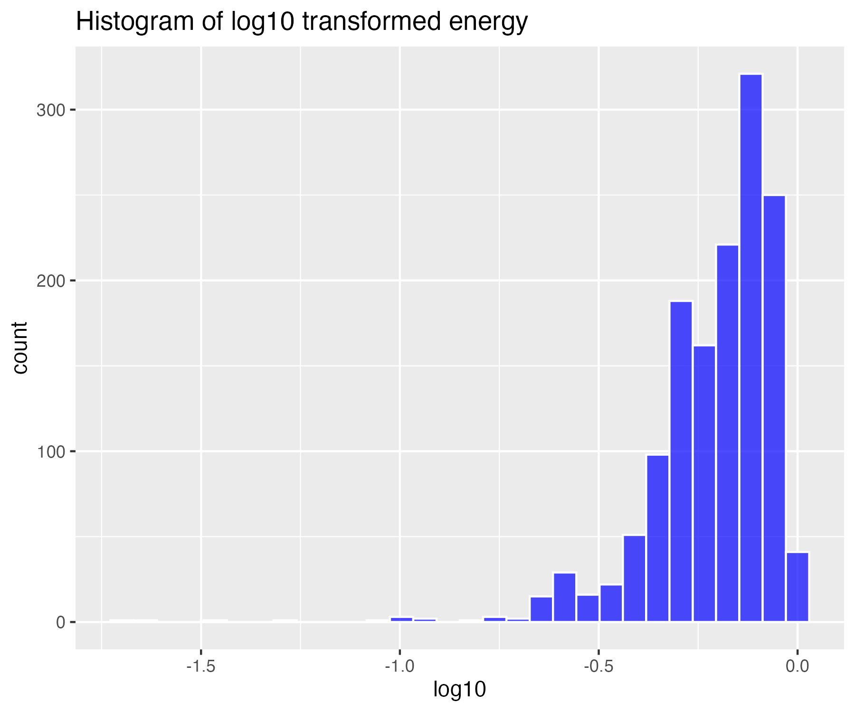

## Natural log transform of energy (for higher skew)

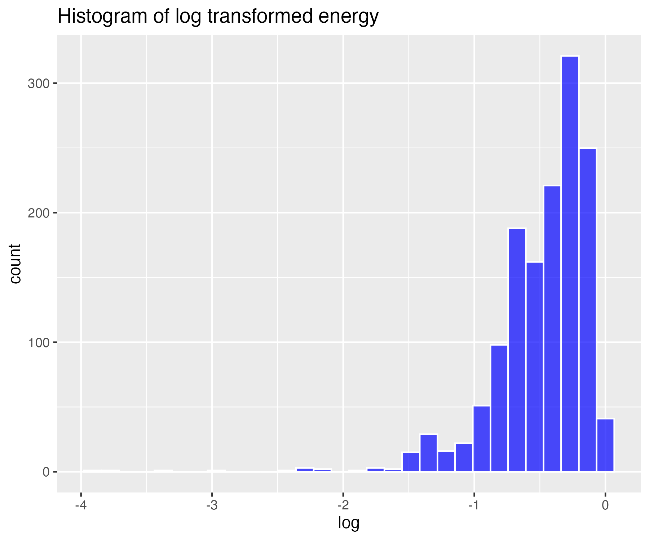

## Inverse transform of energy (for severe skew)

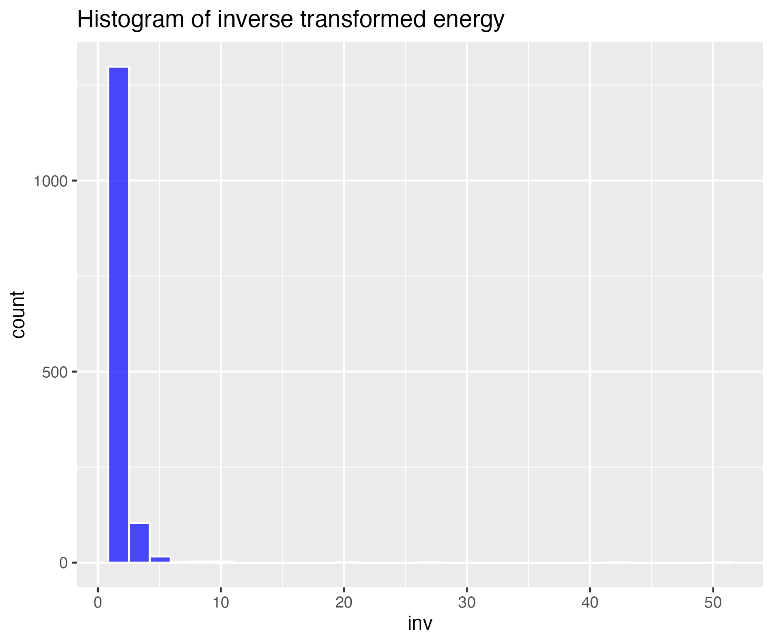

## Histogram of non-transformed loudness

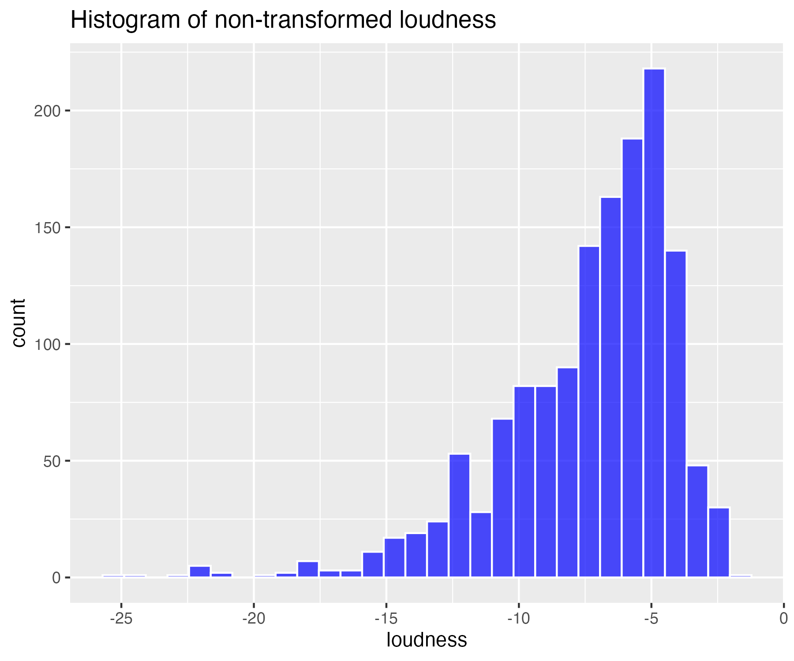

## Square-root transform of loudness (for moderate skew)

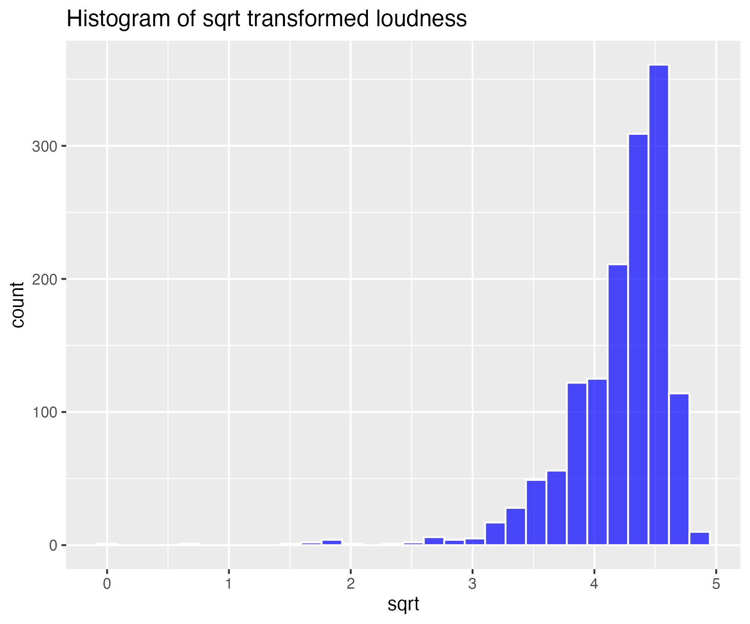

## Log base 10 transform of loudness (for high skew)

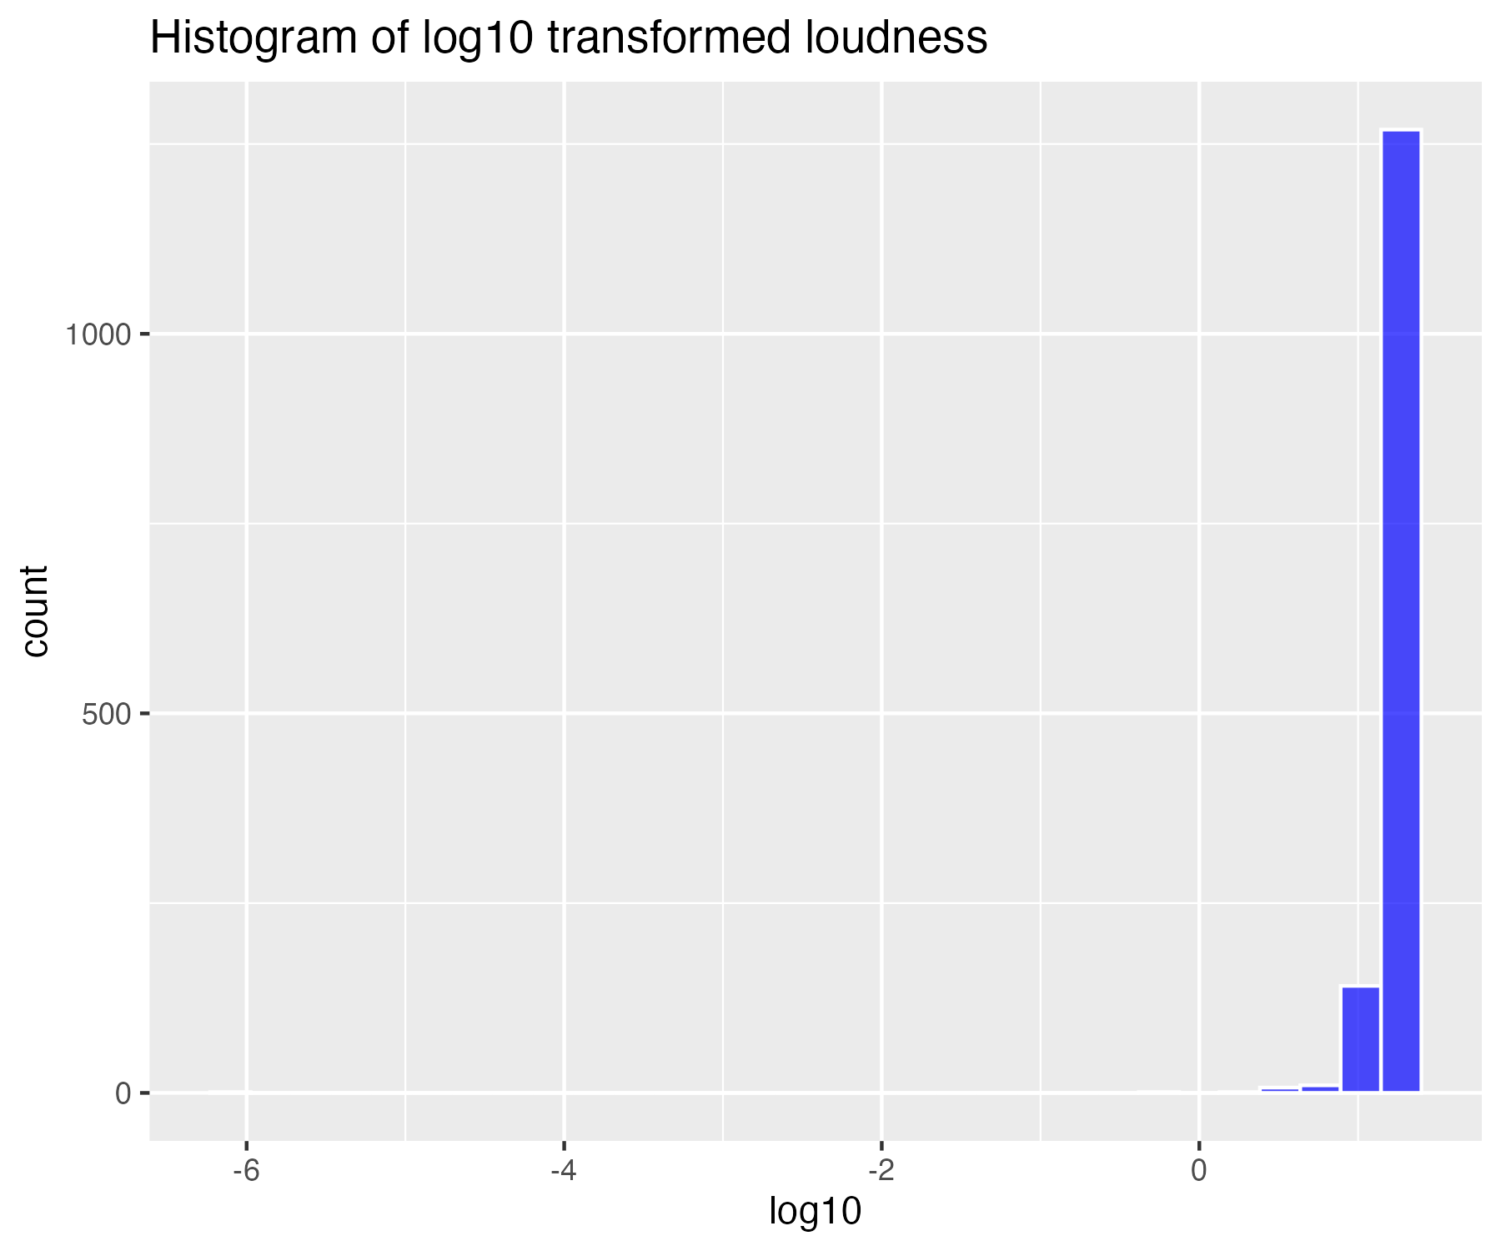

## Natural log transform of loudness (for higher skew)

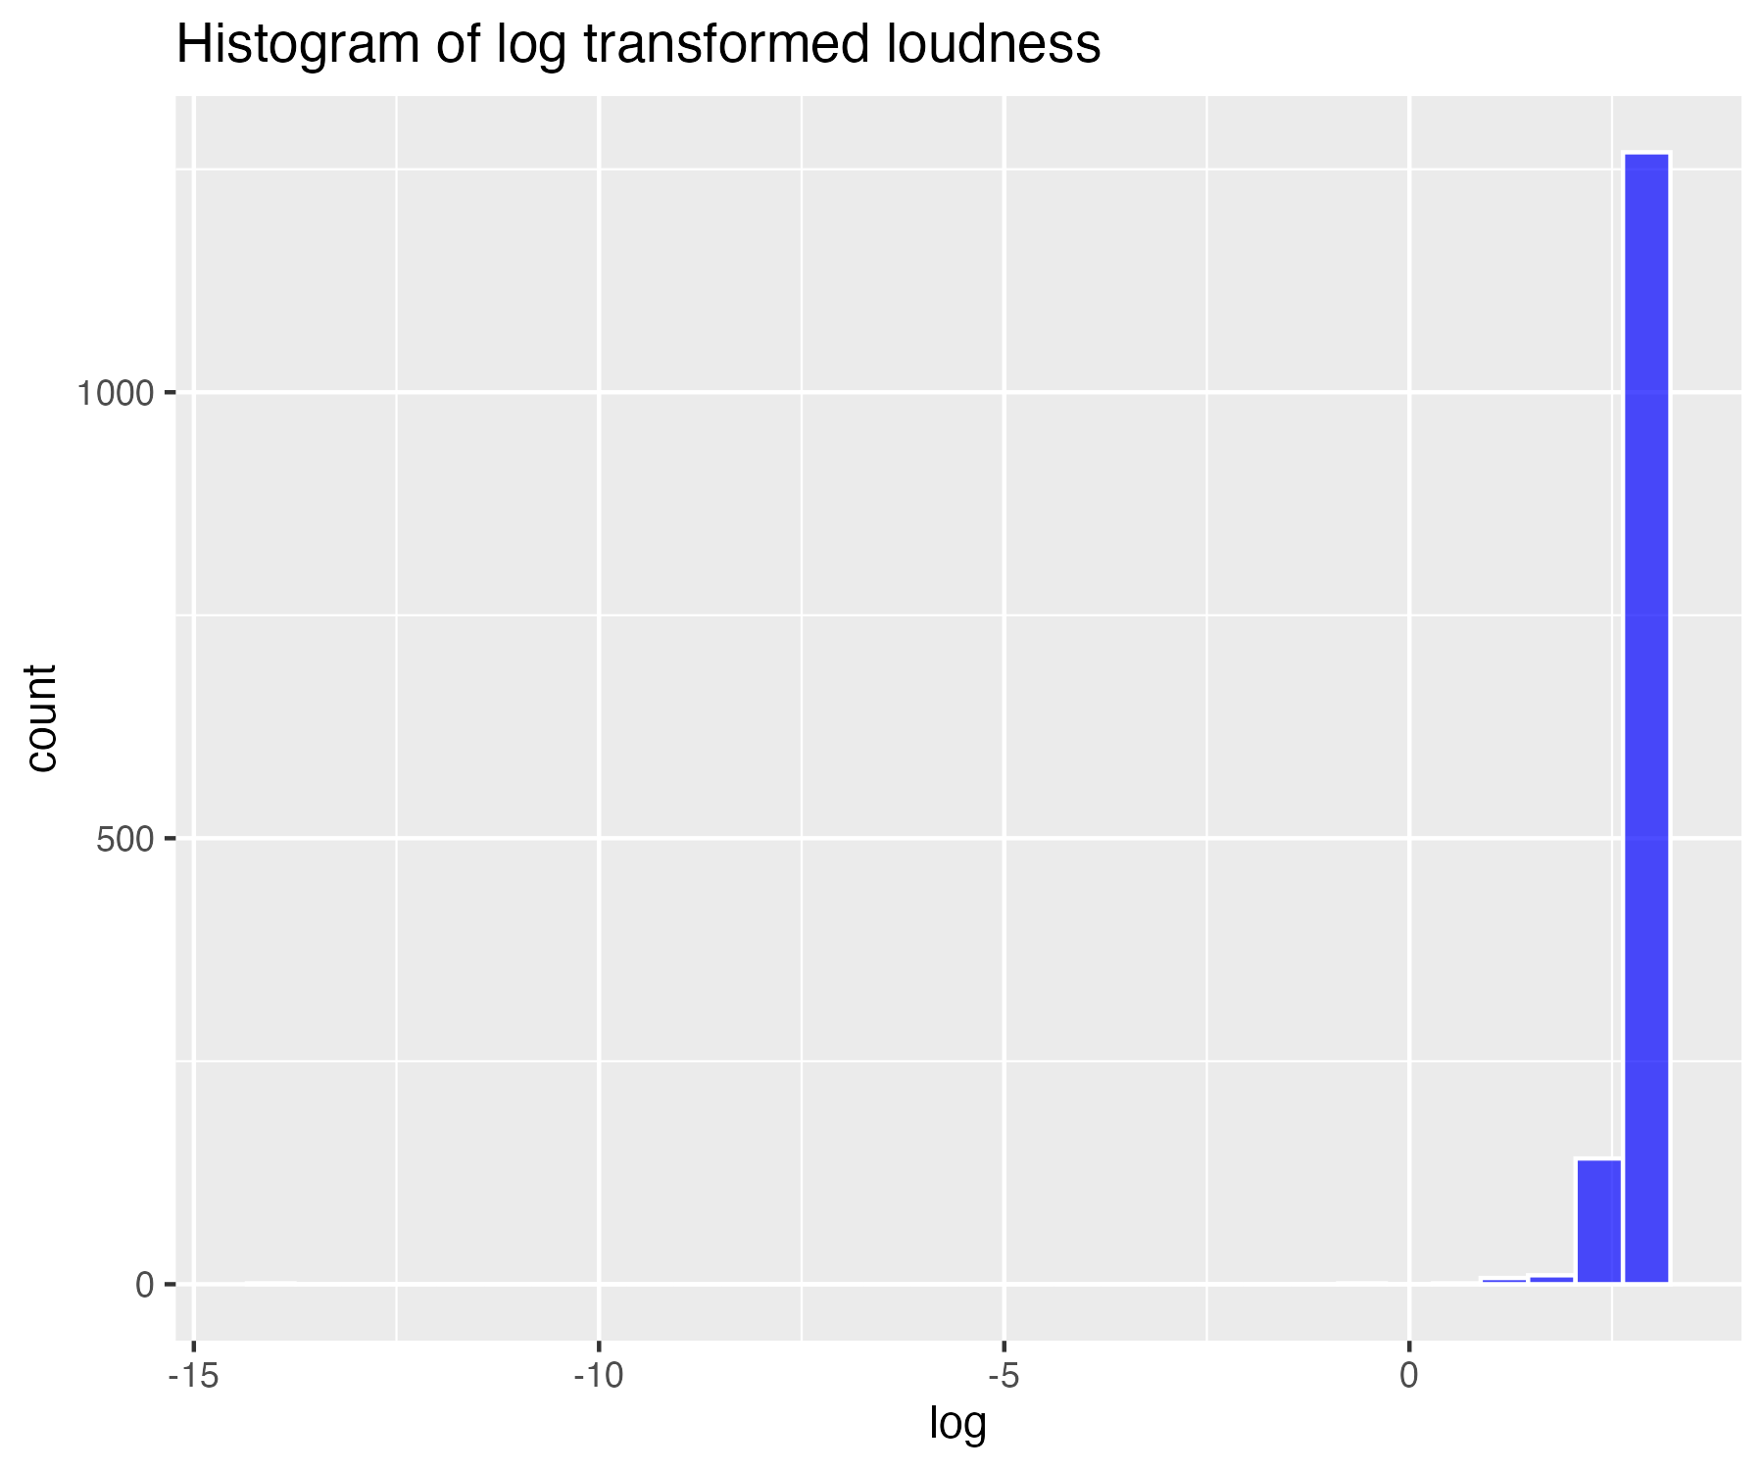

## Inverse transform of loudness (for severe skew)

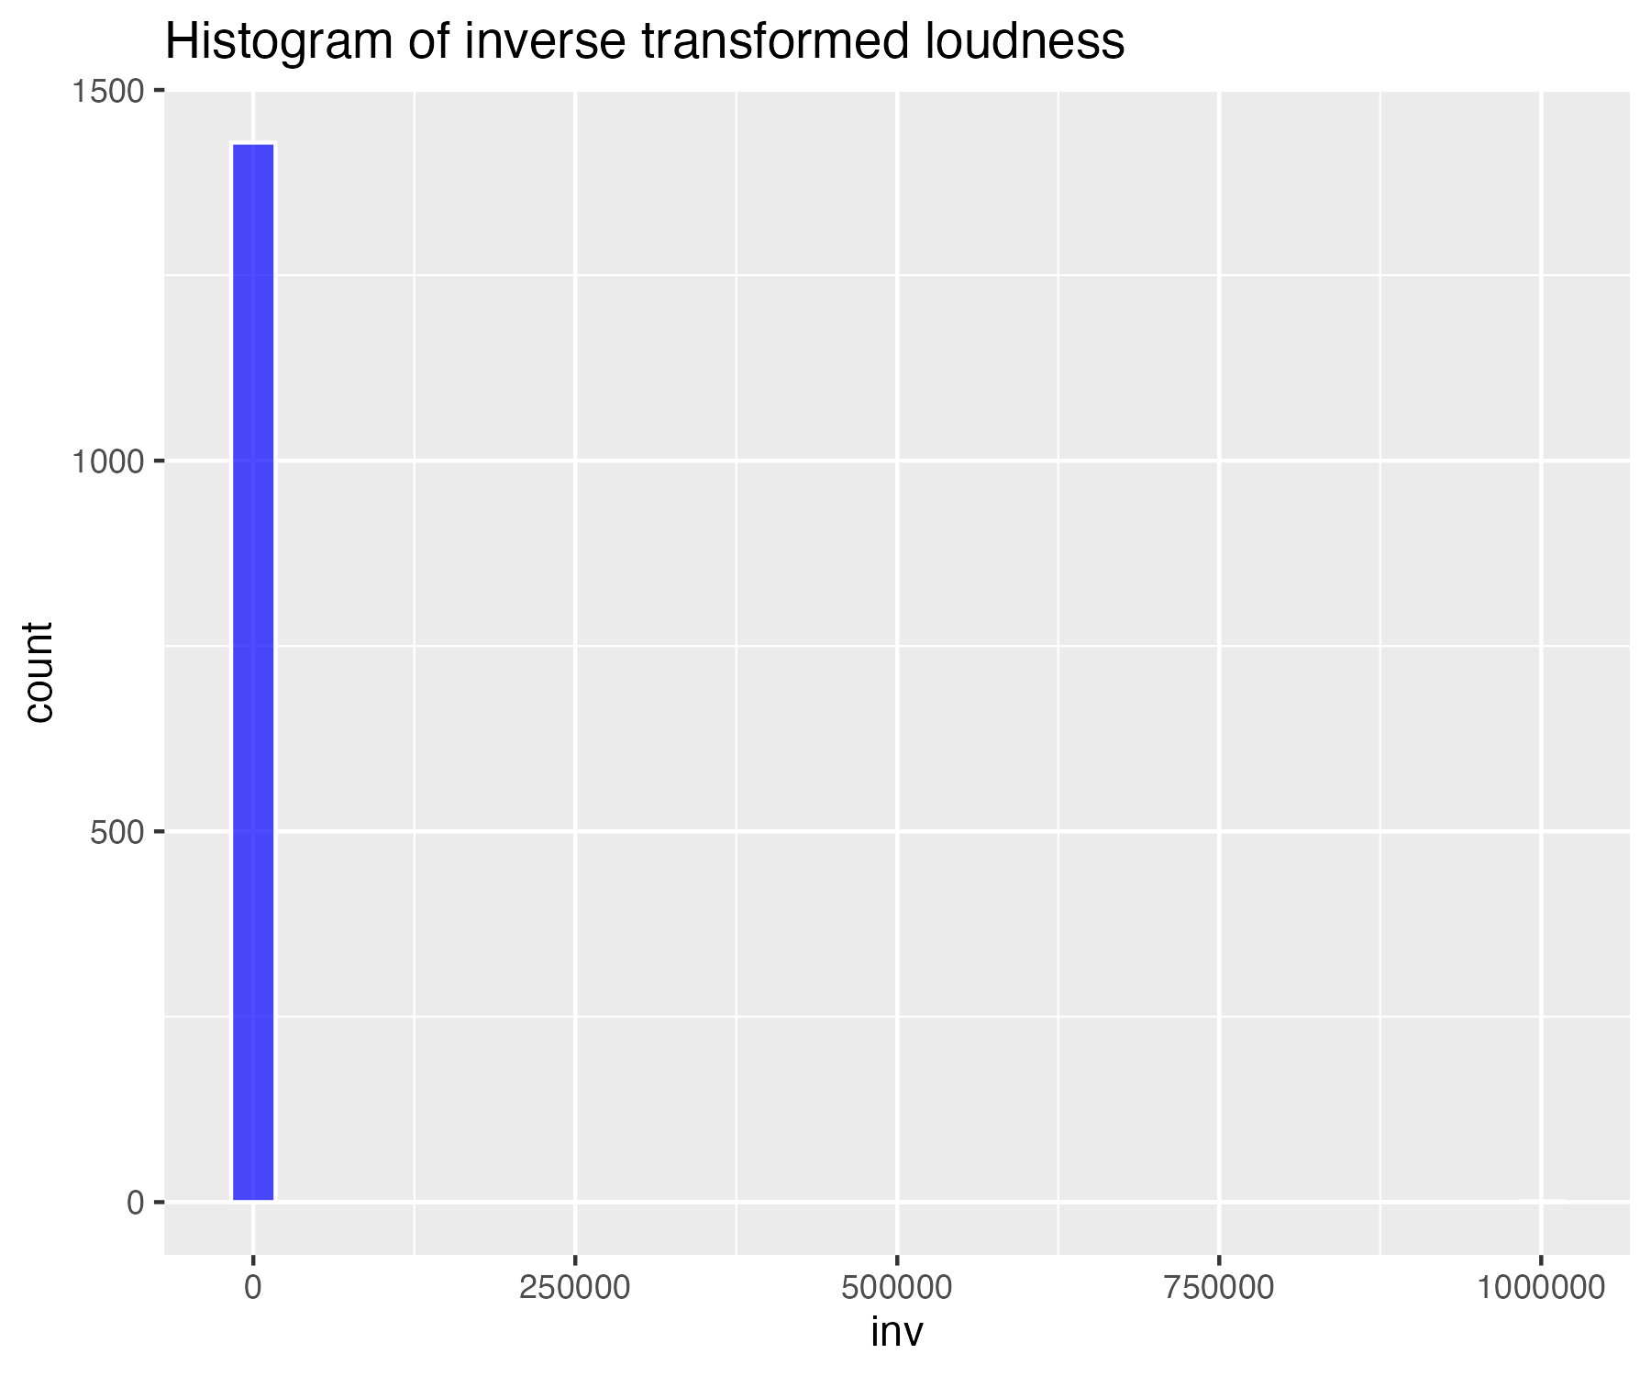

## Histogram of non-transformed speechiness

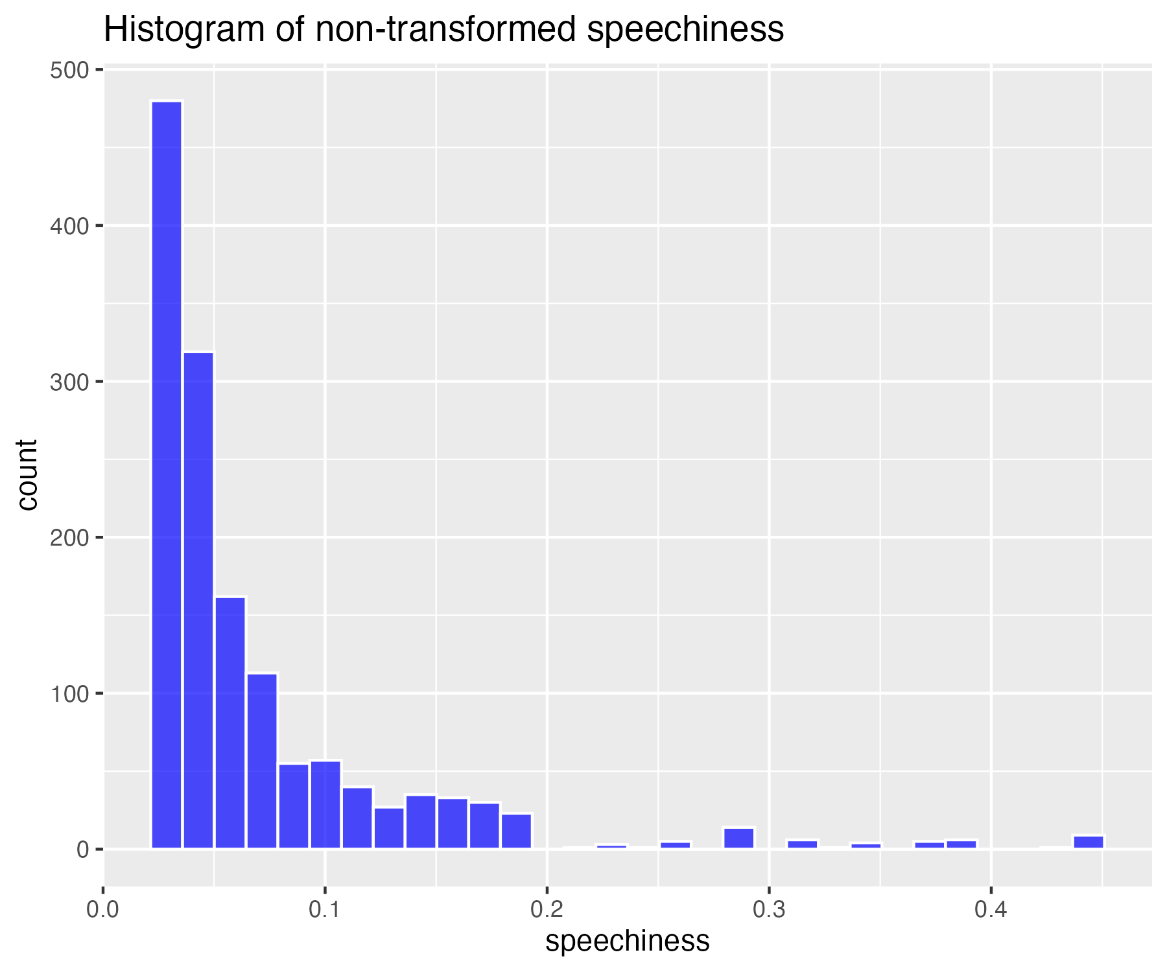

## Square-root transform of speechiness (for moderate skew)

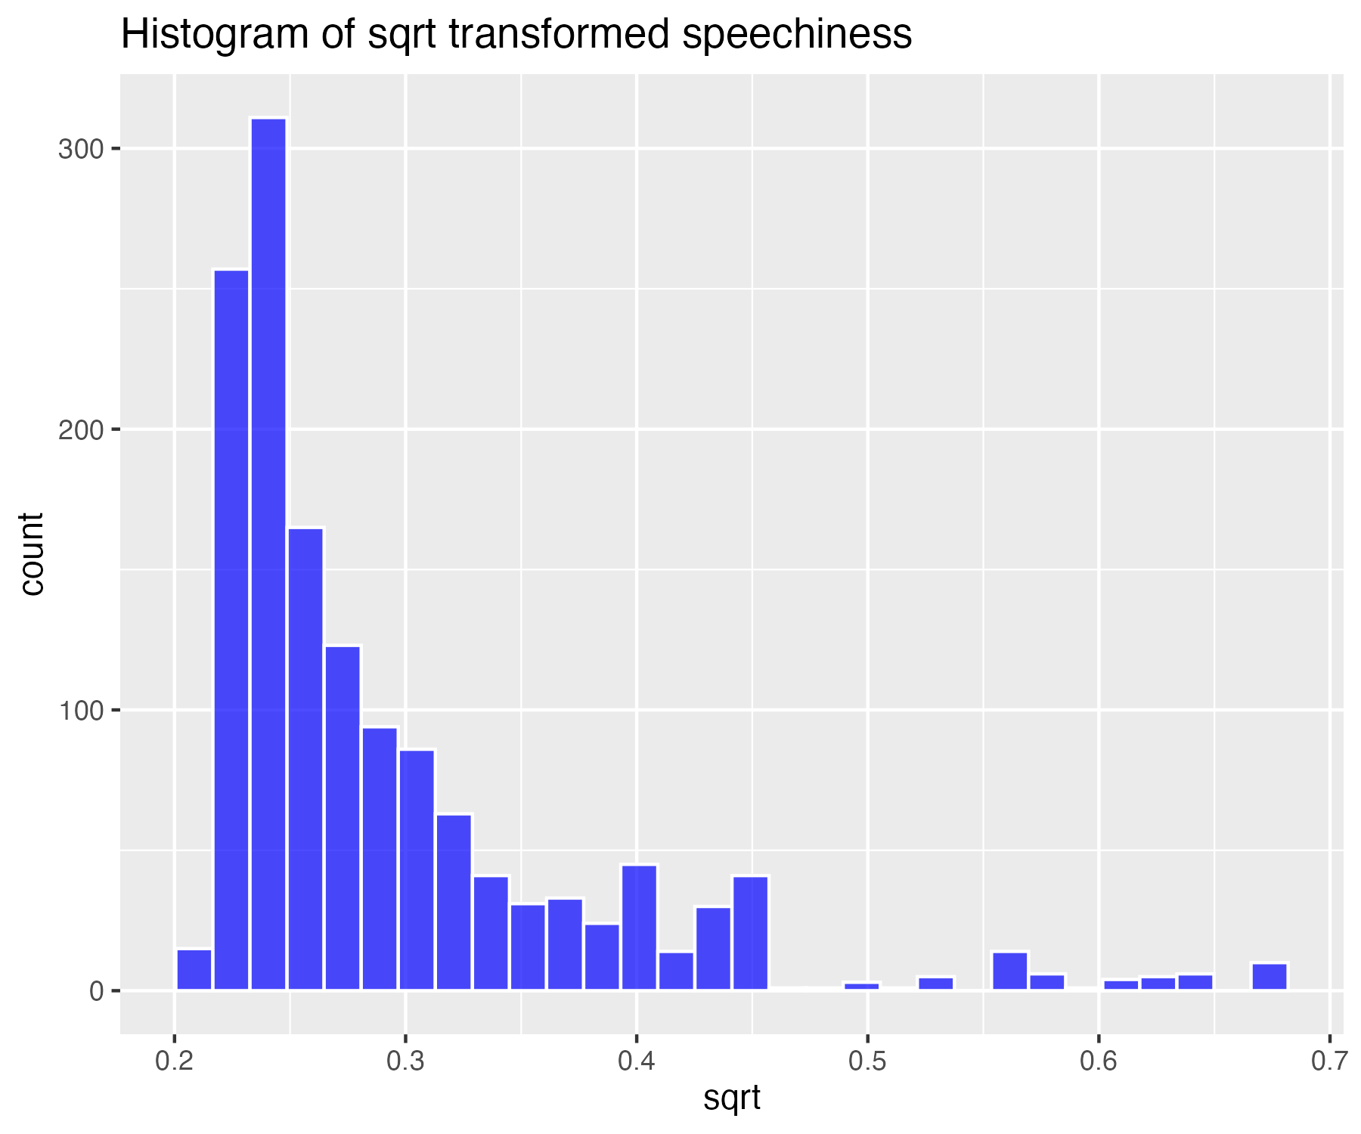

## Log base 10 transform of speechiness (for high skew)

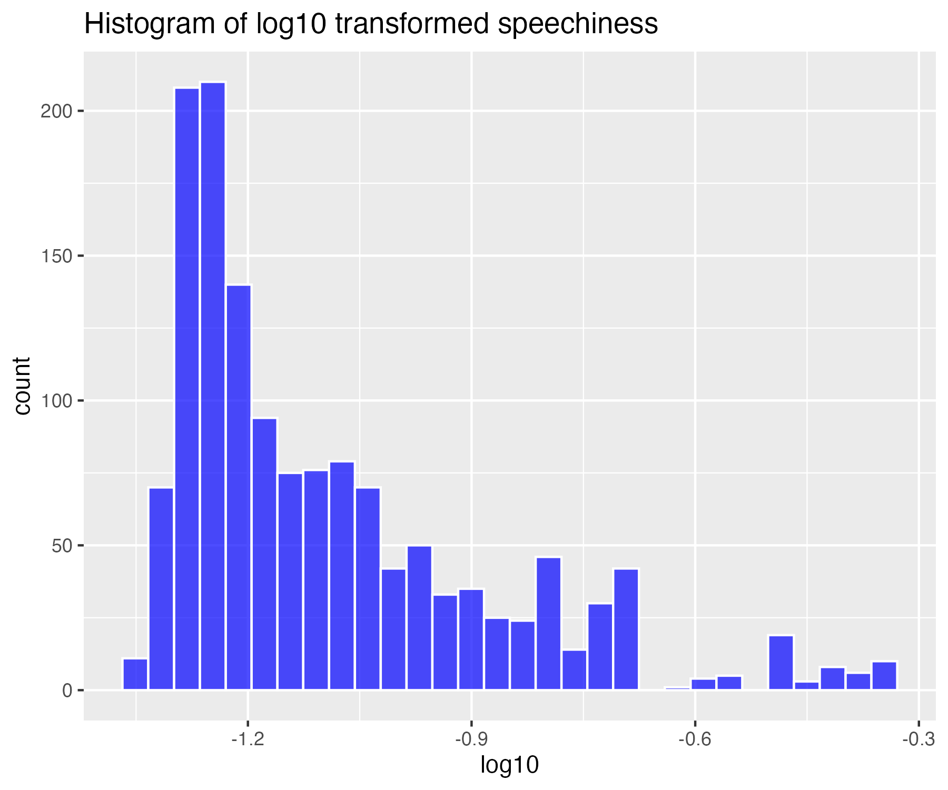

## Natural log transform of speechiness (for higher skew)

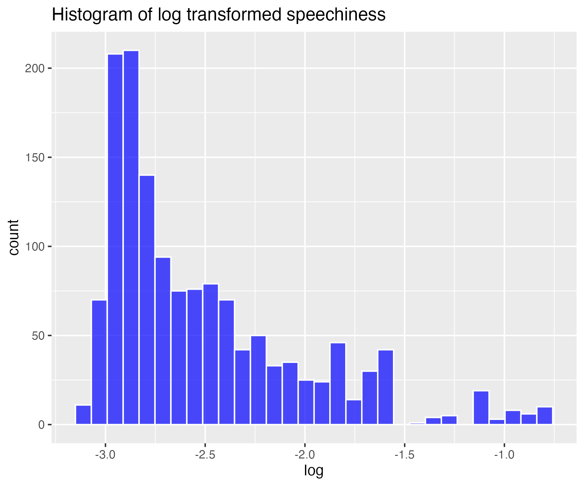

## Inverse transform of speechiness (for severe skew)

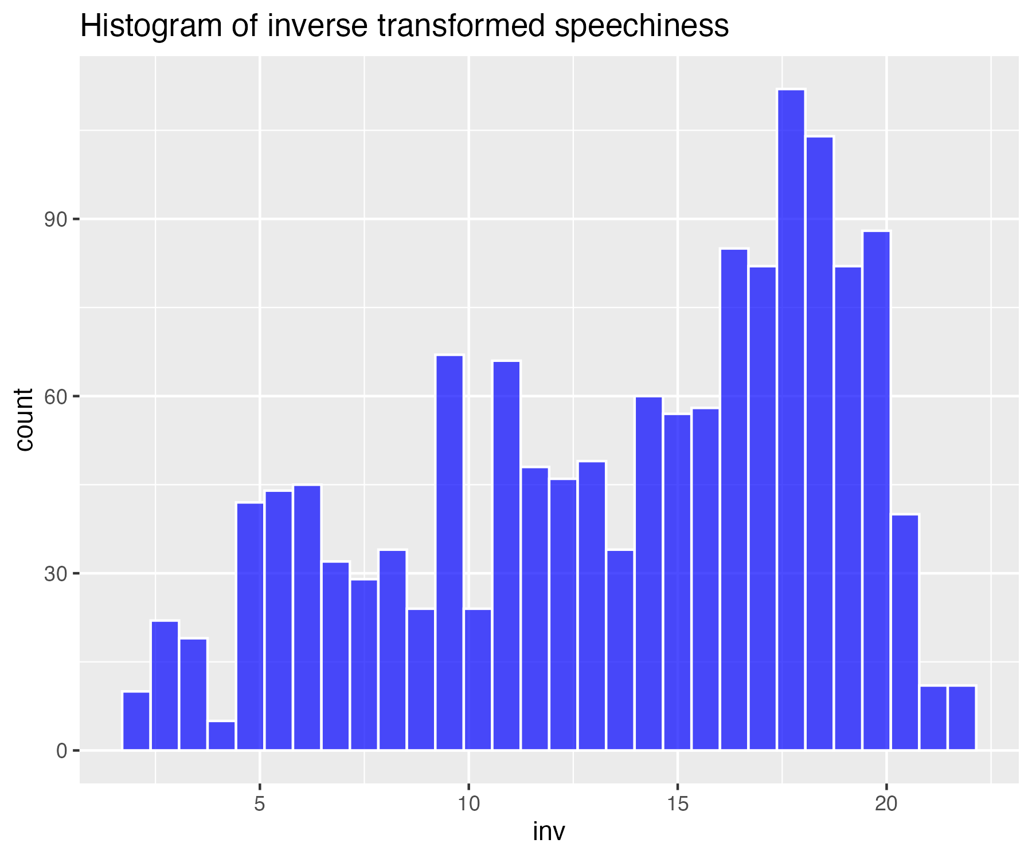

## Histogram of non-transformed acousticness

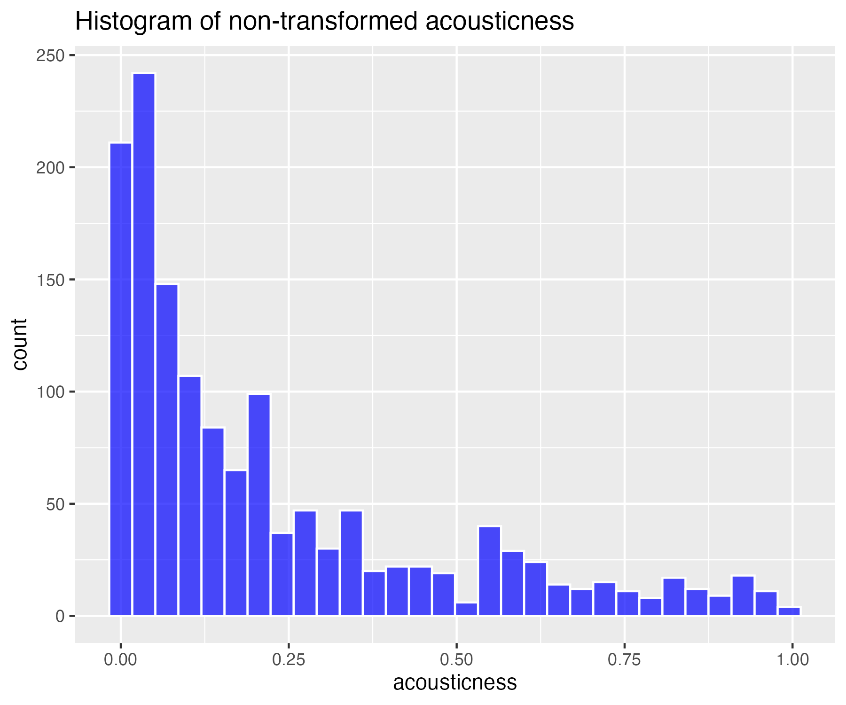

## Square-root transform of acousticness (for moderate skew)

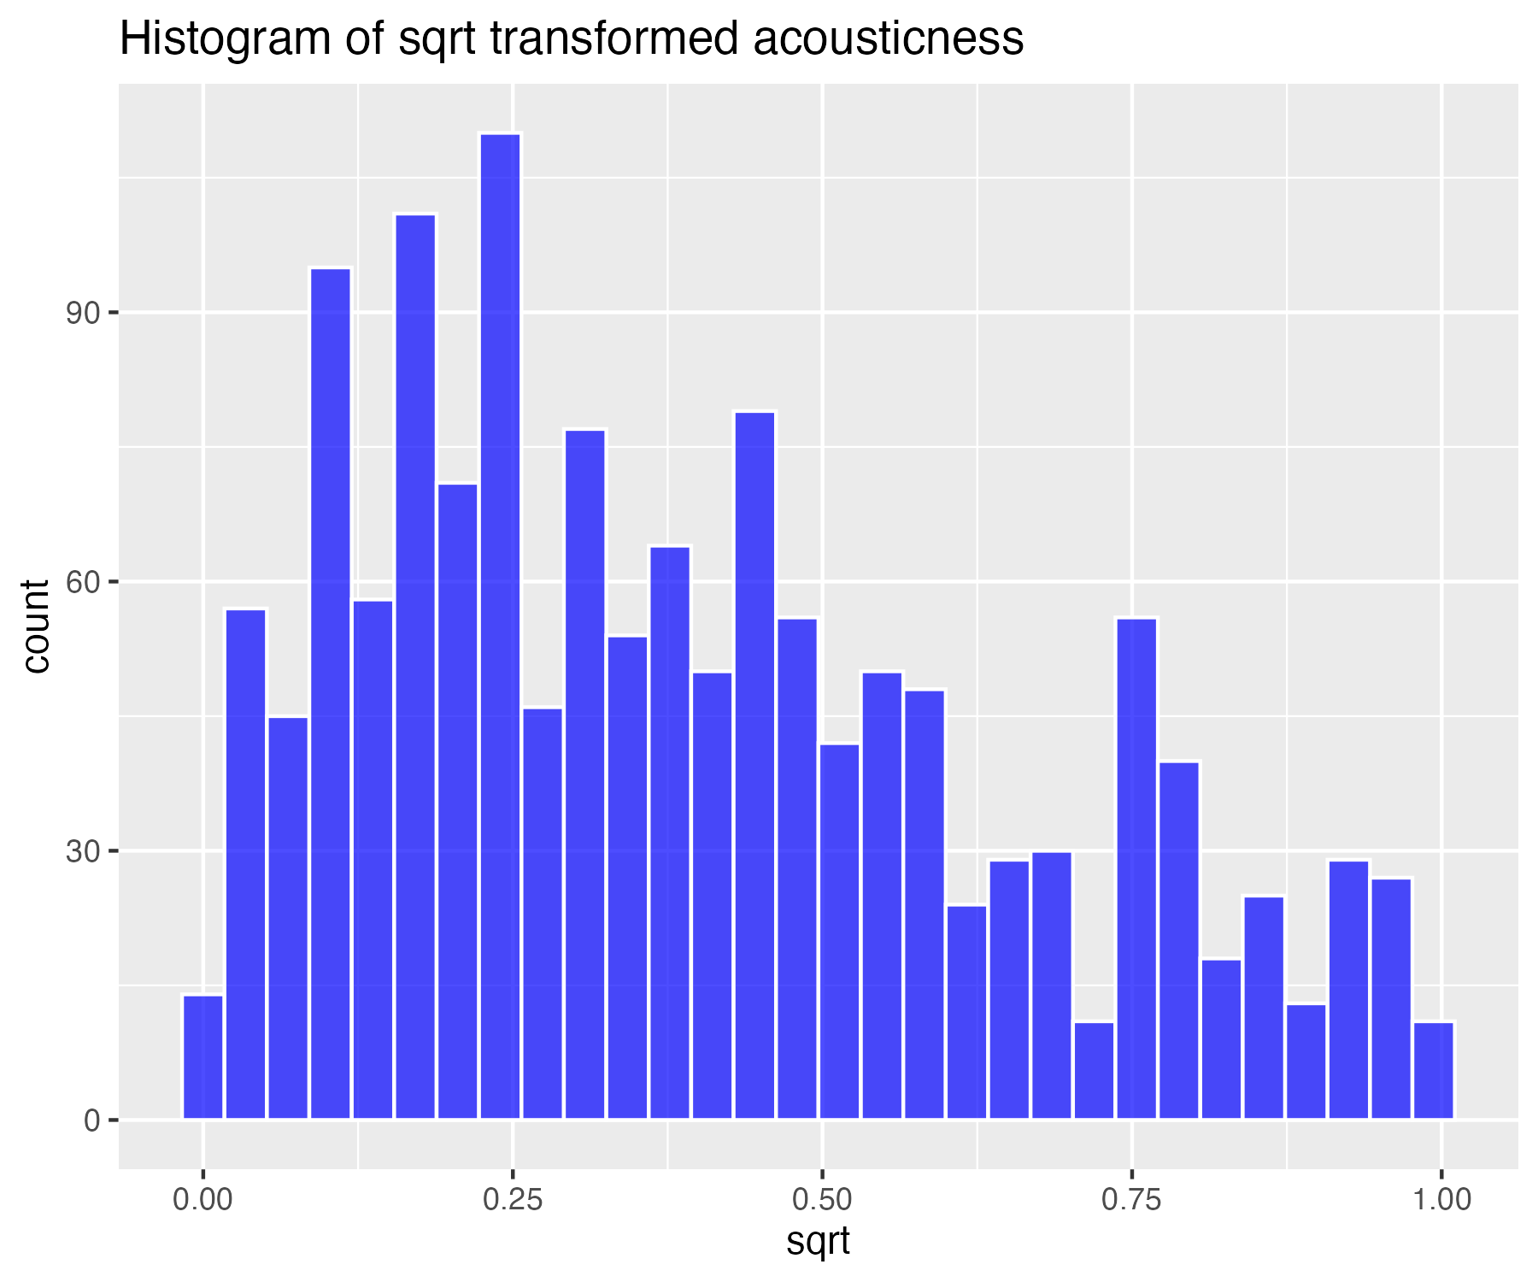

## Log base 10 transform of acousticness (for high skew)

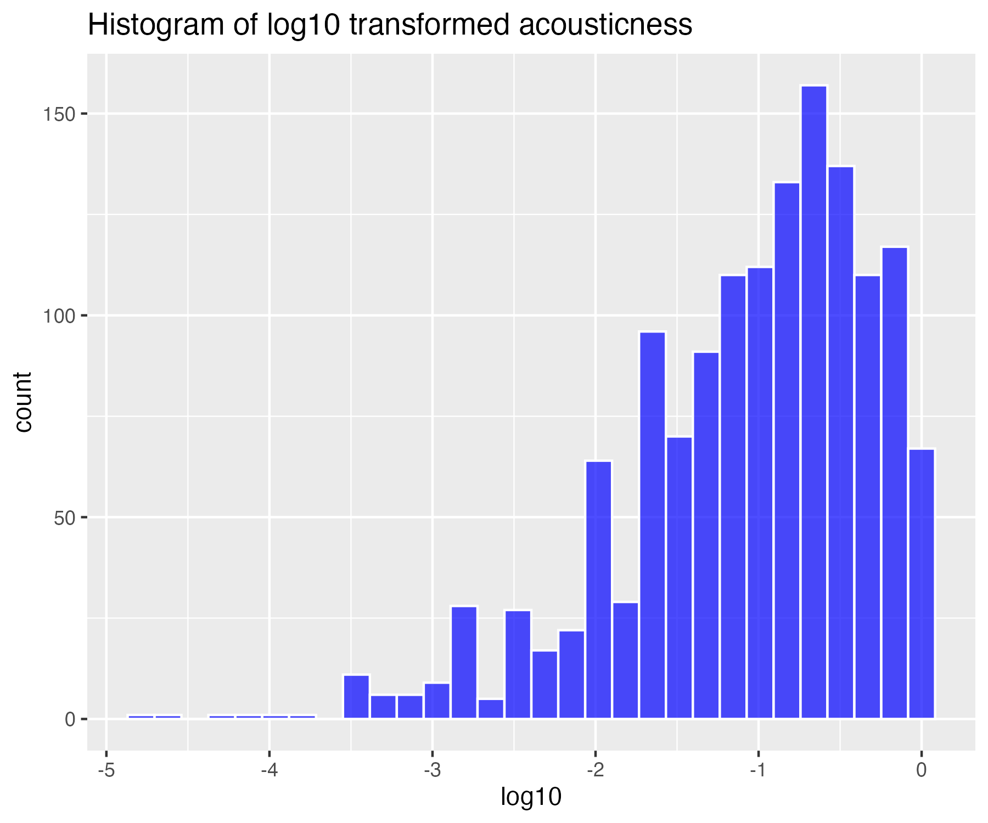

## Natural log transform of acousticness (for higher skew)

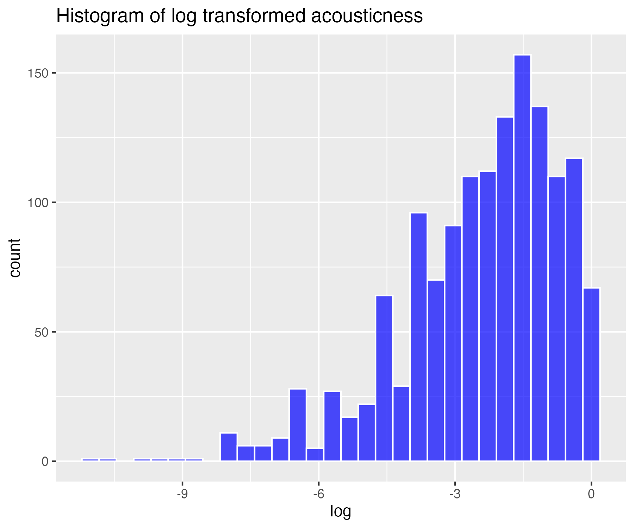

## Inverse transform of acousticness (for severe skew)

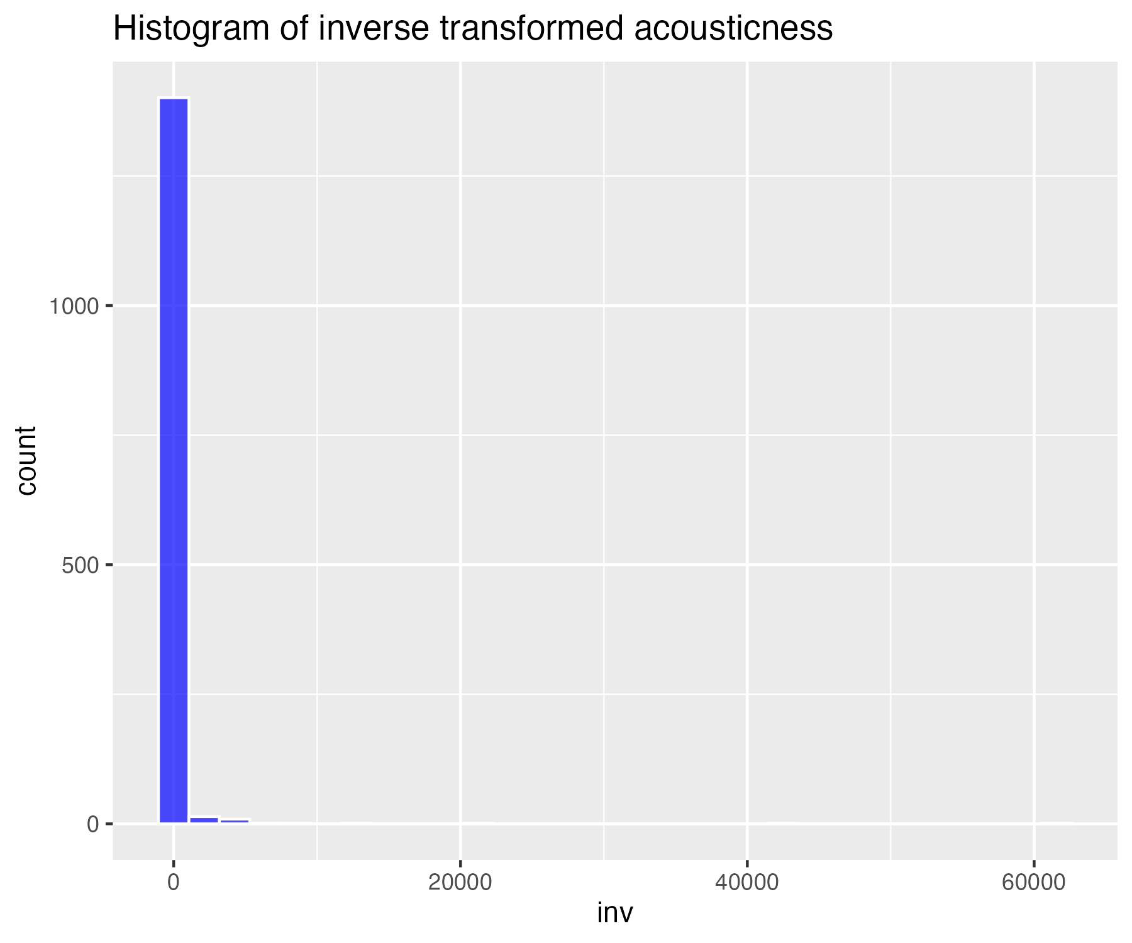

## Histogram of non-transformed instrumentalness

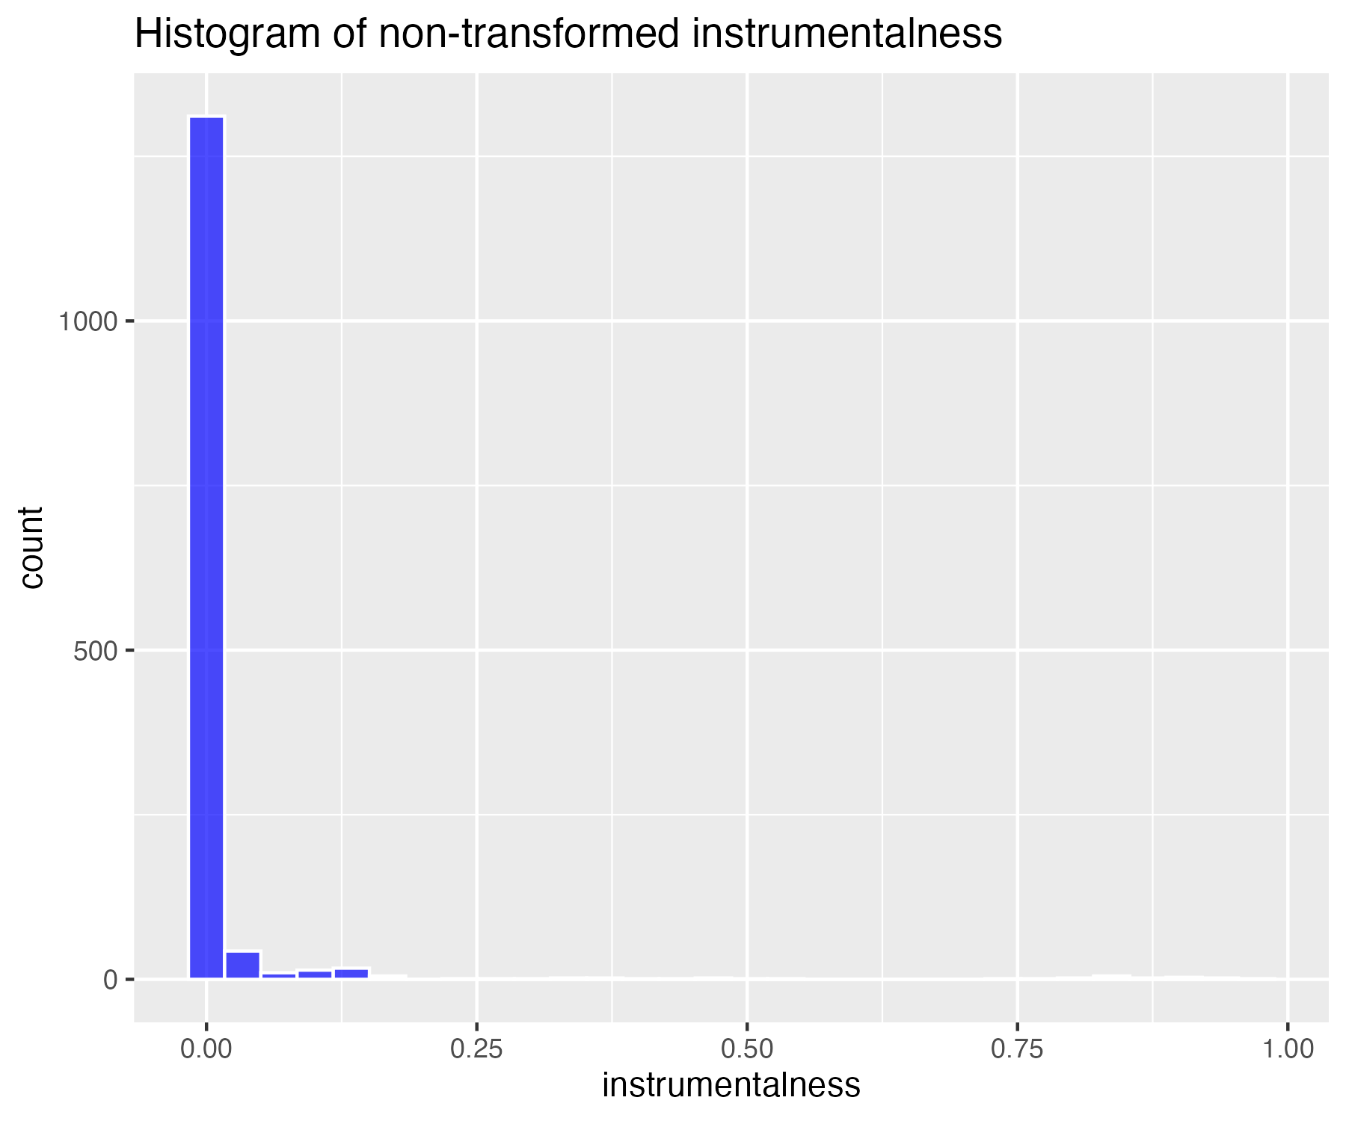

## Square-root transform of instrumentalness (for moderate skew)

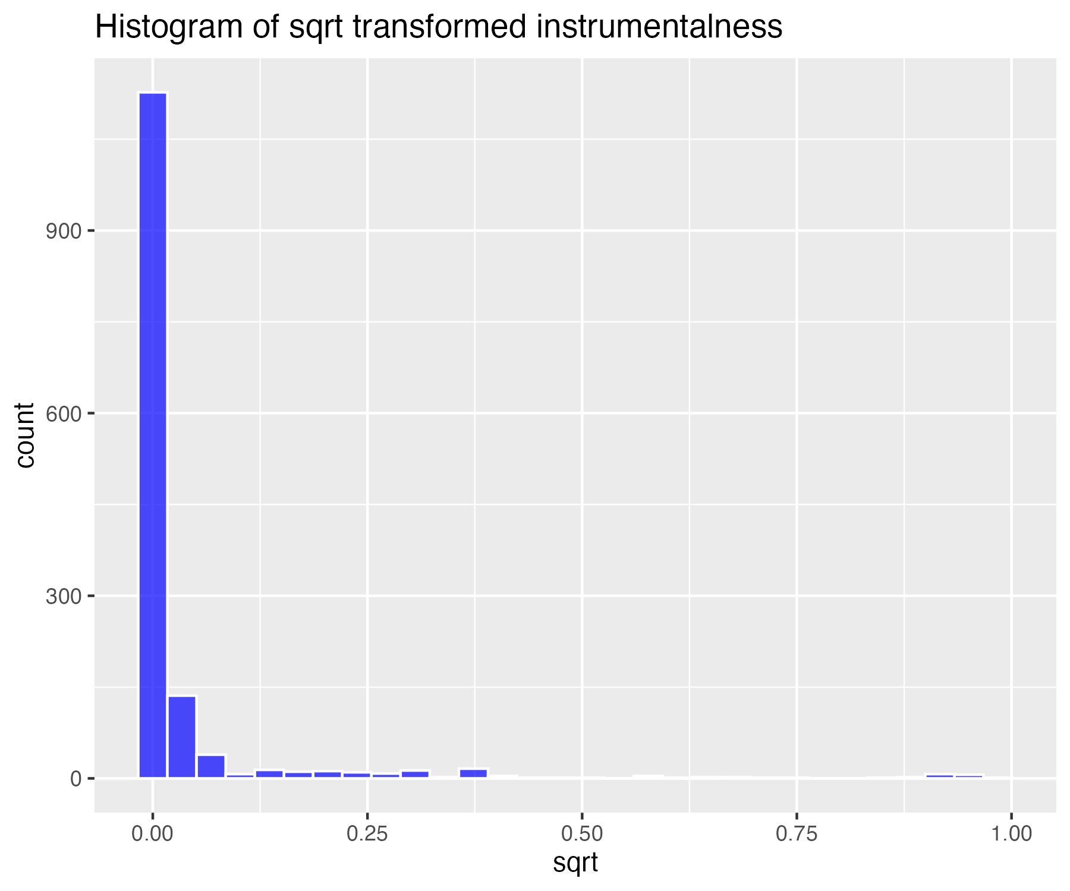

## Log base 10 transform of instrumentalness (for high skew)

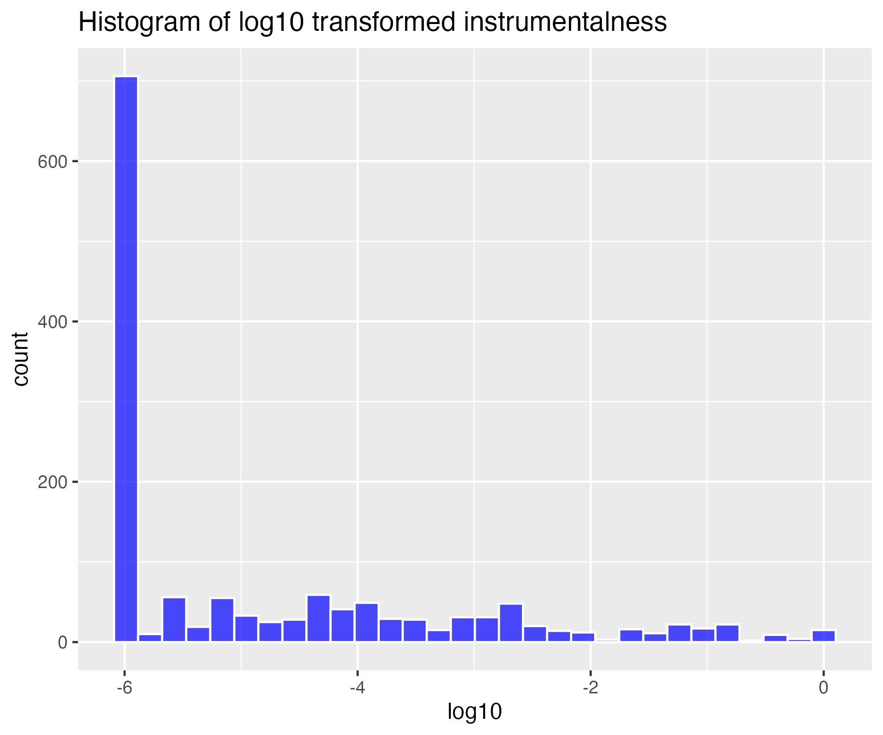

## Natural log transform of instrumentalness (for higher skew)

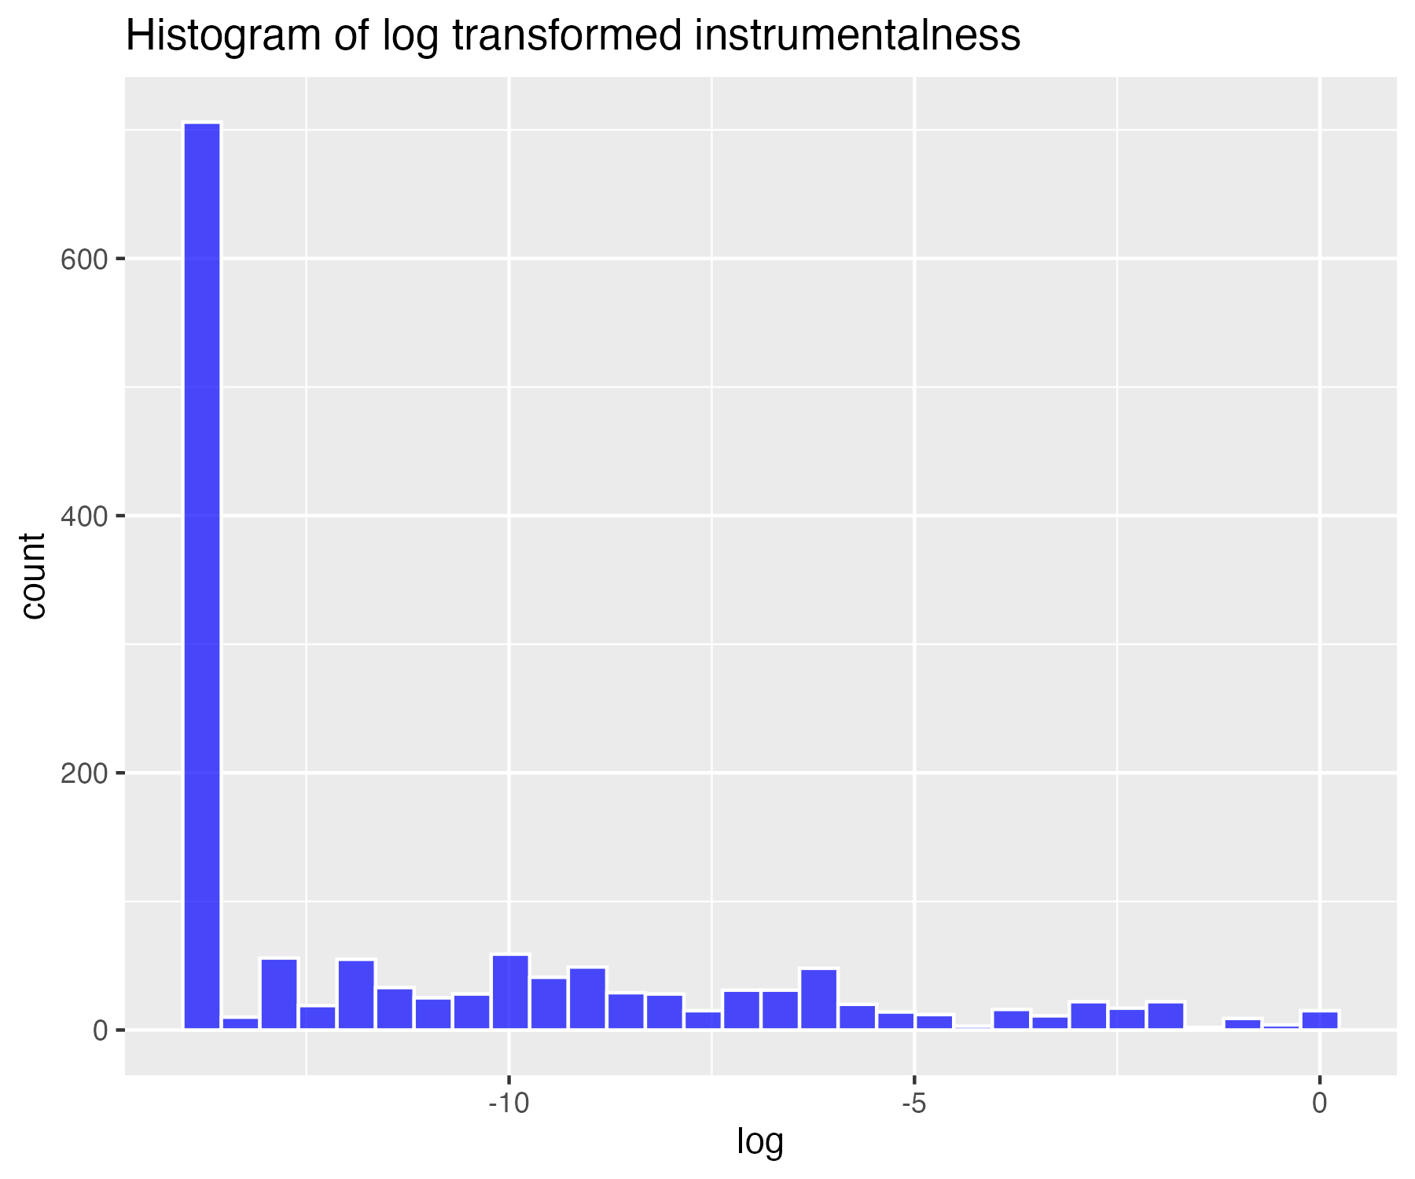

## Inverse transform of instrumentalness (for severe skew)

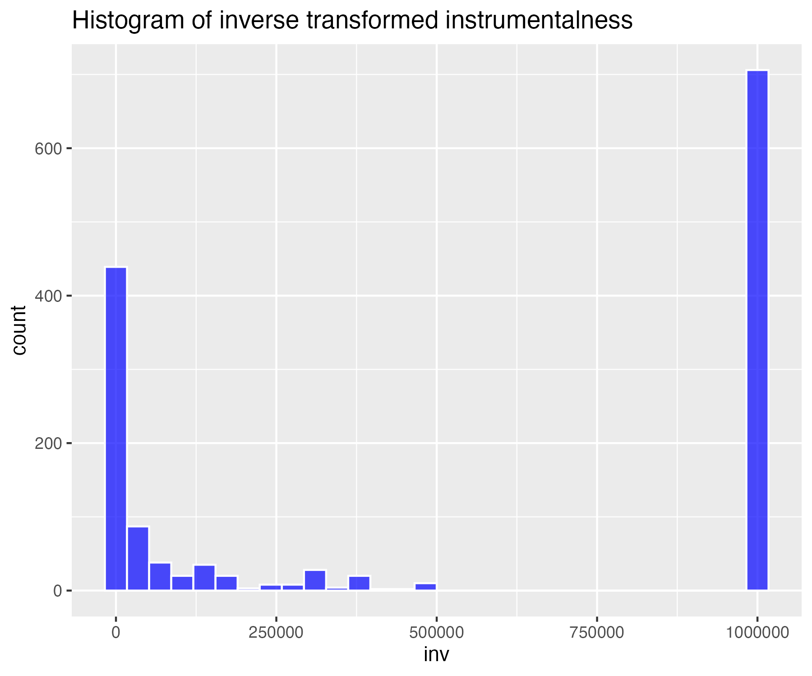

## Histogram of non-transformed liveness

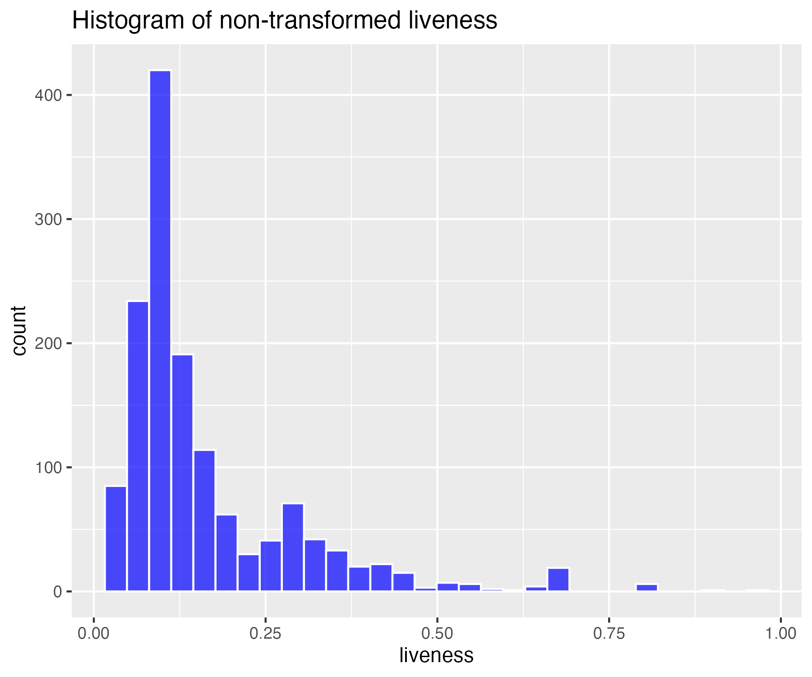

## Square-root transform of liveness (for moderate skew)

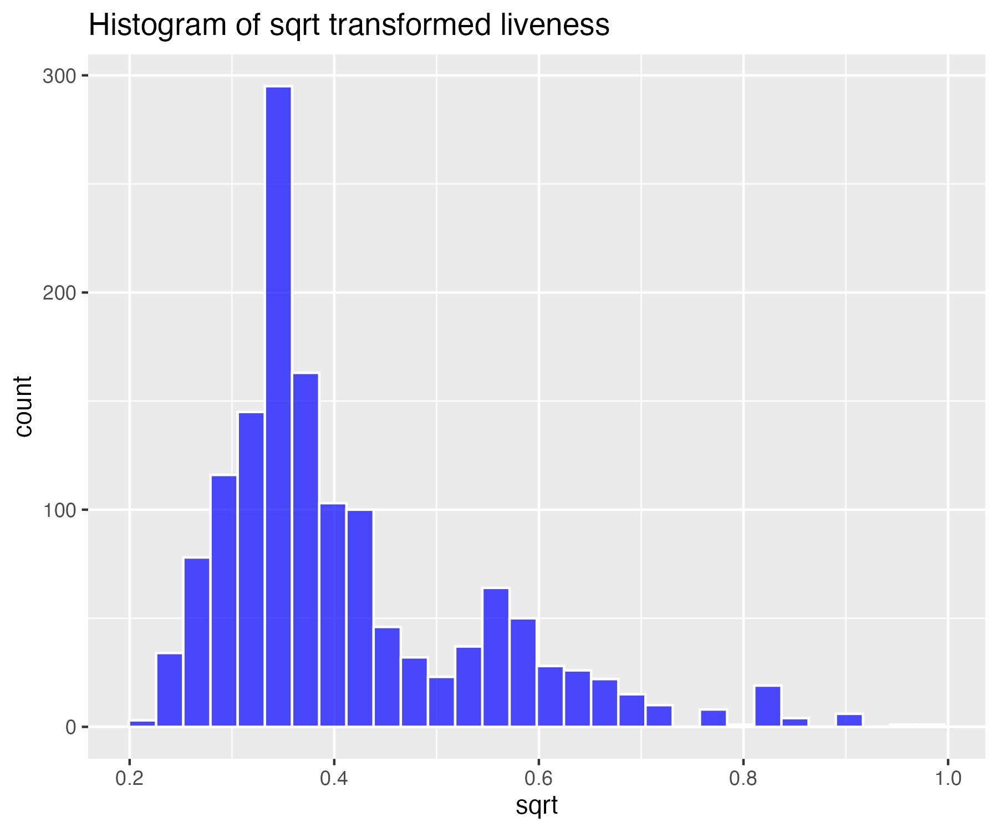

## Log base 10 transform of liveness (for high skew)

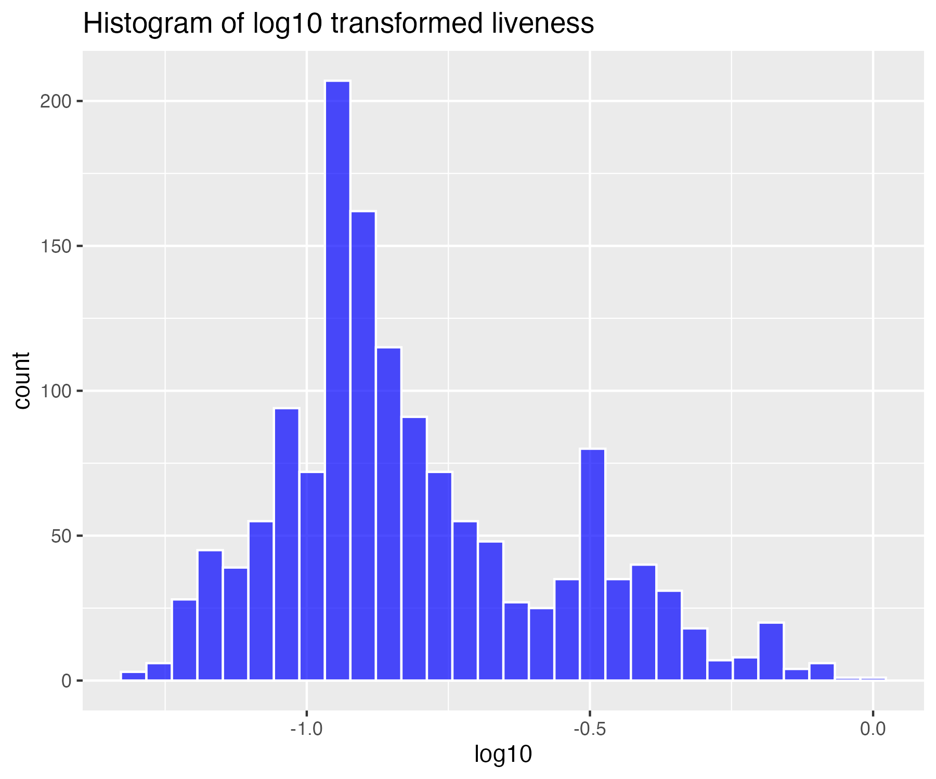

## Natural log transform of liveness (for higher skew)

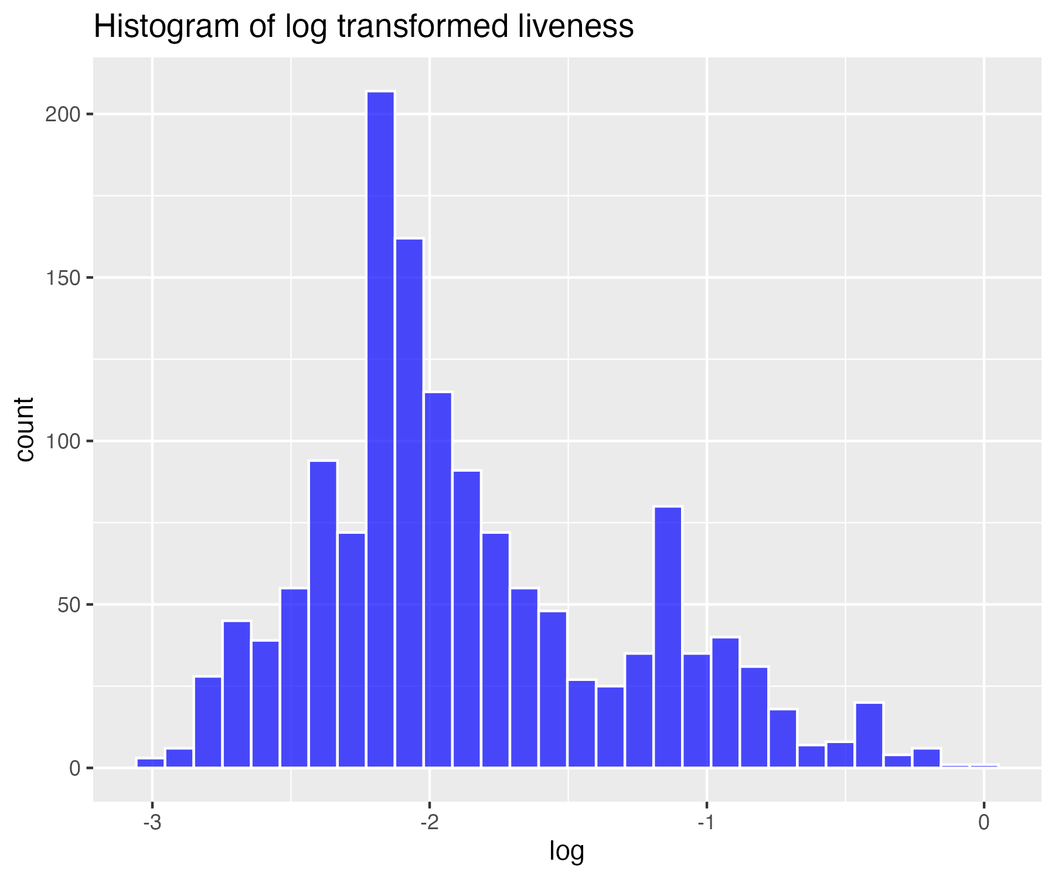

## Inverse transform of liveness (for severe skew)

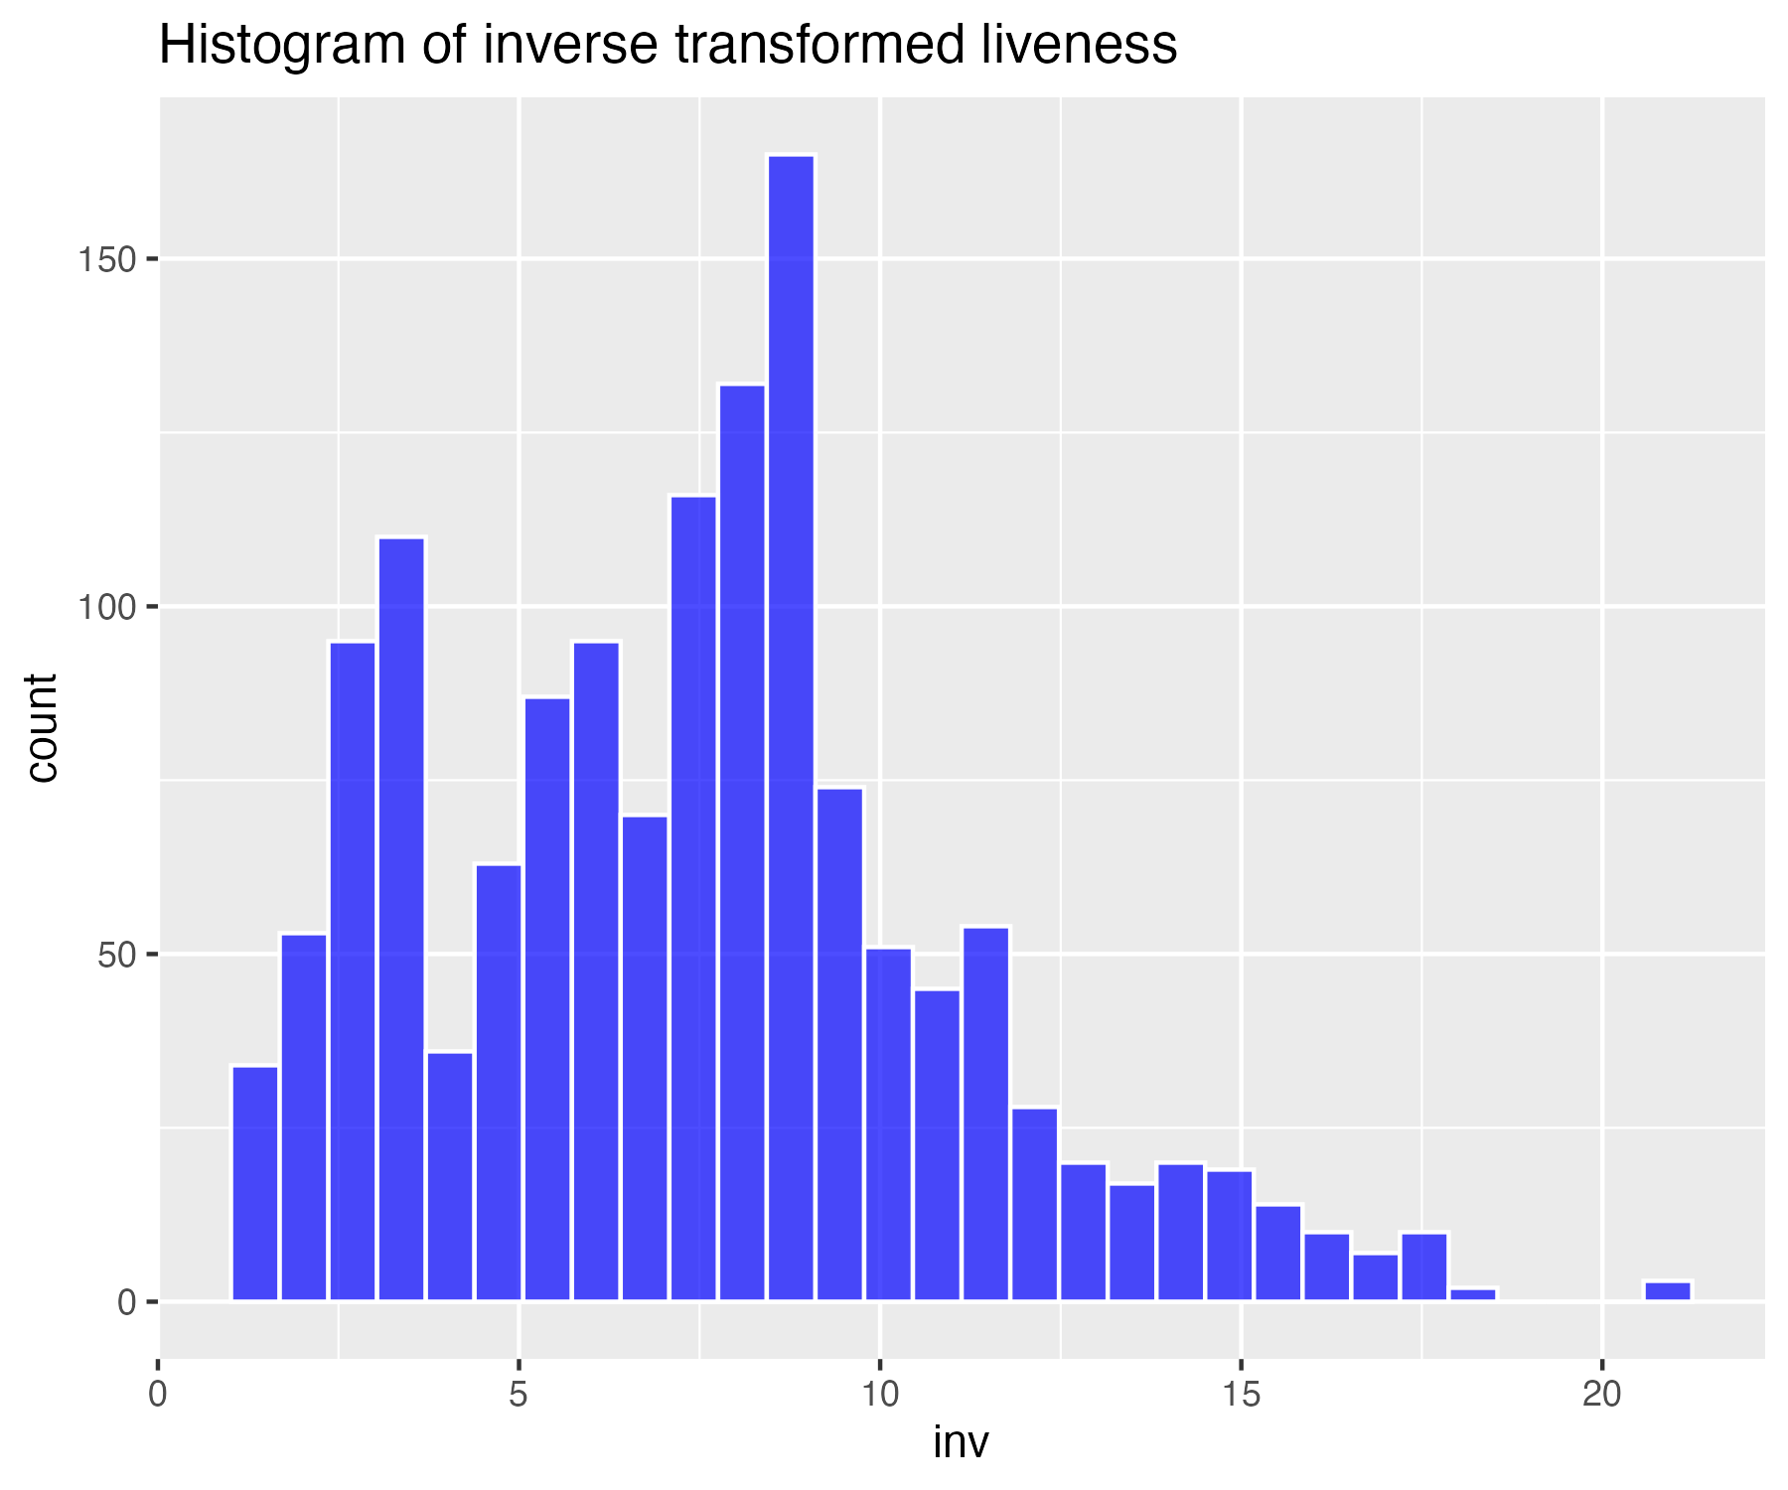

## Histogram of non-transformed valence

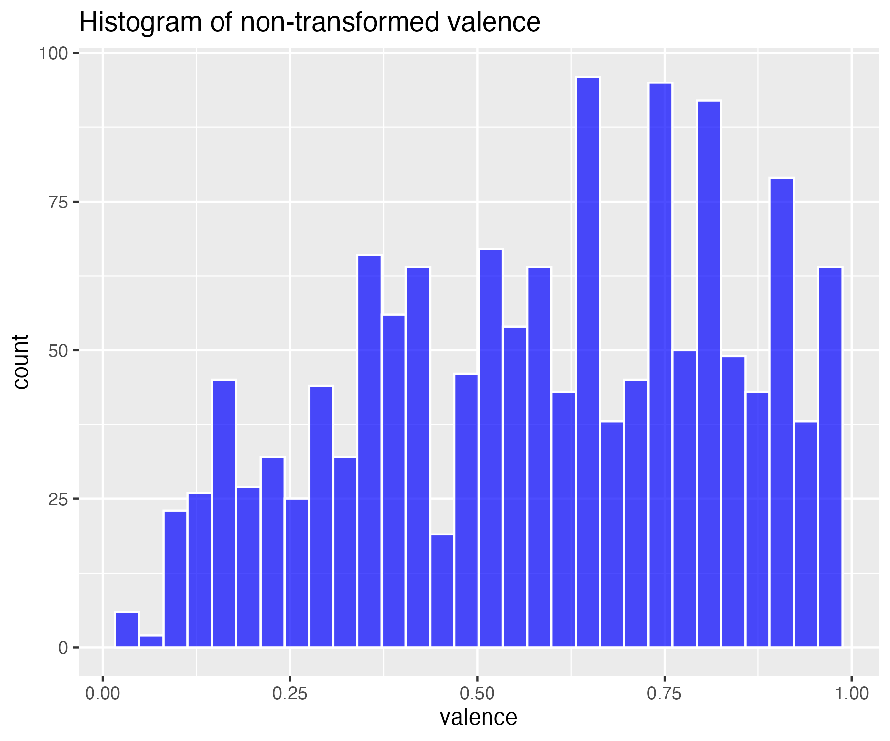

## Square-root transform of valence (for moderate skew)

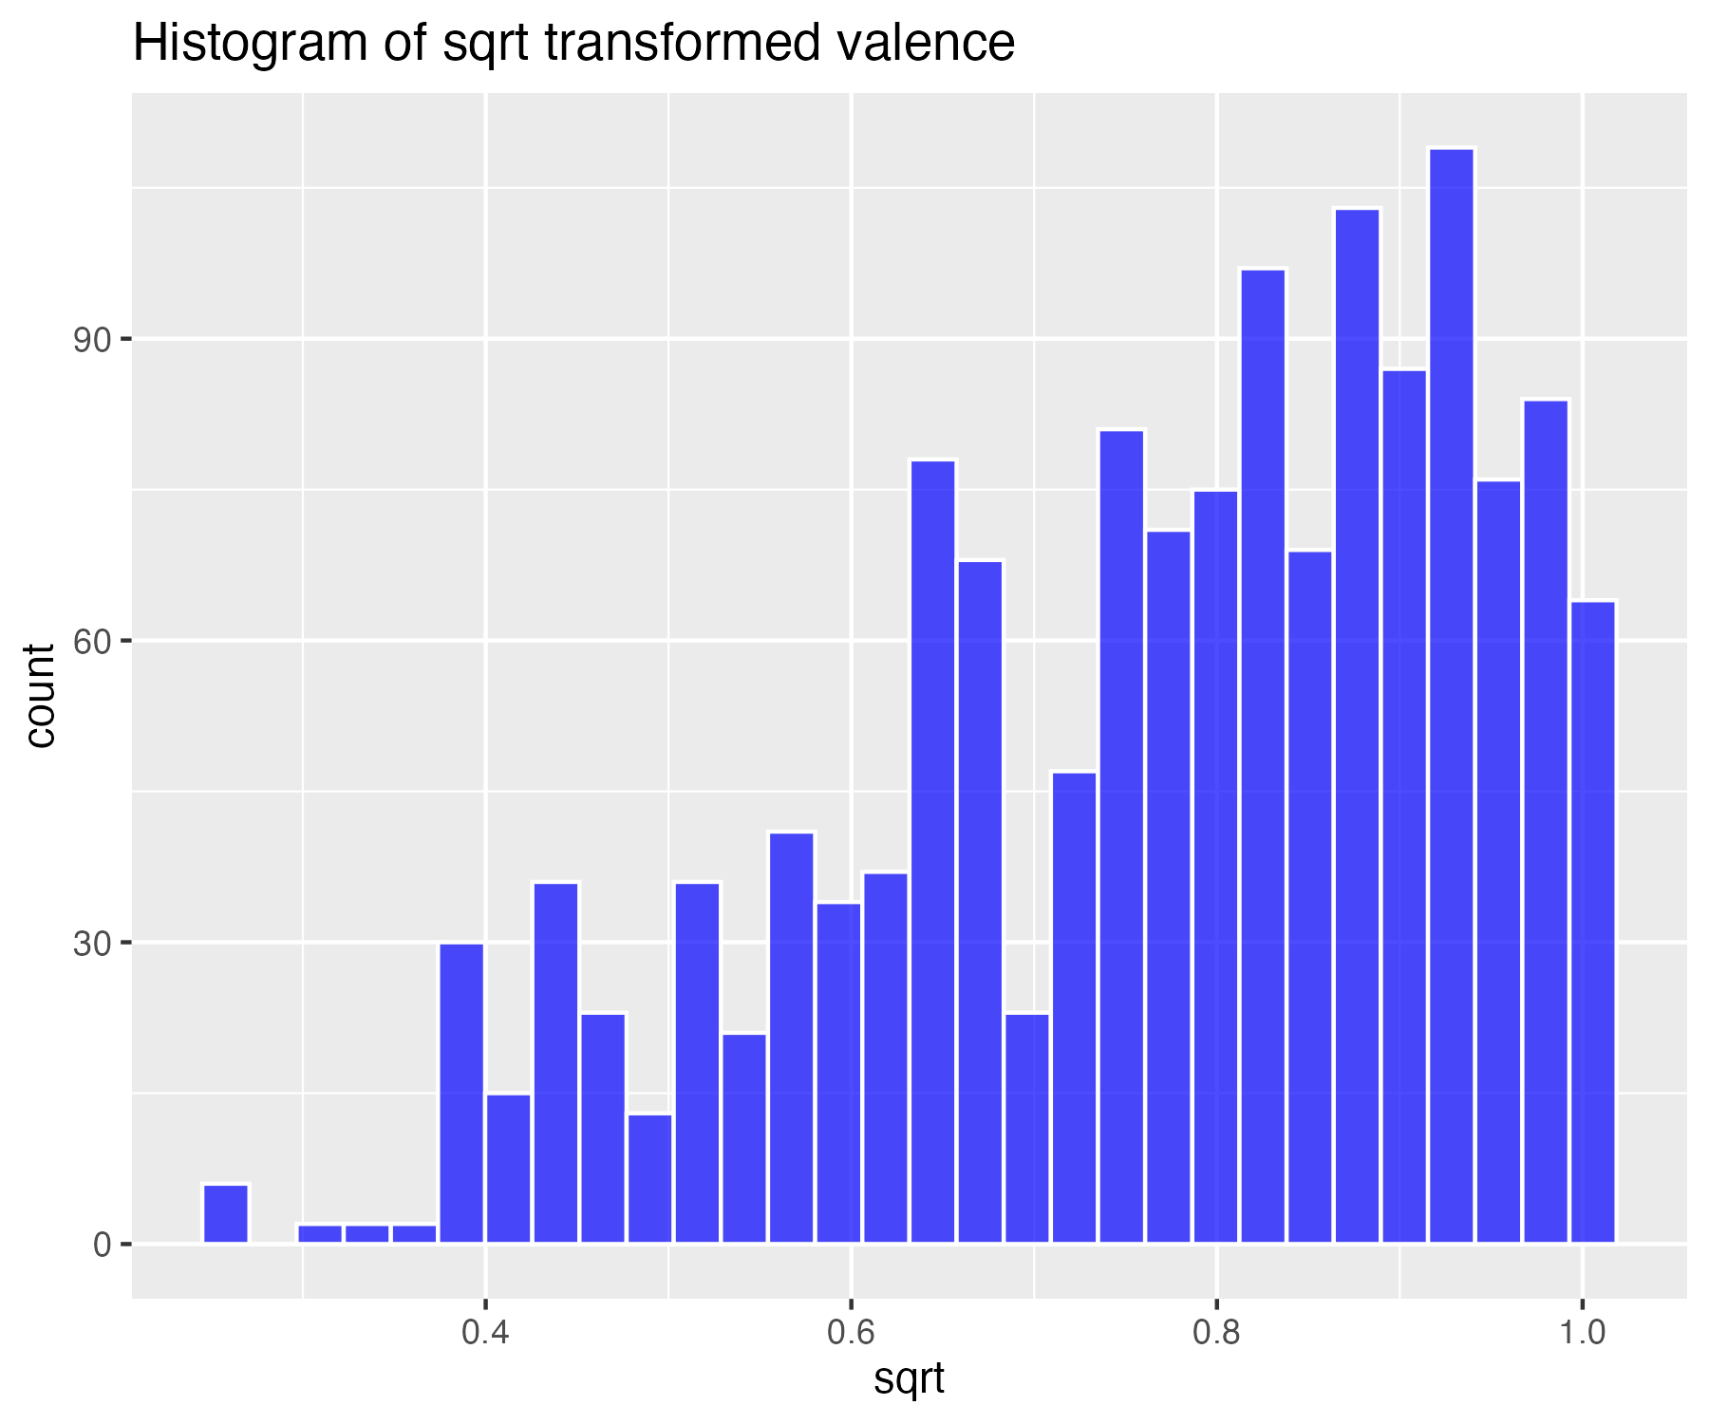

## Log base 10 transform of valence (for high skew)

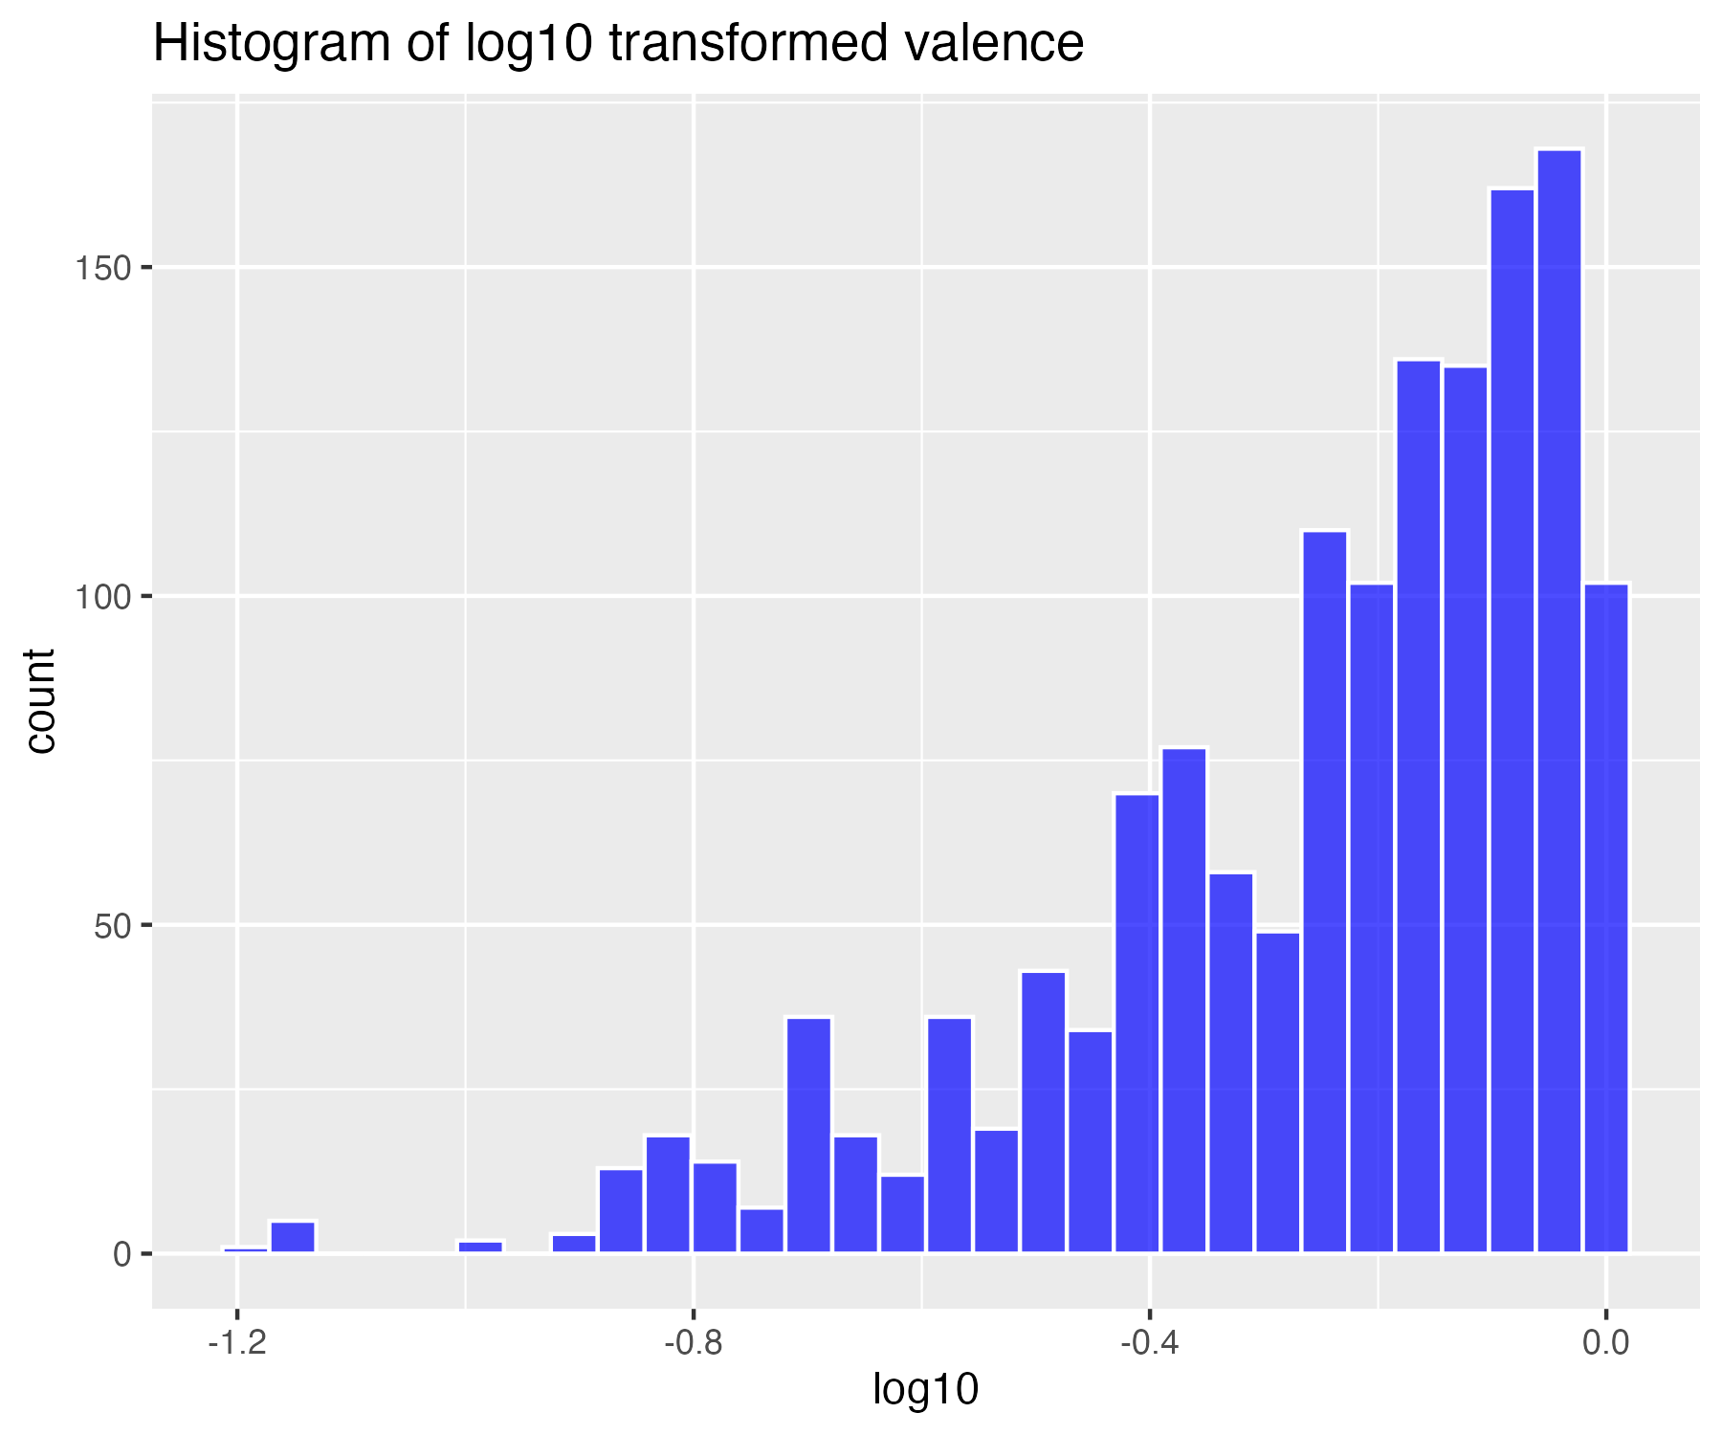

## Natural log transform of valence (for higher skew)

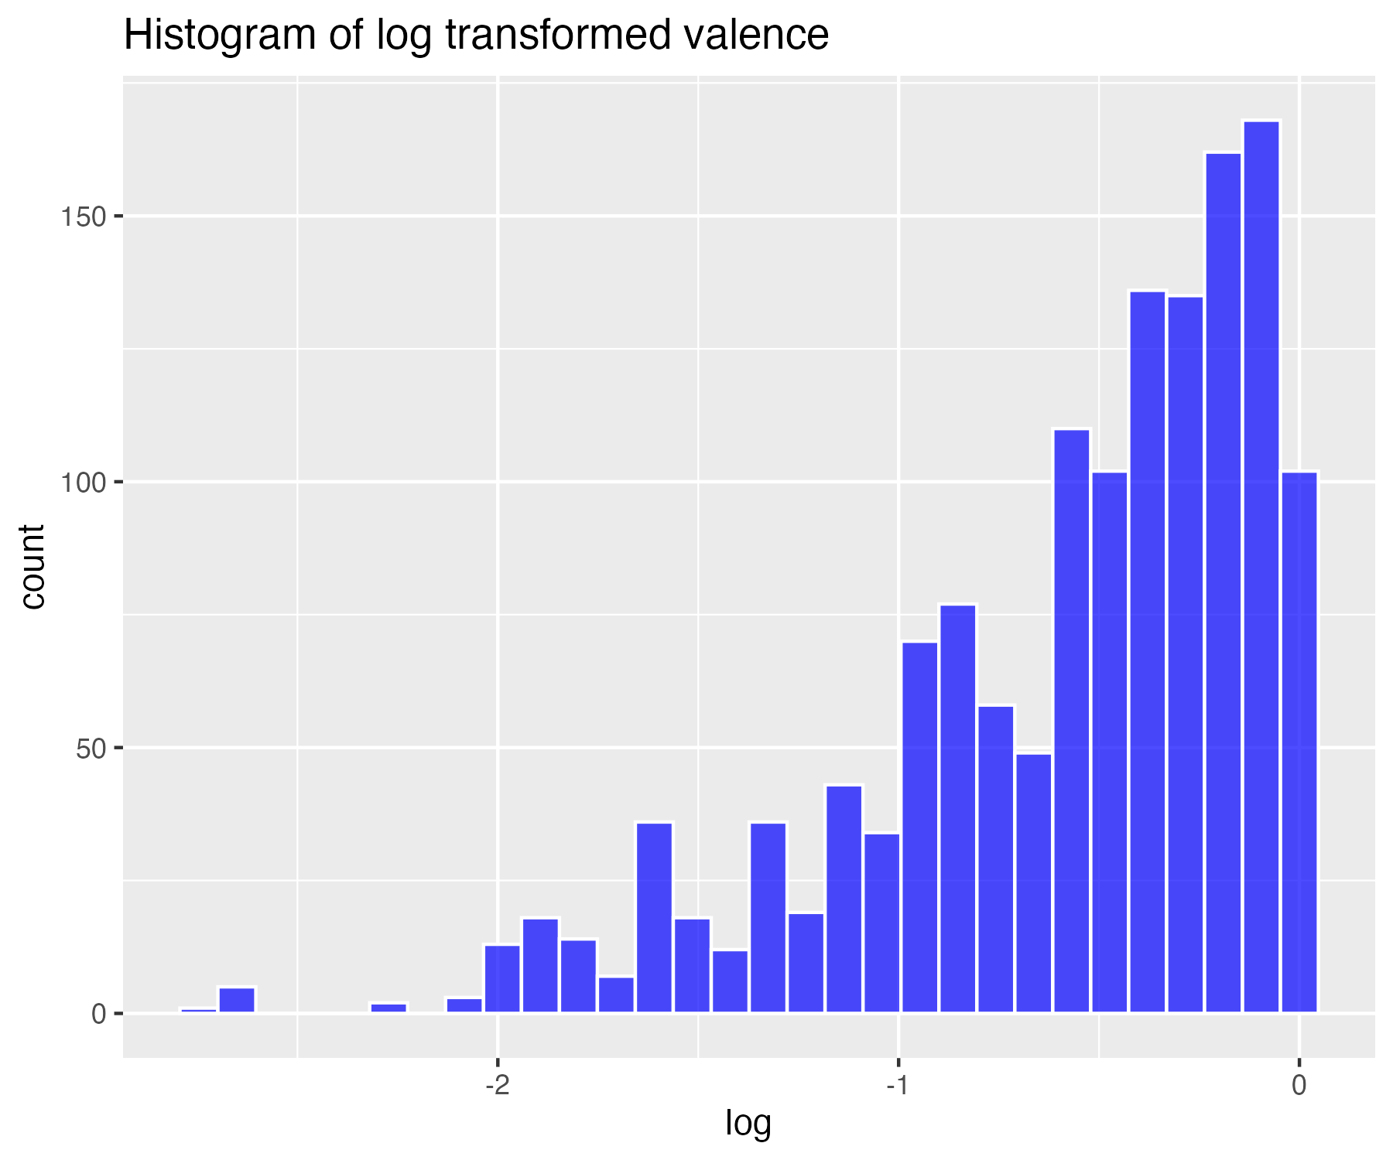

## Inverse transform of valence (for severe skew)

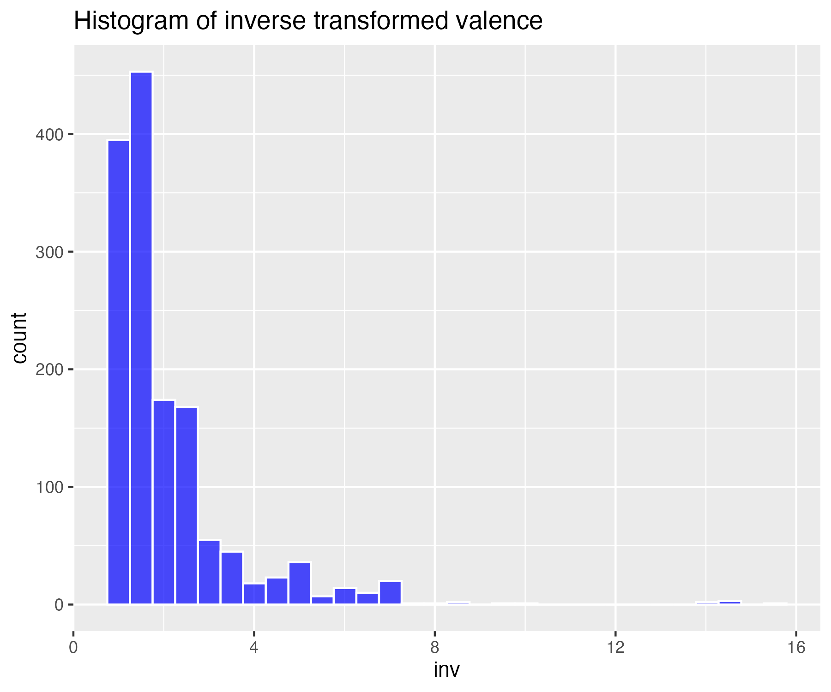

## Histogram of non-transformed tempo

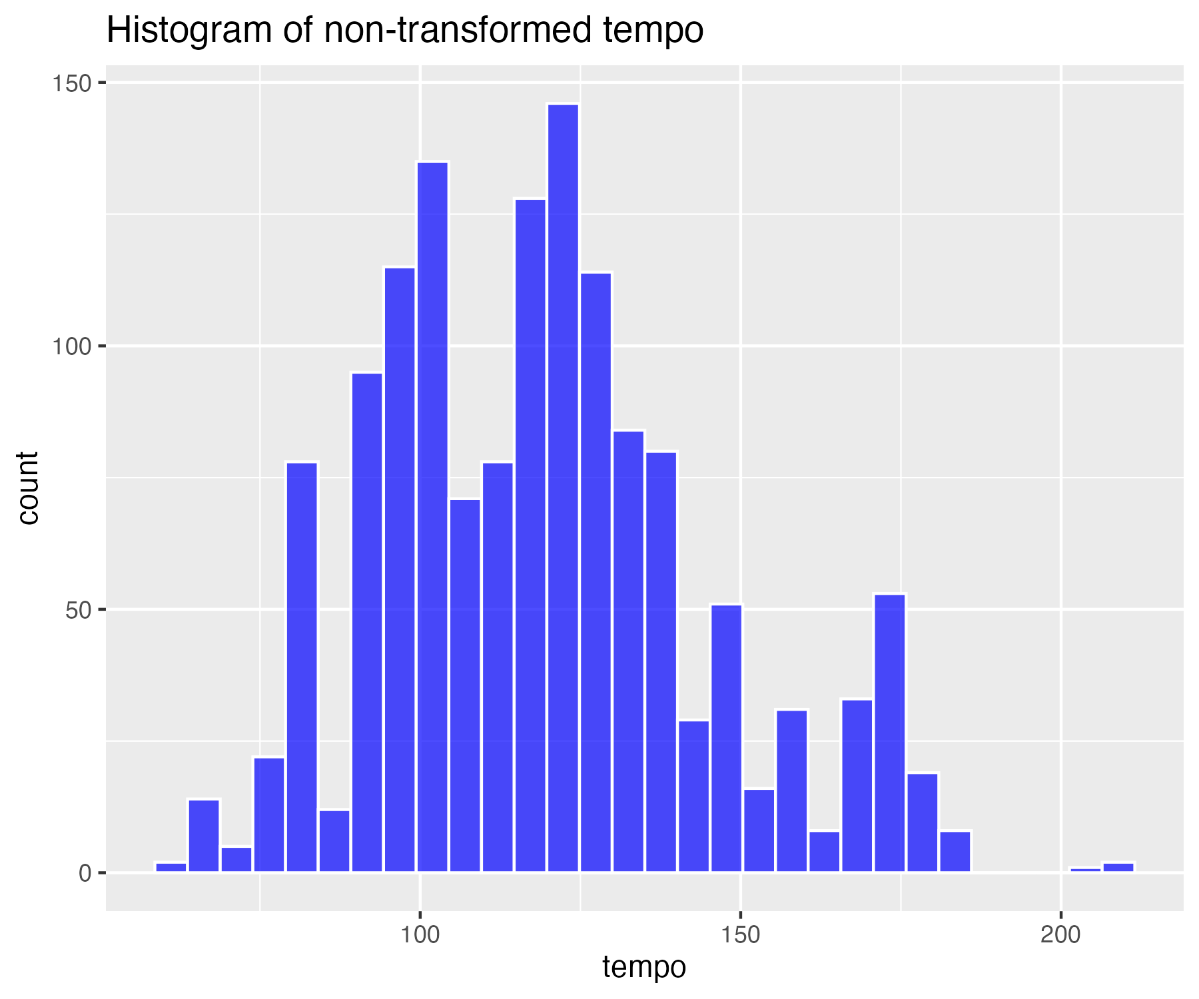

## Square-root transform of tempo (for moderate skew)

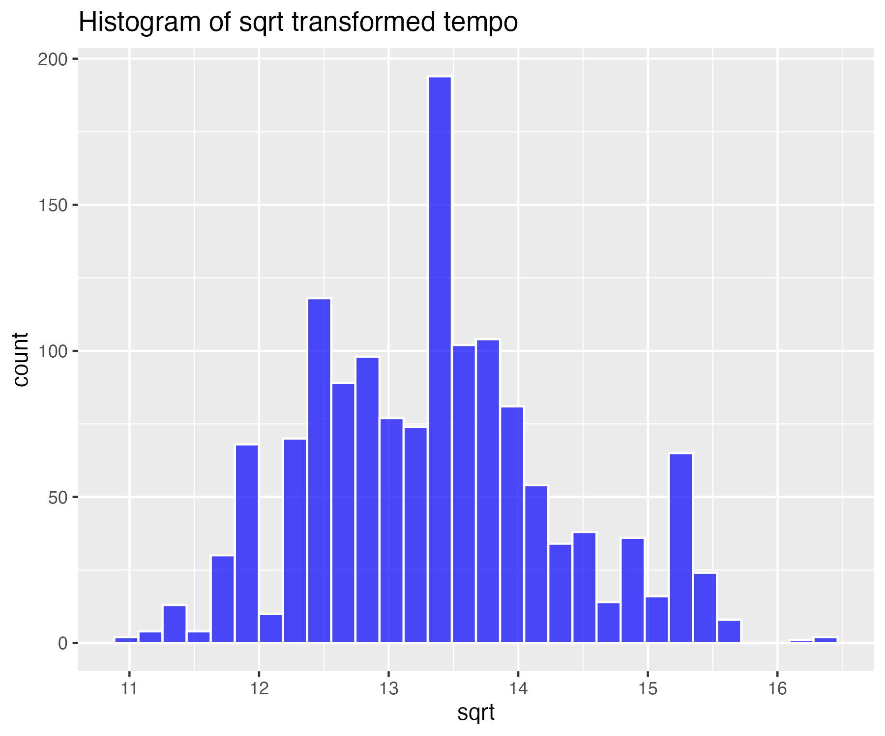

## Log base 10 transform of tempo (for high skew)

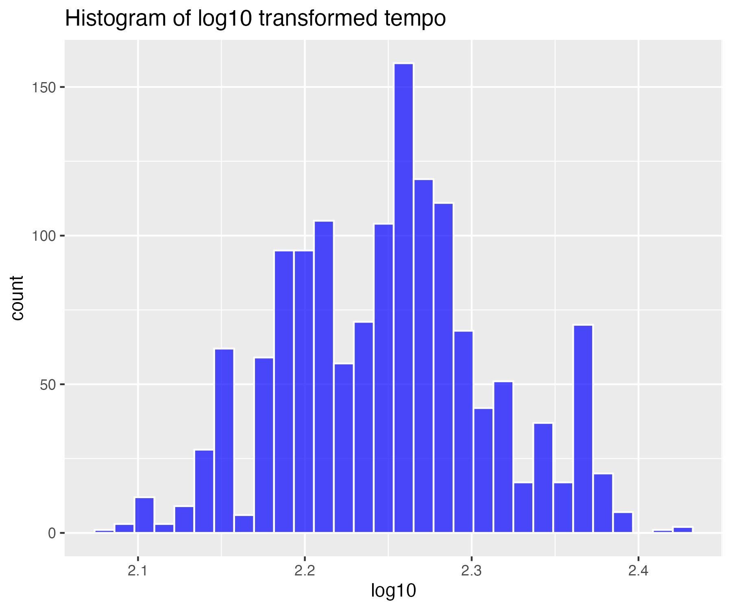

## Natural log transform of tempo (for higher skew)

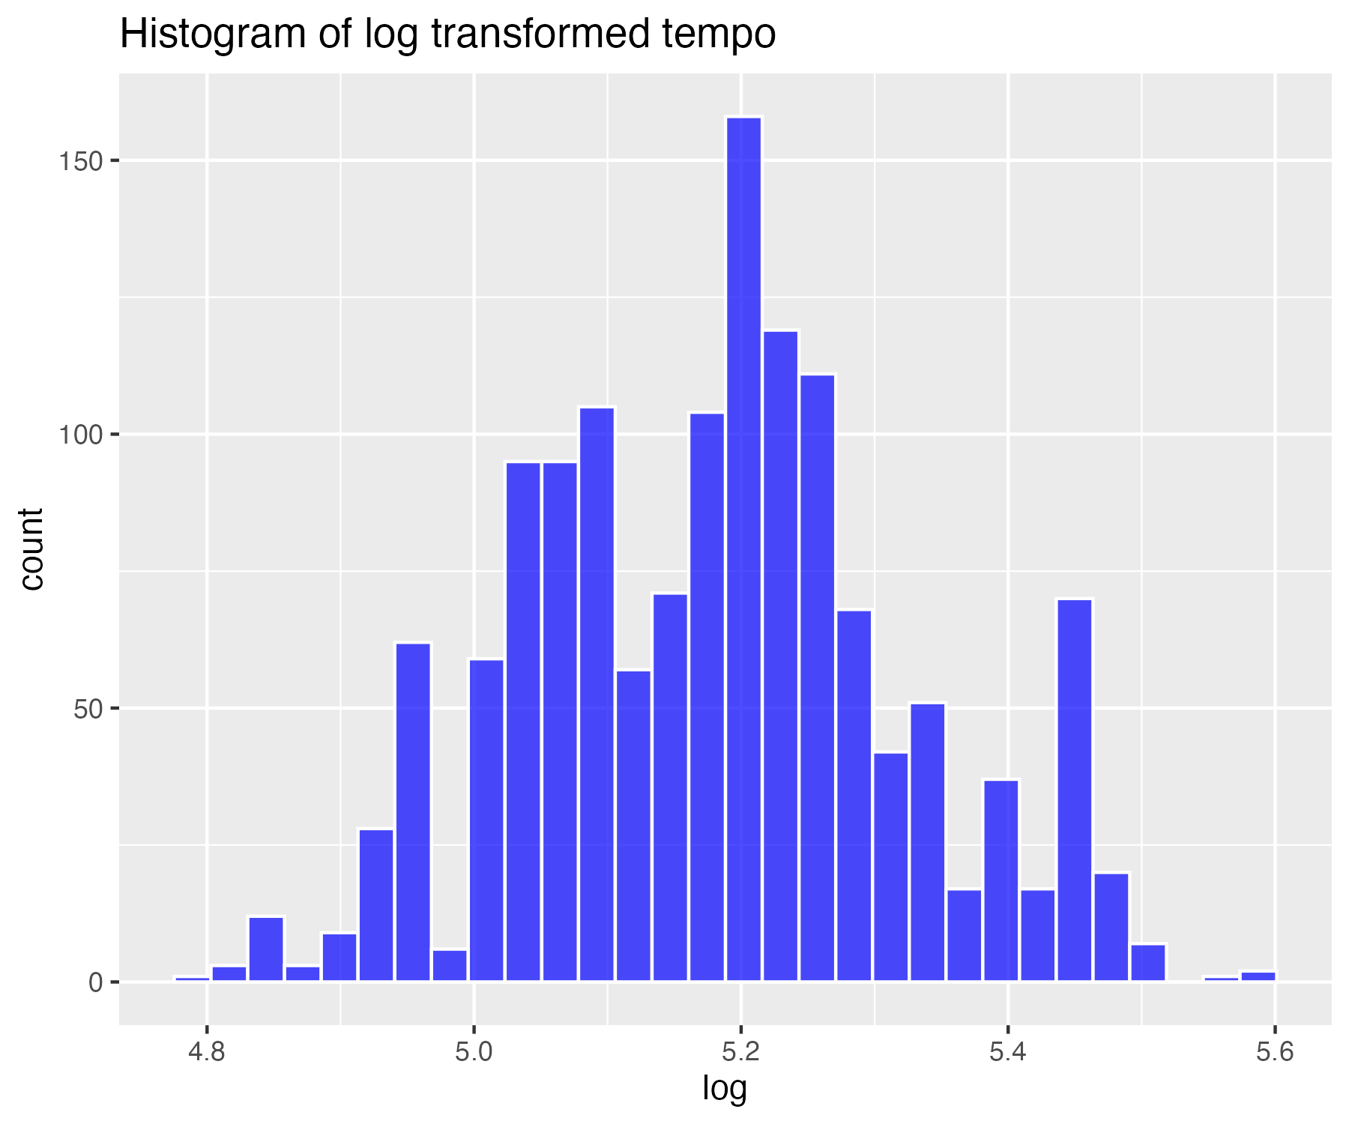

## Inverse transform of tempo (for severe skew)

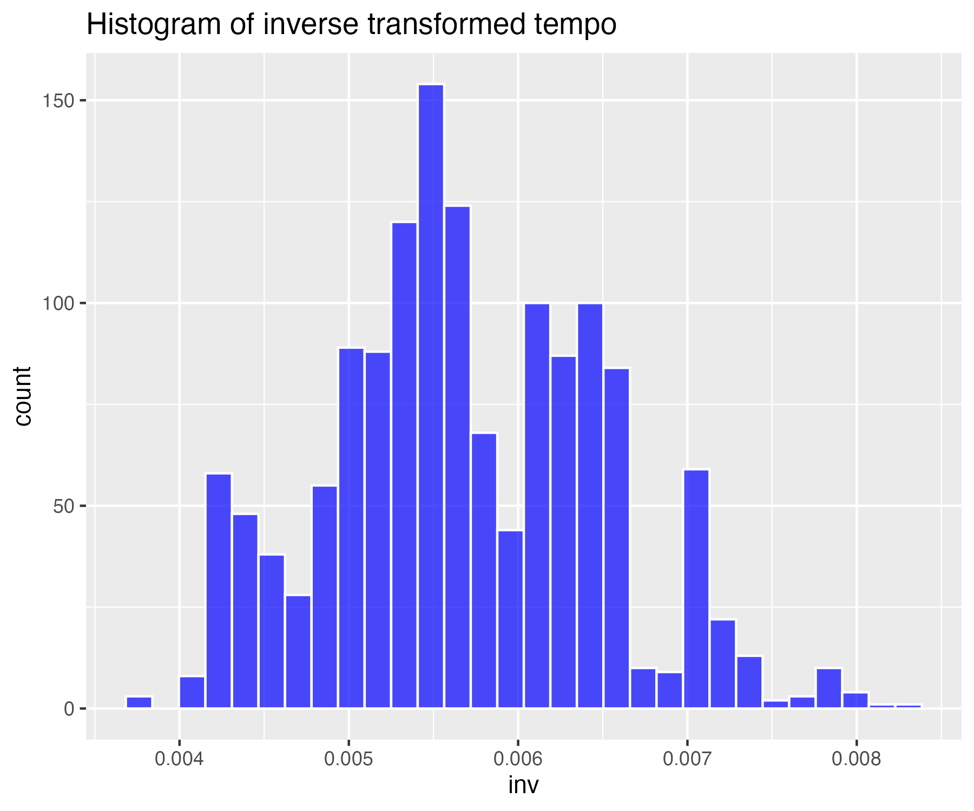

## Descriptives summary table for all variables (not transformed)

| matrix.nrow...20..ncol...1. | danceability | energy | loudness | speechiness | acousticness | instrumentalness | liveness | valence | tempo |
| --- | --- | --- | --- | --- | --- | --- | --- | --- | --- |
| nbr.val | 1,430.00 | 1,430.00 | 1,430.00 | 1,430.00 | 1,430.00 | 1,430.00 | 1,430.00 | 1,430.00 | 1,430.00 |
| nbr.null | 0.00 | 0.00 | 0.00 | 0.00 | 0.00 | 706.00 | 0.00 | 0.00 | 0.00 |
| nbr.na | 0.00 | 0.00 | 0.00 | 0.00 | 0.00 | 0.00 | 0.00 | 0.00 | 0.00 |
| min | 0.15 | 0.01 | -25.27 | 0.02 | 0.00 | 0.00 | 0.02 | 0.03 | 60.49 |
| max | 0.96 | 0.99 | -1.60 | 0.44 | 1.00 | 0.97 | 0.96 | 0.97 | 208.28 |
| range | 0.81 | 0.98 | 23.67 | 0.42 | 0.99 | 0.97 | 0.93 | 0.94 | 147.79 |
| sum | 951.65 | 915.59 | -10,498.75 | 101.90 | 317.53 | 26.71 | 231.26 | 839.94 | 170,134.78 |
| median | 0.68 | 0.66 | -6.64 | 0.04 | 0.13 | 0.00 | 0.11 | 0.61 | 118.95 |
| mean | 0.67 | 0.64 | -7.34 | 0.07 | 0.22 | 0.02 | 0.16 | 0.59 | 118.98 |
| SE.mean | 0.00 | 0.00 | 0.09 | 0.00 | 0.01 | 0.00 | 0.00 | 0.01 | 0.69 |
| CI.mean.0.95 | 0.01 | 0.01 | 0.17 | 0.00 | 0.01 | 0.01 | 0.01 | 0.01 | 1.35 |
| var | 0.02 | 0.03 | 10.82 | 0.00 | 0.06 | 0.01 | 0.02 | 0.06 | 672.32 |
| std.dev | 0.15 | 0.18 | 3.29 | 0.07 | 0.25 | 0.10 | 0.13 | 0.24 | 25.93 |
| coef.var | 0.22 | 0.28 | -0.45 | 0.94 | 1.12 | 5.46 | 0.83 | 0.42 | 0.22 |
| skewness | -0.57 | -0.50 | -1.42 | 2.92 | 1.35 | 7.31 | 2.19 | -0.28 | 0.50 |
| skew.2SE | -4.39 | -3.89 | -11.01 | 22.56 | 10.46 | 56.45 | 16.95 | -2.13 | 3.83 |
| kurtosis | 0.13 | -0.15 | 3.03 | 10.05 | 0.89 | 55.86 | 5.72 | -0.98 | -0.08 |
| kurt.2SE | 0.48 | -0.59 | 11.70 | 38.85 | 3.44 | 215.95 | 22.13 | -3.80 | -0.30 |
| normtest.W | 0.98 | 0.98 | 0.90 | 0.64 | 0.81 | 0.18 | 0.75 | 0.96 | 0.97 |
| normtest.p | 0.00 | 0.00 | 0.00 | 0.00 | 0.00 | 0.00 | 0.00 | 0.00 | 0.00 |

## Descriptives summary table for all variables - sqrt transform

| matrix.nrow...20..ncol...1. | danceability_sqrt | energy_sqrt | loudness_sqrt | speechiness_sqrt | acousticness_sqrt | instrumentalness_sqrt | liveness_sqrt | valence_sqrt | tempo_sqrt |
| --- | --- | --- | --- | --- | --- | --- | --- | --- | --- |
| nbr.val | 1,430.00 | 1,430.00 | 1,430.00 | 1,430.00 | 1,430.00 | 1,430.00 | 1,430.00 | 1,430.00 | 1,430.00 |
| nbr.null | 0.00 | 0.00 | 0.00 | 0.00 | 0.00 | 0.00 | 0.00 | 0.00 | 0.00 |
| nbr.na | 0.00 | 0.00 | 0.00 | 0.00 | 0.00 | 0.00 | 0.00 | 0.00 | 0.00 |
| min | 0.55 | 0.14 | 0.00 | 0.21 | 0.00 | 0.00 | 0.22 | 0.25 | 11.00 |
| max | 1.05 | 1.00 | 4.86 | 0.68 | 1.00 | 0.99 | 0.99 | 1.00 | 16.39 |
| range | 0.51 | 0.86 | 4.86 | 0.47 | 0.99 | 0.98 | 0.77 | 0.75 | 5.39 |
| sum | 1,284.63 | 1,139.48 | 6,021.06 | 420.74 | 564.71 | 58.40 | 587.80 | 1,098.97 | 19,108.07 |
| median | 0.91 | 0.82 | 4.32 | 0.26 | 0.36 | 0.00 | 0.37 | 0.80 | 13.40 |
| mean | 0.90 | 0.80 | 4.21 | 0.29 | 0.39 | 0.04 | 0.41 | 0.77 | 13.36 |
| SE.mean | 0.00 | 0.00 | 0.01 | 0.00 | 0.01 | 0.00 | 0.00 | 0.00 | 0.03 |
| CI.mean.0.95 | 0.00 | 0.01 | 0.02 | 0.00 | 0.01 | 0.01 | 0.01 | 0.01 | 0.05 |
| var | 0.01 | 0.02 | 0.20 | 0.01 | 0.07 | 0.02 | 0.02 | 0.03 | 0.92 |
| std.dev | 0.09 | 0.12 | 0.44 | 0.09 | 0.26 | 0.13 | 0.13 | 0.17 | 0.96 |
| coef.var | 0.10 | 0.16 | 0.11 | 0.29 | 0.65 | 3.20 | 0.32 | 0.22 | 0.07 |
| skewness | -0.88 | -1.10 | -2.55 | 2.03 | 0.56 | 4.96 | 1.40 | -0.66 | 0.32 |
| skew.2SE | -6.77 | -8.53 | -19.69 | 15.70 | 4.31 | 38.33 | 10.86 | -5.12 | 2.47 |
| kurtosis | 0.92 | 2.01 | 12.63 | 4.53 | -0.67 | 27.20 | 1.84 | -0.41 | -0.23 |
| kurt.2SE | 3.54 | 7.76 | 48.83 | 17.53 | -2.60 | 105.16 | 7.10 | -1.57 | -0.90 |
| normtest.W | 0.95 | 0.93 | 0.81 | 0.76 | 0.95 | 0.34 | 0.87 | 0.94 | 0.98 |
| normtest.p | 0.00 | 0.00 | 0.00 | 0.00 | 0.00 | 0.00 | 0.00 | 0.00 | 0.00 |

## Descriptives summary table for all variables - log10 transform

| matrix.nrow...20..ncol...1. | danceability_log10 | energy_log10 | loudness_log10 | speechiness_log10 | acousticness_log10 | instrumentalness_log10 | liveness_log10 | valence_log10 | tempo_log10 |
| --- | --- | --- | --- | --- | --- | --- | --- | --- | --- |
| nbr.val | 1,430.00 | 1,430.00 | 1,430.00 | 1,430.00 | 1,430.00 | 1,430.00 | 1,430.00 | 1,430.00 | 1,430.00 |
| nbr.null | 0.00 | 0.00 | 0.00 | 0.00 | 0.00 | 0.00 | 0.00 | 0.00 | 0.00 |
| nbr.na | 0.00 | 0.00 | 0.00 | 0.00 | 0.00 | 0.00 | 0.00 | 0.00 | 0.00 |
| min | -0.53 | -1.70 | -6.00 | -1.34 | -4.79 | -6.00 | -1.31 | -1.19 | 2.08 |
| max | 0.04 | 0.00 | 1.37 | -0.34 | 0.00 | -0.01 | -0.01 | 0.00 | 2.43 |
| range | 0.57 | 1.70 | 7.37 | 1.00 | 4.79 | 5.99 | 1.31 | 1.19 | 0.35 |
| sum | -139.35 | -300.62 | 1,770.93 | -1,561.67 | -1,516.68 | -6,816.76 | -1,157.77 | -363.42 | 3,216.85 |
| median | -0.08 | -0.18 | 1.27 | -1.17 | -0.90 | -5.69 | -0.87 | -0.19 | 2.25 |
| mean | -0.10 | -0.21 | 1.24 | -1.09 | -1.06 | -4.77 | -0.81 | -0.25 | 2.25 |
| SE.mean | 0.00 | 0.00 | 0.01 | 0.01 | 0.02 | 0.04 | 0.01 | 0.01 | 0.00 |
| CI.mean.0.95 | 0.00 | 0.01 | 0.01 | 0.01 | 0.04 | 0.08 | 0.01 | 0.01 | 0.00 |
| var | 0.01 | 0.03 | 0.05 | 0.05 | 0.59 | 2.63 | 0.06 | 0.05 | 0.00 |
| std.dev | 0.09 | 0.16 | 0.22 | 0.21 | 0.77 | 1.62 | 0.25 | 0.22 | 0.06 |
| coef.var | -0.91 | -0.77 | 0.18 | -0.20 | -0.72 | -0.34 | -0.30 | -0.87 | 0.03 |
| skewness | -1.25 | -2.64 | -25.36 | 1.35 | -1.11 | 1.19 | 0.74 | -1.20 | 0.14 |
| skew.2SE | -9.69 | -20.38 | -195.94 | 10.42 | -8.55 | 9.17 | 5.71 | -9.28 | 1.09 |
| kurtosis | 2.33 | 14.54 | 815.88 | 1.38 | 1.48 | 0.33 | 0.03 | 1.15 | -0.31 |
| kurt.2SE | 9.01 | 56.20 | 3,154.41 | 5.33 | 5.72 | 1.29 | 0.12 | 4.44 | -1.19 |
| normtest.W | 0.92 | 0.81 | 0.24 | 0.85 | 0.93 | 0.78 | 0.95 | 0.89 | 0.99 |
| normtest.p | 0.00 | 0.00 | 0.00 | 0.00 | 0.00 | 0.00 | 0.00 | 0.00 | 0.00 |

## Descriptives summary table for all variables - log transform

| matrix.nrow...20..ncol...1. | danceability_log | energy_log | loudness_log | speechiness_log | acousticness_log | instrumentalness_log | liveness_log | valence_log | tempo_log |
| --- | --- | --- | --- | --- | --- | --- | --- | --- | --- |
| nbr.val | 1,430.00 | 1,430.00 | 1,430.00 | 1,430.00 | 1,430.00 | 1,430.00 | 1,430.00 | 1,430.00 | 1,430.00 |
| nbr.null | 0.00 | 0.00 | 0.00 | 0.00 | 0.00 | 0.00 | 0.00 | 0.00 | 0.00 |
| nbr.na | 0.00 | 0.00 | 0.00 | 0.00 | 0.00 | 0.00 | 0.00 | 0.00 | 0.00 |
| min | -1.21 | -3.91 | -13.82 | -3.09 | -11.03 | -13.82 | -3.02 | -2.74 | 4.80 |
| max | 0.10 | 0.00 | 3.16 | -0.77 | -0.01 | -0.03 | -0.02 | 0.00 | 5.59 |
| range | 1.31 | 3.91 | 16.98 | 2.31 | 11.02 | 13.79 | 3.01 | 2.75 | 0.80 |
| sum | -320.87 | -692.20 | 4,077.73 | -3,595.87 | -3,492.28 | -15,696.16 | -2,665.85 | -836.82 | 7,407.08 |
| median | -0.19 | -0.40 | 2.92 | -2.69 | -2.07 | -13.11 | -2.01 | -0.44 | 5.19 |
| mean | -0.22 | -0.48 | 2.85 | -2.51 | -2.44 | -10.98 | -1.86 | -0.59 | 5.18 |
| SE.mean | 0.01 | 0.01 | 0.01 | 0.01 | 0.05 | 0.10 | 0.02 | 0.01 | 0.00 |
| CI.mean.0.95 | 0.01 | 0.02 | 0.03 | 0.03 | 0.09 | 0.19 | 0.03 | 0.03 | 0.01 |
| var | 0.04 | 0.14 | 0.26 | 0.24 | 3.10 | 13.92 | 0.32 | 0.26 | 0.02 |
| std.dev | 0.20 | 0.37 | 0.51 | 0.49 | 1.76 | 3.73 | 0.57 | 0.51 | 0.14 |
| coef.var | -0.91 | -0.77 | 0.18 | -0.20 | -0.72 | -0.34 | -0.30 | -0.87 | 0.03 |
| skewness | -1.25 | -2.64 | -25.36 | 1.35 | -1.11 | 1.19 | 0.74 | -1.20 | 0.14 |
| skew.2SE | -9.69 | -20.38 | -195.94 | 10.42 | -8.55 | 9.17 | 5.71 | -9.28 | 1.09 |
| kurtosis | 2.33 | 14.54 | 815.88 | 1.38 | 1.48 | 0.33 | 0.03 | 1.15 | -0.31 |
| kurt.2SE | 9.01 | 56.20 | 3,154.41 | 5.33 | 5.72 | 1.29 | 0.12 | 4.44 | -1.19 |
| normtest.W | 0.92 | 0.81 | 0.24 | 0.85 | 0.93 | 0.78 | 0.95 | 0.89 | 0.99 |
| normtest.p | 0.00 | 0.00 | 0.00 | 0.00 | 0.00 | 0.00 | 0.00 | 0.00 | 0.00 |

## Descriptives summary table for all variables - inverse transform

| matrix.nrow...20..ncol...1. | danceability_inv | energy_inv | loudness_inv | speechiness_inv | acousticness_inv | instrumentalness_inv | liveness_inv | valence_inv | tempo_inv |
| --- | --- | --- | --- | --- | --- | --- | --- | --- | --- |
| nbr.val | 1,430.00 | 1,430.00 | 1,430.00 | 1,430.00 | 1,430.00 | 1,430.00 | 1,430.00 | 1,430.00 | 1,430.00 |
| nbr.null | 0.00 | 0.00 | 0.00 | 0.00 | 0.00 | 0.00 | 0.00 | 0.00 | 0.00 |
| nbr.na | 0.00 | 0.00 | 0.00 | 0.00 | 0.00 | 0.00 | 0.00 | 0.00 | 0.00 |
| min | 0.90 | 1.00 | 0.04 | 2.17 | 1.01 | 1.03 | 1.02 | 1.00 | 0.00 |
| max | 3.36 | 50.00 | 1,000,000.00 | 21.93 | 61,576.35 | 1,000,000.00 | 20.58 | 15.53 | 0.01 |
| range | 2.45 | 49.00 | 999,999.96 | 19.76 | 61,575.35 | 999,998.97 | 19.56 | 14.53 | 0.00 |
| sum | 1,830.95 | 2,595.58 | 1,000,086.36 | 19,496.84 | 274,236.59 | 751,916,269.78 | 10,607.88 | 3,008.69 | 8.13 |
| median | 1.21 | 1.50 | 0.05 | 14.76 | 7.90 | 492,610.84 | 7.45 | 1.56 | 0.01 |
| mean | 1.28 | 1.82 | 699.36 | 13.63 | 191.77 | 525,815.57 | 7.42 | 2.10 | 0.01 |
| SE.mean | 0.01 | 0.05 | 699.30 | 0.13 | 56.18 | 12,569.93 | 0.09 | 0.04 | 0.00 |
| CI.mean.0.95 | 0.02 | 0.11 | 1,371.77 | 0.26 | 110.19 | 24,657.49 | 0.19 | 0.08 | 0.00 |
| var | 0.09 | 4.17 | 699,300,614.78 | 25.48 | 4,512,571.41 | 225,944,421,264.96 | 12.89 | 2.42 | 0.00 |
| std.dev | 0.30 | 2.04 | 26,444.29 | 5.05 | 2,124.28 | 475,336.11 | 3.59 | 1.55 | 0.00 |
| coef.var | 0.24 | 1.12 | 37.81 | 0.37 | 11.08 | 0.90 | 0.48 | 0.74 | 0.14 |
| skewness | 2.36 | 16.84 | 37.74 | -0.51 | 23.29 | -0.05 | 0.52 | 3.50 | 0.22 |
| skew.2SE | 18.21 | 130.16 | 291.59 | -3.93 | 179.93 | -0.35 | 4.01 | 27.08 | 1.70 |
| kurtosis | 9.10 | 345.83 | 1,423.00 | -0.87 | 602.10 | -1.94 | 0.17 | 18.88 | -0.21 |
| kurt.2SE | 35.18 | 1,337.08 | 5,501.68 | -3.37 | 2,327.88 | -7.50 | 0.66 | 72.98 | -0.81 |
| normtest.W | 0.81 | 0.21 | 0.01 | 0.94 | 0.05 | 0.69 | 0.97 | 0.65 | 0.99 |
| normtest.p | 0.00 | 0.00 | 0.00 | 0.00 | 0.00 | 0.00 | 0.00 | 0.00 | 0.00 |