# Normality Tests

## Plots for danceability variable

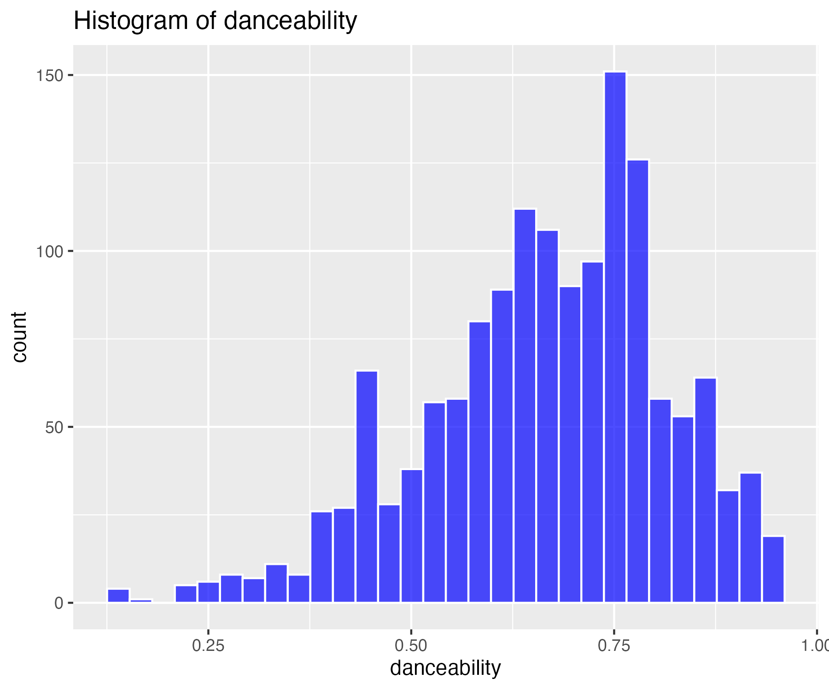

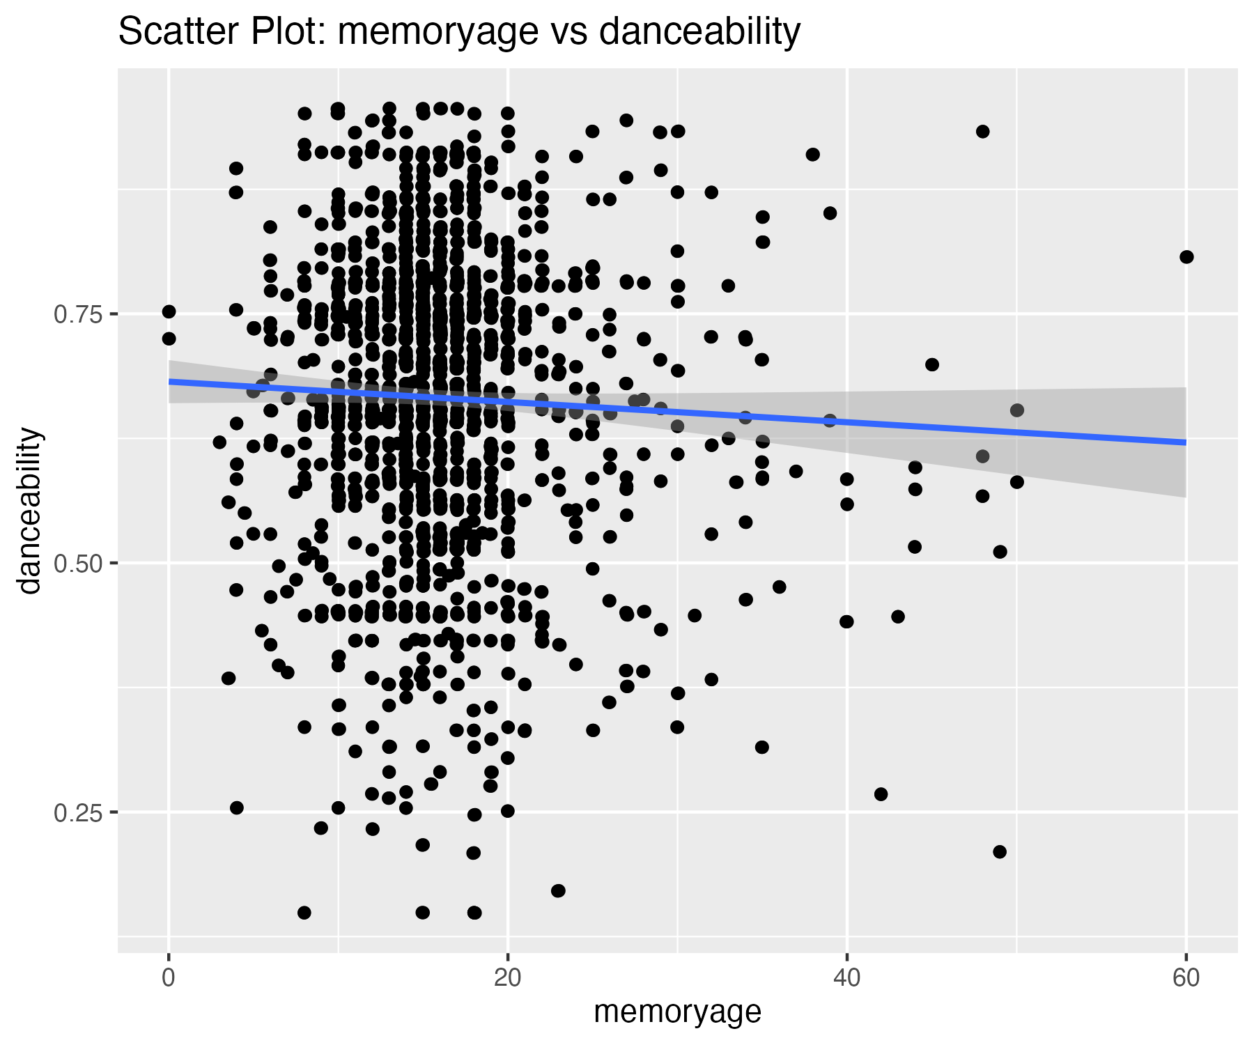

There are 5 outliers in this variable that were removed.

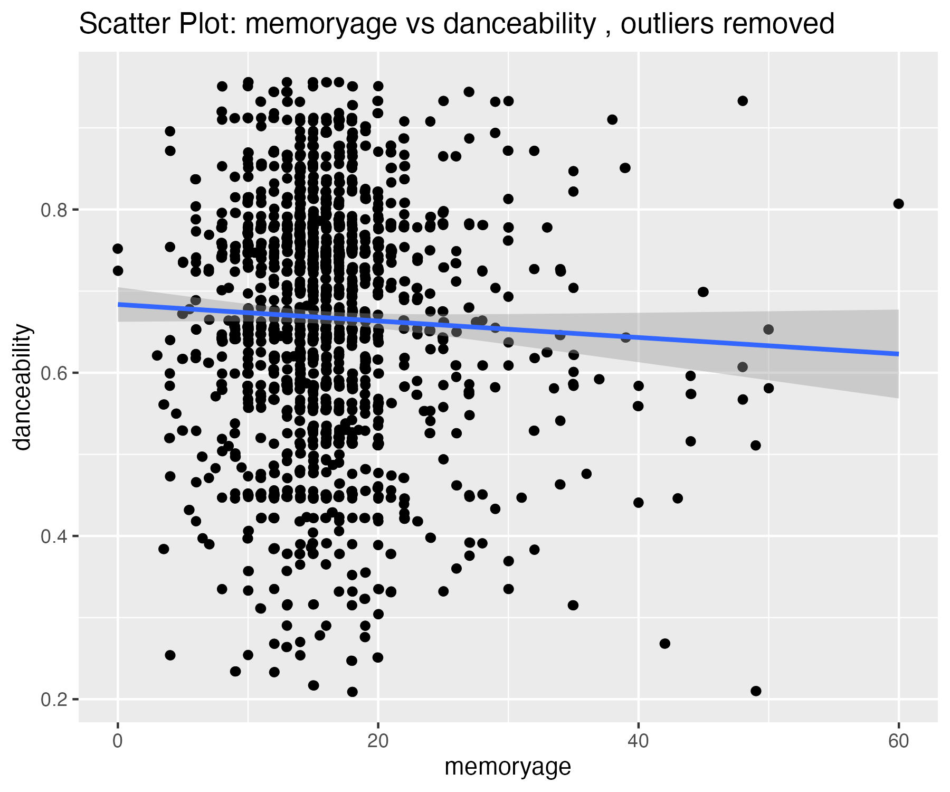

## Plots for energy variable

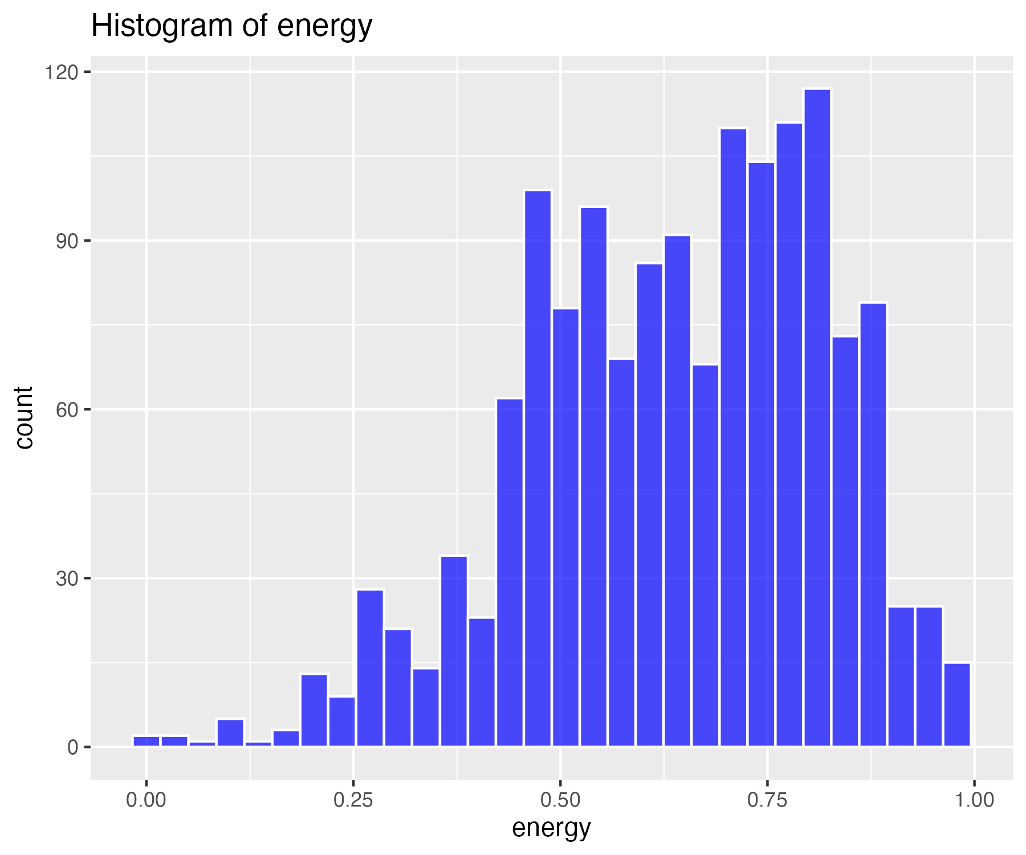

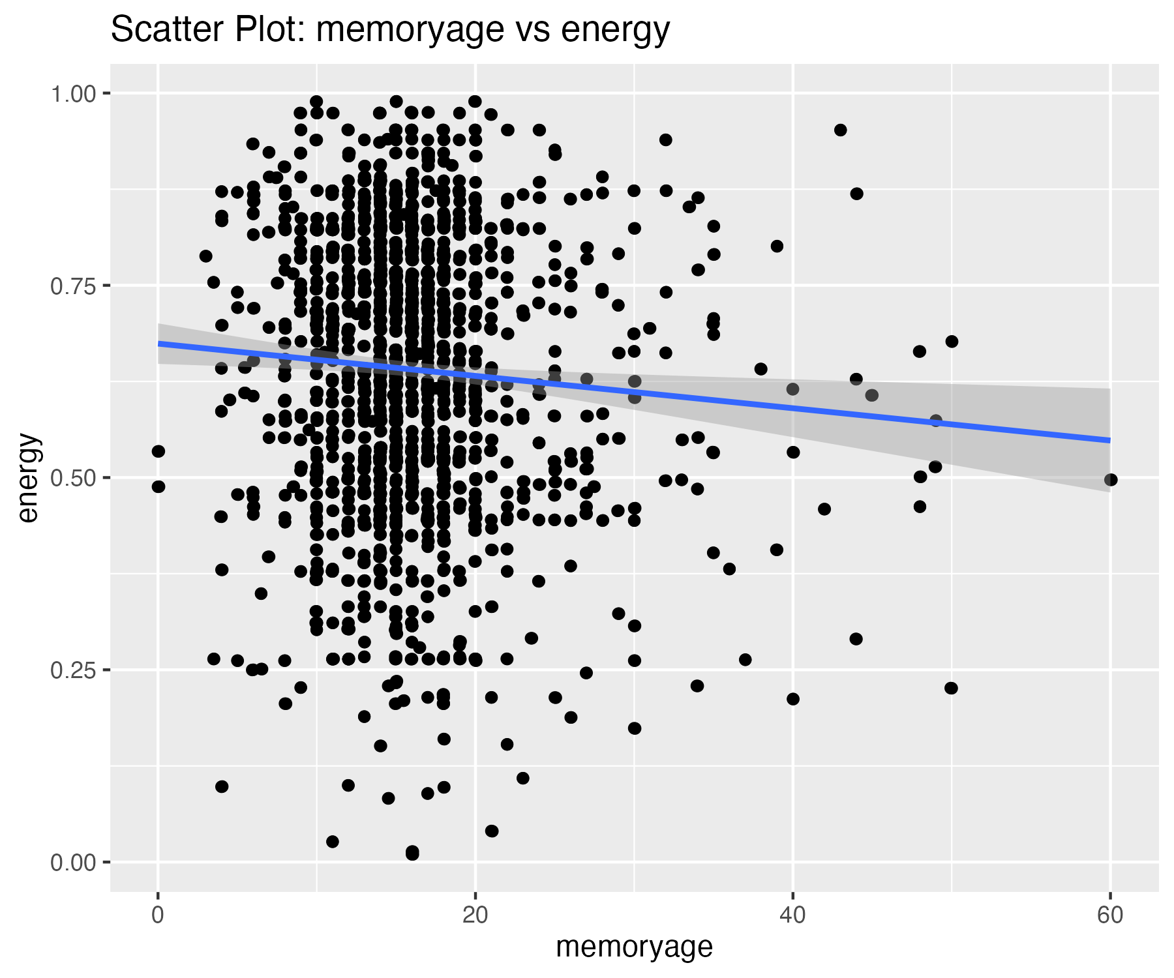

There are 4 outliers in this variable that were removed.

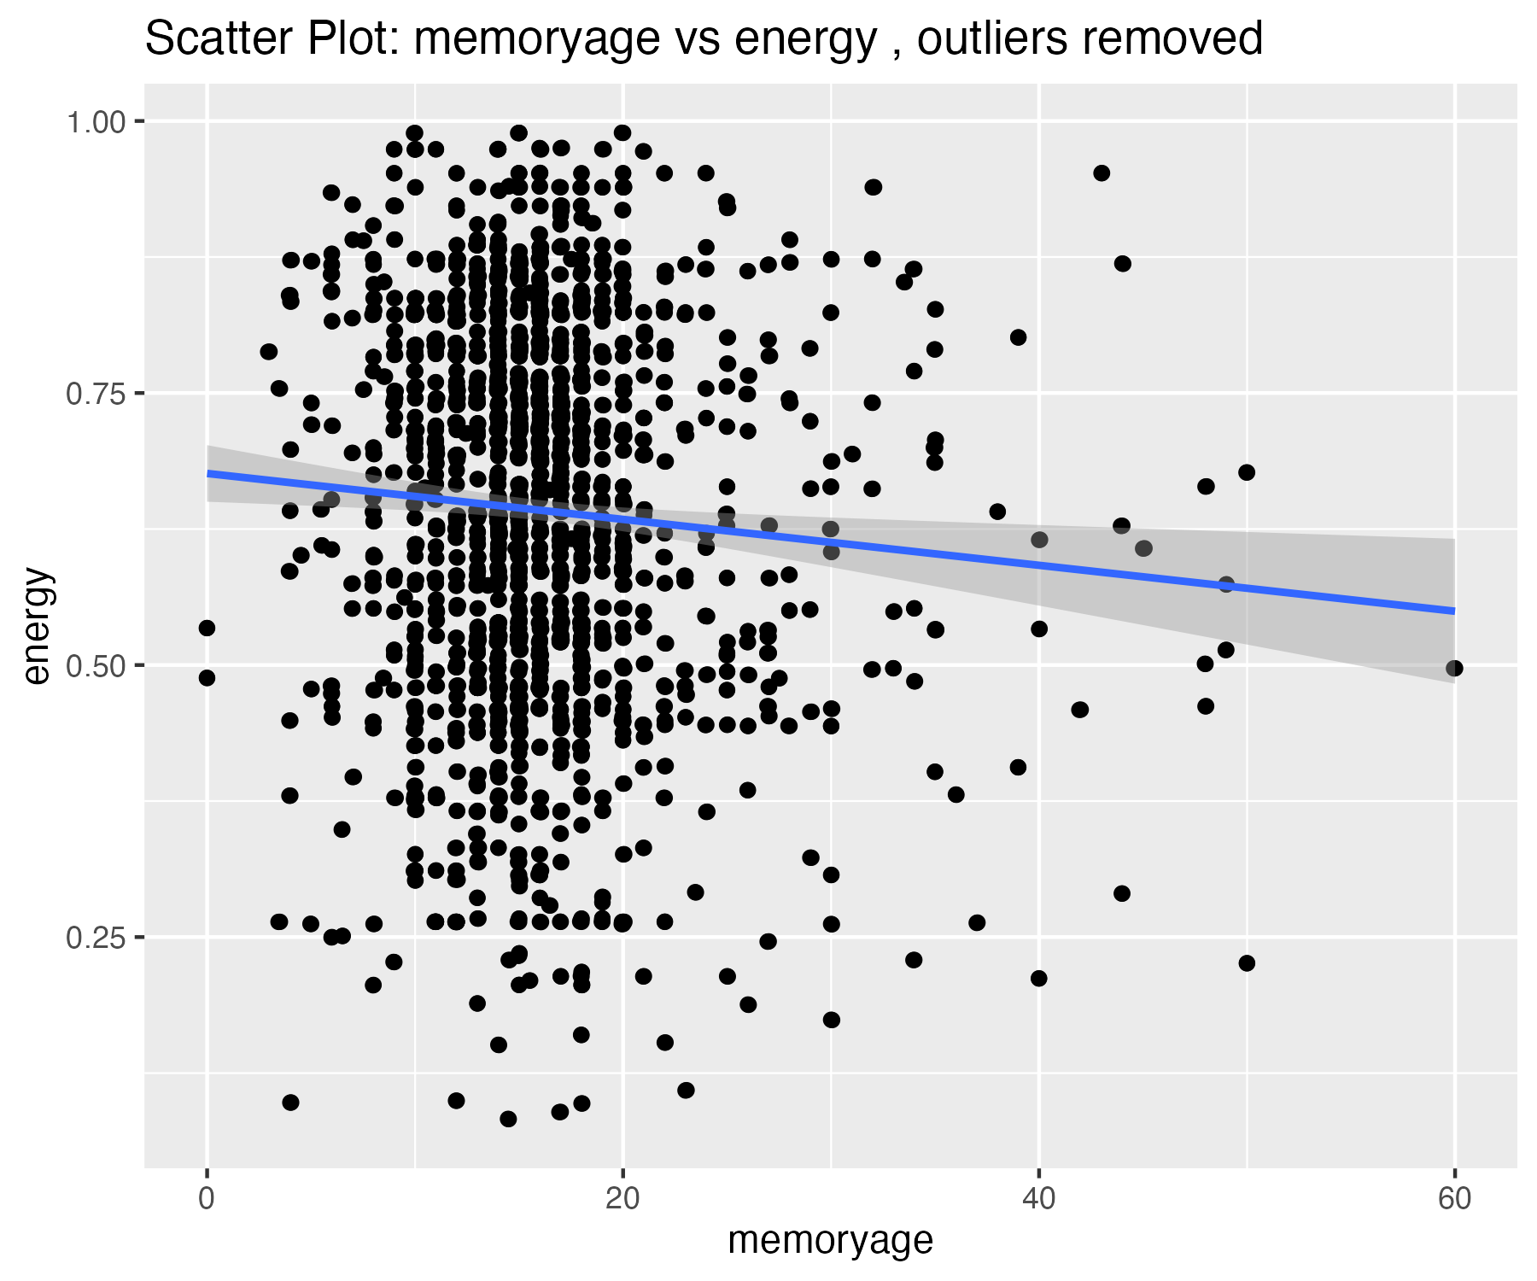

## Plots for loudness variable

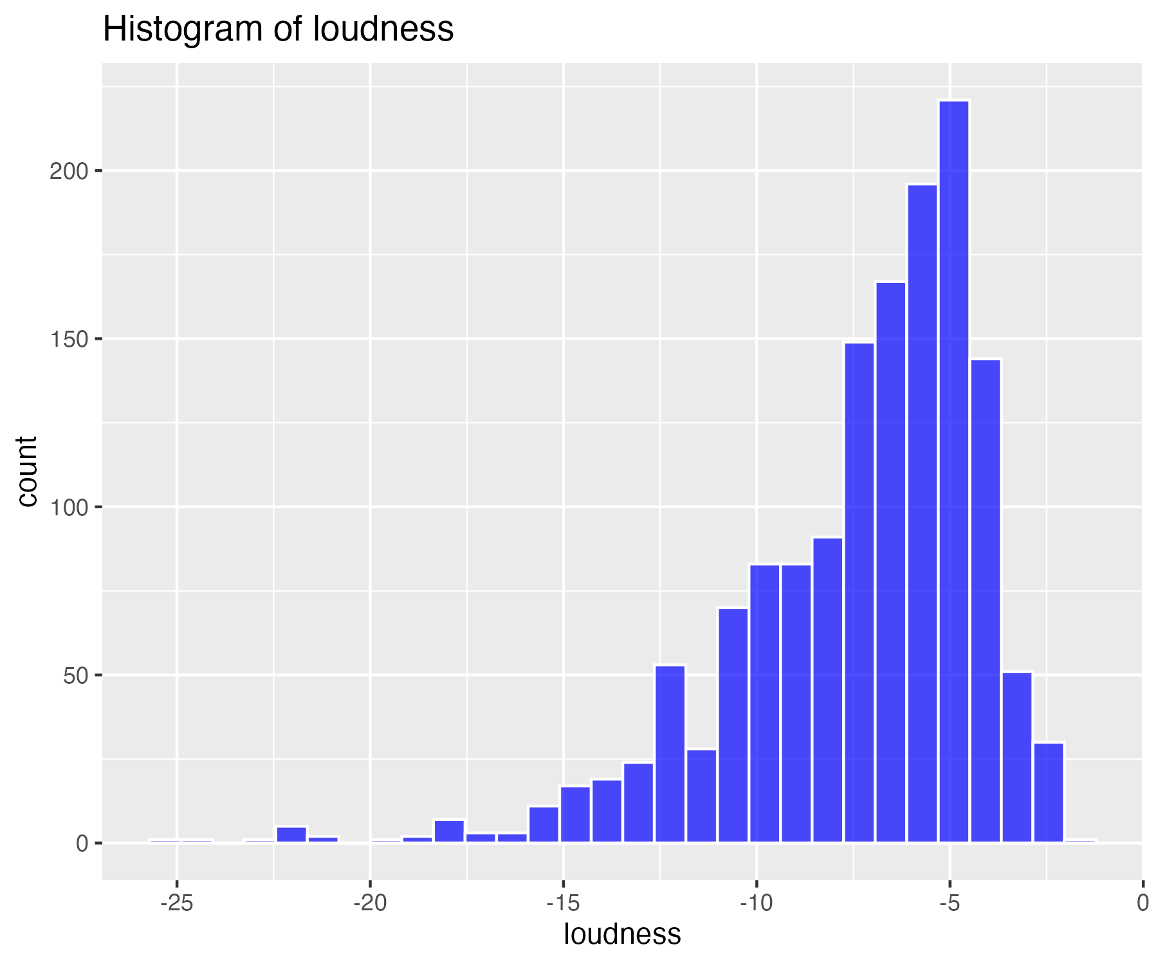

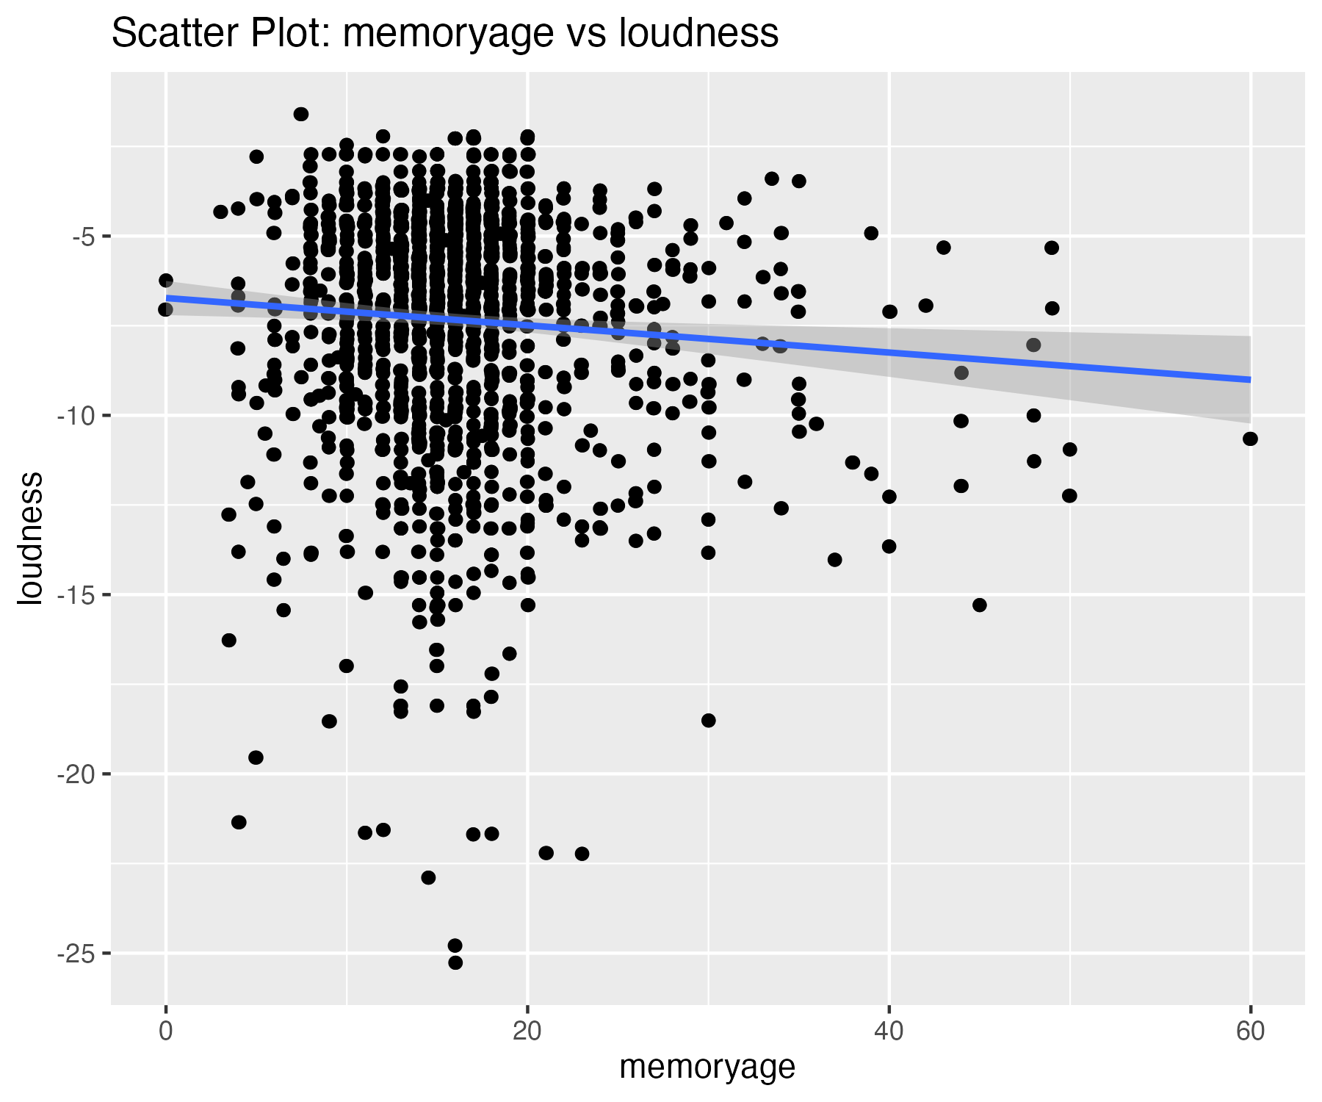

There are 18 outliers in this variable that were removed.

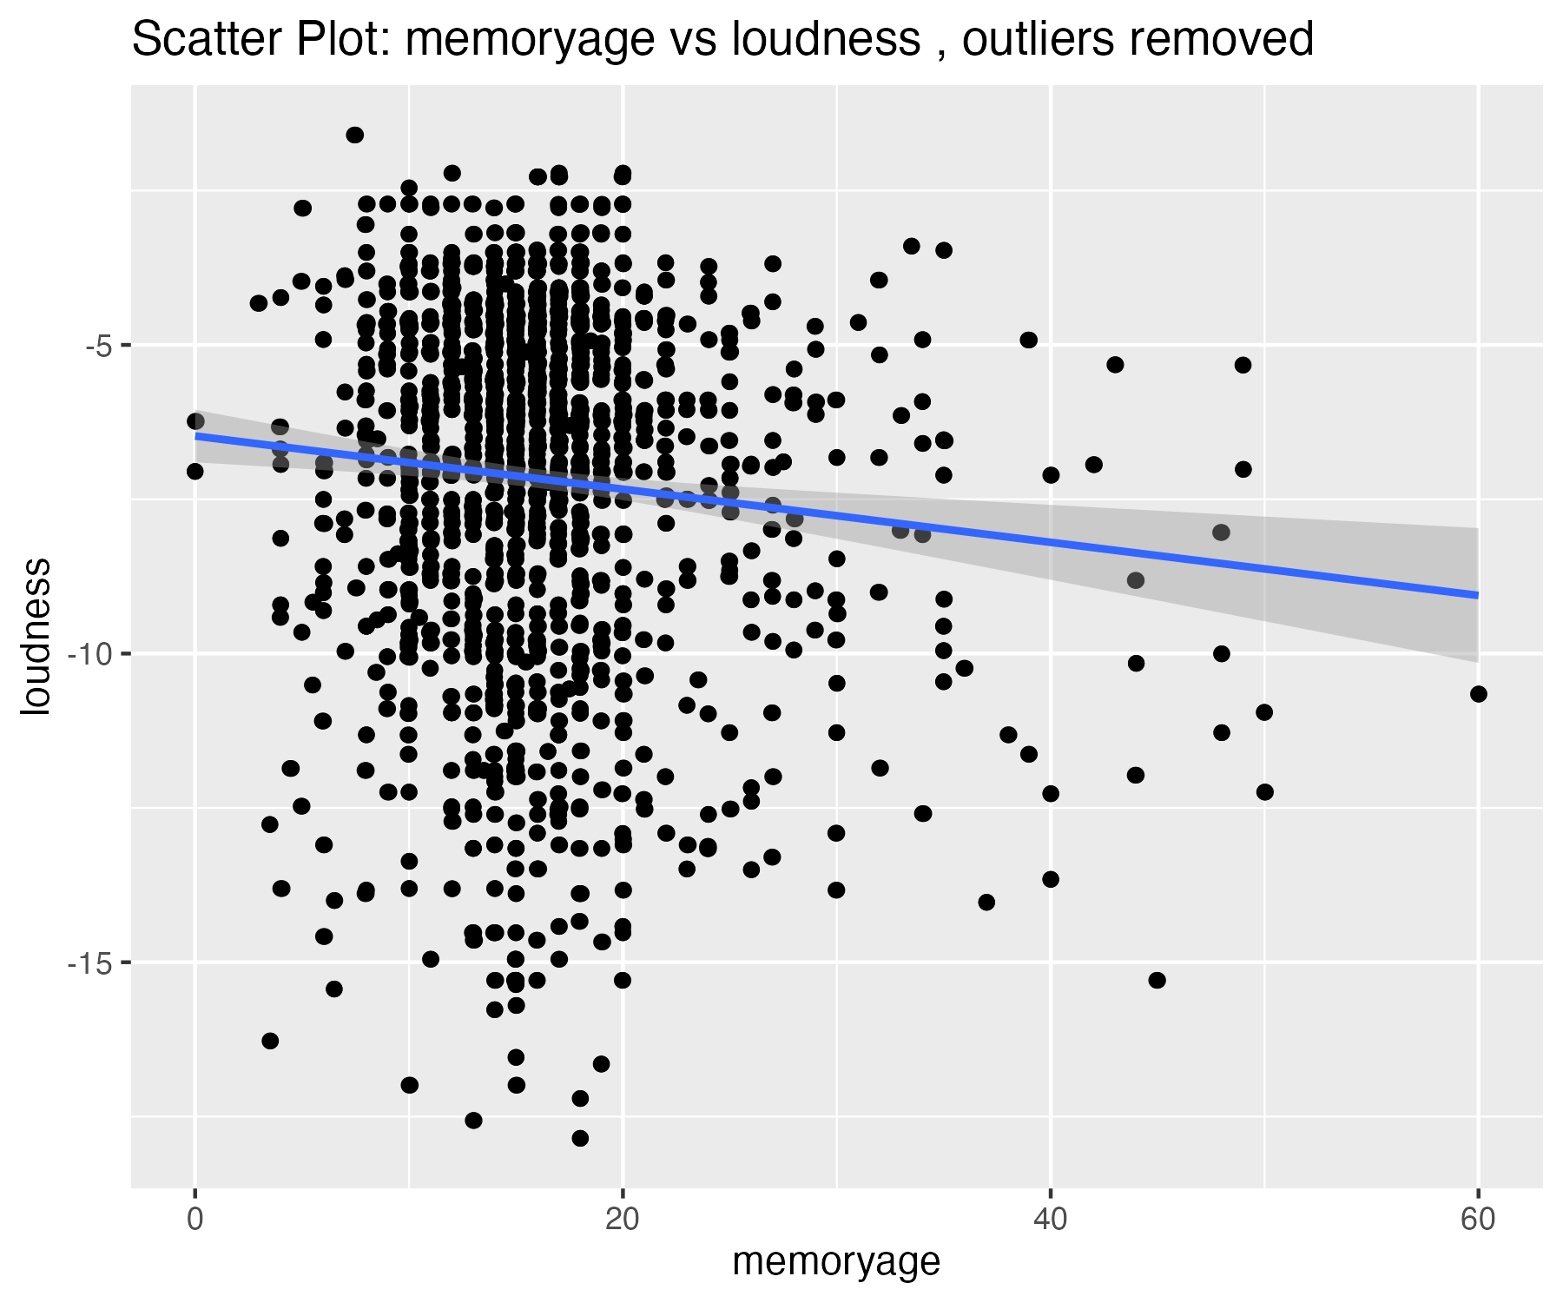

| matrix.nrow...20..ncol...1. | danceability | energy | loudness |
| --- | --- | --- | --- |
| nbr.val | 1,464.00 | 1,464.00 | 1,464.00 |
| nbr.null | 0.00 | 0.00 | 0.00 |
| nbr.na | 0.00 | 0.00 | 0.00 |
| min | 0.15 | 0.01 | -25.27 |
| max | 0.96 | 0.99 | -1.60 |
| range | 0.81 | 0.98 | 23.67 |
| sum | 975.50 | 937.14 | -10,709.35 |
| median | 0.68 | 0.66 | -6.55 |
| mean | 0.67 | 0.64 | -7.32 |
| SE.mean | 0.00 | 0.00 | 0.09 |
| CI.mean.0.95 | 0.01 | 0.01 | 0.17 |
| var | 0.02 | 0.03 | 10.68 |
| std.dev | 0.15 | 0.18 | 3.27 |
| coef.var | 0.22 | 0.28 | -0.45 |
| skewness | -0.57 | -0.50 | -1.44 |
| skew.2SE | -4.47 | -3.89 | -11.23 |
| kurtosis | 0.13 | -0.15 | 3.09 |
| kurt.2SE | 0.53 | -0.59 | 12.10 |
| normtest.W | 0.98 | 0.98 | 0.90 |
| normtest.p | 0.00 | 0.00 | 0.00 |

| matrix.nrow...20..ncol...1. | danceability | energy | loudness | stat.desc.mydata_z.z_var..norm...TRUE. |
| --- | --- | --- | --- | --- |
| nbr.val | 1,464.00 | 1,464.00 | 1,464.00 | 1,446.00 |
| nbr.null | 0.00 | 0.00 | 0.00 | 0.00 |
| nbr.na | 0.00 | 0.00 | 0.00 | 0.00 |
| min | 0.15 | 0.01 | -25.27 | -3.22 |
| max | 0.96 | 0.99 | -1.60 | 1.75 |
| range | 0.81 | 0.98 | 23.67 | 4.97 |
| sum | 975.50 | 937.14 | -10,709.35 | 73.75 |
| median | 0.68 | 0.66 | -6.55 | 0.23 |
| mean | 0.67 | 0.64 | -7.32 | 0.05 |
| SE.mean | 0.00 | 0.00 | 0.09 | 0.02 |
| CI.mean.0.95 | 0.01 | 0.01 | 0.17 | 0.05 |
| var | 0.02 | 0.03 | 10.68 | 0.79 |
| std.dev | 0.15 | 0.18 | 3.27 | 0.89 |
| coef.var | 0.22 | 0.28 | -0.45 | 17.48 |
| skewness | -0.57 | -0.50 | -1.44 | -0.91 |
| skew.2SE | -4.47 | -3.89 | -11.23 | -7.06 |
| kurtosis | 0.13 | -0.15 | 3.09 | 0.38 |
| kurt.2SE | 0.53 | -0.59 | 12.10 | 1.49 |
| normtest.W | 0.98 | 0.98 | 0.90 | 0.94 |
| normtest.p | 0.00 | 0.00 | 0.00 | 0.00 |