## Histogram of non-transformed danceability

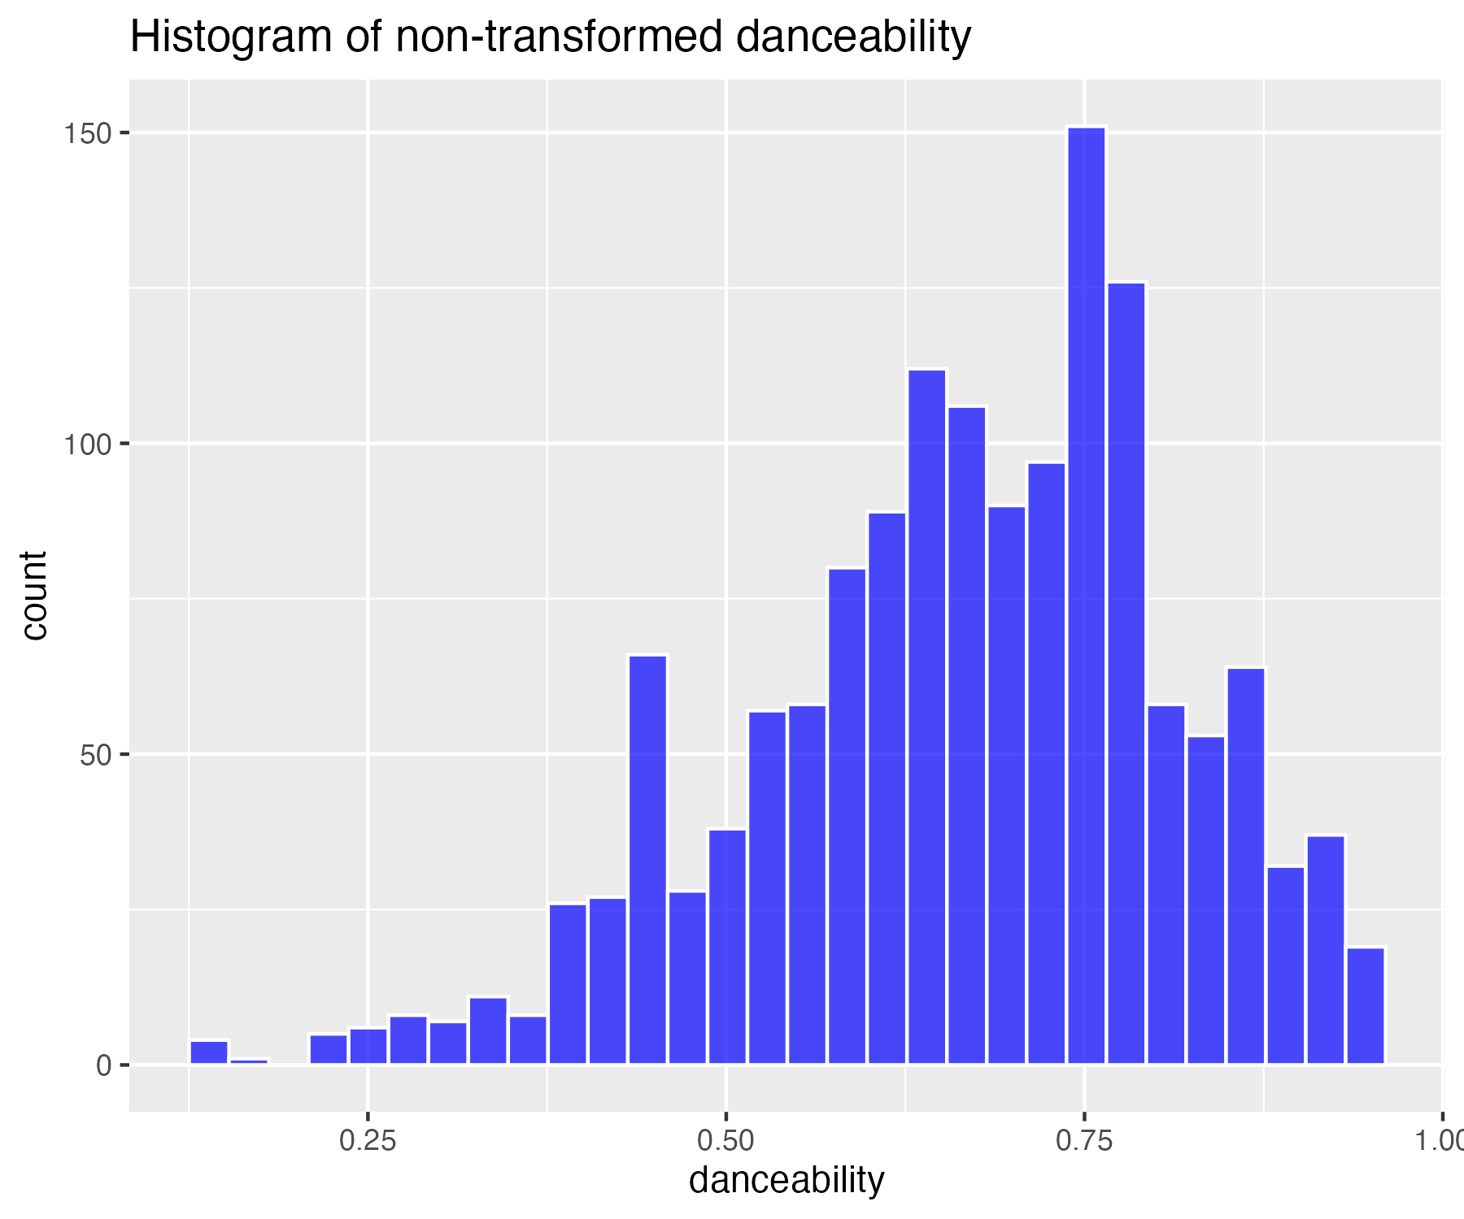

## Square-root transform of danceability (for moderate skew)

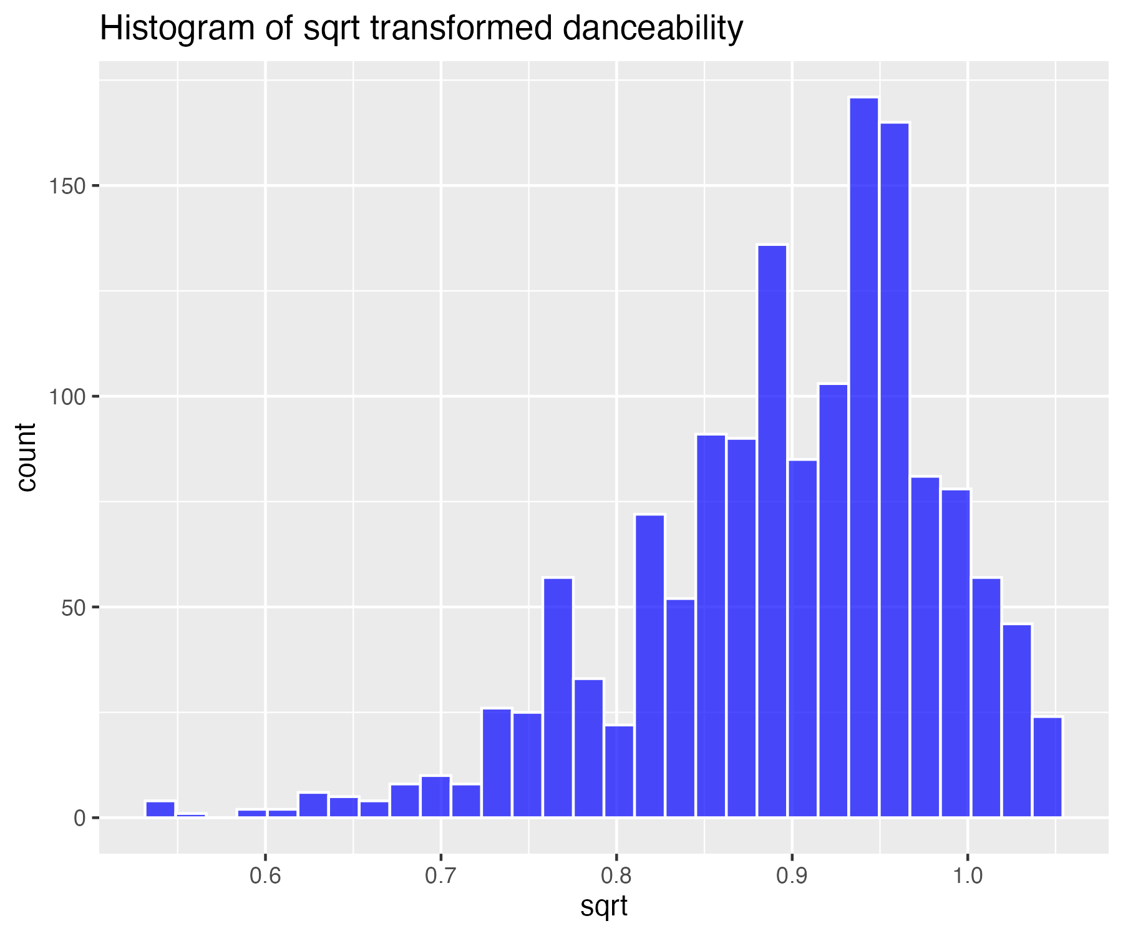

## Log base 10 transform of danceability (for high skew)

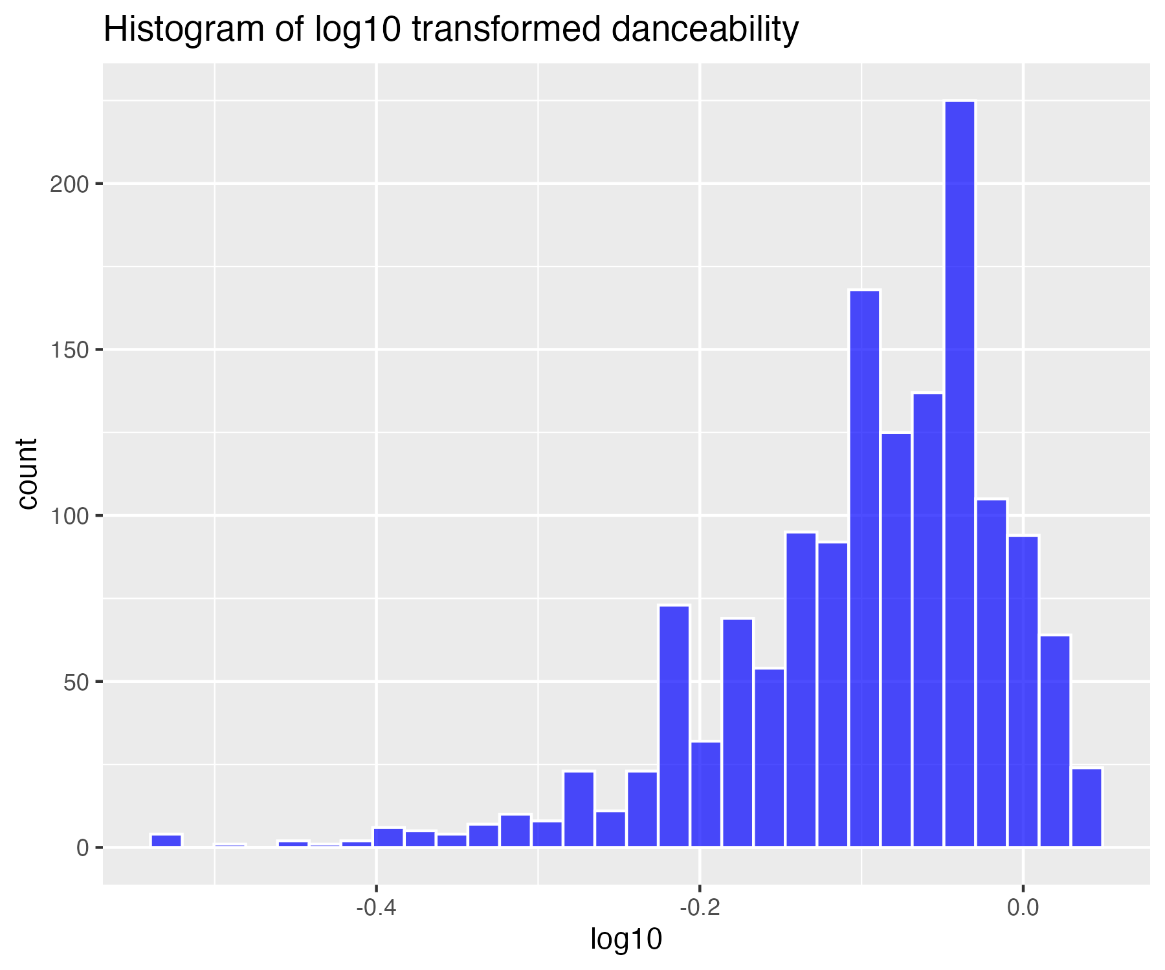

## Natural log transform of danceability (for higher skew)

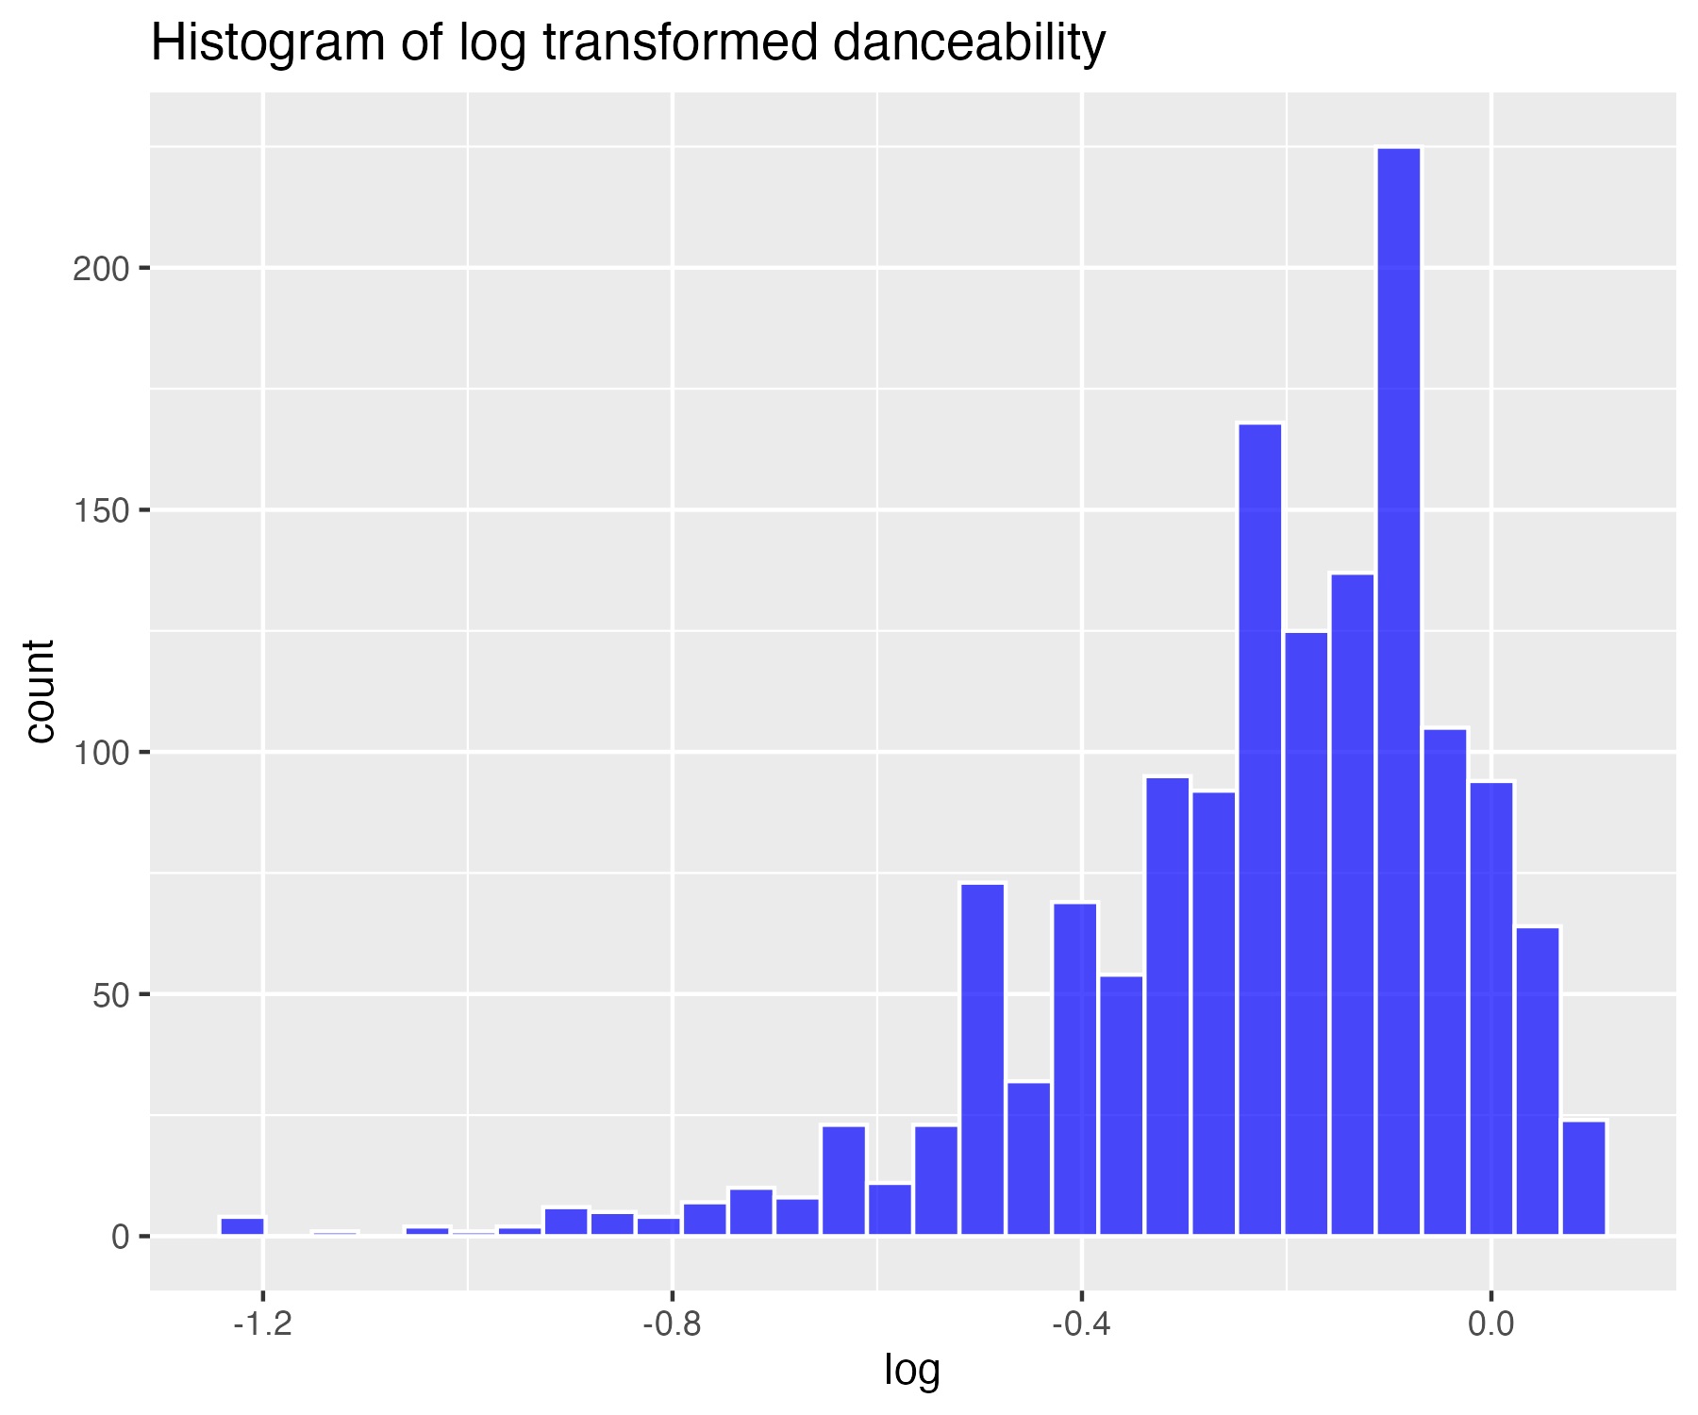

## Inverse transform of danceability (for severe skew)

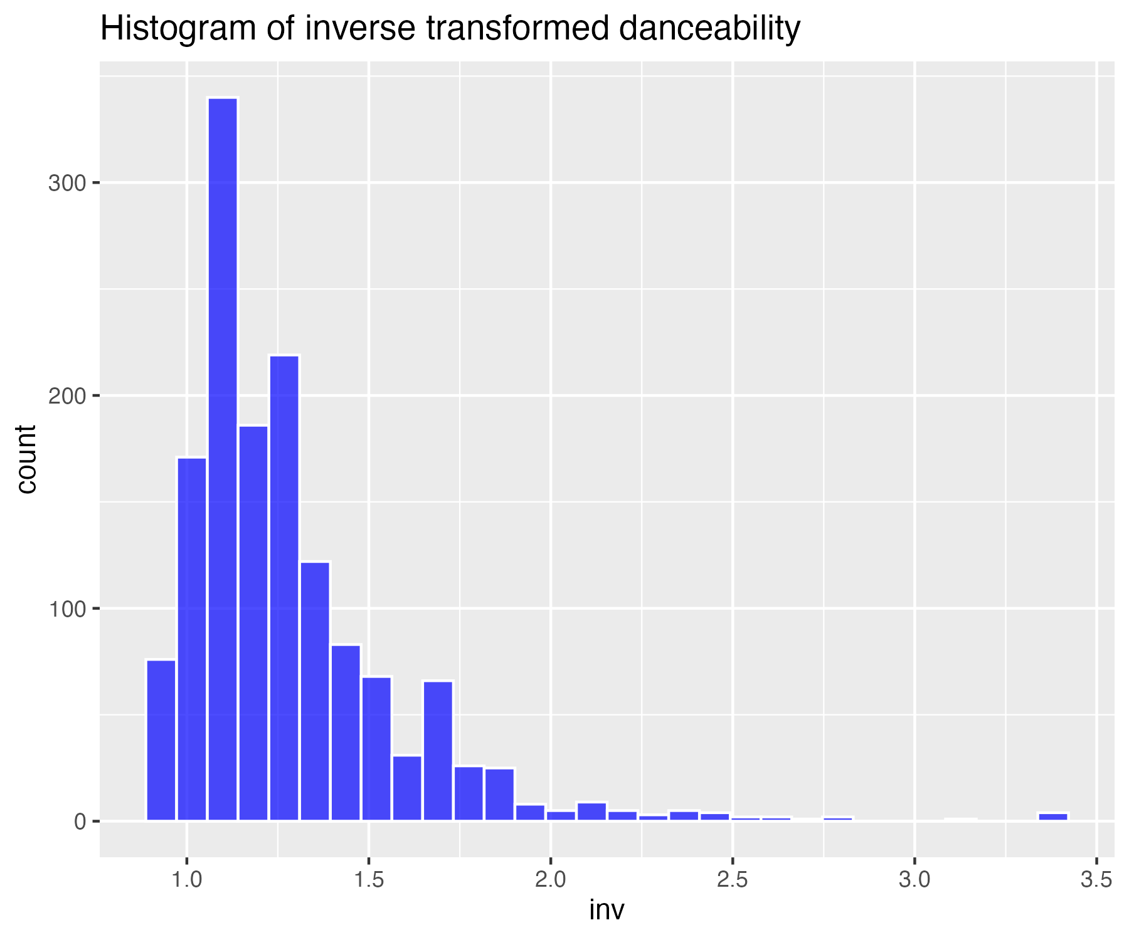

## Histogram of non-transformed energy

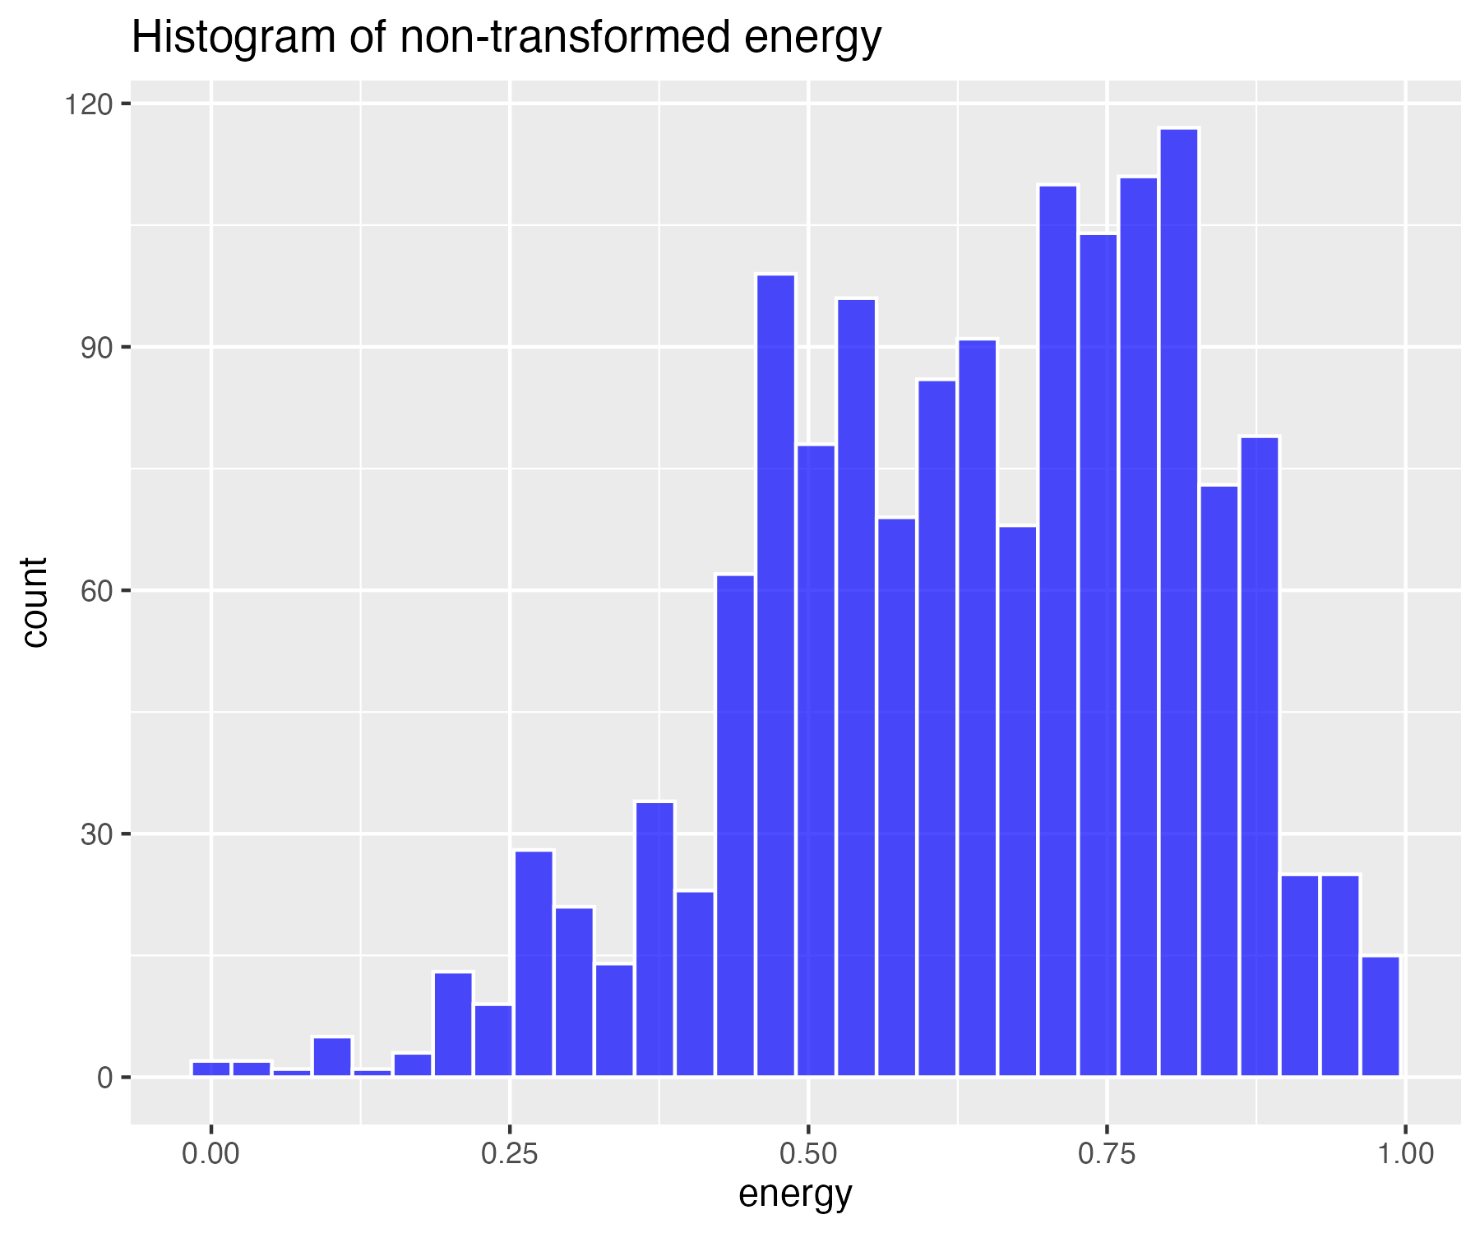

## Square-root transform of energy (for moderate skew)

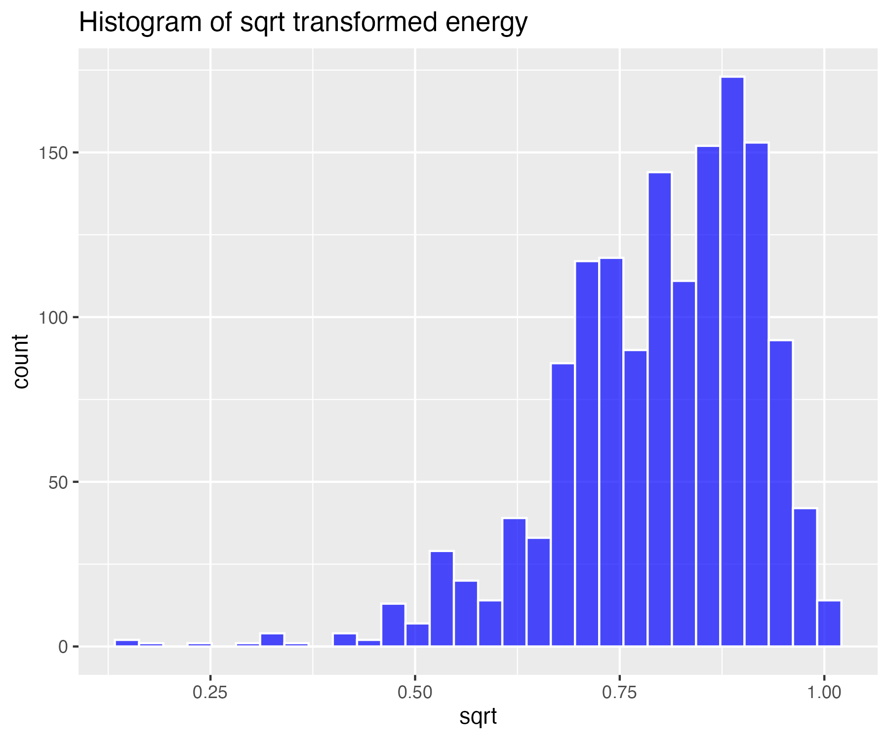

## Log base 10 transform of energy (for high skew)

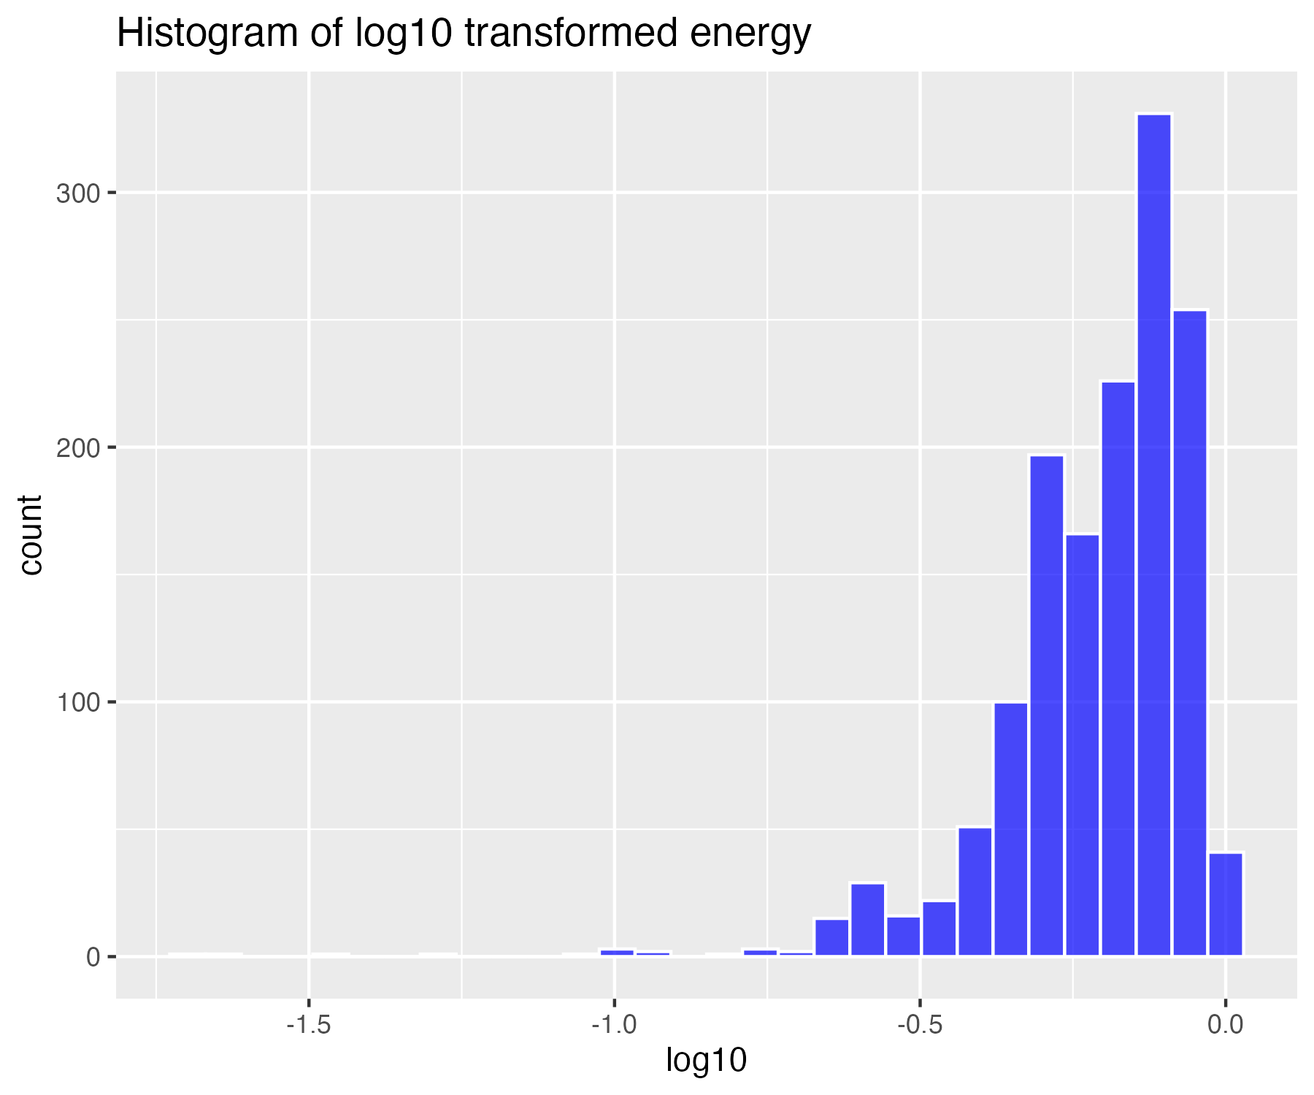

## Natural log transform of energy (for higher skew)

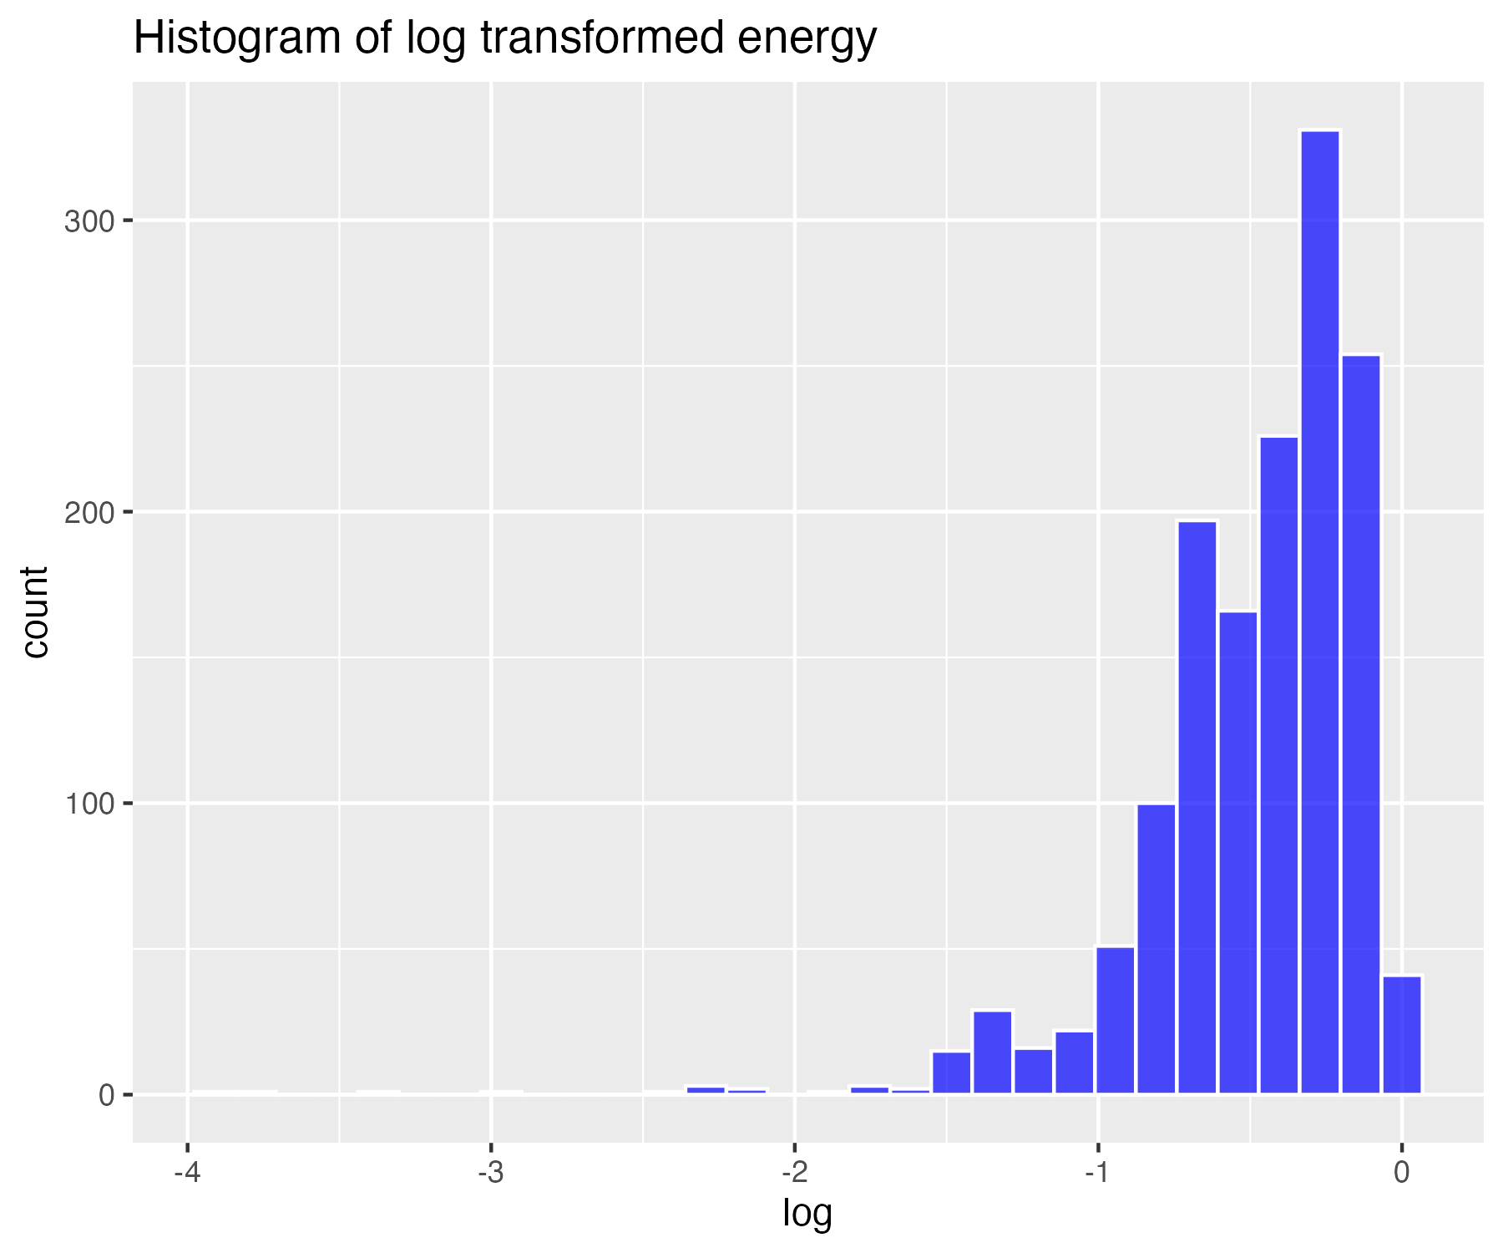

## Inverse transform of energy (for severe skew)

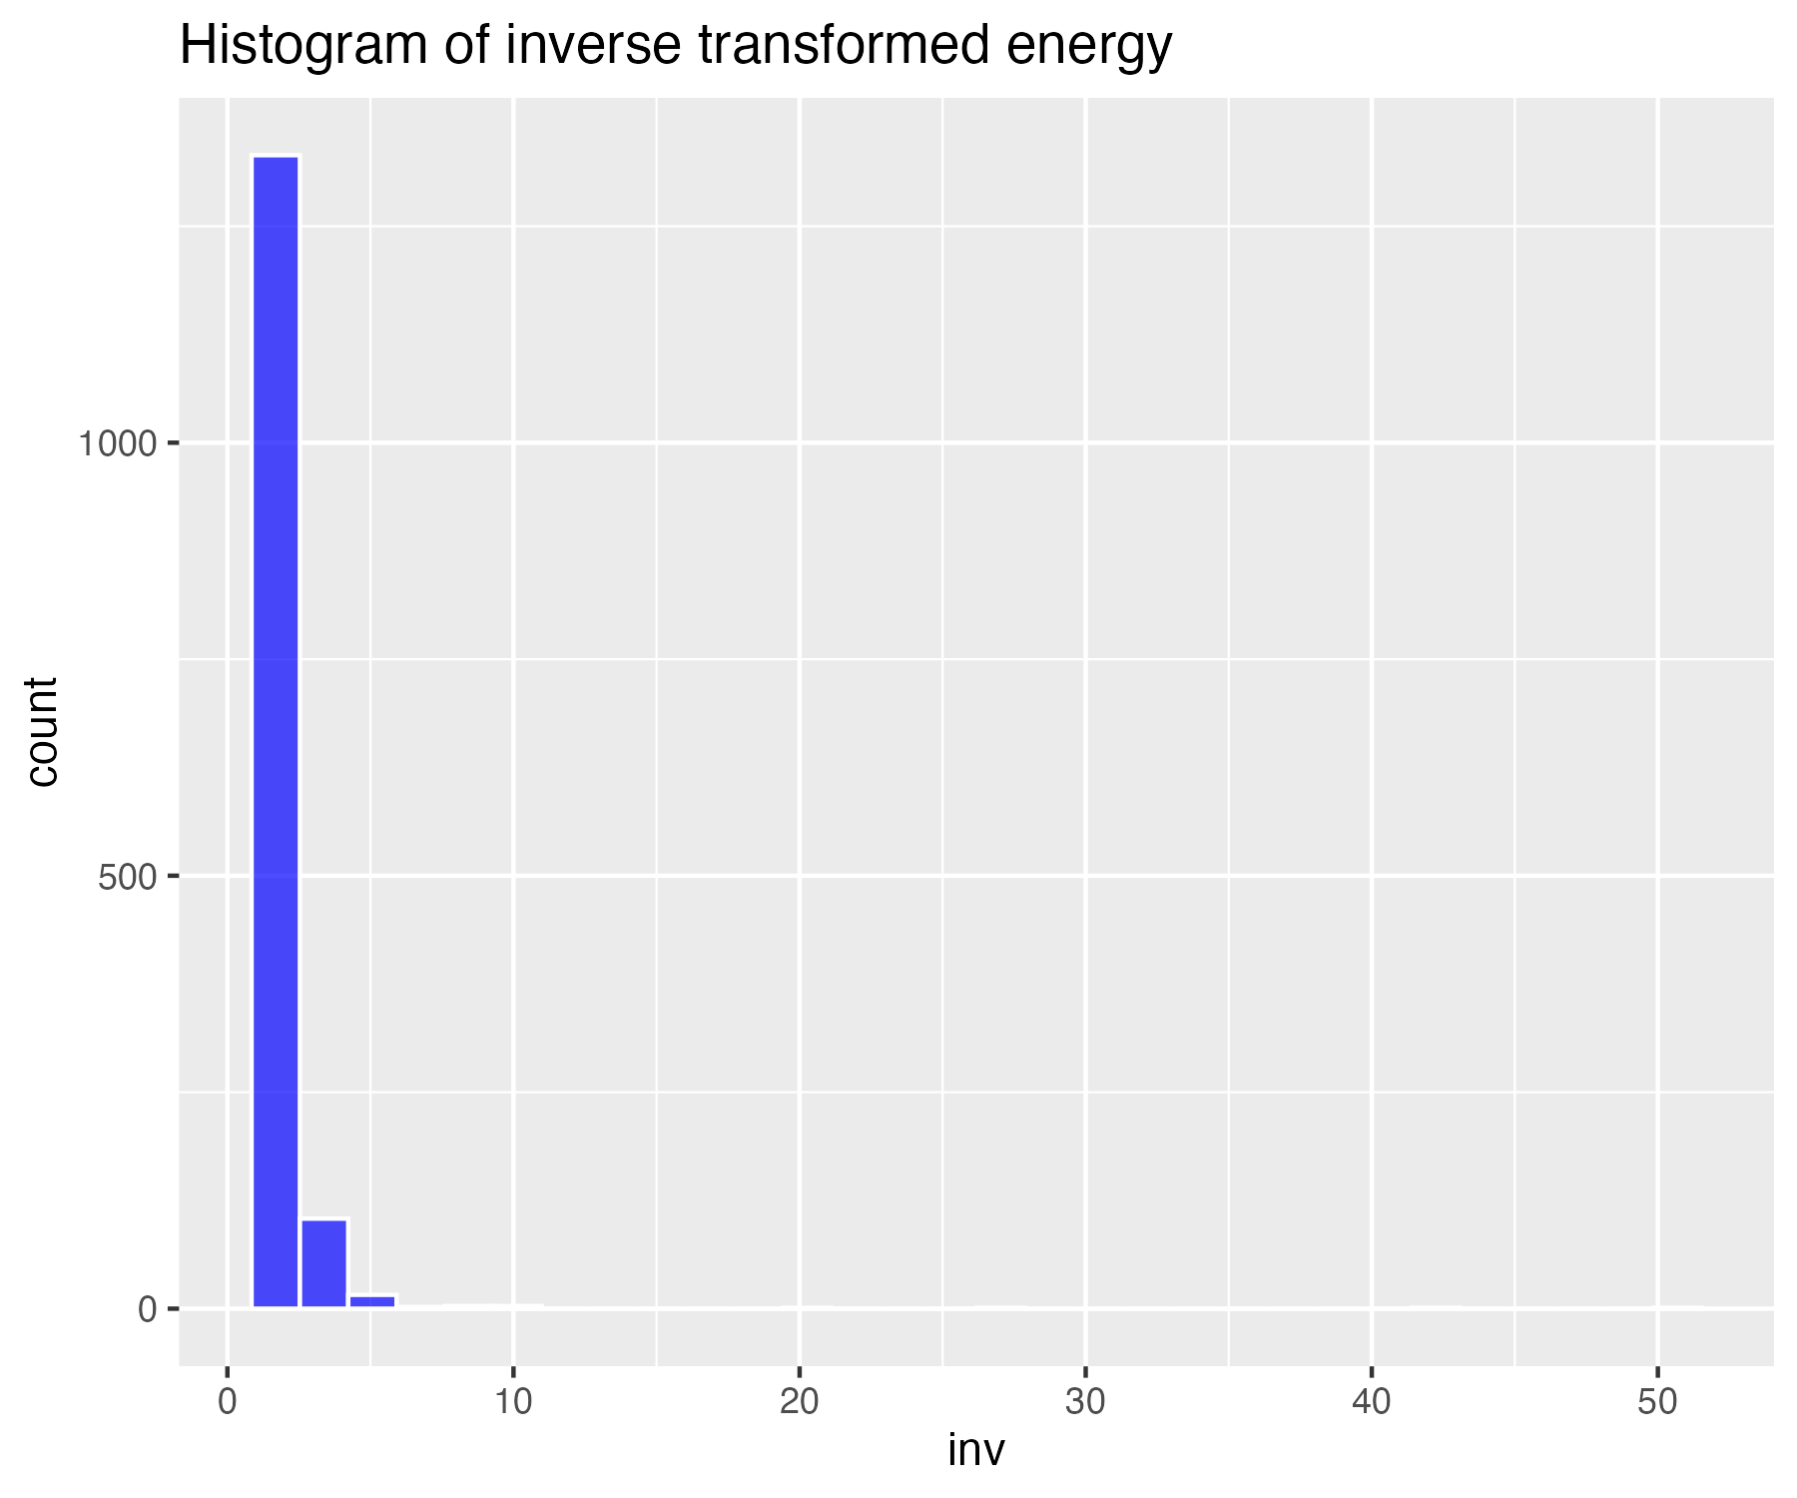

## Histogram of non-transformed loudness

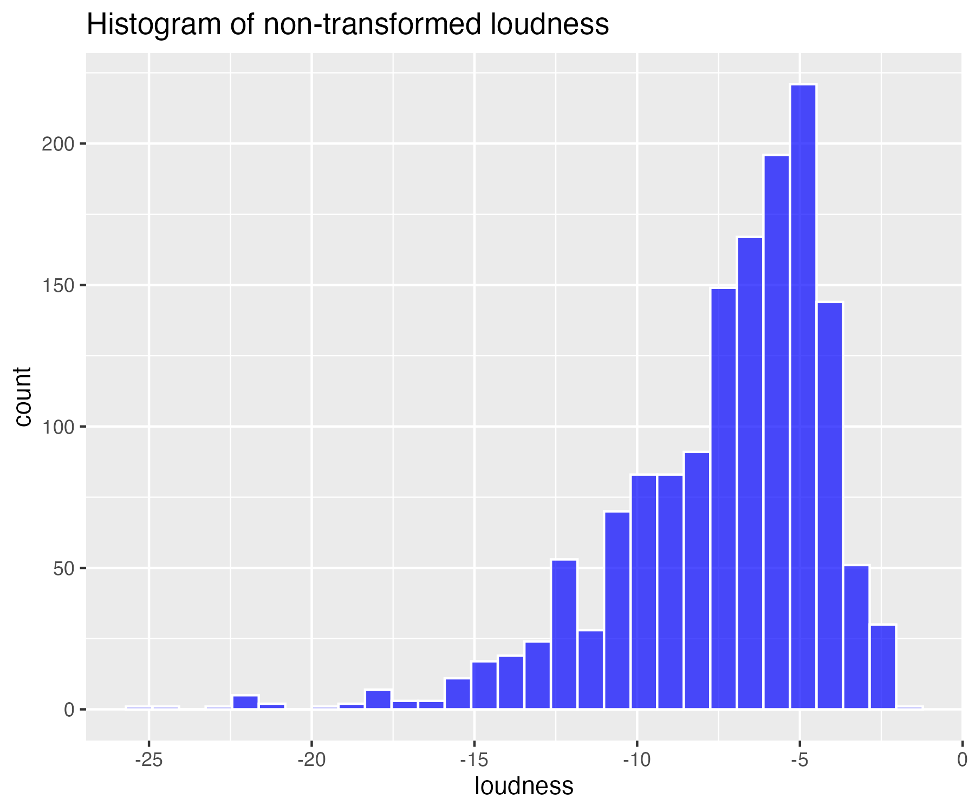

## Square-root transform of loudness (for moderate skew)

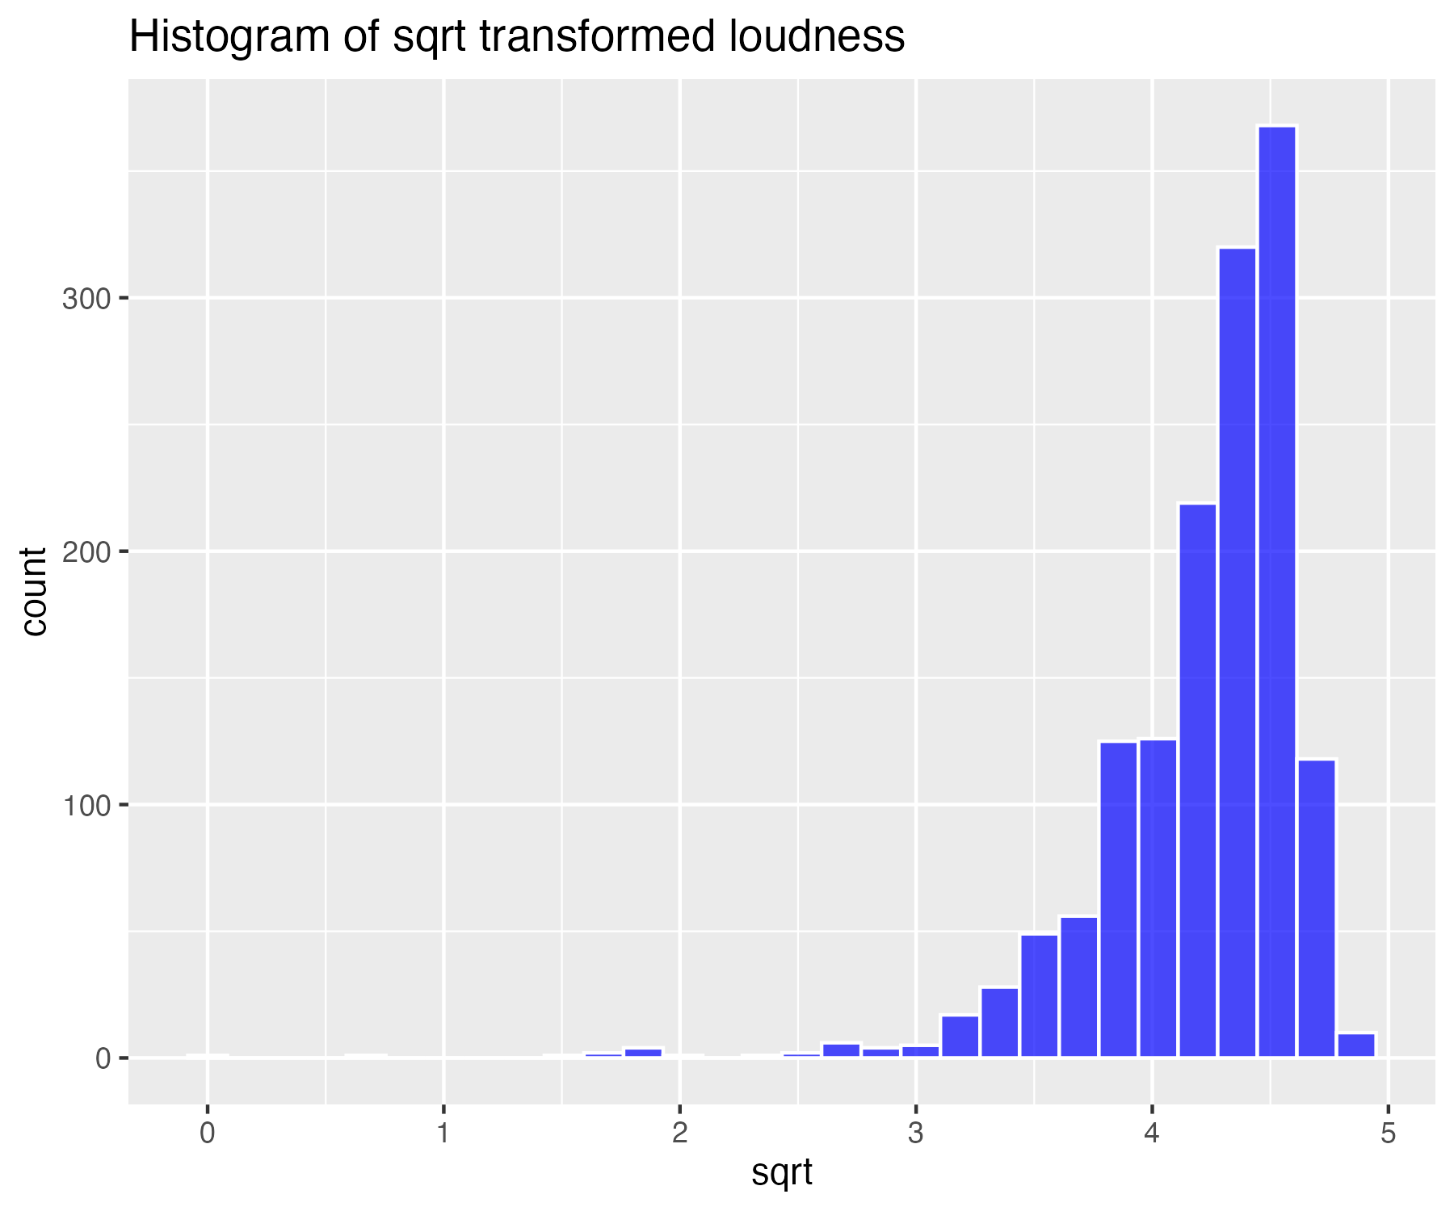

## Log base 10 transform of loudness (for high skew)

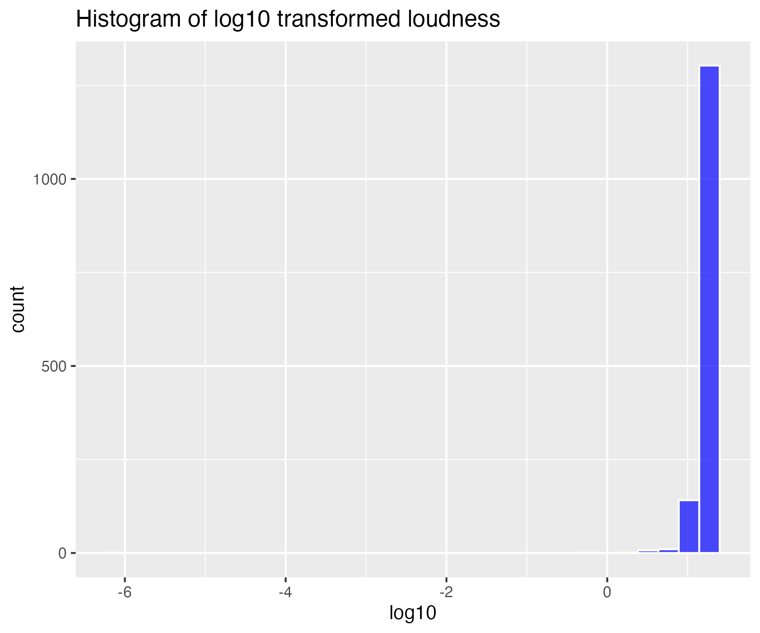

## Natural log transform of loudness (for higher skew)

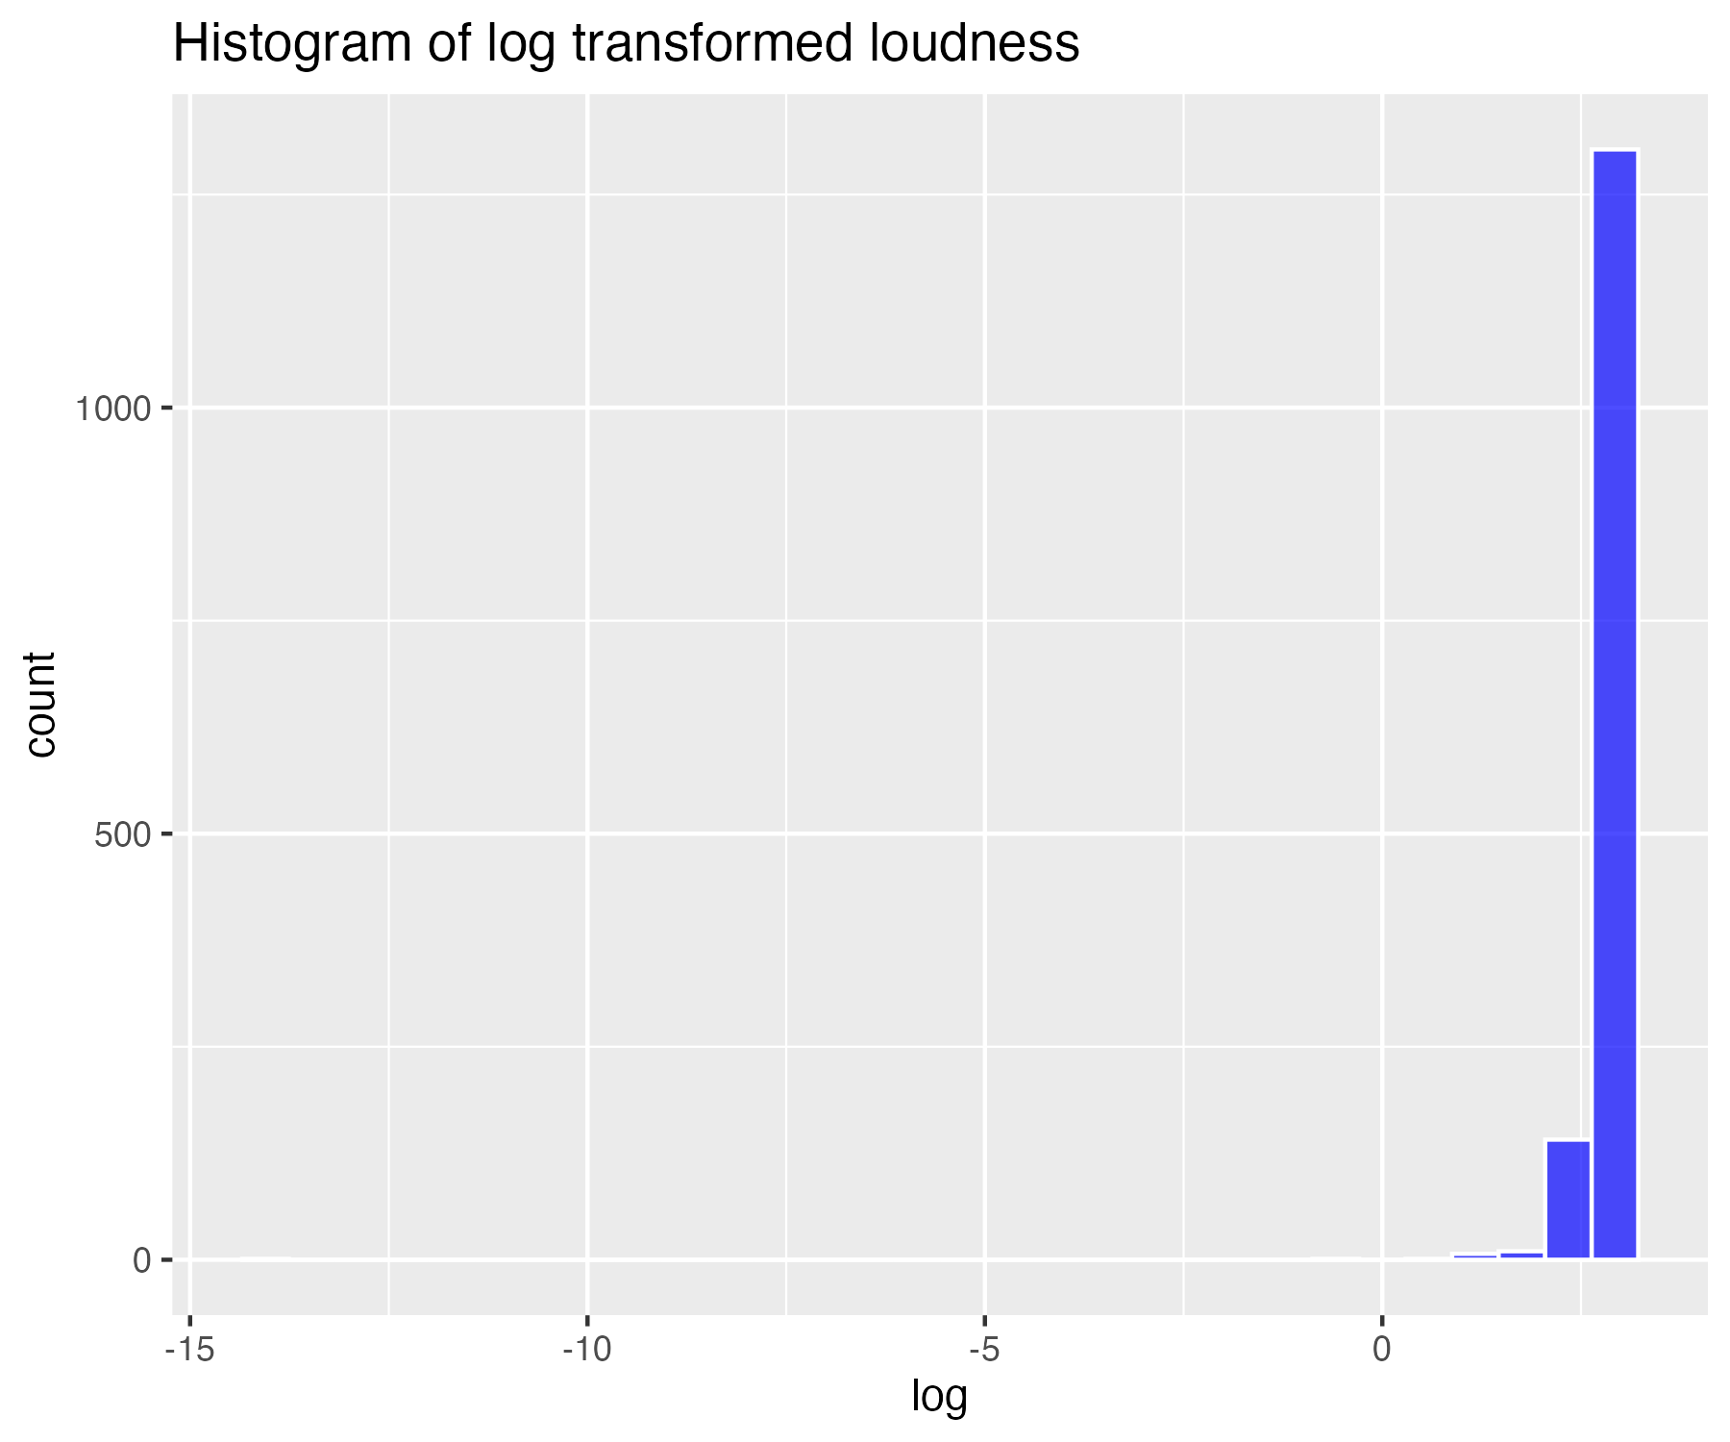

## Inverse transform of loudness (for severe skew)

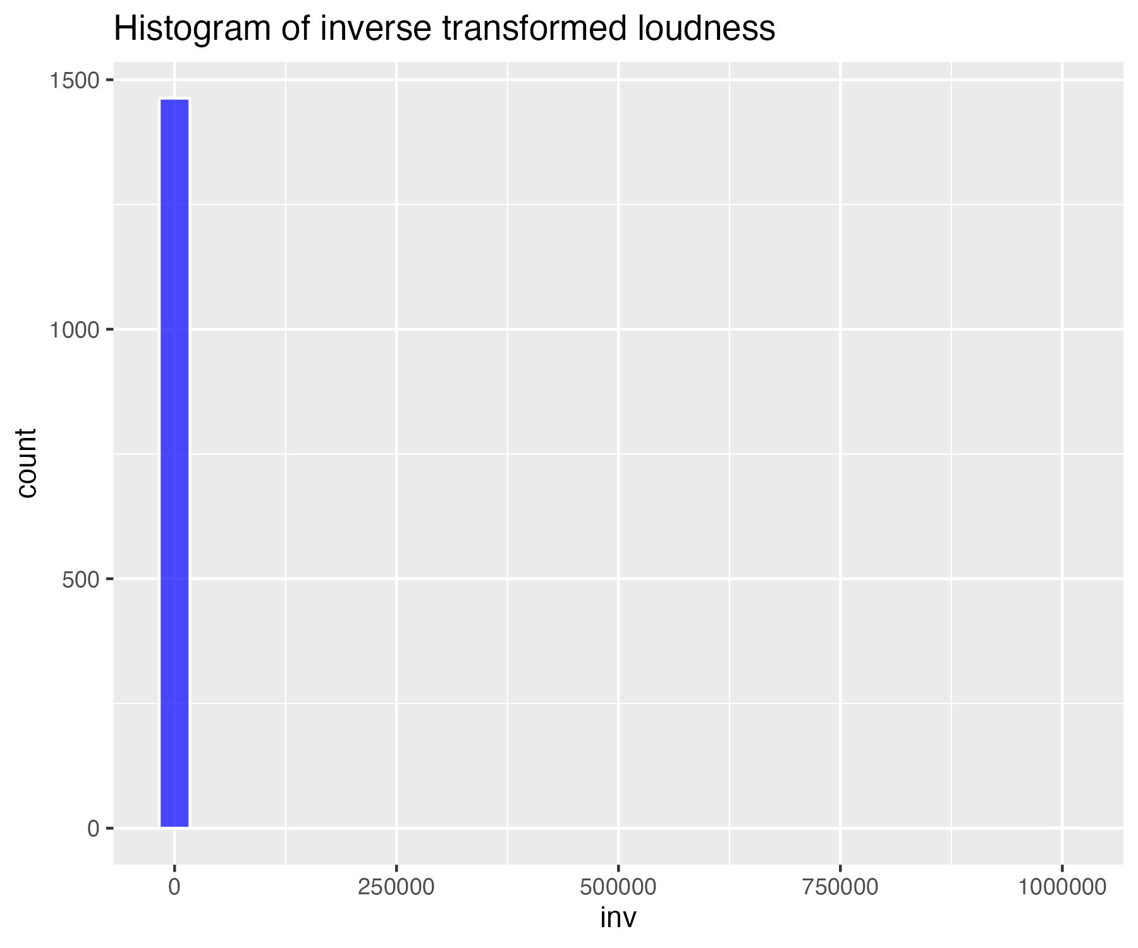

## Histogram of non-transformed speechiness

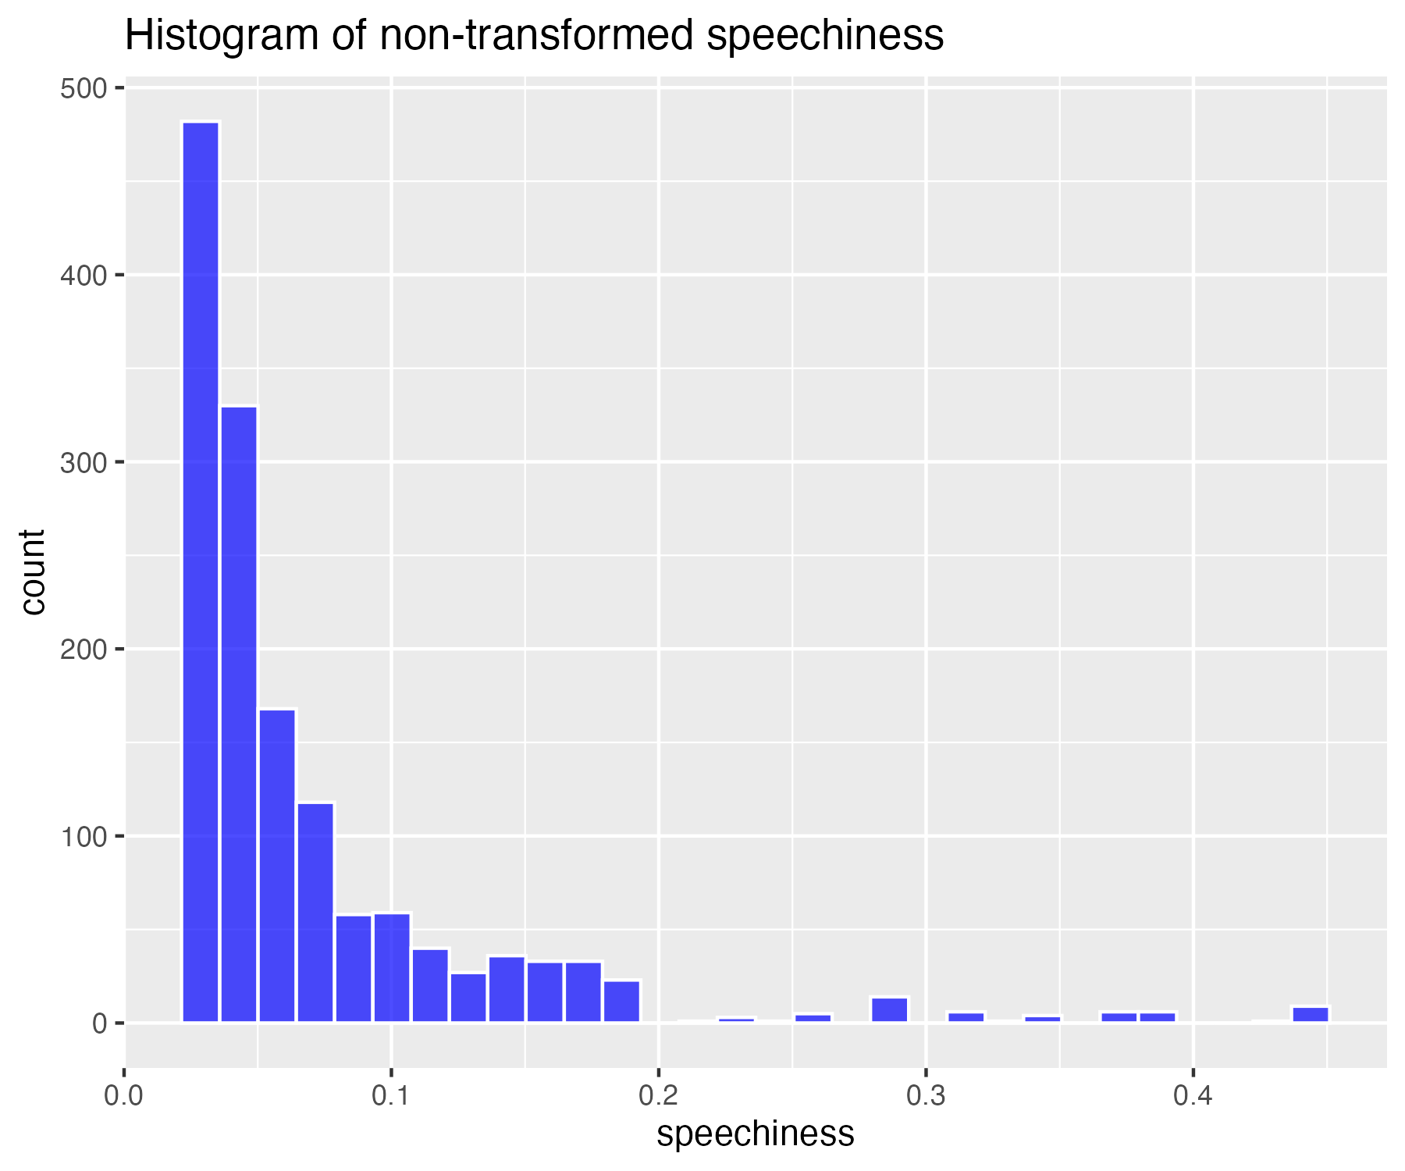

## Square-root transform of speechiness (for moderate skew)

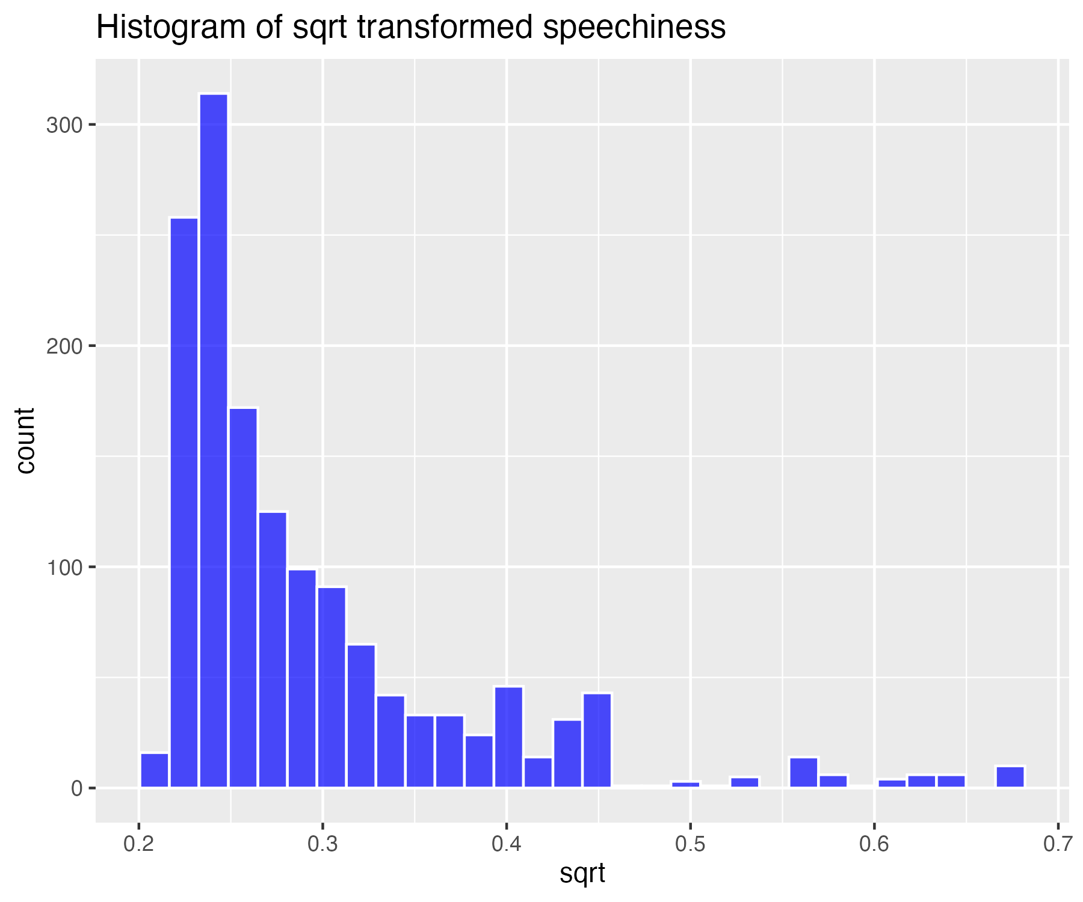

## Log base 10 transform of speechiness (for high skew)

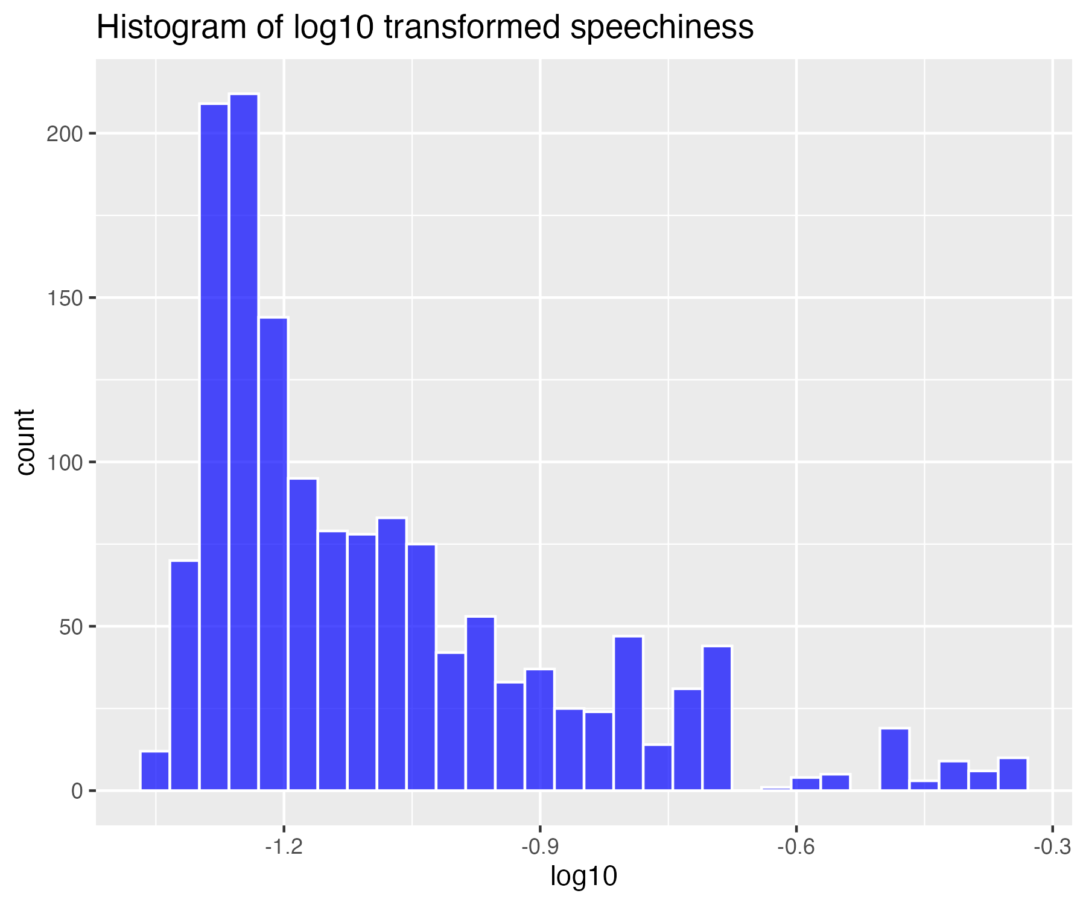

## Natural log transform of speechiness (for higher skew)

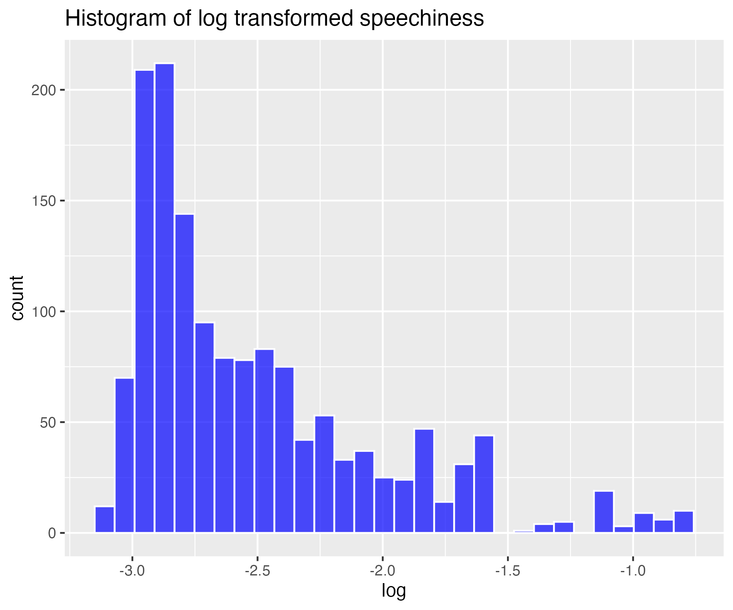

## Inverse transform of speechiness (for severe skew)

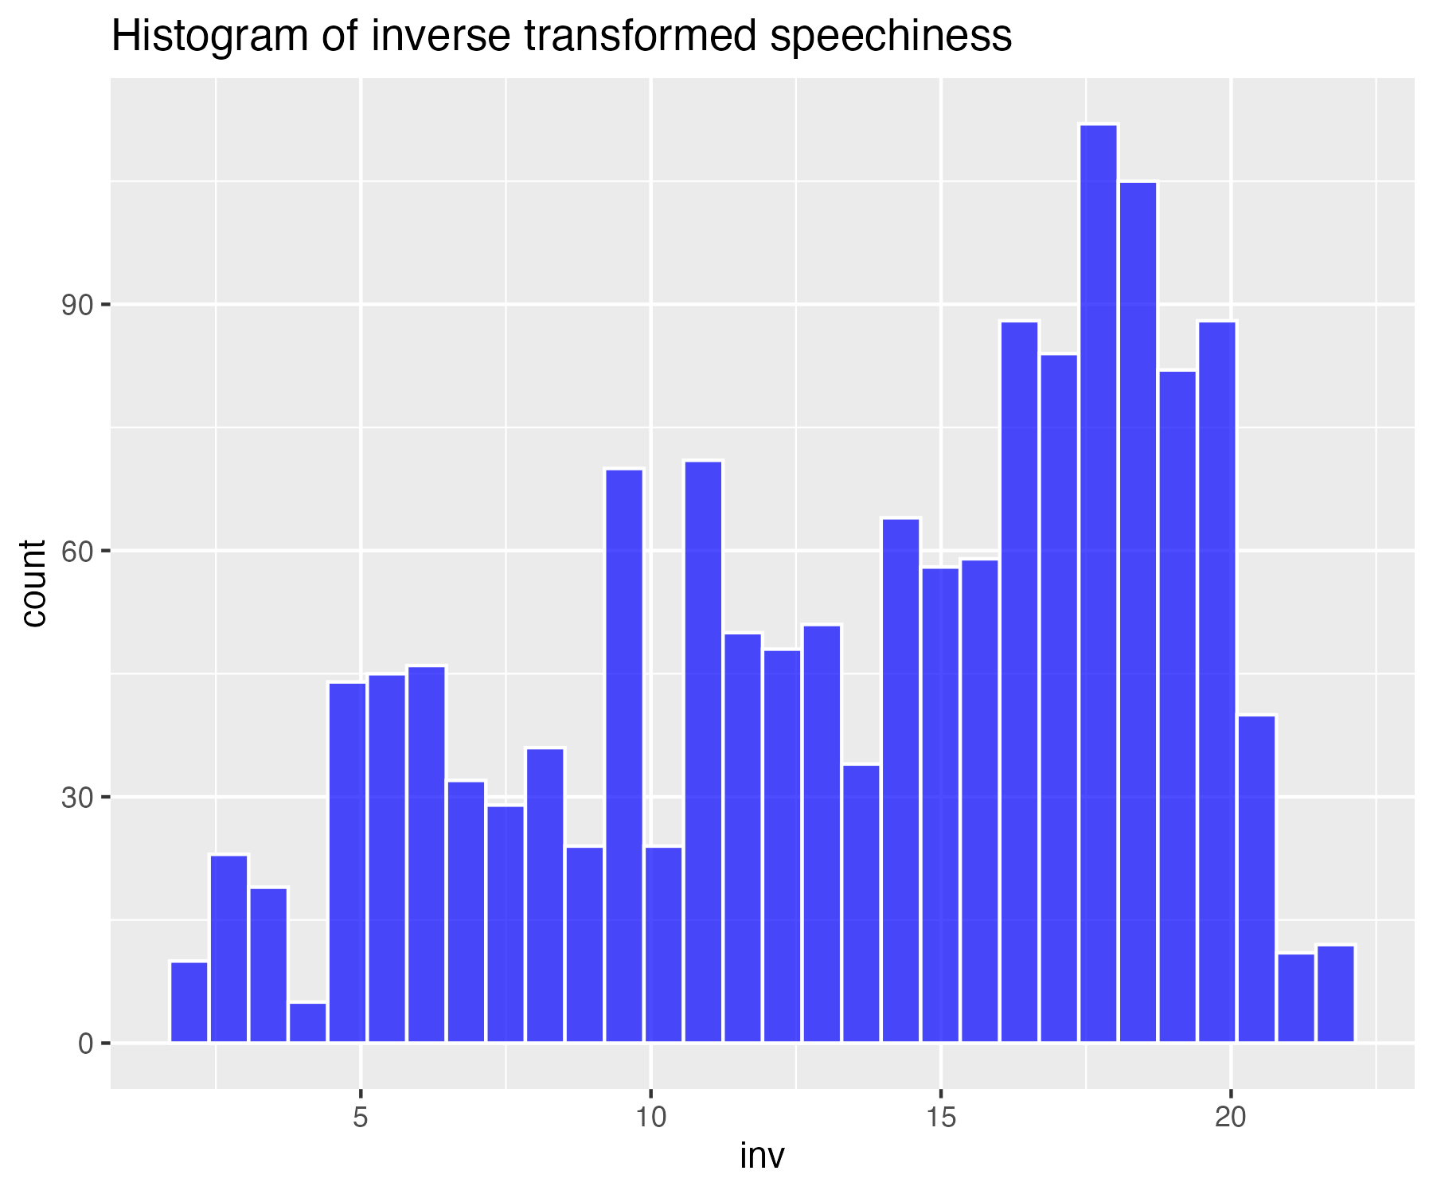

## Histogram of non-transformed acousticness

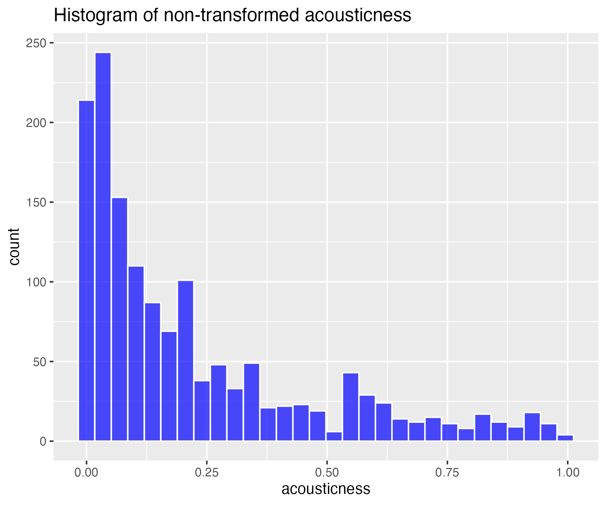

## Square-root transform of acousticness (for moderate skew)

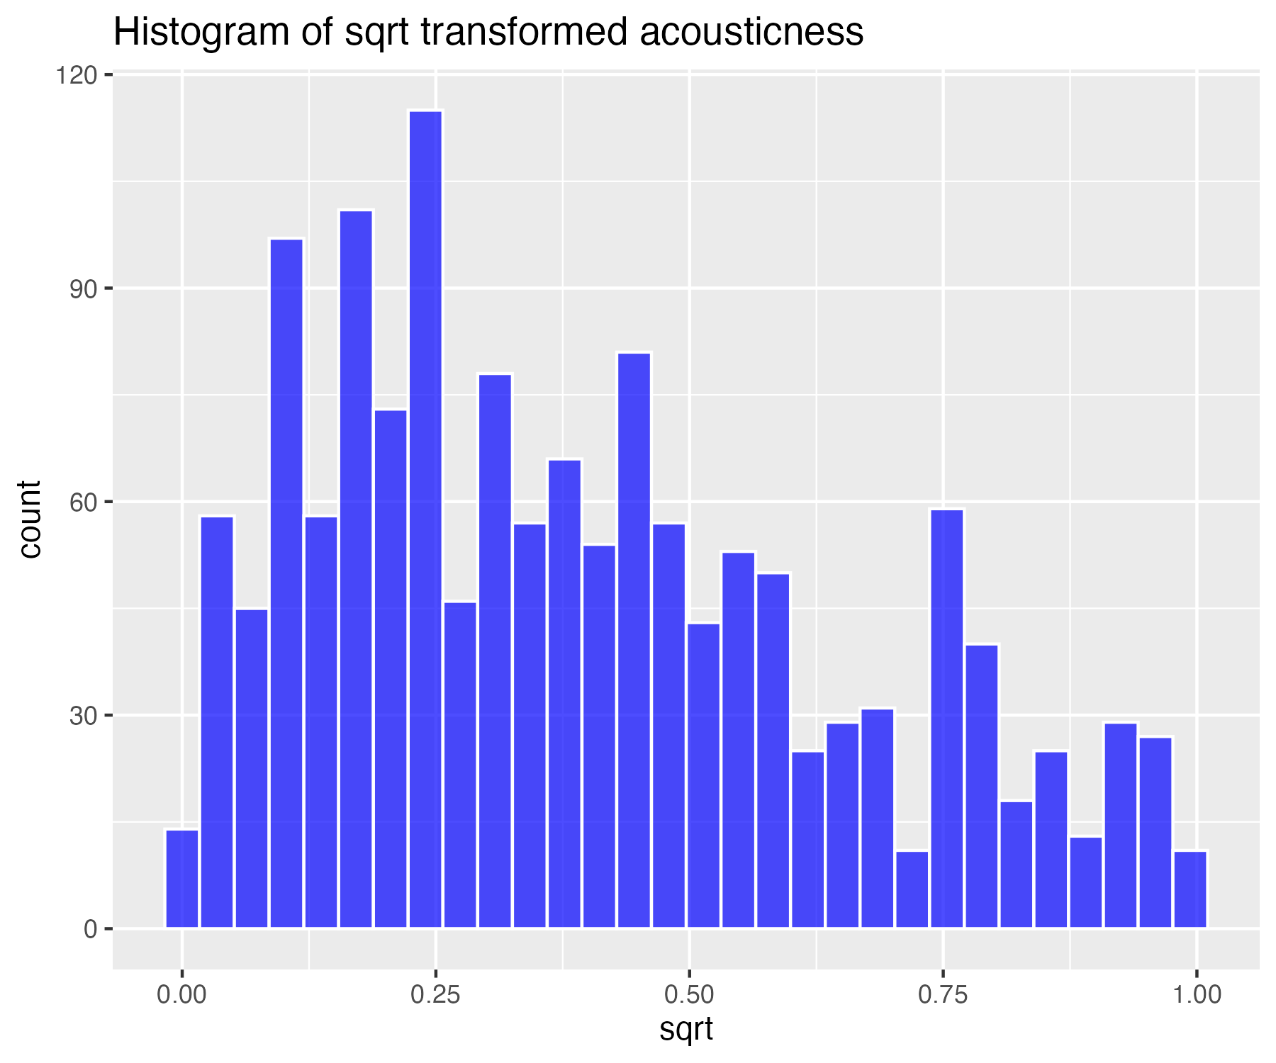

## Log base 10 transform of acousticness (for high skew)

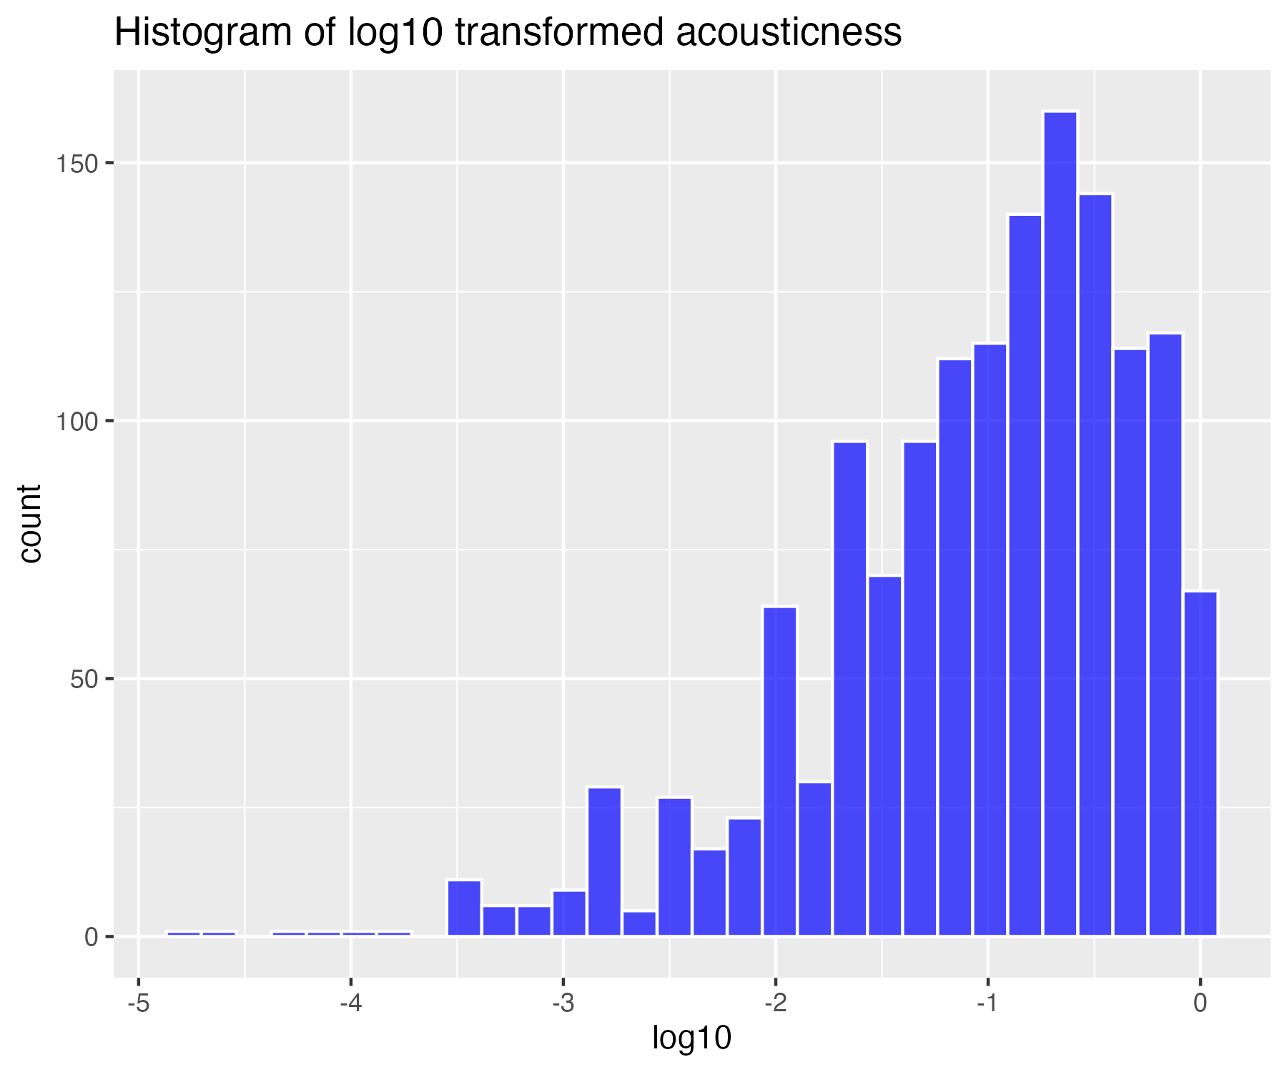

## Natural log transform of acousticness (for higher skew)

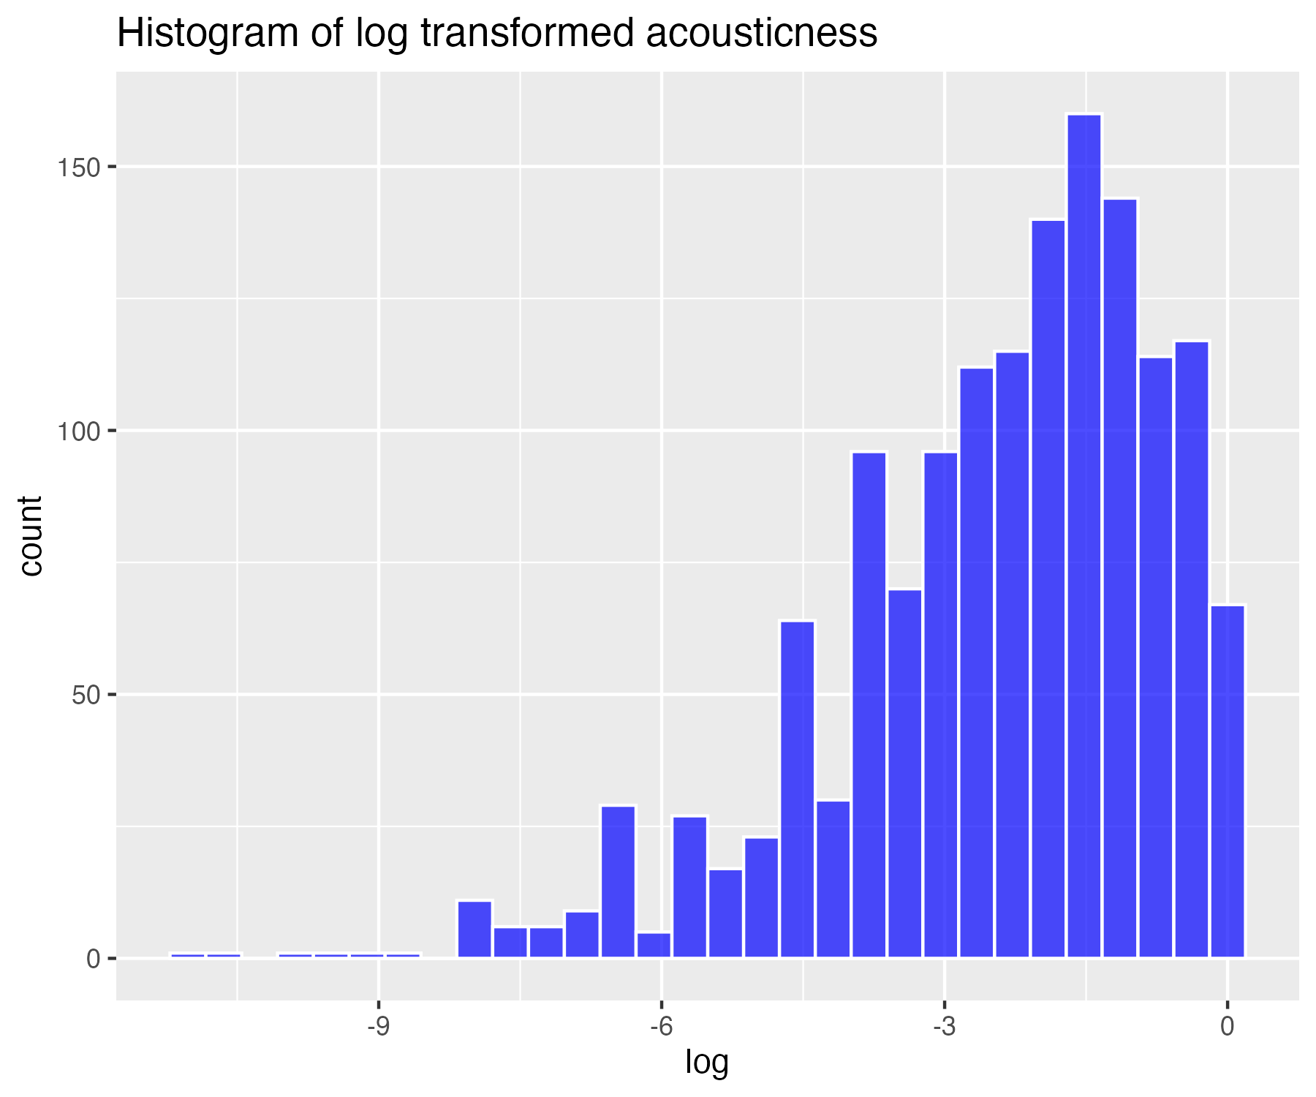

## Inverse transform of acousticness (for severe skew)

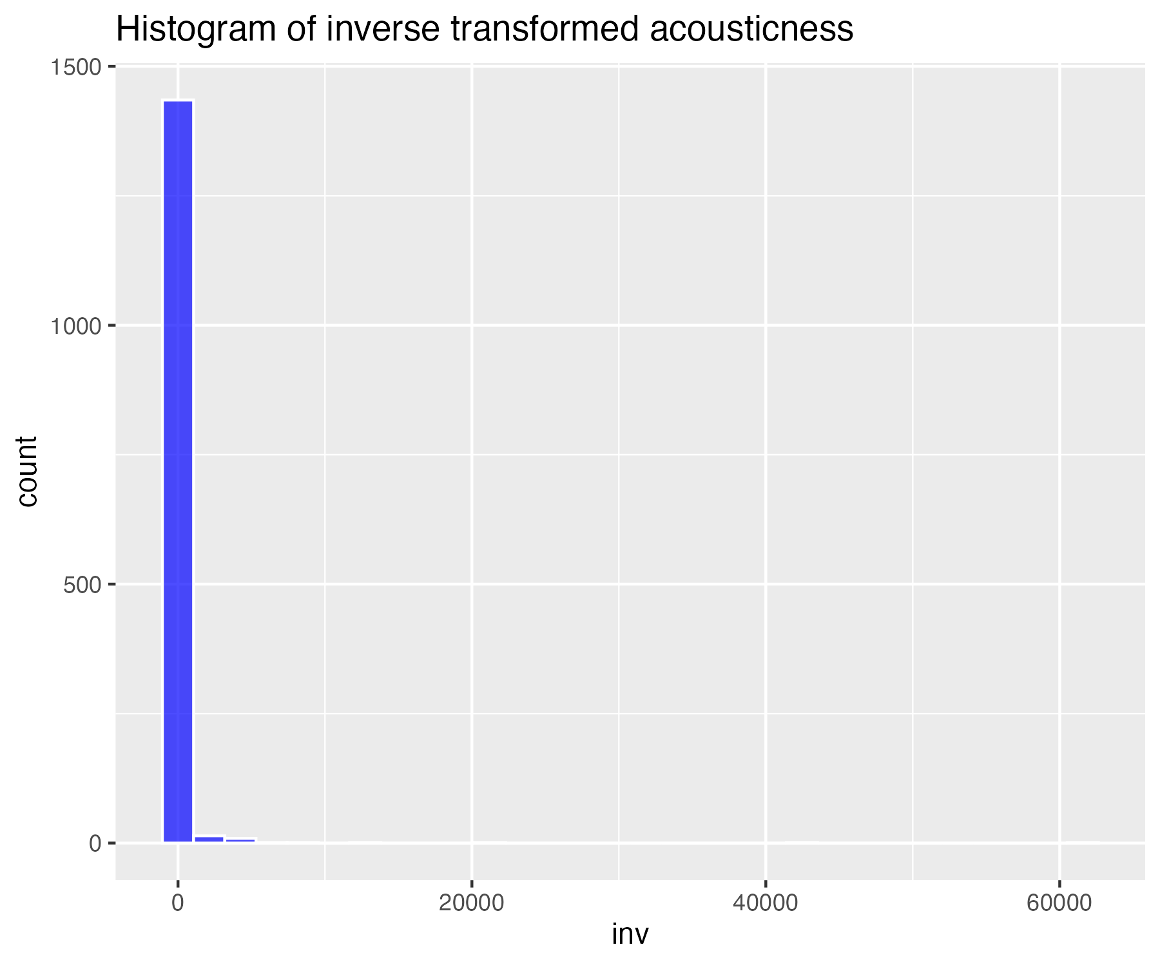

## Histogram of non-transformed instrumentalness

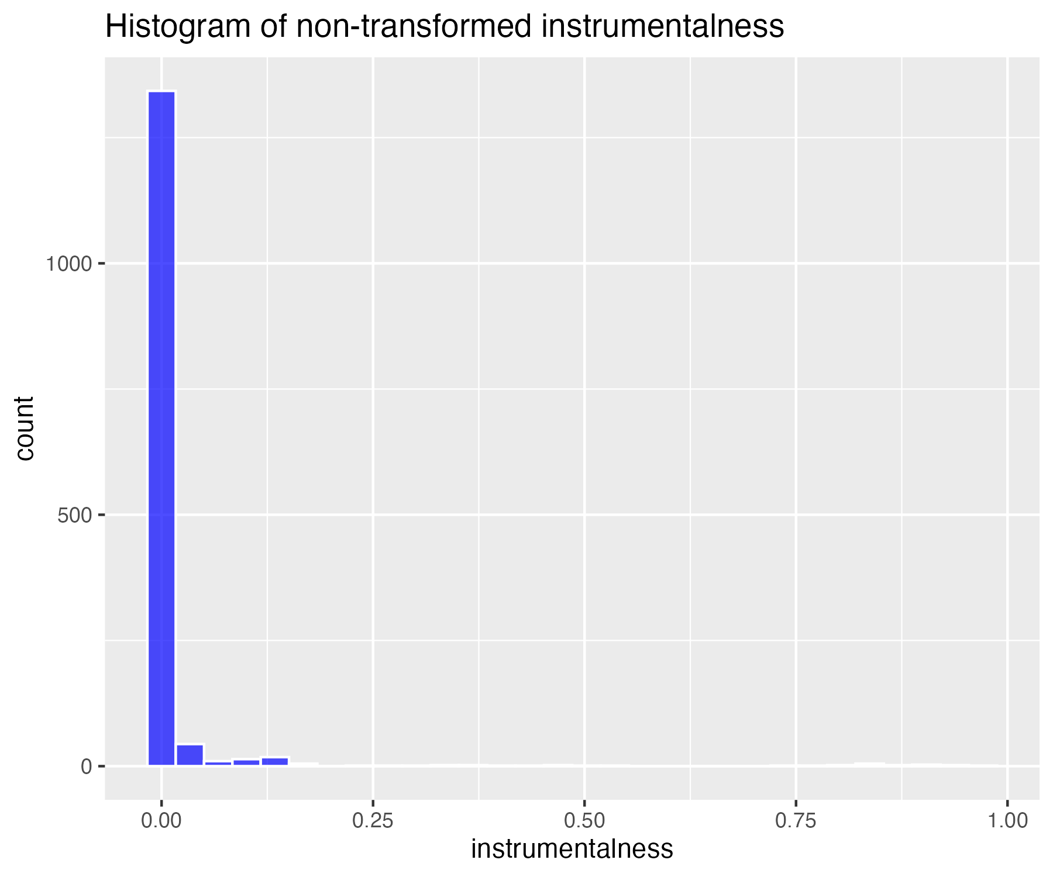

## Square-root transform of instrumentalness (for moderate skew)

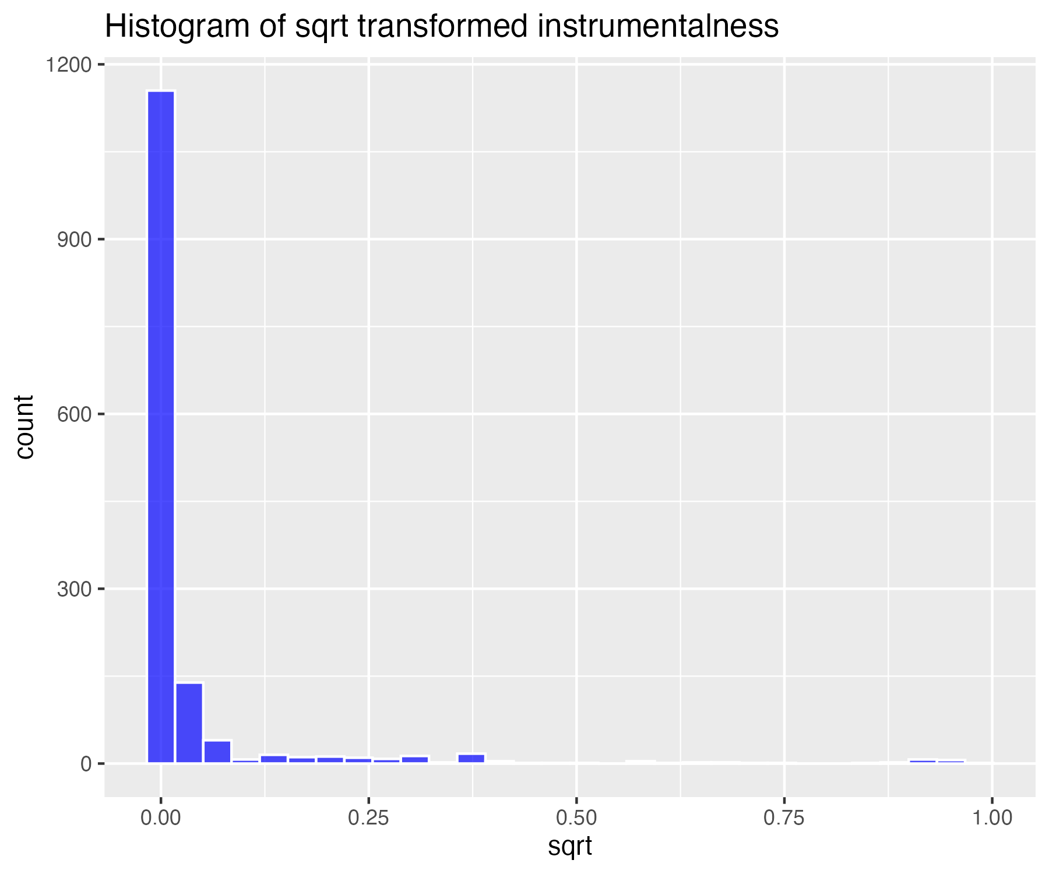

## Log base 10 transform of instrumentalness (for high skew)

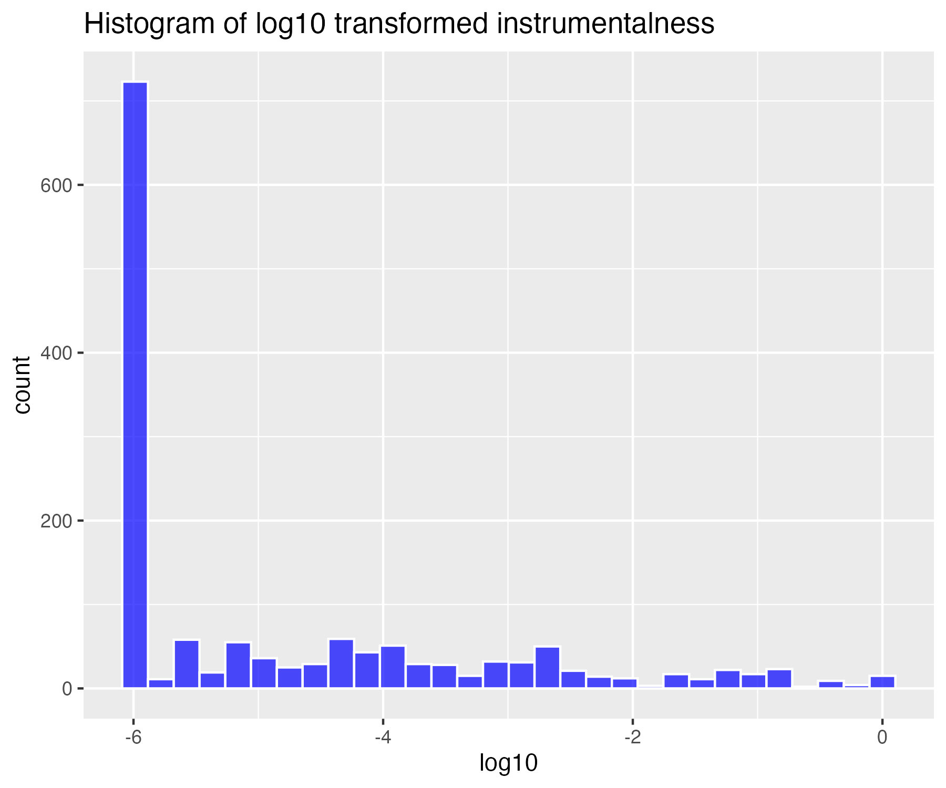

## Natural log transform of instrumentalness (for higher skew)

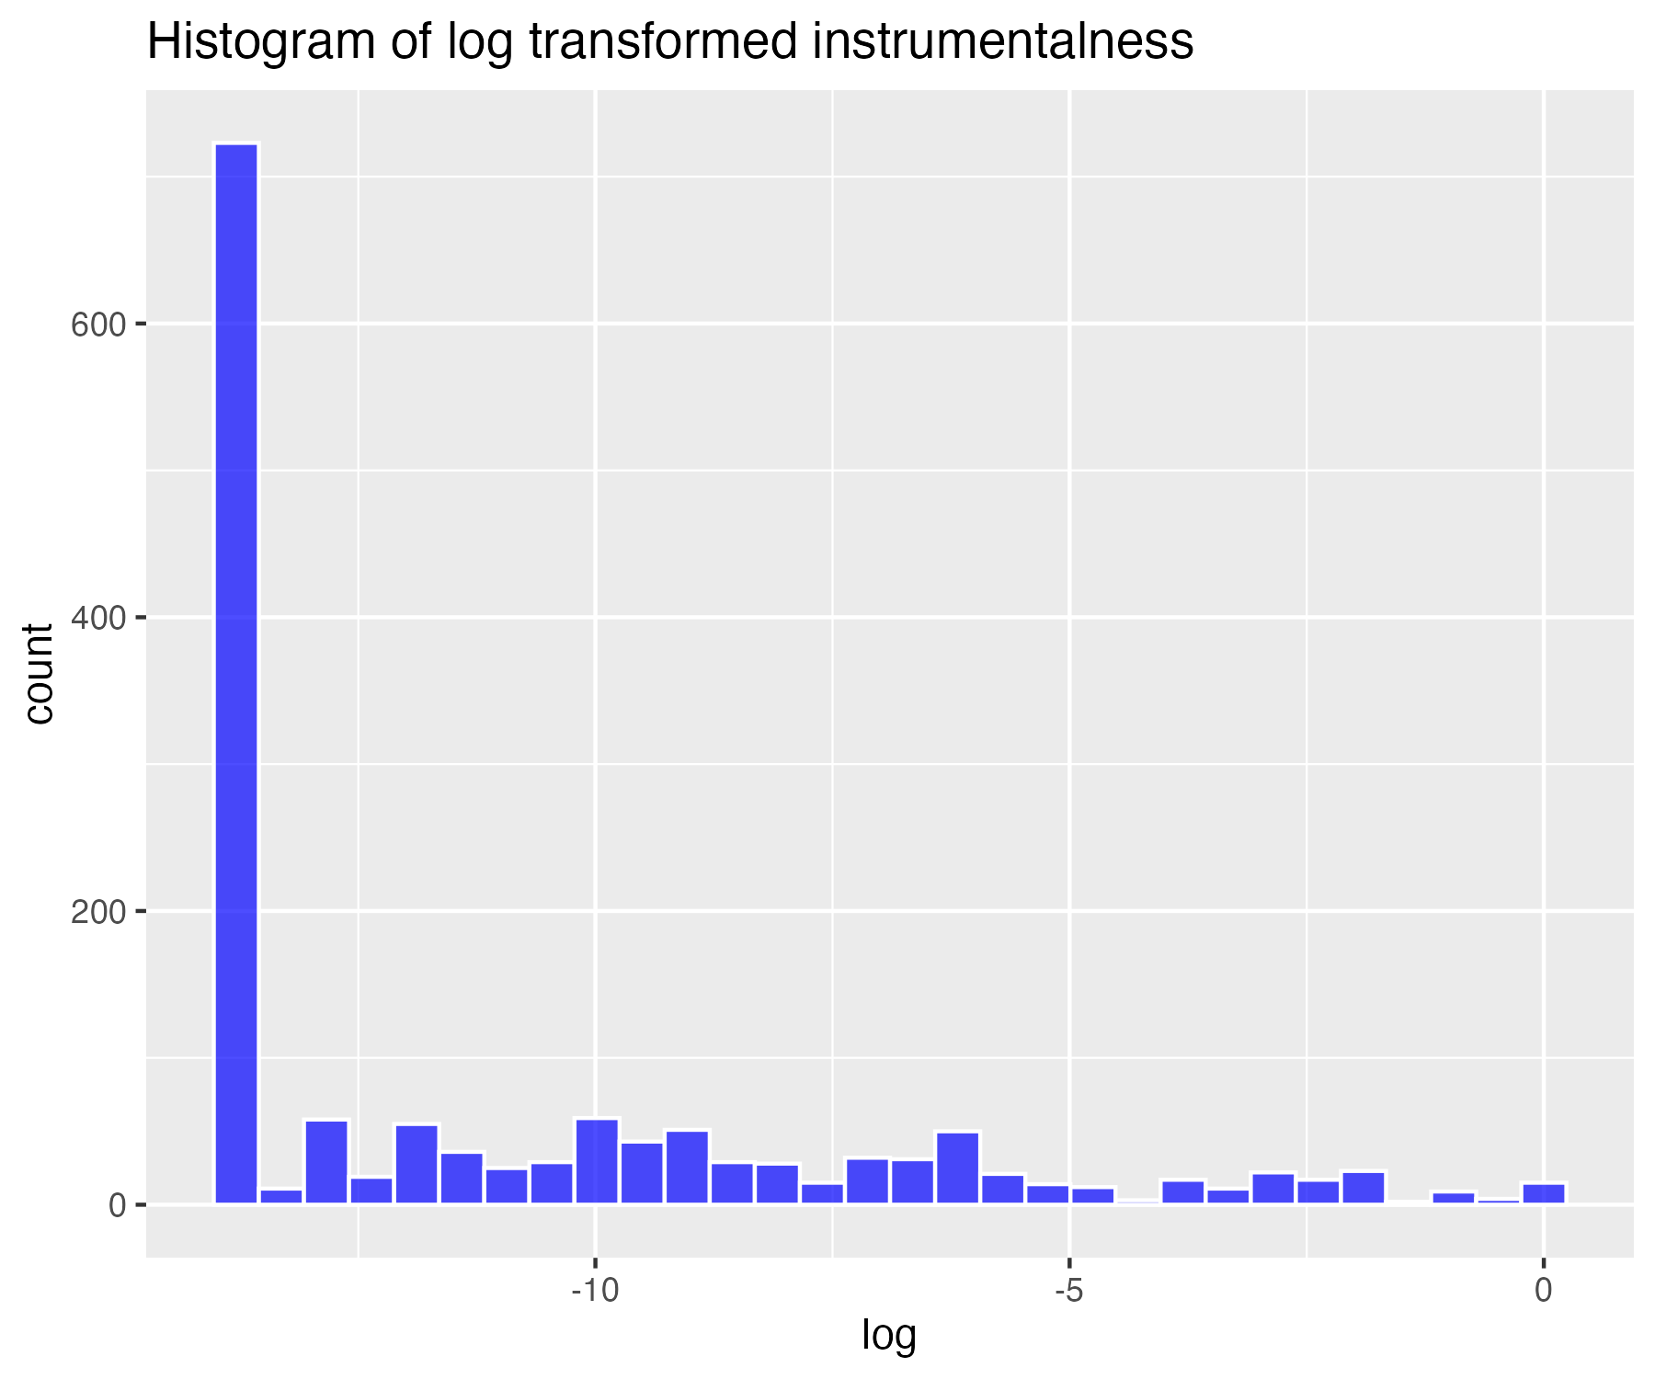

## Inverse transform of instrumentalness (for severe skew)

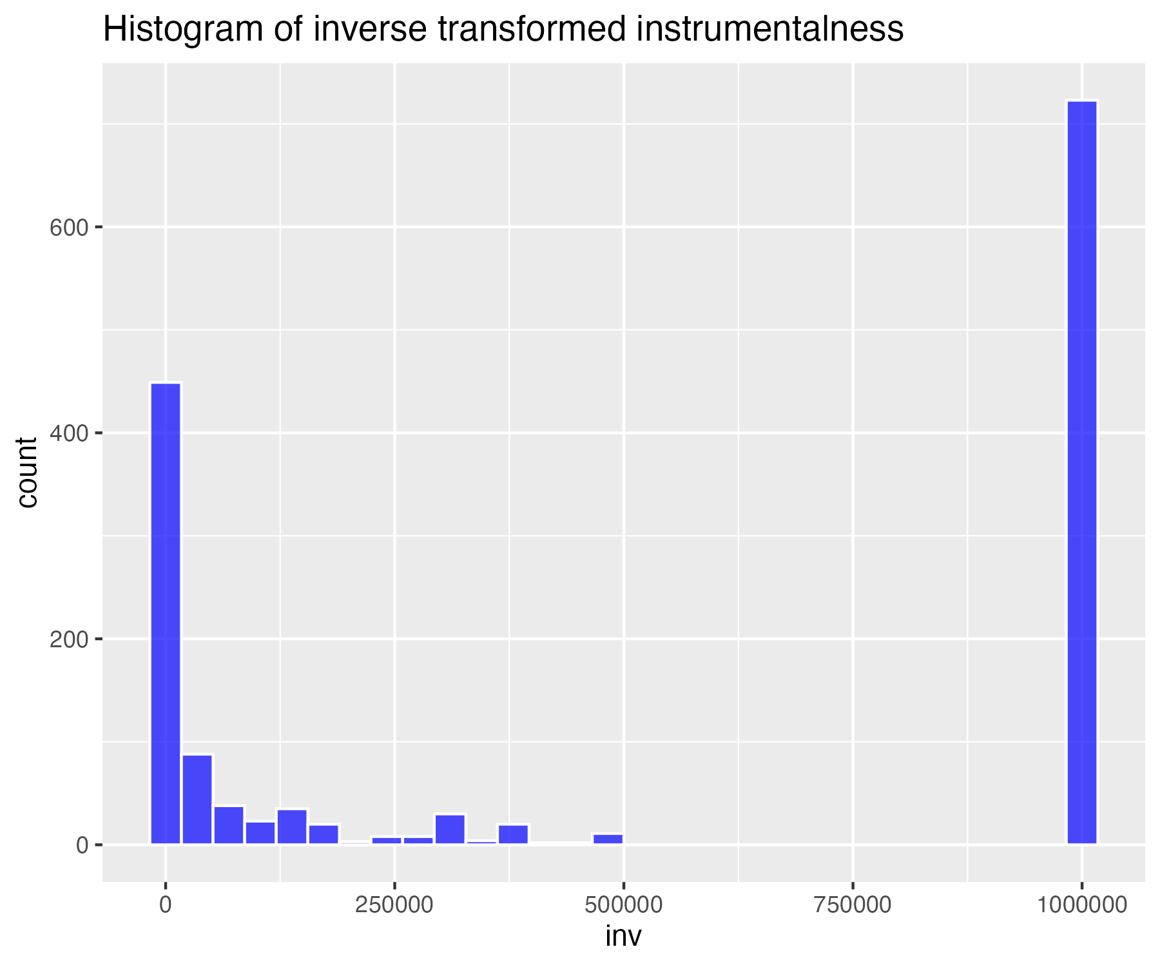

## Histogram of non-transformed liveness

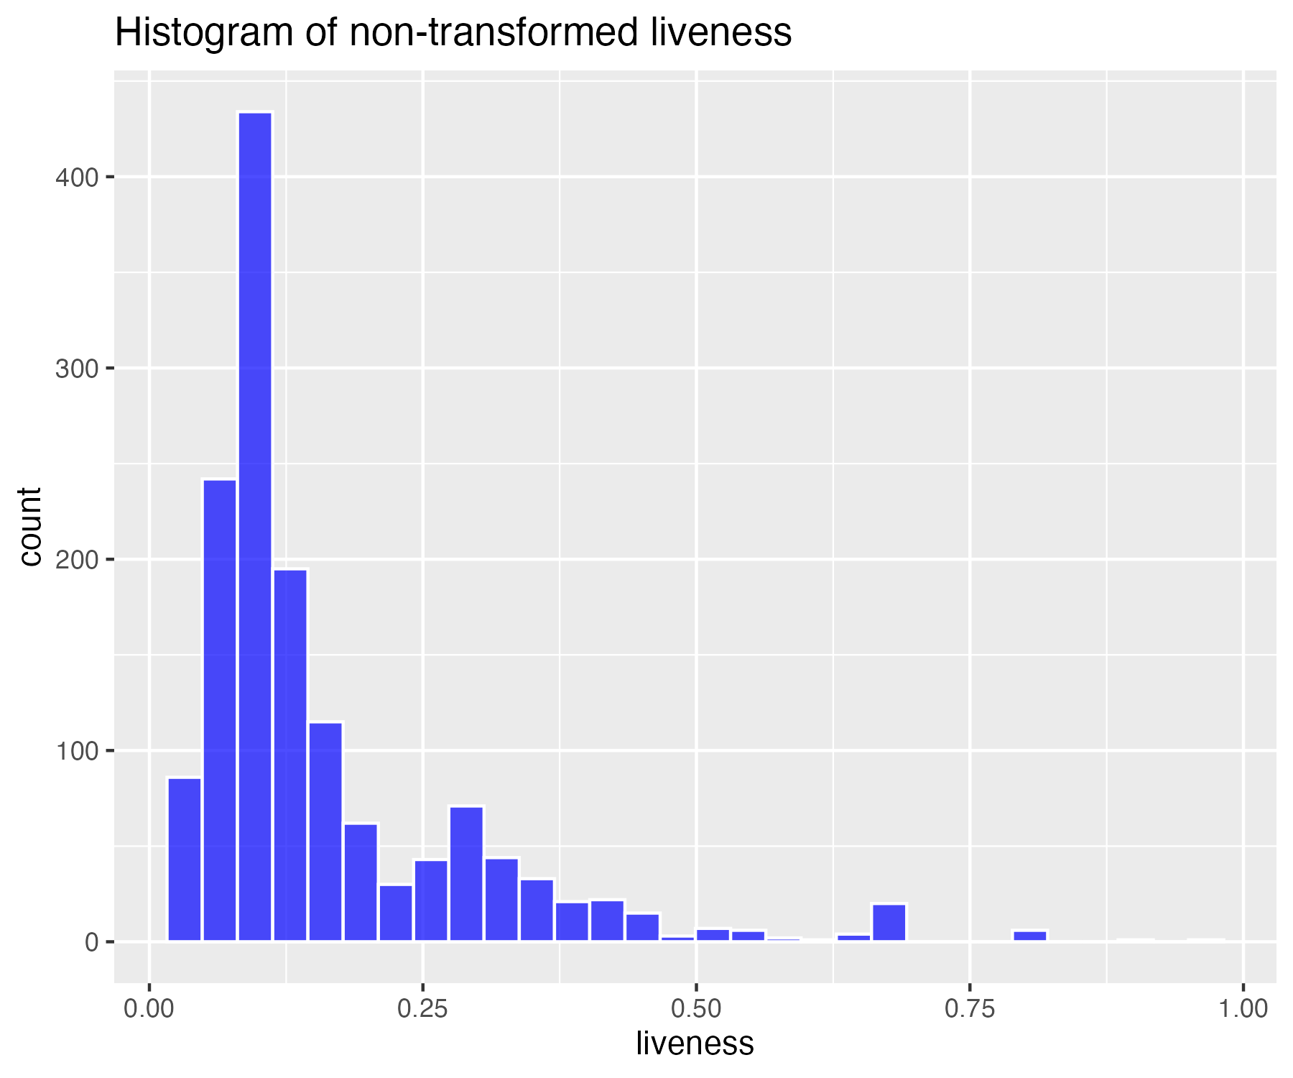

## Square-root transform of liveness (for moderate skew)

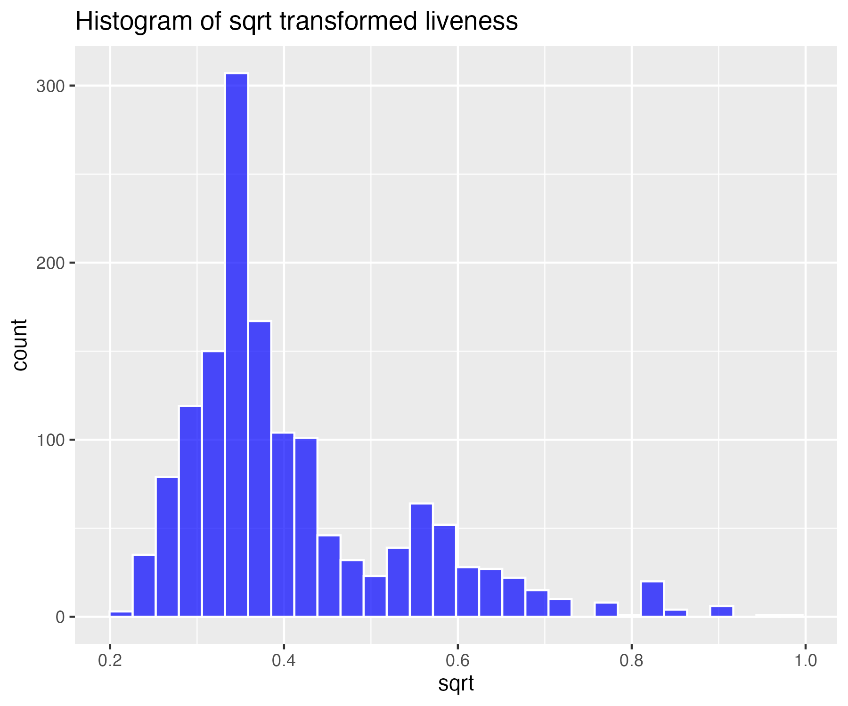

## Log base 10 transform of liveness (for high skew)

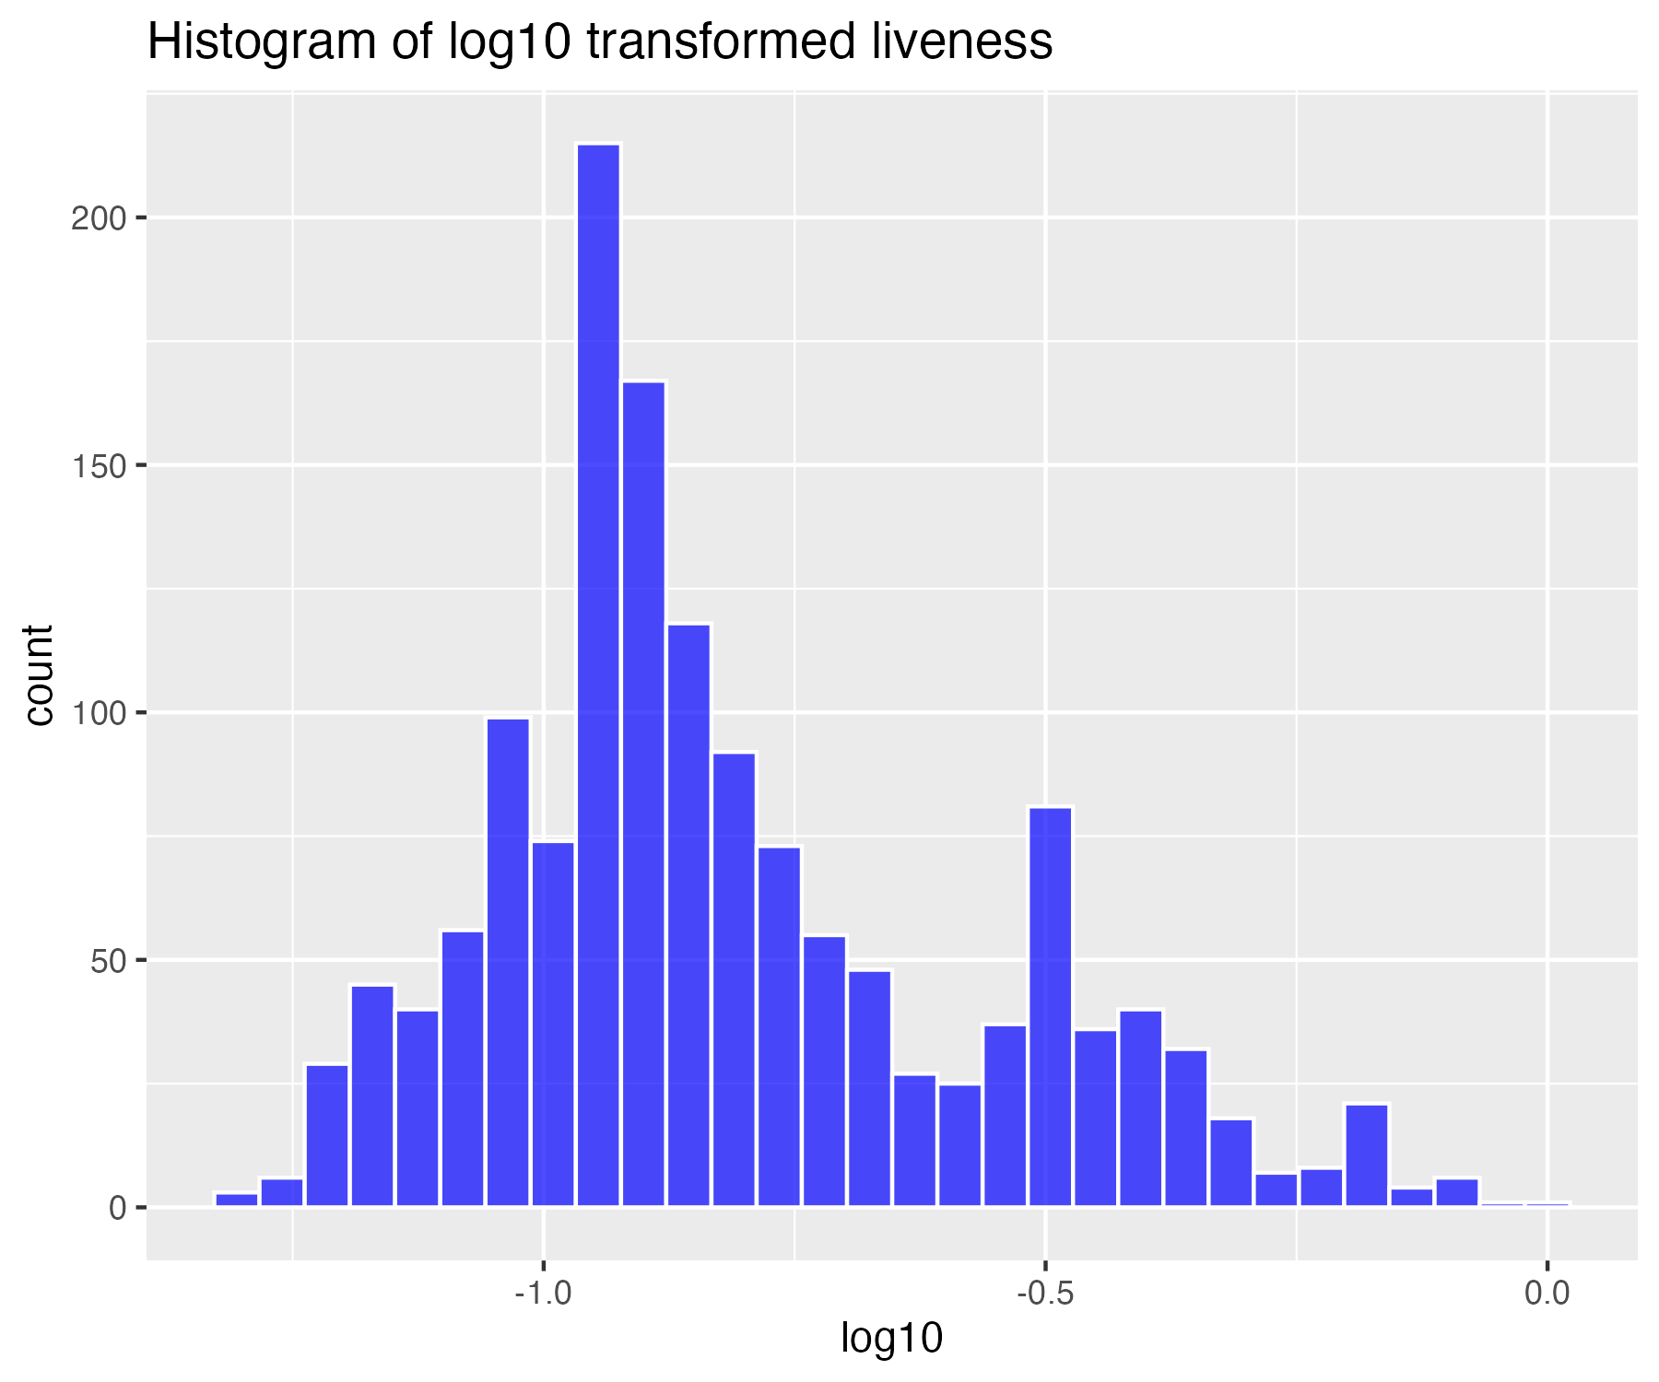

## Natural log transform of liveness (for higher skew)

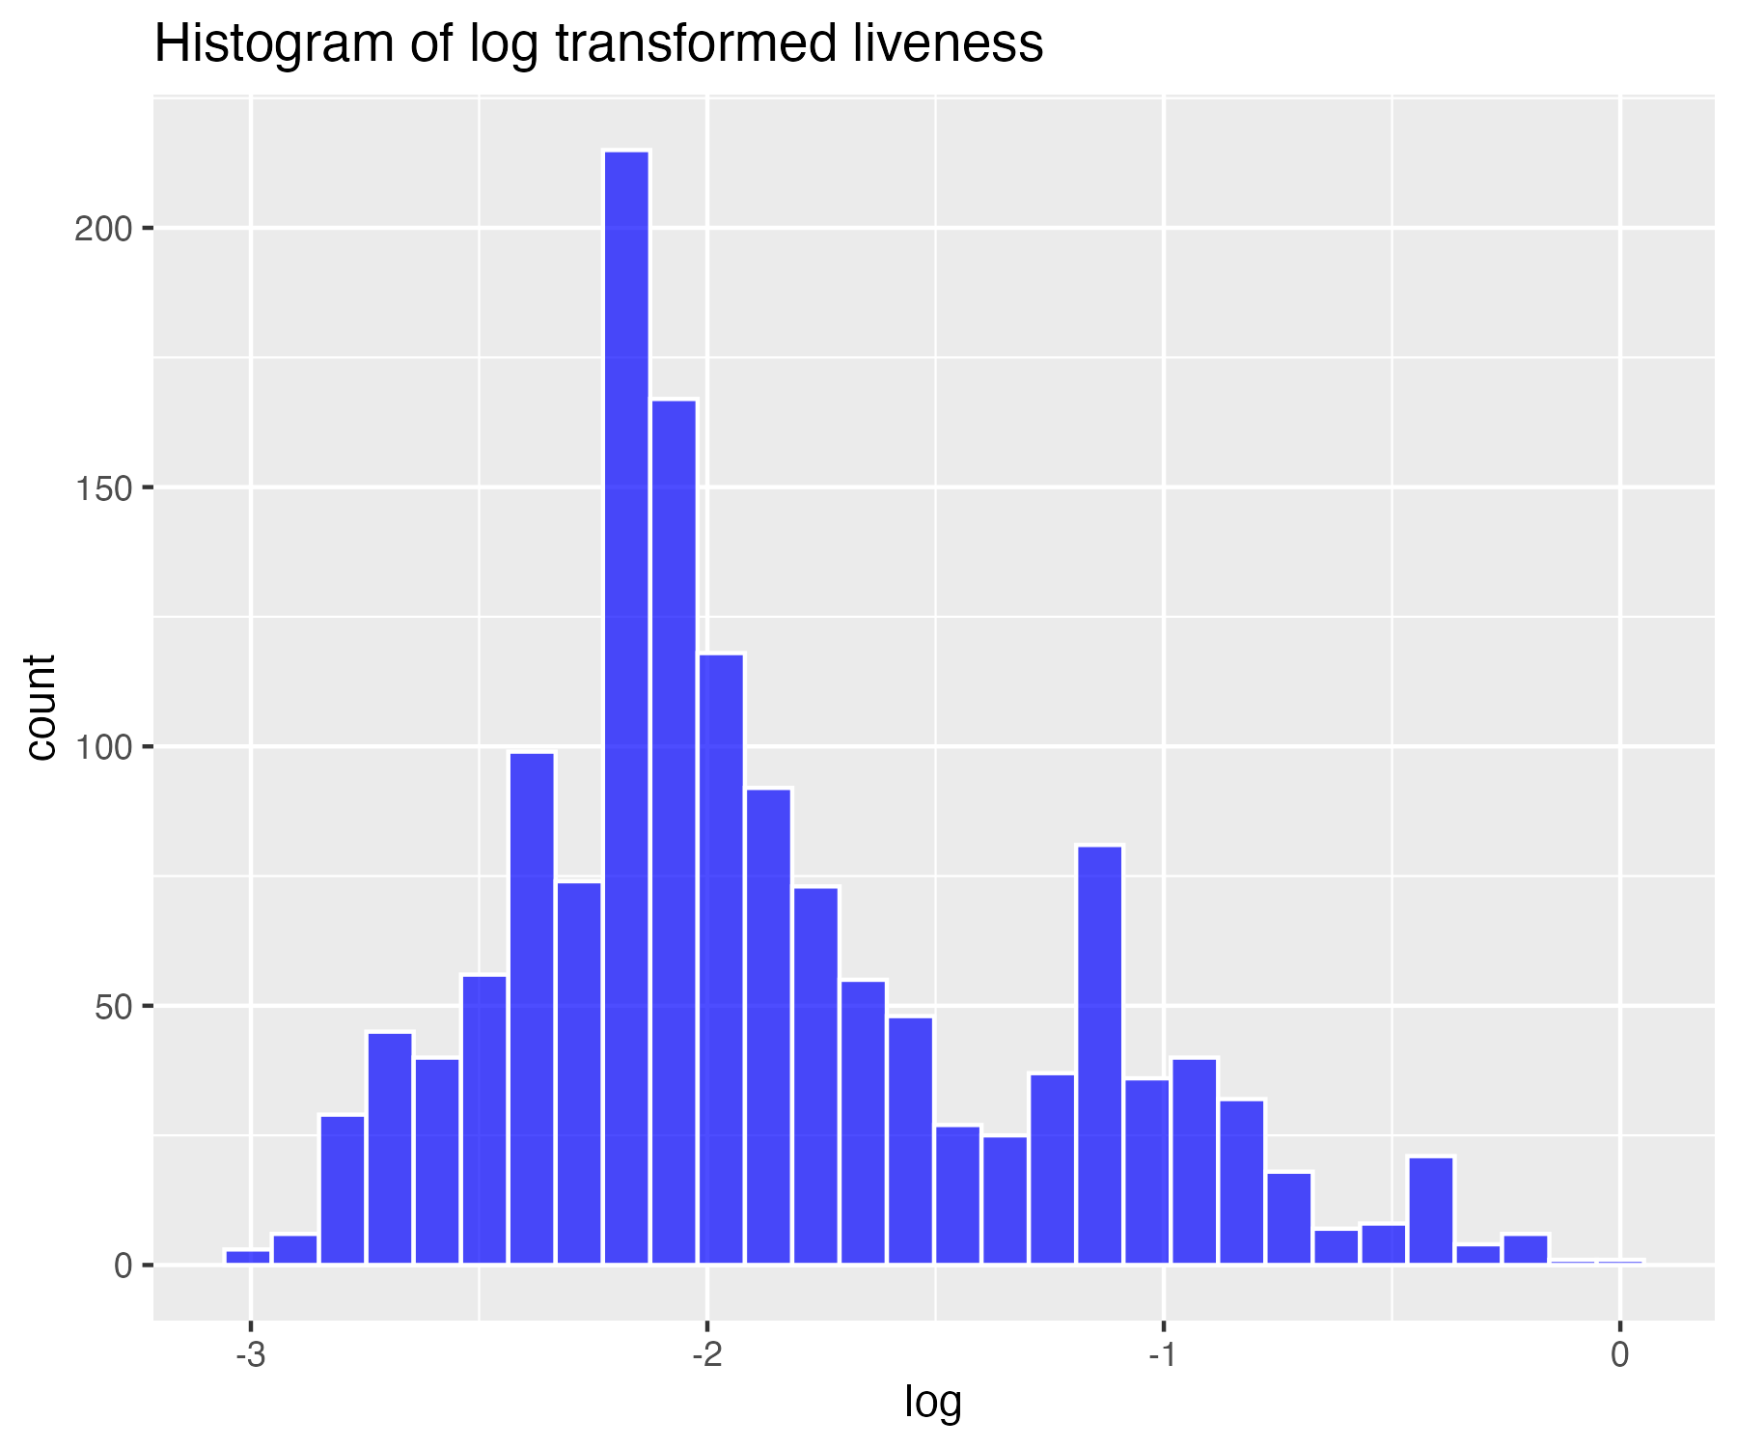

## Inverse transform of liveness (for severe skew)

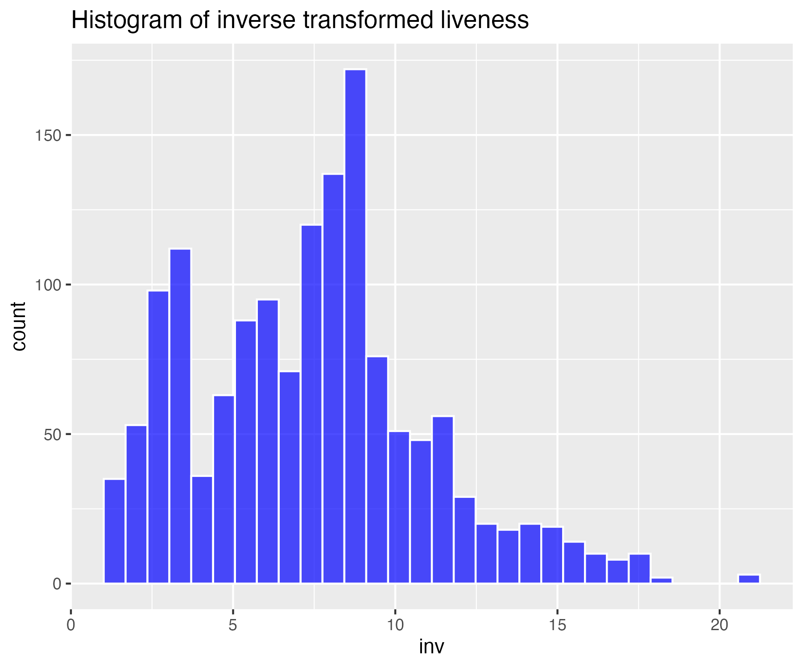

## Histogram of non-transformed valence

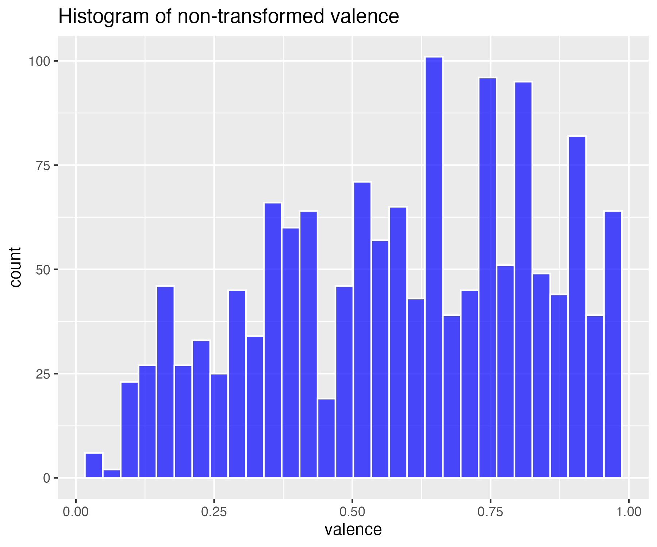

## Square-root transform of valence (for moderate skew)

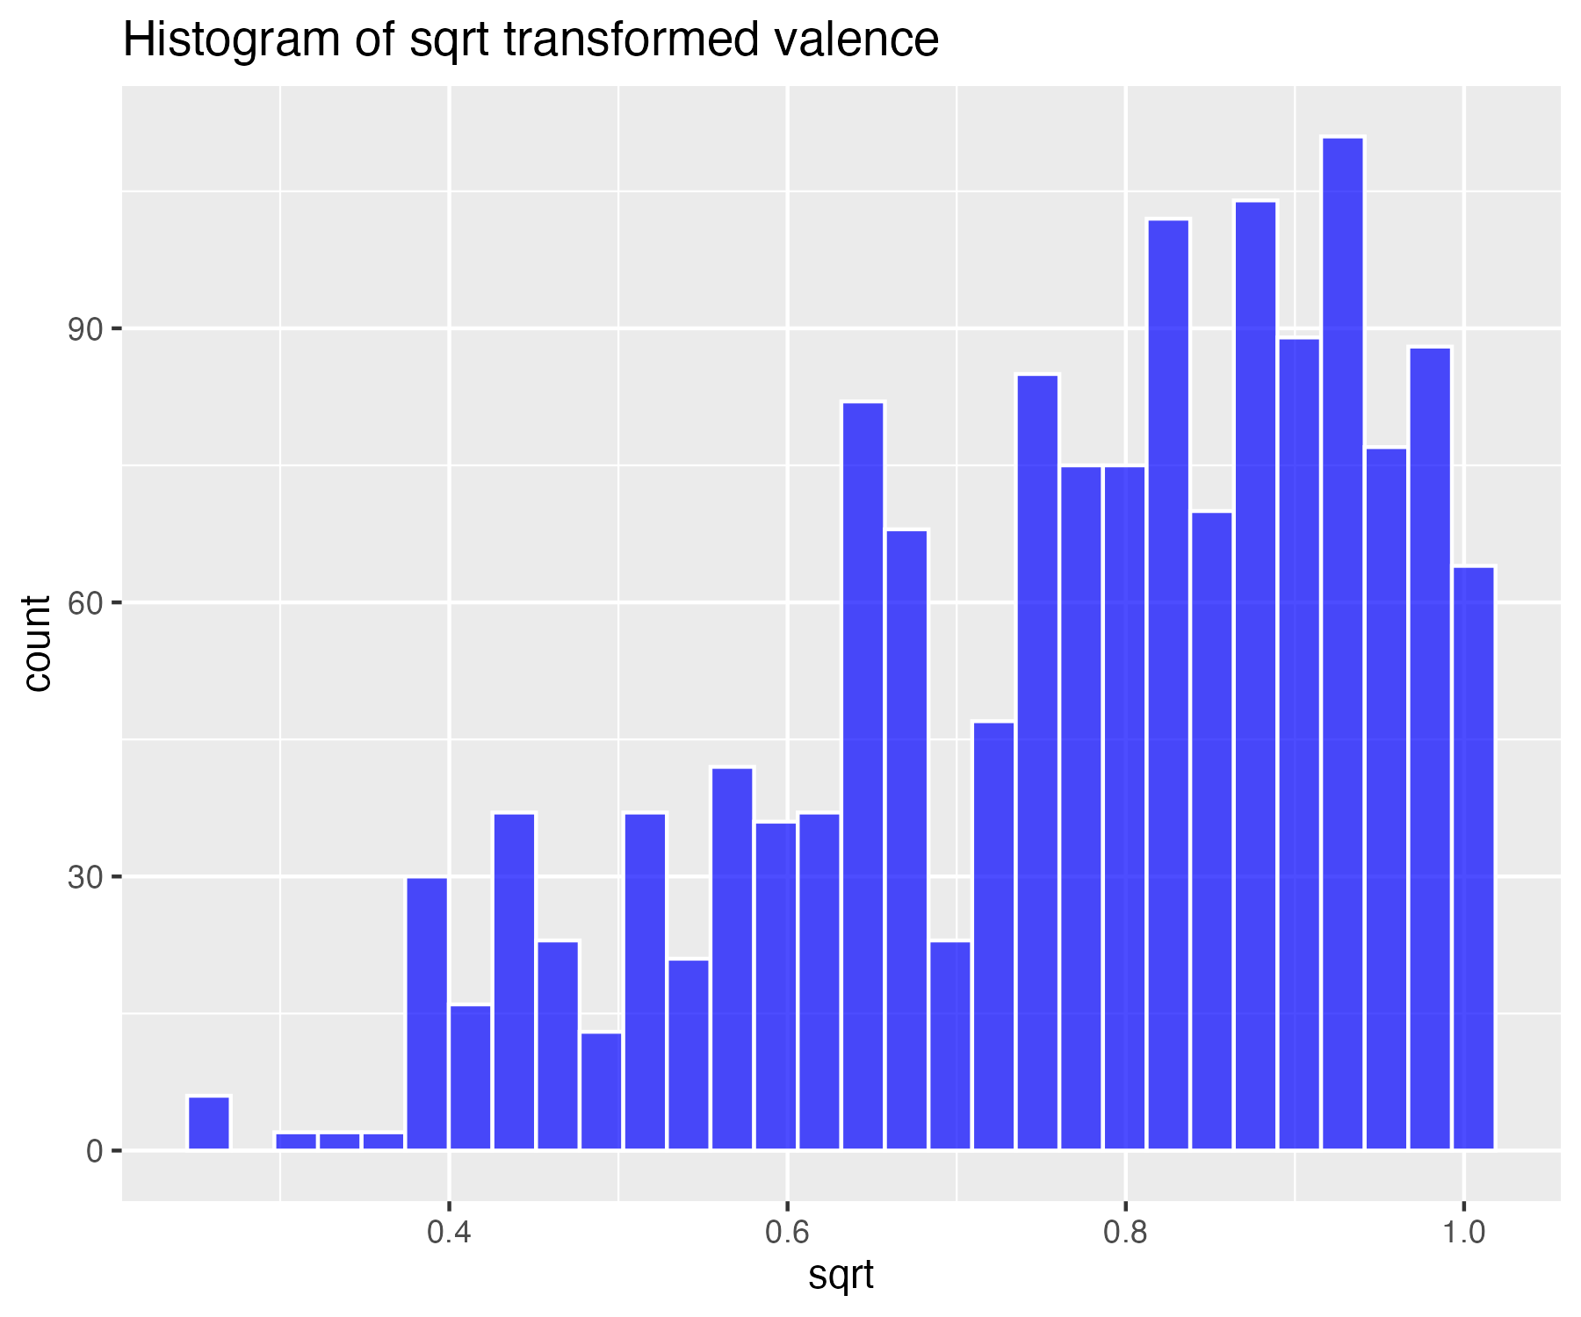

## Log base 10 transform of valence (for high skew)

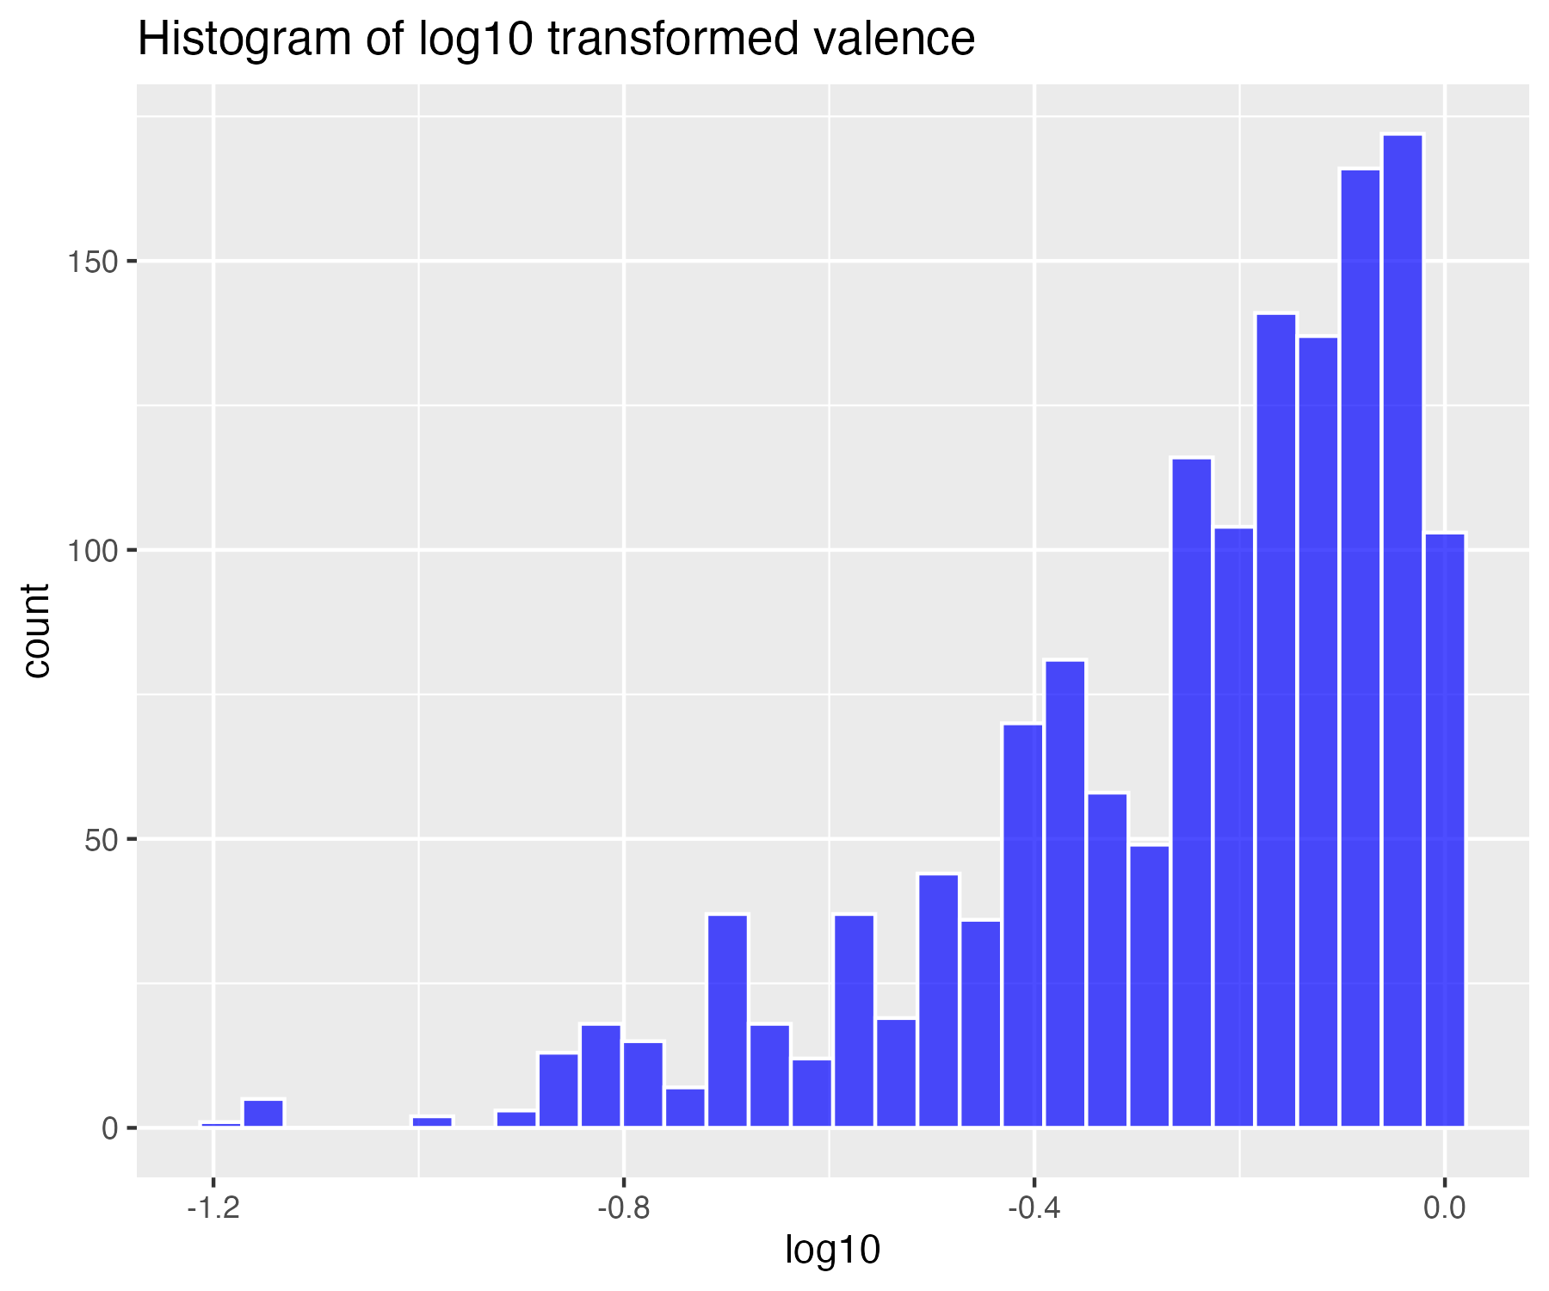

## Natural log transform of valence (for higher skew)

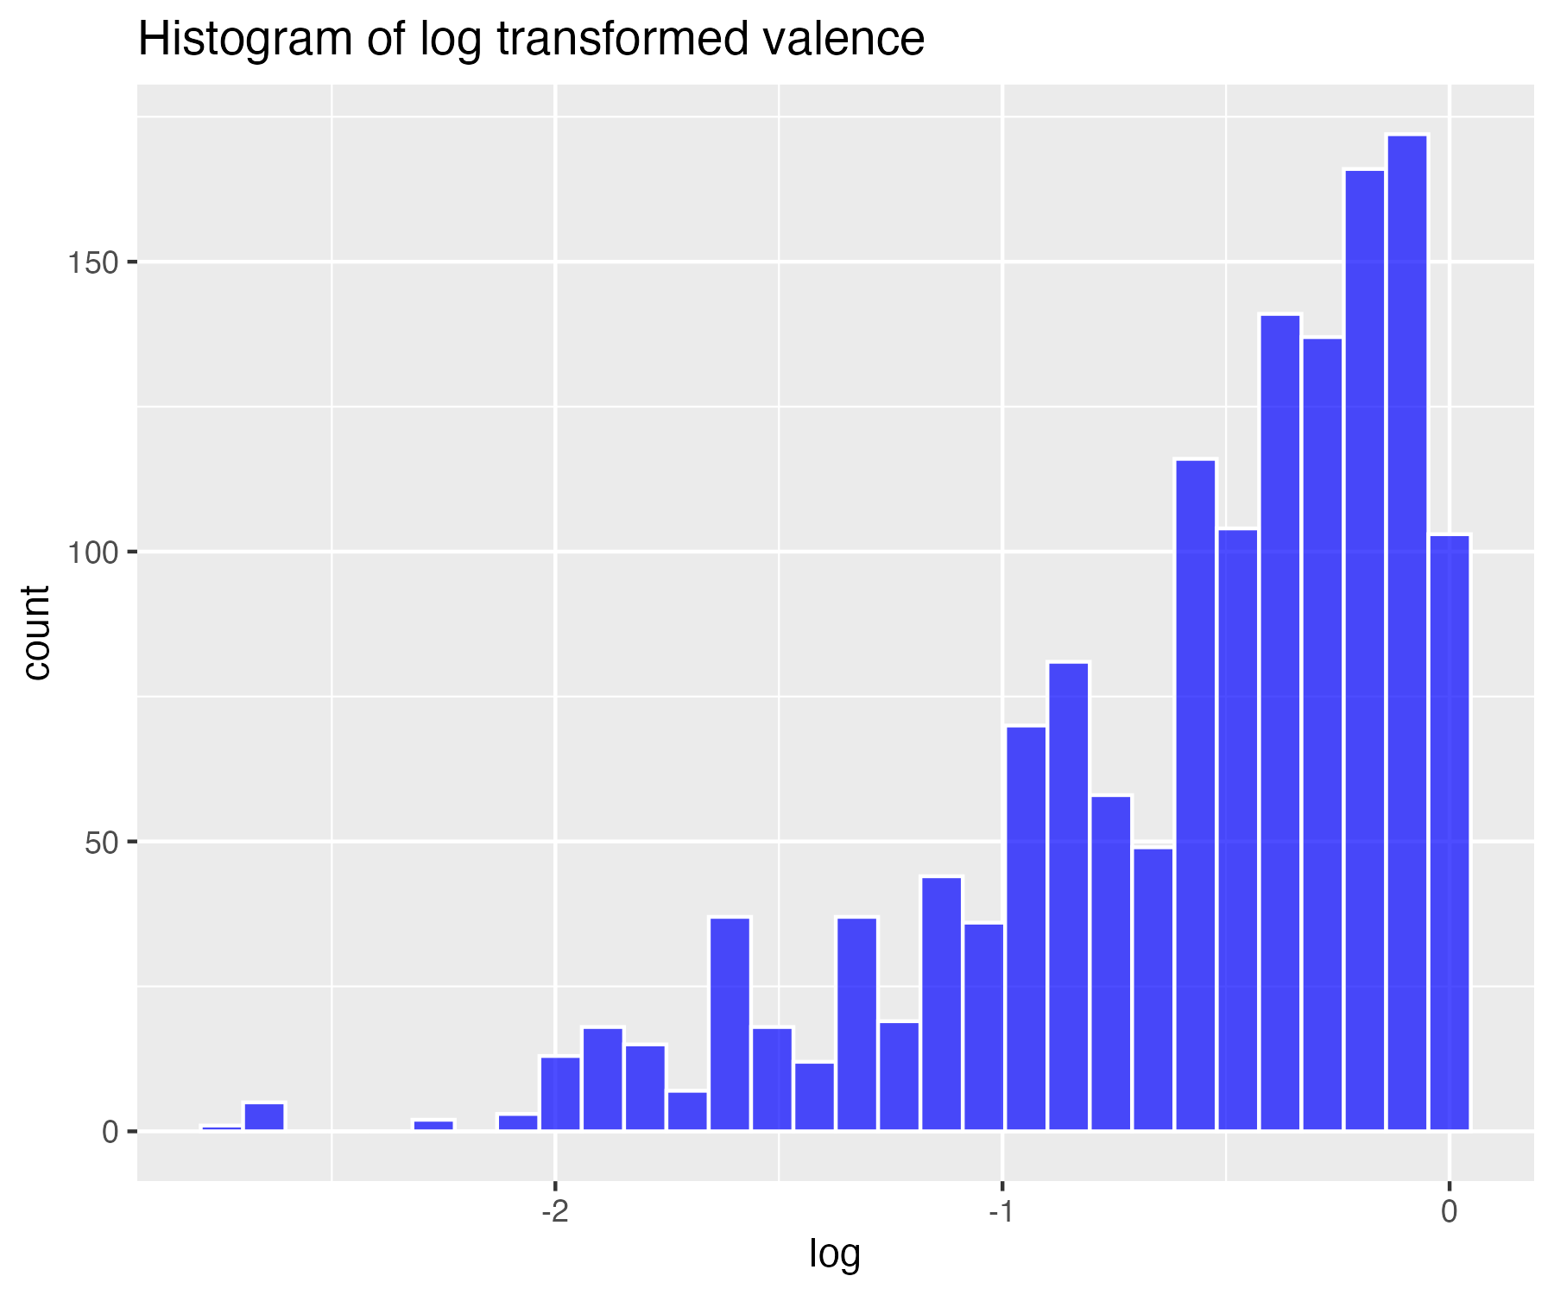

## Inverse transform of valence (for severe skew)

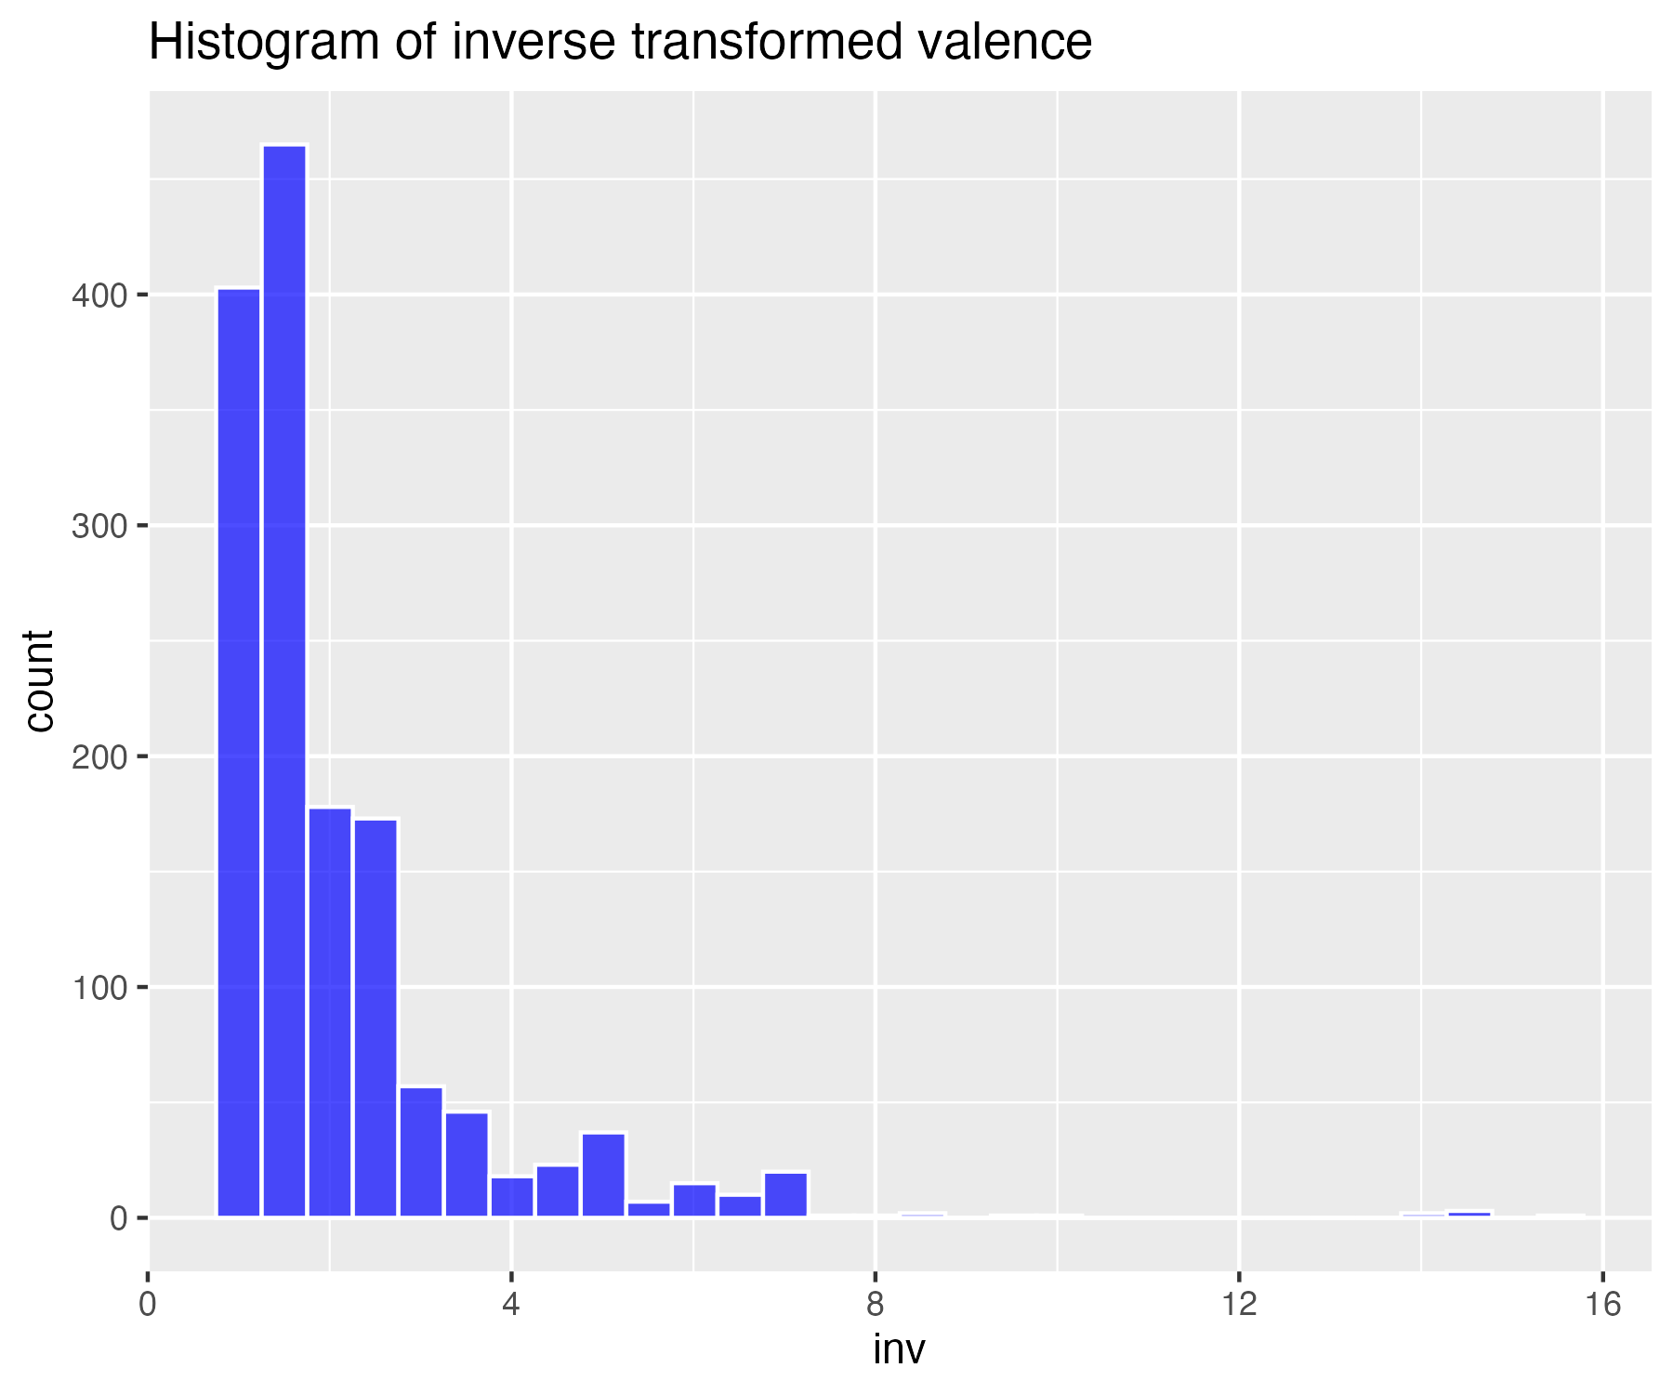

## Histogram of non-transformed tempo

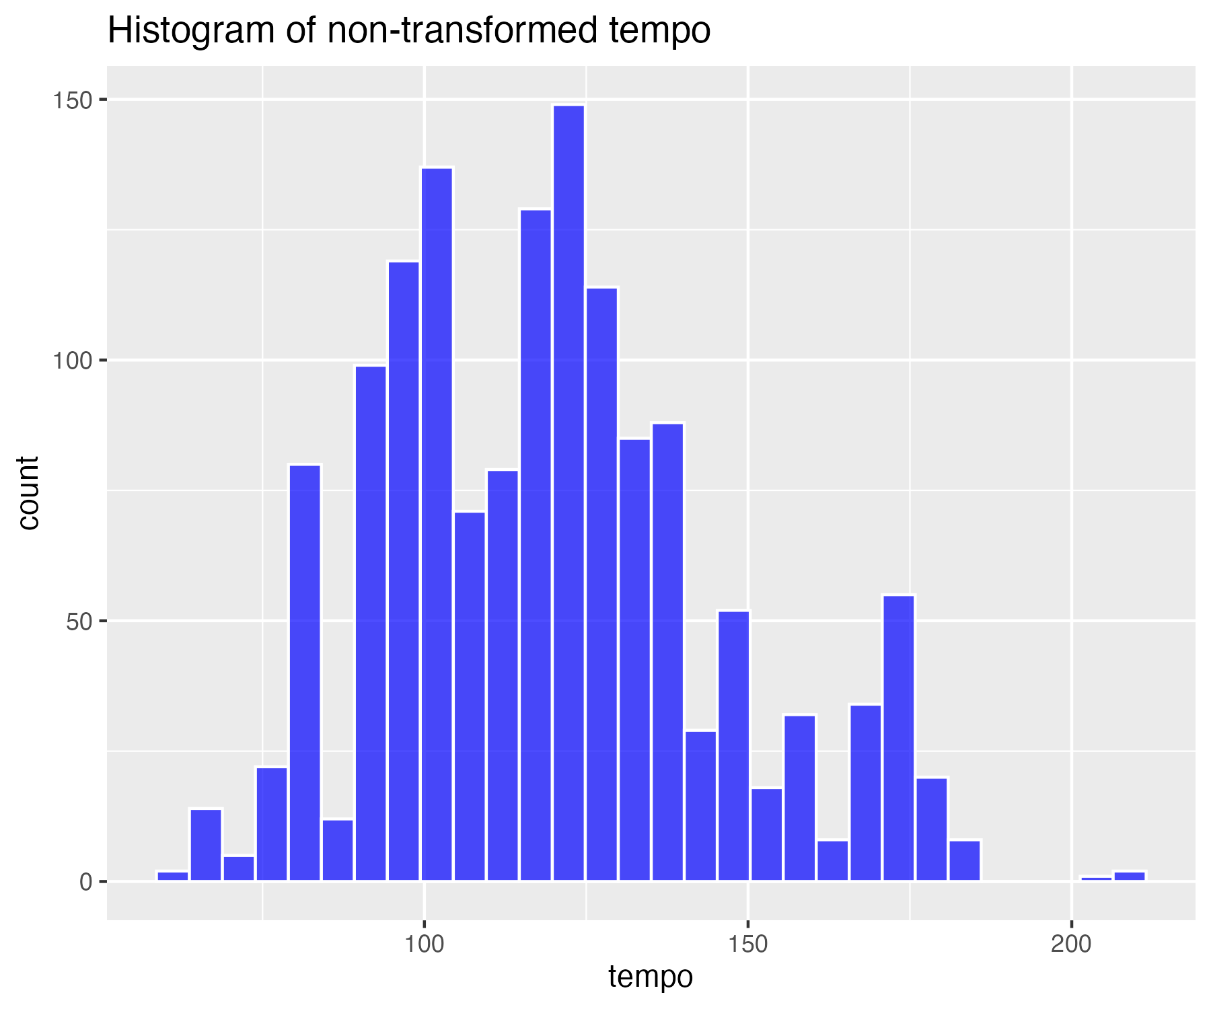

## Square-root transform of tempo (for moderate skew)

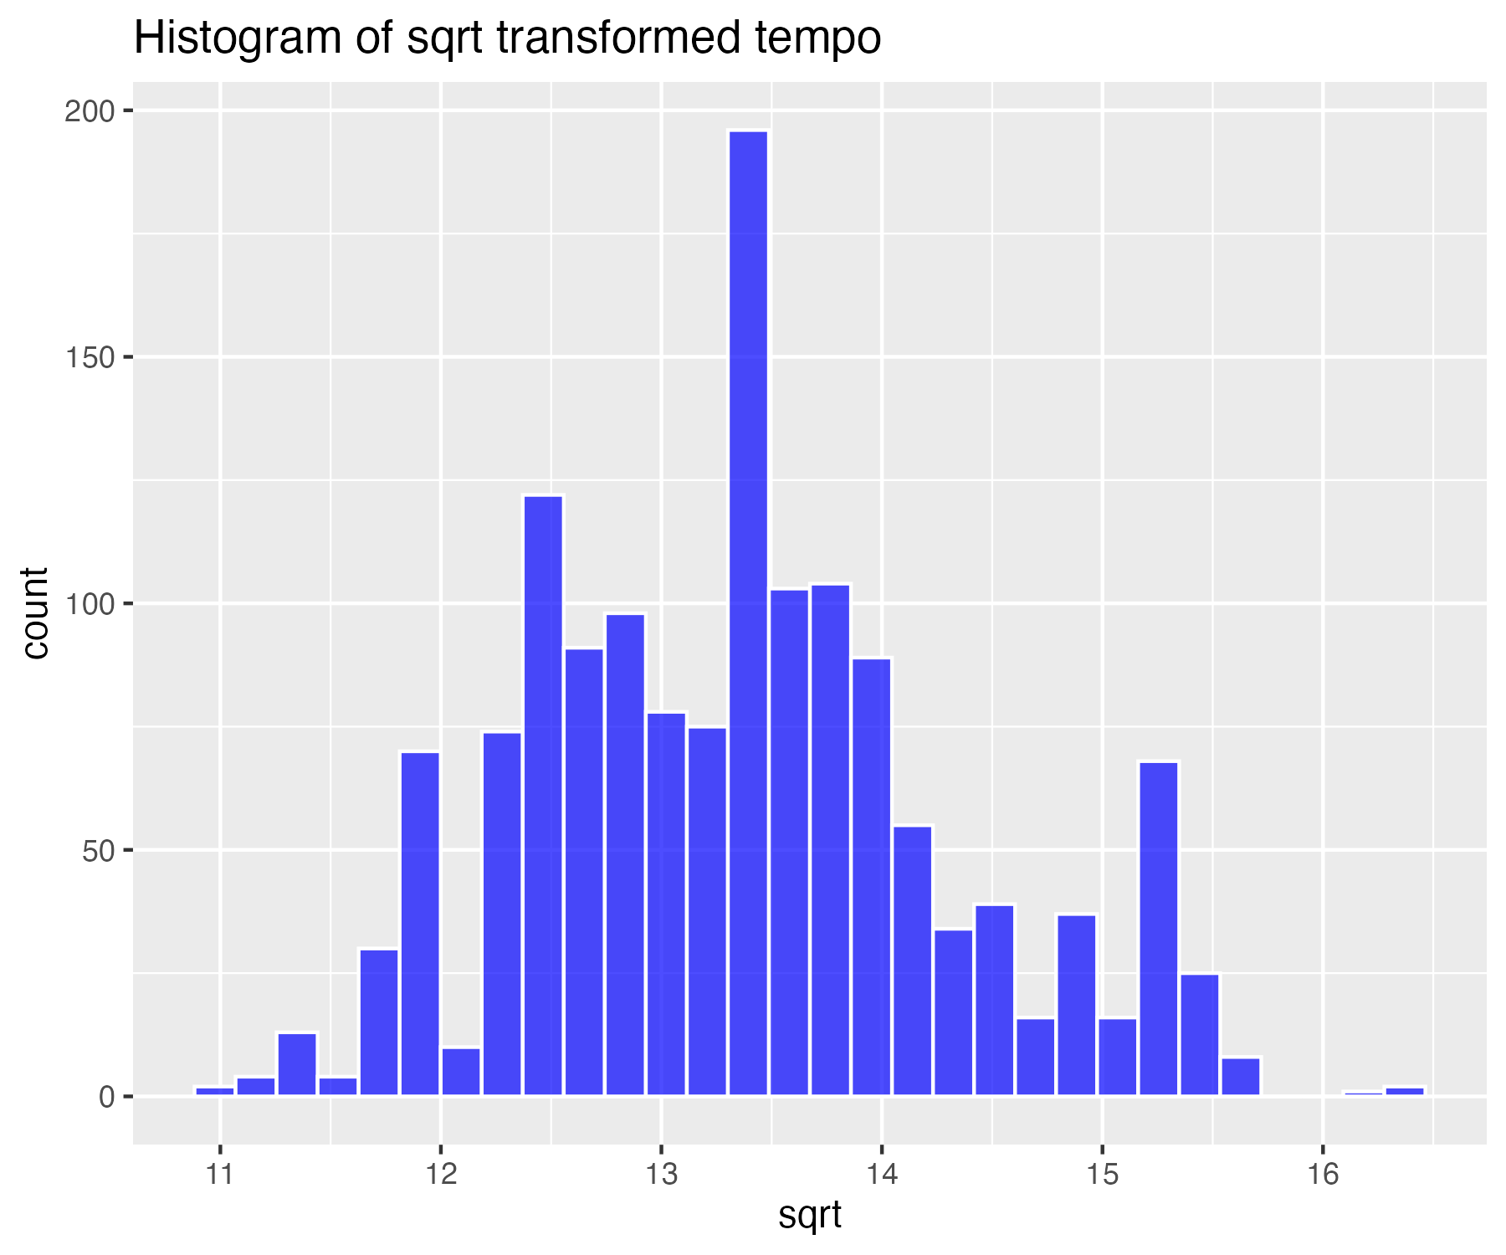

## Log base 10 transform of tempo (for high skew)

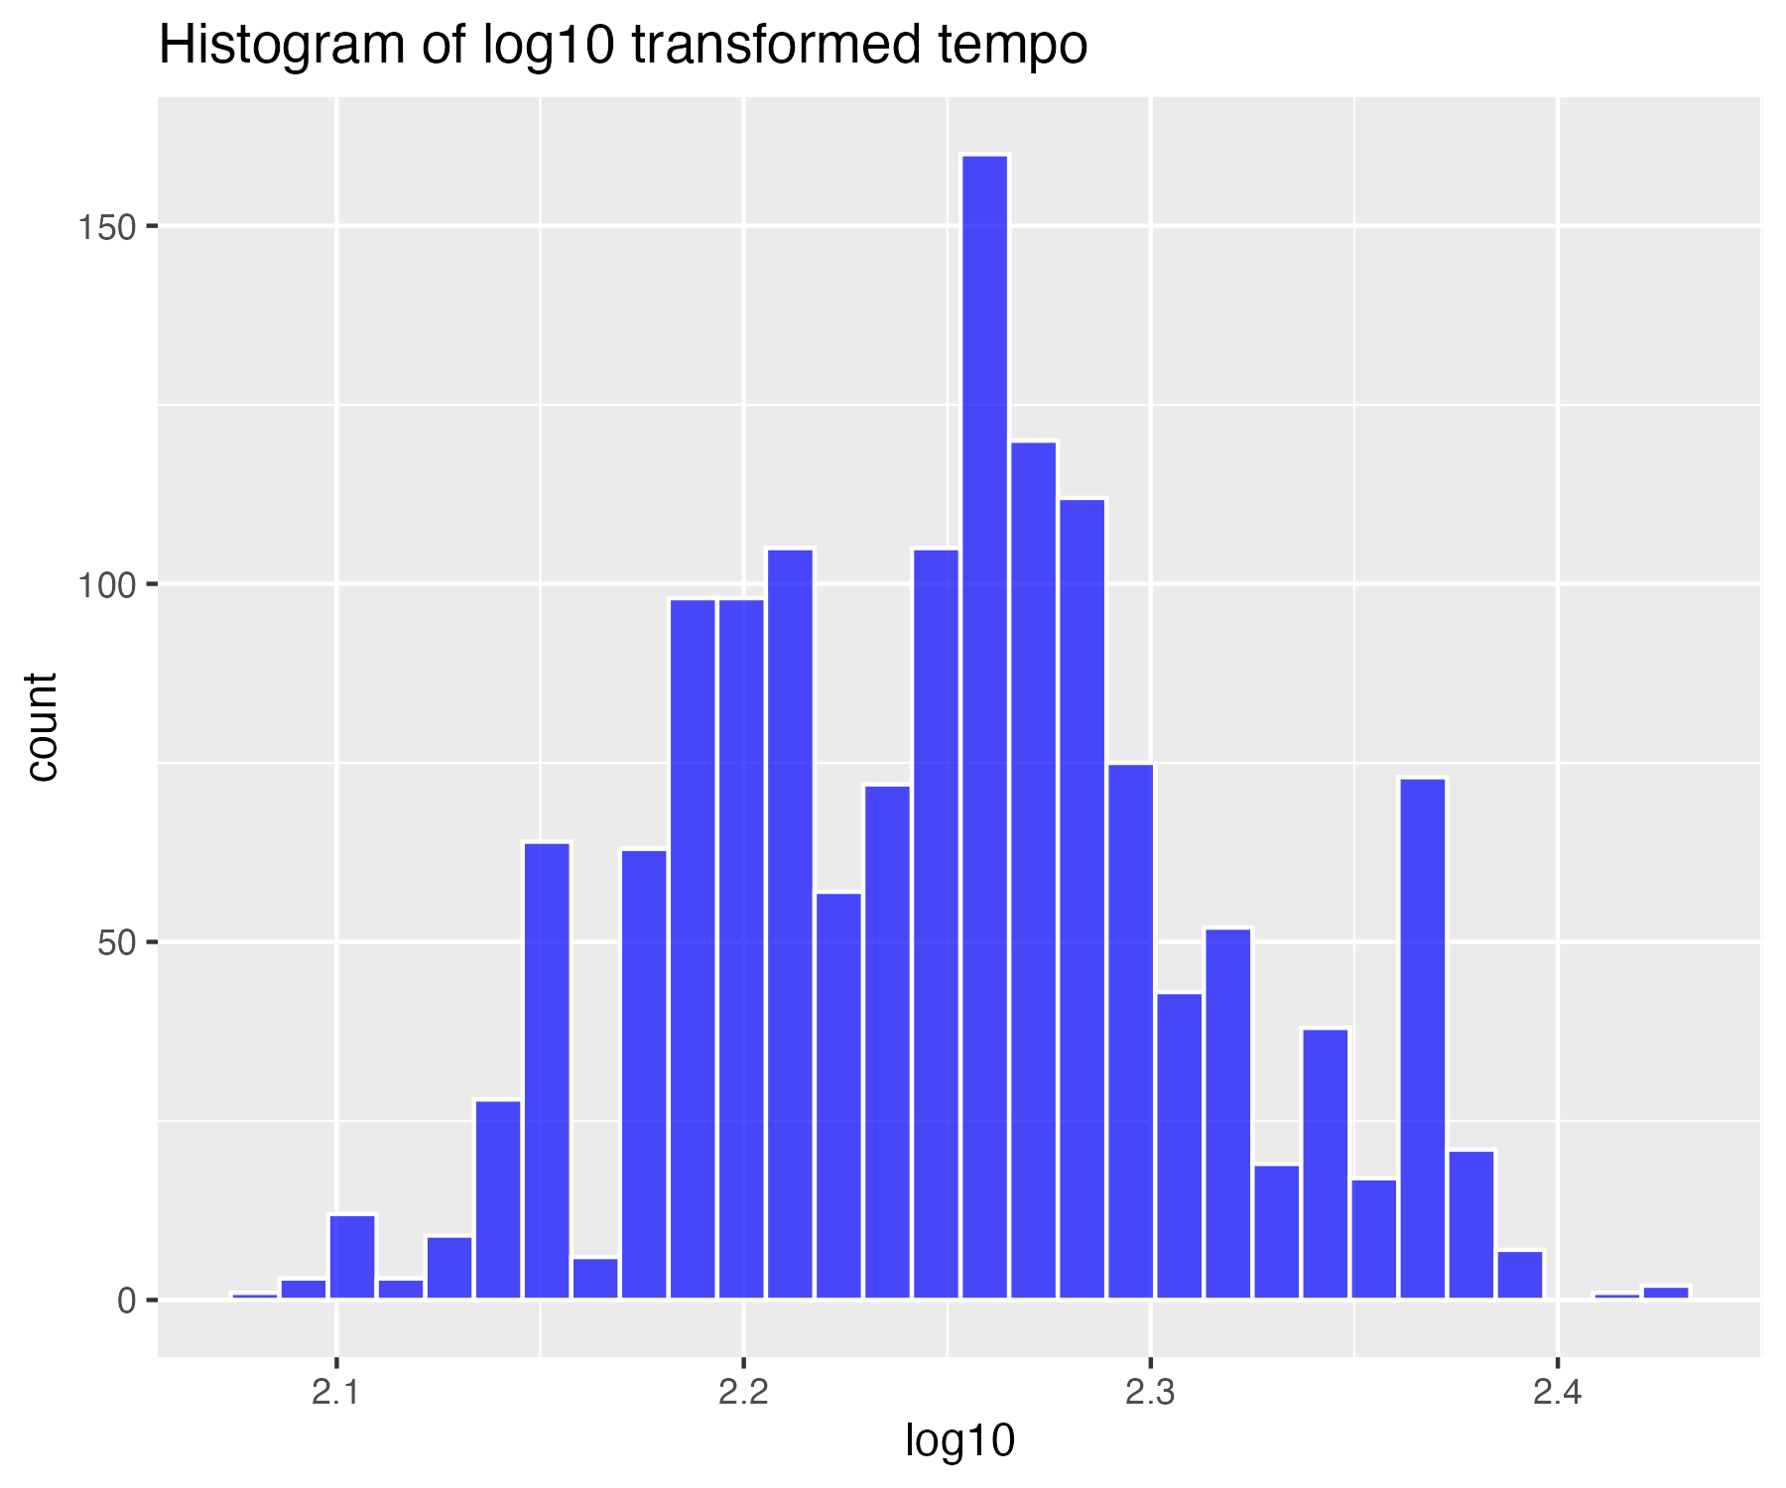

## Natural log transform of tempo (for higher skew)

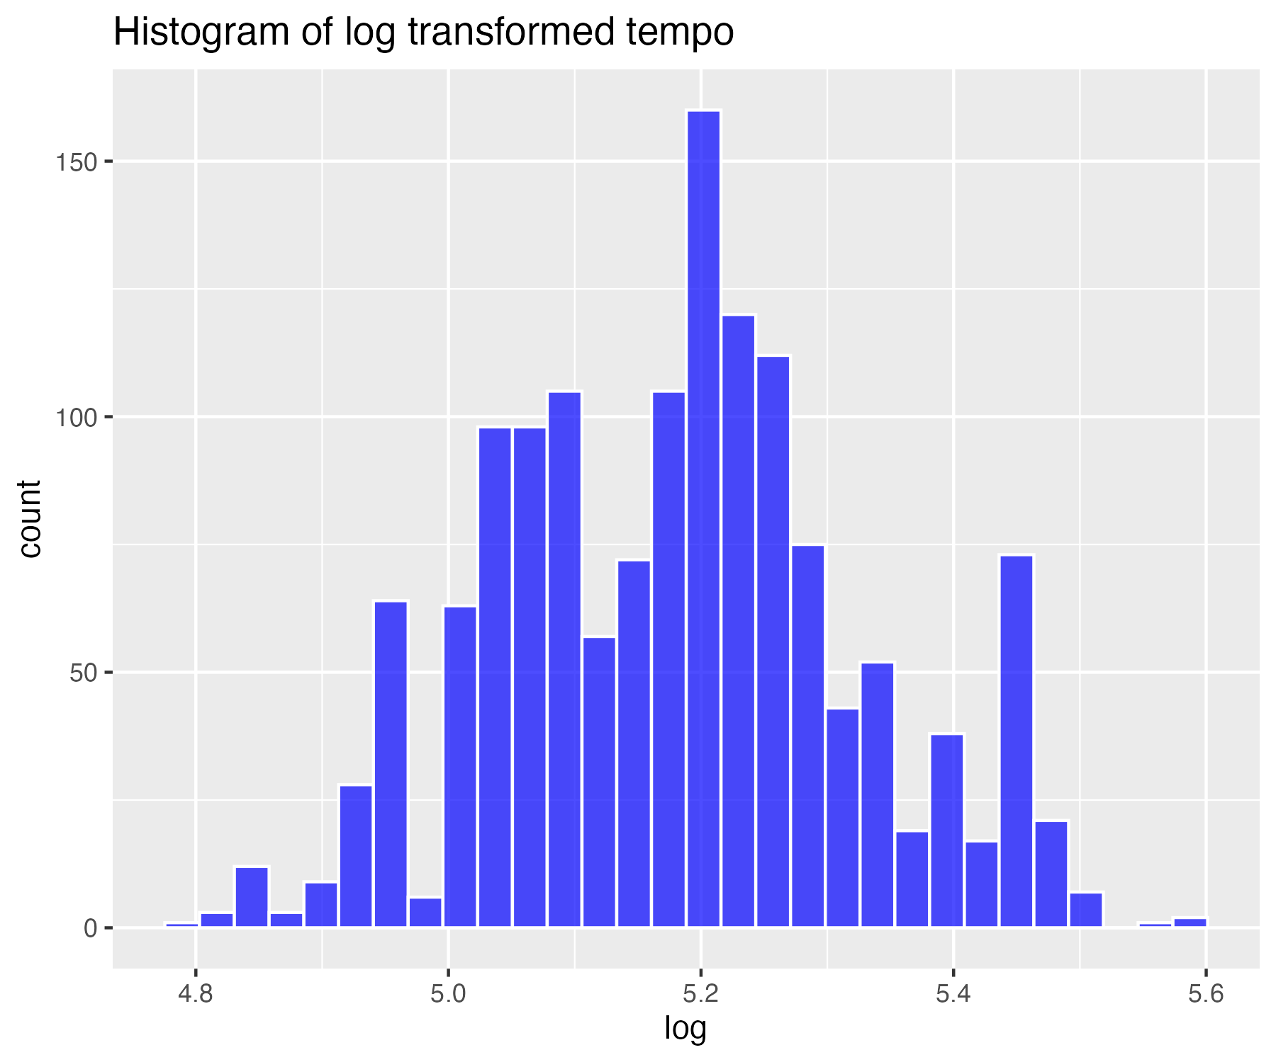

## Inverse transform of tempo (for severe skew)

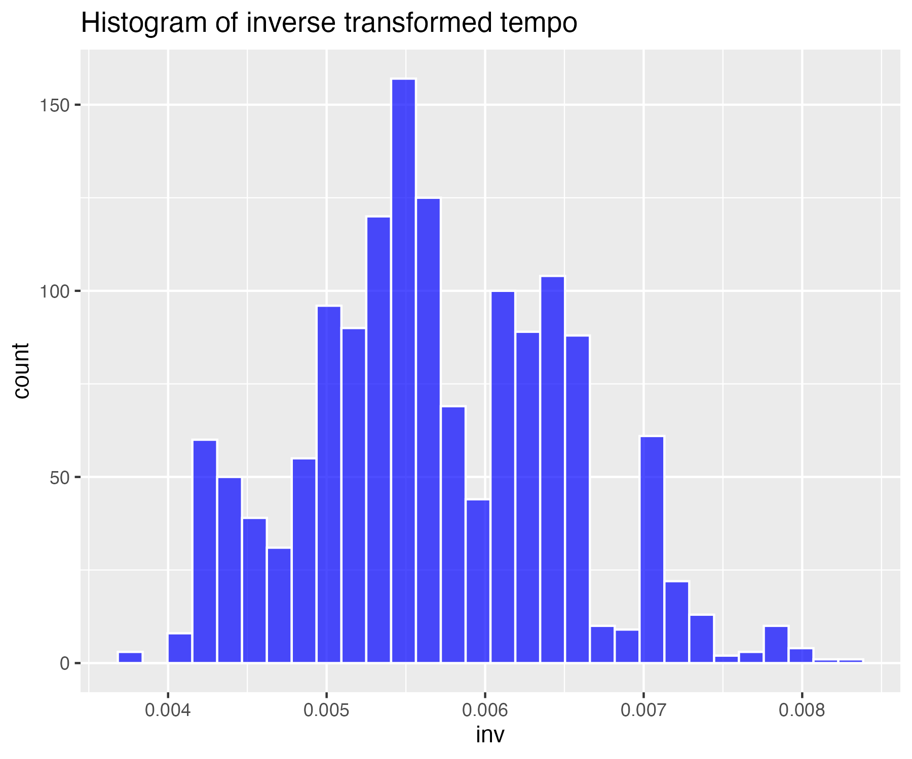

## Descriptives summary table for all variables (not transformed)

| matrix.nrow...20..ncol...1. | danceability | energy | loudness | speechiness | acousticness | instrumentalness | liveness | valence | tempo |
| --- | --- | --- | --- | --- | --- | --- | --- | --- | --- |
| nbr.val | 1,464.00 | 1,464.00 | 1,464.00 | 1,464.00 | 1,464.00 | 1,464.00 | 1,464.00 | 1,464.00 | 1,464.00 |
| nbr.null | 0.00 | 0.00 | 0.00 | 0.00 | 0.00 | 723.00 | 0.00 | 0.00 | 0.00 |
| nbr.na | 0.00 | 0.00 | 0.00 | 0.00 | 0.00 | 0.00 | 0.00 | 0.00 | 0.00 |
| min | 0.15 | 0.01 | -25.27 | 0.02 | 0.00 | 0.00 | 0.02 | 0.03 | 60.49 |
| max | 0.96 | 0.99 | -1.60 | 0.44 | 1.00 | 0.97 | 0.96 | 0.97 | 208.28 |
| range | 0.81 | 0.98 | 23.67 | 0.42 | 0.99 | 0.97 | 0.93 | 0.94 | 147.79 |
| sum | 975.50 | 937.14 | -10,709.35 | 104.62 | 324.23 | 26.87 | 235.99 | 859.70 | 174,361.54 |
| median | 0.68 | 0.66 | -6.55 | 0.04 | 0.13 | 0.00 | 0.11 | 0.61 | 118.98 |
| mean | 0.67 | 0.64 | -7.32 | 0.07 | 0.22 | 0.02 | 0.16 | 0.59 | 119.10 |
| SE.mean | 0.00 | 0.00 | 0.09 | 0.00 | 0.01 | 0.00 | 0.00 | 0.01 | 0.68 |
| CI.mean.0.95 | 0.01 | 0.01 | 0.17 | 0.00 | 0.01 | 0.01 | 0.01 | 0.01 | 1.33 |
| var | 0.02 | 0.03 | 10.68 | 0.00 | 0.06 | 0.01 | 0.02 | 0.06 | 676.50 |
| std.dev | 0.15 | 0.18 | 3.27 | 0.07 | 0.25 | 0.10 | 0.13 | 0.24 | 26.01 |
| coef.var | 0.22 | 0.28 | -0.45 | 0.94 | 1.12 | 5.49 | 0.83 | 0.42 | 0.22 |
| skewness | -0.57 | -0.50 | -1.44 | 2.92 | 1.36 | 7.39 | 2.20 | -0.27 | 0.49 |
| skew.2SE | -4.47 | -3.89 | -11.23 | 22.82 | 10.63 | 57.74 | 17.22 | -2.14 | 3.82 |
| kurtosis | 0.13 | -0.15 | 3.09 | 10.04 | 0.93 | 57.17 | 5.75 | -0.98 | -0.11 |
| kurt.2SE | 0.53 | -0.59 | 12.10 | 39.27 | 3.63 | 223.62 | 22.50 | -3.83 | -0.44 |
| normtest.W | 0.98 | 0.98 | 0.90 | 0.64 | 0.81 | 0.18 | 0.75 | 0.96 | 0.97 |
| normtest.p | 0.00 | 0.00 | 0.00 | 0.00 | 0.00 | 0.00 | 0.00 | 0.00 | 0.00 |

## Descriptives summary table for all variables - sqrt transform

| matrix.nrow...20..ncol...1. | danceability_sqrt | energy_sqrt | loudness_sqrt | speechiness_sqrt | acousticness_sqrt | instrumentalness_sqrt | liveness_sqrt | valence_sqrt | tempo_sqrt |
| --- | --- | --- | --- | --- | --- | --- | --- | --- | --- |
| nbr.val | 1,464.00 | 1,464.00 | 1,464.00 | 1,464.00 | 1,464.00 | 1,464.00 | 1,464.00 | 1,464.00 | 1,464.00 |
| nbr.null | 0.00 | 0.00 | 0.00 | 0.00 | 0.00 | 0.00 | 0.00 | 0.00 | 0.00 |
| nbr.na | 0.00 | 0.00 | 0.00 | 0.00 | 0.00 | 0.00 | 0.00 | 0.00 | 0.00 |
| min | 0.55 | 0.14 | 0.00 | 0.21 | 0.00 | 0.00 | 0.22 | 0.25 | 11.00 |
| max | 1.05 | 1.00 | 4.86 | 0.68 | 1.00 | 0.99 | 0.99 | 1.00 | 16.39 |
| range | 0.51 | 0.86 | 4.86 | 0.47 | 0.99 | 0.98 | 0.77 | 0.75 | 5.39 |
| sum | 1,315.90 | 1,166.62 | 6,169.36 | 431.28 | 578.45 | 59.15 | 600.91 | 1,125.10 | 19,568.89 |
| median | 0.91 | 0.82 | 4.33 | 0.26 | 0.36 | 0.00 | 0.36 | 0.80 | 13.40 |
| mean | 0.90 | 0.80 | 4.21 | 0.29 | 0.40 | 0.04 | 0.41 | 0.77 | 13.37 |
| SE.mean | 0.00 | 0.00 | 0.01 | 0.00 | 0.01 | 0.00 | 0.00 | 0.00 | 0.03 |
| CI.mean.0.95 | 0.00 | 0.01 | 0.02 | 0.00 | 0.01 | 0.01 | 0.01 | 0.01 | 0.05 |
| var | 0.01 | 0.02 | 0.19 | 0.01 | 0.07 | 0.02 | 0.02 | 0.03 | 0.92 |
| std.dev | 0.09 | 0.12 | 0.44 | 0.09 | 0.26 | 0.13 | 0.13 | 0.17 | 0.96 |
| coef.var | 0.10 | 0.15 | 0.10 | 0.29 | 0.65 | 3.20 | 0.32 | 0.22 | 0.07 |
| skewness | -0.88 | -1.10 | -2.56 | 2.03 | 0.55 | 4.99 | 1.42 | -0.66 | 0.31 |
| skew.2SE | -6.88 | -8.59 | -20.05 | 15.86 | 4.33 | 39.03 | 11.07 | -5.17 | 2.46 |
| kurtosis | 0.93 | 2.02 | 12.82 | 4.53 | -0.66 | 27.63 | 1.86 | -0.40 | -0.26 |
| kurt.2SE | 3.63 | 7.92 | 50.13 | 17.73 | -2.59 | 108.08 | 7.29 | -1.57 | -1.03 |
| normtest.W | 0.95 | 0.93 | 0.81 | 0.76 | 0.95 | 0.33 | 0.86 | 0.94 | 0.98 |
| normtest.p | 0.00 | 0.00 | 0.00 | 0.00 | 0.00 | 0.00 | 0.00 | 0.00 | 0.00 |

## Descriptives summary table for all variables - log10 transform

| matrix.nrow...20..ncol...1. | danceability_log10 | energy_log10 | loudness_log10 | speechiness_log10 | acousticness_log10 | instrumentalness_log10 | liveness_log10 | valence_log10 | tempo_log10 |
| --- | --- | --- | --- | --- | --- | --- | --- | --- | --- |
| nbr.val | 1,464.00 | 1,464.00 | 1,464.00 | 1,464.00 | 1,464.00 | 1,464.00 | 1,464.00 | 1,464.00 | 1,464.00 |
| nbr.null | 0.00 | 0.00 | 0.00 | 0.00 | 0.00 | 0.00 | 0.00 | 0.00 | 0.00 |
| nbr.na | 0.00 | 0.00 | 0.00 | 0.00 | 0.00 | 0.00 | 0.00 | 0.00 | 0.00 |
| min | -0.53 | -1.70 | -6.00 | -1.34 | -4.79 | -6.00 | -1.31 | -1.19 | 2.08 |
| max | 0.04 | 0.00 | 1.37 | -0.34 | 0.00 | -0.01 | -0.01 | 0.00 | 2.43 |
| range | 0.57 | 1.70 | 7.37 | 1.00 | 4.79 | 5.99 | 1.31 | 1.19 | 0.35 |
| sum | -141.91 | -307.44 | 1,814.39 | -1,597.06 | -1,547.79 | -6,984.61 | -1,187.04 | -371.86 | 3,293.74 |
| median | -0.08 | -0.18 | 1.27 | -1.17 | -0.90 | -5.69 | -0.88 | -0.19 | 2.25 |
| mean | -0.10 | -0.21 | 1.24 | -1.09 | -1.06 | -4.77 | -0.81 | -0.25 | 2.25 |
| SE.mean | 0.00 | 0.00 | 0.01 | 0.01 | 0.02 | 0.04 | 0.01 | 0.01 | 0.00 |
| CI.mean.0.95 | 0.00 | 0.01 | 0.01 | 0.01 | 0.04 | 0.08 | 0.01 | 0.01 | 0.00 |
| var | 0.01 | 0.03 | 0.05 | 0.05 | 0.58 | 2.61 | 0.06 | 0.05 | 0.00 |
| std.dev | 0.09 | 0.16 | 0.22 | 0.21 | 0.76 | 1.62 | 0.25 | 0.22 | 0.06 |
| coef.var | -0.91 | -0.76 | 0.18 | -0.20 | -0.72 | -0.34 | -0.30 | -0.87 | 0.03 |
| skewness | -1.26 | -2.64 | -25.60 | 1.34 | -1.12 | 1.19 | 0.75 | -1.20 | 0.14 |
| skew.2SE | -9.83 | -20.65 | -200.17 | 10.50 | -8.74 | 9.30 | 5.87 | -9.38 | 1.08 |
| kurtosis | 2.35 | 14.70 | 832.85 | 1.37 | 1.52 | 0.34 | 0.05 | 1.15 | -0.34 |
| kurt.2SE | 9.19 | 57.49 | 3,257.91 | 5.38 | 5.95 | 1.33 | 0.19 | 4.49 | -1.31 |
| normtest.W | 0.92 | 0.82 | 0.24 | 0.86 | 0.92 | 0.77 | 0.95 | 0.89 | 0.99 |
| normtest.p | 0.00 | 0.00 | 0.00 | 0.00 | 0.00 | 0.00 | 0.00 | 0.00 | 0.00 |

## Descriptives summary table for all variables - log transform

| matrix.nrow...20..ncol...1. | danceability_log | energy_log | loudness_log | speechiness_log | acousticness_log | instrumentalness_log | liveness_log | valence_log | tempo_log |
| --- | --- | --- | --- | --- | --- | --- | --- | --- | --- |
| nbr.val | 1,464.00 | 1,464.00 | 1,464.00 | 1,464.00 | 1,464.00 | 1,464.00 | 1,464.00 | 1,464.00 | 1,464.00 |
| nbr.null | 0.00 | 0.00 | 0.00 | 0.00 | 0.00 | 0.00 | 0.00 | 0.00 | 0.00 |
| nbr.na | 0.00 | 0.00 | 0.00 | 0.00 | 0.00 | 0.00 | 0.00 | 0.00 | 0.00 |
| min | -1.21 | -3.91 | -13.82 | -3.09 | -11.03 | -13.82 | -3.02 | -2.74 | 4.80 |
| max | 0.10 | 0.00 | 3.16 | -0.77 | -0.01 | -0.03 | -0.02 | 0.00 | 5.59 |
| range | 1.31 | 3.91 | 16.98 | 2.31 | 11.02 | 13.79 | 3.01 | 2.75 | 0.80 |
| sum | -326.77 | -707.90 | 4,177.79 | -3,677.37 | -3,563.92 | -16,082.67 | -2,733.26 | -856.23 | 7,584.13 |
| median | -0.19 | -0.41 | 2.93 | -2.69 | -2.06 | -13.11 | -2.02 | -0.45 | 5.19 |
| mean | -0.22 | -0.48 | 2.85 | -2.51 | -2.43 | -10.99 | -1.87 | -0.58 | 5.18 |
| SE.mean | 0.01 | 0.01 | 0.01 | 0.01 | 0.05 | 0.10 | 0.01 | 0.01 | 0.00 |
| CI.mean.0.95 | 0.01 | 0.02 | 0.03 | 0.03 | 0.09 | 0.19 | 0.03 | 0.03 | 0.01 |
| var | 0.04 | 0.14 | 0.25 | 0.24 | 3.07 | 13.86 | 0.32 | 0.26 | 0.02 |
| std.dev | 0.20 | 0.37 | 0.50 | 0.49 | 1.75 | 3.72 | 0.57 | 0.51 | 0.14 |
| coef.var | -0.91 | -0.76 | 0.18 | -0.20 | -0.72 | -0.34 | -0.30 | -0.87 | 0.03 |
| skewness | -1.26 | -2.64 | -25.60 | 1.34 | -1.12 | 1.19 | 0.75 | -1.20 | 0.14 |
| skew.2SE | -9.83 | -20.65 | -200.17 | 10.50 | -8.74 | 9.30 | 5.87 | -9.38 | 1.08 |
| kurtosis | 2.35 | 14.70 | 832.85 | 1.37 | 1.52 | 0.34 | 0.05 | 1.15 | -0.34 |
| kurt.2SE | 9.19 | 57.49 | 3,257.91 | 5.38 | 5.95 | 1.33 | 0.19 | 4.49 | -1.31 |
| normtest.W | 0.92 | 0.82 | 0.24 | 0.86 | 0.92 | 0.77 | 0.95 | 0.89 | 0.99 |
| normtest.p | 0.00 | 0.00 | 0.00 | 0.00 | 0.00 | 0.00 | 0.00 | 0.00 | 0.00 |

## Descriptives summary table for all variables - inverse transform

| matrix.nrow...20..ncol...1. | danceability_inv | energy_inv | loudness_inv | speechiness_inv | acousticness_inv | instrumentalness_inv | liveness_inv | valence_inv | tempo_inv |
| --- | --- | --- | --- | --- | --- | --- | --- | --- | --- |
| nbr.val | 1,464.00 | 1,464.00 | 1,464.00 | 1,464.00 | 1,464.00 | 1,464.00 | 1,464.00 | 1,464.00 | 1,464.00 |
| nbr.null | 0.00 | 0.00 | 0.00 | 0.00 | 0.00 | 0.00 | 0.00 | 0.00 | 0.00 |
| nbr.na | 0.00 | 0.00 | 0.00 | 0.00 | 0.00 | 0.00 | 0.00 | 0.00 | 0.00 |
| min | 0.90 | 1.00 | 0.04 | 2.17 | 1.01 | 1.03 | 1.02 | 1.00 | 0.00 |
| max | 3.36 | 50.00 | 1,000,000.00 | 21.93 | 61,576.35 | 1,000,000.00 | 20.58 | 15.53 | 0.01 |
| range | 2.45 | 49.00 | 999,999.96 | 19.76 | 61,575.35 | 999,998.97 | 19.56 | 14.53 | 0.00 |
| sum | 1,871.89 | 2,650.76 | 1,000,088.17 | 19,902.79 | 275,369.97 | 770,440,522.66 | 10,883.24 | 3,075.97 | 8.32 |
| median | 1.21 | 1.50 | 0.05 | 14.75 | 7.87 | 492,610.84 | 7.56 | 1.56 | 0.01 |
| mean | 1.28 | 1.81 | 683.12 | 13.59 | 188.09 | 526,257.19 | 7.43 | 2.10 | 0.01 |
| SE.mean | 0.01 | 0.05 | 683.06 | 0.13 | 54.88 | 12,417.84 | 0.09 | 0.04 | 0.00 |
| CI.mean.0.95 | 0.02 | 0.10 | 1,339.88 | 0.26 | 107.64 | 24,358.67 | 0.18 | 0.08 | 0.00 |
| var | 0.09 | 4.07 | 683,060,026.97 | 25.37 | 4,408,577.42 | 225,752,851,039.51 | 12.84 | 2.39 | 0.00 |
| std.dev | 0.30 | 2.02 | 26,135.42 | 5.04 | 2,099.66 | 475,134.56 | 3.58 | 1.55 | 0.00 |
| coef.var | 0.24 | 1.11 | 38.26 | 0.37 | 11.16 | 0.90 | 0.48 | 0.74 | 0.14 |
| skewness | 2.36 | 17.03 | 38.18 | -0.50 | 23.56 | -0.05 | 0.51 | 3.50 | 0.22 |
| skew.2SE | 18.47 | 133.13 | 298.53 | -3.87 | 184.19 | -0.37 | 3.98 | 27.39 | 1.71 |
| kurtosis | 9.17 | 353.67 | 1,457.00 | -0.87 | 616.43 | -1.94 | 0.17 | 18.92 | -0.24 |
| kurt.2SE | 35.89 | 1,383.47 | 5,699.48 | -3.42 | 2,411.34 | -7.58 | 0.67 | 74.01 | -0.93 |
| normtest.W | 0.81 | 0.21 | 0.01 | 0.94 | 0.05 | 0.69 | 0.97 | 0.65 | 0.99 |
| normtest.p | 0.00 | 0.00 | 0.00 | 0.00 | 0.00 | 0.00 | 0.00 | 0.00 | 0.00 |