SHEIKH MUHAMMAD AMIR

04699.72.393

[SHEIKH.AMIR@GMAIL.](mailto:SHEIKH.AMIR@GMAIL.)COM

**ASSIGNMENT: TO DEVELP A SAMPLE FRAMEWORK**

As advised I created a sample web based framework to support Client – Server development. I used Visual studio 2015 and LOCAL SQL SERVER EXPRESS DB to develop this. I’ve used **.net stack (Asp.net MVC, WebApi, SQL Server LocalDb)** with **Typescript, Angular2, NodeJs etc.** I have created 2 projects in the solution and feel it could be a great starting point to support highly scalable modern web application architecture.

# Program Execution Instructions

1. Please download the code from the GitHub
2. There is no nugget or database in the source code
3. Install Nodejs
4. Solution is configured to use Typescript 2.3. Make sure SDK is installed from ([here](https://www.microsoft.com/en-us/download/details.aspx?id=48593))
5. Once Nodejs, typescripts are installed, open up app folder in command line and run following npm command “npm install” this should install all the related npm packages that are required to run this application. Please ignore the warning messages

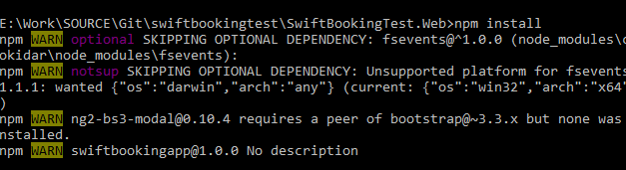

1. Upon build nuggets are restored
2. This project is made with code first approach so running the first time project will create a new database. At the moment database is created when record is added for the first time, also the connection string can be changed from web.config

# Framework Methodology:

1. I have used given sample Project as a baseline and added everything on top of it from the scratch. In this project there are only HTML pages, **AngularJS 2.4**, **Nodejs, Typescript,** and other helping JS files.
2. Server side is being developed using WEBAPI project empty template. We have to enable “CORS” as the client could be deployed on a different url.

# Design Patterns

1. IOC: using Dependency injection (StructureMap)
2. Generic Repository Pattern, EF Code First, Service
3. Single page application using Asp.net MVC, Nodejs, Typescript, Angular2.4, Bootstrap
4. MVC Web Api 2, RestSharp( http client) at server side
5. Server side Unit Testing (Moq)

# Implementation Details:

## Solution Structure:

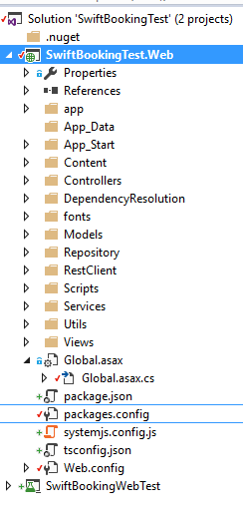

## Web Project Structure

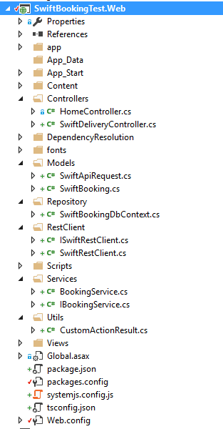

## Frontend Side:

1. Used AngularJS 2.4:
   1. bootstrapping angular 2.x application with Nodejs and typescript
   2. Angular modules, Angular components, angular custom components for this module, nested components
2. Frontend structure for single page application

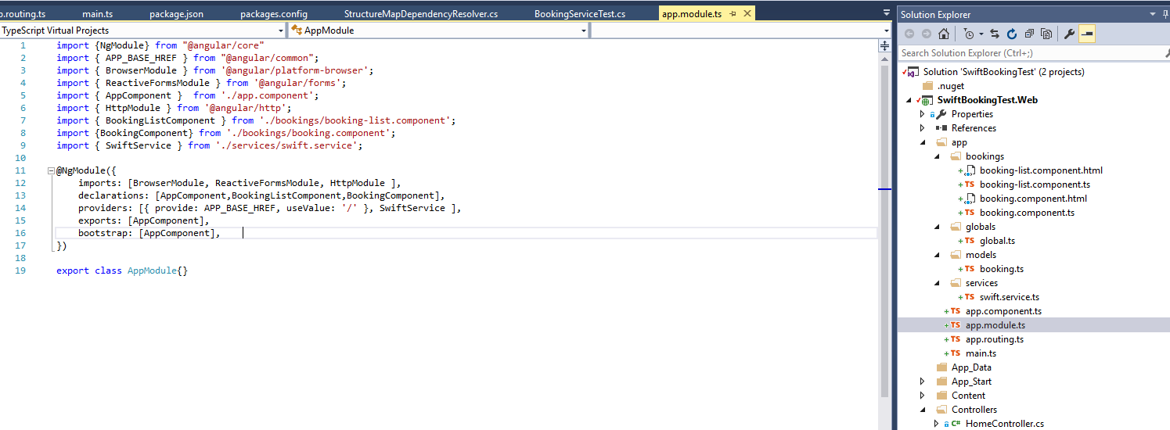

Developers will know that they have to create separate client side folders for the frontend entities like typescript and HTML pages (as shown above).

### Unit Test (MSTEST)

Unit test the project. Currently I have made a POC for Product->WEBAPIController->Detail. I have used **MOQ**  for MOCKING library.

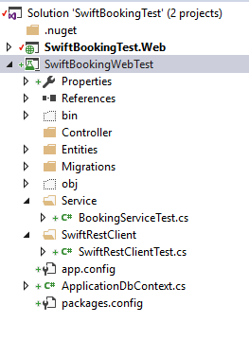

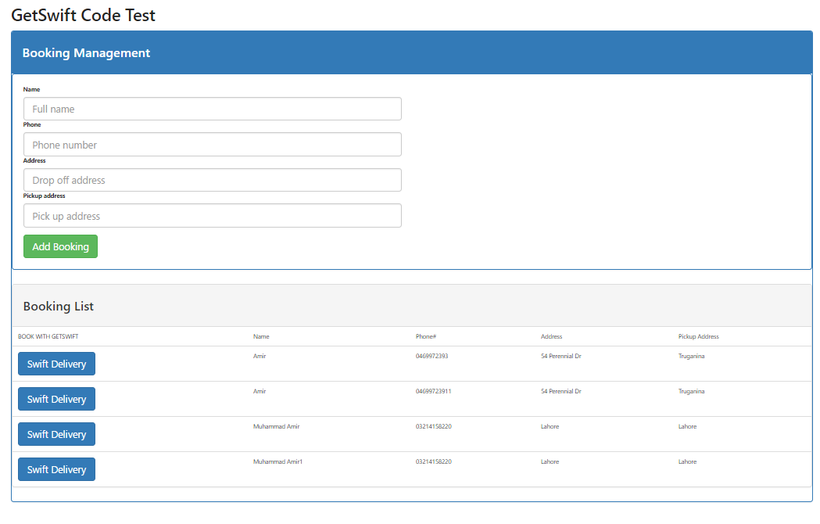

After Swift API Call

