Prompts used for the creation of project -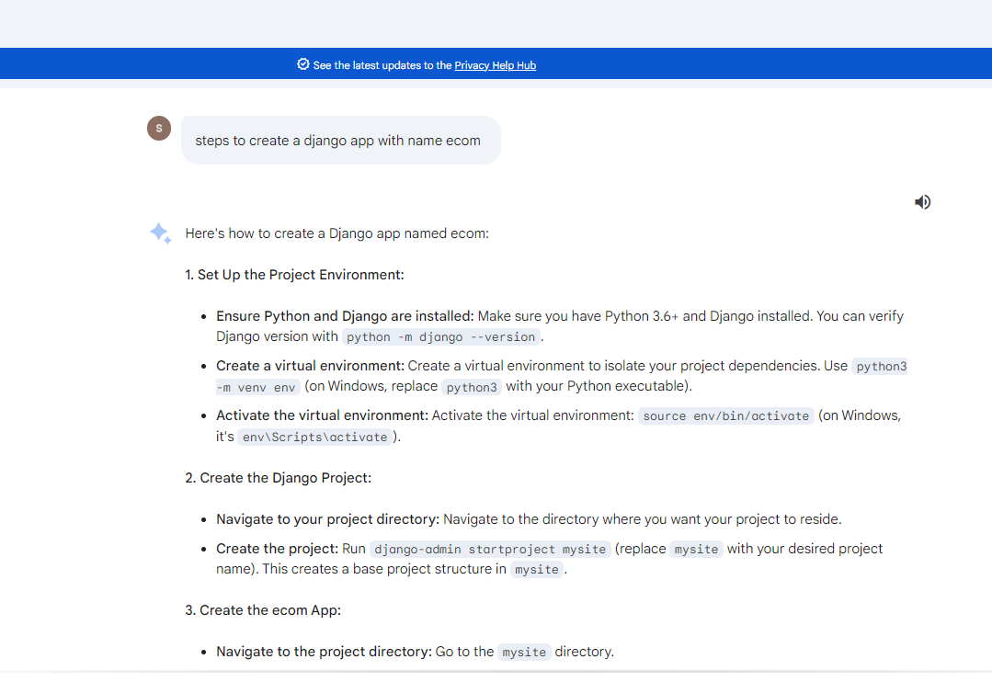

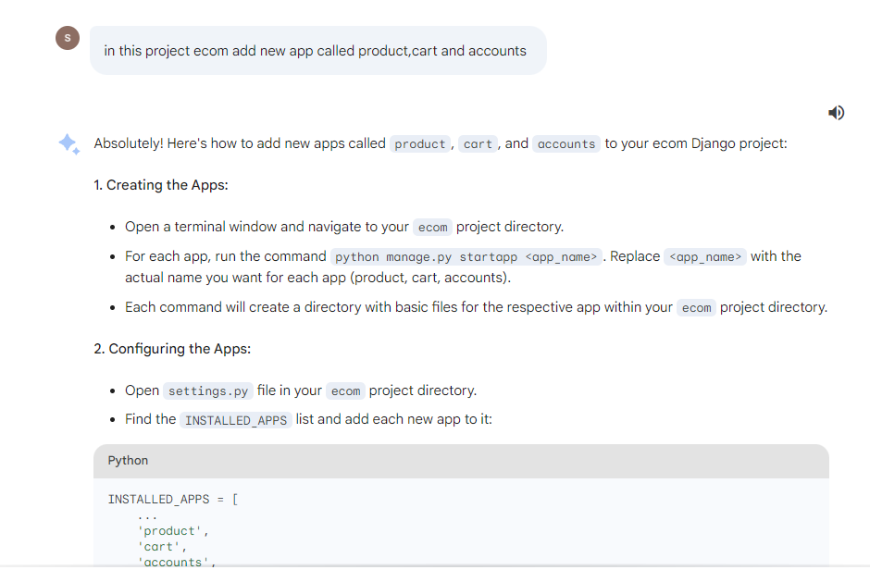

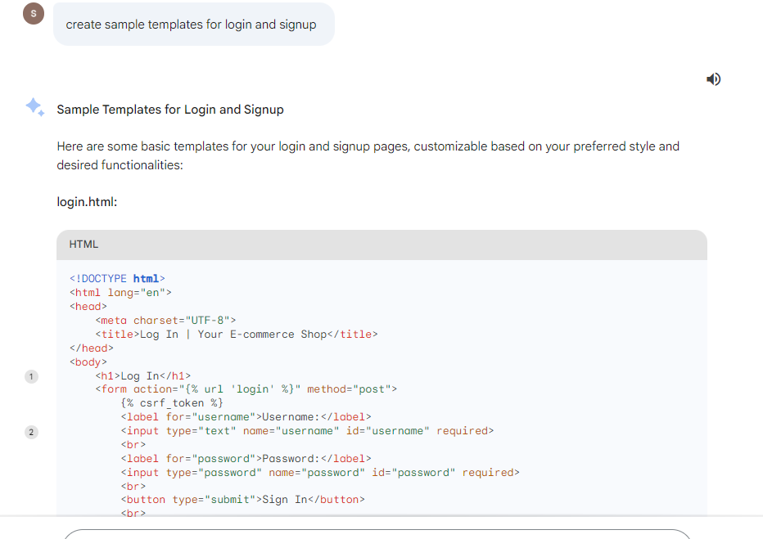

Application Screen Shots -

1. Home Page

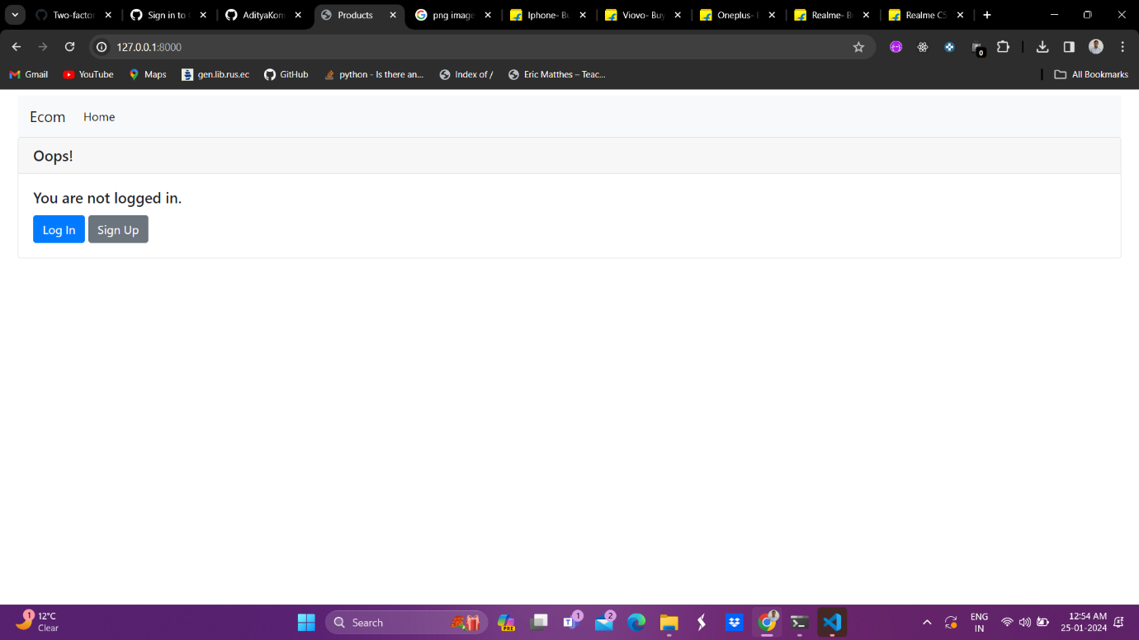

1. Sign Up Page

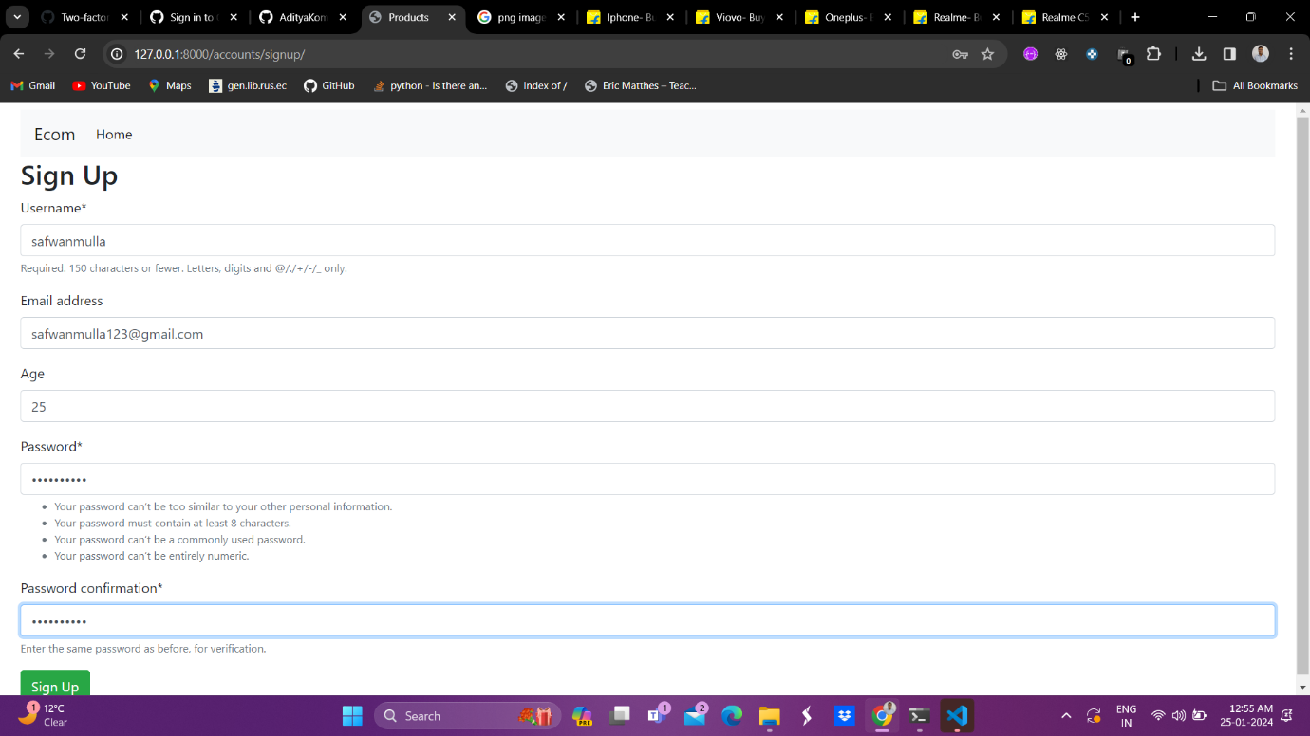

1. Login Page

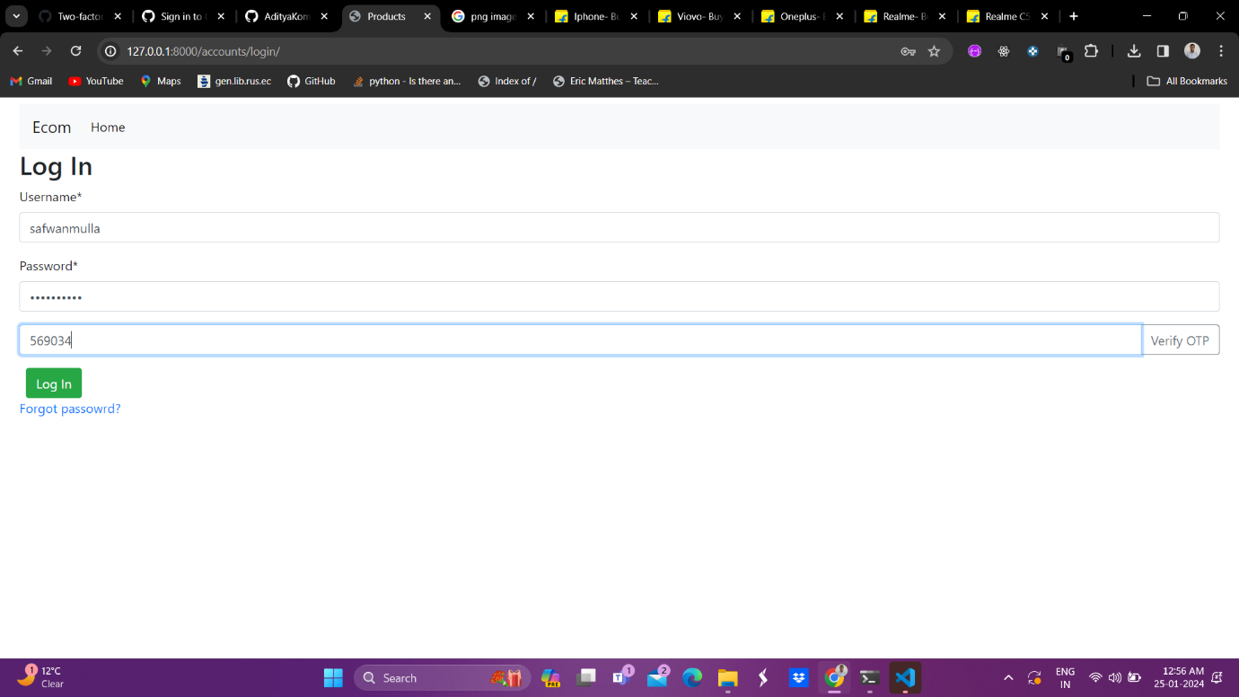

1. Home Page after login

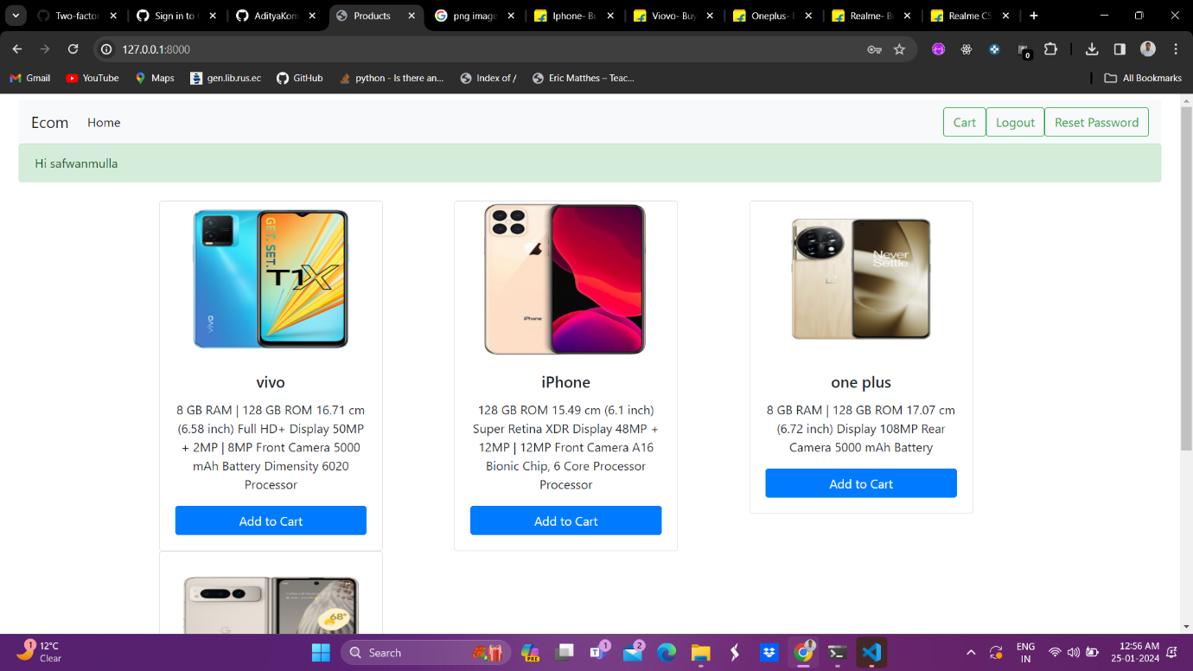

1. Items in Cart

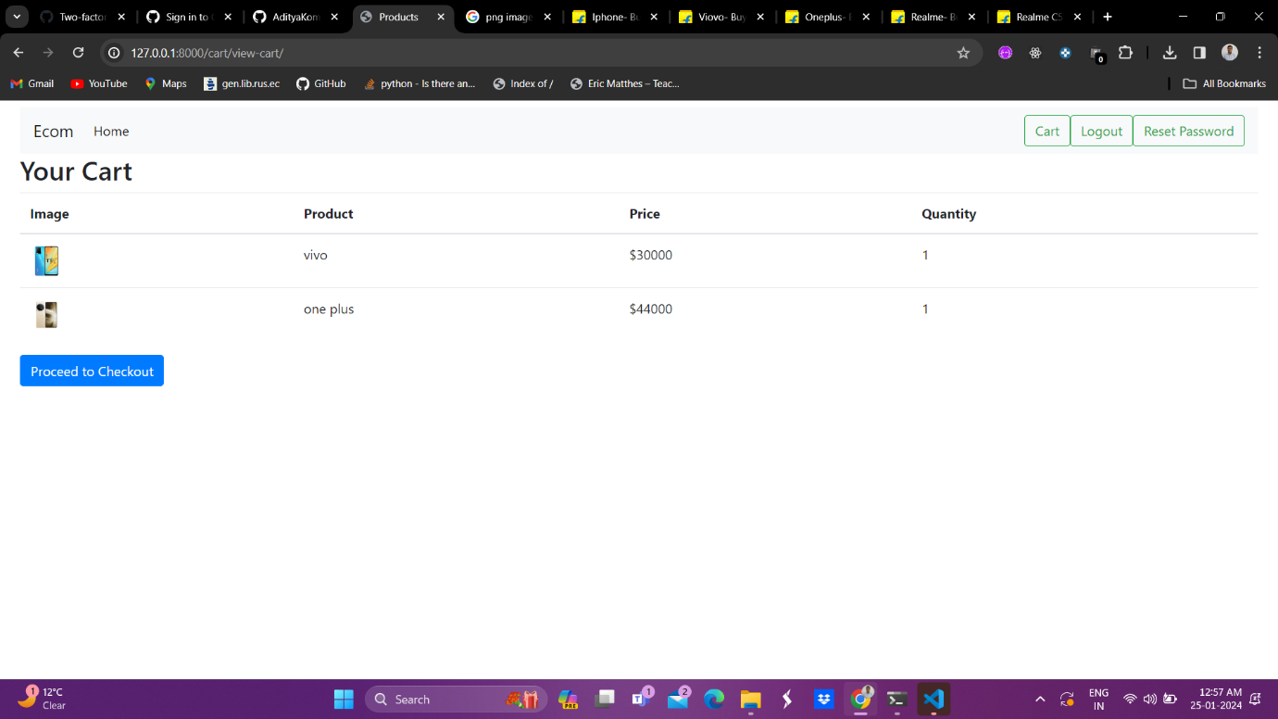

1. Password Reset

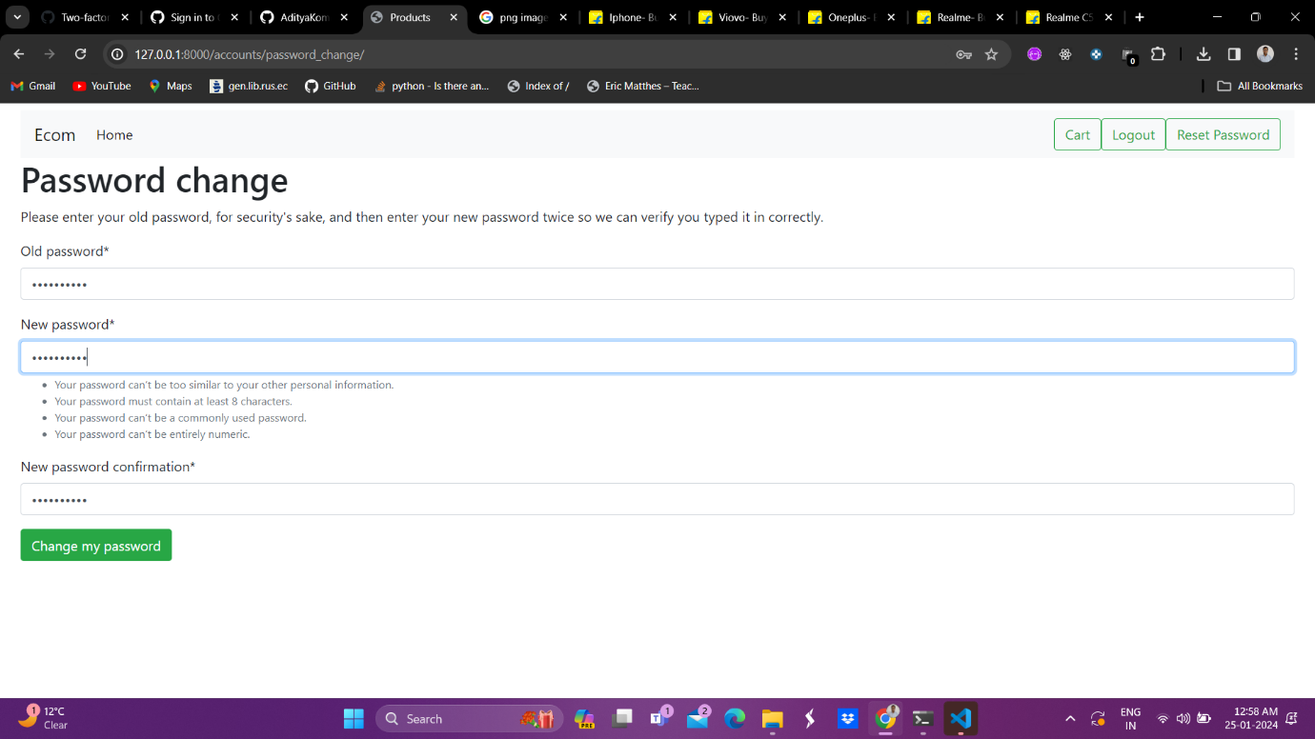

1. Password Reset DoneA computer screen with a white background

   Description automatically generated