**Project Documentation**

1. **Introduction**

**Project Title**: CookBook – Your Virtual Kitchen Assistant

* **Team** **ID**: NM2025TMID31420
* **Team** **Leader**: HAJERA S (Email: [hajera2427@gmail.com](mailto:hajera2427@gmail.com))
* **Team** **Members**:

– SAFRIN FATHIMA M (Email: [safrinfathima2427@gmail.com](mailto:safrinfathima2427@gmail.com))

– SUHANA S (Email: [s.suhana2427@gmail.com](mailto:s.suhana2427@gmail.com))

– RAHATH JUVAIRIYA A (Email: [juvairiya2427@gmail.com](mailto:juvairiya2427@gmail.com))

1. **Project Overview**

* **Purpose:** CookBook is a web-based virtual kitchen assistant designed to revolutionize recipediscovery, organization, and cooking experiences.
* **Features:**

–Recipe discovery with dynamic search

* Comprehensive recipe management
* Trending and popular dishes from TheMealDB API
* Recipe detail pages with ingredients, instructions, and demo videos
* Newsletter subscription

• **Audience**: Beginners, cooking enthusiasts, and professional chefs

1. **Architecture**

* **Fronted:** React.js with React Router, Axios, and Bootstrap/Tailwind CSS
* **Backend:** N/A (focuses on frontend integration with external APIs)
* **Database:** N/A (data fetched dynamically from APIs)

1. **Setup Instructions**

**• Prerequisites**:

* Node.js and npm
* Git
* React.js– Visual Studio Code

**• Installation Steps:**

# Clone/download the project from code drive

# Extract the folder and open in VS Code

#Install dependencies npm install

# Run the project npm start

**• Access:** Visit http://localhost:3000

**5.Folder Structure**

CookBook/

|-- src/

| |-- components/ # Navbar, Hero, Categories, Trending, Newsletter, etc.

| |-- pages/ # Category page, Recipe page | |-- styles/ #CSS files

**6.Running the Application**

• **Development** **server**:

npm start

• **Access**: Visit http://localhost:3000

**7. API Documentation**

* **Categories:** <https://www.themealdb.com/api/json/v1/1/categories.php>
* **Meals by Category:**

https://www.themealdb.com/api/json/v1/1/filter.php?c={category}

* **Meal Details:**

https://www.themealdb.com/api/json/v1/1/lookup.php?i={idMeal}

**8. Authentication**

• Not applicable (open API-based project)

**9. User Interface**

* Landing Page with Hero, Popular Categories, Trending Dishes
* Category Page listing dishes
* Recipe Page with instructions, ingredients, and video tutorial

**10. Testing**

* Manual testing during milestones
* Tools: Browser DevTools, Console logging

**11. Screenshots or Demo**

• Recipe page screenshots (from CookBook guide)

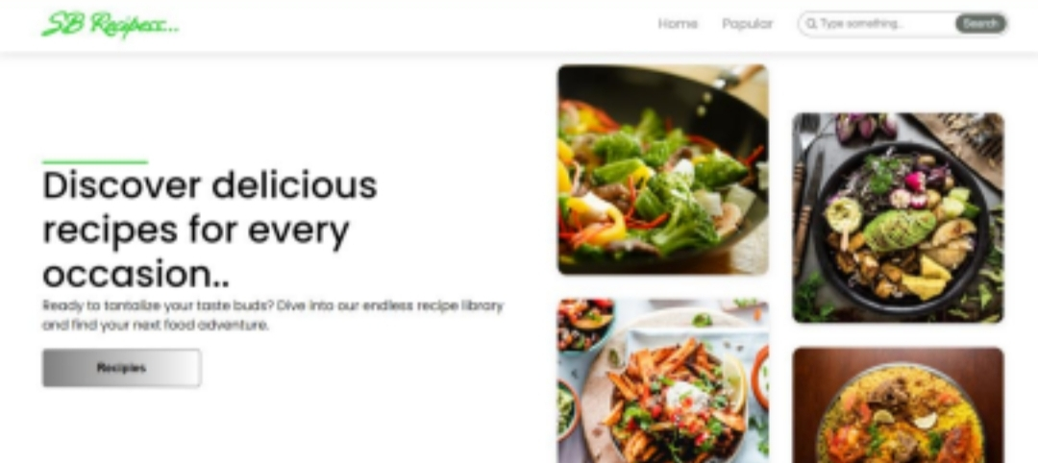

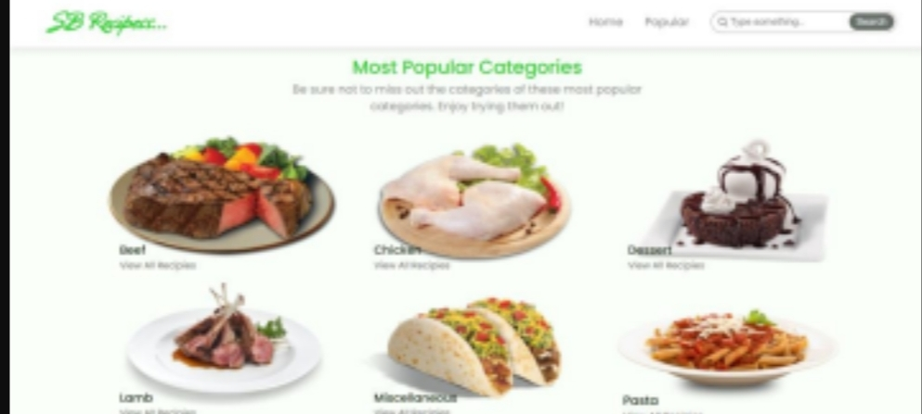

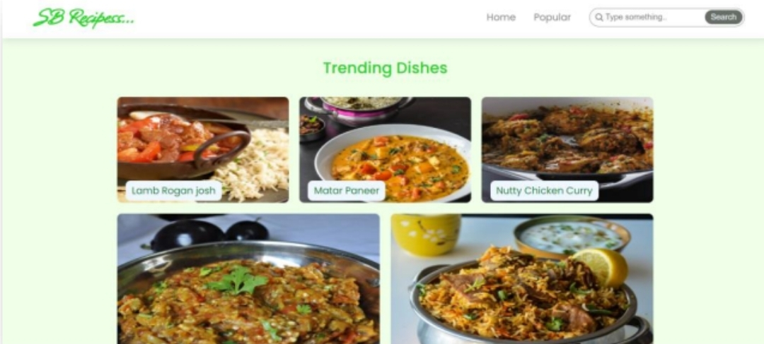

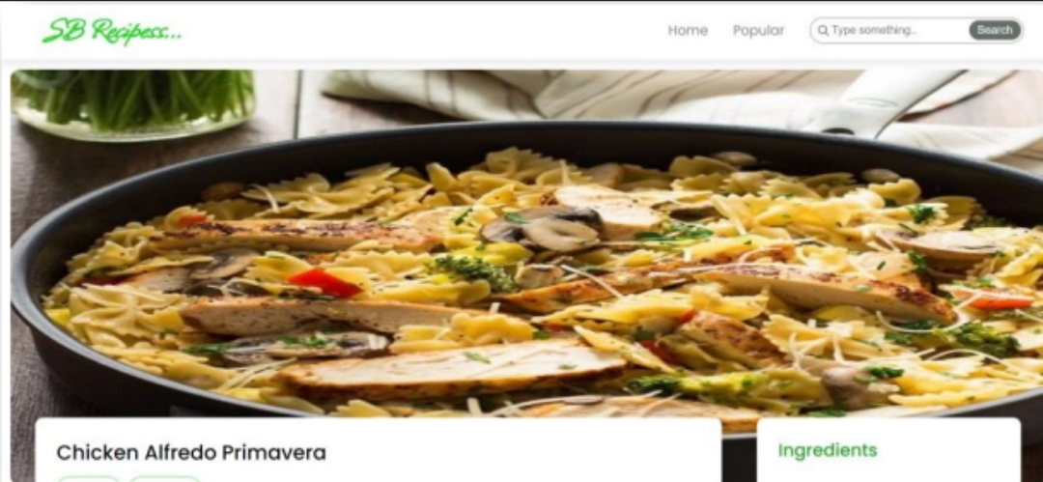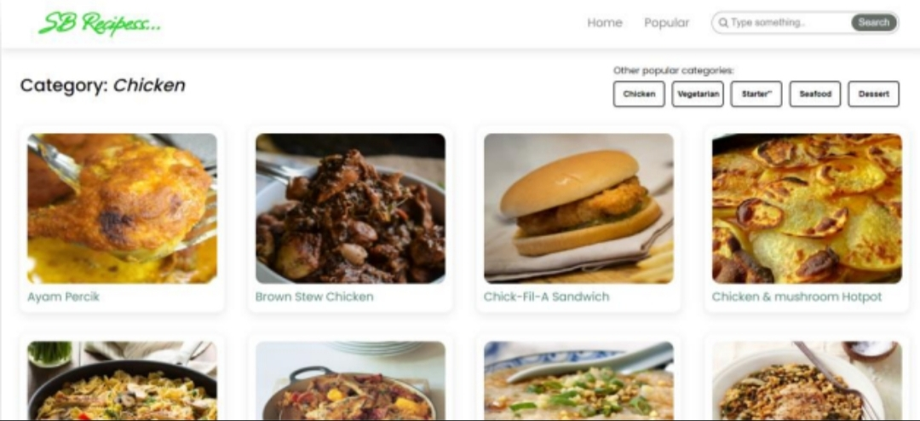

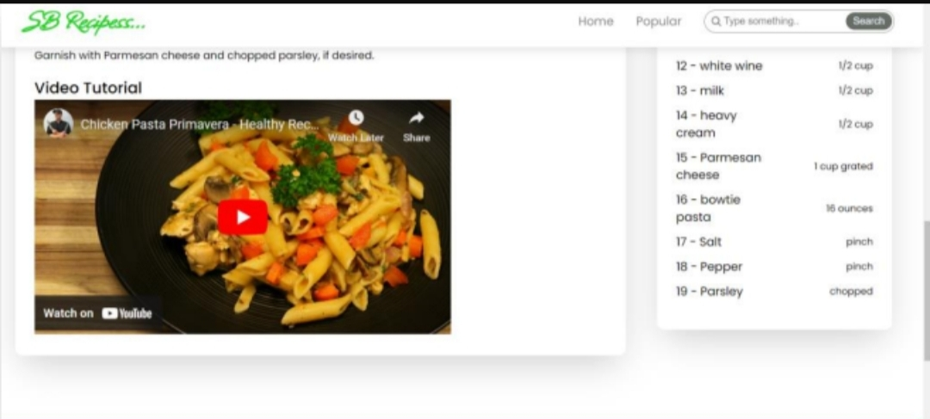

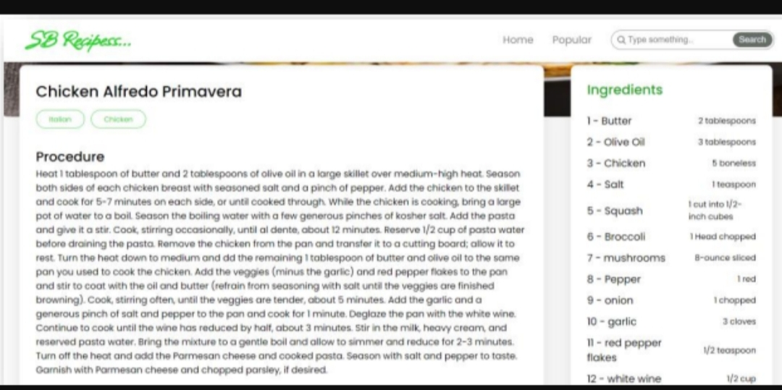

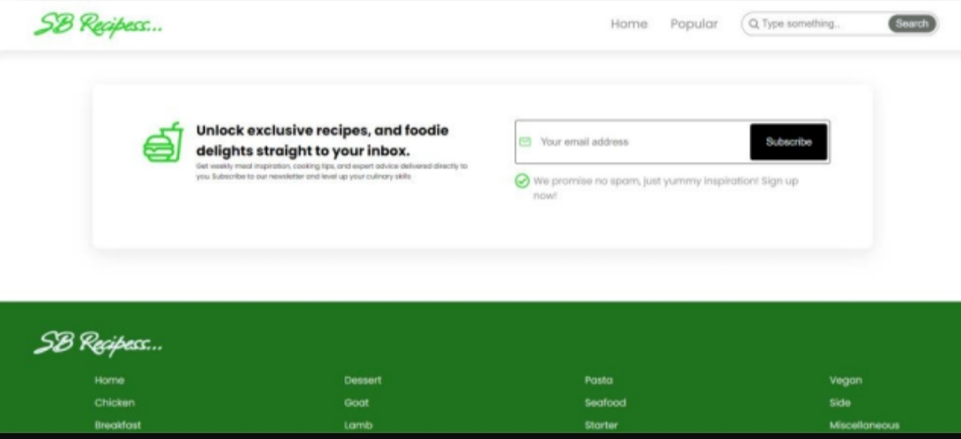

**12. Known Issues**

* Limited to external API data availability
* No authentication or personalization

**13. Future Enhancements**

* Add user authentication and recipe saving• Enable recipe rating and comments
* Expand API integrations for more cuisines