**Course Project User Guide**

# Introduction

In this project, we analyzed the growth rate of St. Petersburg neighborhoods from 2015 to 2022 using the average and median taxable, non-school district property values of properties in those neighborhoods. Our task was to investigate these rates at various levels of granularity: all properties, strictly residential properties, single-family homes, non-homestead single-family homes, and single-family properties in conjunction with missing middle properties. Through data visualizations in Tableau, we address the research question on whether homestead impacts property value growth rates in the area. The business value of this investigation is to observe how the area has developed over the course of seven years and present these findings in a manner which may draw potential investors and businesses to St. Petersburg.

# Methodology

To begin preparing the data for our analysis, we used R studio software to remove the columns of data in both the 2015 and 2022 data sets which were not relevant to our research questions. These included the measures total gross square feet, just value, assessed value school and non-school district, taxable value school district, and land value. We removed these columns because they would not contribute to our investigation of the taxable, non-school district value growth rates. We kept the fields for physical location like address, city, zip code, longitude, and latitude to preserve our ability to build a geographic visualization, if necessary. After this step, our data sets had thirteen columns: pin, assessment year, property use, homestead, land square footage, acres, neighborhood, taxable value non-school district, physical address, city, zip code, latitude, and longitude.

Next, we observed the row values of each field in R for inconsistencies and outlier values. We found that some of the neighborhoods in the 2022 data set had been renamed from the 2015 data set to include the qualifier “NBRHD ASSN.” For example, a home in the 2015 data set might be in the Twin Brooks neighborhood, but the same house in the 2022 data set would be in the Twin Brooks NBRHD ASSN neighborhood. So, we used R to find the neighborhoods with the “NBRHD ASSN” suffix and remove the additional term so that the two data sets would have matching descriptors. Lastly, we discovered that some rows had an assessment year of 0 rather than 2015 or 2022. The homes in these rows were also missing critical information like taxable value, their zip code, as well as the geographic identifiers latitude and longitude. Consequently, we removed these rows from the data set. Once these steps were complete, our data sets were clean and connected to Tableau for creating meaningful visualizations.

# Results

Analysis of the growth rates of each neighborhood from 2015 to 2022 using the mean and median values:

1. **For all** **properties :** 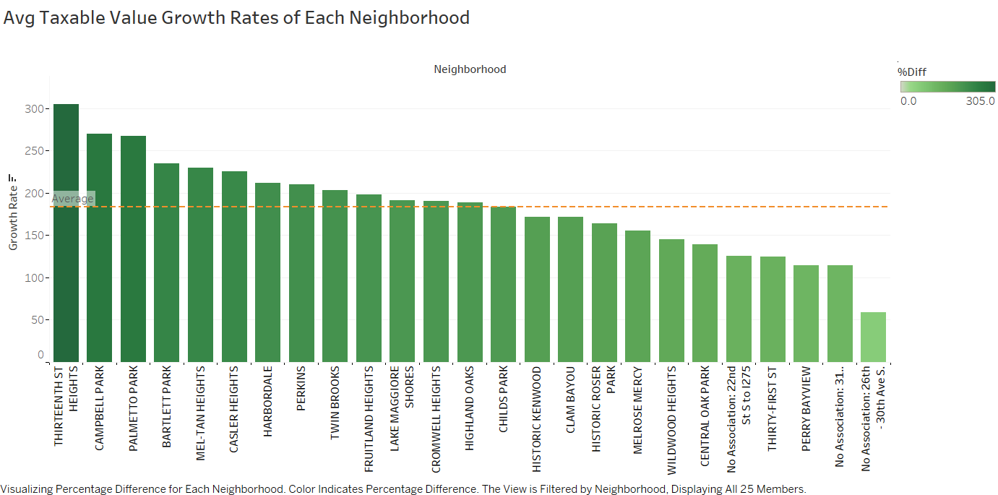

Median:

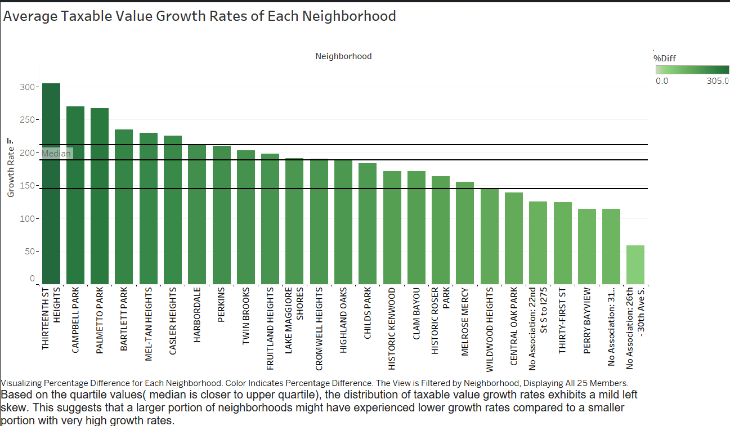

* Highest Growth: The Thirteenth Street Heights neighborhood exhibits the most remarkable growth at **305.0%**. This exceptional rise suggests potential revitalization efforts or significant development projects in the area.
* Lowest Growth: The No Association: 26th - 30th Ave S. neighborhood demonstrates the lowest growth rate at **59.0%**. This could be due to numerous factors, such as an already established housing market with higher baseline values in 2015.
* Average Growth: The average growth rate across all 25 neighborhoods is **183.8%.** This indicates a substantial increase in average taxable property values within the South St. Petersburg CRA during this period.
* Median: Based on the quartile values (median is closer to upper quartile), the distribution of taxable value growth rates exhibits a mild left skew. This suggests that a larger portion of neighborhoods might have experienced lower growth rates compared to a smaller portion with very high growth rates.

1. **For all strictly residential properties:**

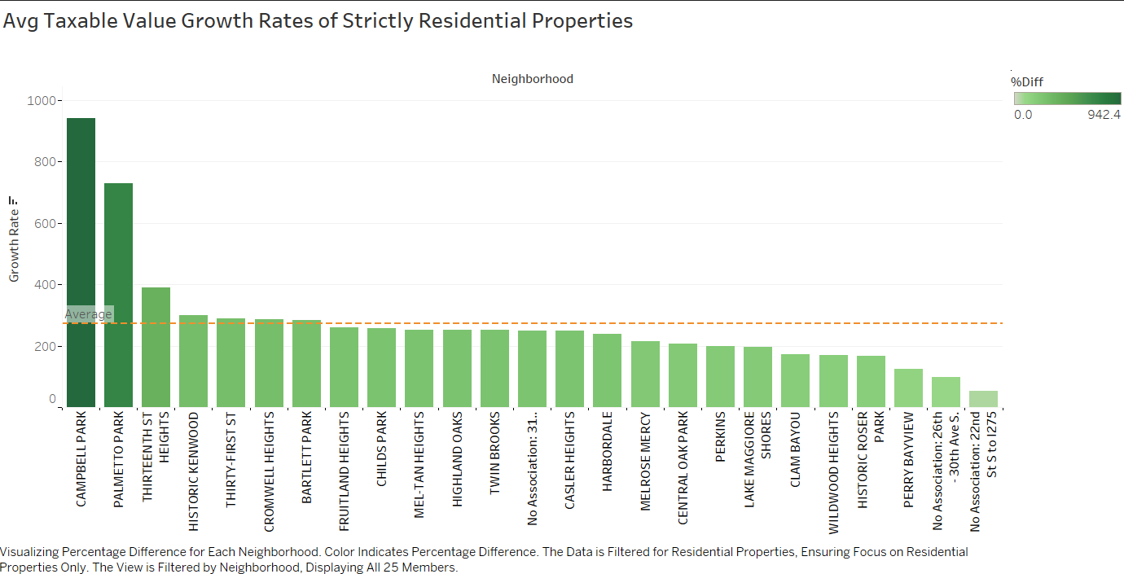

* Highest Growth Rate: Campbell Park has the highest growth rate at **942.4%**. This indicates a substantial increase in the average taxable value of residential properties in this neighborhood over the past seven years. The average value has more than tripled!
* Lowest Growth Rate: The No Association: 22nd St S to 1275 neighborhood has the lowest growth rate at **54.0%**. Here, the average taxable value of residential properties has increased by just over half during the same period.
* Average Growth Rate: The average growth rate across all analyzed neighborhoods for strictly residential properties is **273.2%.** This suggests a significant overall increase in residential property values within the South St. Petersburg CRA.

1. **For all single-family residential properties:**

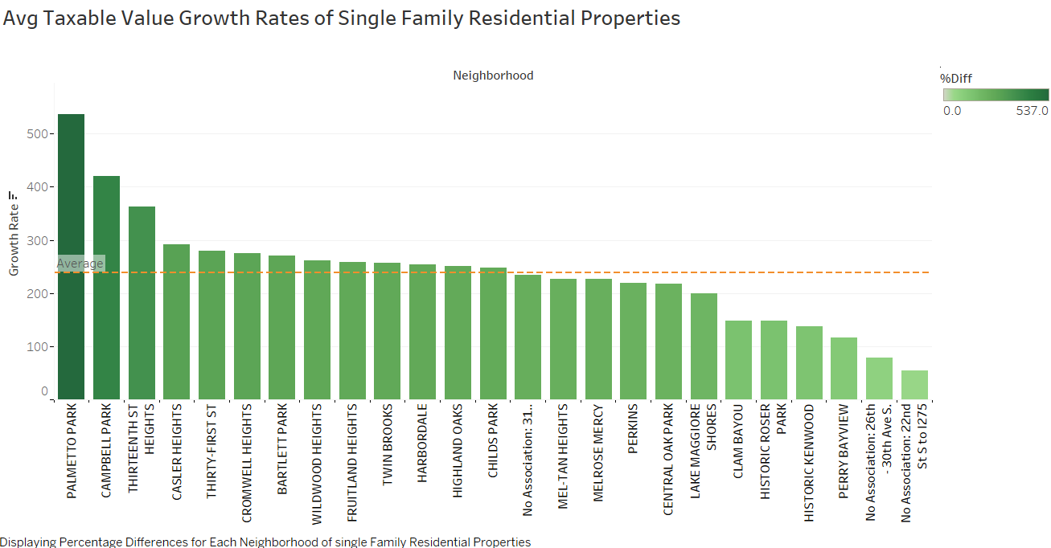

* Highest Growth Rate: PALMETTO PARK boasts the highest growth rate at **537.0%**. This signifies a remarkable increase in the average taxable value of single-family homes in this neighborhood over the past seven years. The average value has more than quintupled!
* Lowest Growth Rate: No Association: 22nd St S to 1275 remains the neighborhood with the lowest growth rate at **54.0%**. The average taxable value of single-family homes here has only grown by slightly more than half during the same period.
* Average Growth Rate: The average growth rate across all analyzed neighborhoods for single-family residential properties is **239%**. This suggests a significant overall increase in single-family home values within the South St. Petersburg CRA, but slightly lower than the 282.4% observed for all residential properties.
* Comparison with All Residential Properties: The lower average growth rate for single-family homes compared to all residential properties (245.3% vs. 282.4%) suggests that other residential property types (condominiums, townhouses, etc.).

1. **For single-family residential properties that are NOT homesteaded:** 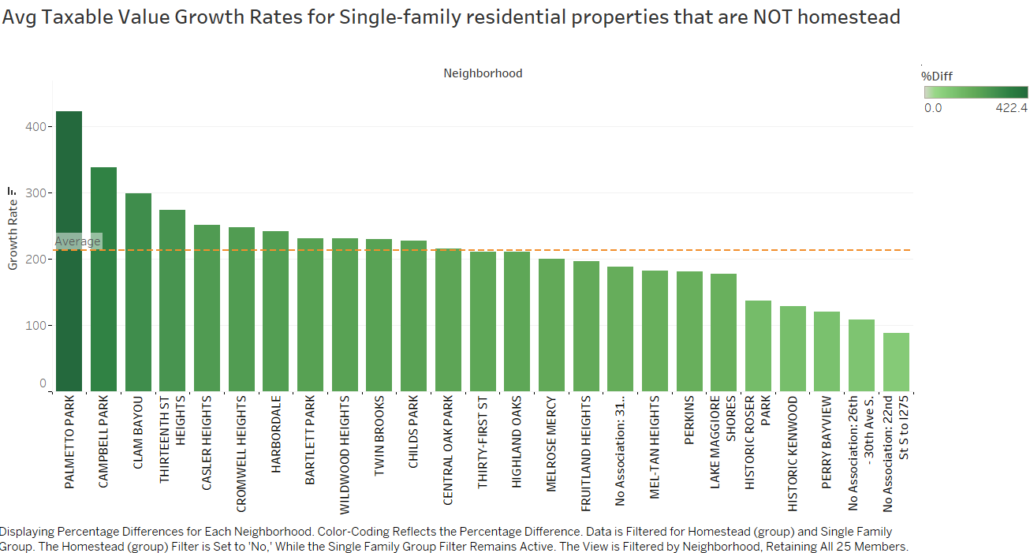

* Highest Growth Rate: Palmetto Park has the highest growth rate at **422.4%.** This signifies a substantial increase in the average taxable value of non-homesteaded single-family homes in this neighborhood over the past seven years. The average value has more than quadrupled!
* Lowest Growth Rate: The No Association: 22nd St S to 1275 neighborhood has the lowest growth rate at **87.5%.** The average taxable value of non-homesteaded single-family homes here has increased by less than double during the same period.
* Average Growth Rate: The average growth rate across all analyzed neighborhoods for non-homesteaded single-family residential properties is **213.3%**. This suggests a significant overall increase in non-homesteaded single-family home values within the South St. Petersburg CRA, but lower than the growth rate for all single-family homes (239.0%) which includes homesteaded properties.

1. **For single-family residential properties and missing middle properties:**

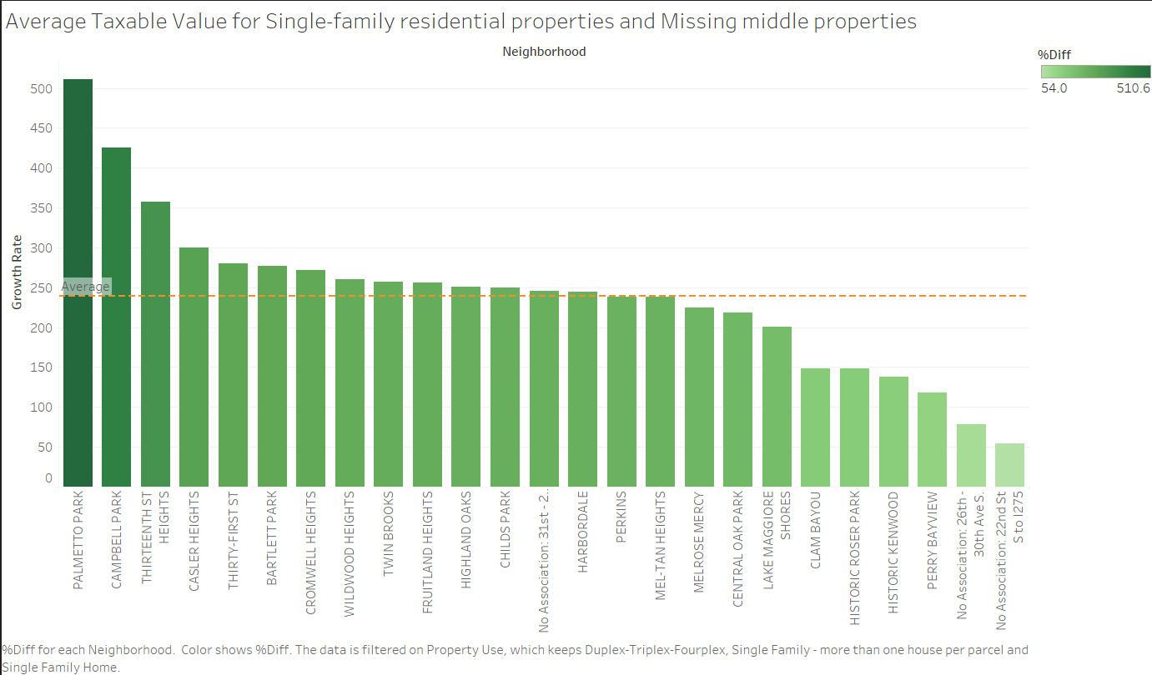

* Highest Growth Rate: Palmetto Park again leads with the highest growth rate at **510.6%**. This indicates a remarkable increase in the average taxable value of properties in this category over the past seven years.
* Lowest Growth Rate: The No Association: 22nd St S to 1275 neighborhood maintains the lowest growth rate at **54.0%**. The average taxable value of properties in this category has only grown by slightly more than half during the same period.
* Average Growth Rate: The average growth rate across all analyzed neighborhoods for this combined category is 239.7%. This suggests a significant overall increase in property values within the South St. Petersburg CRA

1. **Provide a narrative summary of the impact of homestead on the property value growth Rates:**

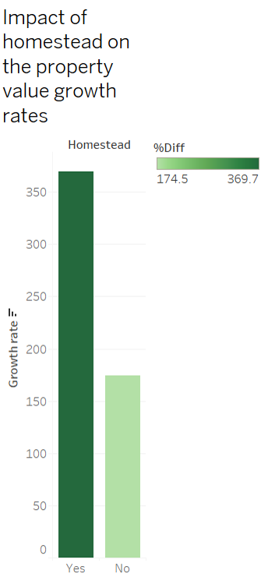

* Homestead Properties Appreciate Faster: Properties with homestead exemptions (homestead-yes) experienced a substantially higher average growth rate (**369.7%**) in taxable value between 2015 and 2022 compared to non-homesteaded properties (homestead-no) which grew at a rate of **174.5%**.

**Median Values and Distribution:**

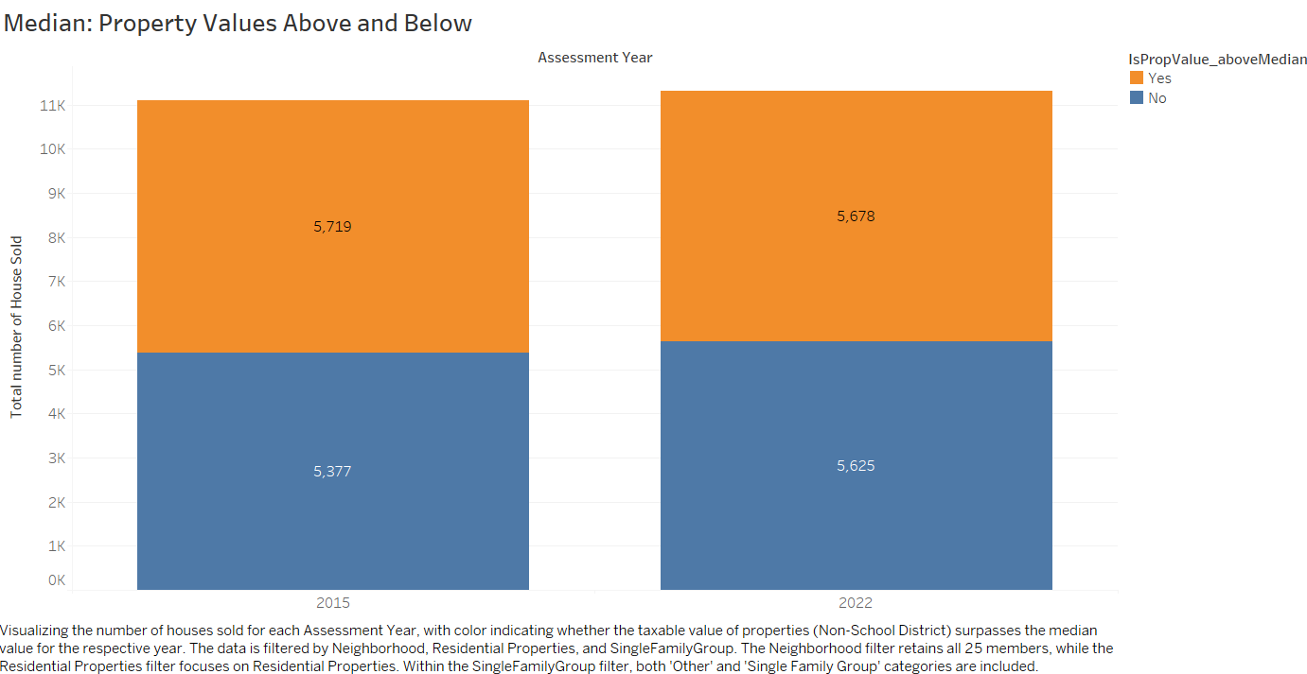

The substantial difference in median values between 2015 and 2022 (a more than threefold increase from $17,571 to $57,373) highlights a significant rise in property values within the South St. Petersburg CRA.

**Outliers**:

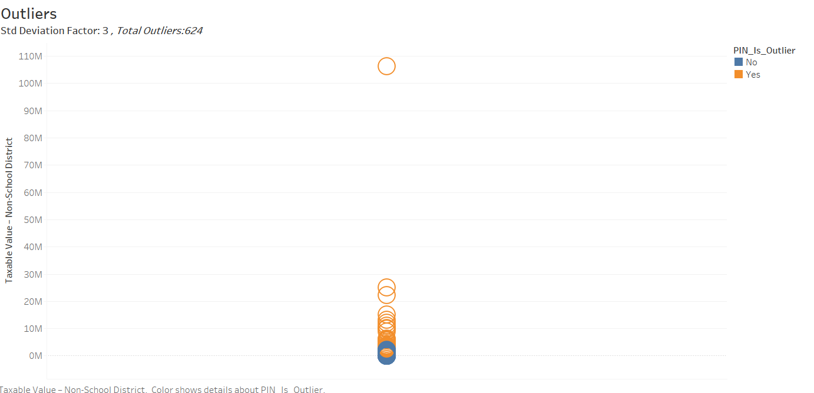

In the visualization of "Taxable Value – Non-School District," outliers are highlighted in orange based on a standard deviation factor of **3**. These outliers represent data points that deviate significantly from the expected distribution of taxable values within the dataset. Upon closer inspection, it's evident that there are **624** data points identified as outliers.

# Conclusions

* **All Properties Growth**: Neighborhoods like Thirteenth Street Heights, Palmetto Park, and Campbell Park have experienced exceptional growth rates, indicating significant revitalization and development within these areas. However, disparities exist, with some neighborhoods showing slower growth rates, such as No Association: 26th - 30th Ave S, suggesting potential challenges or barriers to development in these areas.
* **Strictly Residential Properties Growth:** A healthy housing market is indicated by substantial growth in residential property values. Neighborhoods such as Campbell Park, Palmetto Park, and Historic Kenwood exhibit exceptional growth rates in strictly residential property values, indicating significant demand for residential housing within these areas. Conversely, neighborhoods like No Association: 22nd St S to I275 and No Association: 26th - 30th Ave S. show comparatively lower growth rates, suggesting potential challenges or constraints to residential development in these locations.
* **Single-Family Residential Properties Growth**: Strong appreciation in single-family home values is observed, although slightly lower compared to all residential properties. Neighborhoods such as Campbell Park, Palmetto Park, and Twin Brooks stand out with substantial growth rates in single-family residential property values, indicating strong demand for detached housing within these areas. Conversely, neighborhoods like No Association: 22nd St S to I275 and No Association: 26th - 30th Ave S. show comparatively lower growth rates, suggesting potential challenges or constraints specific to the single-family residential market in these locations.
* **Non-Homesteaded Single-Family Residential Properties Growth:** Neighborhoods like Palmetto Park, Campbell Park, and Bartlett Park demonstrate remarkable growth rates in non-homesteaded single-family residential property values, indicating strong investment potential and demand for non-owner-occupied housing within these areas. Conversely, neighborhoods such as Historic Kenwood and Historic Roser Park exhibit comparatively lower growth rates, suggesting potential challenges or constraints specific to the non-homesteaded single-family residential market in these historic districts. The significant growth observed across various neighborhoods underscores the diverse investment opportunities and market dynamics within the South St. Petersburg CRA, highlighting the importance of targeted strategies to address housing affordability and promote inclusive economic development.
* **Single-Family Residential and Missing Middle Properties Growth:** Robust growth is seen in the combined category, emphasizing housing diversity within the CRA. Neighborhoods like Palmetto Park, Campbell Park, and Thirteenth St Heights show exceptional growth rates, indicating strong demand for diverse housing options. Conversely, areas like No Association: 26th - 30th Ave S. and No Association: 22nd St S to I275 exhibit lower growth, suggesting potential challenges in stimulating investment.
* **Impact of Homestead on Property Value Growth Rates:** Properties with homestead exemptions appreciate significantly faster, influencing property value growth rates. Understanding differential growth rates is crucial for fair development and housing affordability policies.
* **Median Insights:** Based on the quartile values (median is closer to upper quartile), the distribution of taxable value growth rates exhibits a mild left skew. This suggests that a larger portion of neighborhoods might have experienced lower growth rates compared to a smaller portion with very high growth rates.
* **Outliers**: Property values in the South St. Petersburg CRA witnessed a substantial rise in median taxable value between 2015 and 2022. While many outliers were identified, these can be valuable indicators of data discrepancies or the presence of unique, high-value properties within the CRA. Further investigation into these outliers is crucial for a comprehensive and accurate understanding of the complete property value landscape within the CRA.

**Opportunities for Further Analysis:**

* Explore how neighborhood amenities, transportation accessibility, and community development projects influence property values.
* Analyze the relationship between income levels, employment trends, and housing affordability to understand their impact on the local housing market.
* Explore the outliers which can help determine if they represent data discrepancies or highlight the presence of unique, high-value properties within the CRA. This investigation will contribute to a more comprehensive understanding of the complete property value landscape within the CRA.

# Link to Visualizations

Below is the link to our Tableau Workbook on the Tableau Public website.

<https://public.tableau.com/app/profile/eisgroup.3/vizzes>

# Appendix

**Median Visualizations:**

**For all strictly residential properties:**

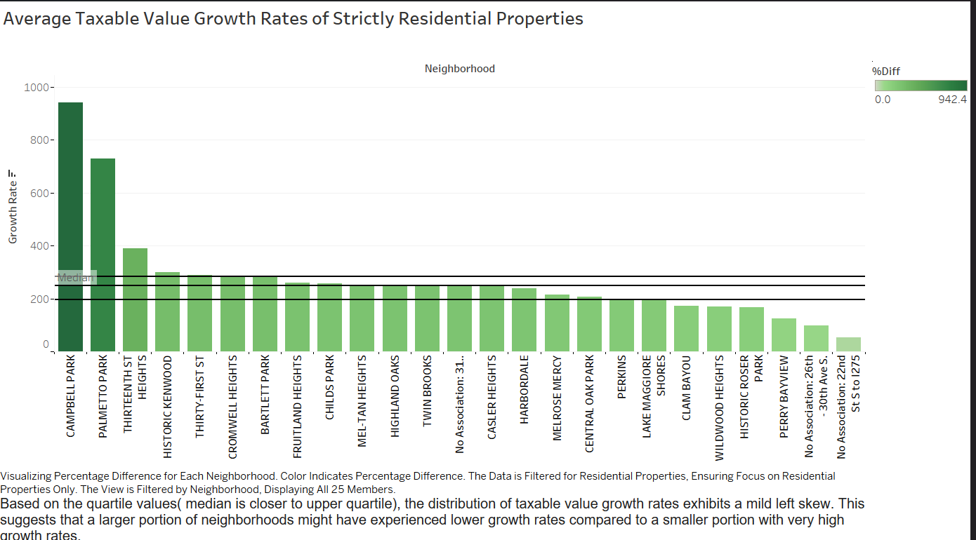

**For all single-family residential properties:**

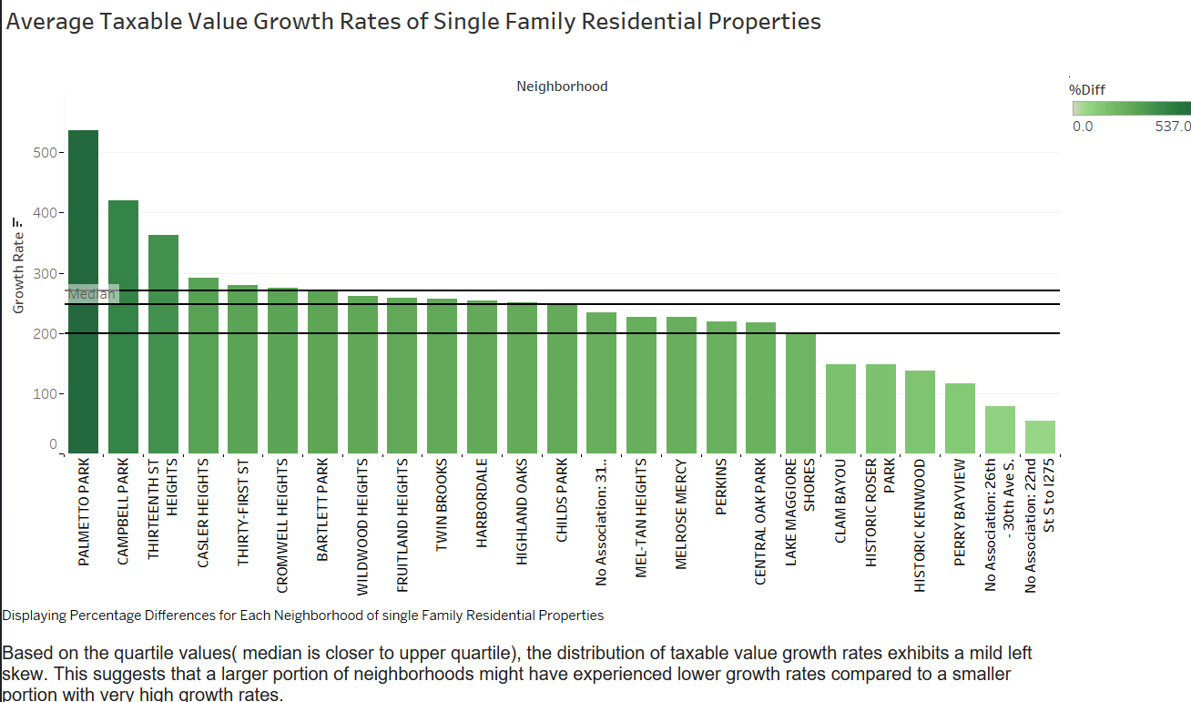

**For single-family residential properties that are NOT homesteaded:**

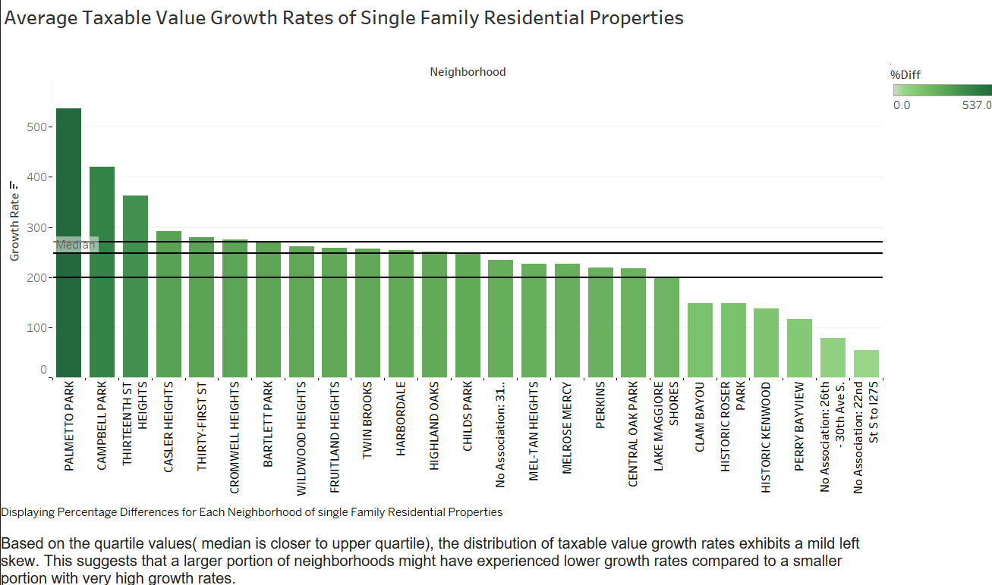

**For single-family residential properties and missing middle properties:**

