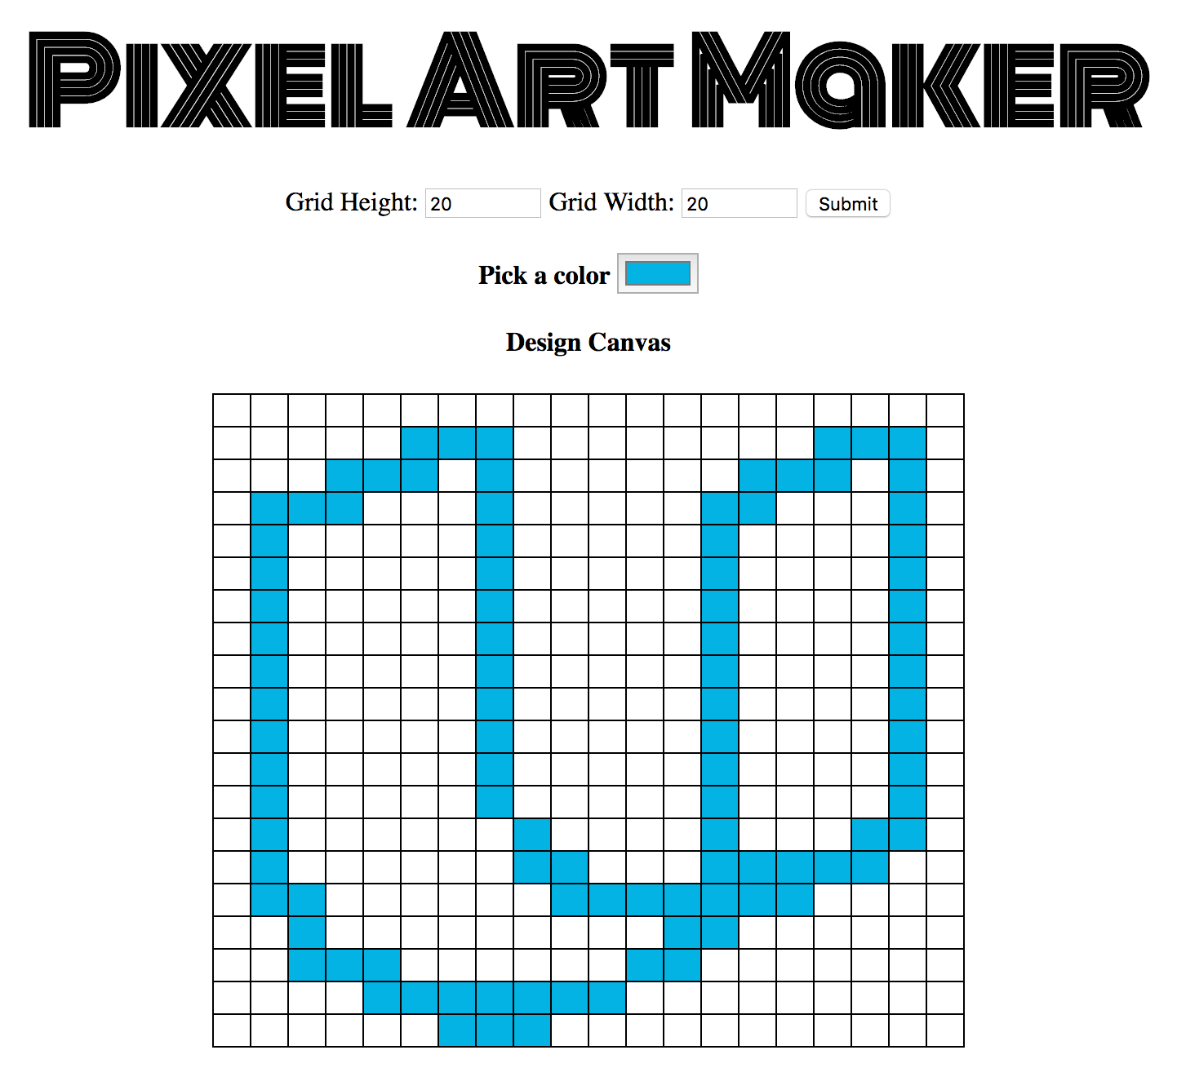

You'll be given starter code, including HTML and CSS, to build the application. You'll write JavaScript code that lets the user to create a grid of squares representing their design, and apply colors to those squares to create a digital masterpiece!

Your users should be able to:

1. Dynamically set the size of the table as an *N* by *M* grid.
2. Choose a color.
3. Click a cell in the grid to fill that cell with the chosen color.

Your primary task is to implement the makeGrid() function, that dynamically creates a grid that the user can interact with.

**What Skills Do I Need?**

In this project, you'll use your front-end programming skills from **JavaScript Foundations** and **Intro to jQuery**, including:

* Defining variables with const and let
* Accessing the DOM using methods of the document object
* Declaring functions and attaching them to DOM objects as event listeners
* Writing nested loops and using loop variables

Although not a requirement, you are encouraged to use **jQuery** to manipulate the DOM for this project.

**How Does This Help My Career?**

Interacting with the DOM — the structure of a web page — is one of the most fundamental skills for a front-end web developer. Mastering event listeners is essential to creating user interfaces — and to quite a few other things. Later in the curriculum you'll see much more about event listeners when you're writing JavaScript code that interacts with the network.