BuildCredit-ER Diagram 1.0

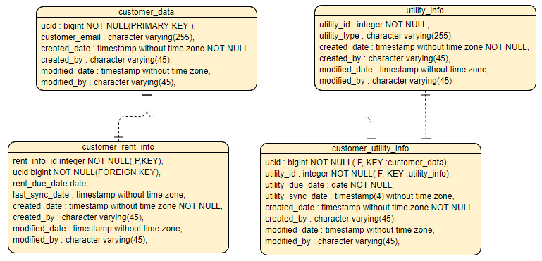

Table Details:

TABLE No 1: customer_data;

CREATE TABLE rtcustomer.customer_data
(
ucid bigint NOT NULL,
customer_email character varying(255) COLLATE pg_catalog."default",
created_date timestamp without time zone NOT NULL,
created_by character varying(45) COLLATE pg_catalog."default" NOT NULL,
modified_date timestamp without time zone,
modified_by character varying(45) COLLATE pg_catalog."default",
CONSTRAINT cust_data_pkey PRIMARY KEY (ucid)
)
WITH (
OIDS = FALSE
)
TABLESPACE pg_default;

ALTER TABLE rtcustomer.customer_data OWNER to moasan;

TABLE No 2: customer_rent_info;

CREATE TABLE rtcustomer.customer_rent_info
(
rent_info_id integer NOT NULL,
ucid bigint NOT NULL,
rent_due_date date,
last_sync_date timestamp without time zone,
created_date timestamp without time zone NOT NULL,
created_by character varying(45) COLLATE pg_catalog."default" NOT NULL,
modified_date timestamp without time zone,
modified_by character varying(45) COLLATE pg_catalog."default",
CONSTRAINT cust_rent_info_pkey PRIMARY KEY (rent_info_id),
CONSTRAINT cust_rent_info_id_fkey FOREIGN KEY (ucid)
REFERENCES rtcustomer.customer_data (ucid) MATCH SIMPLE
ON UPDATE NO ACTION
ON DELETE NO ACTION
)
WITH (
OIDS = FALSE
)
TABLESPACE pg_default;

ALTER TABLE rtcustomer.customer_rent_info OWNER to moasan;

TABLE No 3: utility_info;

CREATE TABLE rtcustomer.utility_info
(
utility_id integer NOT NULL,
utility_type character varying(255) COLLATE pg_catalog."default",
created_date timestamp without time zone NOT NULL,
created_by character varying(45) COLLATE pg_catalog."default",
modified_date timestamp without time zone,
modified_by character varying(45) COLLATE pg_catalog."default",
CONSTRAINT util_info_pkey PRIMARY KEY (utility_id)
)
WITH (
OIDS = FALSE
)
TABLESPACE pg_default;

ALTER TABLE rtcustomer.utility_info OWNER to moasan;

TABLE No 4: customer_utility_info;

CREATE TABLE rtcustomer.customer_utility_info
(
ucid bigint NOT NULL,
utility_id integer NOT NULL,
utility_due_date date NOT NULL,
utility_sync_date timestamp(4) without time zone,
created_date timestamp without time zone NOT NULL,
created_by character varying(45) COLLATE pg_catalog."default" NOT NULL,
modified_date timestamp without time zone,
modified_by character varying(45) COLLATE pg_catalog."default",
CONSTRAINT cust_data_info_id_fkey FOREIGN KEY (ucid)
REFERENCES rtcustomer.customer_data (ucid) MATCH SIMPLE
ON UPDATE NO ACTION
ON DELETE NO ACTION,
CONSTRAINT cust_util_info_id_fkey FOREIGN KEY (utility_id)
REFERENCES rtcustomer.utility_info (utility_id) MATCH SIMPLE
ON UPDATE NO ACTION
ON DELETE NO ACTION
)
WITH (
OIDS = FALSE
)
TABLESPACE pg_default;

ALTER TABLE rtcustomer.customer_utility_info OWNER to moasan;

