**US_294144_Cognizant: Create a lease for customer**

**Understanding of the requirement**

Create a lease for the Extra credit customer

**Assumptions**:

* User Details such as Address, Landlord information and Rental Payment details are provided
* GitLab Apiary access will be provided

**High level Technical design and solution**

* 1. Impacted Modules

BCM Modules

* 1. Impacted Workflows
     1. Overview:

For the subscribed user, BCM will be able to create a lease for the given lease details.

If the given lease is created for the user, then the BCM will receive the error code from the RentTrack and BCM will send back the corresponding readable response message to the invoker

If the lease is created successfully, then the BCM will send back the corresponding readable response message to the invoker.

* + 1. APIs Involved:

POST and PATCH/api/tenant/leases

* + - * + BCM is the consumer
        + Payload : Address, Landlord information and Rental Payment details
        + Error Codes:

201 - Returned when successful

400 - Error validating data. Please check parameters and retry.

409 - User exists.

500 - Internal Server Error

* + 1. Messaging Infrastructure: N/A
    2. UI Screens: N/A
  1. DB Changes:

1. Table Name : customer_data

The token related details will be used for create lease api call.

Table Description :

* ucid
* customer_email
* created_date
* modified_date
* access_token
* refresh_token
* token_expiry
* token_created_date
  1. Dependencies

RentTrack API

* 1. Blocker Inputs needed

The sandbox access need to be provided

* 1. Design Patterns considered and the chosen one

SOA

g) Sequence Diagram:

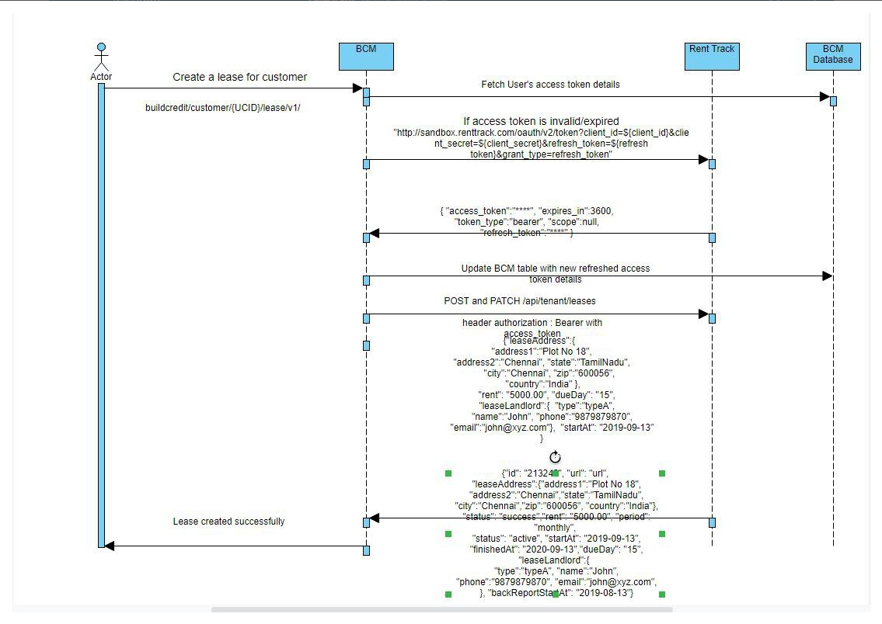

**Business** :

**Step 1 :** For the subscribed user, BCM will be invoke the below API to create a lease for the given lease details.

POST /api/tenant/leases.{_format}

**Input :**

| Parameter | Type | Required? | Format | Description |
| --- | --- | --- | --- | --- |
| address | object (LeaseAddressDTO) | true |  |  |
| address[address1] | string | true | {not blank} |  |
| address[address2] | string | false |  |  |
| address[state] | string | true | {not blank} |  |
| address[city] | string | true | {not blank} |  |
| address[zip] | string | true | {not blank} |  |
| address[country] | string | false |  |  |
| rent | float | false |  | Rent amount. Include decimal. |
| due_day | integer | false |  | Day of the month. |
| landlord | object (LeaseLandlordDTO) | false |  |  |
| landlord[type] | string | false |  |  |
| landlord[name] | string | false |  |  |
| landlord[phone] | string | false |  |  |
| landlord[email] | string | false |  |  |
| start_at | DateTime | false |  | Lease start date. Format YYYY-mm-dd. |

**Output** :

| Parameter | Type | Versions | Description |
| --- | --- | --- | --- |
| 201 - Returned when successful |  | | |
| id | integer | * |  |
| url | string | * |  |
| address | object (LeaseAddress) | * |  |
| status | string | * |  |
| rent | string | * |  |
| start_at | string | * | Format "YYYY-MM-DD" |
| finished_at | string | * | Format "YYYY-MM-DD" |
| due_day | string | * |  |
| landlord | object (LeaseLandlord) | * |  |
| back_report_start_at | string | * | Format "YYYY-MM-DD" |

**Step 2** : If the lease is already exists, then the BCM will invoke the below PATCH api call

PATCH /api/tenant/leases/{id}.{_format}

**Input :**

| Parameter | Type | Required? | Format | Description |
| --- | --- | --- | --- | --- |
| address |  | false |  |  |
| rent | numeric | false |  |  |
| due_day |  | false |  |  |
| landlord |  | false |  |  |

**Output :**

204 - Success

**Clarifications**:

* Do we need to capture any lease information in BCM database?

-It should not be captured in BCM database

**Code / Framework References**

**Misc:**